Data driven agriculture management system using AI and IoT technologies

Artificial Intelligence (AI) and the Internet of Things (IoT) are emerging as transformative technologies in advanced modern agricultural systems, enabling smart, data-driven farming practices. Agriculture plays a critical role in sustaining human life, and the integration of AI-IoT technologies allows continuous monitoring and intelligent management of agricultural ecosystems to enhance productivity, quality, and sustainability. However, Smart Sustainable Agriculture (SSA) faces significant challenges, including large and geographically dispersed farms, deployment and management of AI-IoT devices, data interoperability, real-time data stream processing, and scalable storage architectures. This paper presents a system architecture oriented Data-Driven Agriculture Management framework that integrates IoT-based sensor networks, AI-driven predictive analytics, and optimization mechanisms for precision farming. The proposed system continuously monitors soil moisture, temperature, humidity, and nutrient (NPK) parameters through IoT devices, processes large-scale agricultural data streams, and employs advanced machine learning and transformer-based forecasting models for soil and crop condition prediction. An integrated optimization layer enables precision irrigation scheduling, nutrient dosage control, yield forecasting, and intelligent resource allocation. The framework emphasizes scalable and resilient platform design, incorporating explainable AI techniques and optimized algorithms to support farmer-centric decision-making. By improving water-use efficiency, minimizing fertilizer over-application, and enhancing crop productivity, the proposed architecture contributes to sustainable and resource-efficient agricultural systems. Addressing interoperability, scalability, and usability challenges presents significant opportunities to revolutionize precision agriculture and build resilient food systems for future generations
Open command prompt and type command to run the project
“python manage.py runserver”
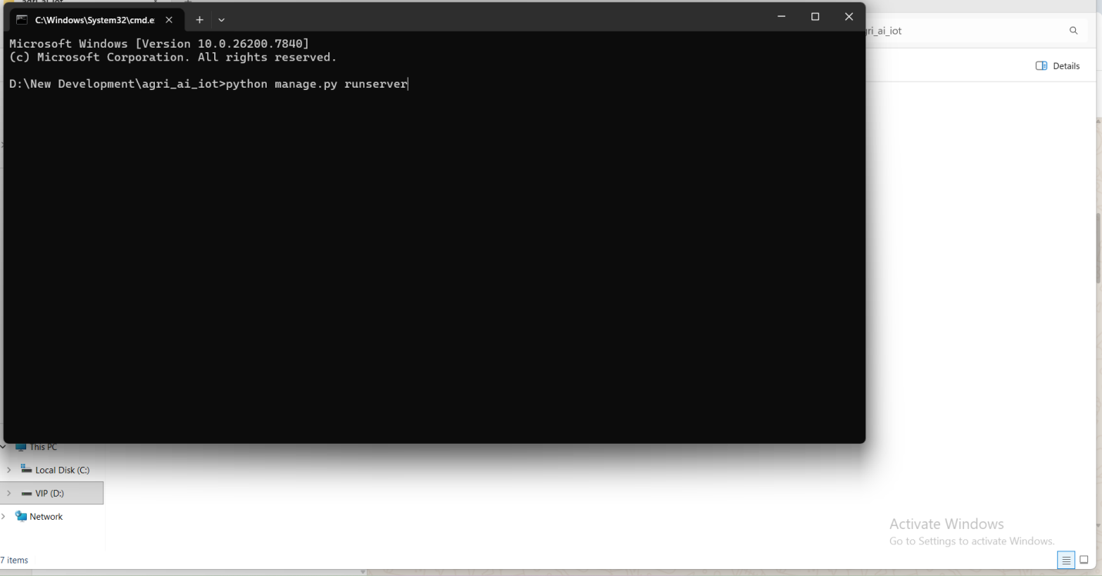

After type command enter
Then we will get 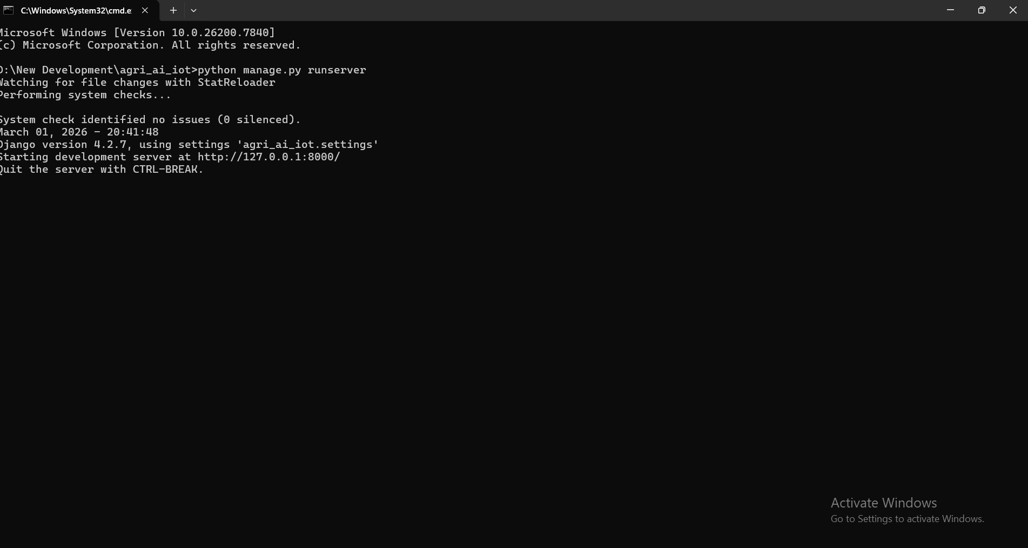

Copy URL http://127.0.0.1:8000/ and open in the browser and paste url
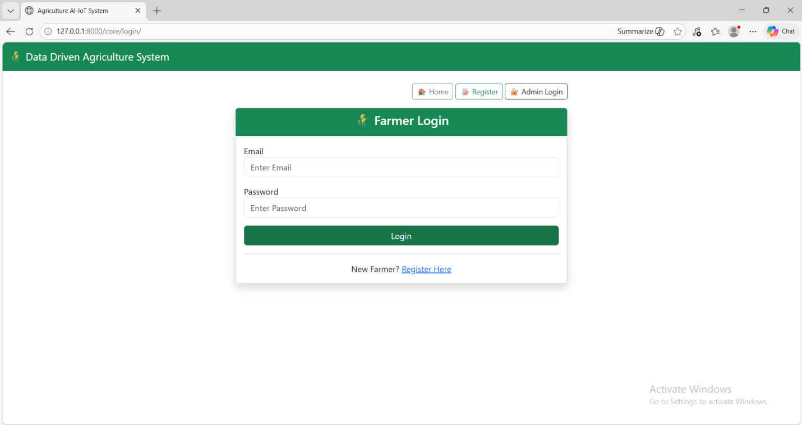

Farmer Registration page
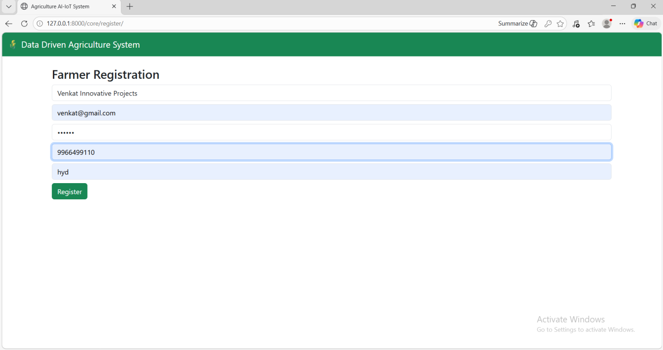

Then Login Page
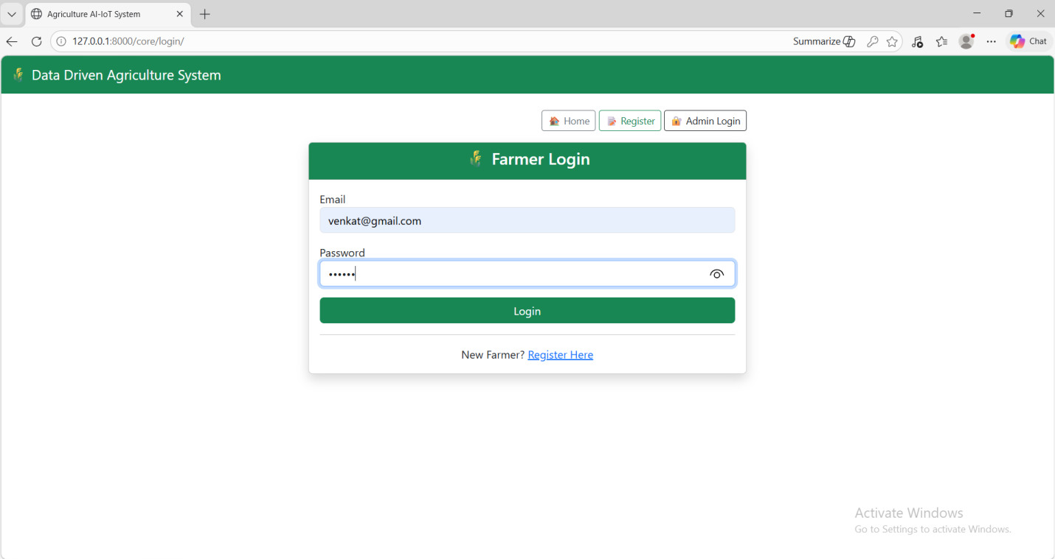

Farmer Home page
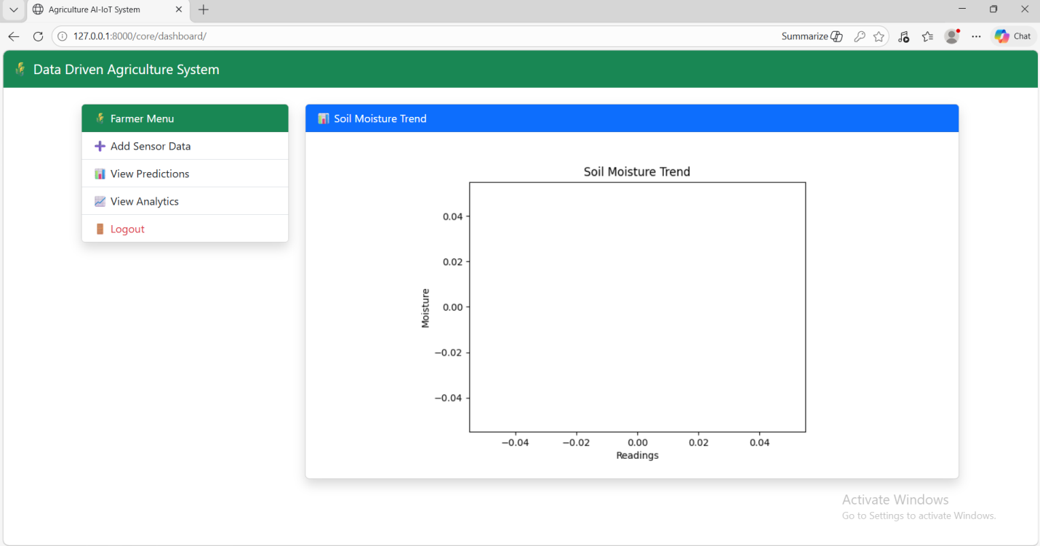

Add Sensor Data
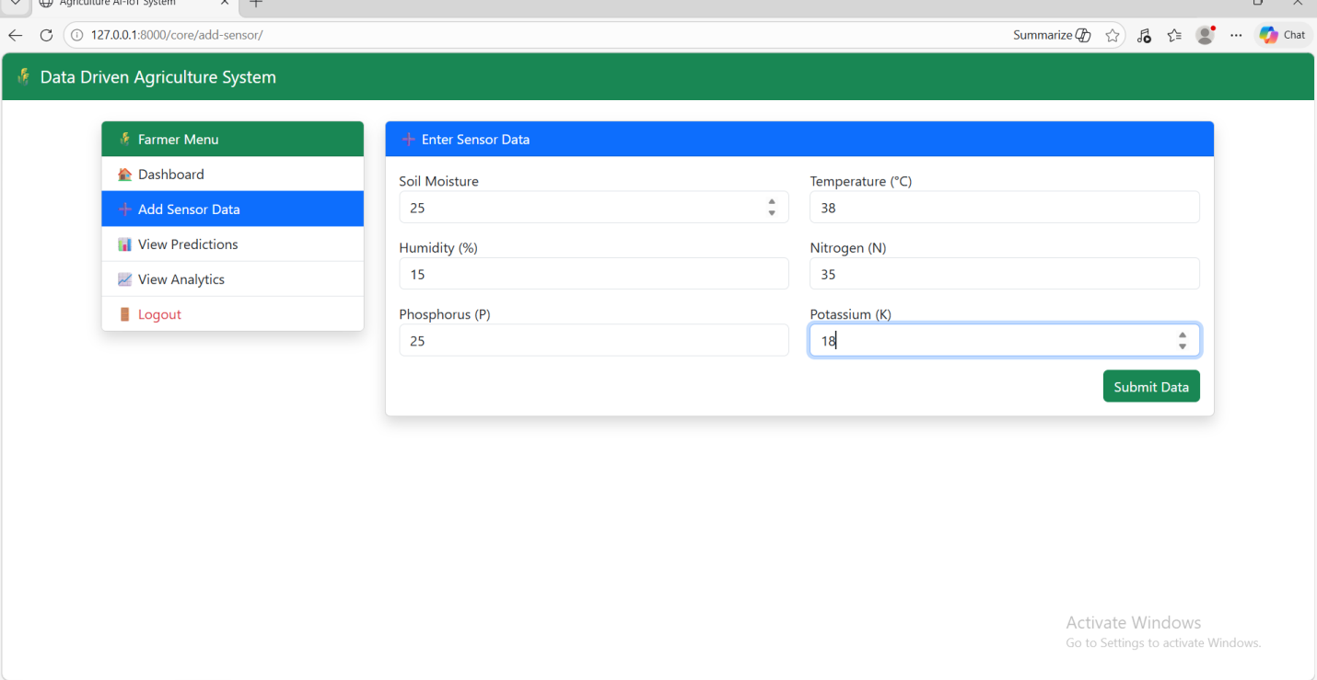

After Adding sensor data based on that prediction will come
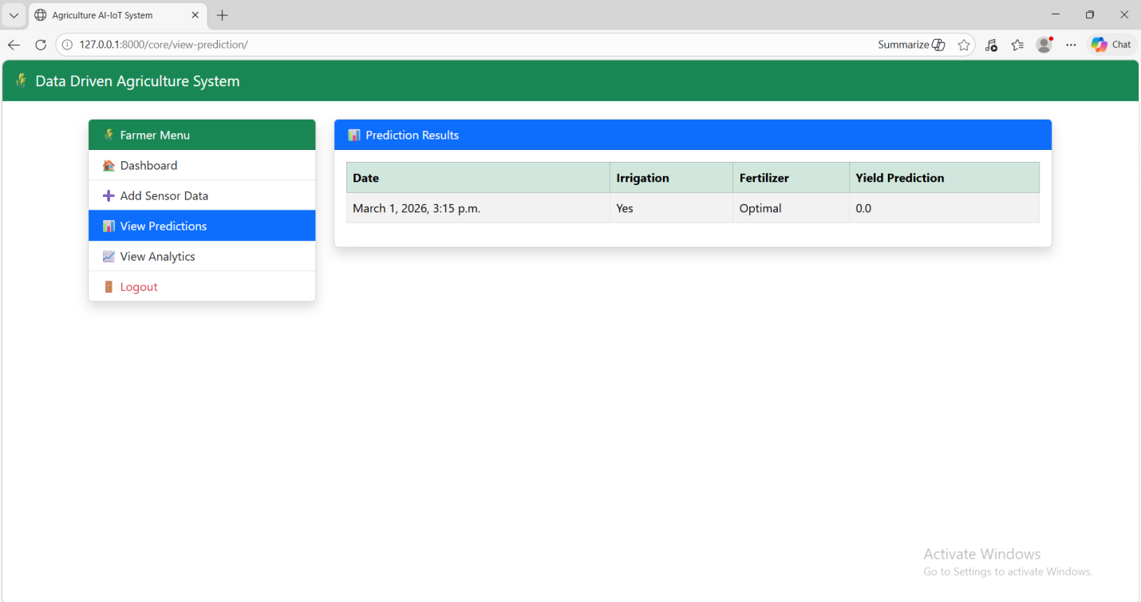

View Analysis
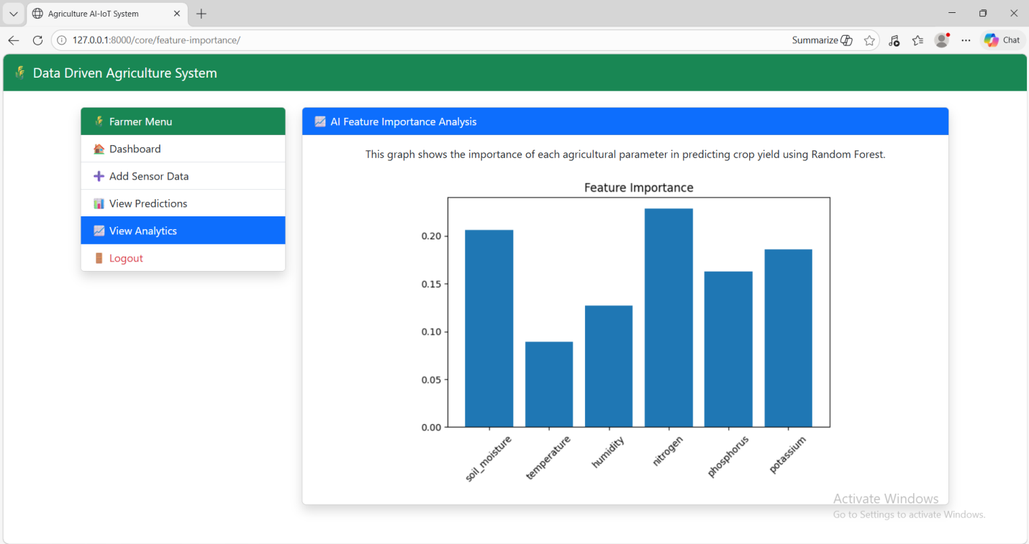

Admin Login page
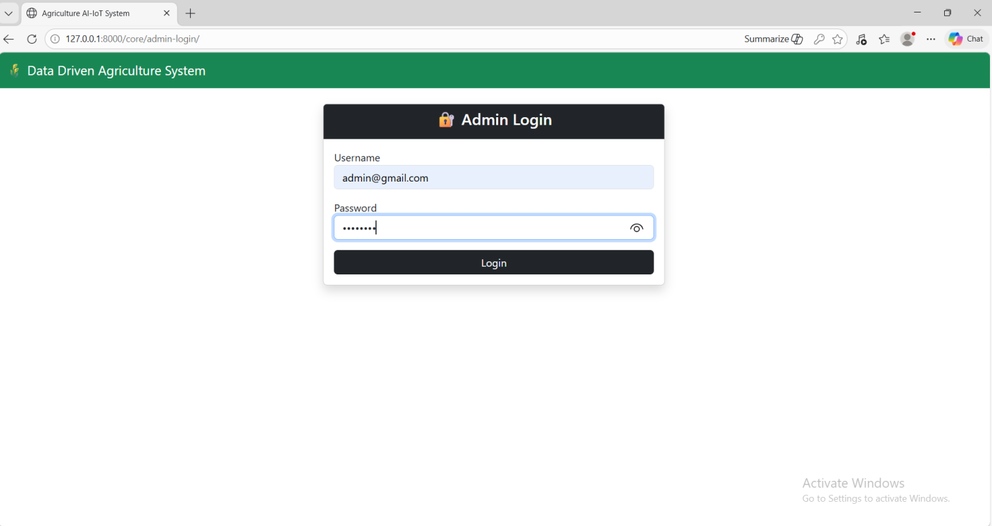

Admin Dashboard page
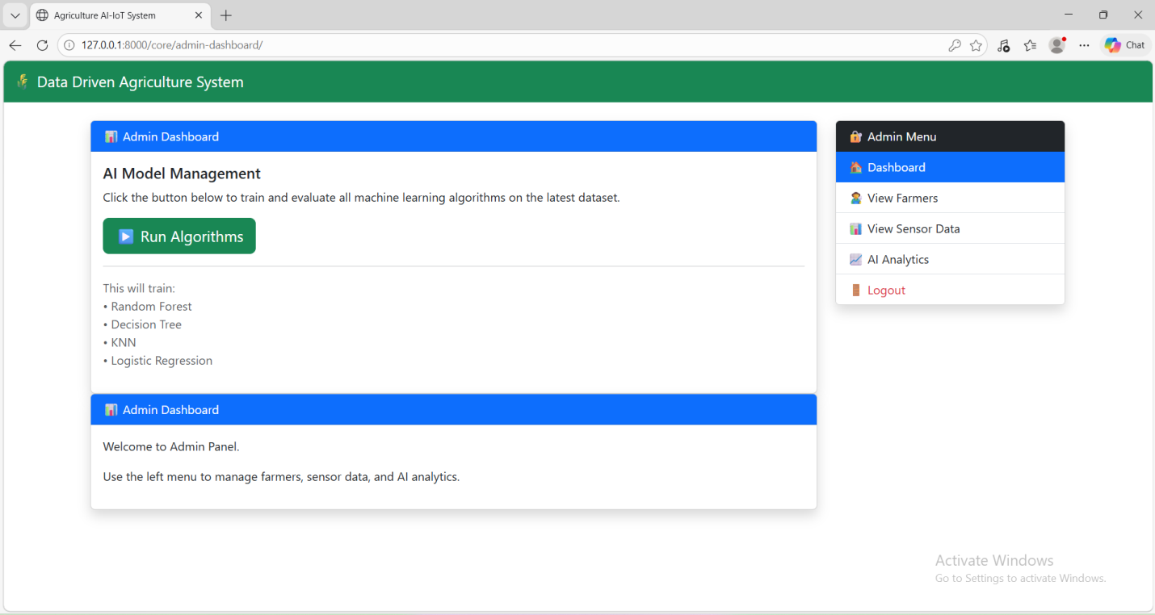

After running algorithams
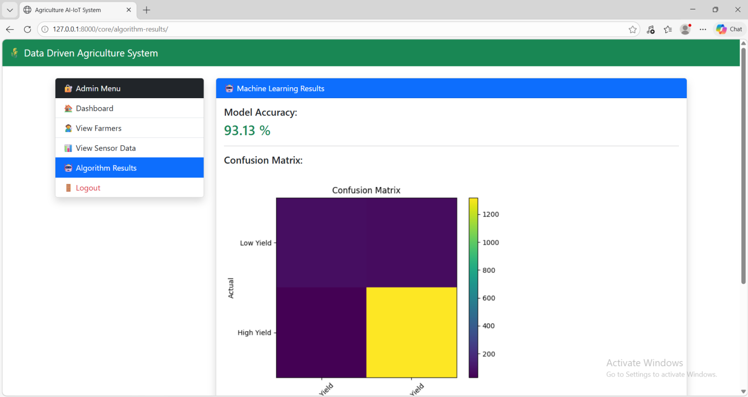

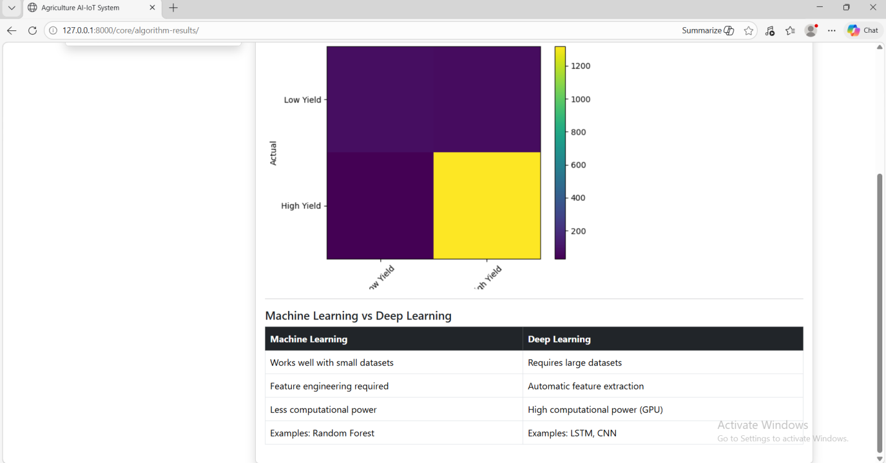
View Farmers
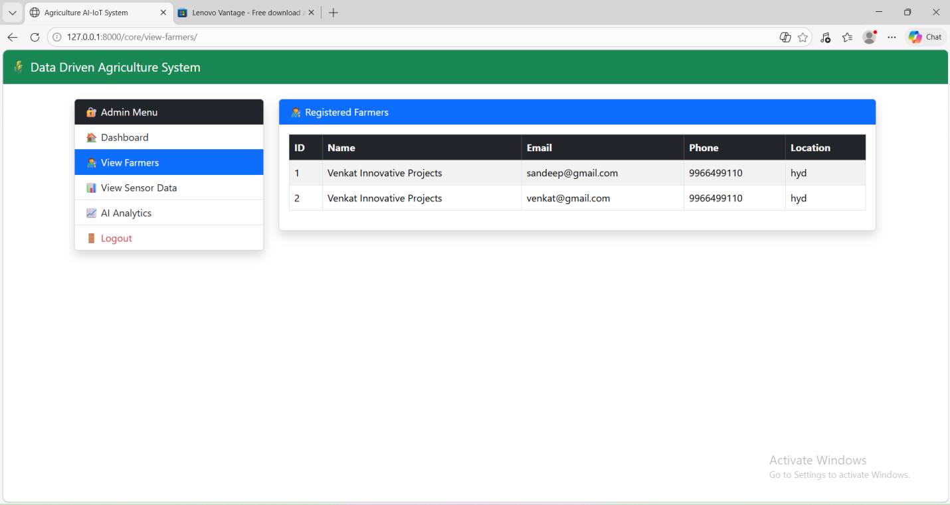

View Sensors Data
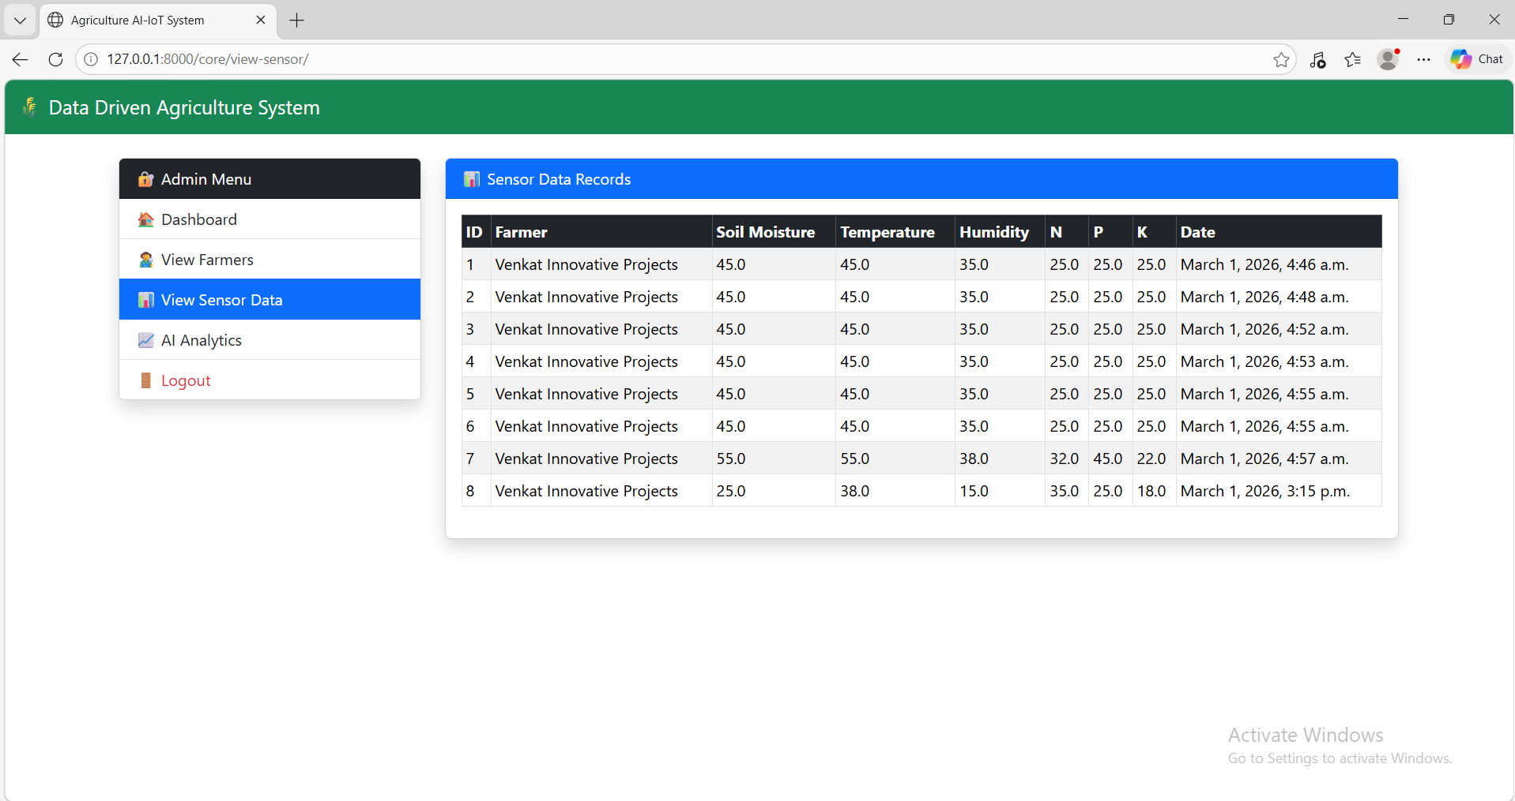

View Analysis
