Week-1. Lists, Links and Images
1a) Write a HTML program, to explain the working of lists.
Note: It should have an ordered list, unordered list, nested lists and ordered list in an
unordered list and definition lists.
AIM: To write a HTML program, to explain the working of lists
Note: It should have an ordered list, unordered list, nested lists and ordered list in an
unordered list and definition lists.
DESCRIPTION :
<ol> – Creates an ordered (numbered) list.
<ul> – Creates an unordered (bulleted) list.
<li> – Defines a list item in <ol> or <ul>.
<dl> – Creates a definition list.
<dt> – Defines a term in a definition list.
<dd> – Gives the description for the term (<dt>).
CODE:
<!DOCTYPE html>
<html>
<head>
<title>HTML Lists Example</title>
</head>
<body>
<h1>Working with Lists in HTML</h1>
<!-- Ordered List -->
<h2>Ordered List</h2>
<ol>
<li>HTML</li >
<li>CSS</li>
<li>JavaScript</li>
</ol>
<!-- Unordered List -->
<h2>Unordered List</h2>
<ul>
<li>Apple</li>
<li>Banana</li>
<li>Cherry</li>
</ul>
<!-- Nested Lists -->
<h2>Nested List</h2>
<ol>
<li>Frontend
<ul>
<li>HTML</li>
<li>CSS</li>
<li>JavaScript</li>
</ul>
</li>
<li>Backend
<ul>
<li>Node.js</li>
<li>Python</li>
</ul>
</li>
</ol>
<!-- Ordered List inside Unordered List -->
<h2>Ordered List inside Unordered List</h2>
<ul>
<li>Web Technologie
<ol>
<li>HTML</li>
<li>CSS</li>
<li>JavaScript</li>
</ol>
</li>
<li>Database
<ol>
<li>MySQL</li>
<li>MongoDB</li>
</ol>
</li>
</ul>
<!-- Definition List -->
<h2>Definition List</h2>
<dl>
<dt>HTML</dt>
<dd>HyperText Markup Language</dd>
<dt>CSS</dt>
<dd>Cascading Style Sheets</dd>
<dt>JS</dt>
<dd>JavaScript – Scripting language for web pages</dd>
</dl>
</body>
</html>
OUTPUT:
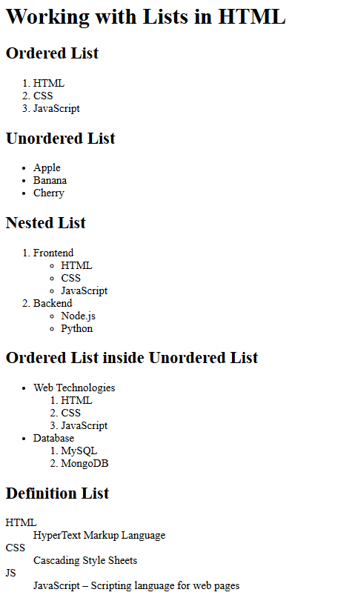

1b) Write a HTML program, to explain the working of hyperlinks using <a> tag and href, target Attributes.
Note: Use text to link https://www.aec.edu.in/
Use image to link https://www.aec.edu.in/?p=Gallery
AIM : To write a HTML program and to explain the working of hyperlinks using <a> tag and href, target Attributes.
DESCRIPTION:
<a> (Anchor Tag):
Used to create hyperlinks to other web pages, email addresses, or files.
href (Hypertext REFerence):
Specifies the URL or link destination.
target Attribute:
Specifies where to open the linked document.
_blank opens the link in a new tab.
_self (default) opens in the same tab.
<img> (Image Tag):
Used to embed images in a web page.
src defines the image path.
alt provides alternative text if the image doesn't load.
width sets the image width in pixels.
CODE:
<!DOCTYPE html>
<html>
<head>
<title>Hyperlink Example</title>
</head>
<body>
<h1>Working with Hyperlinks in HTML</h1>
<!-- Text Link -->
<h2>Text Hyperlink</h2>
<p>
Visit the official website of
<a href="https://www.aec.edu.in/" target="_blank">Aditya Engineering College</a>
for more information.
</p>
<!-- Image Link -->
<h2>Image Hyperlink</h2>
<p>Click the image below to visit the AEC Gallery:</p>
<a href="https://www.aec.edu.in/?p=Gallery" target="_blank">
<img src="test.PNG" alt="AEC Gallery" width="50" height="50">
</a>
</body>
</html>
OUTPUT:
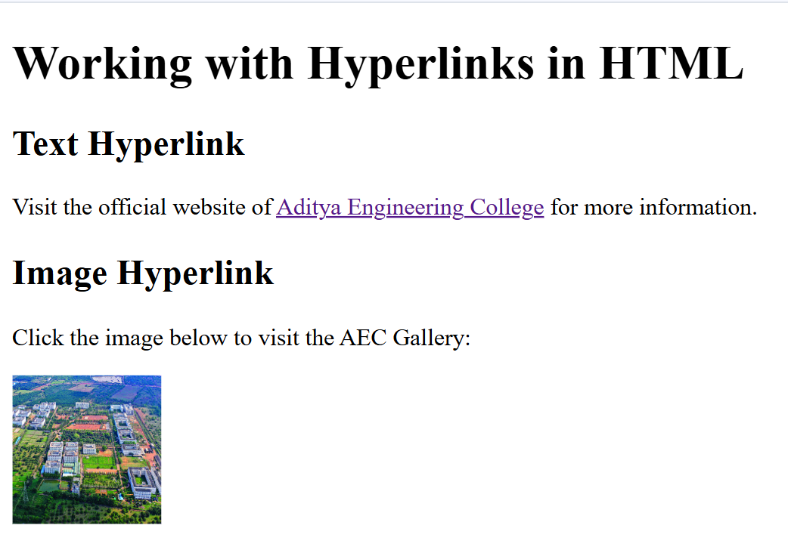

1c) Create a HTML document that has your image and your friend’s image with a specific height and width. Also when clicked on the images it should navigate to their respective profiles.
AIM: To create an HTML webpage that displays two images (mine and my friend’s) with fixed dimensions, and enables navigation to our respective online profiles when the images are clicked.
DESCRIPTION:
- <h1> – Defines the main heading on the page.
- <a> – Creates a hyperlink to another page or site.
- <img> – Inserts an image into the webpage.
- src – Specifies the image file path.

CODE:
<!DOCTYPE html>
<html>
<head>
<title>my image and my friends image</title>
</head>
<body>
<h1>our profiles</h1>
<ahref="https://www.linkedin.com/in/srividya-mutya-00064a32b?utm_source=share&utm_campaign=share_via&utm_content=profile&utm_medium=android_app">
<img src="srividya.jpg" width="300px" height="300px"></a>
<ahref="https://www.linkedin.com/in/vani-prasanna-seeram-a2859a337?utm_source=share&utm_campaign=share_via&utm_content=profile&utm_medium=android_app">
<img src="vani.jpg" width="300px" height="300px"></a>
</body>
</html>
OUTPUT:
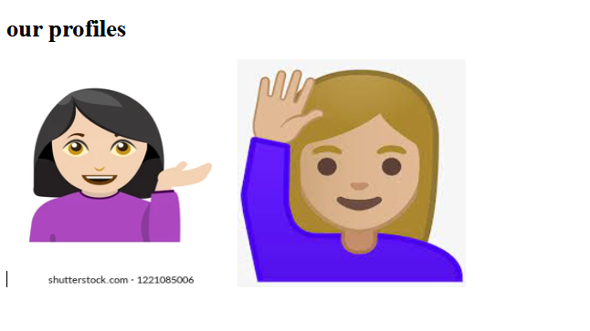

1d) Write a HTML program in such a way that rather than placing large images on a page, the preferred technique is to use thumbnails by setting the height and width parameters to something like to 100*100 pixels. Each thumbnails image is also a link to a full-sized version of the image. Create an image gallery using this technique.
AIM: To create an HTML image gallery that displays small thumbnail images (100×100 pixels) which, when clicked, open their respective full-size versions in a new tab, improving page loading speed and user experience.
DESCRIPTION :
• <h1> – Main heading
• <a> – Creates a clickable link
• href – Link to full-size image
• target – Opens link in new tab
• <img> – Displays image
• src – Image file path
• alt – Text if image fails
• width/height – Sets image size (thumbnail)
CODE:
<!DOCTYPE html>
<html>
<head>
<title>THUMBNAIL GALLERY</title>
</head>
<body>
<h1>thumbnail image gallery</h1>
<p>click on any image to view the full size version</p>
<a href="srividya.jpg" target="_blank">
<img src="https://images.app.goo.gl/96U4zbPLscTG9LKy9"width="100px" height="100px"></a>
<a href="vani.jpg/">
<imgsrc="https://images.app.goo.gl/bGH3PyN3depPNg8t7"width="100px"height="100px"></a></body></html>
OUTPUT:

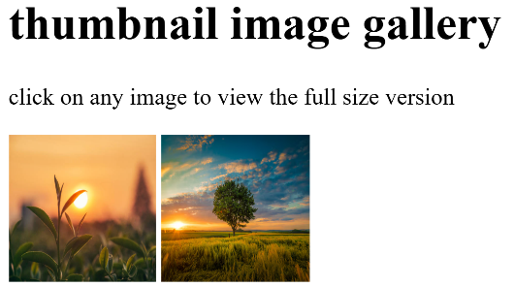0
This Photo by Unknown Author is licensed under CC BY
Viva Questions:
- What is the difference between <ol> and <ul>?
Ans) <ol> creates an ordered list with numbers or letters; <ul> creates an unordered list with bullets.
- Which tag is used to define a list item?
Ans) The <li> tag is used inside <ul> or <ol> to define a list item.
- How do you create a hyperlink in HTML?
Ans) By using the <a> tag. Example: <a href="https://example.com">Click here</a>.
- What attribute is required in the <a> tag to define the link?
Ans) The href attribute specifies the URL of the link.
- What is the use of the target="_blank" attribute in an anchor tag?
Ans) It opens the linked page in a new tab or window.
- Which tag is used to insert an image in HTML?
Ans) The <img> tag is used to embed an image.
- What are the required attributes of the <img> tag?
Ans) src (image URL) and alt (alternate text).
- Can we make an image clickable? If yes, how?
Ans) Yes, wrap the <img> tag inside an <a> tag.
Example: <a href="page.html"><img src="img.jpg" alt="Image"></a>
- What is the use of the <dl>, <dt>, and <dd> tags?
Ans) They create a description list:
- <dl>: starts the list; <dt>: defines the term;<dd>: gives the definition
- How can you display an image of fixed size?
Ans) Use width and height attributes.
Example: <img src="pic.jpg" width="200" height="100">
Week-2: Tables, Forms and Frames
2a)Write a HTML program, to explain the working of tables. (use tags: <table>, <tr>, <th>, <td> and attributes: border, rowspan, colspan).
AIM : To create an HTML table using <table>, <tr>, <th>, and <td> tags with attributes like border, rowspan, and colspan, to organize and display tabular data effectively.
DESCRIPTION:
• <table> – Creates a table.
• <tr> – Defines a row in the table.
• <th> – Defines a header cell (bold and centered).
• <td> – Defines a normal data cell.
• border – Adds a border around the table and cells.
• rowspan – Merges cells vertically across rows.
• colspan – Merges cells horizontally across columns
CODE:
<!DOCTYPE html>
<html lang="en">
<head>
<title>Company Employee Information</title>
</head>
<style>
table{
border-collapse: collapse;
}
</style>
<body>
<h1>Company Employee Information</h1>
<table border="1">
<thead>
<tr>
<th rowspan="2"> Emp Id </th>
<th rowspan="2"> Name </th>
<th rowspan="2"> Department </th>
<th rowspan="2"> Designation </th>
<th colspan="2"> Contact Info </th>
<th rowspan="2"> Salary </th>
<th rowspan="2"> Adress </th>
</tr>
<tr>
<th> Email </th>
<th> Phone</th>
</tr>
</thead>
<tbody>
<tr>
<td>Emp101</td>
<td>Alice Johnson</td>
<td>HR</td>
<td>Manager</td>
<td>alice.hr@company.com</td>
<td>9876543210</td>
<td>60,000$</td>
<td>New York, USA</td>
</tr>
<tr>
<td>Emp102</td>
<td>Bob Smith</td>
<td>IT</td>
<td>Software Engineer</td>
<td>bob.it@company.com</td>
<td>9123456780</td>
<td>80,000$</td>
<td>San Francisco, USA</td>
</tr>
<tr>
<td>Emp103</td>
<td>Charlie Lee</td>
<td>Finance</td>
<td>Analyst</td>
<td>charlie.finance@company.com</td>
<td>9988776655</td>
<td>60,000$</td>
<td>Chicago, USA</td>
</tr>
</tbody>
</table>
</body>
</html>

OUTPUT:
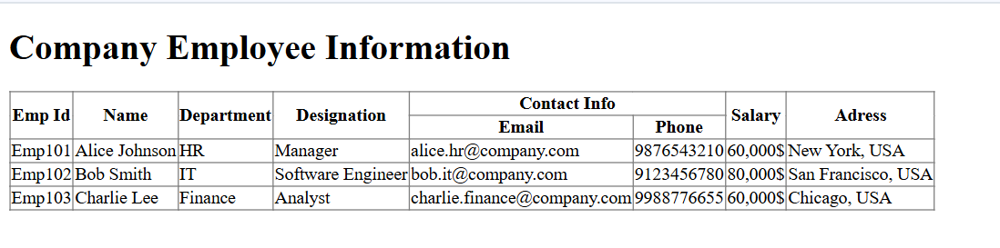

2b)Write a HTML program, to explain the working of tables by preparing a timetable. (Note: Use <caption> tag to set the caption to the table & also use cell spacing, cell padding, border, rowspan, colspan etc.).
AIM : To create a structured and readable class timetable using HTML tables with appropriate tags (<table>, <tr>, <th>, <td>, <caption>) and attributes like border, cellpadding, cellspacing, rowspan, and colspan, demonstrating the layout of weekly classes in a visually organized manner.
DESCRIPTION:
• <table> – Creates a table structure.
• <caption> – Adds a title above the table.
• <tr> – Defines a row in the table.
• <th> – Creates a header cell (bold and centered).
• <td> – Adds a data cell in the table.
• border – Adds borders to the table and cells.
• cellpadding – Adds space inside each cell.
• cellspacing – Adds space between table cells.
CODE:
<!DOCTYPE html>
<html lang="en">
<head>
<title>TIMETABLE</title>
</head>
<style>
table{
width: 100%;
}
td{
padding-left: 10px;
}
h1{
text-align: center;
}
h3{
text-align: center;
}
</style>
<body>
<thead>
<h1>B.tech I Semester Timetable</h1>

<table border="1" cellpadding="10" cellspacing="2">
<caption><strong>Department of Computer Science & Engineering</strong></caption>
<thead>
<tr>
<th> Day </th>
<th> 9:00-10:00 </th>
<th> 10:00-11:00 </th>
<th> 11:00-12:00 </th>
<th> 12:00-1:00 </th>
<th> 1:00-2:00 </th>
<th> 2:00-3:00 </th>
<th> 3:00-4:00 </th>
</tr>
</thead>
<tbody>
<tr>
<td> Monday </td>
<td> Mathematics-I </td>
<td> Physics </td>
<td> English </td>
<td rowspan="5"> Lunch Break </td>
<td> Python Programming </td>
<td> Engineering Graphics </td>
<td> Library </td>
</tr>
<tr>
<td> Tuesday </td>
<td> Engineering Chemistry </td>
<td> English </td>
<td> Workshop </td>
<td> Mathematics-I </td>
<td> Physics </td>
<td> Sports </td>
</tr>
<tr>
<td> Wednesay </td>
<td> Python Lab </td>
<td colspan="2"> Python Programming Lab </td>
<td> English </td>
<td> Engineering Graphics </td>
<td> Mentoring Hour </td>
</tr>
<tr>
<td> Thursday </td>
<td> Physics Lab </td>
<td colspan="2"> Physics Laboratory </td>
<td> English Chemistry </td>
<td> Mathematics-I </td>
<td> Workshop </td>
</tr>
<tr>
<td> Friday </td>
<td> Engineering Graphics </td>
<td> Physics </td>
<td> Mathematics-I </td>
<td> Python Programming </td>
<td> Library </td>
<td> Sports </td>
</tr>
</tbody>
</table>
</body>
</html>

OUTPUT:
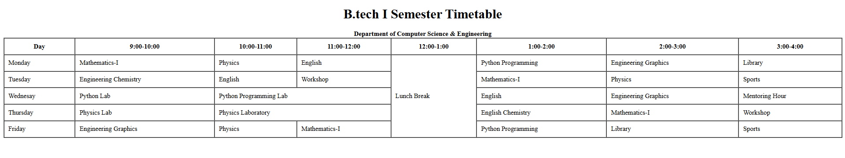

2c)Write a HTML program, to explain the working of forms by designing Registration form.
(Note: Include text field, password field, number field, date of birth field, checkboxes, radio buttons, list boxes using <select>&<option> tags, <text area> andtwo buttons ie: submit and reset. Use tables to provide a better view).
AIM: To design a student registration form using HTML form elements such as text fields, password fields, number and date inputs, radio buttons, checkboxes, dropdown lists, and text areas, arranged within a table layout for better readability and structure.
DESCRIPTION:
• <form> – Creates the form container.
• <input> – Used for fields like text, password, number, date, checkbox, radio, submit, and reset.
• <textarea> – Allows multi-line text input (for address).
• <select> – Creates a dropdown menu.
• <option> – Defines options inside <select>.
• <table> – Used to layout the form neatly.
• <tr> – Table row.
• <td> – Table cell.
• type="text" – Input for name or other text.
• type="password" – Input for password (hidden text).
• type="number" – Input for numbers like phone.
• type="date" – Input for date of birth.
• type="radio" – Select one option from a group.
• type="checkbox" – Select multiple options.
• type="submit"/"reset" – Buttons to submit or reset the form.
CODE:
<!DOCTYPE html>
<html>
<head>
<title>Extended Student Registration Form</title>
</head>
<body>
<h2 align="center">Extended Student Registration Form</h2>
<form action="#" method="post" enctype="multipart/form-data">
<table border="1" cellpadding="10" cellspacing="0" align="center">
<caption><strong>Student Details</strong></caption>
<tr>
<th>Full Name:</th>
<td><input type="text" name="fullname" placeholder="Enter full name"
required></td>
</tr>
<tr>
<th>Email:</th>
<td><input type="email" name="email" placeholder="example@email.com"
required></td>
</tr>
<tr>
<th>Password:</th>
<td><input type="password" name="password" required></td>
</tr>
<tr>
<th>Mobile Number:</th>
<td><input type="tel" name="phone" pattern="[0-9]{10}" placeholder="10-digit
number" required></td>
</tr>
<tr>
<th>Age:</th>
<td><input type="number" name="age" min="17" max="30"></td>
</tr>
<tr>
<th>Date of Birth:</th>
<td><input type="date" name="dob"></td>
</tr>
<tr>
<th>Gender:</th>
<td>
<input type="radio" name="gender" value="Male"> Male
<input type="radio" name="gender" value="Female"> Female
<input type="radio" name="gender" value="Other"> Other
</td>
</tr>
<tr>
<th>Courses Interested:</th>
<td>
<input type="checkbox" name="course" value="C"> C
<input type="checkbox" name="course" value="C++"> C++
<input type="checkbox" name="course" value="Java"> Java
<input type="checkbox" name="course" value="Python"> Python
<input type="checkbox" name="course" value="Web"> Web Development
</td>
</tr>
<tr>
<th>Branch:</th>
<td>
<select name="branch">
<option value="">--Select Branch--</option>
<option value="CSE">Computer Science</option>
<option value="ECE">Electronics</option>
<option value="EEE">Electrical</option>
<option value="MECH">Mechanical</option>
<option value="CIVIL">Civil</option>
</select>
</td>
</tr>
<tr>
<th>College Website:</th>
<td><input type="url" name="website"
placeholder="https://www.example.com"></td>
</tr>
<tr>
<th>Address:</th>
<td><textarea name="address" rows="4" cols="30" placeholder="Enter your
address"></textarea></td>
</tr>
<tr>
<th>Upload Resume:</th>
<td><input type="file" name="resume"></td>
</tr>
<tr>
<th>Preferred Time Slot:</th>
<td><input type="time" name="timeslot"></td>
</tr>
<tr>
<th>Skill Level (0-10):</th>
<td><input type="range" name="skill" min="0" max="10"></td>
</tr>
<tr>
<th>Favorite Color:</th>
<td><input type="color" name="color"></td>
</tr>
<!-- Hidden Field -->
<tr>
<td colspan="2">
<input type="hidden" name="registration_type" value="student">
</td>
</tr>
<tr>
<th colspan="2" align="center">
<input type="submit" value="Submit">
<input type="reset" value="Reset">
</th>
</tr>
</table>
</form>
</body>
</html>

Output:
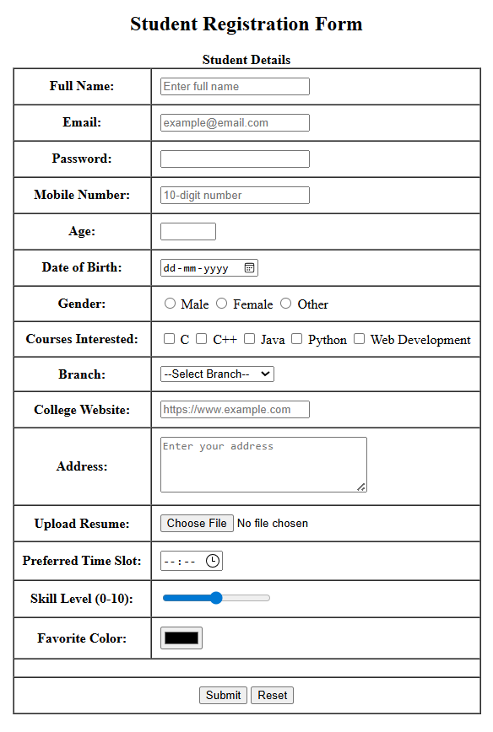

2d)Write a HTML program, to explain the working of frames, such that page is to be divided into 3 parts on either direction. (Note: first frame image, second frame paragraph, third frame hyperlink. And also make sure of using “no frame” attribute such that frames to be fixed).
AIM:
To create a webpage using HTML frames that splits the screen into three parts — one showing an image, one showing a paragraph, and one showing a hyperlink — with a noframes option for unsupported browsers.
DESCRIPTION:
- <frameset> – Used to divide the browser window into multiple frames (rows or columns) instead of using <body>.
- <frame> – Loads a separate HTML page or content into each frame section.
- <noframes> – Displays an alternative message if the browser does not support frames.
CODE:
image.html
<!DOCTYPE html>
<html>
<head><title>Image Frame</title></head>
<body>
<h2 align="center">Welcome to Our Site</h2>
<div align="center"><img src="people.jpeg" alt="Sample Image" width="600"></div>
</body>
</html>
paragraph.html:
<!DOCTYPE html>
<html>
<head><title>Paragraph Frame</title></head>
<body>
<h3 align="center">About Us</h3>
<p align="justify" style="padding: 10px;">
</p>
</body>
</html>
links.html:
<!DOCTYPE html>
<html>
<head>
<title>Links Frame</title>
</head>
<body>
<h3 align="center">Useful Links</h3>
<ul style="text-align: center; list-style-type: none;">
<li><a href="https://www.google.com" target="_blank">Google</a></li>
<li><a href="https://www.wikipedia.org" target="_blank">Wikipedia</a></li>
<li><a href="https://www.w3schools.com" target="_blank">W3Schools</a></li>
</ul>
</body>
</html>
framesetdemo.html:
<!DOCTYPE html>
<html>
<head>
<title>Frameset Example</title>
</head>
<frameset rows="30%,40%,30%">
<frame src="image.html" name="frame1">
<frame src="paragraph.html" name="frame2">
<frame src="links.html" name="frame3">
<noframes>
<body>
<p>This page uses frames but your browser does not support them.</p>
</body>
</noframes>
</frameset>
</html>
Output:
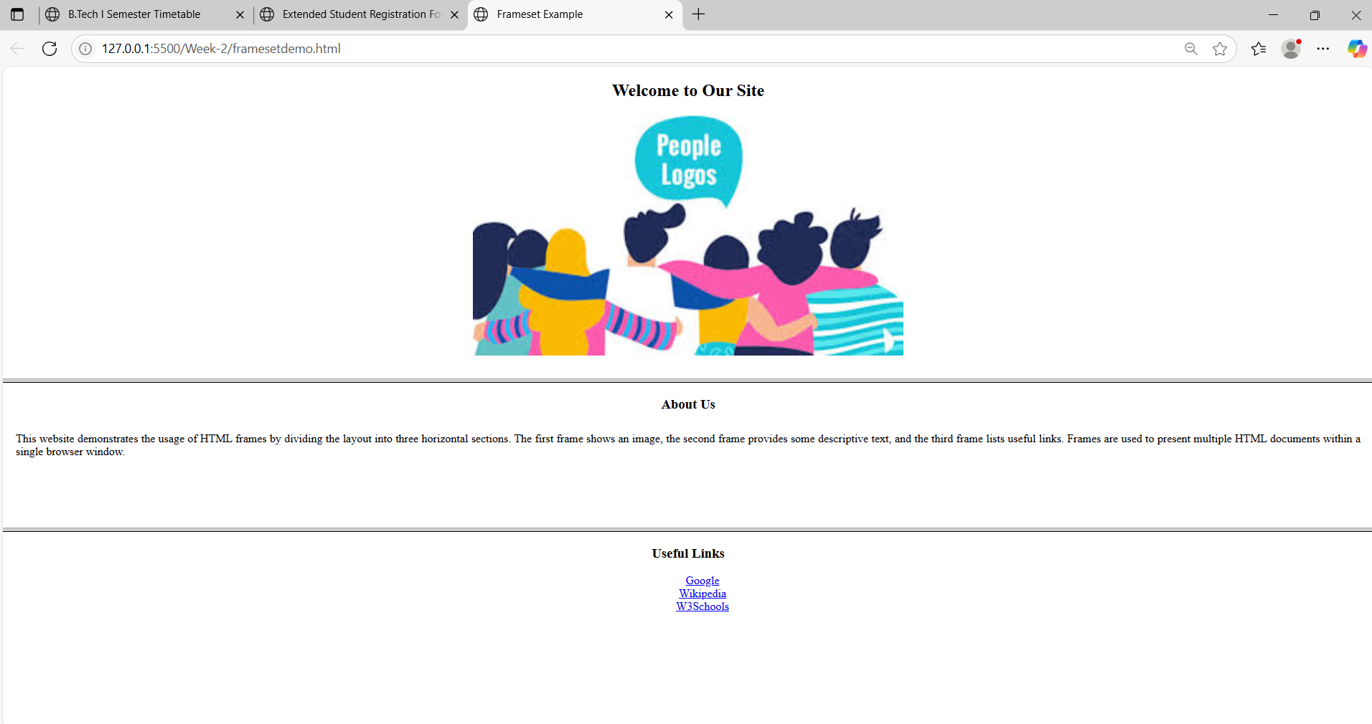
Viva Questions:
  - What is the use of the <table> tag?
Ans) It creates a table to display data in rows and columns.
  - What is the difference between <th> and <td>?
Ans) <th> is a header cell (bold), <td> is a normal cell.
  - Which tag is used to give a title to a table?
Ans) <caption> is used to add a title to the table.
  - What is the default alignment of <th> text?
Ans) Center aligned and bold.
  - What is the use of colspan?
Ans) It merges two or more columns into one cell.
  - What is the use of rowspan?
Ans) It merges two or more rows into one cell.
  - What does cellpadding do?
Ans) It adds space inside the table cell.
  - What does cellspacing do?
Ans) It adds space between the table cells.
Working with Forms
  - What is the purpose of the <form> tag in HTML?
Ans) The <form> tag is used to create a form that collects user input and sends it to a server.
  - What are the two main attributes of the <form> tag?)
Ans) action: URL where the form data is sent
method: HTTP method (GET or POST) used to submit the form
  - What is the use of the <input> tag?)
Ans) The <input> tag is used to create various input fields like textboxes, checkboxes, radio buttons, etc.
  - What is the difference between radio and checkbox inputs?
Ans) radio: allows only one option to be selected from a group and checkbox: allows multiple options to be selected
13)What is the use of the <select> and <option> tags?
Ans) <select> creates a dropdown menu and <option> defines each choice in the dropdown
  - What does the required attribute do in form fields?
Ans) It makes the input field mandatory, so the form can't be submitted without filling it.
Working with Frameset:
  - What is the purpose of the <frameset> tag in HTML?
Ans) The <frameset> tag is used to divide the browser window into multiple sections (frames), where each frame can display a different HTML document.
  - What attribute is used in <frameset> to split the window vertically?
Ans) The cols attribute is used to divide the screen into vertical frames (columns).
Example: <frameset cols="30%,70%">
  - What attribute is used in <frameset> to split the window horizontally?
Ans) The rows attribute is used to divide the screen into horizontal frames (rows).
Example: <frameset rows="50%,50%">
  - Which tag is used inside <frameset> to define each frame?
Ans) The <frame> tag is used to define each frame and load separate documents.
  - How do you load a webpage in a frame?
Ans) Use the src attribute in the <frame> tag.
Example: <frame src="menu.html">
  - What is the use of the noresize attribute in <frame>?
Ans) It prevents the user from resizing the frame manually.

Week-3: HTML5 and CSS
3a) Write a HTML program, that makes use of <article>, <aside>, <figure>, <figcaption>, <footer>, <header>, <main>, <nav>, <section>, <div>, <span> tags.
AIM: To write a HTML program, that makes use of <article>, <aside>, <figure>, <figcaption>, <footer>, <header>, <main>, <nav>, <section>, <div>, <span> tags.
DESCRIPTION:
<article>: Represents an independent piece of content, like a blog post or news article.
<aside>: Contains content related to the main content but separate, like a sidebar or callout.
<figure>: Groups media content (like images) with an optional caption.
<figcaption>: Provides a caption or description for the content inside <figure>.
<footer>: Defines a footer for a section or the whole page, usually with copyright or related info.
<header>: Represents introductory content or navigational aids, like a page title or menu.
<main>: Encapsulates the main content unique to the page.
<nav>: Contains navigation links to different parts of the site.
<section>: Groups related content into thematic sections.
<div>: A generic container used to group content when no semantic tag fits.
<span>: An inline container for styling or marking up parts of text.
CODE:
<!DOCTYPE html>
<html lang="en">
<head>
<meta charset="UTF-8">
<title>Aside as Sidebar</title>
<style>
body {
margin: 0;
font-family: Arial, sans-serif;
}
header, footer {
background-color: #333;
color: white;
padding: 10px;
text-align: center;
}
nav {
background-color: #eee;
padding: 10px;
}
nav a{
margin-right: 10px;
}
.container {
display: flex;
width: 100%;
height: 400px;
}
main {
flex: 3;
padding: 10px;
background-color: #f9f9f9;
}
aside {
width: 15%;
padding: 15px;
margin-left: 25px;
float: right;
font-style: italic;
background-color: #f0f0f0;
border-left: 3px solid #0070d0;
}
footer {
margin-top: 10px;
}
</style>
</head>
<body>
<header>
<h1>Welcome to My College News Portal</h1>
</header>
<nav>
<a href="#">Home</a>
<a href="#">Departments</a>
<a href="#">Events</a>
<a href="#">Contact</a>
</nav>
<div class="container">
<main>
<h2>Main Content</h2>
<p>This is the main content of the page.</p>
<article>
<h2>Annual Tech Fest 2025</h2>
<section>
<p>The Tech Fest 2025 will be held from September 10 to 12. It will include coding contests, robotics, and workshops.</p>
</section>
<figure>
<img src="tech-fest.jpg.png" alt="Tech Fest Banner" width="300">
<figcaption>Figure: Tech Fest 2025 Poster</figcaption>
</figure>
</article>
</main>
<aside>
<h3>Sidebar Tips</h3>
<p>Use semantic tags for clean HTML structure.</p>
</aside>
</div>
<footer>
<p>&copy; 2025 My Website</p>
</footer>
</body>
</html>
OUTPUT:

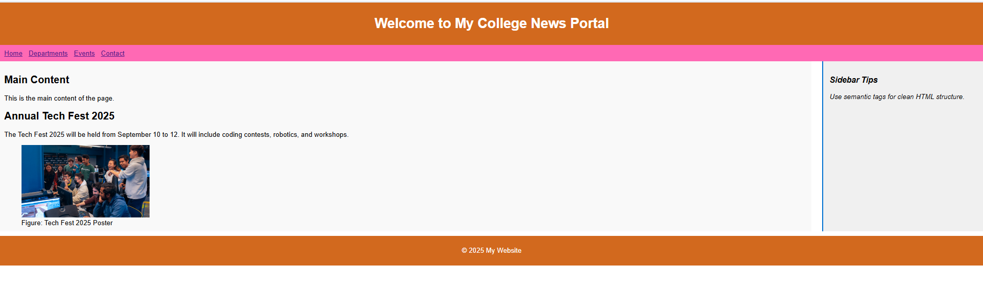

3 b)Write a HTML program, to embed audio and video into HTML web page
AIM: To write a HTML program, to embed audio and video into HTML web page
DESCRIPTION:
<audio>: Embeds audio content with playback controls.
<video>: Embeds video content with playback controls and size settings.
<section>: Groups related content into sections.
<source>: Specifies the media file and its type for audio or video elements
CODE:
<!DOCTYPE html>
<html>
<head>
<title>Embedding Audio and Video</title>
</head>
<body>
<h2>HTML5 Audio and Video Embedding</h2>
<section><h3>Audio Example:</h3>
<audiocontrols><source src="https://www.soundhelix.com/examples/mp3/SoundHelix-Song-1.mp3" type="audio/mpeg"> Your browser does not support the audio element.</audio>
</section>
<br>
<section>
<h3>
Video Example:
</h3>
<video width="600" height="340" controls>
<source src="https://media.istockphoto.com/id/1999341160/video/close-up-of-young-australian-fur-seals-playing-in-clear-blue-open-ocean-water.mp4?s=mp4-640x640-is&k=20&c=XTMiDRR7mH4E4dm1twOkCDdrmviZOZfPsgZIY0aYmkE=" type="video/mp4">
Your browser does not support the video tag.
</video>
</section>
</body>
</html>

OUTPUT:
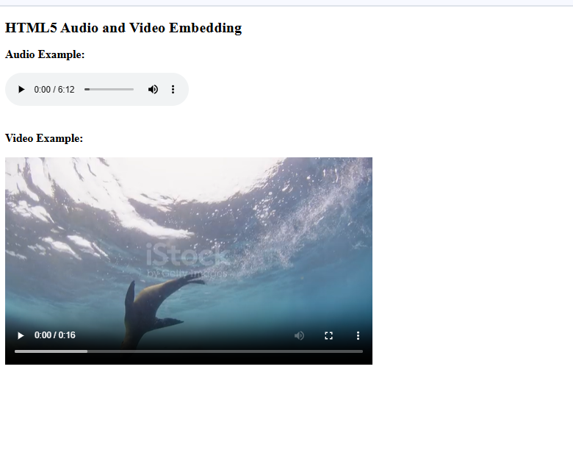

3c)Write a program to apply different types (or levels of styles or style specification formats) -inline, internal, external styles to HTML elements. (identify selector, property and value).
AIM: To write a program to apply different types (or levels of styles or style specification formats) -inline, internal, external styles to HTML elements. (identify selector, property and value).
DESCRIPTION:
<style>: Contains internal CSS styles.
<link>: Links to an external CSS stylesheet.
<h2>: Heading element styled with inline CSS.
<p>: Paragraph element styled with internal or external CSS.
CODE:
<!DOCTYPE html>
<html lang="en">
<head><meta charset="UTF-8" />
<meta name="viewport" content="width=device-width, initial-scale=1" />
<title>CSS Types Demo</title><!-- Internal CSS -->
<style>
.internal-style {
color: teal;
font-weight: bold;
font-style: italic;
margin: 10px 0;}
</style><!-- External CSS -->
<link rel="stylesheet" href="style.css" />
</head>
<body><!-- Inline CSS -->
<h2 style="color: chocolate; text-align: center;">
This heading is styled with <u>Inline CSS</u>
</h2> <!-- Internal CSS -->
<p class="internal-style">This paragraph is styled with <u>Internal CSS</u> (inside &lt;style&gt; tag in &lt;head&gt;) </p><!-- External CSS -->
<p class="external-style">
This paragraph is styled with <u>External CSS</u> (from style.css file)
</p>
</body>
</html>
Output:
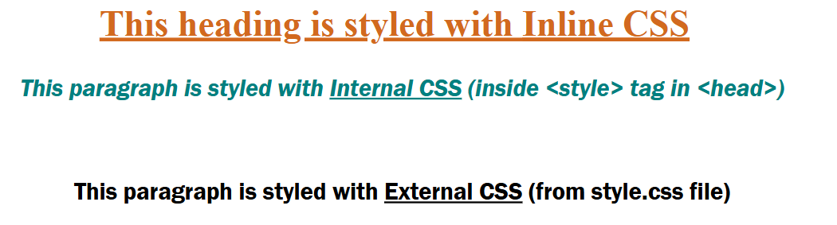
Viva Questions:
1. What is the purpose of the <article> tag in HTML?
Ans) The <article> tag is used to represent independent, self-contained content such as blog posts, news articles, or forum posts.
2. What does the <aside> tag represent in HTML?
Ans) The <aside> tag is used for content that is tangentially related to the main content, like sidebars, tips, or advertisements.
3. What is the <figure> tag used for?
Ans) The <figure> tag is used to enclose media or illustrations, such as images, diagrams, or code snippets.
4. What is the role of <figcaption> in HTML?
Ans) The <figcaption> tag provides a caption or description for the content inside the <figure> tag.
5. What does the <footer> tag define?
Ans) The <footer> tag represents the footer of a document or a section, typically containing copyright, contact info, or related links.
6. What is the <header> tag used for?
Ans) The <header> tag defines the introductory content or navigation links for a section or entire webpage.
7. What is the use of the <main> tag in HTML5?
Ans) The <main> tag specifies the central content of a webpage that is unique and not repeated across pages like headers or footers.
8. What is the purpose of the <nav> tag?
Ans) The <nav> tag is used to define a section that contains navigation links like menus, tables of contents, etc.
9. How is the <section> tag different from <div>?
Ans) <section> is a semantic tag used to group related content with a heading, while <div> is a generic container without any semantic meaning.
10. What is the difference between <div> and <span> tags?
Ans) <div> is a block-level container used for structuring page layout, while <span> is an inline container used for styling small portions of text.
Week-4: Selector Forms
4 a)Write a program to apply different types of selector forms
i. Simple selector (element, id, class, group, universal)
ii. Combinator selector (descendant, child, adjacent sibling, general sibling)
iii. Pseudo-class selector
iv. Pseudo-element selector
v. Attribute selector
AIM: To write a program to apply different types of selector forms
DESCRIPTION:
<style>: Contains internal CSS styles demonstrating various selectors.
<h1>: Heading styled using a type selector.
<h2>: Heading included in group selector styling.
<p>: Paragraph elements styled by group, class, and ID selectors.
4 a) Simple Selectors
Code:
<!DOCTYPE html>
<html>
<head>
<title>Simple Selectors Demo</title>
<style>
/* Universal Selector */
* {
font-family: Arial, sans-serif;
}

/* Type Selector */
h1 {
color: darkblue;
}

/* Class Selector */
.highlight {
background-color: yellow;
font-weight: bold;
}

/* ID Selector */
#main-para {
color: green;
font-size: 18px;
}
/* Group Selector */
h2, p {
margin-bottom: 10px;
}
</style>
</head>
<body>
<h1>Welcome to the Selector Demo</h1>
<h2>This is a subheading</h2>
<p>This paragraph is affected by the group selector.</p>
<p id="main-para">This paragraph is styled using an ID selector.</p>
<p class="highlight">This paragraph uses a class selector for highlighting.</p>
</body>
</html>
Output:
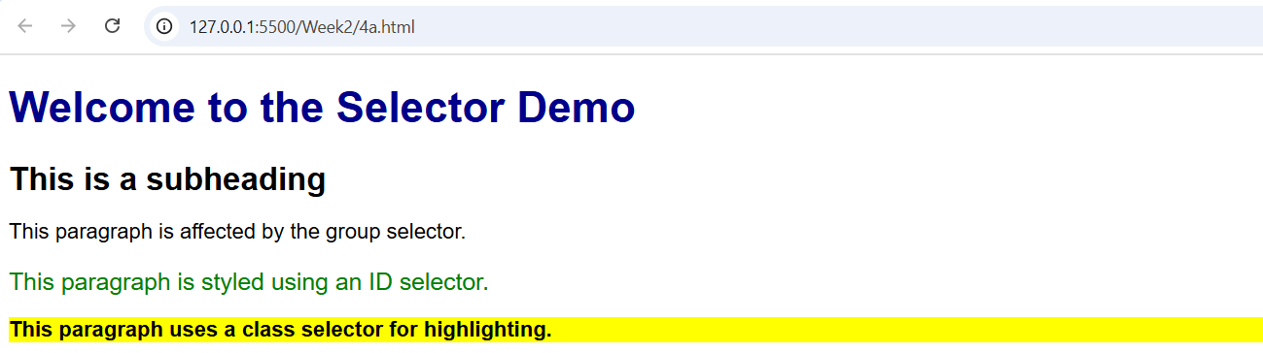

4 b) Combinator Selectors:
<!DOCTYPE html>
<html>
<head>
<style>
.university{
width: 50%;
border: 8px solid gray;
border-radius: 5px;
margin: 50px auto;
}
div p{
background-color: aquamarine;
}
/*div > p{
background-color: blanchedalmond;
} */
/* h2+p{
background-color: lightblue;
} */
/* h2~p{
background-color: lightgray;
} */
</style>
</head>
<body>
<h1>Aditya University Information</h1>
<div class="university">
<div class="department">
<h2>CSE</h2>
<p>Head: Ms. Sudha Rani T</p>
<p>Associate Profissor</p>
<div class="faculty">
<h2>Faculty</h2>
<p>Prof. Ramesh</p>
<p>Prof. Sivaram</p>
</div>
</div>
<div class="department">
<h2>IT</h2>
<p>Head: Ms.A. Rajababu</p>
<p>Associate Profissor</p>
<div class="faculty">
<h2>Faculty</h2>
<p>Prof. Balaram</p>
<p>Prof. Kalyan</p>
</div>
</div>
<p>This is testing University styles</p>
</div>
<p>This is for testing paragraph styles</p>
</body>
</html>
OUTPUT:
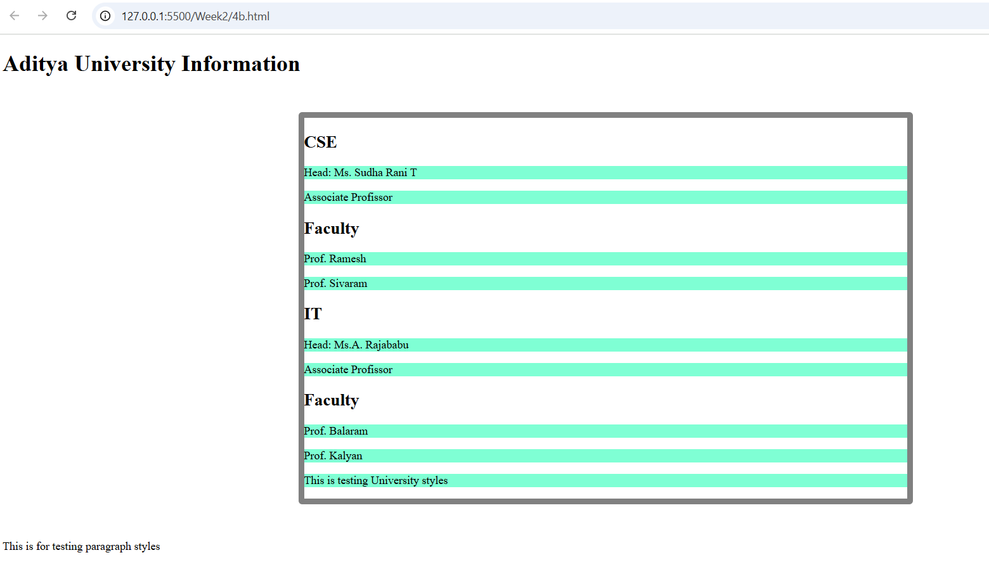

4 c) Pseudo-class selector
<!DOCTYPE html>
<html>
<head>
<title>Login Form with Pseudo-Classes</title>
<style>
body {
font-family: Arial, sans-serif;
padding: 20px;
}

.form {
width: 300px;
margin: auto;
padding: 20px;
border: 2px solid #ccc;
border-radius: 8px;
}

input[type="text"],
input[type="password"] {
width: 90%;
padding: 10px;
margin-bottom: 15px;
border: 1px solid #ccc;
border-radius: 4px;
}

input:focus {
border-color: dodgerblue;
background-color: #f0f8ff;
}

button:hover {
background-color: dodgerblue;
color: white;
cursor: pointer;
}
a:visited {
color: purple;
}

input:invalid {
border-color: red;
}
button {
width: 100%;
padding: 10px;
background-color: lightgray;
border: none;
border-radius: 4px;
}
</style>
</head>
<body>
<div class="form">
<h2>Login Form</h2>
<form>
<label>Username:</label>
<input type="text" required placeholder="Enter username"
<label>Password:</label>
<input type="password" required placeholder="Enter password">
<button type="submit">Login</button>
</form>
<p><a href="#">Forgot password?</a></p>
</div>
</body>
</html>
OUTPUT:
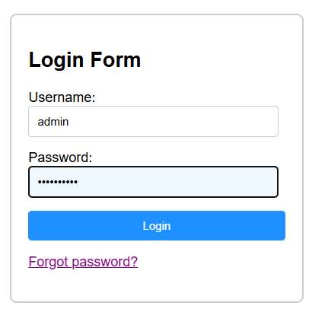

4 d) Pseudo Element Selector:
<!DOCTYPE html>
<html lang="en">
<head>
<title>Pseudo Element Selector Example</title>
<style>
h1::before {
content: "👉 ";
color: green;
}
h1::after {
content: " ✅";
color: blue;
}
p::first-line {
font-weight: bold;
color: red;
}
p::first-letter {
font-size: 24px;
color: purple;
}
</style>
</head>
<body>
<h1>Welcome to Web Design</h1>
<p>HTML and CSS are the building blocks of web development.
You can use selectors to style content in creative ways.
</p>
</body>
</html>

OUTPUT:
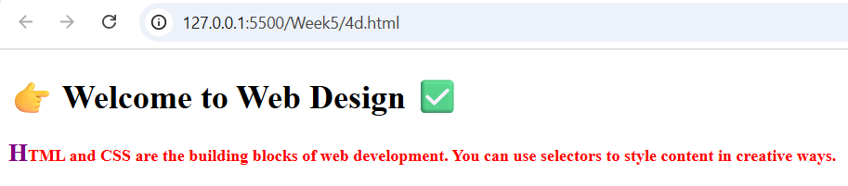

4 e) Attribute selector:
<!DOCTYPE html>
<html>
<head>
<title>Attribute Selector Demo</title>
<style>
input[type="text"] {
border: 2px solid blue;
}
a[href^="https"] {
font-style: italic;
}
input[placeholder*="name"] {
background-color: #f0f8ff;
}
</style>
</head>
<body>
<h2>Form Example</h2>
<input type="text" placeholder="Enter your name"><br><br>
<input type="password" placeholder="Enter password"><br><br>
<a href="https://example.com">Visit Example Site</a><br>
<a href="http://othersite.com">Visit Another Site</a>
</body>
</html>
Output:
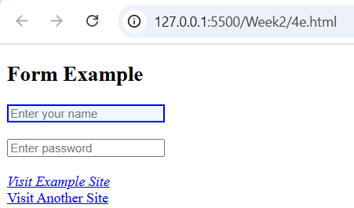
Viva Questions:
1. What is an element selector in CSS?
Ans) It selects HTML elements by their tag name.
Example: p { color: blue; } selects all <p> tags.
2. What is an ID selector?
Ans) It selects an element with a specific ID using #.
Example: #header { background: yellow; }
3. What is a class selector?
Ans) It selects all elements with a specific class using ..
Example: .box { border: 1px solid black; }
4. What is a group selector?
Ans) It groups multiple selectors to apply the same styles.
Example: h1, h2, h3 { font-weight: bold; }
5. What is the universal selector?
Ans) It selects all elements on the page using *.
Example: * { margin: 0; padding: 0; }
6. What is a descendant selector?
Ans) It selects all elements inside a specified element.
Example: div p { color: green; } selects all <p> inside <div>.
7. What is a child selector?
Ans) It selects direct child elements only using >.
Example: ul > li { list-style: none; }
8. What is an adjacent sibling selector?
Ans) It selects the next sibling immediately after a specified element using +.
Example: h1 + p { color: red; }
9. What is a general sibling selector?
Ans) It selects all siblings after the specified element using ~.
Example: h1 ~ p { font-style: italic; }
10. What is a pseudo-class in CSS?
Ans) It defines a special state of an element using :.
Example: a:hover { color: orange; }
11. What does :first-child do?
Ans) Selects the first child of a parent.
Example: li:first-child { color: red; }
12. What does :nth-child(n) do?
Ans) Selects the nth child of a parent.
Example: li:nth-child(2) { color: blue; }
13. What is a pseudo-element in CSS?
Ans) It styles specific parts of an element using ::.
Example: p::first-line { font-weight: bold; }
14. What does ::before do?
Ans) Inserts content before an element.
Example: h1::before { content: "★ "; }
15. What is an attribute selector in CSS?
Ans) It selects elements based on the presence or value of an attribute.
Example: input[type="text"] { border: 1px solid gray; }

Week-5: CSS with Color, Background, Font, Text and CSS Box Model
5 a) Write a program to demonstrate the various ways you can reference a color in CSS.
AIM: To write a program to demonstrate the various ways you can reference a color in CSS.
DESCRIPTION:
• <!DOCTYPE html> – Declares the document type and version of HTML (HTML5).
• <html> – Root element containing the whole webpage content.
• <head> – Holds metadata, page title, and CSS styles.
• <title> – Sets the title shown in the browser tab.
• <style> – Contains internal CSS styling rules.
• <body> – Contains all visible content on the webpage.
CODE:
<!DOCTYPE html>
<html>
<head>
<title>CSS Color Referencing Demo</title>
<style>
.named-color {
color: red;
background-color: lightyellow;
}
.hex-color {
color: #0000FF; /* Blue */
background-color: #F0F0F0;
}
.rgb-color {
color: rgb(0, 128, 0); /* Green */
background-color: rgb(230, 230, 250);
}
.rgba-color {
color: rgba(255, 165, 0, 0.9); /* Orange with slight transparency */
background-color: rgba(255, 255, 255, 0.5);
}
.hsl-color {
color: hsl(240, 100%, 50%); /* Blue */
background-color: hsl(60, 100%, 90%);
}
.hsla-color {
color: hsla(300, 100%, 50%, 0.8); /* Purple with transparency */
background-color: hsla(0, 0%, 100%, 0.5);
}
</style>
</head>
<body>
<h2>Different Ways to Apply Colors in CSS</h2>
<p class="named-color">This text uses a named color: <strong>red</strong>.</p>
<p class="hex-color">This text uses a hex code: <strong>#0000FF</strong>.</p>
<p class="rgb-color">This text uses RGB format: <strong>rgb(0, 128, 0)</strong>.</p>
<p class="rgba-color">This text uses RGBA: <strong>rgba(255, 165, 0, 0.9)</strong>.</p>
<p class="hsl-color">This text uses HSL: <strong>hsl(240, 100%, 50%)</strong>.</p>
<p class="hsla-color">This text uses HSLA: <strong>hsla(300, 100%, 50%, 0.8)</strong>.</p>
</body>
</html>
Output:
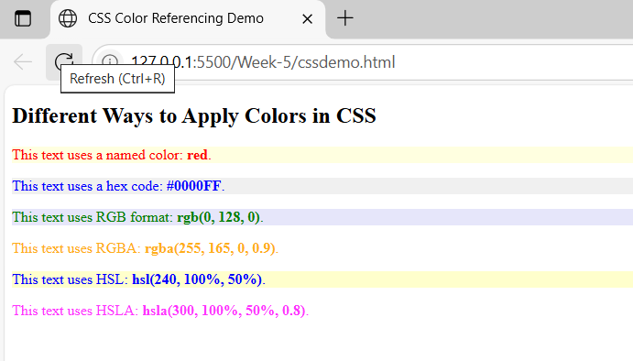
5 b) Write a CSS rule that places a background image halfway down the page, tilting it horizontally. The image should remain in place when the user scrolls up or down.
AIM:
To apply a background image in CSS that is horizontally centered, placed halfway down the page, remains fixed during scrolling, and is flipped horizontally.
DESCRIPITION:
• background-image – Specifies the image to be used as the background of an element.
• background-position – Controls where the background image appears; can be set with keywords or coordinates (e.g., center 50% for halfway down).
• background-attachment: fixed; – Keeps the background image in place when scrolling.
• transform: scaleX(-1); – Flips the image horizontally (applied to an element or pseudo-element holding the image).
CODE:
<!DOCTYPE html>
<html>
<head>
<title>Fixed Flipped Background Example</title>
<style>
body {
margin: 0;
height: 200vh; /* Makes the page scrollable */
}
.background {
position: fixed;
top: 20%; /* Halfway down the page */
left: 0;
width: 100%;
height: 200px; /* Adjust as needed */
background-image:url('https://picsum.photos/id/1015/600/400');
background-repeat: no-repeat;
background-size: cover;
background-position: center;
transform: rotate(-15deg); /* Flip horizontally */
z-index: -1; /* Place behind content */
}
.content {
padding: 50px;
font-size: 20px;
}
</style>
</head>
<body>
<div class="background"></div>
<div class="content">
<h1>Scroll Down</h1>
<p>This is an example page with a background image fixed halfway down and flipped horizontally.</p>
<p>Keep scrolling to see the background image stay in place.</p>
<p>Lorem ipsum dolor sit amet, consectetur adipiscing elit. Pellentesque luctus velit sit amet justo feugiat, vel cursus lorem tincidunt.</p>
</div>
</body>
</html>
Output:
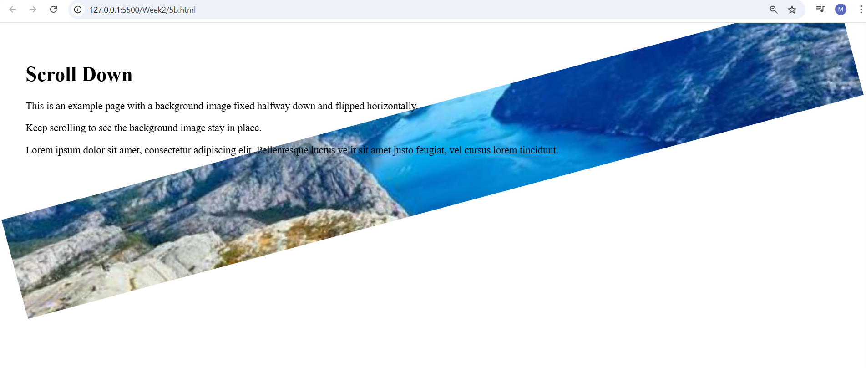

5 c) Write a program using the following terms related to CSS font and text:
i. font-size ii. font-weight iii. font-style
iv. text-decoration v. text-transformation vi. text-alignment
AIM:
To demonstrate the use of various CSS font and text-related properties such as font-size, font-weight, font-style, text-decoration, text-transform, and text-align.
DESCRPITION:
• font-size – Specifies the size of the text.
• font-weight – Specifies the thickness or boldness of the text (e.g., normal, bold, 700).
• font-style – Specifies the style of the text (e.g., normal, italic, oblique).
• text-decoration – Adds or removes decoration from text (e.g., underline, overline, line-through).
• text-transform – Controls the capitalization of text (e.g., uppercase, lowercase, capitalize).
• text-align – Specifies the horizontal alignment of text (e.g., left, right, center, justify).
CODE:
<!DOCTYPE html>
<html>
<head>
<title>CSS Font and Text Properties</title>
<style>
.font-size {
font-size: 24px; /* Increases text size */
}
.font-weight {
font-weight: bold; /* Makes text bold */
}
.font-style {
font-style: italic; /* Makes text italic */
}
.text-decoration {
text-decoration: underline; /* Underlines the text */
}
.text-transform {
text-transform:uppercase; /* Converts text to uppercase */
}
.text-align {
text-align: center; /* Centers the text */
}
</style>
</head>
<body>
<h2>CSS Font and Text Formatting Examples</h2>
<p class="font-size">This text uses <strong>font-size: 24px</strong>.</p>
<p class="font-weight">This text uses <strong>font-weight: bold</strong>.</p>
<p class="font-style">This text uses <strong>font-style: italic</strong>.</p>
<p class="text-decoration">This text uses <strong>text-decoration: underline</strong>.</p>
<p class="text-transform">This text uses <strong>text-transform: uppercase</strong>.</p>
<p class="text-align">This text uses <strong>text-align: center</strong>.</p>
</body>
</html>
Output:
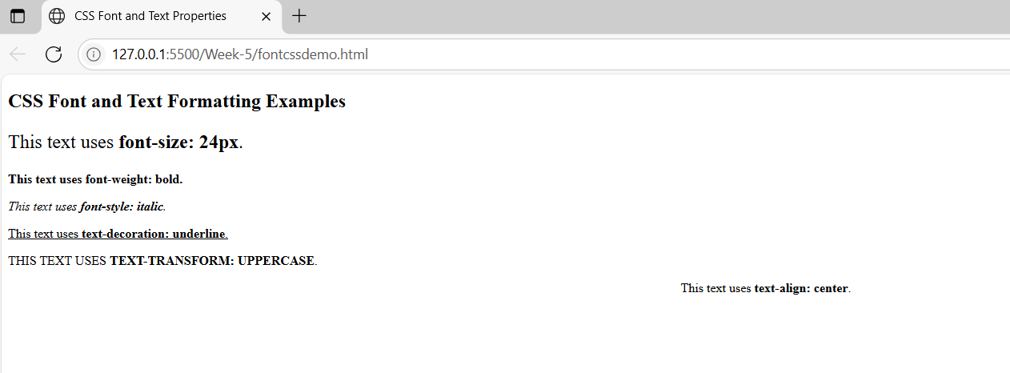

5 d) Write a program, to explain the importance of CSS Box model using
i. Content ii. Border iii. Margin iv. Padding
AIM:
To demonstrate the importance of the CSS Box Model and explain its components: content, border, margin, and padding.
DESCRIPTION:
• content – The actual area where text, images, or other elements appear.
• border – A line surrounding the content and padding, which can have style, color, and width.
• margin – The space outside the border, creating distance between elements.
• padding – The space between the content and the border, used to control inner spacing.
CODE:
<!DOCTYPE html>
<html>
<head> <title>CSS Box Model Demo</title>
<style>
.box {
width: 300px;
height: 100px;
background-color: lightyellow; /* Content background */
padding: 20px; /* Space inside border */
border: 5px solid orange; /* Border around content and padding */
margin: 30px auto; /* Space outside the border */
text-align: center;
font-size: 18px;
box-sizing: content-box; /* Default box model behavior */
}
body {
background-color: #f2f2f2;
font-family: Arial, sans-serif;
}
</style>
</head>
<body>
<h2 style="text-align:center;">CSS Box Model Explanation</h2>
<div class="box">
<strong>Content:</strong> This is the main content.<br>
<strong>Padding:</strong> Adds space inside the box.<br>
<strong>Border:</strong> Adds a visible edge around it.<br>
<strong>Margin:</strong> Adds space outside the box.
</div>
</body>
</html>
OUTPUT:
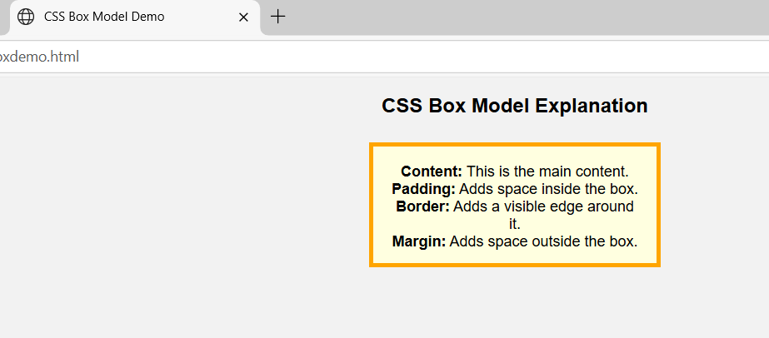
Viva Questions:
1) What is the difference between color and background-color in CSS?
Ans) color sets the text (foreground) color.background-color sets the background color of an element.
2) What are the different ways to define colors in CSS?
Ans)
- Color names (e.g., red, blue)
- Hex codes (e.g., #ff0000)
- RGB values (e.g., rgb(255, 0, 0))
- RGBA (e.g., rgba(255, 0, 0, 0.5))
- HSL (e.g., hsl(0, 100%, 50%))
- HSLA (e.g., hsla(0, 100%, 50%, 0.5))
3) What does the a stand for in rgba or hsla?
Ans) It stands for alpha, which controls the transparency of the color (0 = fully transparent, 1 = fully opaque).
  - What is the Box Model in CSS?
Ans) The CSS Box Model is a layout concept that wraps every HTML element in four parts:
  - Content → Actual text or image
  - Padding → Space between content and border
  - Border → Line around padding and content
  - Margin → Space outside the border
  - What is the difference between padding and margin?
Ans)
- padding: Space inside the element, between content and border
- margin: Space outside the element, between border and neighboring elements

