C:\Documents and Settings\HP_Administrator\Local Settings\Temporary Internet Files\Content.IE5\J8CEFNYP\MCBD09375_0000[1].wmfGet optimum output from your customers input

Your most valuable asset is often your **customers output**. Your customers opinion should be the very thing that shapes your business after all why are you in business if not for your customers? Finding out what your customer is thinking is not always so easy, naturally they will not hesitate to tell you when they are not satisfied. If you have disappointed them or somehow in their opinion not delivered what you promised then good lord will you hear about it! Unfortunately it is not always that easy to get them to tell you when they are happy about something or what they like about your business.

**Surveys**

**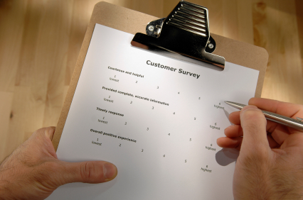**

Surveys are an excellent way to find out how your customers feel about a new product, service, location, store policy or virtually anything that's important to your business. A survey will tell you what your customers expect of you and your company, and clearly express how you are performing in their eyes.

The typical survey will run you about $3,000 to survey a large segment of your customer base. While this may seem like a lot, in most cases you will find that it is well worth the investment.

**In order to assemble an effective survey you should consider the following tips:**

**Know what your objectives are**

****

In order for a survey to be effective you need to have a clear goal, such as how your regular customers feel about a particular aspect of service. This may help you find out why someone who was once a steady customer is now shopping elsewhere.

**Make it worth their time to respond to the survey**

A good way to get a customer to fill out a survey is to provide a special discount or even a raffle entry form with the survey. While the prize does not have to C:\Documents and Settings\HP_Administrator\Local Settings\Temporary Internet Files\Content.IE5\IEFHXR4Z\MCSO02221_0000[1].wmfbe lavish a nice prize will attract your customers to return the survey and the raffle entry. This can also be a great tool for attracting new business. Also by returning it in person you can take the chance to personally thank them.

**Ask questions that are about important issues to them**

Let the customer know that their opinion is important to you and that you value what they say. The more the survey pertains to issues that matter to them the more likely they are to return it. Make the questions about specific points; do not make the questions too general. You survey should be fun to fill out, not something they just set aside with intentions to get to “some other time”.  
  
**Keep it simple!**

Limit the number of questions to about 10 or 12. If the customer thinks it will take a lot of their time they will usually just throw it away.

**Require the customer to return it in person**

While this may seem like an imposition, chances are if they have to mail it they won’t. By placing a discount coupon on it you have a better chance of the customer bringing it back in the store.  
  
**Leave space for comments**

By allowing a customer to fill out comments they can do more than just check mark a box or circle a number. This will allow the customer to provide some valuable input.   
  
**Test survey before mailing it**

Ask some good customers to fill it out the next time you see them. Not only will they fill – out the survey but they will also give you their input on how to improve the survey. Kind of like a survey for the survey.  
  
**Mail to your best customers**

People are more prone to take the time to fill it out if they do business with you on a regular basis. By mailing to about 2,000 valuable customers you should receive about 150 filled out surveys back. If the majority of your business comes from a select few people aim your questions at their particular needs.

**Announce the survey**

Promoting the survey and the coupon or raffle before mailing it will alert your customers to keep an eye out on it. A brief attention-commanding announcement should be delivered a week before the survey is officially mailed. 