DATE

Updates & Follow-Ups

- Bullet points of update items

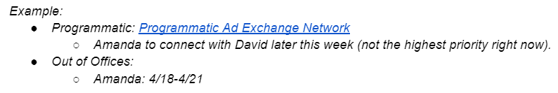

Pacing
- 1 - 2 sentences summarizing budget pacing.

[Insert Screenshot from Shape showing budget pacings]

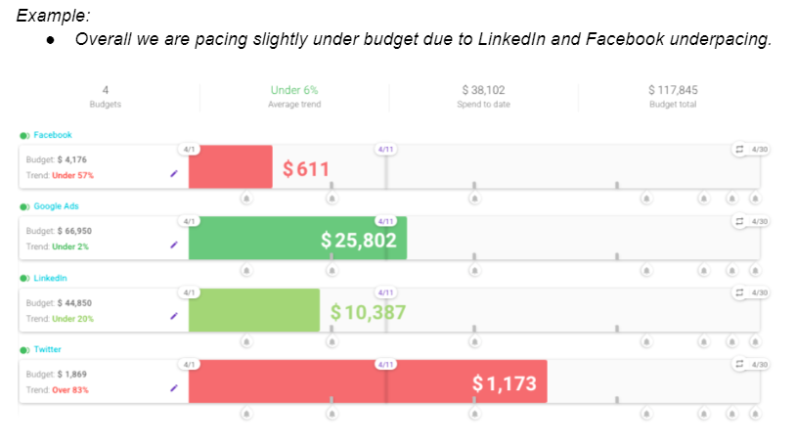

Performance
- Bullet point updates on channel/campaign performance

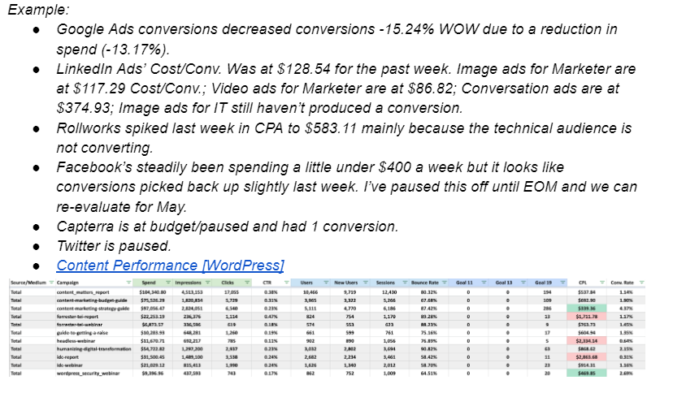

Discussion Items
- Bullet points on discussion items for the call

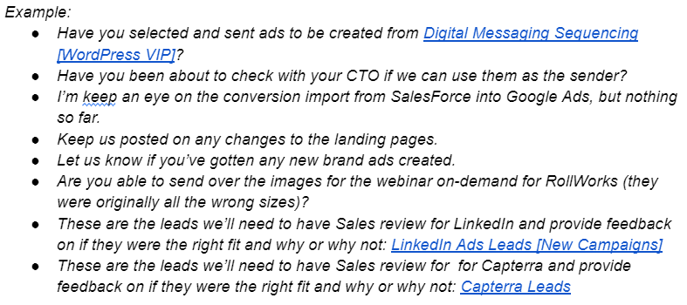

What’s Next
[Insert link to Asana Board (project board if in project phase, ongoing board if in ongoing)]

- [Assignee/Team] Bullet point next steps with the responsible team in brackets.

