Windows Network Troubleshooting
HOME LAB 01 • EVIDENCE-VERIFIED PROJECT REPORT
COMPLETED November 9, 2026
AUTHOR Jose Nava | Windows laptop, 16 GB RAM | Wi-Fi connection
PROJECT TYPE Free, independent Tier 1 support practice; no production incident

Project objective
Perform a structured Windows network-health assessment using built-in command-line and PowerShell utilities, interpret each result, and record repeatable diagnostic evidence. No network settings were changed.

Results at a glance
STEP / COMMAND | OBSERVED RESULT | VERIFICATION
1 ipconfig | Wi-Fi IPv4 + gateway present; mask /22 | Screenshot 01
2 ipconfig /all | DHCP Yes; DNS servers listed | Participant-reported
3 ping 127.0.0.1 | 4/4 replies, 0% loss | Participant-reported
4 ping default gateway | 4/4 replies, 0% loss; avg 3 ms | Screenshot 02
5 ping 1.1.1.1 | 4/4 replies, 0% loss; avg 8 ms | Screenshot 03
6 nslookup example.com | IPv4 and IPv6 answers returned | Screenshot 04
7 Test-NetConnection -Port 443 | TcpTestSucceeded: True | Screenshot 05

Interpretation and technical conclusion
All seven required checks passed. The laptop had a configured IPv4 Wi-Fi connection; the loopback and gateway responded; a public IP responded without relying on DNS; the tested hostname resolved; and the laptop could establish a TCP connection to remote port 443. The ping times were 3 ms average to the gateway and 8 ms average to 1.1.1.1. No fault was identified in the network functions tested.
Limitations: DHCP and loopback results were reported by the participant but not shown in the attached screenshots. Successful TCP port reachability does not verify a complete HTTPS page load, TLS certificate trust, or application performance. This was a verification exercise, not an outage investigation or repair.

Simulated help desk ticket
REQUEST Verify Windows network configuration, name resolution, and internet reachability.
ACTIONS Reviewed IP/DHCP/DNS configuration; ran loopback, gateway, public-IP, DNS and remote-port tests.
DISPOSITION Verification completed. No remediation needed or performed.

Resume-ready project description
Completed and documented a Windows network-health lab using ipconfig, ping, nslookup, and Test-NetConnection to validate IPv4/DHCP settings, gateway and external reachability, DNS resolution, and TCP port 443 connectivity.

Screenshot evidence — configuration and reachability
Screenshots are from the lab participant. Private device/network details are masked for sharing; diagnostic results are unchanged.
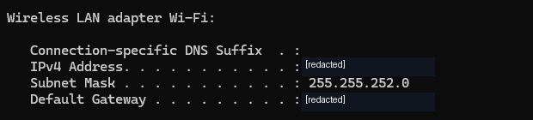
E1. Wi-Fi adapter: IPv4, /22 subnet mask, and default gateway listed (IP details masked).
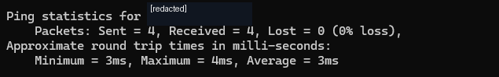
E2. Default gateway ICMP test: 4 sent, 4 received, 0% lost; average 3 ms.
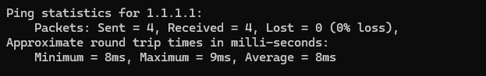
E3. External IP test (1.1.1.1): 4 sent, 4 received, 0% lost; average 8 ms.

Screenshot evidence — DNS and TCP
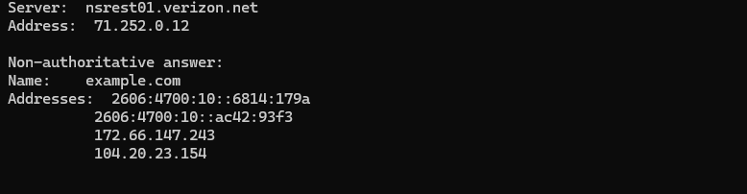
E4. DNS: nslookup example.com returned IPv4 and IPv6 records.
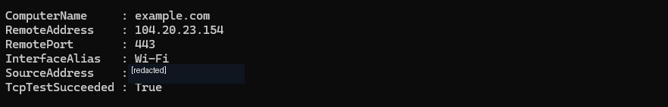
E5. PowerShell: Test-NetConnection on port 443 returned TcpTestSucceeded: True.

Evidence integrity
Only cropping and privacy masking were applied to published screenshots. No successful result, response count, measurement, or DNS record was fabricated or modified. The full observed-output details are preserved in the companion worksheet.

