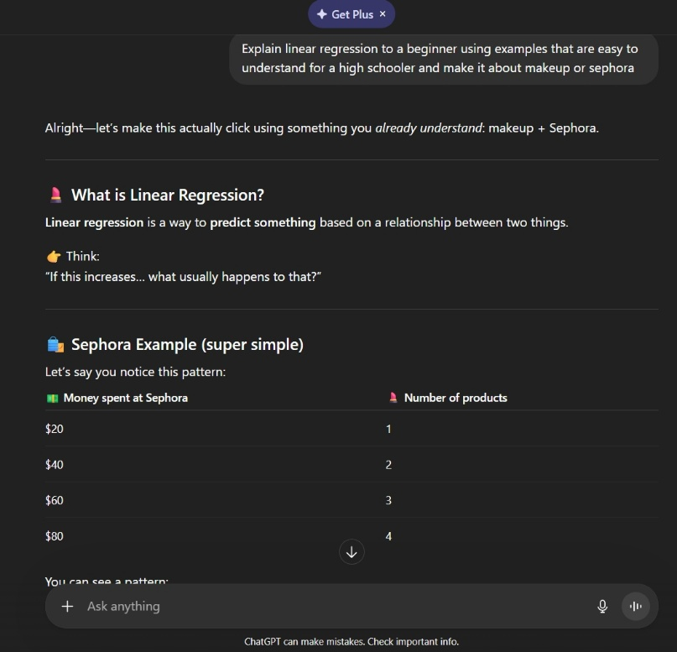 | Explain linear regression to a beginner using examples that are easy to understand for a high schooler and make it about makeup or Sephora.  The improvised prompt above presents me with a familiar topic I can understand and follow. When terms or examples, I’m familiar with are used to explain regression, it takes an unfamiliar subject and connects it to what I already experience in my day-to-day life. I can no apply regression to other topics because I used this improvised prompt as a learning tool.

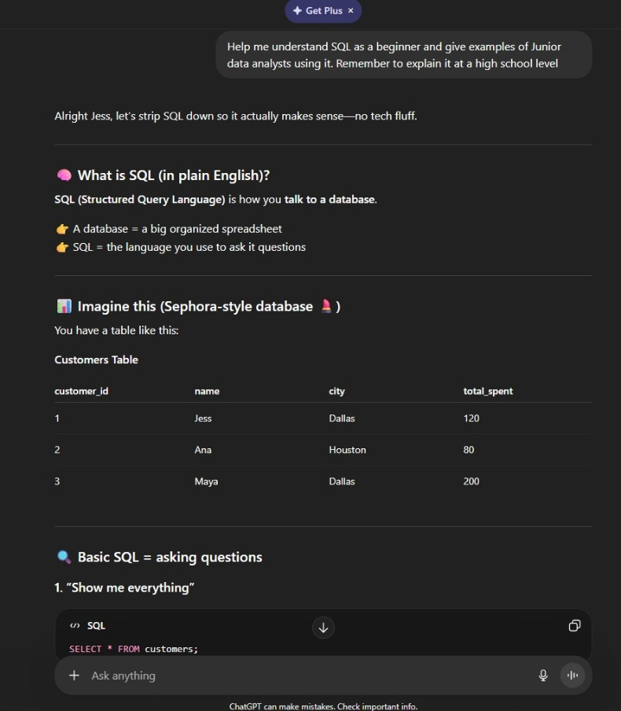 | Help me understand SQL as a beginner and give examples of Junior data analysts using it. Remember to explain it at a high school level.  The improved prompt above introduces SQL using a small group of data mocking sales from Sephora. It gives step by step coding prompts and explains the results each command produces. This helps the reader with no prior SQL knowledge understand the language.

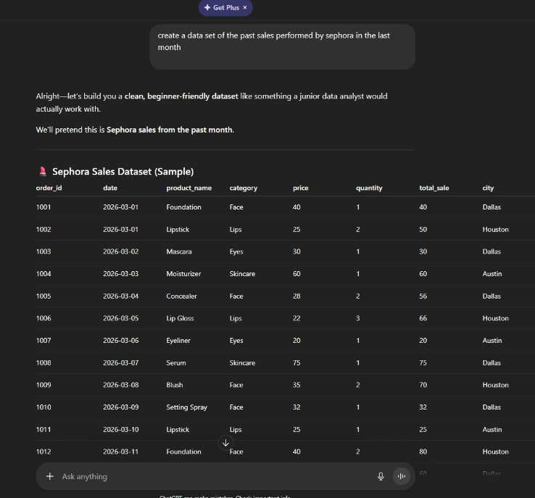 | create a data set of the past sales performed by Sephora in the last month  This improved prompt allows me to mockup sales within a time frame. Emphasizing the time can help the user gather the data and analyze it.

