This paper will try to decipher Rongorongo using the brute force method.

The paper by (Pozdniakov, Pozdniakov, 2007) has put forth a theory that the Rongorongo script is syllabic and contains only 52 main glyphs (corresponding to ~54 possible syllables in Rapanui language). His points could be summarized in these points

* The script is syllabic (or mostly syllabic)
* Glyphs connected together represent multi-syllable words
* There are only 52 main glyphs, and the rest from Barthel’s catalogue are either allographs, ligatures, glyphs with non-phonetic (stylistic?) variation or non-syllabic glyphs with some other function
* There may possibly be a reduplicator glyph to repeat syllables or syllable-pairs. Pozdniakov gives evidence both for and against the reduplicator theory, so if it does exist, it must not have been used often (perhaps some scribes preferred to use it, while others preferred to spell out words in full?)

If we will accept this theory, then it should be possible to find out the phonetic meaning of all syllabic glyphs using the brute force search method. The theory behind it is:

1. Generate all possible glyph-syllable mappings
2. For each mapping, replace the glyphs with syllables in the Rongorongo corpus
3. For each resulting text, try to match the text with all possible Rapanui dictionary words. That mapping which reveals the most dictionary words must be the correct one.

Of course, it sounds simple in theory, but in practice there is a big obstacle to this method: the amount of possible glyph-syllable mapping permutations is:

$$P(54, 52)= \frac{54!}{\left(54-52\right)!}=1.15×{10}^{71}$$

This amount is so large that no modern computer can handle that many permutations. So unfortunately, trying to brute-force the entire syllabary is out of question. We must, instead, try to narrow the scope down to only a few glyphs/syllables at a time.

The way to do it is to find a set of Rongorongo ligatures that altogether consist of only a small amount of base glyphs. Then, follow the above steps to brute-force the mappings and find that mapping which turns the most ligatures into dictionary words. Record this mapping, then do the same with another set of ligatures, and repeat until all glyphs are mapped to syllables.

For example, if we brute-force 4 glyphs at a time, then the amount of possible mapping permutations is:

$$P\left(54, 4\right)= \frac{54!}{\left(54-4\right)!}=7,590,024$$

Now that’s a reasonable amount for us. This could be generated by modern computers in just a few minutes. So, for the purposes of our tests below, we will try to find sets of ligatures altogether consisting of 4 glyphs or less.

Of course, this approach isn’t guaranteed to be perfect, as it relies on these assumptions:

1. **That the glyphs that we process from different ligatures are indeed same**

Pozdniakov’s 2007 revised glyph index is far from being perfect. Although he did put considerable effort into conflating allographs and separating ligatures, in my opinion he conflated *too much* allographs. Here is an example string of glyphs from Er06:

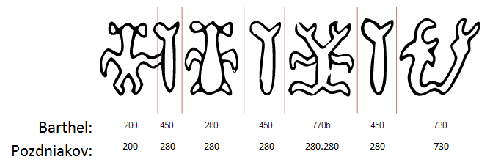

Pozdniakov regarded Barthel’s glyph 450 to be an allograph of 280, and ‘split’ glyph 770b into a pair of glyphs 280. Now, if we apply these indexing rules to the above string of glyphs, we get the same syllable repeated 6 times in the format: AB B B BB B C. This, of course, doesn’t make sense if it was a real text. In addition, why would a scribe write the same syllable consecutively using 3 different allographs?

In addition, in (Pozdniakov’s 2016), he admits that we are still not sure about the possible head/hand/feet variations within anthropomorphic and zoomorphic glyphs. His statistical analysis from 2007 shows that that different hands are actually separate glyphs ligatured onto the body, but regarding head and leg position variations we don’t have a confident answer.

Thus, for the purpose of this test, I will avoid using different anthropomorphic/zoomorphic glyphs within the same word set, with the exception of same glyphs with different hands, which we have a reason to believe are ligatures. In addition, I will only use glyphs that both Barthel and Pozdniakov agree on being separate glyphs.

1. **That the ligatures that we take are indeed syllabic, and not from one of the non-syllabic fragments**

Here we have to make sure that the taken ligatures are not from one of the “special” texts, such as C (Mamari calendar) or I (Santiago staff). We also have to make sure that the glyphs are common, because rare glyphs are likely to be non-syllabic.

1. **That the Rapanui vocabulary that we use is the same as the one that is encoded in Rongorongo script.**

For this test, I will be using the vocabulary based on the CEIPP dictionary taken from <http://kohaumotu.org/Rongorongo/Dictionary/dictionary_complete.html> . Now, I understand that the modern Rapanui language may differ from the one using during Rongorongo era. I also acknowledge that this dictionary is not complete and some words in Rongorongo may be in different cases/forms than those provided in the dictionary.

So, if I could get my hands on a Rongorongo-era Rapanui vocabulary, which is complete, and which contains all possible forms of all words, that would help with this test a lot, but until I have that, I would have to use the CEIPP dictionary instead.