Jessica Brennan

Machine Learning

HW 2 Write-up

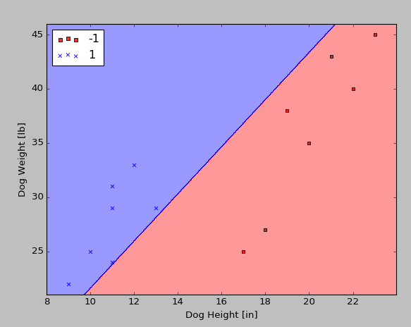

-1 = Border-Collie, 1 = Corgi

The Perceptron did find a decision boundary for this dataset, which is the line drawn in the plot above.

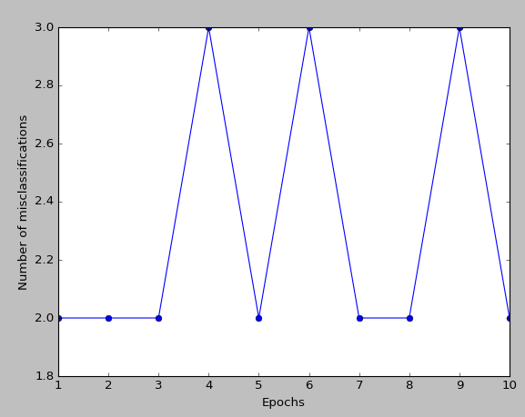

As you can see from the plot above, the Perceptron was unable to converge on this dataset. The misclassifications jumped back and forth from 2 to 3, never getting below 2. If this Perceptron were able to converge, it would eventually get down to 0.

1. I used the SGD version of Adaline and the highest percentage of accuracy I received was 77.9%.
2. The most predictive features of my Titanic model were Gender, Pclass, and Fare, in that order. This makes sense as we know that the high class passengers, women, and people who paid more for their ticket (closely related to class) were more likely to be allowed on the life boats to survive. When I combined Pclass, Fare, and Gender I received nearly my overall accuracy percentage. Adding in Age brought it down slightly.

Individual

Pclass accuracy = 70.4%

SibSp accuracy = 63.3%

Parch accuracy = 62.2%

Fare accuracy = 70%

Gender accuracy = 76%

AgeFill accuracy = 63.3%

Combos

Pclass/Fare/Gender accuracy = 76.4%

Pclass/Fare/Gender/AgeFill accuracy = 75.3%