## Radiated Emissions

### Purpose

The purpose of this test is to ensure that the RF energy unintentionally emitted from the EUT does not exceed the limits listed below as defined in the applicable test standard and measured from a receiving antenna. This helps protect broadcast radio services such as television, FM radio, pagers, cellular telephones, emergency services, and so on, from unwanted interference.

### Limit(s)

The method is as defined in ANSI C63.4:2014. The limits are as defined in FCC Part 15 Section 15.109 and ICES-003 Issue 6 Section 6.2:

CLASS A

FCC Part 15, Subpart B and ICES-003 Limits - 30MHz ‒ 1GHz

|  |  |
| --- | --- |
| **Frequency Rangea** | **Quasi-Peak Limits - 3mb** |
| 30 MHz – 88 MHz | 49.5 dBµV/m |
| 88 MHz – 216 MHz | 54 dBµV/m |
| 216 MHz – 960 GHz | 57 dBµV/m |
| 960 MHz – 1 GHz | 60 dBµV/m |

|  |  |  |
| --- | --- | --- |
| **Frequency Rangea** | **Average Limit - 3mc** | **Peak Limit - 3md** |
| 1 GHz and Up | 60 dBµV/m | 80 dBµV/m |

aThe frequency range scanned is in accordance to FCC Part 15 Section 15.33(b).

bLimit is with a resolution bandwidth of 120 kHz, a video bandwidth at least three times greater than the resolution bandwidth, and using a Quasi-Peak detector.

cLimit is with a resolution bandwidth of 1 MHz and using an Average detector.

dLimit is with a resolution bandwidth of 1 MHz, a video bandwidth at least three times greater than the resolution bandwidth, and using a Peak detector.

Based on ANSI C63.4 Section 4.2, if the Peak detector measurements do not exceed the Quasi-Peak limits, where defined, then the EUT is deemed to have passed the requirements.

**Typical Radiated Emissions Setup**

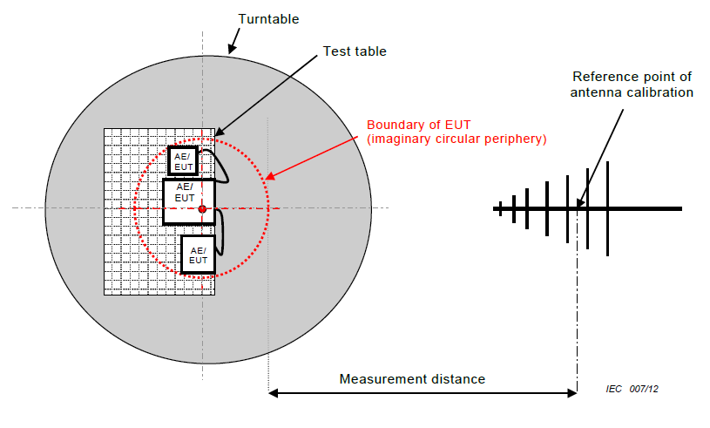

Note: In accordance with FCC Part 15, section 15.31(f)(1), testing was performed at a 3 meter test distance and an extrapolation factor, if applicable, of 20 dB/decade was applied. For example, an extrapolation of 10m to 3m is 20log(10/3) = 10.5 dB.

### Measurement Uncertainty

The expanded measurement uncertainty is calculated in accordance with CISPR 16-4-2 and is ±5.04dB for 30MHz – 1GHz and ±5.16dB for 1GHz – 18GHz with a 'k=2' coverage factor and a 95% confidence level.

### Preliminary Graphs

The graphs shown below are maximized peak measurement graphs measured with a resolution bandwidth greater than or equal to the final required detector over a full 0-360°. This peaking process is done as a worst case measurement and enables the detection of frequencies of concern for final measurement. For final measurements with the appropriate detector, where applicable, please refer to the tables under Final Measurements.

In accordance with FCC Part 15, Subpart A, Section 15.33, the device was scanned to a minimum of a 1 GHz. For devices containing clocks higher than 108 MHz, they were scanned above 1 GHz to meet the requirements of FCC Part 15, Section 15.33.

Insert RE Photos Here

### Final Measurements

The worst case measurement as listed in the table below appeared at a vertical antenna height of 140 cm and a table azimuth of 262 degrees, as pictured in Appendix B.

Quasi-Peak Emissions Table

Quasi-Peak Emissions Table

Note:

Peak = Peak measurement

QP = Quasi-Peak measurement

All peak values are under peak limits where peak limits are defined (> 1GHz).

See ‘Appendix B – EUT, Peripherals, and Test Setup Photos’ for photos showing the test set-up for the highest radiated emission.

### Test Equipment List

|  |  |  |  |  |  |
| --- | --- | --- | --- | --- | --- |
| **Equipment** | **Model No.** | **Manufacturer** | **Last Calibration Date** | **Next Calibration Date** | **Asset #** |
| Spectrum Analyzer | 8566B | HP | Dec. 13, 2017 | Dec. 13, 2019 | GEMC 190 |
| Quasi-Peak Adapter | 85650A | HP | Dec. 13, 2017 | Dec. 13, 2019 | GEMC 191 |
| Spectrum Analyzer | ESU 40 | Rohde & Schwarz | Jan. 12, 2018 | Jan. 12, 2020 | GEMC 233 |
| Spectrum Analyzer | FSU 26 | Rohde & Schwarz | Feb. 15, 2017 | Feb. 15, 2019 | GEMC 232 |
| BiLog Antenna | 3142-C | ETS | Oct. 19, 2018 | Oct. 19, 2020 | GEMC 8 |
| BiLog Antenna | 3142-C | ETS | Feb. 22, 2017 | Feb. 22, 2019 | GEMC 137 |
| BiLog Antenna | CBL6111 | Chase | Mar. 12, 2018 | Mar. 12, 2020 | GEMC 201 |
| BiLog Antenna | HLP-3003C | TDK RF Solutions | Oct. 19, 2018 | Oct. 19, 2020 | GEMC 231 |
| Horn Antenna  1.5 – 18 GHz | 6878/24 | Q-par | Sept 22, 2016 | Sept 22, 2018 | GEMC 6365 |
| Horn Antenna  2 – 18 GHz | WBH218HN | Q-par | Feb. 27, 2018 | Feb. 27, 2020 | GEMC 6375 |
| Horn Antenna  1 – 18 GHz | AH-118 | Com-Power Corporation | July 12, 2017 | July 12, 2019 | GEMC 214 |
| Horn Antenna  1 – 18 GHz | HRN-0118 | TDK RF Solutions | Feb. 13, 2018 | Feb. 13, 2020 | GEMC 235 |
| Attenuator 3 dB | 612-03-1 | Meca Electronics, Inc | NCR | NCR | GEMC 222 |
| Attenuator 10 dB | 612-10-1 | Meca Electronics, Inc | NCR | NCR | GEMC 224 |
| Attenuator 6 dB | 612-6-1 | Meca Electronics, Inc | NCR | NCR | GEMC 287 |
| Attenuator 6 dB | 612-6-1 | Meca Electronics, Inc | NCR | NCR | GEMC 286 |
| Pre-Amp  9 kHz – 1 GHz | LNA 6901 | Teseq | Feb. 2, 2017 | Feb. 2, 2019 | GEMC 168 |
| Pre-Amp  9 kHz – 1 GHz | CPA9230 | Chase | Feb. 28, 2018 | Feb. 28, 2020 | GEMC 301 |
| Pre-Amp | LNA-1450 | RF Bay Inc. | Oct. 18, 2018 | Oct. 11, 2020 | GEMC 221 |
| Pre-Amp | LNA-10-20 | RF Bay Inc. | Feb. 2, 2017 | Feb. 2, 2019 | GEMC 244 |
| Pre-Amp | LPA-6-30 | RF Bay Inc. | Feb. 2, 2017 | Feb. 2, 2019 | GEMC 243 |
| Pre-Amp  1 – 26.5 GHz | HP 8449B | HP | Nov. 15, 2017 | Nov. 15, 2019 | GEMC 189 |
| Pre-Amp  1 – 26.5 GHz | HP 8449B | HP | Jun. 12, 2018 | Jun. 12, 2020 | GEMC 312 |
| RF Cable 10m | LMR-400-10M-50Ω-MN-MN | LexTec | NCR | NCR | GEMC 27 |
| RF Cable 3m | HP305S | Semflex | NCR | NCR | GEMC 310 |
| RF Cable 10m | LMR-400-10M-50Ω-MN-MN | LexTec | NCR | NCR | GEMC 274 |
| RF Cable 2m | Sucoflex 104A | Huber+Suhner | NCR | NCR | GEMC 271 |
| Emissions Software | 0.1.97 | TUV SUD Canada, Inc | NCR | NCR | GEMC 58 |
| BAT-EMC Emission | 3.17.0.25 | Nexio, Inc. | NCR | NCR | GEMC 311 |

FCC_ICES003_RE-CLASS-A_Rev1