**Introduction**

Post November 20,2021 update, Domino can be sync with Github and vice-versa.

NOTE : Only those files will be sync which are generated after November 20,2021.

**Steps to perform on Github**

Follow these instructions to get Github details:

1. Get the correct URL of the Repository that needs to be sync with Domino.

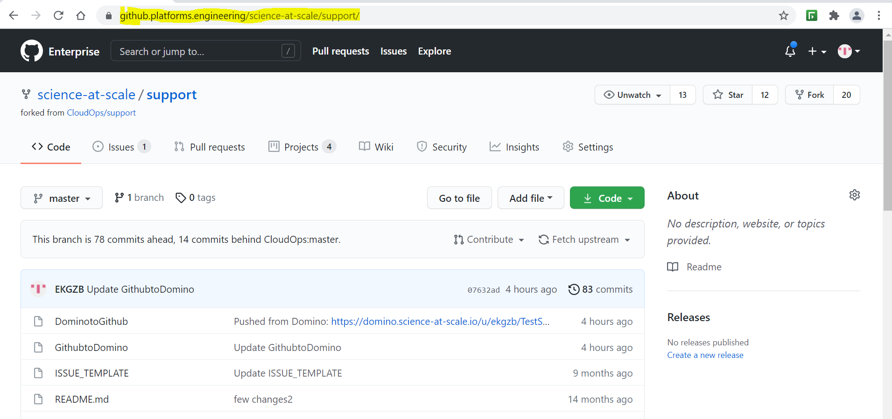

1. Verify user have Read and Write permissions to the Repository.

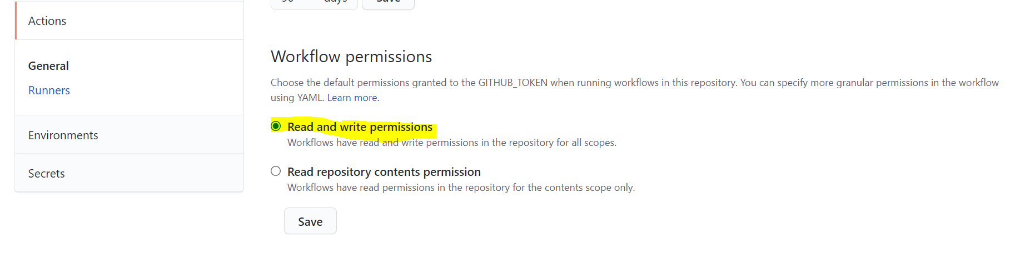

1. Go to the following location: Account Settings -> Developer Settings

And there generate users new Personal Access Tokens (PAT) and save a copy of it (Give it a name like TestSupport).

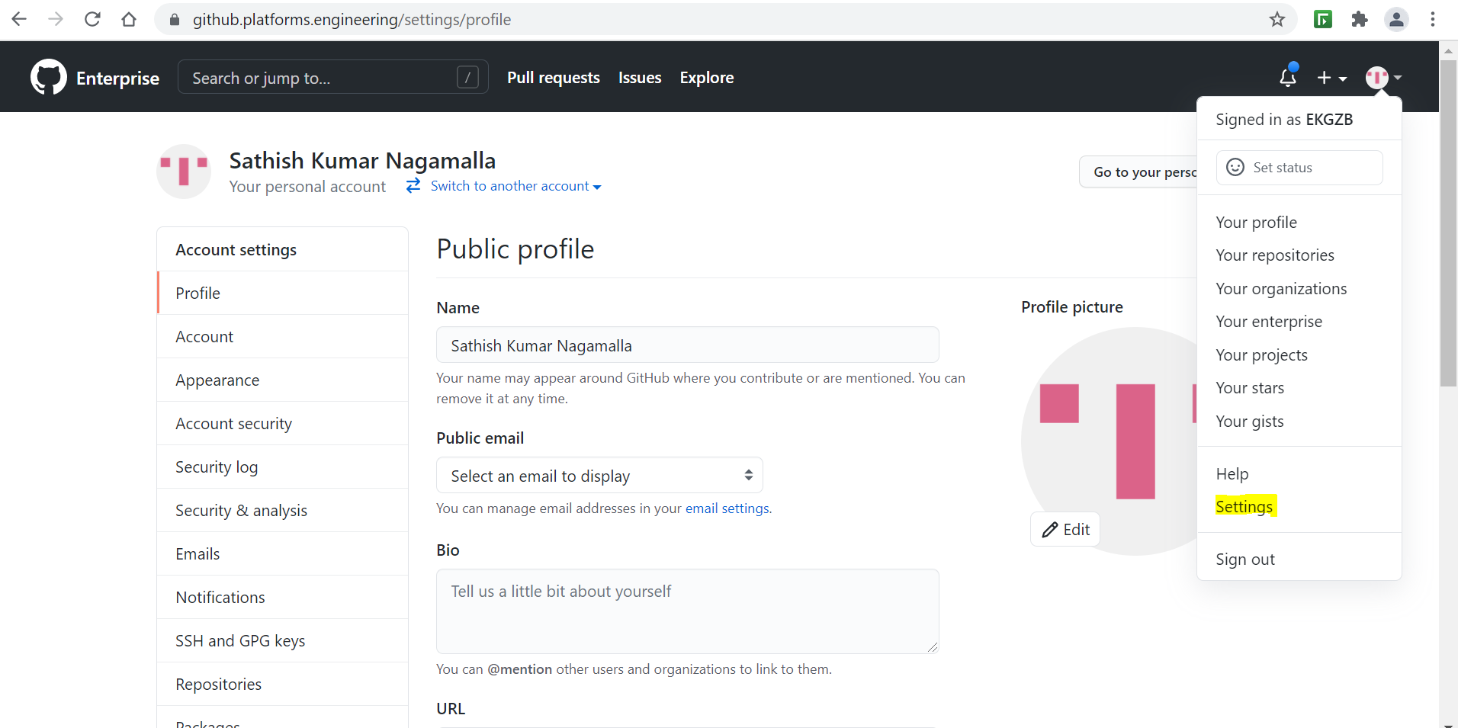

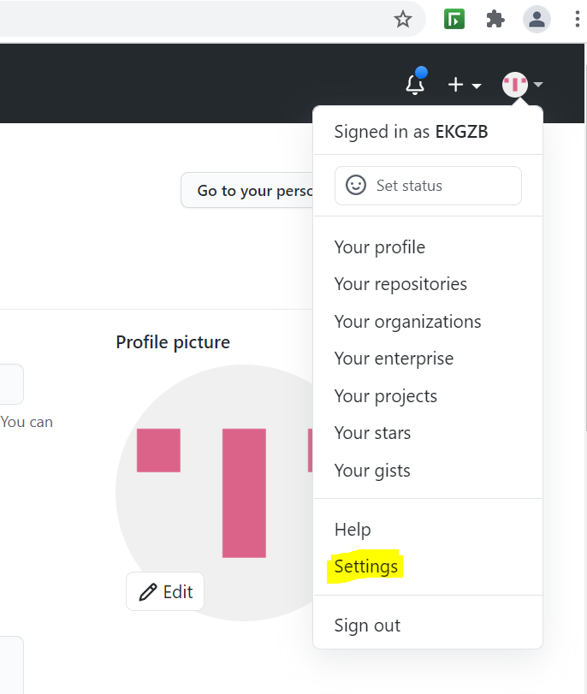

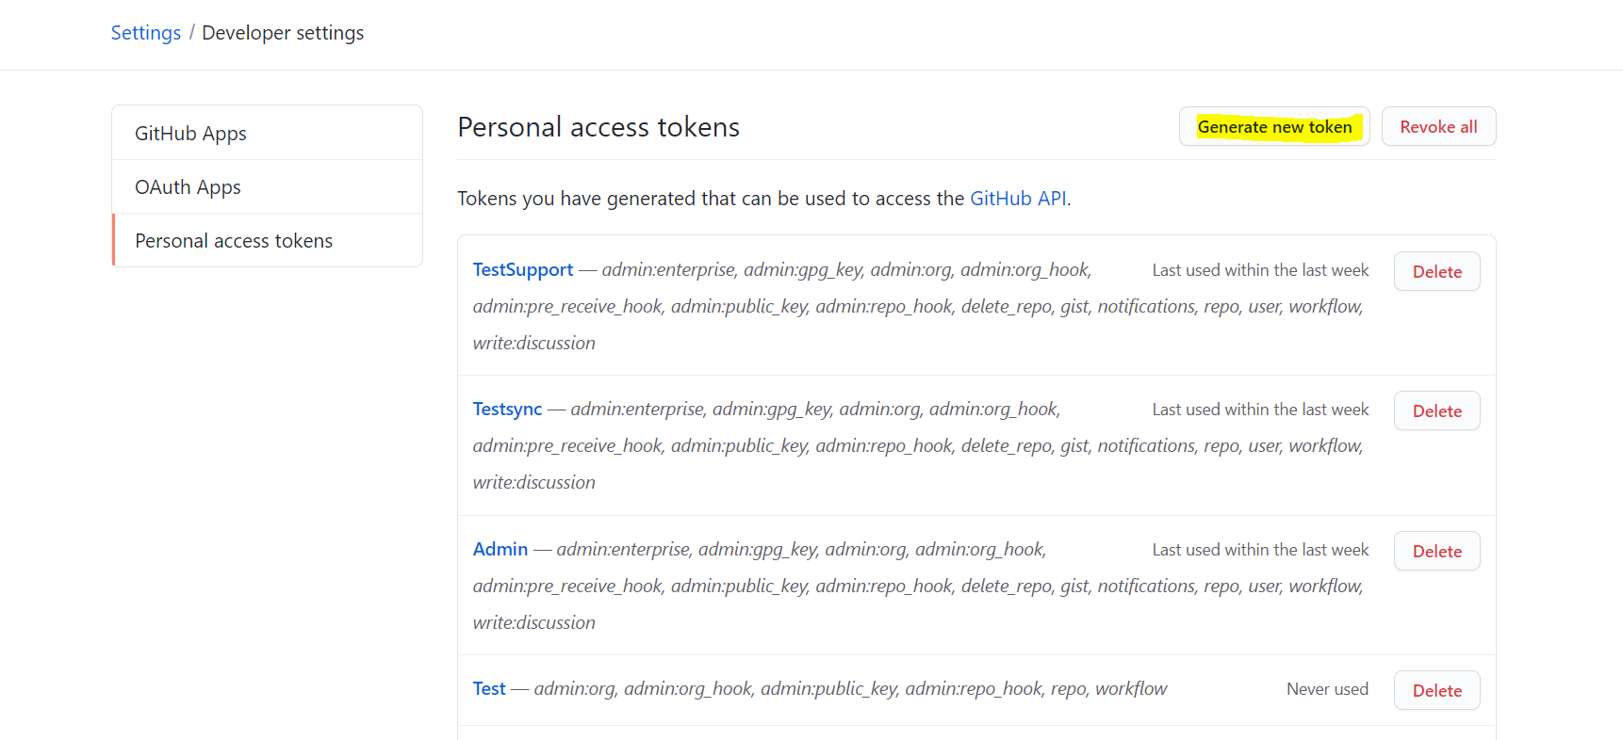

**Steps to perform in Domino**

1. Go to the following location: User Account Settings -> Git Credentials ->Add Credentials

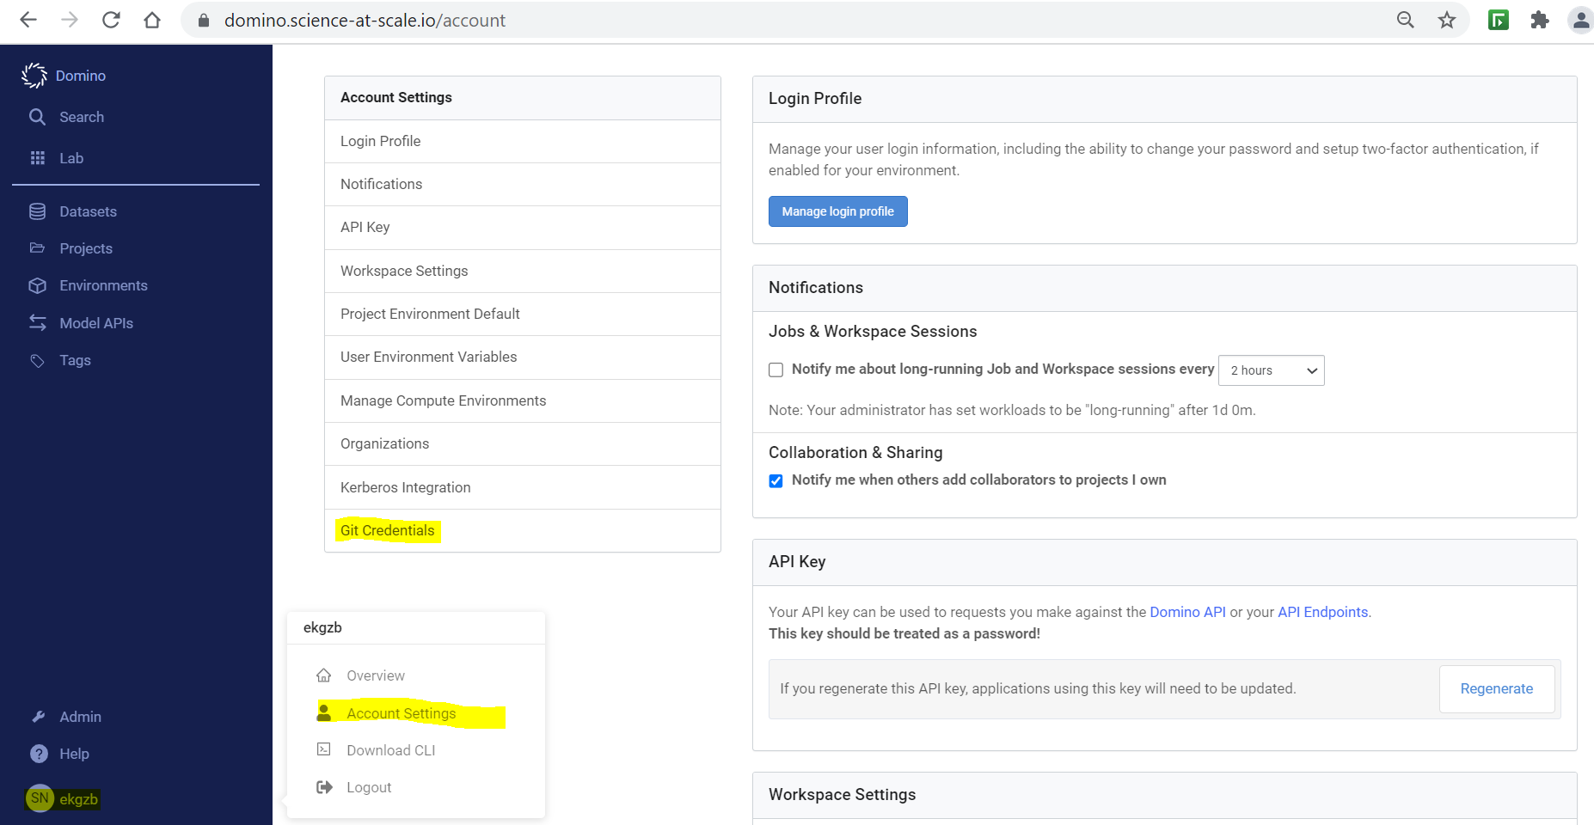

1. Select “Github Enterprise” from Git Service Provider drop-down menu.
2. Ensure to mention correct Domain (Ex: github.platforms.engineering).
3. Select “Personal Access Token” from Access Type drop-down menu.

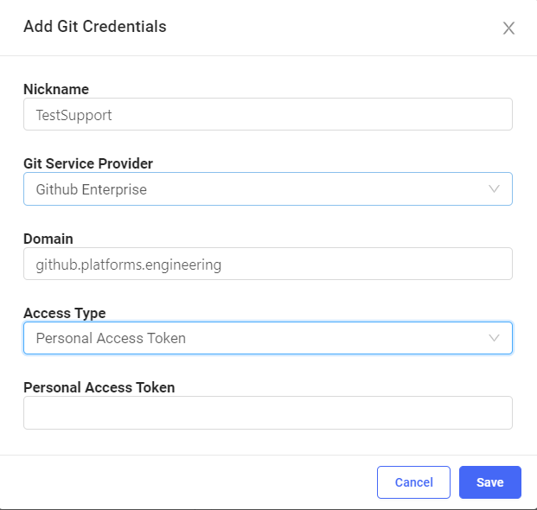

1. Go to your specific project -> Select "Code" on the left-hand side
2. Verify Repository Info and Repository Credentials are selected properly.

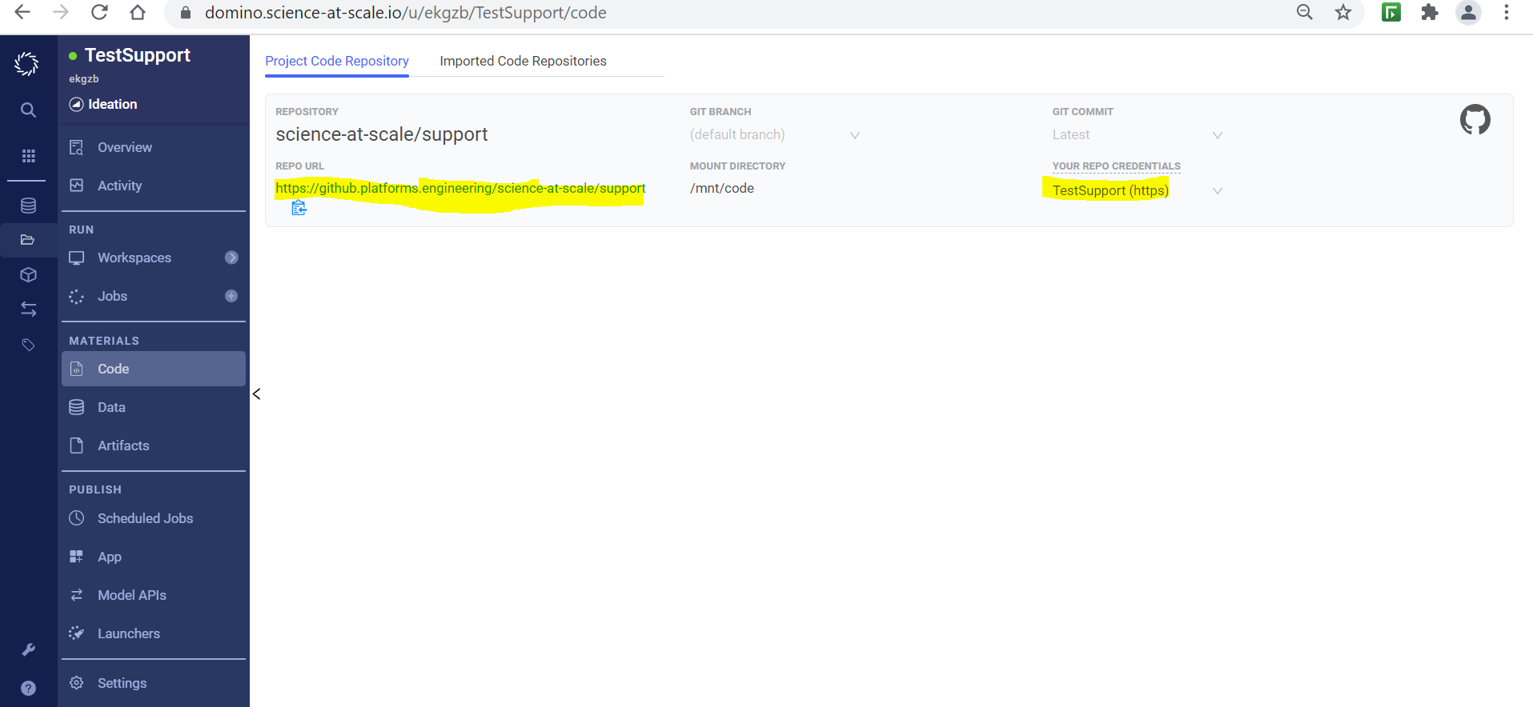

1. Spin-up a New workspace.
2. Once Workspace is up and running user should be able to see "Git Repo" under /mnt/code

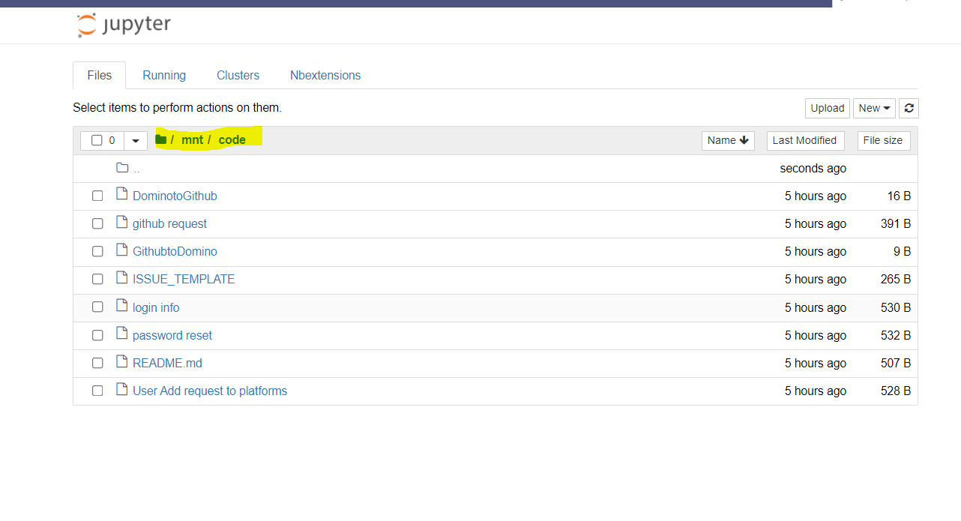

1. On the Left-hand side, user should be able to see File changes/Sync options.

**For illustration**

* Creating a file at Domino end and after syncing, verifying the changes at Github.

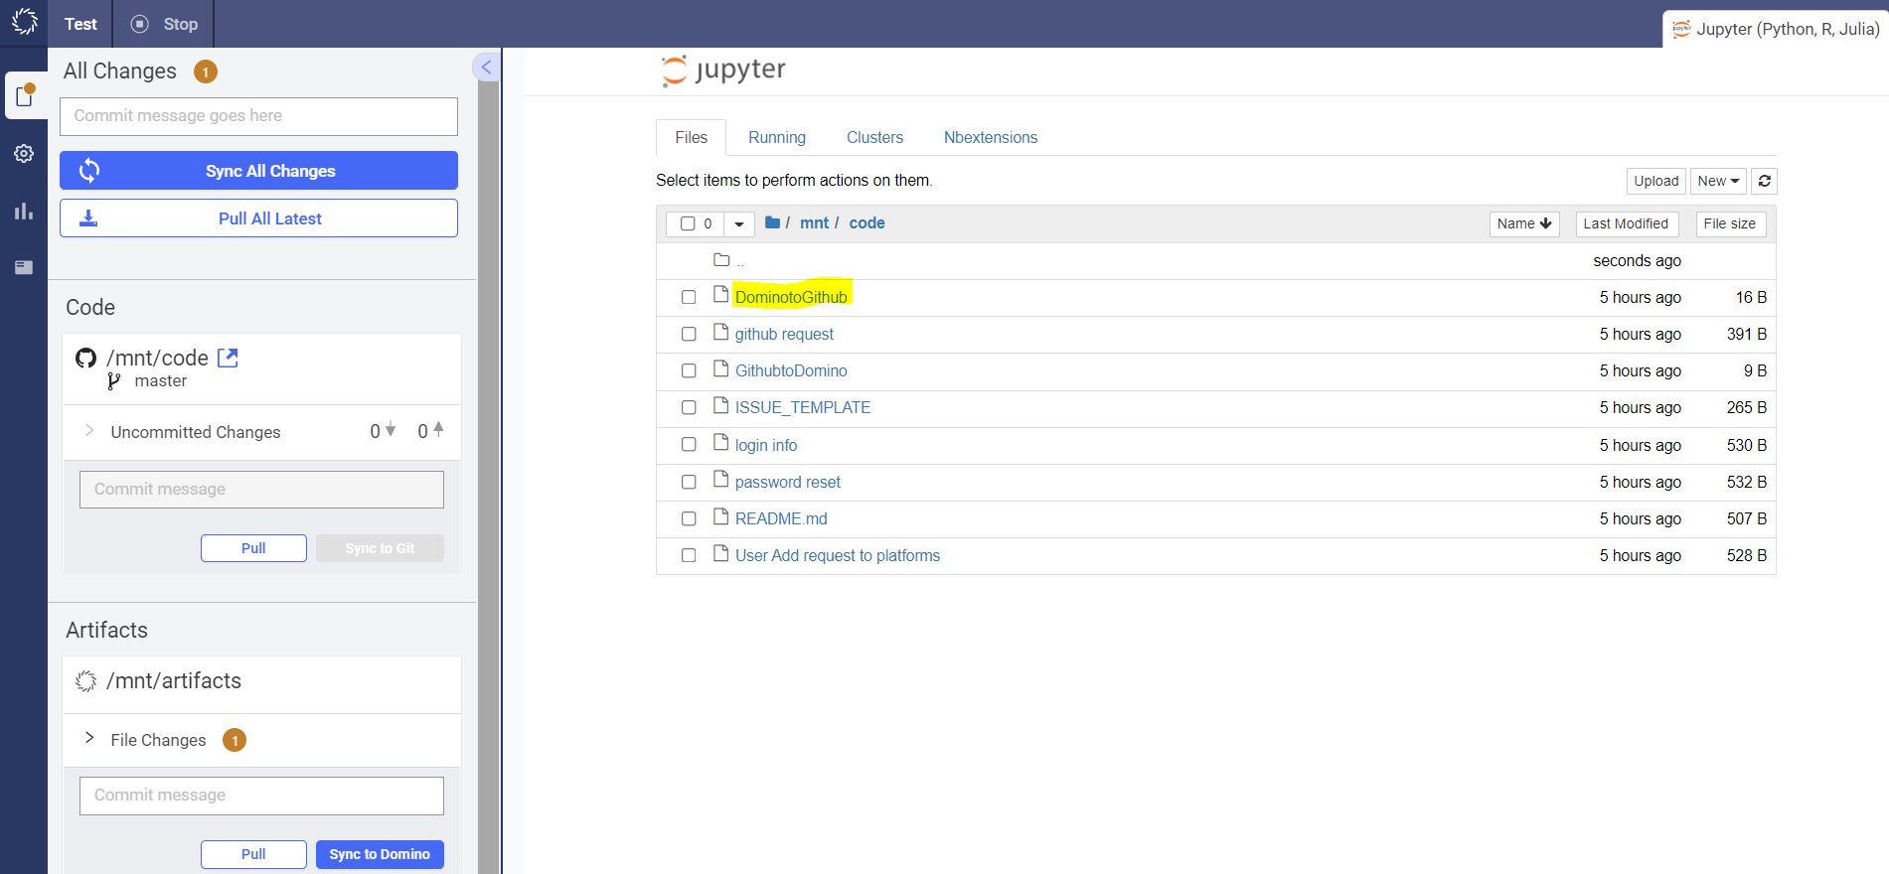

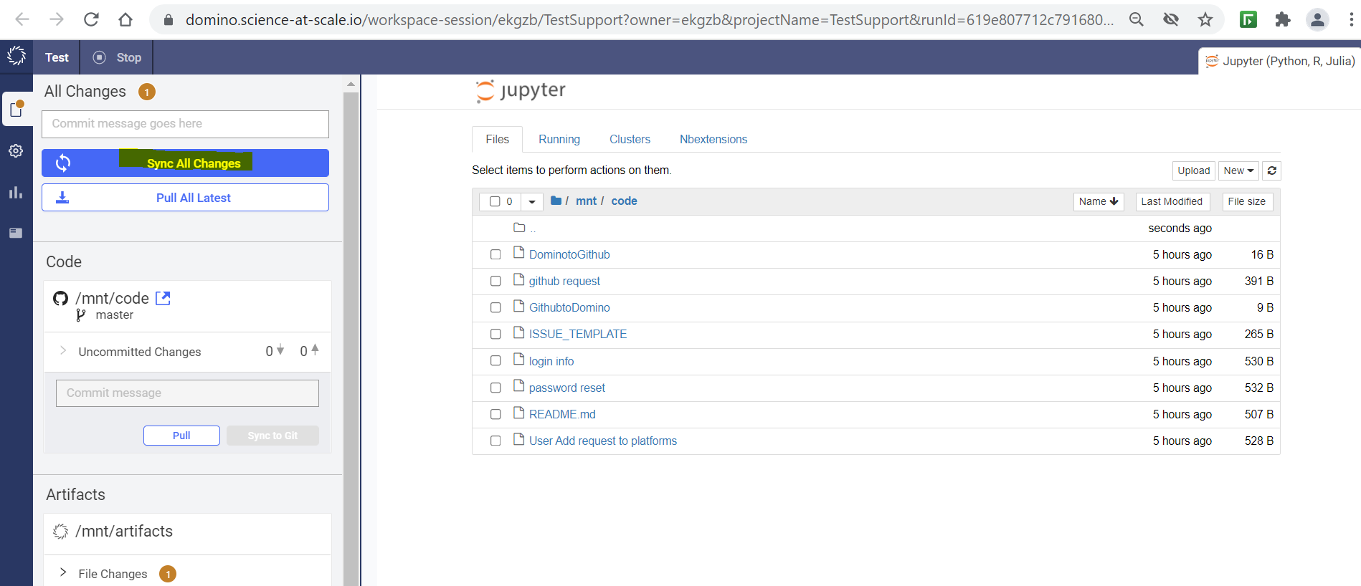

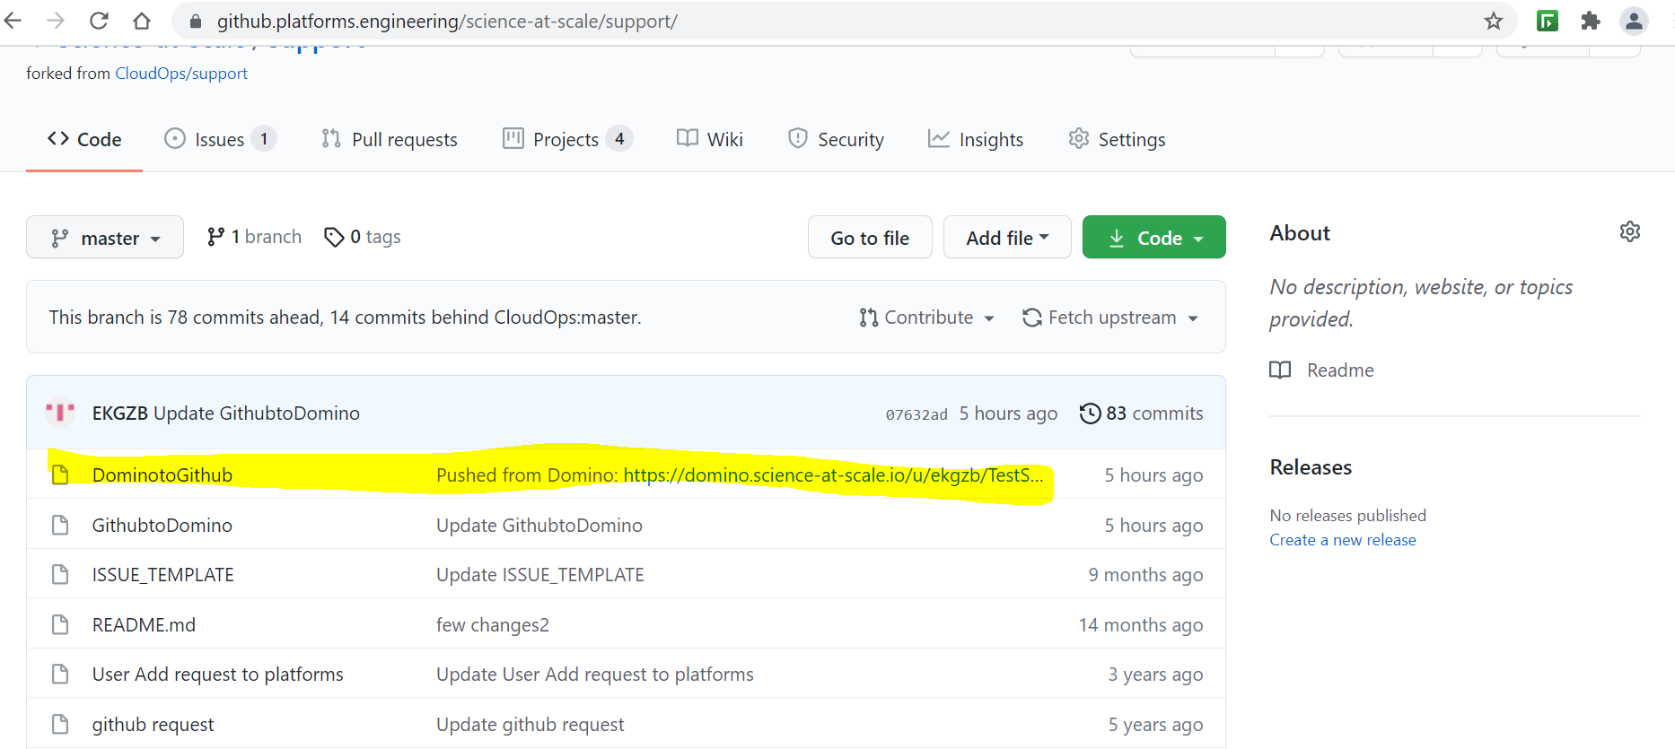

* Creating a file at Github and verifying the changes at Domino.

