# NBN Web Services Workshop Exercises

## November 19th 2011

## Jon Cooper

### Resources

* soapUI: [www.soapui.org](http://www.soapui.org)
* XAMPP: <http://www.apachefriends.org/en/xampp-windows.html>
* Nusoap php soap library: [http://sourceforge.net/projects/nusoap](https://webmail.nerc.ac.uk/owa/,DanaInfo=nercowa.ad.nerc.ac.uk,SSL+redir.aspx?C=dd64fe670be744b7a47f6d57a589bde9&URL=http%3a%2f%2fsourceforge.net%2fprojects%2fnusoap%2f)
* Quantum GIS: <http://www.qgis.org/>
* NBN web services reference: [http://data.nbn.org.uk/Documentation/Web_Services](http://data.nbn.org.uk/Documentation/Web-Services)
* NBN web services WSDL: <http://www.nbnws.net/ws_3_5/GatewayWebService?wsdl>
* NBN Guide to web service registration keys: [[http://data.nbn.org.uk/Documentation/Web_Services](http://data.nbn.org.uk/Guidebooks/WebServicesDocumentation)](http://data.nbn.org.uk/Guidebooks)  > Registration
* NBN Web Services Forum: <http://forums.nbn.org.uk/viewforum.php?id=15>
* NBN site keys (including Vice Counties), designation keys, taxon group keys, etc can be found here: [http://data.nbn.org.uk/Documentation/Web_Services](http://data.nbn.org.uk/Guidebooks/WebServicesDocumentation) > Resources
* Biological Records Centre Easy Maps documentation: <http://www.brc.ac.uk/resources.htm>

### Registration keys

These are mandatory in all web service calls, here are two pre-prepared ones for use in different exercises:

* a85d4c129728e58da6ed1b9af84632e15e2b5927 – public access for exercises 2, 3, 7 & 8
* b2918589cb31065453af08d75b9a6f5f7c632bca – variable user access for exercises 4 & 5

### List of exercises

1. Easy Maps
2. Use soapUI to create a Grid Map request
3. Basic grid map in php
4. Using a Variable User Access Key to send credentials to web service
5. Interactive site selection and species lists
6. Adding the NBN WMS to a GIS system
7. Extra time: species list for a dataset and adding to grid map
8. Extra time: The taxonomic search web service

### Exercises

**Important note:** this document will be provided to you in electronic form. You will need it open on your p.c. so you can cut-and-paste code directly into your exercises.

#### Exercise 1 EasyMaps

The Biological Records Centre had developed a wrapper around the Grid Map web service to make it very easy for you to obtain a grid map in your web page. It takes care of web service communication, as well as acknowledging data providers and adhering to the NBN terms and conditions. All you have to do is embed an iFrame containing the ‘Easy Map link’ in your html document. Its full documentation can be found here: <http://www.brc.ac.uk/resources.htm> > Easy NBN distribution maps.

**Note:** the NBN Gateway team is soon to take over the running of Easy Maps from the Biological Records Centre, so all documentation and hosting will take place through the NBN website.

In this exercise we will create the simplest Easy Map first, and then customise it using the additional parameters it supports from the NBN grid map web service.

1. In Notepad++ create the new web page <XAMPP installation dir>\htdocs\nbn\EasyMaps.html and add the following content to it:

<html>

<head></head>

<body>

<iframe width=**"400"** height=**"600"**

src=**"http://www.brc.ac.uk/schemes/NBNWidget/tvkGridmap.aspx?tvk=NHMSYS0000875473"**</iframe>

</body>

</html>

1. View the map in Chrome (<http://localhost/nbn/EasyMaps.html>), which should look like the one below. Note that the species key can be changed to whatever species you require (search for species using the search box on <http://data.nbn.org.uk>):

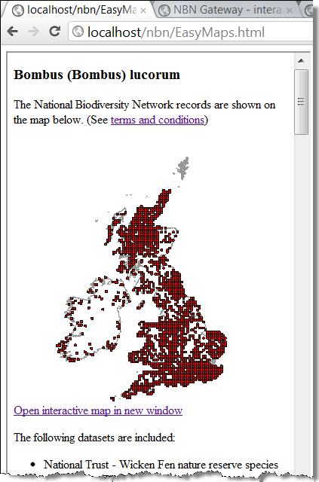

1. There are many options for customising the map as shown in the Easy Maps documentation (<http://www.brc.ac.uk/resources.htm> > Easy NBN distribution maps). Here is an example illustrating some customisations:
   * zoom to Cheshire
   * add an Ordnance Survey background
   * display 2km squares
   * change the colour of the squares to blue
   * only show records for one specific datasets (GA000917)
   * make image 500 by 500 pixels

<html>

<head></head>

<body>

<iframe width=**"600"** height=**"800"**

src=**"http://www.brc.ac.uk/schemes/NBNWidget/tvkGridmap.aspx?tvk=NHMSYS0000875473&res=2km&vc=58&bg=OS&w=500&h=500&b0fill=0000ff&ds=GA000917"**</iframe>

</body>

</html>

Your map should look like this:

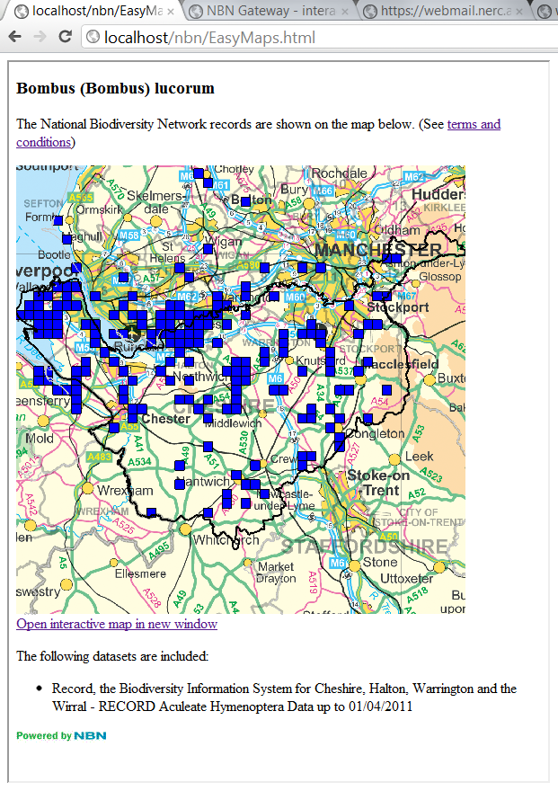

#### Exercise 2. Use SOAPUI to create a Grid Map request

The purpose of this exercise is to become familiar with using soapUI to investigate the NBN web services. You will build and test a request to the GridMap web service. This request will be needed for a later exercise.

There are 3 parts to this exercise:

1. We will start by creating a new soapUI project that references the NBN’s WSDL and provides example requests to all the NBN web services.
2. Then, focus on the GridMap web service to create a working request and view the response.
3. Finally, prepare the request for use in a later php exercise

##### **Create a new soapUI project**

* 1. Open soapUI (Start > soapUI)
  2. Right click Projects and choose New soapUI Project

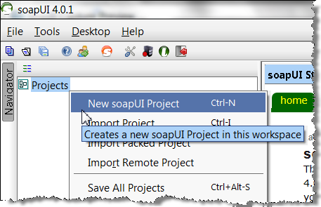

* 1. In the dialog:
  + give it a name (eg NBN)
  + Initial WSDL =  <http://www.nbnws.net/ws_3_5/GatewayWebService?wsdl>
  + Make sure ‘Create Requests’ is ticked
  + Press OK

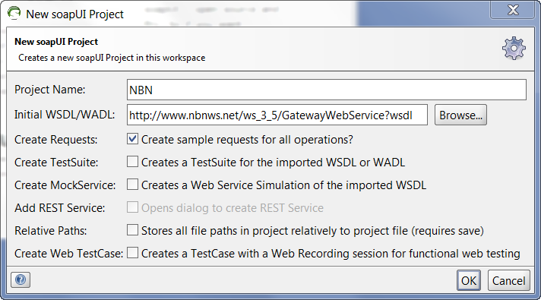

* 1. You should now have a full list of all the NBN web services in the Navigator panel:

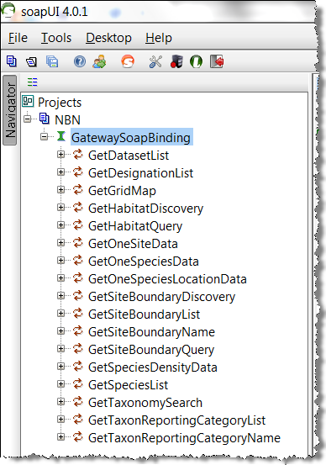

##### **Create a working GridMap request**

* 1. Expand GetGridMap and double click Request 1 to open the request in the editor. This displays the request we need to edit. Note that it indicates what elements are optional:

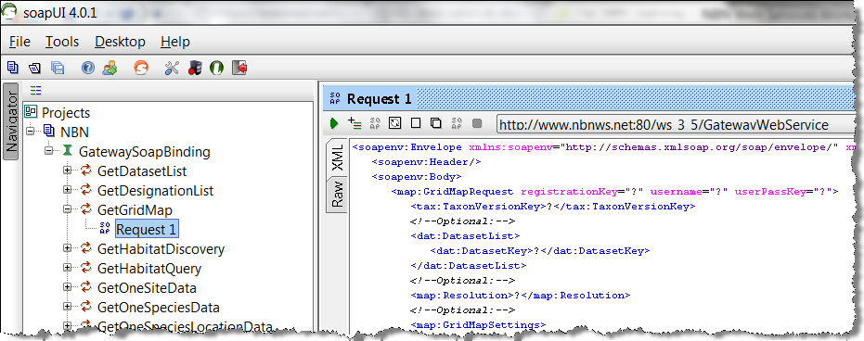

* 1. Create the simplest possible Grid Map request by making the following edits to the request:
* Edit <map:GridMapRequest... so it looks like this:

<map:GridMapRequest registrationKey="a85d4c129728e58da6ed1b9af84632e15e2b5927">

* Add a species key to the <tax:TaxonVersionKey> element, so it looks like this:

<tax:TaxonVersionKey>NBNSYS0000005629</tax:TaxonVersionKey>

* Delete all Optional elements (everything between </tax:TaxonVersionKey> and </map:GridMapRequest>)
* It should look like this (if you have any problems cut-and-paste the xml below into soapUI):

<soapenv:Envelope xmlns:soapenv=**"http://schemas.xmlsoap.org/soap/envelope/"** xmlns:map=**"http://www.nbnws.net/Map"** xmlns:tax=**"http://www.nbnws.net/Taxon"** xmlns:dat=**"http://www.nbnws.net/Dataset"** xmlns:spat=**"http://www.nbnws.net/Spatial"** xmlns:sit=**"http://www.nbnws.net/SiteBoundary"**>

<soapenv:Header/>

<soapenv:Body>

<map:GridMapRequest registrationKey=**"a85d4c129728e58da6ed1b9af84632e15e2b5927"**>

<tax:TaxonVersionKey>**NBNSYS0000005629**</tax:TaxonVersionKey>

</map:GridMapRequest>

</soapenv:Body>

</soapenv:Envelope>

* 1. Time to run it. The purpose of this request is to get a grid map response for the species with the key NBNSYS000005629, which is the dragonfly Norfolk Hawker (other species keys can be found via the NBN Gateway <http://data.nbn.org.uk> by adding your species name to the search box). To run it and get the response press the green arrow in the top left of Request 1. Your result will look like this:

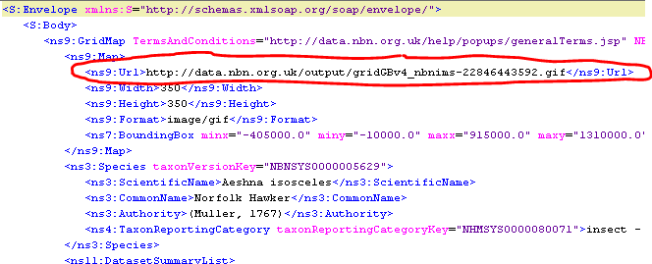

You can see the url to the map image (circled), together with information about the species and the data providers.

* 1. View the map by copying the Url of the gif image into a browser, it should look like this:

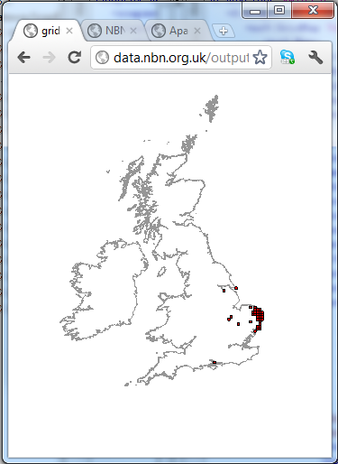

##### **Prepare the request ready for exercise 3**

Finally, one of the reasons for using soapUI is to provide a reasonably easy way to create xml requests to copy-and-paste into your php code. The request in soapUI needs to have all the ‘SOAP’ bits removing from it before it is ready for use in php (eg in Exercise 2). Here are the steps:

* 1. Copy the request into Notepad++ and make these two edits
  2. Copy all the namespace attributes except ‘xmlns:soapenv’ from the <soapenv:Envelope> tag into the <map:GridMapRequest> tag, like this:

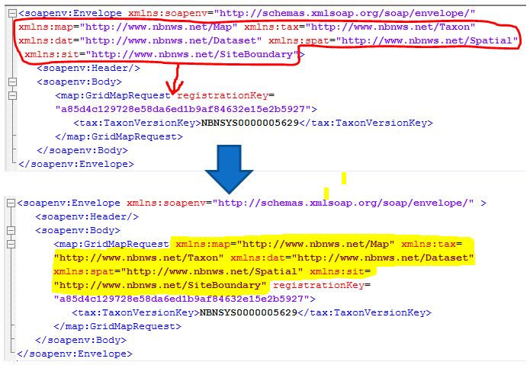

* 1. Delete the <soapenv:Envelope>, <soapenv:Header> and <soapenv:Body> tags, like this:

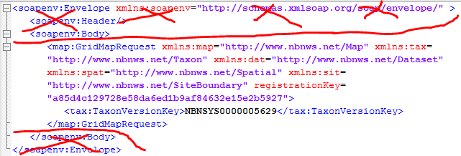

* 1. What you are left with is a request that can be copied directly into php in exercise 2, like this:

<map:GridMapRequest xmlns:map=**"http://www.nbnws.net/Map"** xmlns:tax=**"http://www.nbnws.net/Taxon"** xmlns:dat=**"http://www.nbnws.net/Dataset"** xmlns:spat=**"http://www.nbnws.net/Spatial"** xmlns:sit=**"http://www.nbnws.net/SiteBoundary"** registrationKey=**"a85d4c129728e58da6ed1b9af84632e15e2b5927"**>

<tax:TaxonVersionKey>**NBNSYS0000005629**</tax:TaxonVersionKey>

</map:GridMapRequest>

#### Exercise 3. Basic grid map in php

The purpose of this exercise is to use the request from Exercise 2 to create a grid map on a web page using php. The php code is already written for you, all that is needed is to add the request and view the results. Once this is working we will try to do a more complex request to produce a more customised map image.

The web page also shows you what needs to be present to conform to the NBN’s terms and conditions.

There are 3 parts to this exercise:

1. Make sure XAMPP is running, which is used for hosting php pages
2. Add your request to the php page and view in Chrome
3. Create a request for a more customised map and view in Chrome

**Note:** save all your php files in the directory <XAMPP installation dir>\htdocs\nbn\. Where <XAMPP installation dir>\will be something like C\xampp\. All php files can then be viewed in your browser at <http://localhost/nbn/filename.php>.

##### **Make sure XAMPP is running**

The software used to run the php examples in is called XAMMP. To get it running do this:

* 1. Open the ‘XAMPP Control Panel’. Your machines may vary so try these options to open it:
     1. If it exists double click this icon  in your System Tray (bottom left)
     2. Look on your desktop for XAMPP Control Panel and double click it
     3. Try looking for Start > All Programs > Apache Friends > XAMPP > XAMPP Control panel
  2. In the XAMPP Control Panel, click the Start button next to Apache:

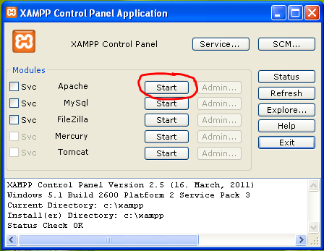

Apache should now be running ready to display php pages:

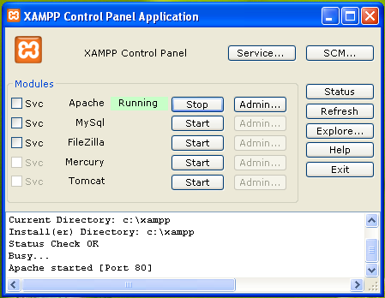

* 1. To test to make sure all is working, open Chrome and go to: <http://localhost/nbn/GridMap.php>. This is what you should see: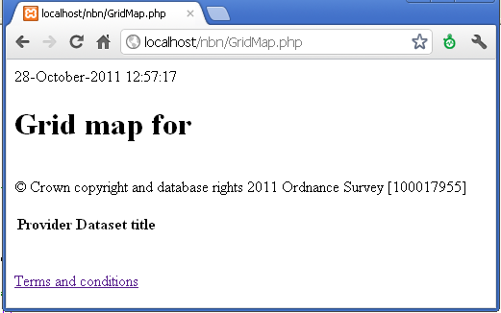

##### **Add the request from exercise 2 to php**

Now we will open a php page in Notepad++, add our request and view the final page in Chrome:

* 1. In Notepad++, open the source file: <XAMPP installation dir>\htdocs\nbn\GridMap.php.
  2. Find the section in code that says:

$gridMapQuery = '

!!!PASTE YOUR REQUEST OVER THE TOP OF THIS TEXT!!!

';

* 1. Replace the comment with your request from exercise 1 (that is hopefully still open in Notepad++). It should look like this:

$gridMapQuery = '

<map:GridMapRequest xmlns:map="http://www.nbnws.net/Map" xmlns:tax="http://www.nbnws.net/Taxon" xmlns:dat="http://www.nbnws.net/Dataset" xmlns:spat="http://www.nbnws.net/Spatial" xmlns:sit="http://www.nbnws.net/SiteBoundary" registrationKey="a85d4c129728e58da6ed1b9af84632e15e2b5927">

<tax:TaxonVersionKey>NBNSYS0000005629</tax:TaxonVersionKey>

</map:GridMapRequest>

';

1. Save it and then view the results in Chrome: <http://localhost/nbn/GridMap.php>. Here’s what is should look like:

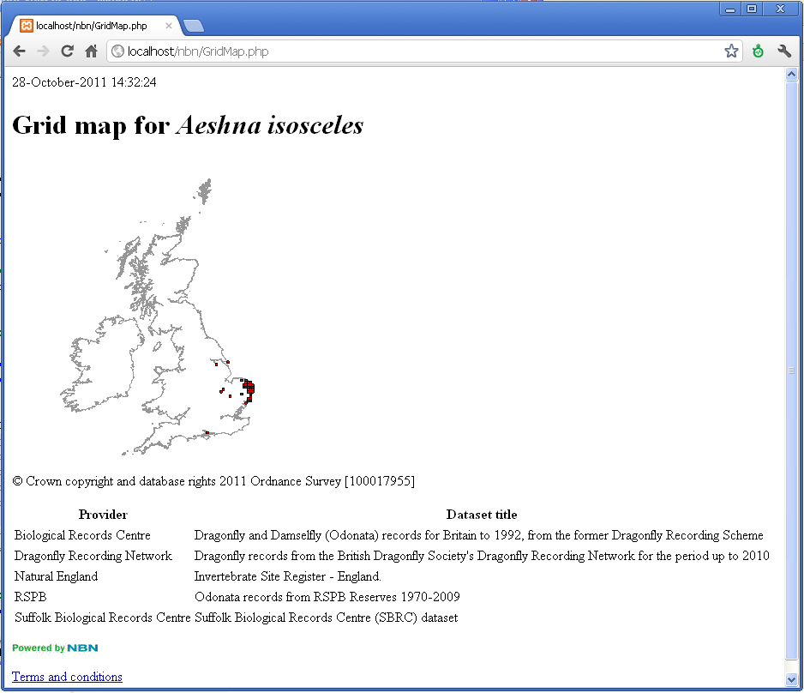

##### **Create a more customised map**

You now have the most basic grid map conforming to the NBN terms and conditions. However, if you review the optional query elements that were available to you in soapUI, or take a look at the grid map web services documentation ([http://data.nbn.org.uk/Documentation/Web_Services](http://data.nbn.org.uk/Web-Services-Documentation) > Grid map), you’ll see there are plenty of customisations you can do in the query. In this exercise we will build and use a request that does the following

* + species will be *Bombus (Bombus) lucorum* (NHMSYS0000875473)
  + restrict records to one specific dataset (GA000917 – a dataset provided by RECORD)
  + display records as 2km squares
  + zoom to Cheshire Vice County
  + show an Ordnance Survey background
  + make the squares to blue
  + make image 500 by 500 pixels
  1. In soapUI, create a new empty GridMapRequest:
     + - 1. In soapUI Navigator panel right click GetGridMap to open New Request dialog
         2. Give it the name Request 2 and then OK
         3. Request 2 will now open with the full set of optional tags ready to be edited:

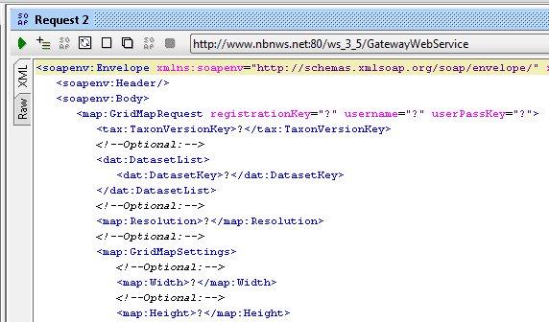

* 1. Now step through the edits you need to do:
     + - Put the registration key in:

<map:GridMapRequest registrationKey=**"a85d4c129728e58da6ed1b9af84632e15e2b5927"**>

* Add the species key:

<tax:TaxonVersionKey>**NHMSYS0000875473**</tax:TaxonVersionKey>

* Restrict it to a single dataset. Datasets can be reviewed at <http://data.nbn.org.uk> > Browse Datasets:

A

<dat:DatasetList>

<dat:DatasetKey>**GA000917**</dat:DatasetKey>

</dat:DatasetList>

* Display records as 2km squares (see Resolution on [http://data.nbn.org.uk/Documentation/Web_Services](http://data.nbn.org.uk/Web-Services-Documentation) > Grid Map):

<map:Resolution>**_2km**</map:Resolution>

* The vice county, square colour, Ordnance Survey background and image size are all assigned in the <GridMapSettings> as shown below. See [http://data.nbn.org.uk/Documentation/Web_Services](http://data.nbn.org.uk/Web-Services-Documentation) > Grid Map for more information.

<map:GridMapSettings>

<map:Width>**500**</map:Width>

<map:Height>**500**</map:Height>

<map:Background>**OSMap**</map:Background>

<map:ViceCounty>**58**</map:ViceCounty>

<map:FillColour>**#0000ff**</map:FillColour>

</map:GridMapSettings>

* Your final request should look like this:

<soapenv:Envelope xmlns:soapenv=**"http://schemas.xmlsoap.org/soap/envelope/"** xmlns:map=**"http://www.nbnws.net/Map"** xmlns:tax=**"http://www.nbnws.net/Taxon"** xmlns:dat=**"http://www.nbnws.net/Dataset"** xmlns:spat=**"http://www.nbnws.net/Spatial"** xmlns:sit=**"http://www.nbnws.net/SiteBoundary"**>

<soapenv:Header/>

<soapenv:Body>

<map:GridMapRequest registrationKey=**"a85d4c129728e58da6ed1b9af84632e15e2b5927"**>

<tax:TaxonVersionKey>**NHMSYS0000875473**</tax:TaxonVersionKey>

<dat:DatasetList>

<dat:DatasetKey>**GA000917**</dat:DatasetKey>

</dat:DatasetList>

<map:Resolution>**_2km**</map:Resolution>

<map:GridMapSettings>

<map:Width>**500**</map:Width>

<map:Height>**500**</map:Height>

<map:Background>**OSMap**</map:Background>

<map:ViceCounty>**58**</map:ViceCounty>

<map:FillColour>**#0000ff**</map:FillColour>

</map:GridMapSettings>

</map:GridMapRequest>

</soapenv:Body>

</soapenv:Envelope>

* Run it (small green arrow top left) and copy the url of the gif image from the results and view it in your browser. You should see an image like this:

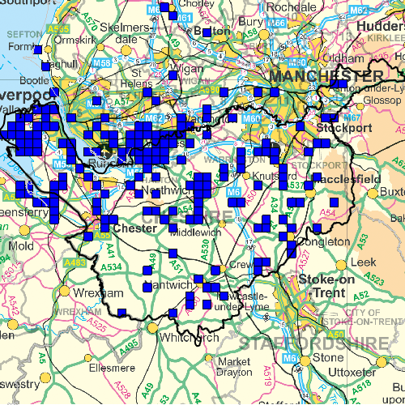

* 1. Prepare the request for adding to php, as described in Exercise 1 Step 3, it should look like this:

<map:GridMapRequest registrationKey=**"a85d4c129728e58da6ed1b9af84632e15e2b5927"** xmlns:map=**"http://www.nbnws.net/Map"** xmlns:tax=**"http://www.nbnws.net/Taxon"** xmlns:dat=**"http://www.nbnws.net/Dataset"** xmlns:spat=**"http://www.nbnws.net/Spatial"** xmlns:sit=**"http://www.nbnws.net/SiteBoundary"**>

<tax:TaxonVersionKey>**NHMSYS0000875473**</tax:TaxonVersionKey>

<dat:DatasetList>

<dat:DatasetKey>**GA000917**</dat:DatasetKey>

</dat:DatasetList>

<map:Resolution>**_2km**</map:Resolution>

<map:GridMapSettings>

<map:Width>**500**</map:Width>

<map:Height>**500**</map:Height>

<map:Background>**OSMap**</map:Background>

<map:ViceCounty>**58**</map:ViceCounty>

<map:FillColour>**#0000ff**</map:FillColour>

</map:GridMapSettings>

</map:GridMapRequest>

* 1. Copy and paste this request into your GridMap.php page from exercise 2 (<XAMPP installation dir>\htdocs\nbn\GridMap.php). The php code snippet should look like this:

//This is where the web service request should go

$gridMapQuery = '

<map:GridMapRequest registrationKey="a85d4c129728e58da6ed1b9af84632e15e2b5927" xmlns:map="http://www.nbnws.net/Map" xmlns:tax="http://www.nbnws.net/Taxon" xmlns:dat="http://www.nbnws.net/Dataset" xmlns:spat="http://www.nbnws.net/Spatial" xmlns:sit="http://www.nbnws.net/SiteBoundary">

<tax:TaxonVersionKey>NHMSYS0000875473</tax:TaxonVersionKey>

<dat:DatasetList>

<dat:DatasetKey>GA000917</dat:DatasetKey>

</dat:DatasetList>

<map:Resolution>_2km</map:Resolution>

<map:GridMapSettings>

<map:Width>500</map:Width>

<map:Height>500</map:Height>

<map:Background>OSMap</map:Background>

<map:ViceCounty>58</map:ViceCounty>

<map:FillColour>#0000ff</map:FillColour>

</map:GridMapSettings>

</map:GridMapRequest>

';

* 1. Save it and take a look a look at it: <http://localhost/nbn/GridMap.php>. Hopefully you will see this:

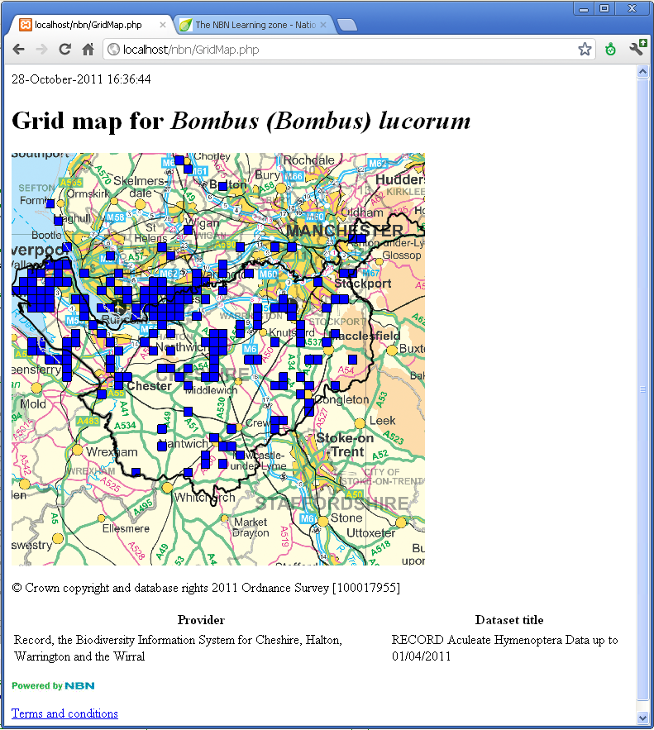

#### Exercise 4: Use Variable User Access key to send credentials to web service

The purpose of this exercise is to allow a username and password to be entered on the web page and sent to the web service. If the credentials match an NBN Gateway login then that user’s access to data is used, otherwise a SOAP fault is returned.

1. In Notepad++ open <XAMPP installation dir>\htdoxs\nbn\ GridMapLogin.php. This is our basic grid map example again and we are going to edit it to add credential handling. Comments are included in the code to show you where to add the snippets below.
2. Just beneath the body tag, add a form for collecting the username and password:

<!—Exercise 3: Add form for entering username and password-->

<form action=**"http://localhost/nbn/GridMapLogin.php"** method=**"post"**>

<p>**Username:** <input type=**"text"** name=**"username"** /></p>

<p>**Password:** <input type=**"password"** name=**"password"** /></p>

<p><input type=**"submit"** /></p>

</form>

1. Just before you create the xml request string, extract the username and password and prepare them for appending to the request. The attribute names used in the request are always ‘username’ and ‘userPassKey’, where the ‘userPassKey’ is an md5 hash of the password. In this example I simply create an empty string if no credentials are found, which will have no effect on the request (step 4):

//Exercise 3

//If a username and password have been entered then create a string

//ready for the request containing the password and hashed password

$username = (is_null($_POST['username']) ? '' : $_POST['username']);

$password = (is_null($_POST['password']) ? '' : $_POST['password']);

$hasCredentials = (($username != '') && ($password != ''));

$credentialsForQuery = '';

**if**($hasCredentials){

$credentialsForQuery = ' username="' . $username . '" userPassKey="' . md5($password) . '"';

}

1. Now alter your request so that it has a valid ‘variable user access’ registration key, and also has the credentials from step 3:

//Exercise 3: Extend the GridMapRequest to contain the credentials

//Note: the registrationKey MUST be a valid 'Variable user access' one

$gridMapQuery =

'<map:GridMapRequest registrationKey="b2918589cb31065453af08d75b9a6f5f7c632bca"

' . $credentialsForQuery . '

xmlns:map="http://www.nbnws.net/Map"

xmlns:tax="http://www.nbnws.net/Taxon"

xmlns:dat="http://www.nbnws.net/Dataset"

xmlns:spat="http://www.nbnws.net/Spatial"

xmlns:sit="http://www.nbnws.net/SiteBoundary">

<tax:TaxonVersionKey>NBNSYS0000005629</tax:TaxonVersionKey>

</map:GridMapRequest>';

1. In Chrome you should see the page shown below. If you don’t put any credentials in it will still work, but you will only have access to publicly available data. If you have an NBN Gateway login you can add that to get your enhanced access to data.

#### 

#### Exercise 5: Interactive site selection and species lists

The purpose of this exercise is to show some of the web services other than the Grid Map that are available to you and to illustrate how they can be used together. It shows how you can present a list of sites and view a report for each one. The list of sites is for a specific category (National Trust for Scotland), the exercise will change this to a different category (Special Areas of Conservation) to illustrate how to find the different keys you need.

1. In Chrome go to [http://localhost/nbn/SiteReport.php](http://localhost/nbn/exercise5.php). You should see the basic web page shown below. It shows a list of properties from the National Trust for Scotland on the left. When a property is selected and submitted, a report is shown on the right with a map, species list and the data providers.

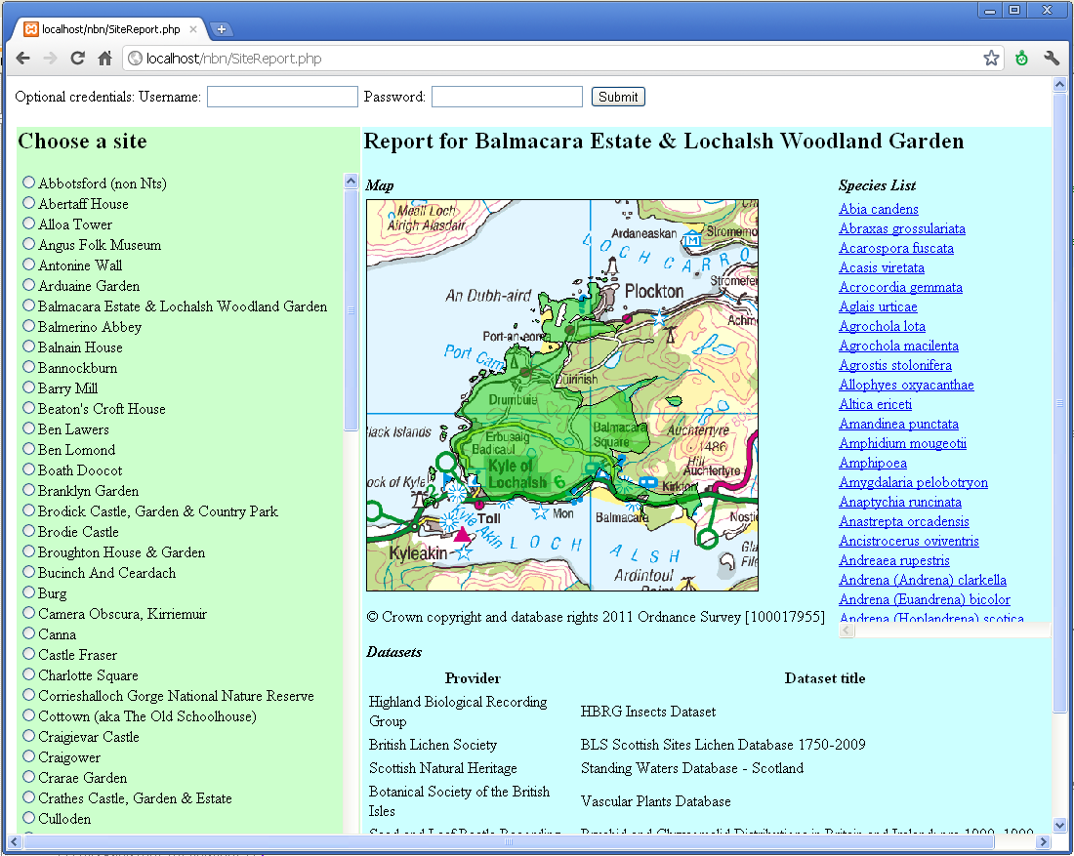

1. Open the source code <XAMPP installation dir>\htdocs\nbn\SiteReport.php in Notepad++. Notice that it uses these three web services:
   * Species List (look for $SpeciesListQuery)
   * Site Boundary List (look for $SpeciesListQuery)
   * Site Boundary Name (look for $SiteBoundaryNameRequest)
2. The list of sites displayed is for the National Trust for Scotland. This is controlled by the SiteBoundaryType key in the Site Boundary List web service. The list of available keys can be found at [http://data.nbn.org.uk/Documentation/Web_Services](http://data.nbn.org.uk/Web-Services-Documentation) > Site Boundary List. Try changing it to a site list for a different site type (eg National Nature Reserves) by making the following two changes:
   * 1. Change the site type key, find the following:

$SiteBoundaryType='NTS';

and change it to:

$SiteBoundaryType='NNR';

* + Add a default NNR site for the first visit to the page. (**Note:** sites can be reviewed by going to <http://data.nbn.org.uk> > Browse Datasets > All Geographical Datasets > National Nature Reserves in England). Find the following:

$ProviderKey = 'GA000505';

$SiteKey = 'BAL';

and change it to:

$ProviderKey = 'GA000337';

$SiteKey = '1006001';

Refresh your page ([http://localhost/nbn/SiteReport.php](http://localhost/nbn/exercise5.php)), it should look like this:

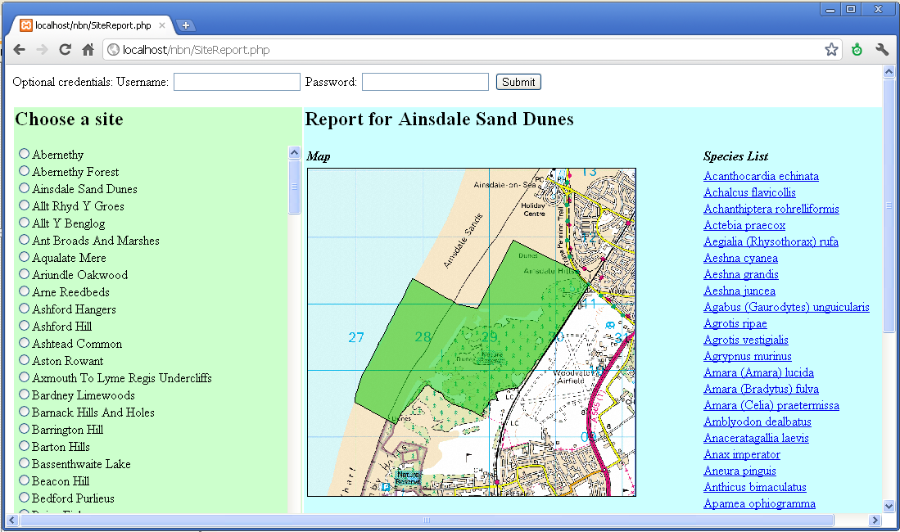

#### Exercise 6: Adding the NBN WMS to a GIS system

The purpose of this exercise is to demonstrate how to add an NBN WMS to a GIS system. The GIS system we are using is Quantum GIS, which is freely available from [www.qgis.org](http://www.qgis.org). We will add a geology WMS provided by the British Geological Society and then overlay species records from the NBN Gateway. The species we will map is the Dark Bush Cricket (NHMSYS0001387435).

1. Open Quantum GIS: Start > Quantum GIS
2. Set the projection system to British National Grid:
   1. Settings > Project properties...
   2. In the Project Properties dialog:
      * Search for ‘British National Grid’ (red circle below)
      * Make sure you have ‘Search for Name’ (red circle below)
      * Select ‘OSGB 1936 / British National Grid’ (red arrow below) and then OK:

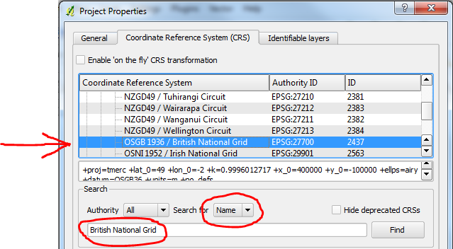

1. Add the Bedrock WMS from the British Geological Society:
   1. Go to ‘Add Layer(s) from a Server’ dialog: Layer > WMS Layer...

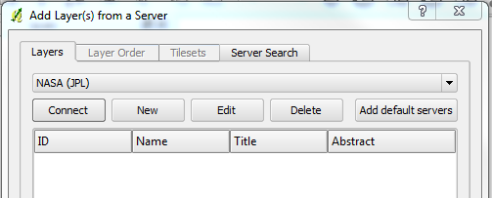

* 1. Press New and in ‘Create a new WMS Connection’ dialog enter the WMS information:
     + - Name = BGS data
       - URL = http://ogc.bgs.ac.uk/cgi-bin/BGS_Bedrock_and_Superficial_Geology/wms?
       - OK

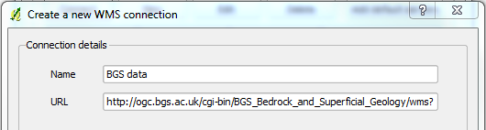

* 1. Back in the ‘Add Layer(s) from a Server’ dialog connect to the WMS you’ve just added and select a layer, like this:
     + In drop down, select ‘BGS data’ (red circle below)
     + Press ‘Connect’ button to populate the list of layers
     + Select the Bedrock Lithology layer (red arrow below), then Add and finally Close.

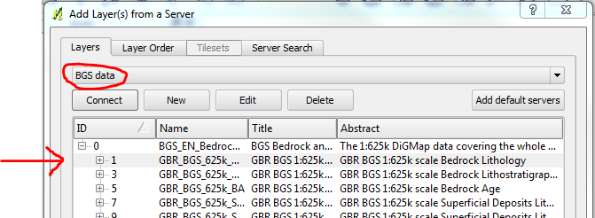

* 1. You should see BGS’s Bedrock map like this:

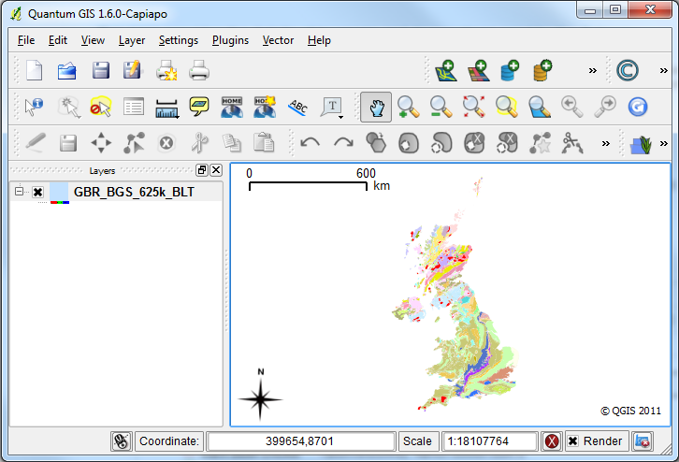

1. Now to add Dark Bush-cricket records from the NBN. It is exactly the same as adding the BGS Bedrock data above (Step 3.), but with these changes:
   1. In step 3.b. use this WMS information:
      * Name = Dark Bush-cricket
      * url =

http://gis.nbn.org.uk/arcgis/rest/services/grids/SingleSpeciesMap/NHMSYS0001387435/WMSServer?

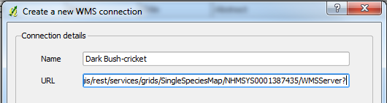

* 1. In step 3.c. choose ‘Dark Bush-cricket’ in the drop down. After pressing ‘Connect’ you should see the list of layers shown below (just press OK if you get any warnings about WMS Provider). Then, one-by-one add the 3 layers arrowed below (TenKM, OneKM and HundredM):

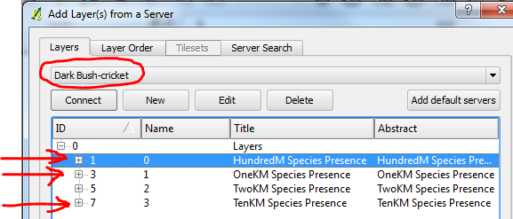

* 1. To make it clearer you can rename the layers to the left of your map (right click on layer and choose Rename):

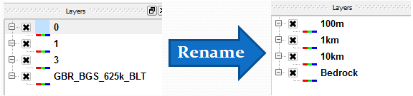

* 1. Finally, make sure they appear in the order shown above, with the 100m on top and Bedrock on bottom (drag and drop if they need re-ordering). This ensures layers are not obscured by others.
  2. You should have a map that looks something like this:

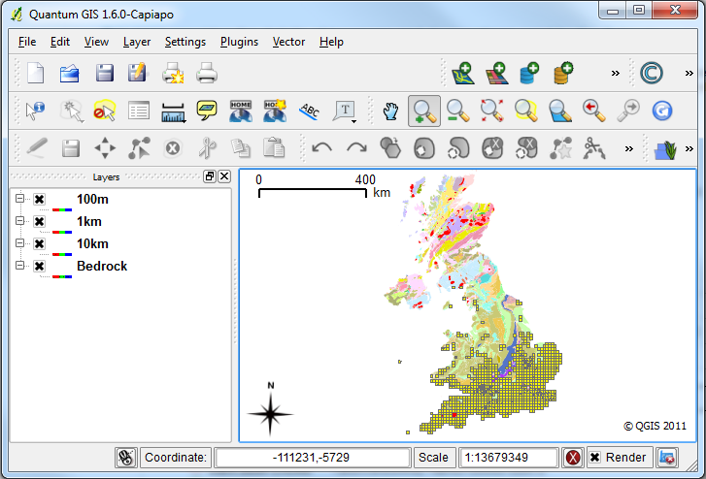

* 1. You can now explore Dark Bush-cricket records with respect Bedrock. The diagram below highlights the main navigation tools to help you move around and turn layers on and off.

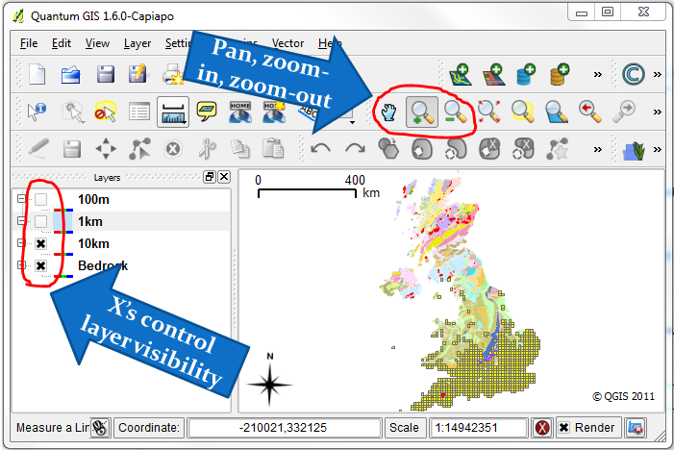

* 1. Here is an example of the 1km layer around the Bristol region:

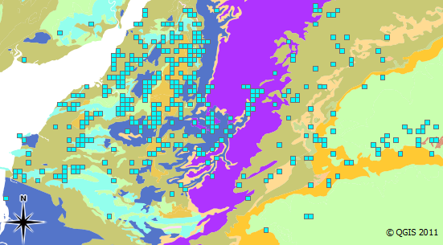

#### Exercise 7: Species list for a dataset and adding to grid map

The purpose of this exercise is to introduce the Species List web service. In this example a species list will be generated for a single dataset. This will then be integrated into the grid map example to provide a selectable list of species maps.

1. Open soapUI and look at the request for GetSpeciesList. Edit it so that it just provides a list of species in the Dragonfly Recorder Network dataset (datasetKey = GA000012). Note: just use the registration key that gives you public access (a85d4c129728e58da6ed1b9af84632e15e2b5927). You should end up with a request that looks like this:

<soapenv:Envelope

xmlns:soapenv=**"http://schemas.xmlsoap.org/soap/envelope/"**

xmlns:tax=**"http://www.nbnws.net/Taxon"**

xmlns:spat=**"http://www.nbnws.net/Spatial"**

xmlns:sit=**"http://www.nbnws.net/SiteBoundary"**

xmlns:map=**"http://www.nbnws.net/Map"**

xmlns:dat=**"http://www.nbnws.net/Dataset"**

xmlns:tax1=**"http://www.nbnws.net/TaxonReportingCategory"**>

<soapenv:Header/>

<soapenv:Body>

<tax:SpeciesListRequest registrationKey=**"a85d4c129728e58da6ed1b9af84632e15e2b5927"**>

<dat:DatasetList>

<dat:DatasetKey>**GA000012**</dat:DatasetKey>

</dat:DatasetList>

</tax:SpeciesListRequest>

</soapenv:Body>

</soapenv:Envelope>

1. Having got that request working, now open <XAMPP installation directory>\htdocs\nbn\SpeciesList.php. Each comment in the code indicates what you need to add to make the page produce a species list. Try working through it and getting it displaying a species list for your request. This is what the web page should look like:

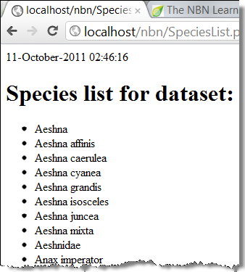

And my working php code looks like this:

<html>

<head>

</head>

<body>

<?php

**print**(date("d-F-Y H:i:s"));

error_reporting(0);

**require_once**('../lib/nusoap.php');

$client = **new** nusoap_client('http://www.nbnws.net/ws_3_5/GatewayWebService?wsdl',**true**);

**if**($client->fault){

**echo** "FAULT: <p>Code: {$client->faultcode} >br />";

**echo** "String: {$client->faultstring} </p>";

}

//Paste your edited species list request from soapUI

$speciesListQuery =

'<tax:SpeciesListRequest

registrationKey="a85d4c129728e58da6ed1b9af84632e15e2b5927"

xmlns:tax="http://www.nbnws.net/Taxon"

xmlns:spat="http://www.nbnws.net/Spatial"

xmlns:sit="http://www.nbnws.net/SiteBoundary"

xmlns:map="http://www.nbnws.net/Map"

xmlns:dat="http://www.nbnws.net/Dataset"

xmlns:tax1="http://www.nbnws.net/TaxonReportingCategory">

<dat:DatasetList>

<dat:DatasetKey>GA000012</dat:DatasetKey>

</dat:DatasetList>

</tax:SpeciesListRequest>

';

//Add the name of the web service (see list of web services in soapUI navigator)

$response = $client->call('GetSpeciesList', $speciesListQuery);

//Extract the information from the response that we need for our web page

//See http://www.nbn.org.uk/Guidebooks/Documentation/Web_Services/the-Web_Services/Species-List/response.aspx for info. on how the response is structured

$SpeciesList = $response['SpeciesList'];

$DatasetTitle = $response['DatasetSummaryList']['DatasetSummary']['ProviderMetadata']['DatasetTitle'];

?>

<!--Add a heading to the page, naming the dataset this species list is from-->

<h1>**Species list for dataset:** <?php **print** $DatasetTitle ?></h1>

<!--Iterate through the species list and display their scientific name-->

<ul>

<?php

**foreach**($SpeciesList['Species'] **as** $Species){

**print** '<li>' . $Species['ScientificName'] . '</li>';

}

?>

</ul>

</body>

</html>

1. *If there is time to spare* you could try integrating the species list into the grid map from exercise 2. You are aiming to have a selectable list of species that changes what is displayed in the map. It will look something like this:

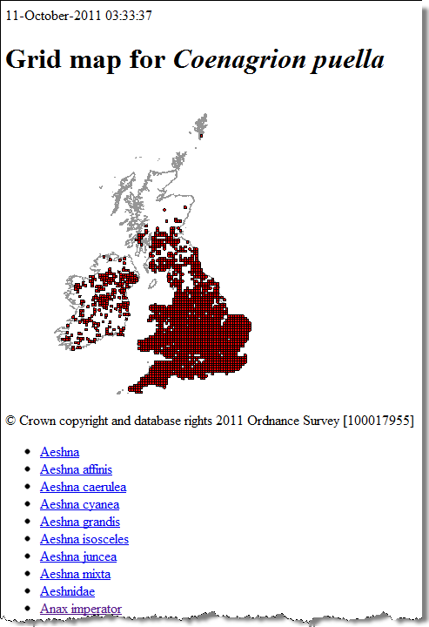

And here is the code from my working example:

<html><head></head><body>

<?php

**print**(date("d-F-Y H:i:s"));

error_reporting(1);

**require_once**('../lib/nusoap.php');

$client = **new** nusoap_client('http://www.nbnws.net/ws_3_5/GatewayWebService?wsdl',**true**);

**if**($client->fault){

**echo** "FAULT: <p>Code: {$client->faultcode} >br />";

**echo** "String: {$client->faultstring} </p>";

}

//Get the species key, if there isn't one then default to the Norfolk Hawker (NBNSYS0000005629)

$taxonkey = (is_null($_GET['taxonkey']) ? 'NBNSYS0000005629' : $_GET['taxonkey']);

//Do the grid map

$gridMapQuery =

'<map:GridMapRequest registrationKey="a85d4c129728e58da6ed1b9af84632e15e2b5927"

xmlns:map="http://www.nbnws.net/Map"

xmlns:tax="http://www.nbnws.net/Taxon"

xmlns:dat="http://www.nbnws.net/Dataset"

xmlns:spat="http://www.nbnws.net/Spatial"

xmlns:sit="http://www.nbnws.net/SiteBoundary">

<tax:TaxonVersionKey>' . $taxonkey . '</tax:TaxonVersionKey>

<dat:DatasetList>

<dat:DatasetKey>GA000012</dat:DatasetKey>

</dat:DatasetList>

</map:GridMapRequest>';

$gridMapResponse = $client->call('GetGridMap', $gridMapQuery);

$Map = $gridMapResponse['Map'];

$MapUrl = $Map['Url'];

$Species = $gridMapResponse['Species'];

$SpeciesName = $Species['ScientificName'];

$DatasetSummaryList = $gridMapResponse['DatasetSummaryList'];

$NBNLogo = $gridMapResponse['!NBNLogo'];

$TermsAndConditions = $gridMapResponse['!TermsAndConditions'];

//Do the species list query

$speciesListQuery = '<tax:SpeciesListRequest

registrationKey="a85d4c129728e58da6ed1b9af84632e15e2b5927"

xmlns:tax="http://www.nbnws.net/Taxon"

xmlns:spat="http://www.nbnws.net/Spatial"

xmlns:sit="http://www.nbnws.net/SiteBoundary"

xmlns:map="http://www.nbnws.net/Map"

xmlns:dat="http://www.nbnws.net/Dataset"

xmlns:tax1="http://www.nbnws.net/TaxonReportingCategory">

<dat:DatasetList>

<dat:DatasetKey>GA000012</dat:DatasetKey>

</dat:DatasetList>

</tax:SpeciesListRequest>';

$speciesListResponse = $client->call('GetSpeciesList', $speciesListQuery);

$SpeciesList = $speciesListResponse['SpeciesList'];

$DatasetTitle = $speciesListResponse['DatasetSummaryList']['DatasetSummary']['ProviderMetadata']['DatasetTitle'];

?>

<h1>**Grid map for** <i><?php **print** $SpeciesName; ?></i></h1>

<div>

<img src=**"**<?php **print** $MapUrl; ?>**"** />

<p>&copy; **Crown copyright and database rights 2011 Ordnance Survey [100017955]**</p>

</div>

<ul>

<?php

**foreach**($SpeciesList['Species'] **as** $Species){

**print** '<li><a href="/nbn/SpeciesList.php?taxonkey=' . $Species['!taxonVersionKey'] . '">' . $Species['ScientificName'] . '</a></li>';

}

?>

</ul>

<table>

<tr><th>**Provider**</th><th>**Dataset title**</th></tr>

<?php

**if** (**isset**($DatasetSummaryList['DatasetSummary'][0])) {

**foreach** ($DatasetSummaryList['DatasetSummary'] **as** $DatasetSummary) {

$ProviderMetadata = $DatasetSummary['ProviderMetadata'];

**print** '<tr><td>'.$ProviderMetadata['DatasetProvider'].'</td>';

**print** '<td>'.$ProviderMetadata['DatasetTitle'].'</td></tr>';

}

} **else** {

$DatasetSummary = $DatasetSummaryList['DatasetSummary'];

$ProviderMetadata = $DatasetSummary['ProviderMetadata'];

**print** '<tr><td>'.$ProviderMetadata['DatasetProvider'].'</td>';

**print** '<td>'.$ProviderMetadata['DatasetTitle'].'</td></tr>';

}

?>

</table>

<p><a href=**"http://data.nbn.org.uk"**><img src=**"**<?php **print** $NBNLogo ?>**"**/></a></p>

<p><a href=**"**<?php **print** $TermsAndConditions ?>**"**>**Terms and conditions**</a></p>

</body></html**>**

#### Exercise 8: The taxonomic search web service

The purpose of this exercise is to demonstrate how to search for species and display taxonomic information for them.

1. Open soapUI and create a working GetTaxonomySearch query that uses the SearchTerm element
2. In Notepad++ create the file <XAMPP installation dir>\htdocs\nbn\TaxonomySearch.php
3. Using previous examples to help you, write a php page that uses your query from step 1. One solution is shown below:

<html>

<head>

</head>

<body>

<?php **print**(date("d-F-Y H:i:s")); ?>

<form action=**"http://localhost/nbn/TaxonomySearch.php"** method=**"post"**>

<p>**Enter search term:** <input type=**"text"** name=**"term"** /></p>

<p><input type=**"submit"** /></p>

</form>

<?php

error_reporting(1);

**require_once**('../lib/nusoap.php');

$client = **new** nusoap_client('http://www.nbnws.net/ws_3_5/GatewayWebService?wsdl',**true**);

**if**($client->fault){

**echo** "FAULT: <p>Code: {$client->faultcode} >br />";

**echo** "String: {$client->faultstring} </p>";

}

//Get the search term

$term = (is_null($_POST['term']) ? '' : $_POST['term']);

$taxonomySearchQuery =

'<tax:TaxonomySearchRequest

registrationKey="a85d4c129728e58da6ed1b9af84632e15e2b5927"

xmlns:tax="http://www.nbnws.net/Taxon/Taxonomy"

xmlns:tax1="http://www.nbnws.net/Taxon">

<tax:SearchTerm>' . $term . '</tax:SearchTerm>

</tax:TaxonomySearchRequest>';

$response = $client->call('GetTaxonomySearch', $taxonomySearchQuery);

$nothingFound = ($response['Taxa'] == '');

**if**($nothingFound){

**print** '<p>Nothing found, please try again</p>';

}**else**{

**print** '<table><tr><th>Name</th><th>Authority</th><th>Taxon version key</th>';

**if** (**isset**($response['Taxa']['Taxon'][0])) {

**foreach**($response['Taxa']['Taxon'] **as** $taxon){

**print** '<tr><td>' . $taxon['TaxonName']['!'] . '</td><td>' . $taxon['Authority'] . '</td><td>' . $taxon['TaxonVersionKey'] . '</td></tr>';

}

}**else**{

$taxon = $response['Taxa']['Taxon'];

**print** '<tr><td>' . $taxon['TaxonName']['!'] . '</td><td>' . $taxon['Authority'] . '</td><td>' . $taxon['TaxonVersionKey'] . '</td></tr>';

}

**print** '</table>';

}

?>

</body>

</html**>**

This produces a web page that looks like this:

