Josh Cheng

Hill Trackr

**Summary**

Hill Trackr is a hands free driving app that is designed to self-plot hills and banks while the user is driving. The original purpose of the app was for the 4x4 and off-road market, serving as a useful tool to find, plot and share obstacles with other drivers. However, it is not limited to just off-roaders, and can be a useful took for cyclist and other activities that require hands free GPS plotting of hills and banks.

**Features**

Hill Trackr allows users to mount their mobile device in any position while maintaining its functionality. This is accomplished by having the users start the tracking once the device is set in place and pressing the “Set Orientation” button **(Image 1)**.

Users can place “Markers” on the map by tilting the phone (front/back) or by rotating the phone (left/right). These events will each place a marker on the map **(Image 3)**. To avoid repeated plotting, the phone must return to past +/- 20 degrees from the pre-set zero of the plotted angle. The markers are saved in a database and are accessible by any user on the site. This allows for users to share all of their plots with each other. If a user plots a “Marker” by accident, they can tap the marker and press remove to delete the marker from the database **(Image 4)**.

Secondary functions that the app can do include showing the current speed of the device, current altitude, and current direction. These are all dependent on the hardware in the device, if the device does not have the proper hardware, such as a compass or an altimeter, the display will be null.

**Custom Application Logic**

Custom logic implemented includes a function that plots the markers (**Figure 1**). This function also stops the markers from being constantly plotted in the same location by changing the value of angle1 once a marker has been plotted. To plot another marker, the device must be rotated a majority of the way back to its pre-set position.

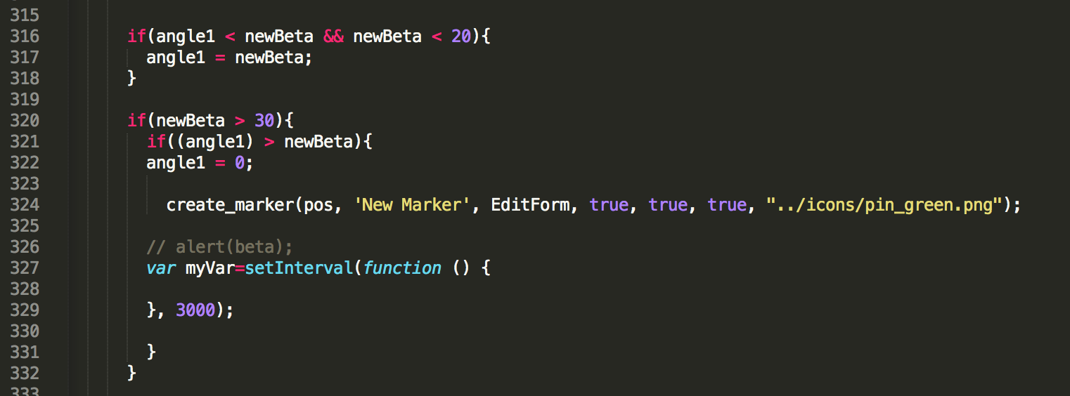**Figure 1. Markers are only plotted once per hill/bank to avoid multiple markers for the same location.**

Another piece of custom logic implemented is a function that allows users to set the orientation of the device that the app will begin at (**Figure 2**). This function reads the current orientation of the phone and converts it to zero (+/-5) **(Image 2)**. This allows users to mount the phone in any position of their choosing. This is accomplished by creating a Boolean that stops the function from cycling through different values as the orientation of the device changes (Figure 3).

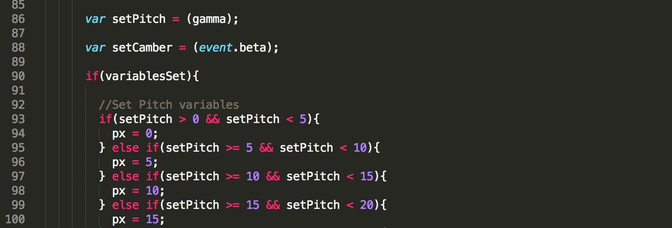

**Figure 2. If variablesSet is true, px/py equals the negative of the current angle but can still be changed.**

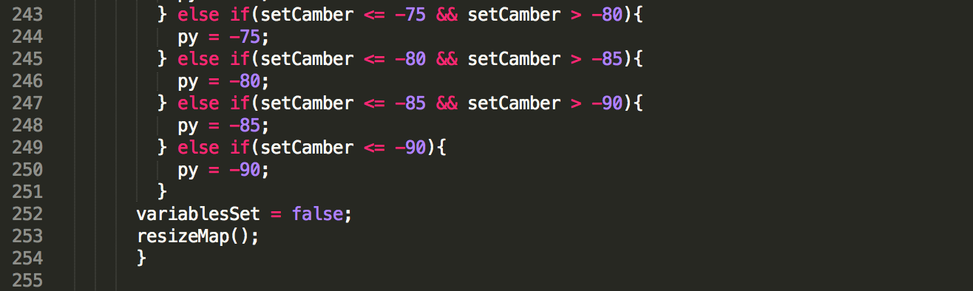

**Figure 3. Once variablesSet is false, px/py equals the angle that the device was at when the button was pressed and cannot be changed.**

**Summary of UX**

The UX that works includes having a majority hands-free hill-plotting app. This is due to relaying solely on the devices’ hardware (such as gyroscope or accelerometer). The only part that requires the user to touch the phone is the initial screen where the user sets the starting orientation of the device and when the user needs to delete a marker. One of the problems with the UX is that the app only works while the phone is in the landscape position with the top of the phone to the left. This can be troublesome to users who are used to having their phone in a portrait position. To solve this, a function to determine the phones position is under construction. This will allow for users to position the phone in any viewing mode and still allow for all of the features of the app to function.

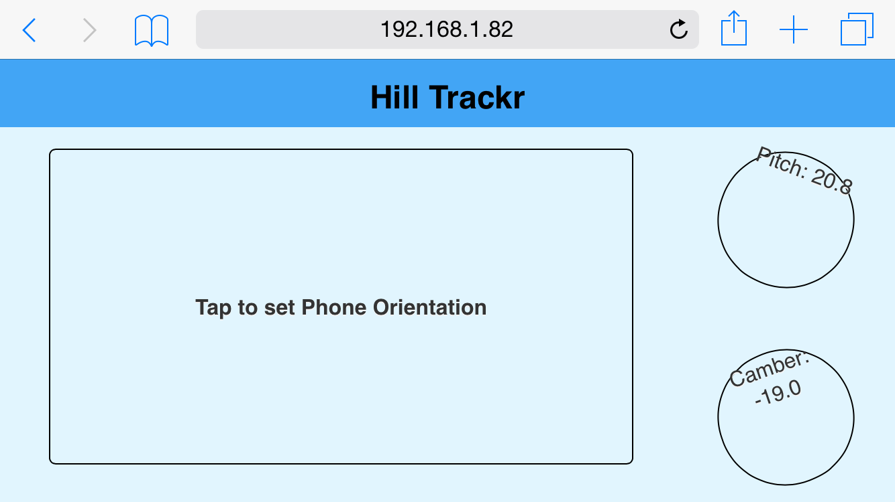

**Image 1. Home screen where users can select what angle to mount their device.**

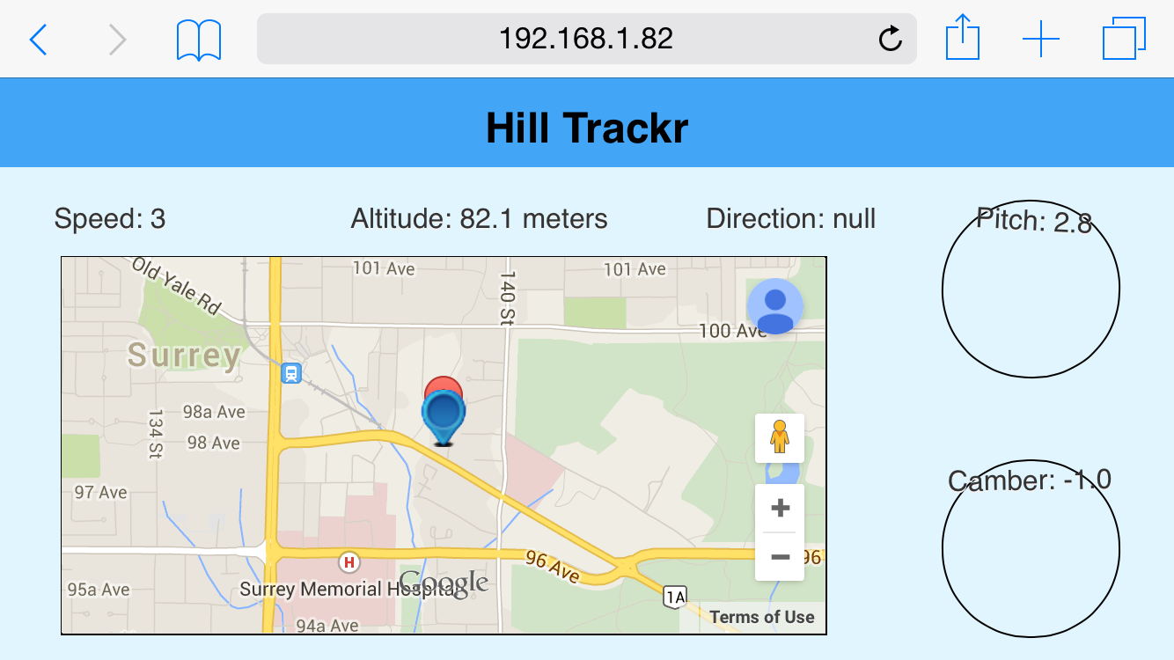

**Image 2. Screen that the users are taken too once they set the angle of their device. Note the angle has returned to zero (+/- 5).**

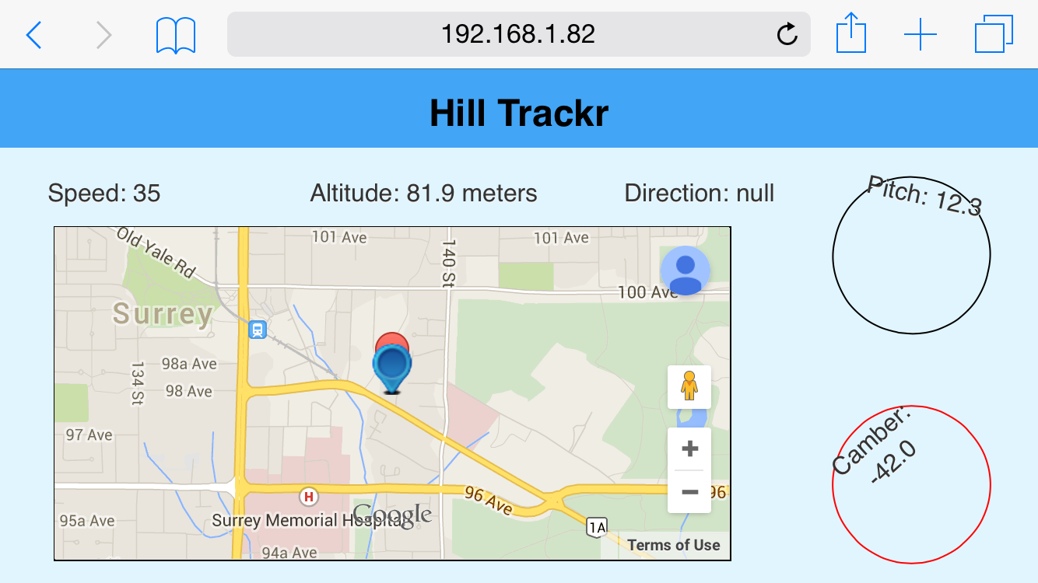

**Image 3. The angle on the device has exceeded 30 degrees and has plotted a marker at the current location.**

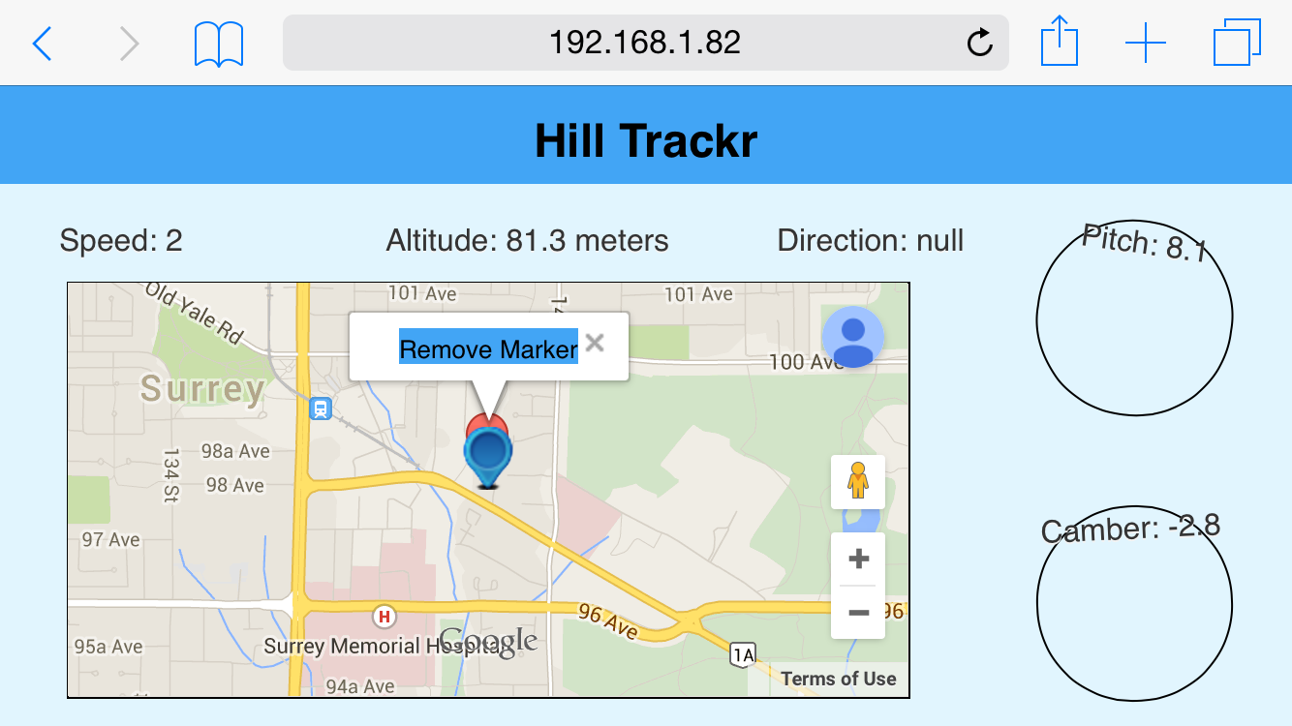

**Image 4. The user tapped the marker and a “Remove Marker” button has appeared.**