



e-Commerce Database for Forty4 Fitness

Jake Conard

Syracuse University

**Table of Contents**

Summary………………………………………………………………………………………………………………………3

Stakeholders…………………………………………………………………………………………………………………3

Business Rules………………………………………………………………………………………………………………4

Glossary…………………………………......…………………………………………………………………………………4

Data Questions………………………………………………………………………………………………………………5

Conceptual Model…………………………………….……………………………………………………………………6

Logical Model…………………………………………………………………………………………..……………………7

SQL Data Definition Language [Creating Tables]………………………………………………………….…8

SQL Data Manipulation Language [Inserting Data]………………………………………………………...10

Answering Data Questions with SELECT Statements and VIEWS……………………………………13

User Interface Design…………………………………………………………………………………………………..16

Process Reflections………………………………………………………………………………………………………17

**Summary**

Forty4 Fitness started selling strength and conditioning workout equipment for high intensity interval training made of functional movements in 2018. The company was started in the owner’s garage and did not require a large database to handle the e-commerce transactions due to the small number of clients and equipment purchases. The owner kept track of the customers, payment information, and all the products in a spreadsheet that they kept on their laptop. Due to substantial company growth in 2019, the owner realized that they needed a more robust e-commerce database to keep track of customers, their payment information, the purchases, and the strength and conditioning products. Due to the company growth the Forty4 Fitness ownership team added a sales staff and a webpage to allow customers to order equipment online. The Forty4 Fitness team reached out the Syracuse University iSchool for assistance in the creation of their database and provided a list of requirements and data questions that they would like the database to help them answer.

**Stakeholders**

Forty4 Fitness is a small family-owned company with only ten employees. The key stakeholders are the Forty4 Fitness Chief Executive Officer and the Forty4Fitness Chief Operating Officer. Additionally, based on the company growth Forty4 Fitness also has a sales team that is responsible for customer outreach and selling the strength and conditioning workout equipment. The stakeholders were interviewed over a three-week period to document the business rules and the data questions that they would most liked answer from the new relational database model.

**Business Rules**

1. A CUSTOMER places a PURCHASE_ORDERS for PRODUCTS
2. A PURCHASE_ORDER includes one or more PRODUCTS
3. A CUSTOMER has one or more PAYMENT_INFORMATION
4. A PURCHASE_ORDER is attributed to one SALES_PERSON
5. A CUSTOMER can place many PURCHASE_ORDERS
6. A PAYMENT_INFORMATION is associated to one or more CUSTOMERS
7. A CUSTOMER must have a name, address, phone number, and email address to make a purchase.
8. The PAYMENT_INFORMATION must include the following credit card number, expiration date, card verification value (CVV), billing address (that may or may not be the same as the customer shipping address), and the card type.
9. The PRODUCTS must include a product number and a detailed description of the product.
10. The PURCHASE_ODER must include a purchase order number, the date of the order, and the final amount of the order.

**Glossary**

* Customer – Someone that makes a purchase on the Forty4 Fitness website.
* Purchase Order – A list of products purchased by a customer on a given date.
* Product – An item sold on the Forty4 Fitness website.
* Salesperson – Member of the Forty4 sales team that assisted or is attributed to the purchase order.
* Payment Information – Credit or Debit Card number used for purchase. Depending on growth may expand to supporting PayPal or other purchasing options.

**Data Questions**

The data questions that Forty4 Fitness wants to answer from the addition of the new database:

1. What is the total number of purchase orders and the max, avg, min sale?
2. What is the largest sales month?
3. What is the best-selling product?
4. Who is the top salesperson?
5. What is the best weekday for sales?

**Conceptual Model**

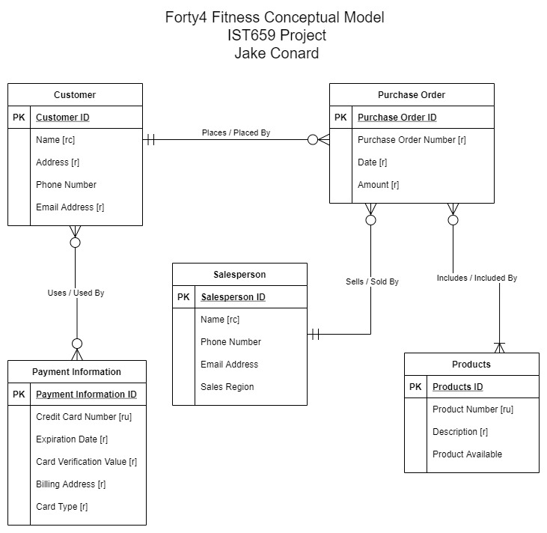

**Logical Model**

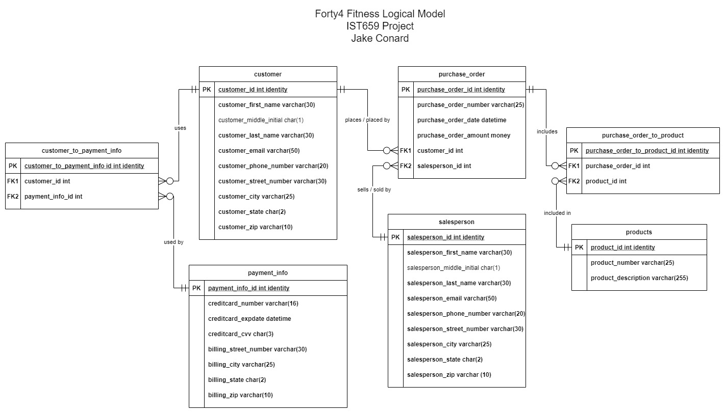

**Part II**

**SQL Data Definition Language [Create Tables]**

* Create Customer Table
  + 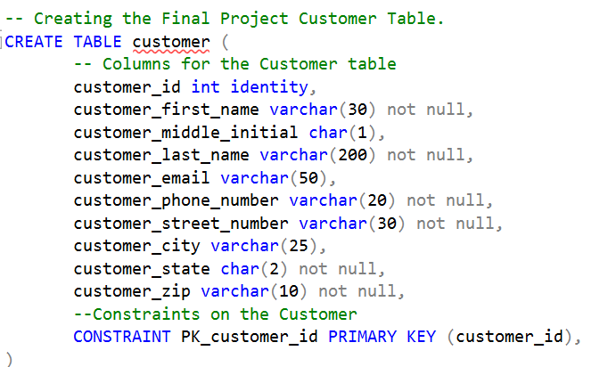
* Create the Payment Info Table
  + 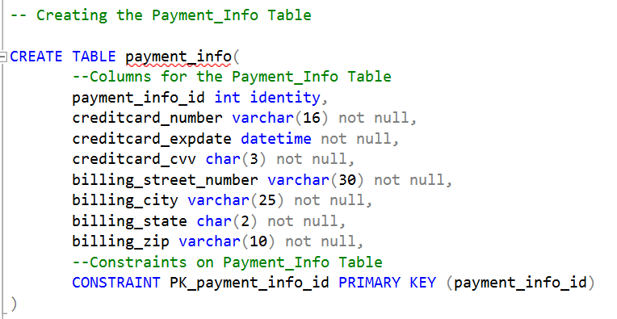
* Create the Customer to Payment Info Bridge Table
  + 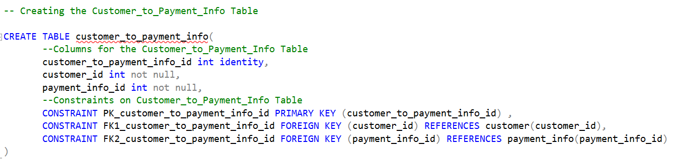
* Create the Products Table
  + 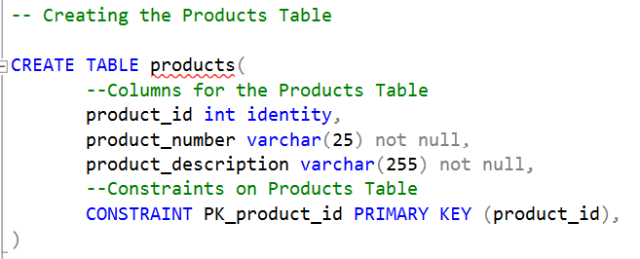
* Create the Salesperson Table
  + 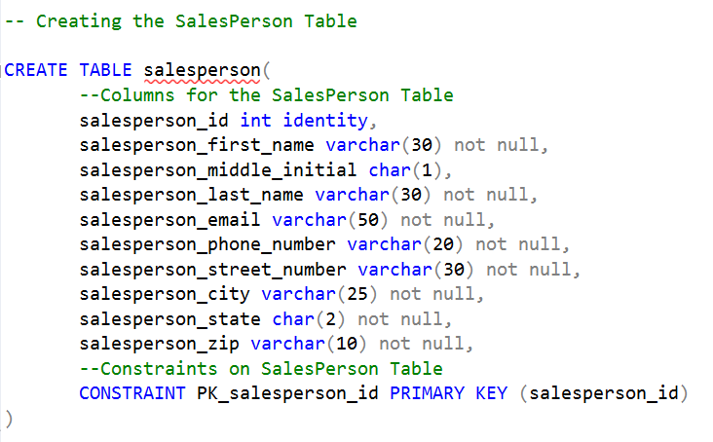
* Create the Purchase Order Table
  + 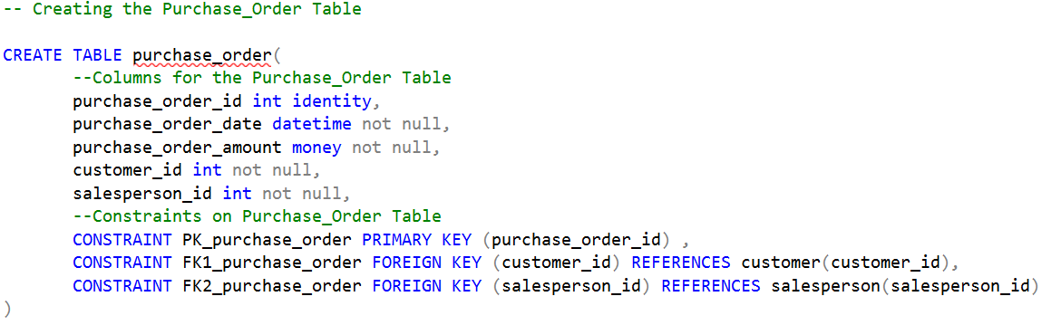
* Create the Purchase Order to Product Bridge Table
  + 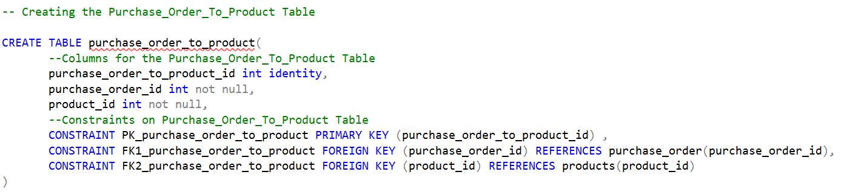

**SQL Data Manipulation Language [Inserting Data]**

* Adding Data to the Customer Table
  + 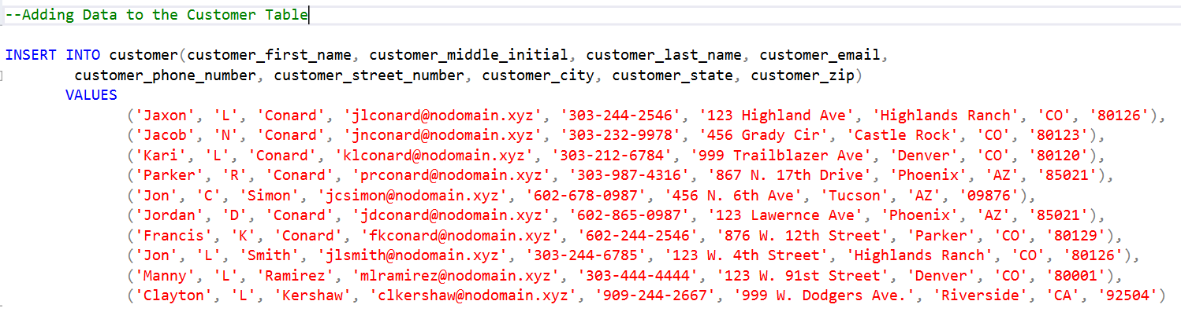
* Adding Data to the Payment Info Table
  + 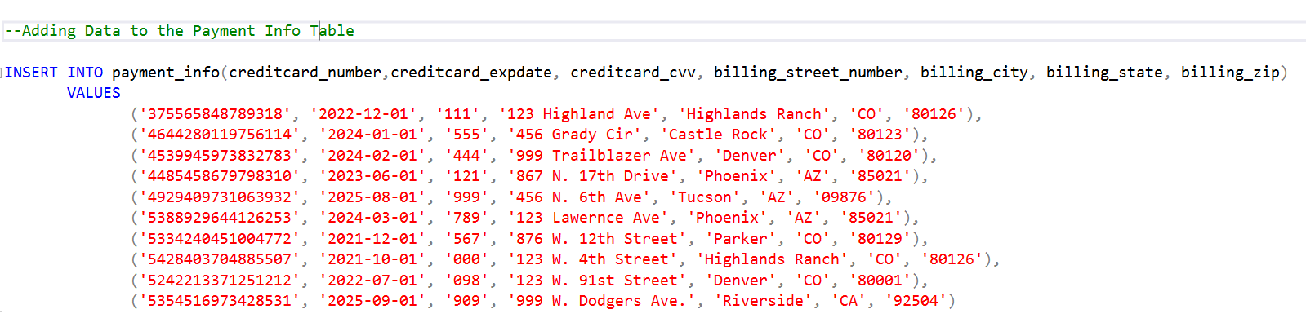
* Adding Data to the Salesperson Table
  + 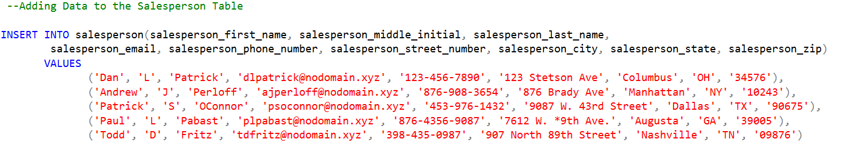
* Adding Data to the Products Table
  + 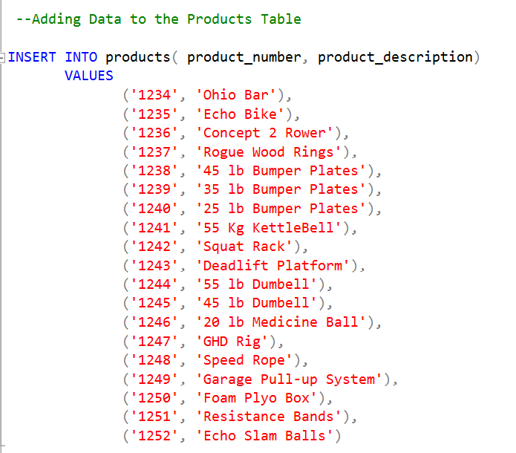
* Adding Data to the Customer to Payment Info Bridge Table
  + 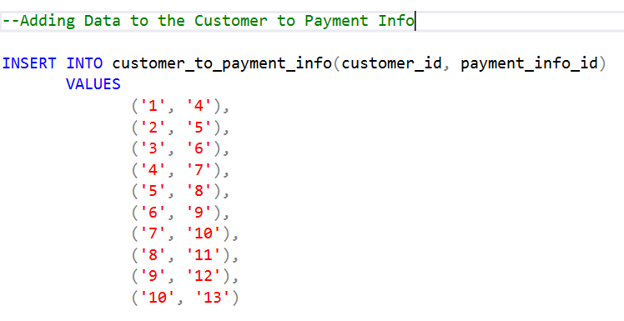
* Adding Data to the Purchase Order Table (and adding a column I forgot in the initial add)
  + 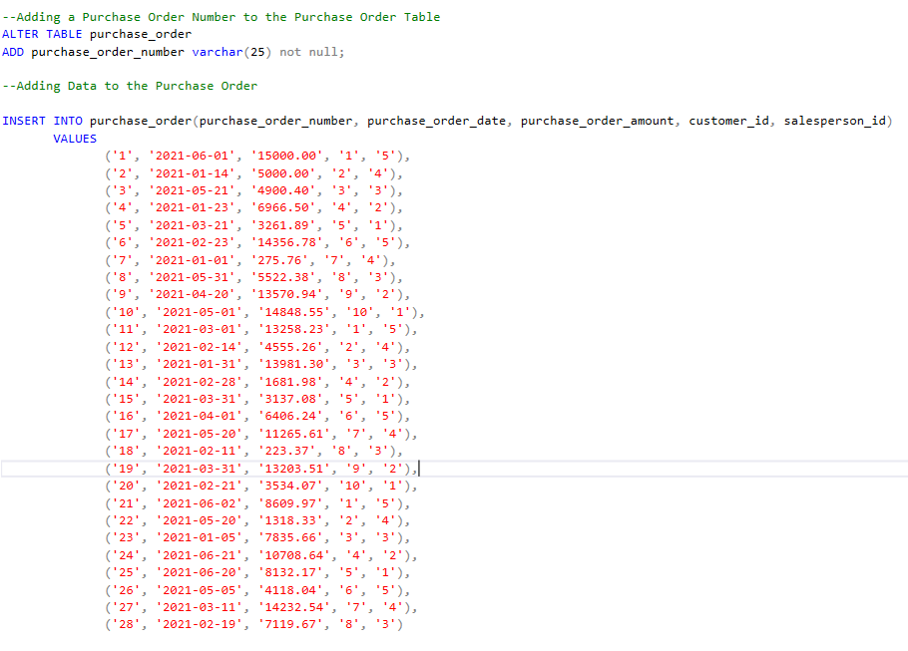
* Adding Data to the Purchase Order to Product Bridge Table (could not capture all the data)
  + 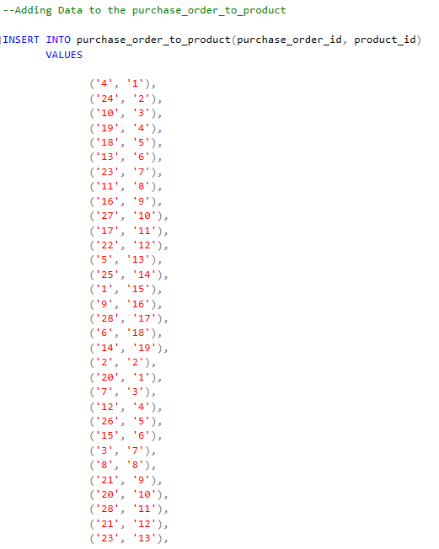

**Answering Data Questions with SELECT Statements and VIEWS**

* What is the total number of purchase orders and the max, avg, min sale?
  + 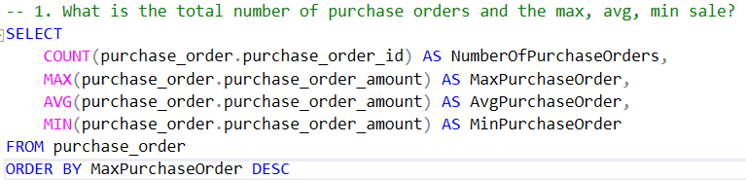
  + 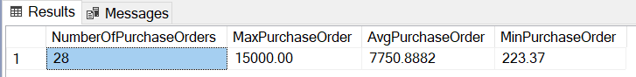
* What is the largest sales month?
  + 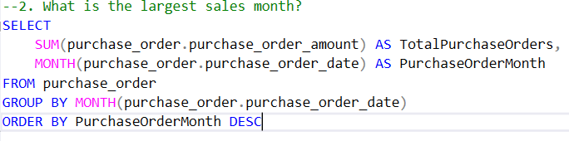
  + 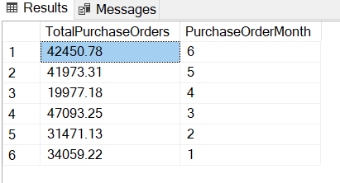
* What is the best-selling product?
  + 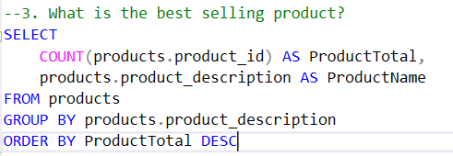
  + 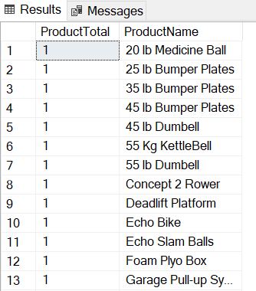
* Who is the top salesperson? [VIEW]
  + 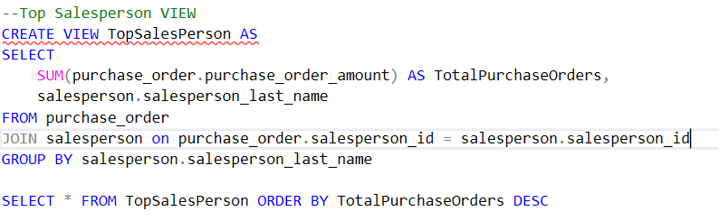
  + 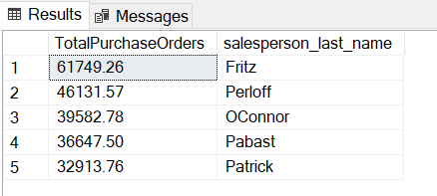
* What is the best weekday for sales? [VIEW]
  + 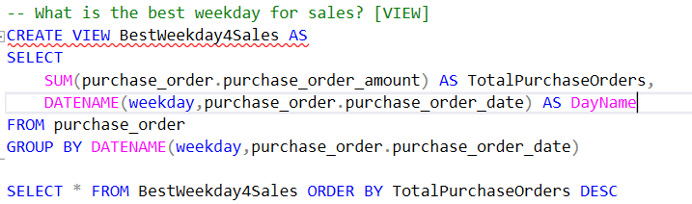
  + 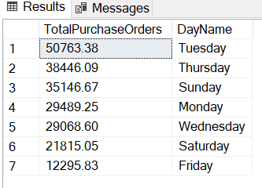

**User Interface Design**

* Purchase Order Input
  + 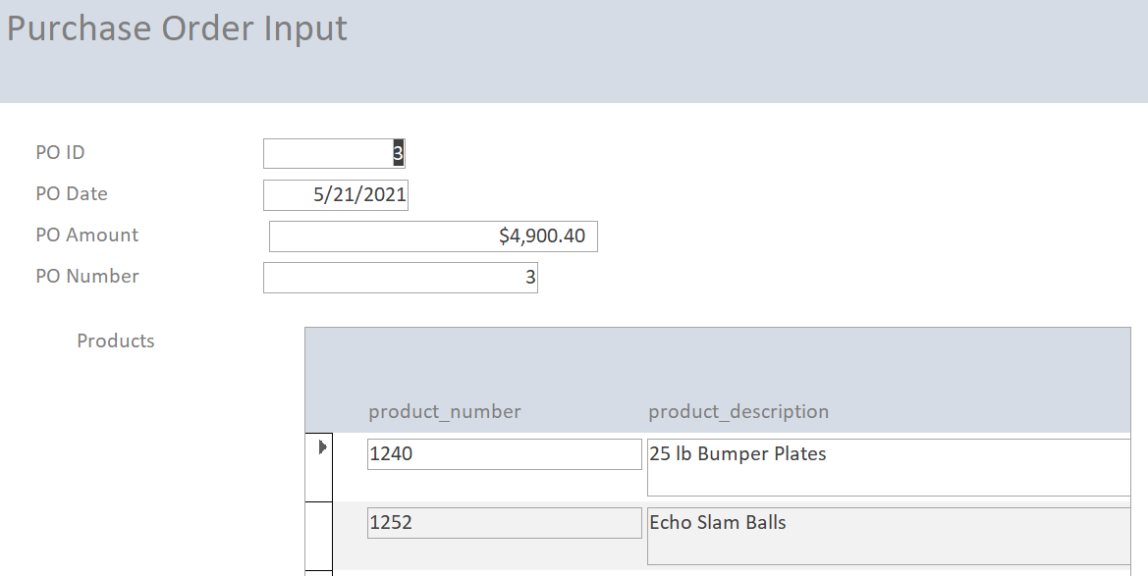
* New Customer Input
  + 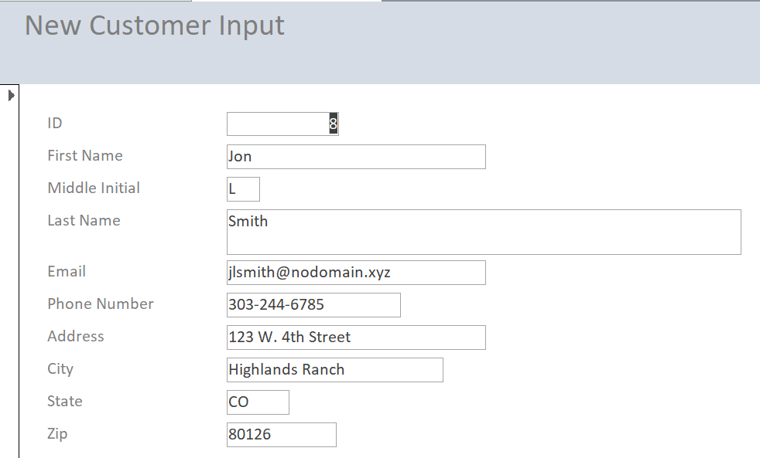
* New Salesperson Input
  + 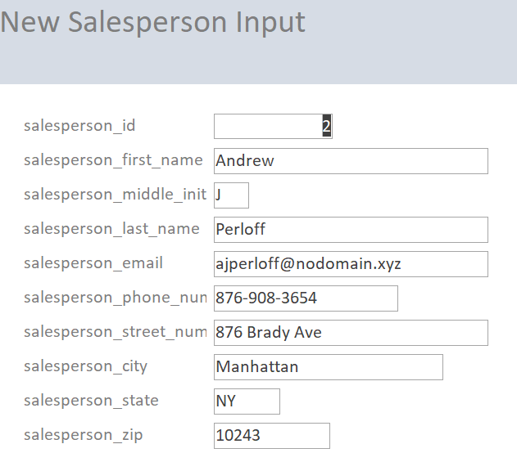
* Top Sales by Month [Report]
  + 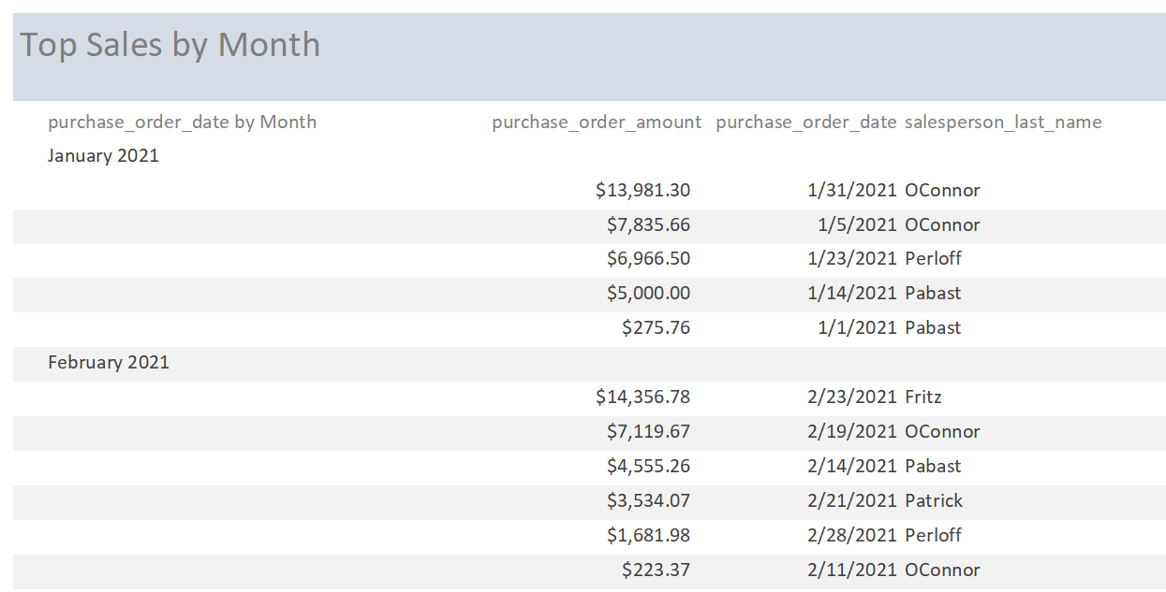

**Process Reflection**

* My biggest process reflection throughout the project has been thinking about the data questions that you are going to try to answer at the beginning of the database creation. I know that this was covered in the reading and the asynchronous material, but I realized my regrets too late in the process. For example, I realized that I was capturing the amount of each purchase order, but I was not capturing the amount of each item. I was still able to answer all my data questions; however, I lacked some granularity about the popularity of items and how that impacted some of the purchase orders. If I were going to start this project over that is one thing that I would do, is capture the cost per product and then aggregate the purchase order price from the products that are on the purchase order.