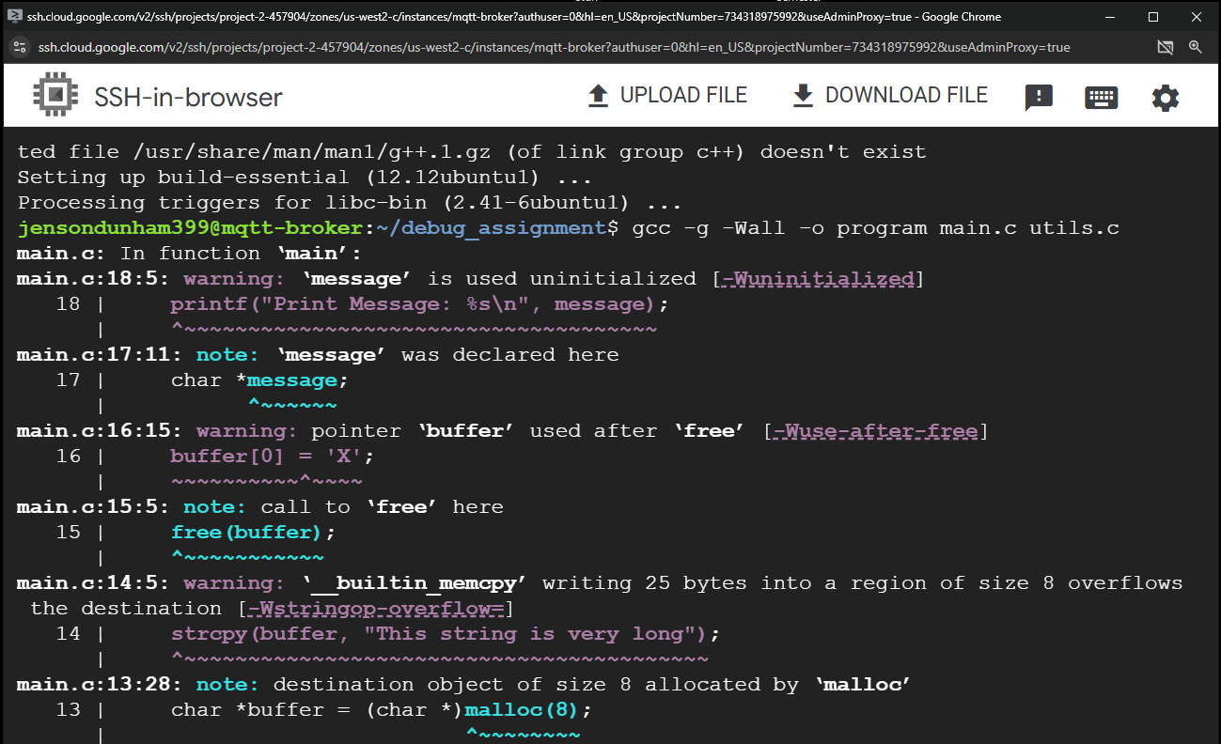

Error 1:
Char *message; not initialized
fix:
initialized message to “test”
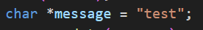

Error 2:
Writing to memory after it is being freed
Fix:
Moved free(buffer) below buffer
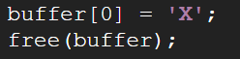

Error 3:
Not enough length allocated to buffer for message
Fix:
Allocated 64 bits

Error 4:
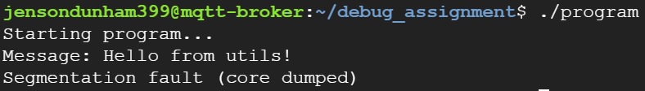

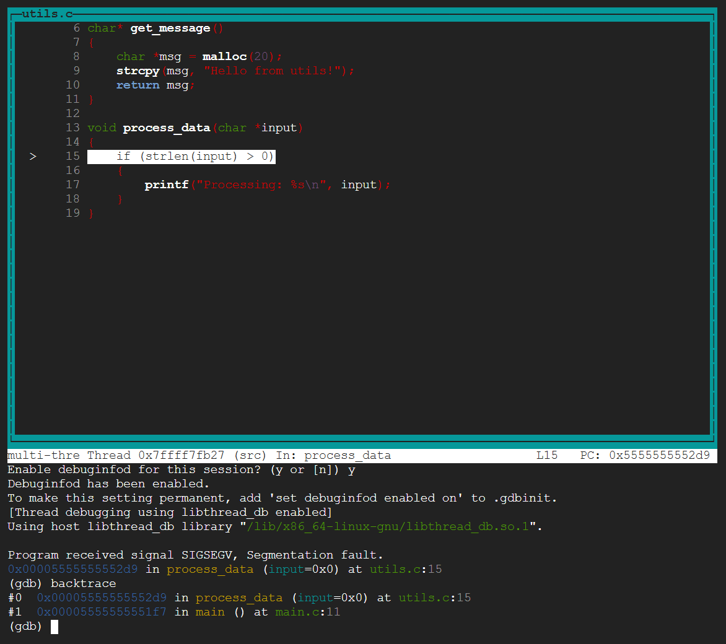

Segmentation fault caused within utils.c, by passing null here:
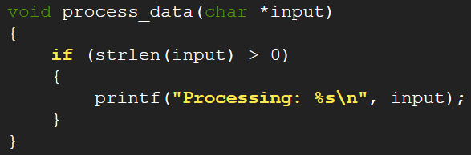
Fix:
Check that *input is not null before it reaches strlen()
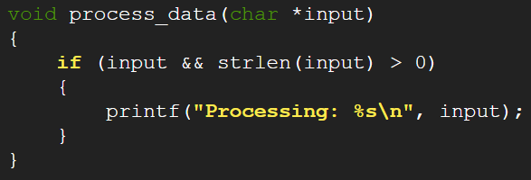

Error 5:
Process_data() not called for second message
Fix:
