Module 4 Partial Credit:

For questions 5 and 6, I continued to use the turns ratio from the book figure, as it wasn’t clear to me to use the 0.5 from the lecture video. I just changed the parameters that were listed in this slide:

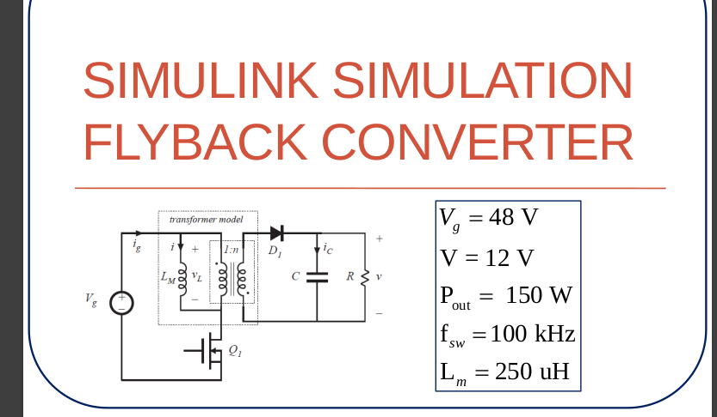

This led to my “incorrect” calculation of the critical resistance for question 5, and will impact my output plots for question 6. I believe my math checks out, as the plot I submitted indicates. If you look, the magnetizing current is just at zero at the end of the switching period, on the brink of DCM. If I update my .m file with an n of 0.5, my R becomes 28.125 as shown in the solution, and my output plot looks more like this:
