Jacob Neiheisel

Professor Posada

CIS 162 – Computer Science 1 – Section 09

27 August 2020

Activity 2 Errors, Fixes, and Explanations

1 - Change Test to test

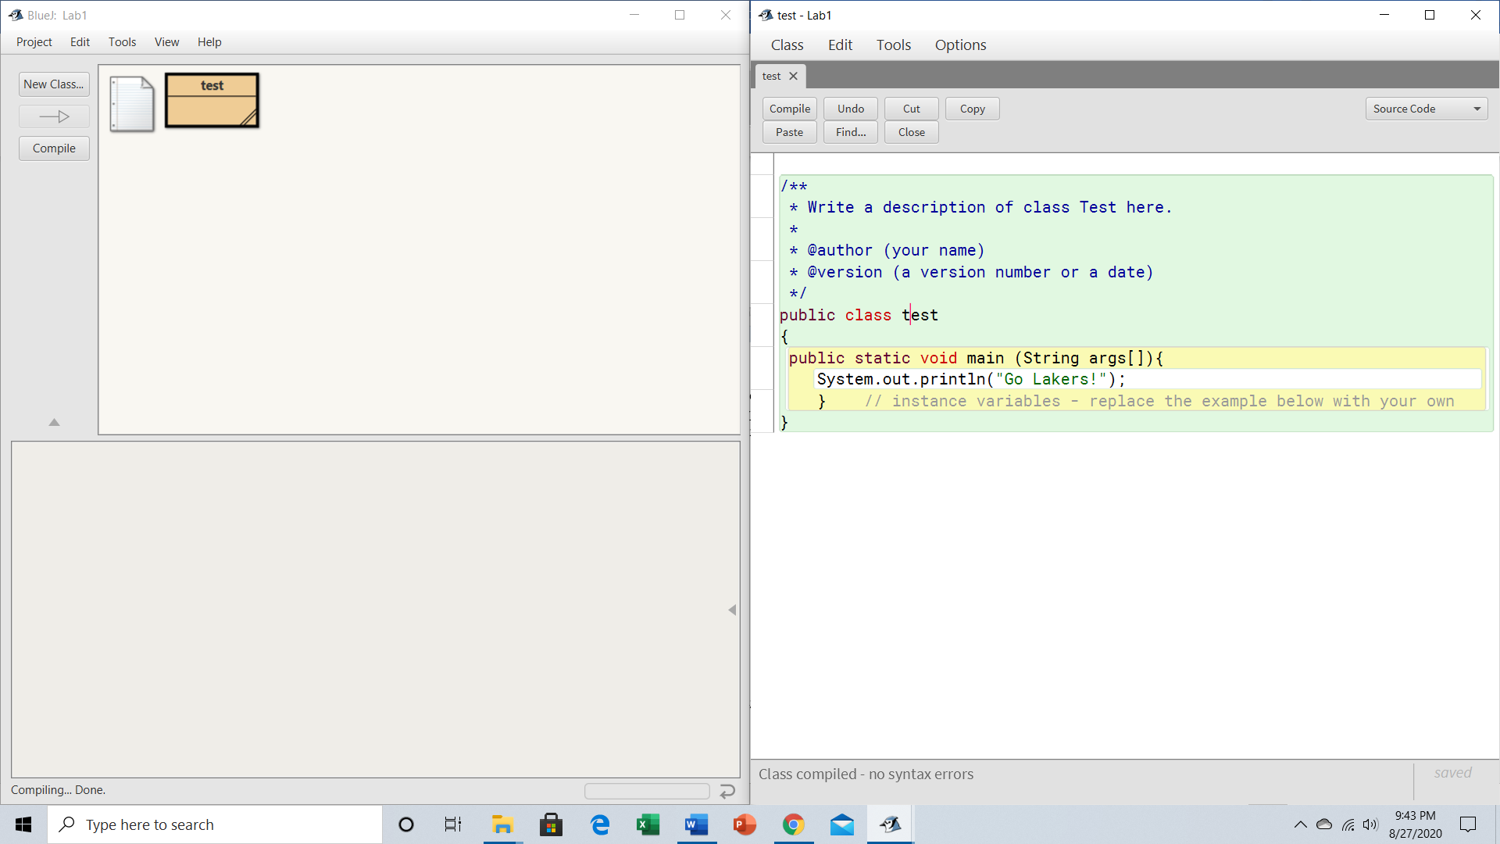

No error: class name is something legible and readable. It is overall just a name change with the class – nothing harmless.

2 - Change Lakers to lakers

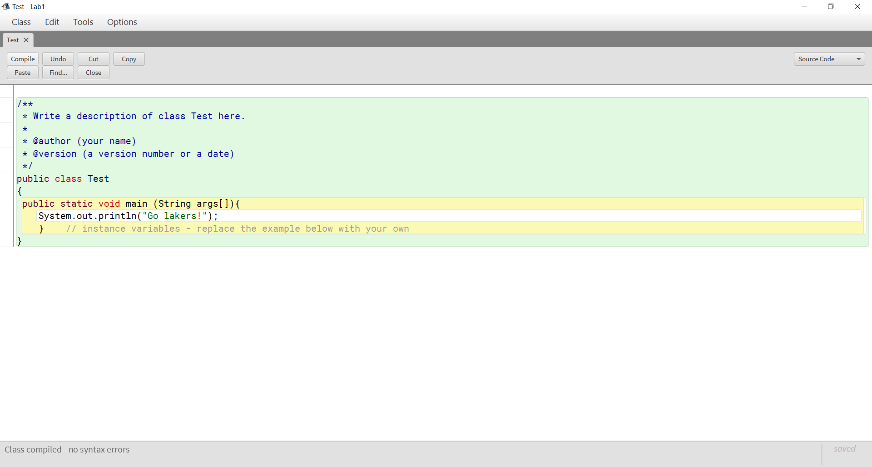

No errors because string was designed to accept these ASCII characters and was not looking for anything syntactical to rely on such as System being spelled correctly.

3 - Remove the first quotation mark in the string

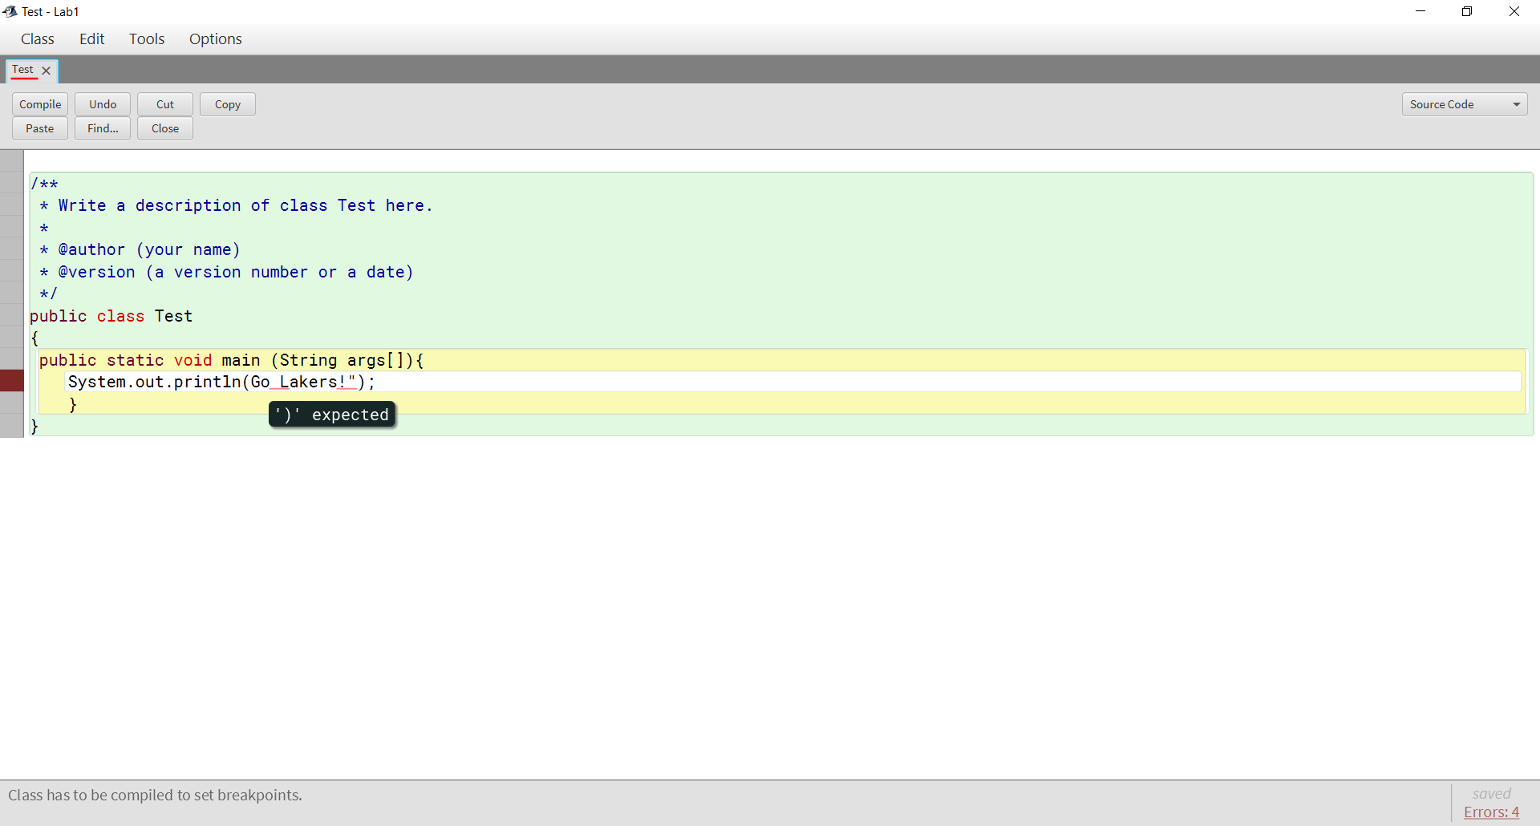

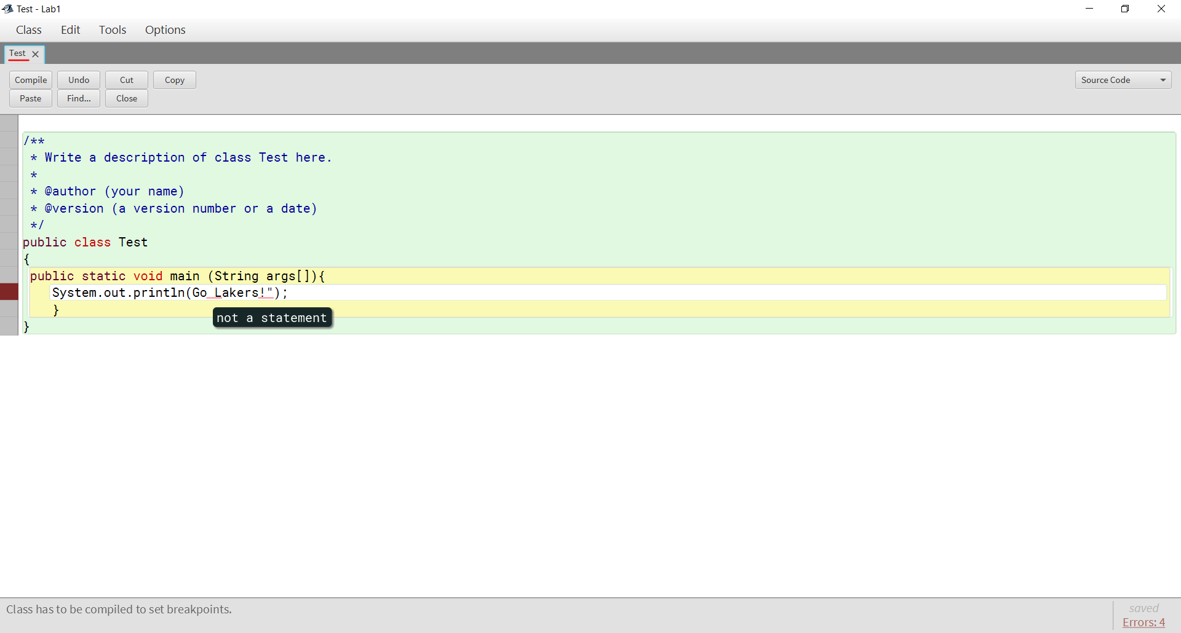

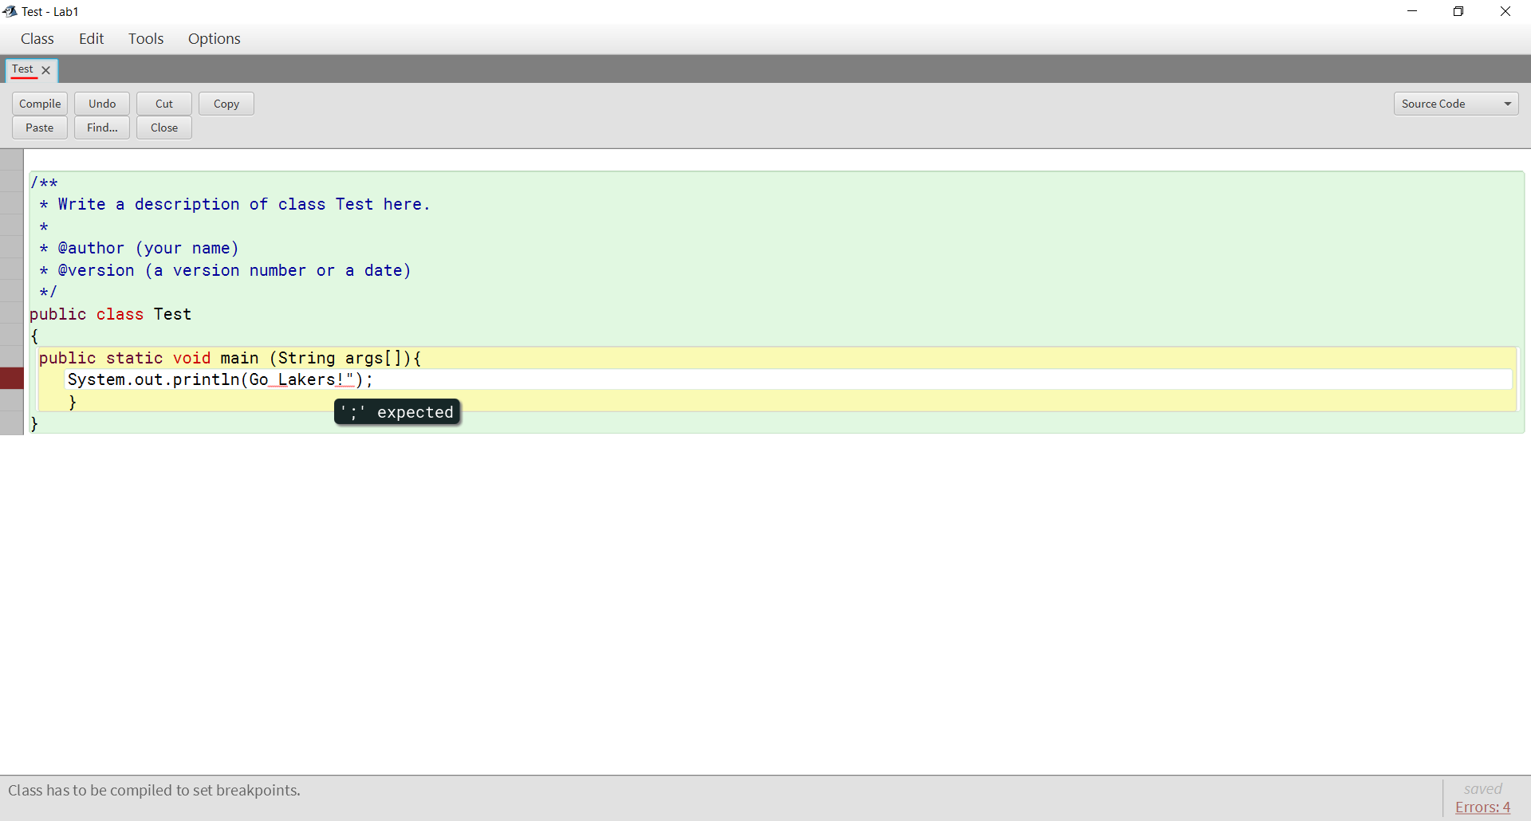

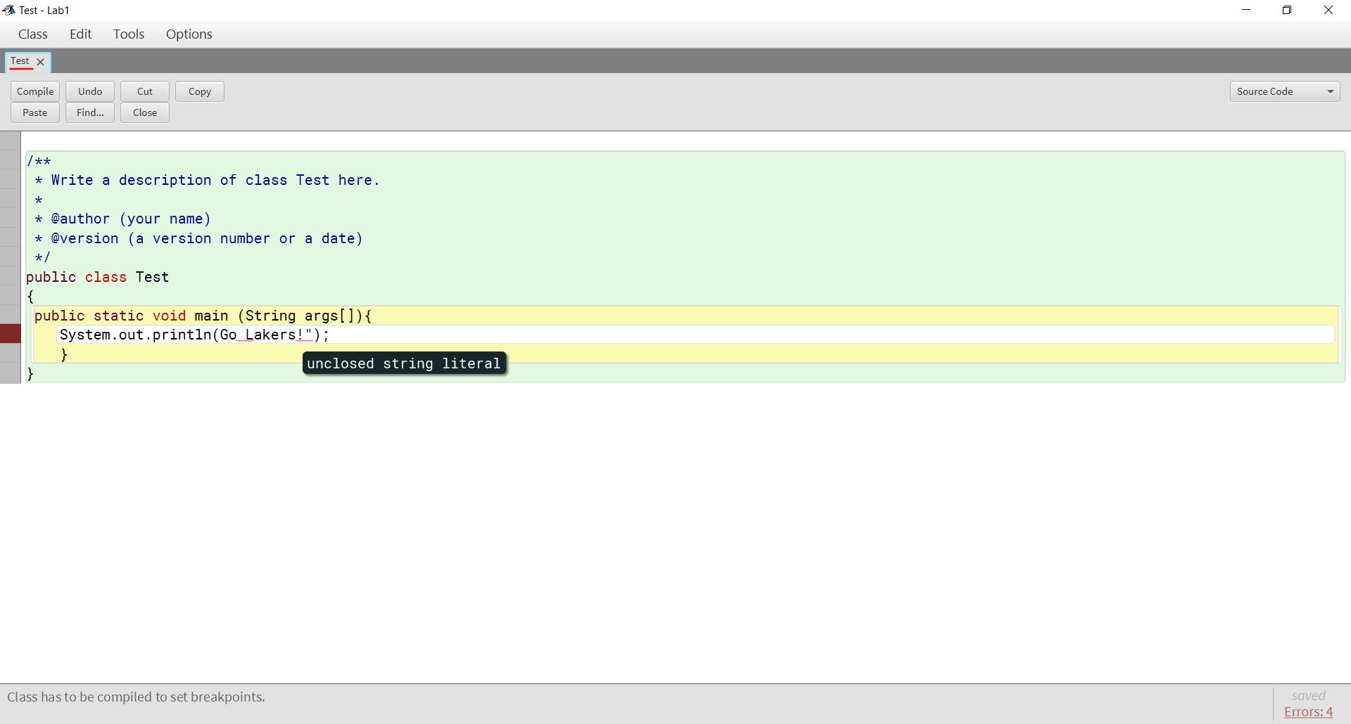

A possible explanation for the first error is that the compiler was assuming there was just a new line created or there was going to be another Java method used. Why the second error possibly occurred is that there was an argument that the compiler was expecting or was assuming that there was another part such as an add-on to the previous function. As a result, the program threw the error. One explanation for the third error is that due to the presumption the add-on mentioned in the last step finished, there was a semi-colon missing and as a result threw the error. With all that culminating, the fourth error was thrown because the compiler saw an open for a string, indicated by the quotation. The compiler did not see a close and did not realize that Go Lakers! was a string, saw the first quotation without an end, and threw the error.

4 - Remove the second quotation mark in the string

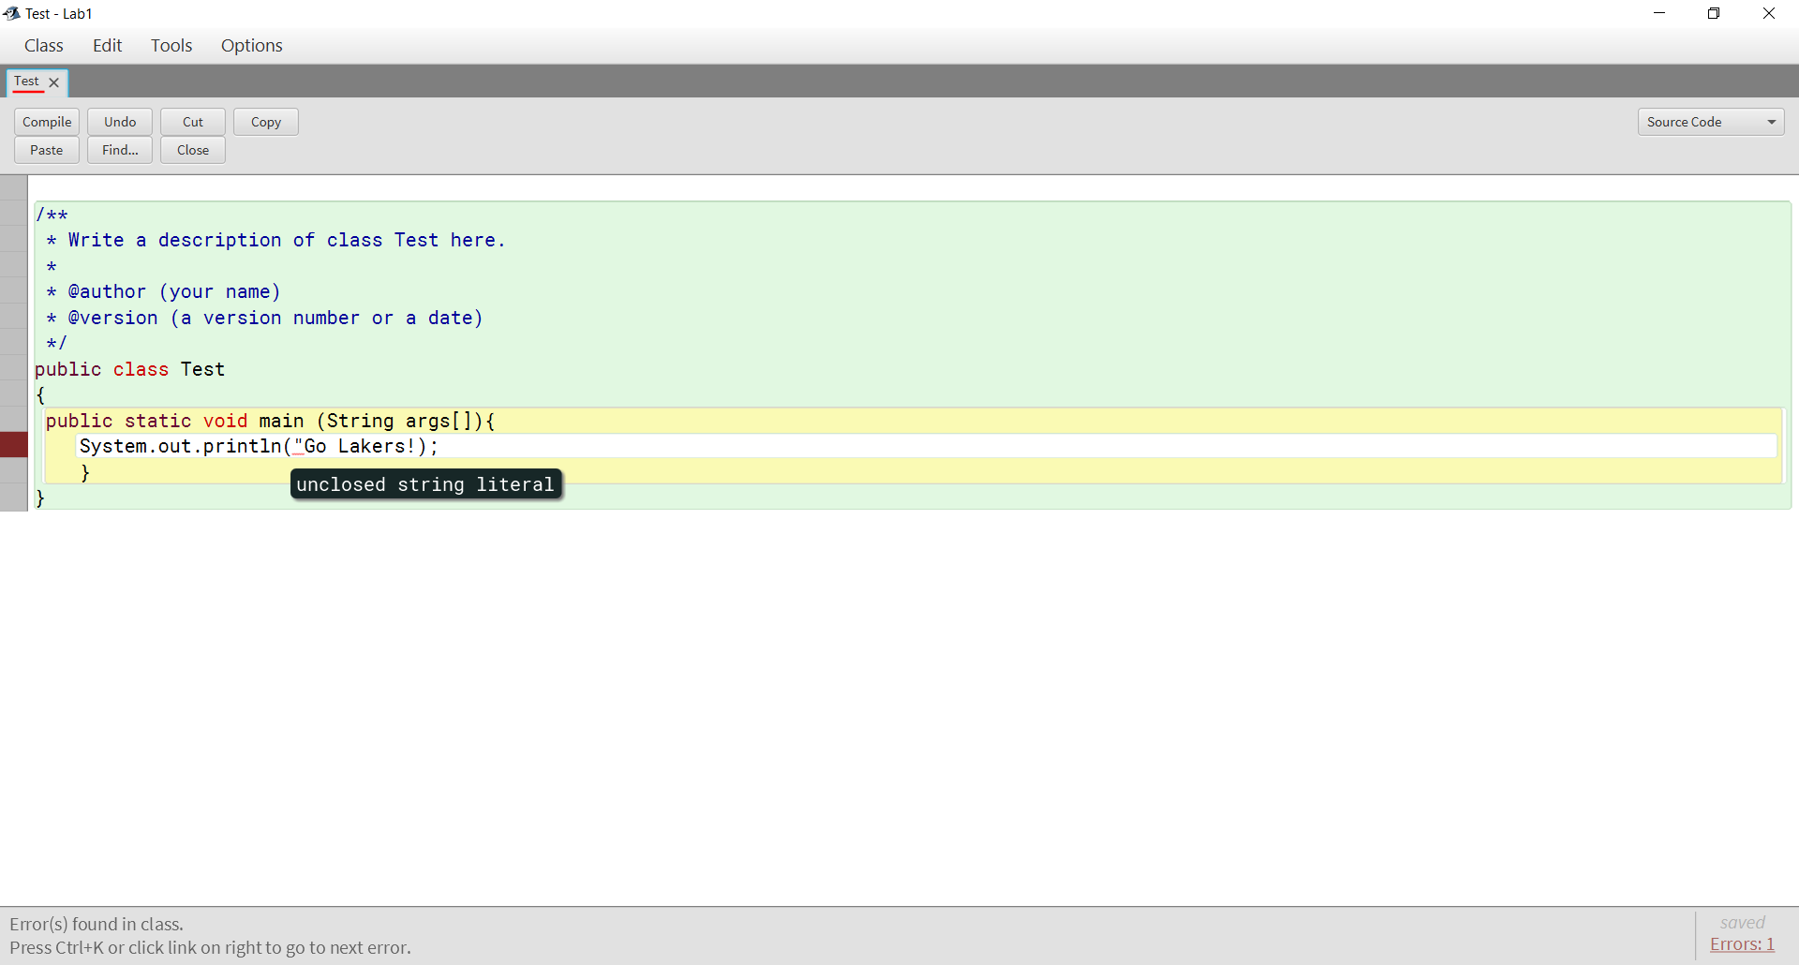

The error here is the same as the fourth error in number 3 in that there was an open to the string, but no close. This resulted in the error thrown by the compiler.

5 - Change main to man

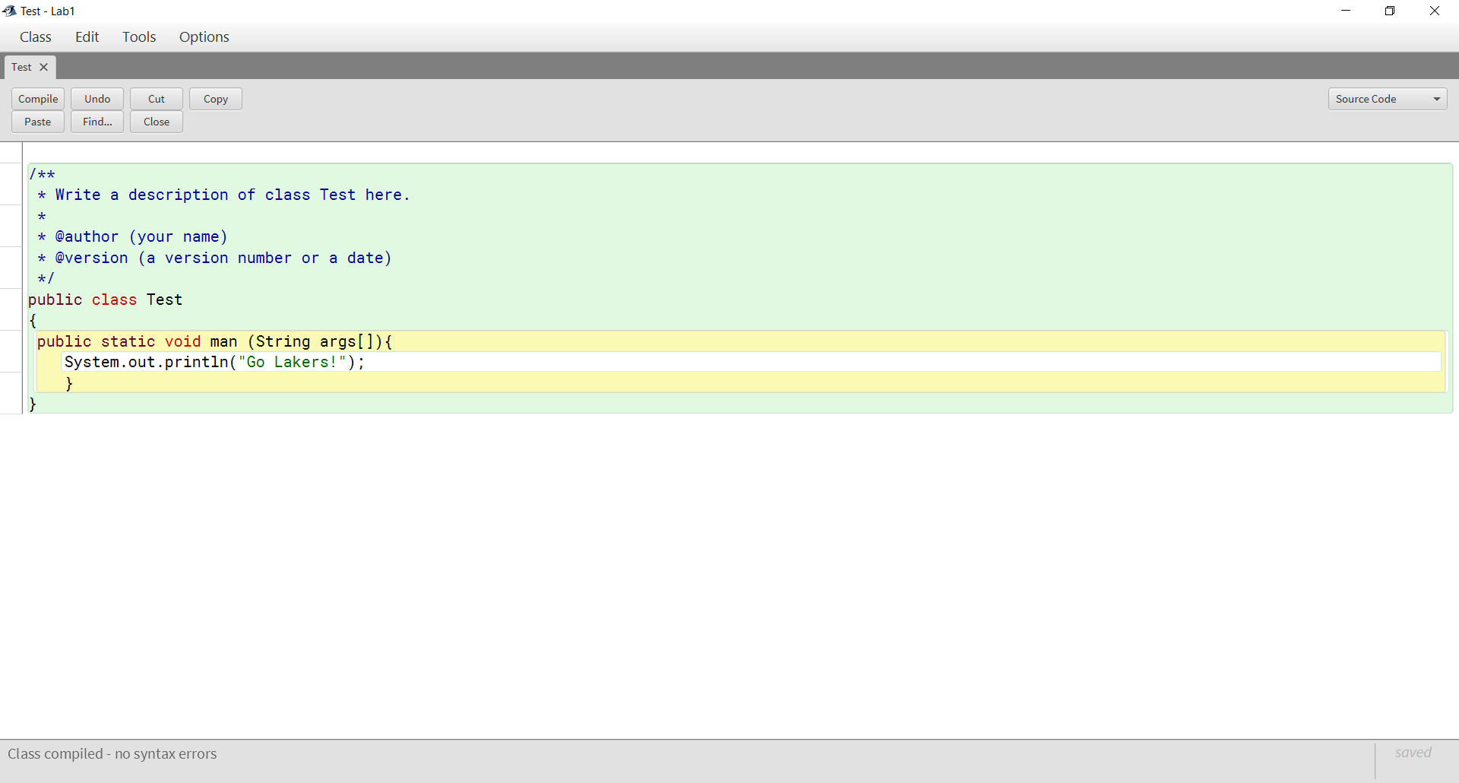

No compilation error here this is an acceptable modification to the compiler due to the method being named something, although it is not the proper main string syntax.

6 - Change println to bogus

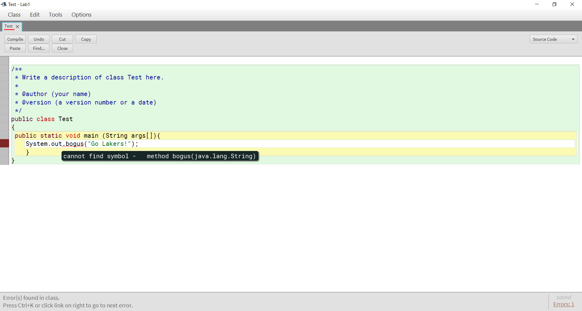

There is an error because that syntax does not call that specific function in Java, rather it calls for something that Java does not have already in the documentation.

7 - Remove the semicolon at the end of the println statement

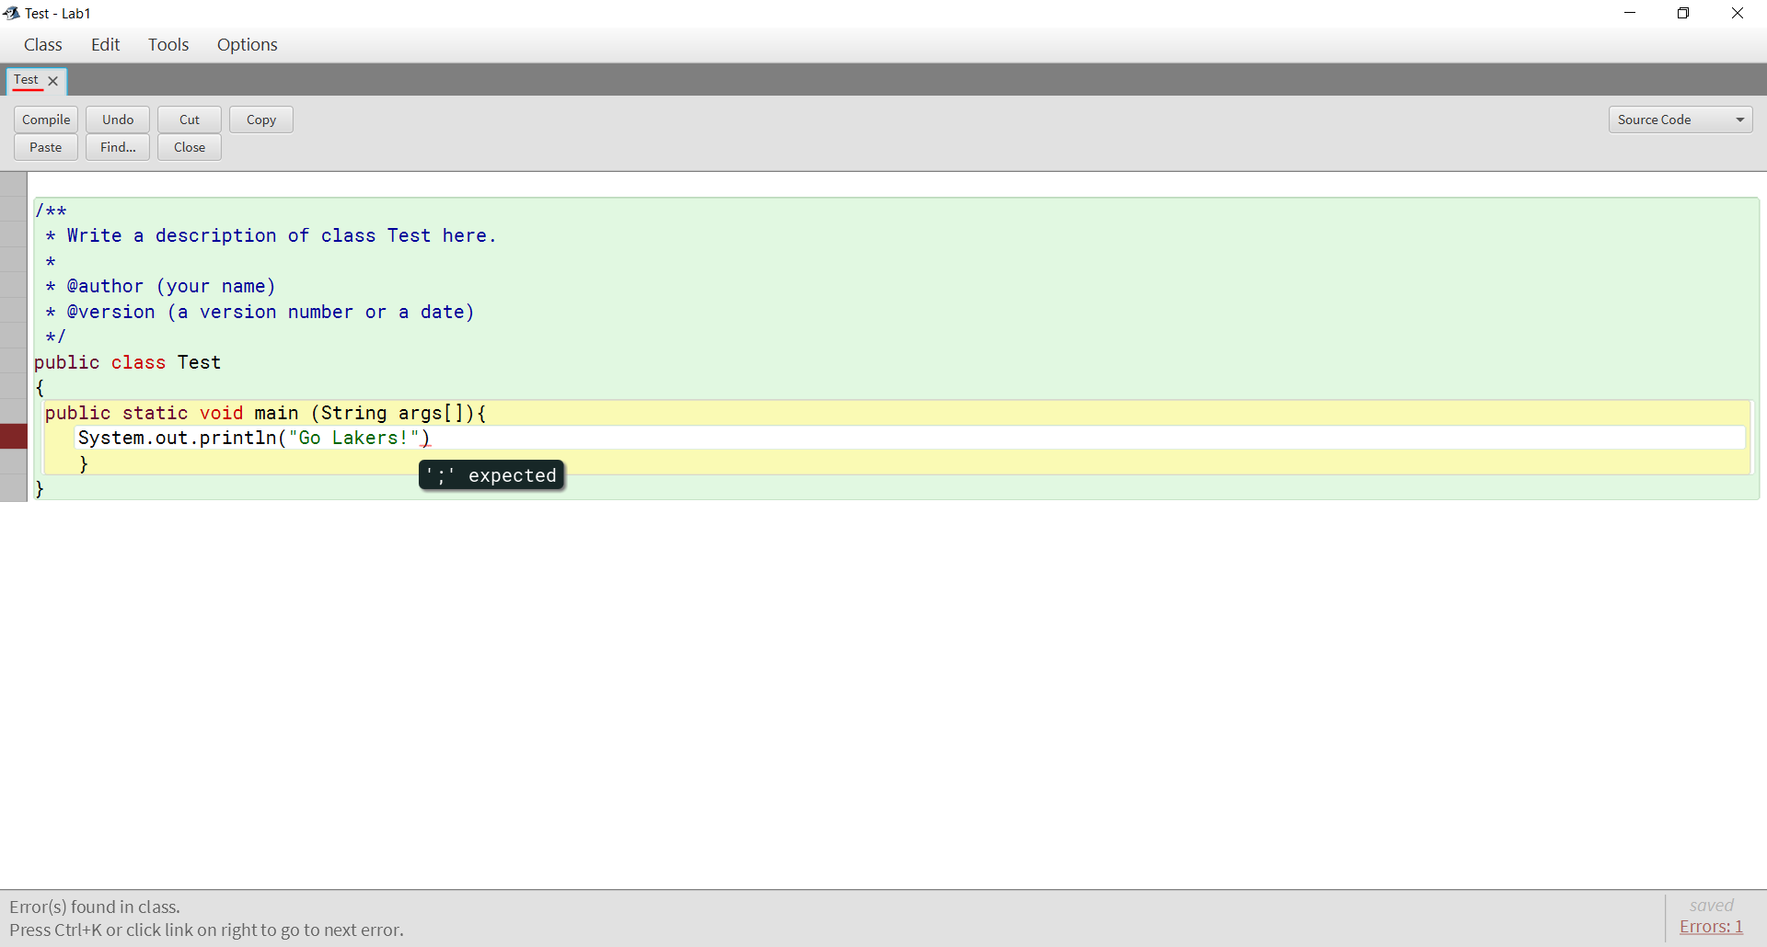

The error lies in the compiler needing to know when the line ends so that it can accurately ensure all lines work.

8 - Remove the last brace in the program

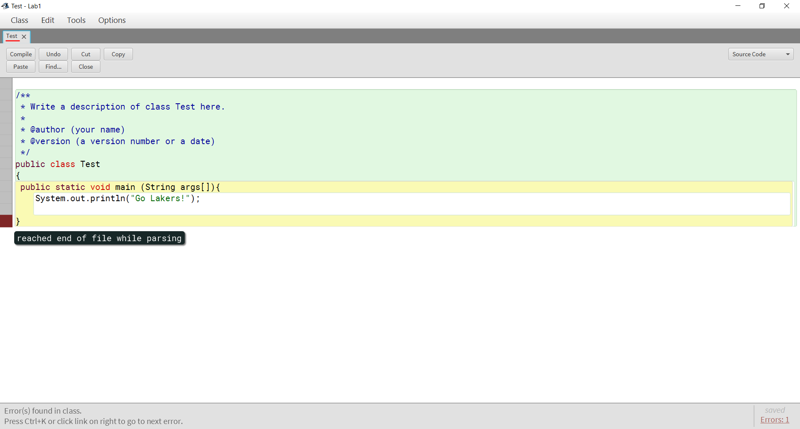

The removal of the last curly brace produces an error because the compiler does not know if there is more to the class or if there are any more instructions.