Jacob Neiheisel

Professor Posada

CIS 162 – Computer Science I – Section 09

14 October 2020

GVdate – the calendar project that functions as a real date calculator

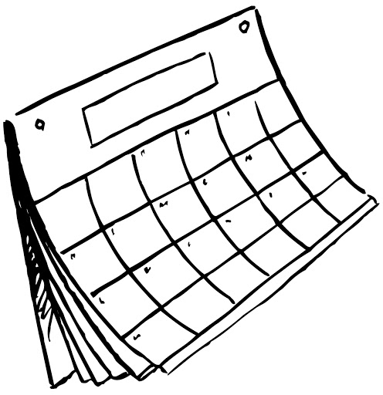

I pledge that this work is entirely mine, and mine alone (except for any code provided by my instructor).

I spent 5 hours 30 minutes on this project from September 28 to October 10 reading the book, designing a solution, writing code, fixing errors, and putting together this document.

