Jacob Neiheisel

Professor Posada

CIS 162 – Computer Science I – Section 09

03 November 2020

Chuck – the GUI game where bets are placed and even won, all on 3 dice

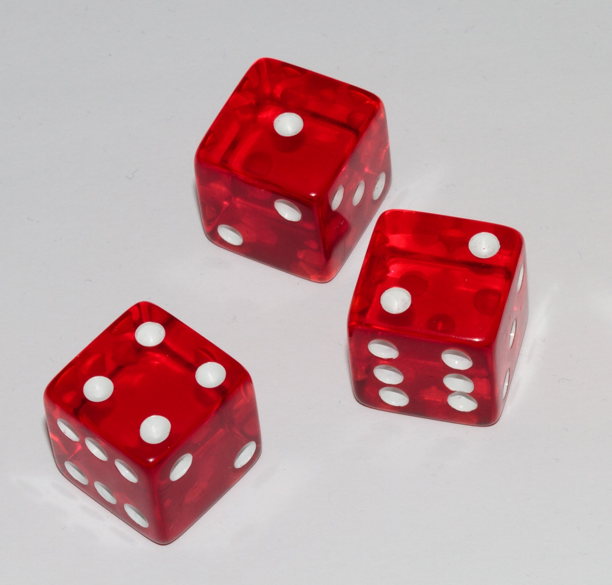

I pledge that this work is entirely mine, and mine alone (except for any code provided by my instructor).

I spent 6 hours 30 minutes on this project from October 19 to November 4 reading the book, designing a solution, writing code, fixing errors, and putting together this document.

