Jacob Neiheisel

Dr. Bowman

CIS 457 – Data Communications

23 March 2022

Project 2

Connect

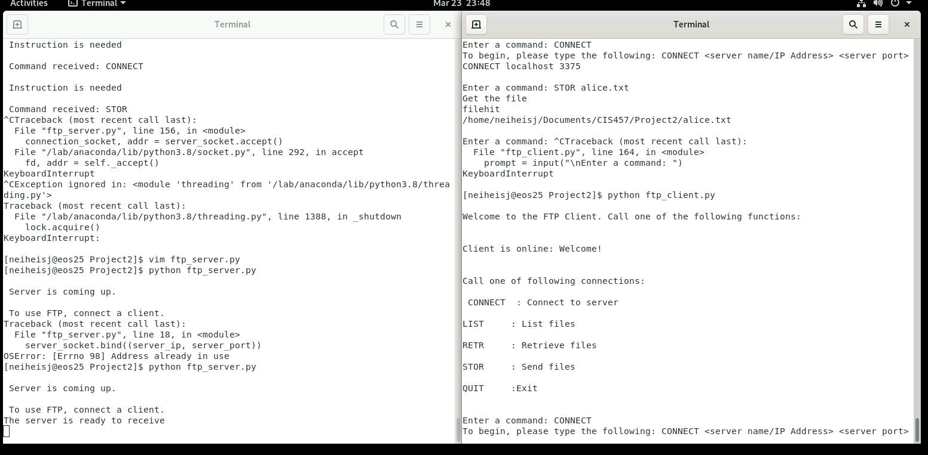

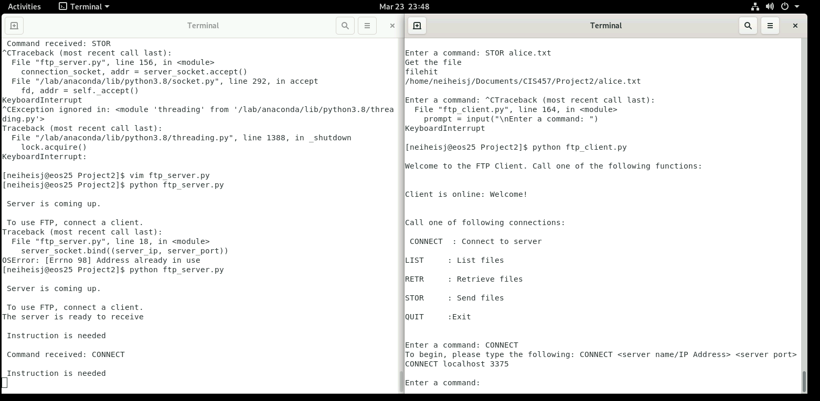

RETR

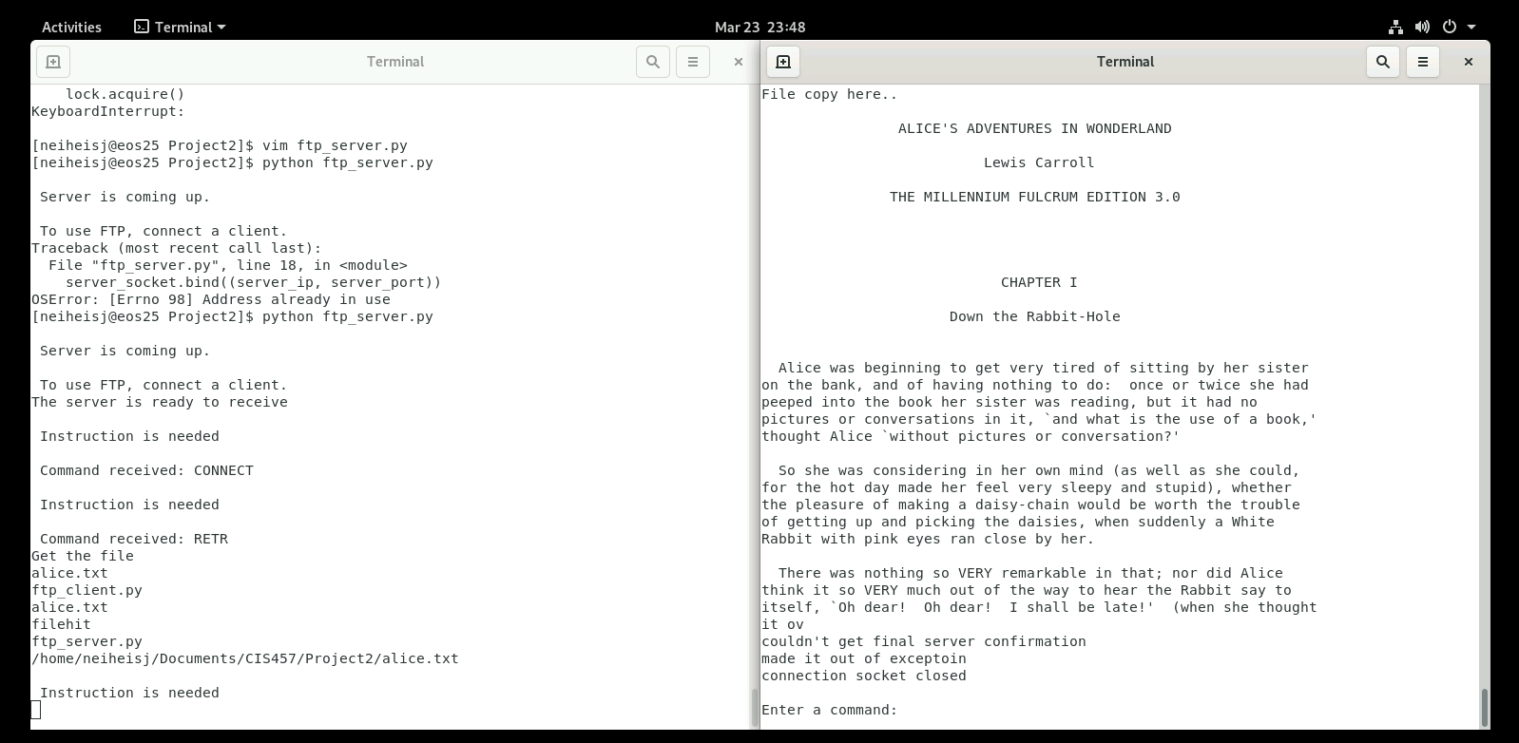

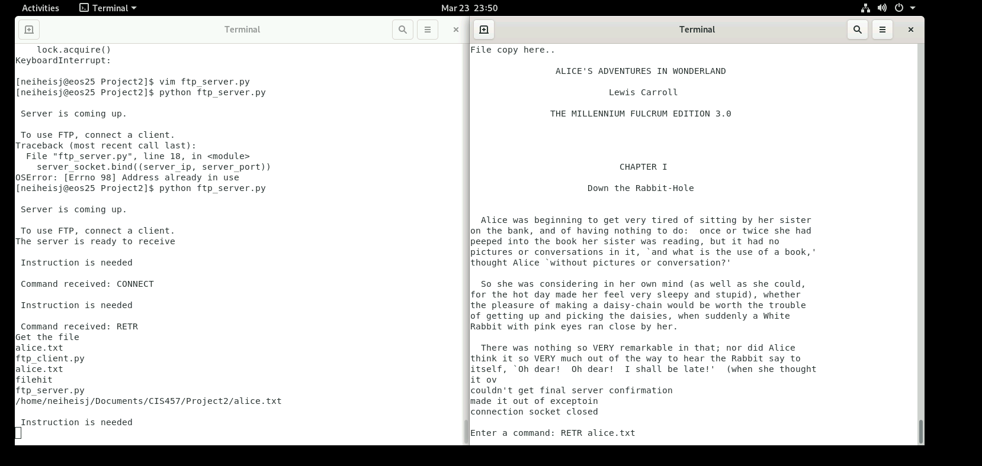

LIST

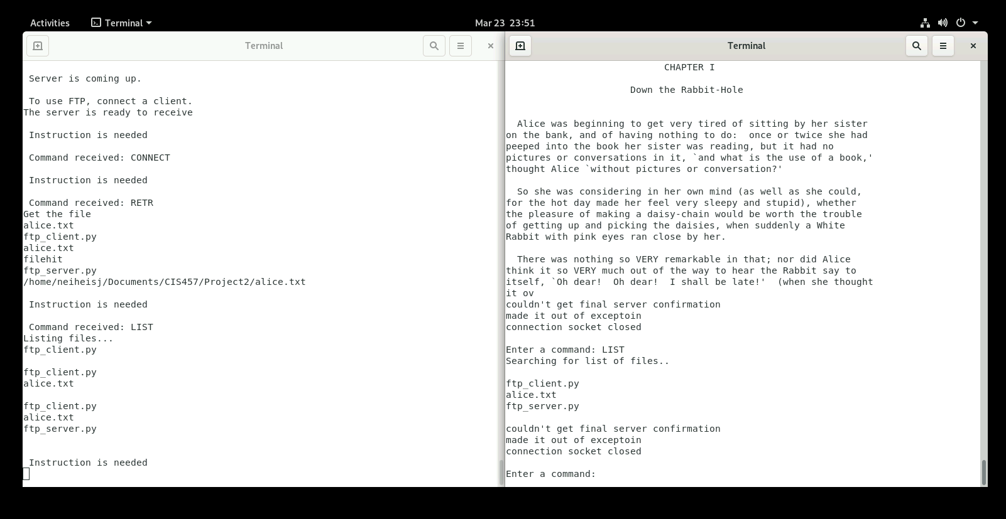

STOR

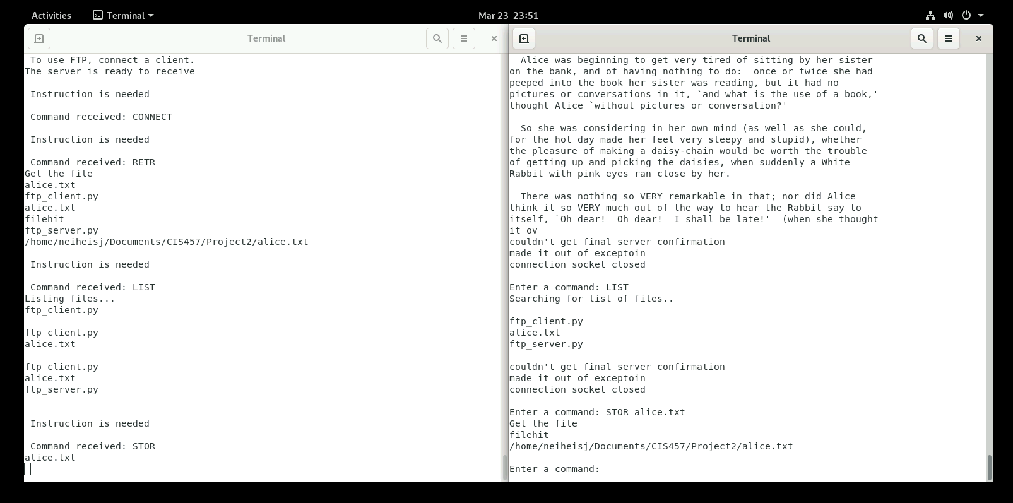

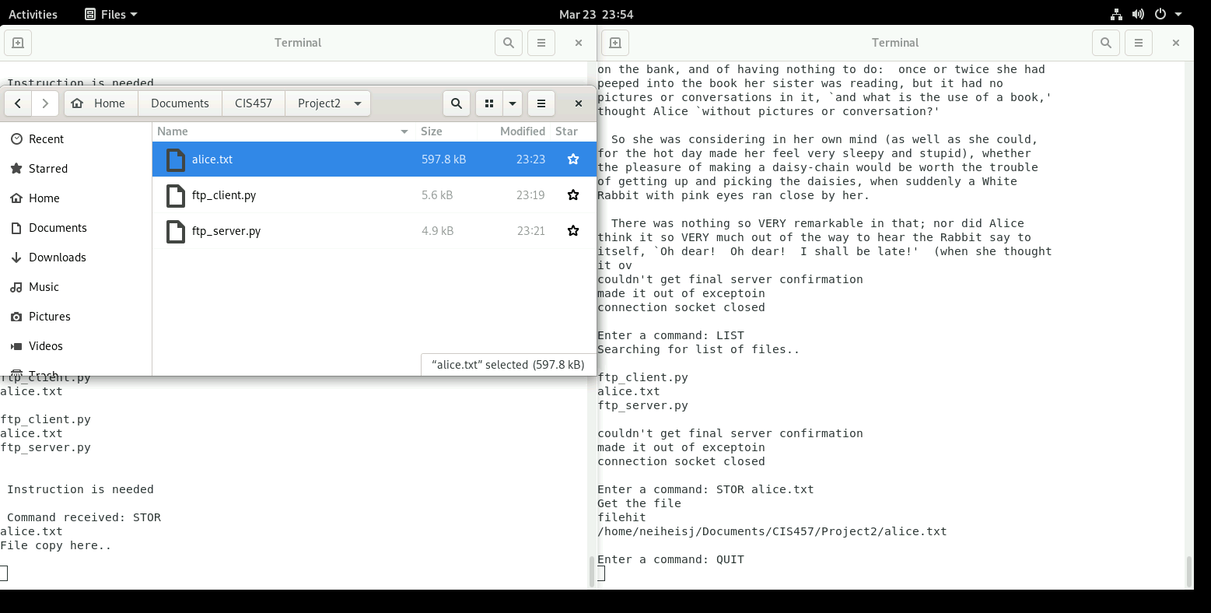

QUIT

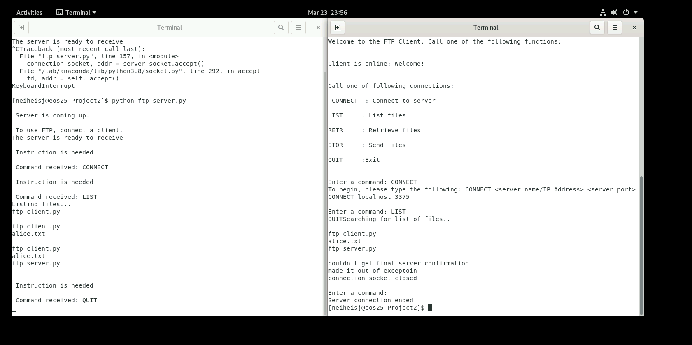

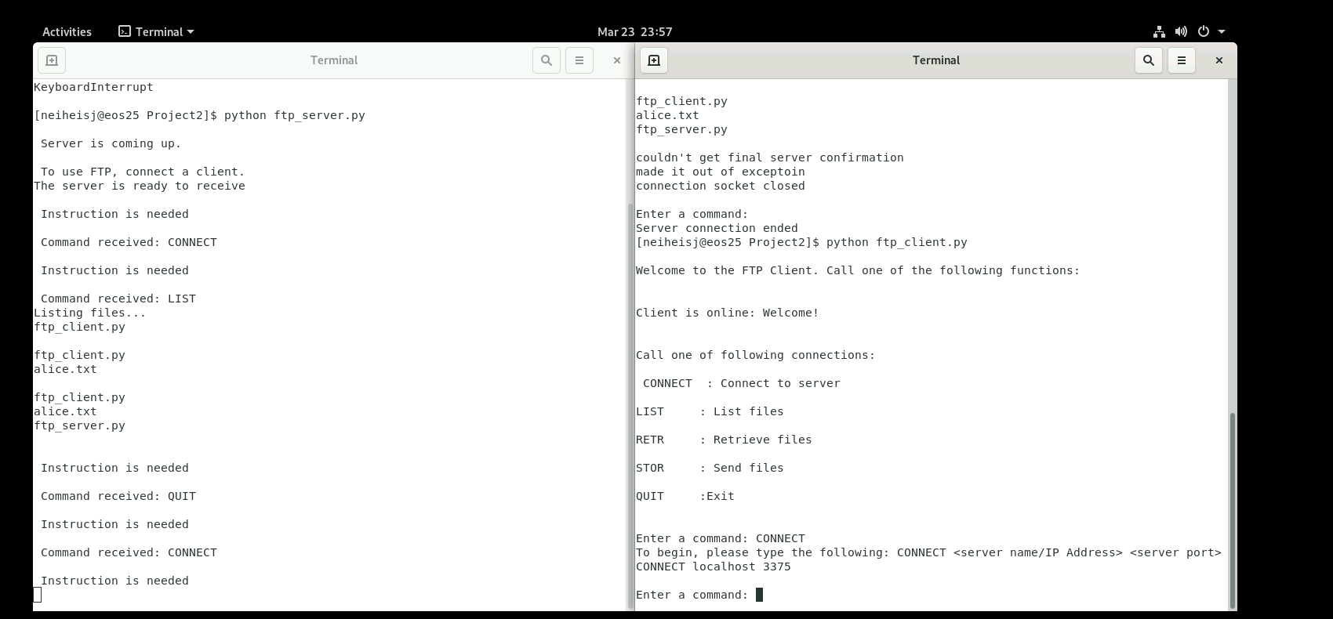

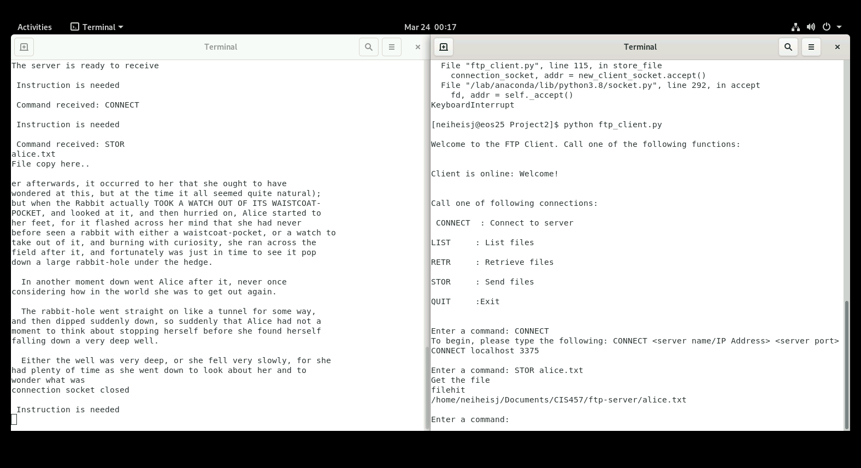

Challenges

Overall challenges here were mainly fit and finish. I also was not able to get the STOR method to work 100%, but I tried my best to make a good showcase. It was easy once I knew overall architecture of how it should look. I do regret not having too much error checking, but I was proud of what I was able to do and the fact that each function, despite its challenges, got easier as time went on.