Results & Discussion
Discussion

Distribution of vegetative practices and biomass production
As demonstrated by this case study, achieving multi-objective change in the landscape will require systematic, spatially explicit planning. The results presented below should be interpreted as system-level outcomes, as variation in practice extent and function limits direct comparison across individual conservation strategies. The INRS presented varying levels of individual scenario adoption based on MLRA due to topographic characteristics (Table 2), and these values were used to determine the proportion of each MLRA within each supplyshed unit to be allocated to prairie and cereal rye biomass practices across spatially explicit vegetative practice outputs from ACPF. There was a fairly even distribution of prairie and cereal rye practices across MLRA 108c. In contrast, MLRA 105 has a high concentration of prairie biomass, and MLRA 104 has patches of concentrated prairie biomass, due to steeper elevations and soil types (Figure 3). Urban areas dominate MLRA 115c, so the distribution of biomass opportunities was sparse, with notably less area.
Using ACPF-informed siting and FiNRT and OFE tools to quantify environmental outcomes, this bioeconomic planning case study explored how targeted deployment of harvestable conservation practices can contribute to statewide nutrient reduction, habitat, and climate goals. The modeled scenario illustrates the scale of environmental benefits achievable with strategic yet minimal land conversion, aligning with targets outlined in the INRS and IWAP. The environmental outcomes from the bioeconomic plan, as presented, include: an annual reduction of 8,279 Mg of nitrate loading to surface water, 10,350 Mg of sediment transported, and approximately 141,000 Mg of CO₂ and 33,316 Mg of CO₂ _{e} N₂O emissions reduced annually (Table 3). By treating 2% of Iowa's cropland, we achieve roughly a 3% reduction in baseline nitrogen load—264,918 Mg annually—targeted by the INRS (2024).
The IWAP (2015) 4% permanent cover goal was exceeded by following INRS recommendations, resulting in several small (< 20 ha) to large (< 300 ha) prairie patches that serve as core patches along with 7,229 ha of linear habitat in the form of prairie strips and herbaceous saturated buffers, and could serve as corridors (Table 3). A more in-depth analysis of landscape connectivity and functional patches is needed to determine them, and should be pursued to assess and quantify more detailed wildlife ecosystem services. In addition, functional wildlife groups, or specific species, should be identified to ensure the hotspots identified are prairie patch complexes supporting those targeted species (Sussman et al. 2019). The wildlife density map presented here illustrates a focal neighborhood radius of 300 m to represent local-scale habitat aggregation, reflecting the spatial scale at which adjacent prairie elements function collectively as usable habitat for multiple grassland bird species and smaller mammals in agricultural landscapes (Figure 3) (references).
Throughout the entire supplyshed, 72,656 ha of cropland were treated with cereal rye, and a total of 42,891 ha of prairie biomass was produced. In this case study, the AD bioeconomy is a developing market with only one buyer, and the biomass generated using a multi-objective approach exceeds the AD facility demand (809 ha of cereal rye and 809 ha prairie). Biogas produced from agricultural residues provides the AD operator with flexibility regarding feedstocks, digester operation, and biogas output (Theurel et al. 2019). The surplus biomass from this bioeconomic plan provides the AD facility with some supply stability and flexibility. Additionally, the surplus supply provides opportunities for the herbaceous market to expand into other AD facilities in the supplyshed, grow the regional bioenergy system to support RNG infrastructure development in rural economies, and improve the landscape.
Throughout the entire supplyshed, 72,656 ha of cropland were treated with cereal rye, and a total of 42,891 ha of prairie biomass was produced. In this case study, the AD bioeconomy is a developing market with only one buyer, and the biomass generated using a multi-objective approach exceeds the AD facility demand (809 ha of cereal rye and 809 ha prairie). Biogas produced from agricultural residues provides the AD operator with flexibility regarding feedstocks, digester operation, and biogas output (Theurel et al. 2019). The surplus biomass from this bioeconomic plan provides the AD facility with some supply stability and flexibility. Additionally, the surplus supply provides opportunities for the herbaceous market to expand into other AD facilities in the supplyshed, grow the regional bioenergy system to support RNG infrastructure development in rural economies, and improve the landscape.

Table 2. The current land use and land cover as well as land area goals are organized following the Iowa Nutrient Reduction Strategy’s (INRS) regional land planning units, major land resource area (MLRA), and supplyshed area. To achieve additionality, the bioeconomy plan targets land currently cropped in continuous corn (CC) or in a corn-soybean rotation (CS). Land area goals for both the Iowa Wildlife Action Plan (IWAP) and INRS are reported in this table.
MLRA AREA INTERSECTED (hectares) |  |  |  |  |  |  |  |  |  |  |  |  |  | Supplyshed
 |  | 104 |  |  | 105 |  |  |  | 108c |  | 115c
IWAP Strategy
4% of supplyshed in permanent cover. | 1,765 |  |  | 352 |  |  | 6,898 |  |  |  | 44 |  | 9,059
INRS Strategy
Plant a rye cover crop on all no-till hectares. ³ | CC |  | CS | CC |  | CS |  | CC |  | CS | CC | CS | CC |  | CS
 | 300 |  | 12,034 | 38 |  | 1,508 |  | 1,976 |  | 56,586 | 2 | 212 | 2,316 |  | 70,340
Installing wetlands to treat 45% of the ag land.⁴ | 522 |  |  | 53 |  |  | 1,849 |  |  |  | 6 |  | 2,430
Installing [saturated] buffers on all applicable hectares.⁴ | 184 |  |  | 12 |  |  | 1,341 |  |  |  | 36 |  | 1,573
Perennial crops (energy crops) to equal pasture/hay acreage in 1987.⁵ | 7,231 |  |  | 1,751 |  |  | 29,820 |  |  |  | 86 |  | 38,888
² MLRA 115c in the 32 km supplyshed is only reported for Iowa; the Illinois portion of this MLRA is excluded from the bioeconomy analysis.
³ Proportion of no-till in MLRA 104, 105, 108c, and 115c is based on data reported in the Conservation Technology Information Center (CTIC) database. No-till on continuous corn fields is 11%, 11%, 15%, and 9%, respectively. No-till on corn-soybean fields is 24%, 31%, 36%, and 33%, respectively.
³ There were NRWs sited that achieved treatment of 45% of agricultural land in the supplyshed, however, the number of NRWs was pared down to remove some of the larger wetland complexes that would require agreement from multiple landowners.
⁵ Perennial crops are assumed to include prairie strips and whole field conversions.

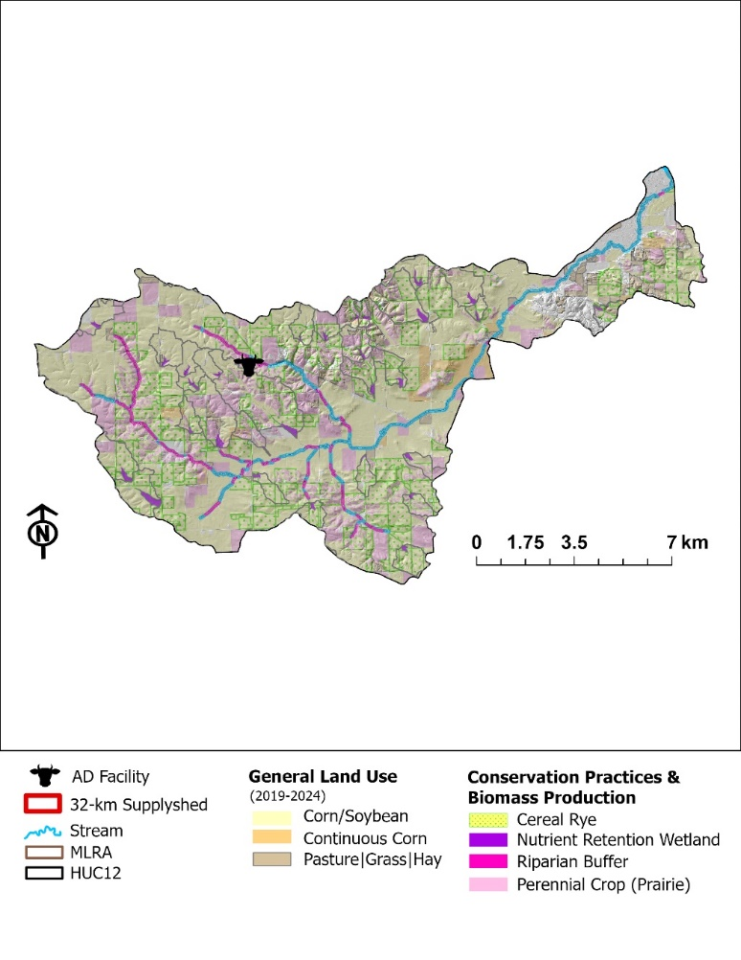
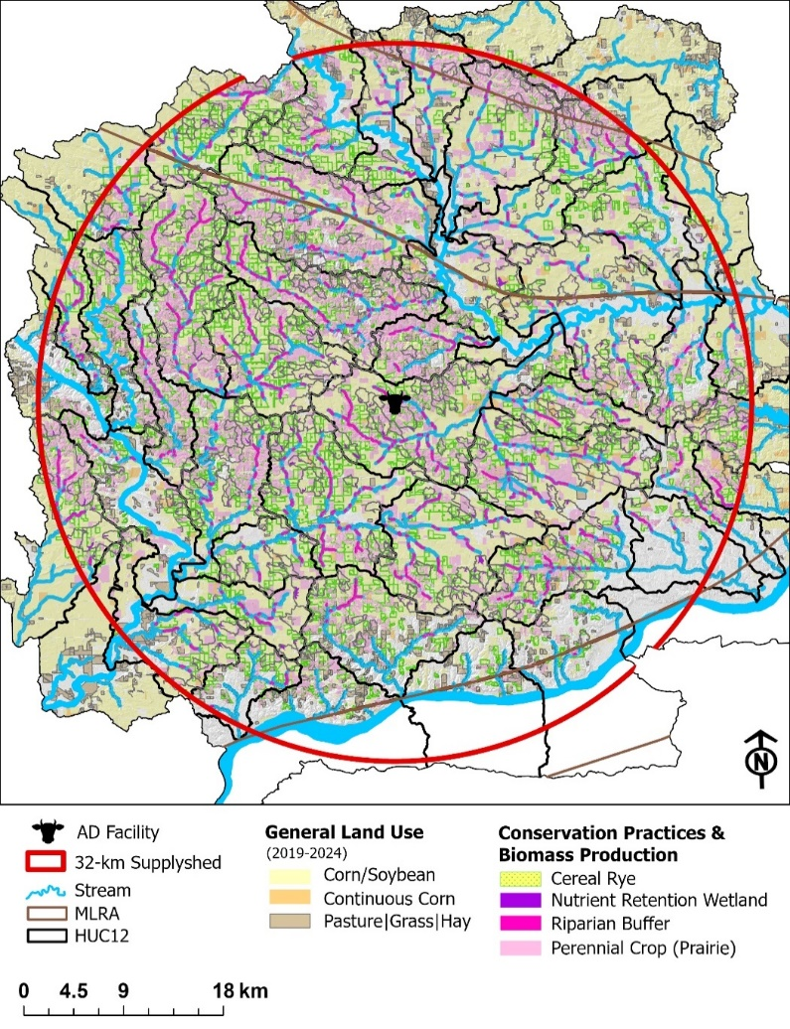
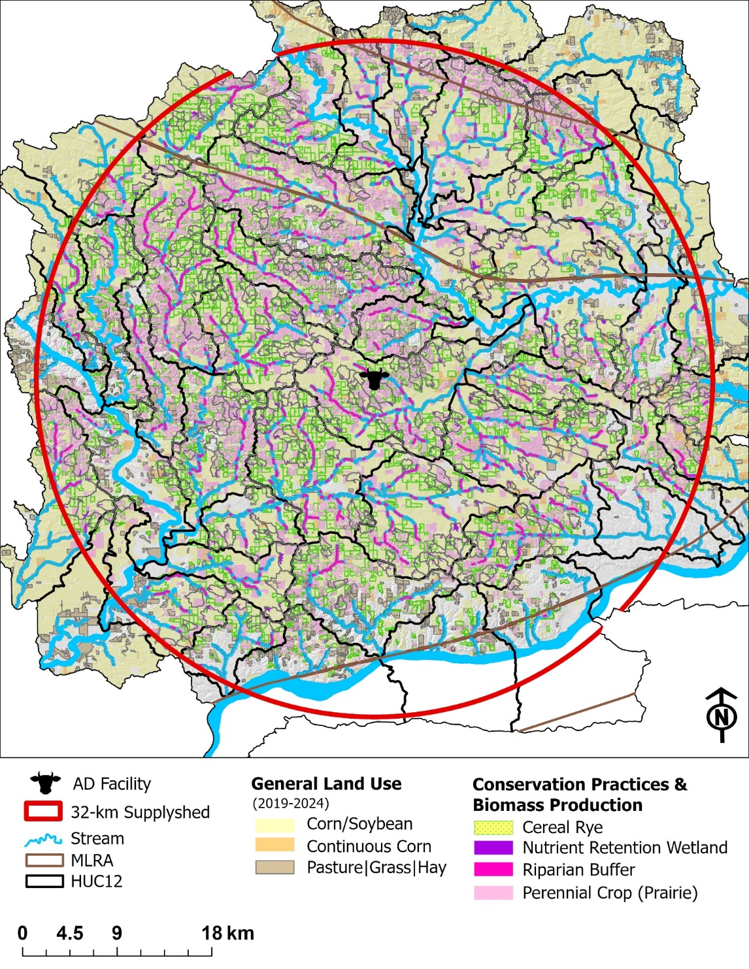
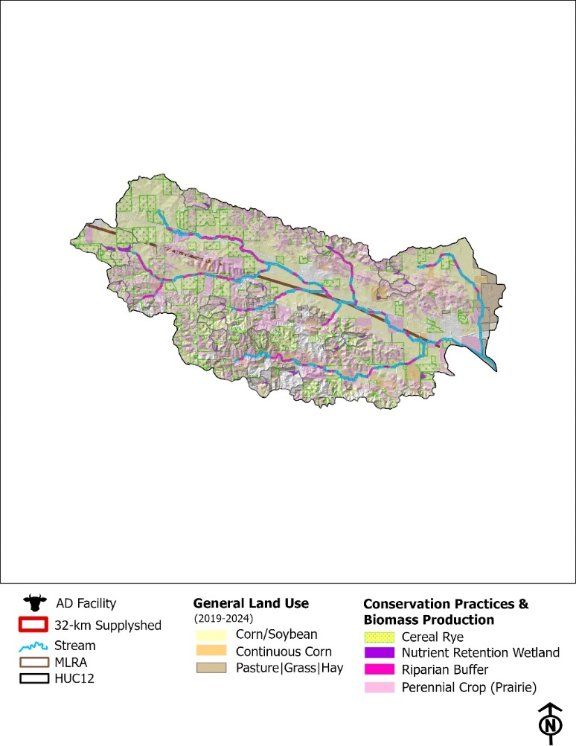
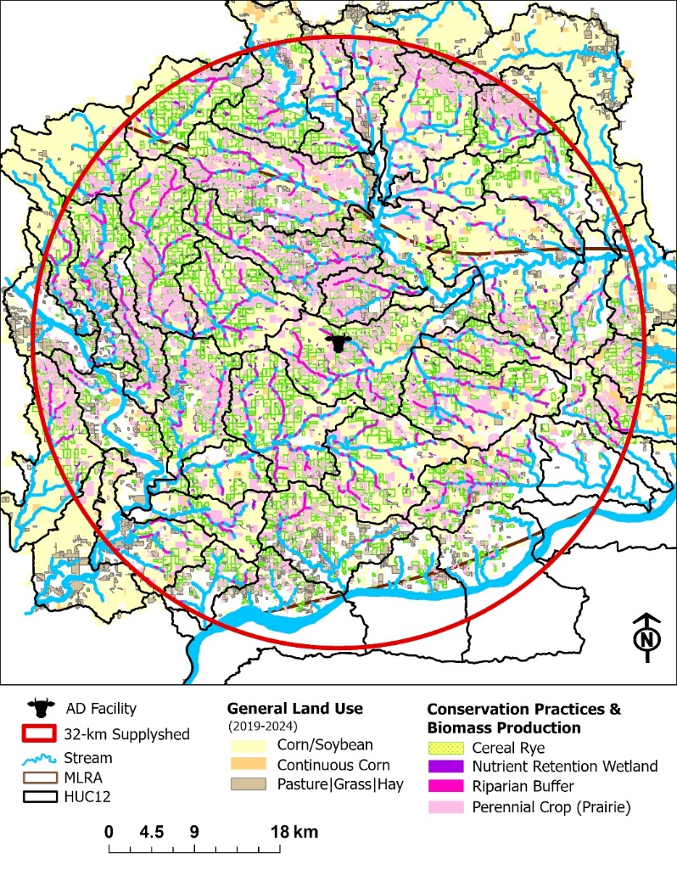
Results Figure 1. Field-scale spatial targeting. Where are practices placed and why? Field 3. Field-scale targeting and intervention (map panels). Prairie sitings, cereal rye, CP. The “where”. Conceptual framework for integrating ACPF-based spatial planning with bioeconomic evaluation to support RNG feedstock system design.

Evaluating Multi-Objective Achievements
The ecosystem services and cost-effectiveness of each land management intervention were quantified for each practice scenario and for each ecosystem service provided relative to the historical corn and soybean system on those same hectares. The data summarized for cost-effectiveness are total cost-effectiveness, and in prairie situations, the opportunity cost (e.g., land costs) is the most expensive part of implementing prairie biomass systems. The cost-effectiveness would look different if the farm operators were the landowners and did not receive rental income on those hectares. Despite high opportunity costs, the prairie-based practices had the best cost-effectiveness for ecosystem services produced, compared with cereal rye (Table 4). There were exceptions to this, though, specifically for CO₂ and N₂O emission reductions in the scenarios for NRW ($6.23 kg⁻¹ CO₂ and $21.81 kg-1 CO_{2 eq}, respectively) and saturated buffers ($2.33 kg⁻¹ CO₂ and $8.14 kg⁻¹ CO₂ _{eq}, respectively) were much higher than cereal rye ($0.58 kg⁻¹ CO₂ and $3.74 kg⁻¹ CO₂ _{eq}, respectively) (Table 4). However, NRW and saturated buffers are more cost-efficient at treating nitrate pollution. Cereal rye has the lowest nitrate reduction fraction (30%) among the other vegetative practices included in this paper and some of the highest total costs ($462.09 ha⁻¹). Thus, it is not the most cost-effective approach for nitrate reduction, given its negligible impact on wildlife habitat. From an AD and farm manager perspective, cereal rye could be an attractive vegetative conservation practice, as it offers the best cost-effectiveness per MMBtu generated and provides row crop farmers with the flexibility to maintain their cash summer crop rotation. Perennial energy crops, in the form of prairie strips and whole-field conversions, are among the most cost-effective scenarios across the entire bioeconomic plan and are even comparable to the cost per MMBtu potential of cereal rye. The scenario also provided the most opportunity to support biodiversity on the landscape through core habitat patches and linear habitat establishment.
Results [Practice Scale] Table 1. Conservation practice (CP) performance. What does intervention do? Median and IQR where possible, and % of total supplyshed occupied/converted by each practice. Referenced first in results to anchor downstream aggregation figures. Outcome per conservation practice (CP). TCE includes structural, vegetation, management, harvest and opportunity costs. Add establishment vs. annual costs distinction?
 | Annual Crop: Winter Rye | Perennial Crop: Prairie
 |  | NRW | Riparian Buffer³ |  | PS | PCP
 |  |  | STB | RIB
Total Area (ha) | 68,539 | 2,196 | 584 | 147 | 6,789 | 27,153
% of fields | 33% | 5% |  |  | 35%
Direct Costs¹ ($ ha⁻¹ yr⁻¹) per CP
Struc + Veg | $230 | $6,137 | $486 | $149 | $173
Veg |  | $788 | $149
Ecosystem Service Outcomes per CP
Biomass Yield  (Mg) | 77.3  (43.3-126.2) | 21.4  (14.3-32.6) | 5.7  (5.3-6.1) | 5.6  (5.3-6.2) | 21.8  (13.6-35.2) | 139.8  (71.7-242.5)
NO₃ Load  (Mg) | 0.17  (0.1-0.3) | 1.4  (1.0-2.2) | 0.3  (0.2-0.8) | 0.6  (0.3-1.2) | 0.2  (0.1-0.4) | 0.5  (0.3-0.8)
Sediment Load  (Mg) | 34.1  (16.2-63.8) | 134.8  (86.0-236.4) | 41.4  (19.5-83.5) | 51.8  (24.6-98.2) | 30.3  (13.3-58.1) | 28.8  (14.3-57.7)
CO₂ Emissions  (Mg CO₂) | 15.2  (8.5-24.7) | 6.8  (4.6-10.4) | 0.9  (0.8-1.0) | 0.9  (0.8-1.0) | 7.0  (4.4-11.3) | 44.7  (22.9-77.5)
N₂O Emissions  (Mg CO₂ _{e}) | 2.4  (1.3-3.9) | 2.4  (1.3-3.9) | 0.3  (0.2-0.3) | 0.3  (0.2-0.3) | 2.0  (1.2-3.2) | 12.8  (6.6-22.1)
Core Habitat Patch | o | o | o | o | o | +
Linear Habitat | o | o | + | + | + | o
Total Cost-effectiveness² per CP
Biomass  ($ Mg⁻¹) | $141* | $2,911  ($2,738-$3,143) | $345  ($325-$358) | $276  ($172-$295) | $129  ($117-$140) | $140  ($120-$150)
Energy  ($ MMBtu⁻¹) | $12* | $227  ($213-$245) | $27  ($25-$28) | $21  ($13- $23) | $10  ($9-$11) | $11  ($9-$12)
NO₃  ($ kg NO₃ ⁻¹) | $66  ($61-$66) | $7  ($34-$55) | $8  ($2-$10) | $4  ($1-$4) | $12  ($11-$14) | $39  ($34-$44)
Sediment  ($ kg sed⁻¹) | $0.34  ($0.18-$0.61) | $0.46  ($0.26-$0.80) | $0.05  ($0.02-$0.09) | $0.03  ($0.01-$0.06) | $0.09  ($0.06-$0.20) | $0.86  ($0.48-$1.32)
CO₂  ($ kg CO₂ ⁻¹) | $0.72* | $2.68  ($2.65-$2.71) | $2.03  ($1.88-$2.06) | $1.76  ($1.11-$1.89) | $0.40  ($0.37-$0.44) | $0.44  ($0.38-$0.47)
N₂O  ($ kg CO_{2 eq}⁻¹) | $4.60* | $9.38  ($9.27-$9.47) | $7.13  ($6.58-$7.20) | $6.14  ($3.89-$6.61) | $1.41  ($1.28-$1.54) | $1.53  ($1.32-$1.64)
* There isn’t a threshold because it is a flat rate per hectare for implementation and the variability was not modeled for biomass yield, energy production and GHG emissions due to limitations in biophysical data at field-scales.
¹ The direct costs are annualized across 10 years at 6% discount rate. The direct costs are broken down into two different categories: 1. Structural and Vegetative, and 2. Vegetative. The Structural and Vegetative category includes direct costs associated with establishment, operation and maintenance of both the structural (i.e., control structures, basin creation) and vegetative components (e.g., buffer) of the conservation practice. The Vegetative category only includes costs for establishment, operation and maintenance of the vegetative component of the conservation practice, while the structural components are assumed to be covered through other funding sources (e.g., conservation payments). Site design in both categories is assumed to be completed by local technical assistance provider (e.g., NRCS) and the costs are left out of the budget. In the case of riparian buffer, the vegetative component incurs the same direct costs.
² The total cost-effectiveness accounts for direct costs in $2026 for structural and vegetative components of establishing, managing and harvesting biomass material from the conservation practice, in addition to the opportunity cost. The total cost is divided by the estimated environmental outcome associated with each conservation practice.
Results Table 2. Field-scale summary statistics. Aggregated descriptive statistics per field. Median and quartiles. Entire Supplyshed and all fields treated.
Metric | Sum |  | Median
 | Rye | Prairie | Rye | Prairie
Area | 68,539 | 36,870 | 19.16  (10.72 - 31.28) | 3.73  (1.65 - 9.16)
Biomass Yield (Mg) | 276,565 | 280,041 | 77.32  (43.27 - 126.22) | 27.66  (13.92 - 68.31)
NO₃ Load (Mg) | 3,746 |  | 0.35  (0.17 – 0.84)
Sediment Load (Mg) | 489,586 |  | 42.14  (17.16 – 104.60)
CO₂ (Mg) | 141,824 |  | 15.35  (6.69 - 31.92)
N₂O (Mg CO_{2 eq}) | 33,505 |  | 3.22  (1.48 - 6.55)
Distance (km) |  |  | 61.2  (43.3 –75.9)
Direct Costs | $38,953,731 | $23,371,824 | $10,890  ($6,095 – $17,778) | $1,741  ($666 – $5,559)
Total Costs |  | $47,878,740 |  | $4,561  (2,028 – 11,381)
Biomass Handling  (Loading/Unloading; $ per field) | $2,654,951 |  | $317  ($134 – $649)
Biomass Transport Costs (hauling + loading/unloading; $ per field) | $11,262,031 |  | $1,313  ($544 – $2,749)
Biomass Transport + Direct Costs ($ per field) | $67,912,856 |  | $8,974  ($3,307 - $18,653)
None of these account for the fact that they are partial loads. Aggregation would be valuable and could potentially reduce some of the transportation costs.
All transportation costs are directed to case study AD facility.
Handling costs are regardless of AD facility location. Only per bale costs.
Transport + loading/unloading costs only occur in years when harvest occurs.
Table x. Field scale economic inputs. Per field: Some fields have a combo platter of prairie and rye biomass material. Transportation costs only in years when biomass material is harvested. Median + quartiles. Handling is flat rate for bales

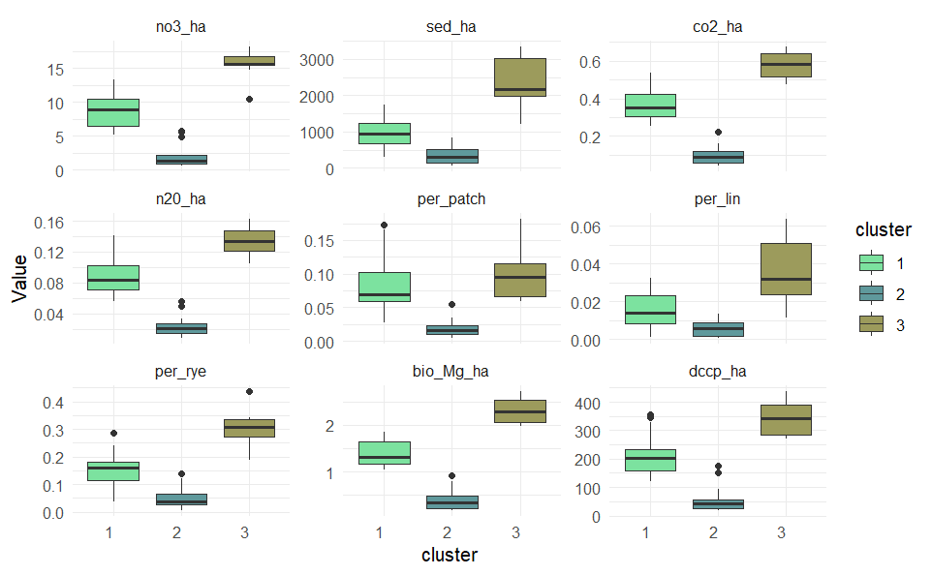
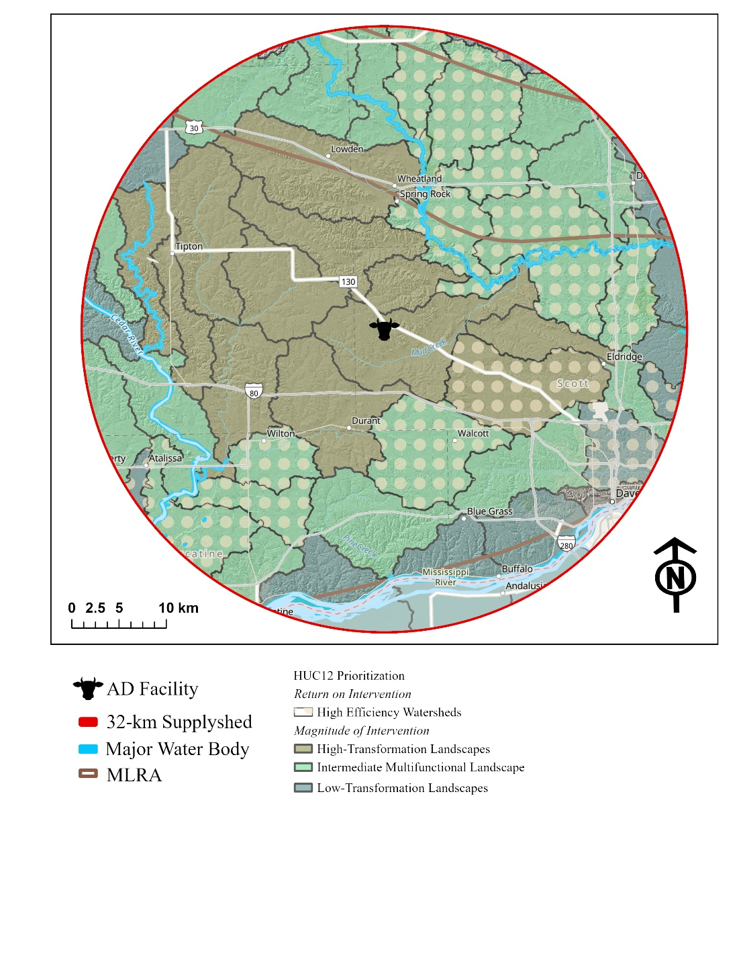

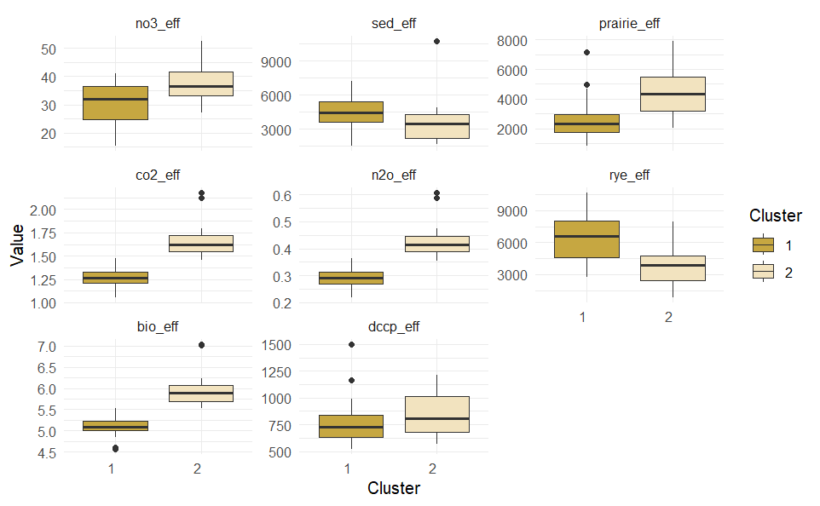
Figure. HUC12 efficiency variability. Costs for this system only looks at structural costs (associated with efficiency reduction potential) + biomass production costs. This map illustrates classification of HUC12 watersheds based on PCA to cluster them by similar environmental outcomes by magnitude and efficiency of land use. The dotted watersheds are estimated to have the highest return on intervention for costs, when only looking at cost of implementation for this multifunctional landscape.

Landscape | # HUC12 | UNSTB | UNP | OC ($/ha)
Magnitude of Intervention
High-Transformation | 12 | 88% | 34% | $2,348
Intermediate-Multifunctional | 22 | 75% | 47% | $1,859
Low-Transformation | 13 | 30% | 29% | $2,042
Return on Intervention
High Efficiency | 15 | 86% | 53% | $1,243
Less Efficiency | 32 | 75% | 34% | $2,406

Bioeconomic Performance (field to HUC12 bridge) Add table after table 2…?

Mobilization of Bioeconomic Plan
We weave it into a shared vision, then redistribute the work in a coordinated effort to pool resources. Identify alignment, target it on the landscape, assign roles, determine who is best suited to have some conversations, and assign and pool resources. The primary stakeholders include: AD bioeconomy planners, watershed planners, conservation professionals, and wildlife managers. Following the explicit land management changes from corn and soybean systems described in the INRS and IWAP, the total costs for vegetative-based biomass production in the supplyshed to develop the multi-objective bioeconomy are $74,917,432 per year (DC: $52,708,361; OC: $22,209,070), where $28,865,862 per year (DC: $11,297,693; OC: $17,568,169) is attributed to IWAP goals alone (Table 3). The total cost for land management and cover changes, if managed exclusively as conservation practices, would be $53,809,271 per year (DC: $29,416,503) for the INRS, of which $20,409,920 (DC: $2,841,751) supports IWAP. The OC costs remain the same in both the harvestable biomass model and the strictly conservation implementation model, as the OC represents the cash rental value of the land's inherent production potential and is unaffected by specific management actions. To see the costs broken down by MLRA and HUC12, see the Supplementary Material X.

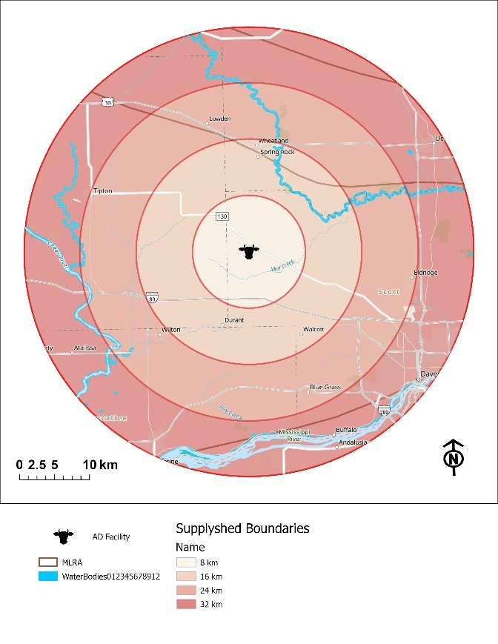
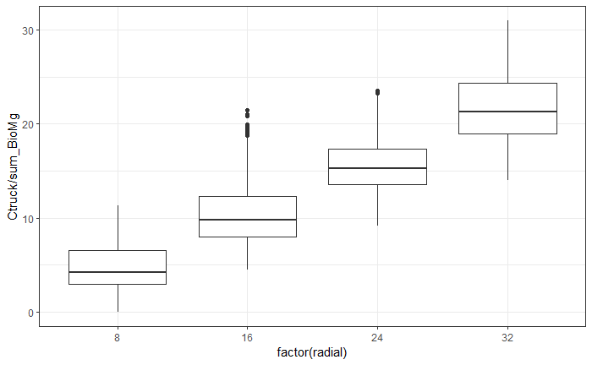
32 km
24 km
16 km
8 km

Figure. Illustration of radial supplyshed distances and summary/distribution of costs for transportation to each band. Each band is evaluated separately.

Table x. Median and quartiles. Based on Mg of biomass material. Regardless of what that material is.
 | 8 | 16 | 24 | 32
Round Trip Distance (km) | 16.1  (11.1-24.7) | 37.1  (30.4-46.5) | 57.8  (51.3-65.6) | 80.2  (71.5-92.0)
Trucking Cost ($/Mg) | $4.27  ($2.94-$6.54) | $9.83  ($8.05-$12.33) | $15.31  ($13.59-$17.38) | $21.26  ($18.94-$24.38)
Handling Cost ($ per field) | $348.72  ($132.09-$742.46) | $342.71  ($140.15-$650.17) | $334.23  ($146.70- $668.00) | $289.39  ($119.22-$612.96)
Delivered Cost ($/Mg) | $128.84  ($65.13-$148.96) | $134.53  ($70.69-$154.29) | $139.04  ($76.40-$160.10) | $143.70  ($82.91-$164.74)
* handling costs are a flat rate: $4.7794 / Mg based on 2026 ISU Custom Rate Survey.

Supplyshed scale Table 4.: Area per band, not total for entire supplyshed. This is additive. Median + QRT; Biomass Yield, Cost of Production, Travel Distance, Transportation (truck+handling) Cost.
 |  | Total Area (ha) | n | Total Yield  (Mg) | Cost of Production ($) |  | TCE  ($ Mg⁻¹) | Round Trip (km) | Transportation Cost ($ Mg⁻¹)
 |  |  |  |  | DC | OC
8 km | R | 5,662 | 220 | 22,847 | $3,217,899 | - | $141 | 16.1  (11.1-24.7) | $9.05  ($7.72- $11.32)
 | P | 2,965 | 431 | 22,433 | $2,464,588 | $3,187,038 | $152
16 km | R | 15,911 | 660 | 64,204 | $9,042,981 | - | $141 | 37.1  (30.4-46.5) | $14.61  ($12.83-$17.11)
 | P | 8,958 | 1,385 | 68,364 | $8,980,515 | $12,126,378 | $159
24 km | R | 21,767 | 879 | 87,834 | $12,371,245 | - | $141 | 57.8  (51.3-65.6) | $20.09  ($18.37-$22.16)
 | P | 12,519 | 1,718 | 95,124 | $10,556,051 | $12,896,272 | $151
32 km | R | 25,199 | 1,071 | 101,681 | $14,321,606 | - | $141 | 80.2  (71.5-92.0) | $26.03  ($23.72-$29.16)
 | P | 12,428 | 1,855 | 94,121 | $10,062,286 | $11,572,548 | $140
Note: trucking is distance dependent. Loading/Unloading + farm-gate/direct costs are similar regardless of radial distance from AD facility.
However, there are some HUC12 watersheds that have different costs due to landscape features, soil types, productivity indices, etc.
[Low-hanging fruit: Yield stability + profitability matrix for planners and outreach strategy. Table 5
Connect these landowners to market opportunities.
Prioritizing cereal rye areas is assumed to occur regardless of yield stability and profit potential, and is focused on the likelihood that a field will be degraded by high runoff. ]
Table 5. Outreach strategy prioritization matrix.
 | Corn Yield Stability
 | Stable High | Stable Low | Unstable
Profitable more than 6 years | - | CR | CR/PR
Unprofitable more than 6 years | CR | CR/PR | PR

The purpose of this research paper is to demonstrate a process that integrates disparate public and private planning frameworks and strategies to generate additionality at multiple planning scales and goal areas within an AD bioeconomy context. Not only can RNG planners benefit from this approach, but also other stakeholders in the supplyshed, since the bioeconomy plan aligns with local watershed groups' and conservation planners' objectives. The field-scale biomass production results were aggregated to the HUC12 watershed level to identify priority watersheds for targeting in the supplyshed. The watersheds were ranked to determine where the greatest environmental outcomes were achieved, the lowest biomass production costs, the least unstable yields, and the least impacts on profitability between 2015 and 2024 were reported (Supplementary materials). The top ten HUC12 watersheds for environmental outcomes were selected to support prioritization, and 17 watersheds have at least one environmental outcome with the greatest benefits (Figure 5). Nine of the 17 watersheds were identified as having the most unstable yields and unprofitable fields (Figure 5). These nine watersheds should be targeted initially to leverage agricultural land for conservation practices and biomass production, generating co-benefits for health and reducing nutrient runoff. The framework presented in this paper uses SCP principles. It provides a replicable SDSS that can be readily applied in other agricultural landscapes where ACPF core data and land management goals are available.
Wildlife crosses watershed boundaries (Figure 3), targeting strategic wildlife habitat complexes and raising funds for them. Knocking on doors, ensuring it is done wisely. Prioritize areas with the most wildlife outcomes. Incorporating a mix of prairie strips, herbaceous riparian buffers and core habitat patches on the landscape created a continuum across the landscape that recognizes some of the Iowa prairie species-specific habitat contours and design a habitat matrix within the supplyshed (Fischer et al., 2004; Fischer & Lindenmayer, 2006; Fischer et al., 2006; Franklin & Lindenmayer 2009) while avoiding hostile habitat areas known for prairie species, such as forests (Guttery et al. 2017). To optimize outcomes for wildlife, we are considering a "wildlife-friendly farming" approach to identify areas dedicated to prairie biomass that increase landscape heterogeneity (Fischer et al. 2008).
Supplyshed approach à we have achieved the biomass goals. There may need to be some buffer here because we assume x, y, and z for harvestability, and these payments may not be annual if they are harvesting 50% of the prairie, or every other year for cereal rye. Prioritize watersheds that are closest and produce the most biomass. Emerging.]
In this case study, the farmer has indicated that 50% of the prairie field would be harvested each year. Using this as a general rule of thumb, we can assume that of the total 142,259 Mg produced annually, 71,130 Mg would be harvested, resulting in 2,510,164 MMBTU yr⁻¹ of RNG (Table 2). The proportion retained each year will range from 33% (as recommended by the Minnesota Department of Natural Resources [Garms et al., 2009]) to 50% (RAE, 2024). The assumed harvest regime incorporates principles from Palik et al. (2021)'s ecological silviculture to mimic the natural, frequent, low-severity disturbance regime of prairie systems, created by grazing and fire, which occurs in late summer to fall. Ecological silviculture manages perennial production systems with goals comparable to those of a prairie bioenergy system, where the management of biomass and wildlife is deeply intertwined. In contrast, for corn stover—one of the most common crop residue digested at AD facilities in Iowa—the harvest regime is focused only on yield maximization—and studies have shown that 100% harvest of stover can decrease grain yields (Boehmel et al., 2008; Karlen et al., 2011; Adler et al., 2015) and negatively impact water quality (Khanal et al., 2014) as well as potentially increase synthetic nutrient amendments within the field since organic material is being removed (Becerra-Pérez et al., 2022).
A more in-depth financial analysis is needed to evaluate benefit opportunities and explore market opportunities, such as environmental markets and the expansion of AD technology in the region that incentivizes the use of prairie and cereal rye biomass. The direct cost and total cost of this bioeconomic plan are approximately $52.7 million and $82.3 million, respectively (Table 6). The case study AD facility cannot sustain this bioeconomic plan with its current feedstock demand; however, it can help develop infrastructure and markets for a perennial feedstock source to generate RNG while supporting overlapping conservation objectives. There may be opportunities to leverage land exiting limited-term easement programs (e.g., CRP) or through payment-for-conservation programs like EQIP, which could offset some of the upfront establishment costs and risk associated with farmers pursuing harvestable biomass models. Therefore, exploring additional market opportunities to align environmental and agronomic goals in the region is worthwhile.
The approach demonstrated in this paper integrates landscape resilience and productivity – reducing nutrient losses and improving soil function without displacing food production on prime farmland. A limitation in this study is that the ACPF and companion tools do not explicitly target and quantify wildlife benefits and connectivity. Additional analysis tools need to be developed to improve this process so planners can effectively target large patches and corridors targeted for species of concern. However, the proposed SDSS framework developed for this study could play an important role in regional RNG strategies by providing distributed, low-risk feedstock sources that enhance both environmental and economic performance over the long term.

Figure 5a. Financial feasibility curves. Purpose: Under what conditions does this system work?
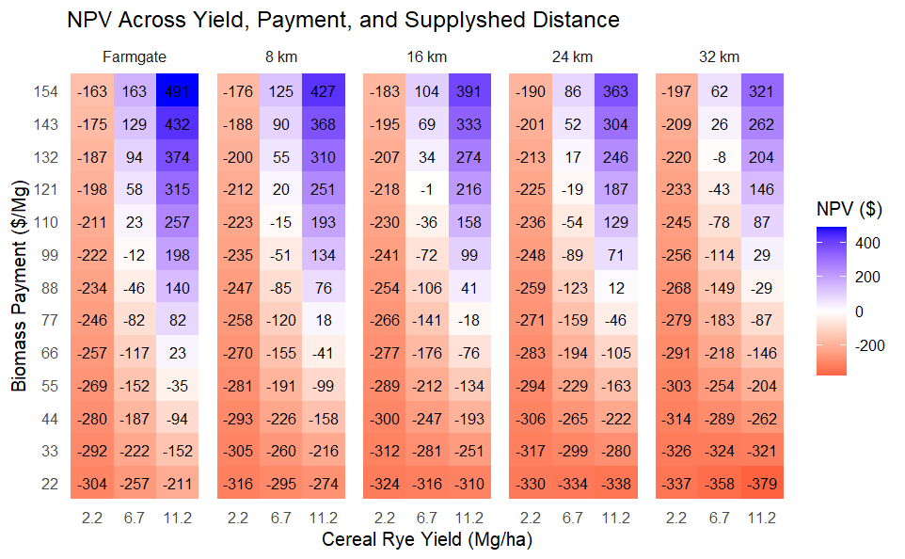
Breakeven
Farmgate: 2.2 Mg/ha = $309/ha; 6.7 Mg / ha = $103 per Mg; 11.2 Mg /ha = $62/Mg
8 km: 2.2 Mg/ha = $321/Mg; 6.7 Mg / ha = $116 per Mg; 11.2 Mg / ha = $74 per Mg
16 km: 2.2 Mg/ha = $327/Mg; 6.7 Mg / ha = $122 per Mg; 11.2 Mg / ha = $81 per Mg
24 km: 2.2 Mg/ha = $333/Mg; 6.7 Mg / ha = $128 per Mg; 11.2 Mg per ha = $86 per Mg
32 km: 2.2 Mg/ha = $341/Mg; 6.7 Mg / ha = $135 per Mg; 11.2 Mg per ha = $94 per Mg
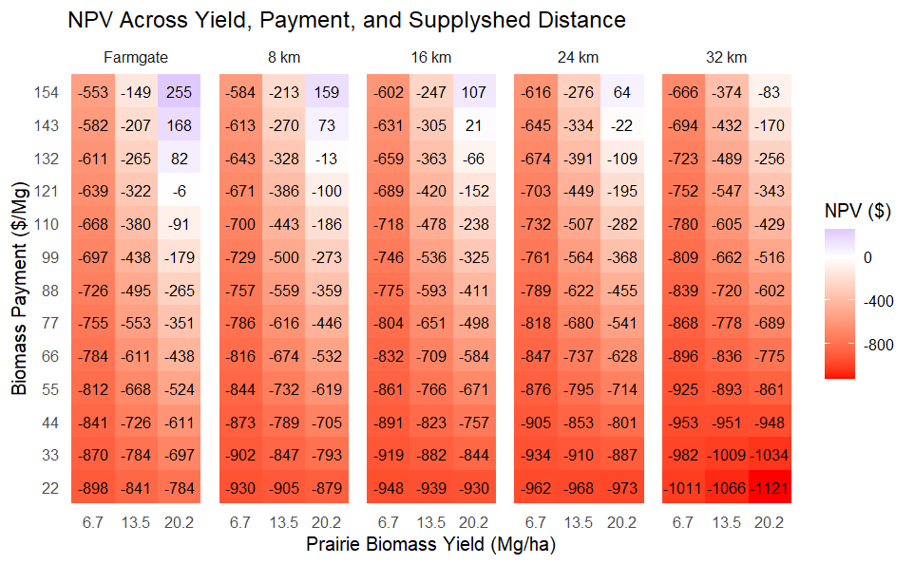
Breakeven
Farmgate: 6.7 Mg/ha = $375/ha; 13.5 Mg / ha = $181 per Mg; 20.2 Mg /ha = $122/Mg
8 km: 6.7 Mg/ha = $387/Mg; 13.5 Mg / ha = $197 per Mg; 20.2 Mg / ha = $135 per Mg
16 km: 6.7 Mg/ha = $394/Mg; 13.5 Mg / ha = $203 per Mg; 20.2 Mg / ha = $141 per Mg
24 km: 6.7 Mg/ha = $399/Mg; 13.5 Mg / ha = $209 per Mg; 20.2 Mg per ha = $147 per Mg
32 km: 6.7 Mg/ha = $407/Mg; 13.5 Mg / ha = $217 per Mg; 20.2 Mg per ha = $155 per Mg

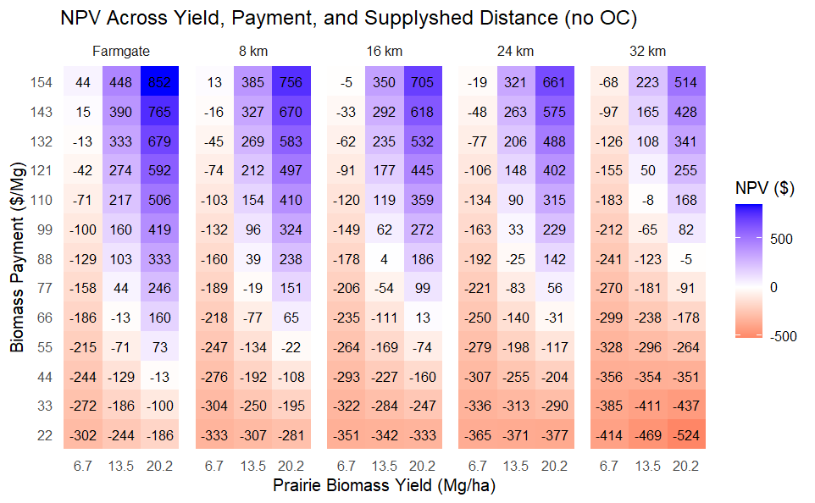
Breakeven
Farmgate: 6.7 Mg/ha = $140/ha; 13.5 Mg / ha = $69 per Mg; 20.2 Mg /ha = $46/Mg
8 km: 6.7 Mg/ha = $152/Mg; 13.5 Mg / ha = $82 per Mg; 20.2 Mg / ha = $58 per Mg
16 km: 6.7 Mg/ha = $158/Mg; 13.5 Mg / ha = $88 per Mg; 20.2 Mg / ha = $65 per Mg
24 km: 6.7 Mg/ha = $164/Mg; 13.5 Mg / ha = $94 per Mg; 20.2 Mg per ha = $70 per Mg
32 km: 6.7 Mg/ha = $172/Mg; 13.5 Mg / ha = $101 per Mg; 20.2 Mg per ha = $78 per Mg

