Multi-scale Systems Story

Questions:
- Does/can an AD bioeconomy goal align with conservation goals?
  - What metrics or programs exist that span both private and public planning efforts?
- Do planning tools and frameworks exist to evaluate and target multi-objective?
  - What tools are available to identify and assess this question?
  - Spatial and theoretical tools and frameworks (SWAT, INVEST, Marxan, AgSolver…)
- Are there metrics that can translate private goals and public goals into a shared vision?
- [Discussion] who needs to be involved in these discussions? (Professionals + land ownership + costs)
- [Discussion] what/how do we implement this plan? What is successful?

Methods:
- Case study summary insert
Case study: AD Facility is EC Iowa, New Liberty
Feedstock portfolio:
History:
Biomass goals:
Supplyshed: 32 km, land use, resource inventory, cities
Overlapping/Regional Plans/Goals:
Groups in the Supplyshed:

- Resource plan analysis, stakeholder identification, define planning units
- Tool inventory/description, pros/cons, strengths/weaknesses, explain tools and limitations, constraints
- Terrain analysis and spatial targeting
- Quantify outcomes and costs
  - Unified cost-effectiveness metric
  - EF
  - Leaching and how we calculate that.
  - Supplementary materials

Stylistic considerations:
- Use consistent color coding for MLRA across panels
- Weighting HUC12 and MLRA results
- Small inset map showing MLRA boundaries with supplyshed overlay
- For Figure 3, keep HUC12-level metrics, but add small icons or color overlays showing dominant CP scenario in each watershed.
Narrative flow of results:
Work is decision-relevant instead of just descriptive.
Three tiers of questions:
- Biophysical (where and how much benefit?)
- Bioeconomic (What does it cost to achieve?)
- Financial viability (will anyone actually do this?)
Flow of tables and figures:
- Practices define performance (Table 1)
- Fields show variability (Figure 2)
- HUC12 outcomes. Watersheds show spatial structure (Figure 3)
- Supplysheds show scaling (Figure 4)
- Financial feasibility (Figure 5)
- Transport/Logistics (Figure 6)
- Tradeoffs (updated fig 5/7)
- Supplyshed summary table
- Final system outcome (Table 4 + Figure 6)

Design principles:
- CP, field, HUC12 per ha
- Supplyshed Totals
- Avoid duplication
- Handle uneven HUC12s properly.
  - Use area-weighting
  - Use clipped HUC12s
  - Report both per ha efficiency and total contribution.
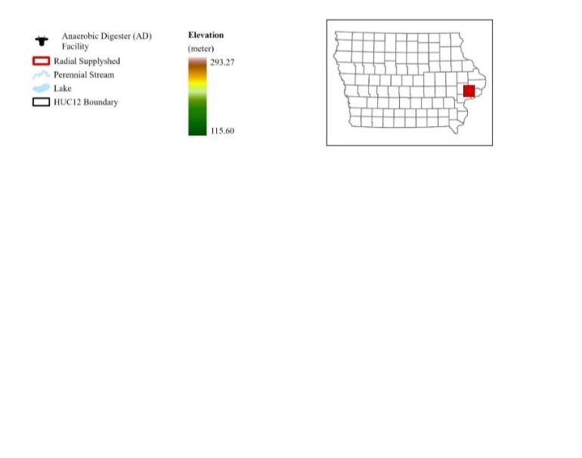
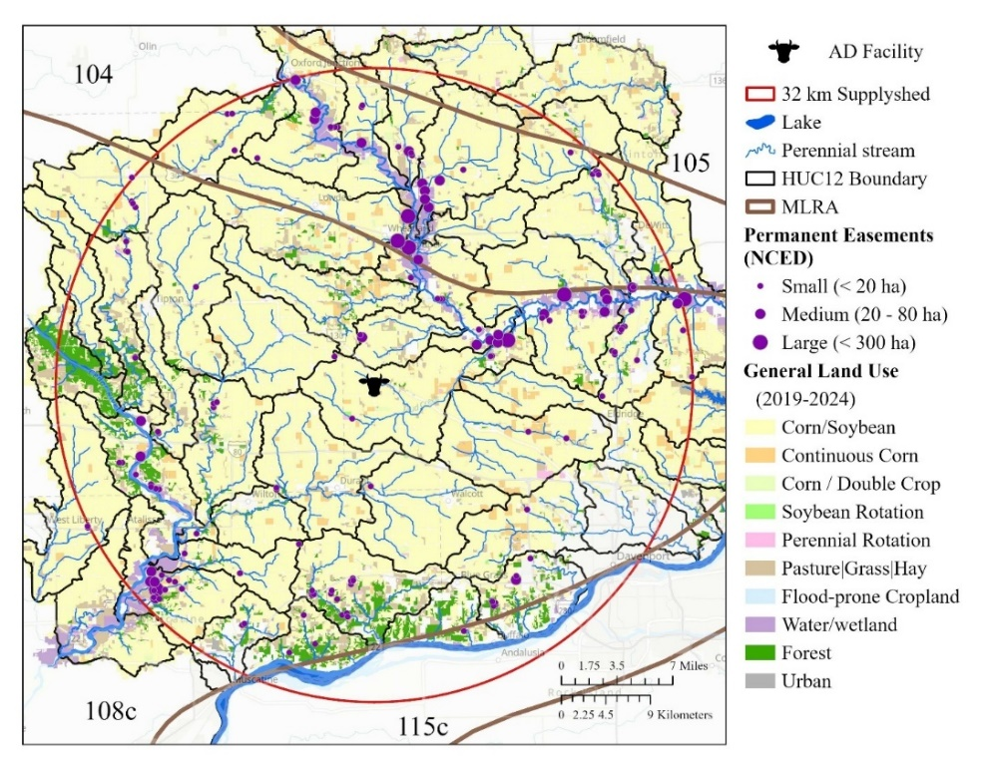
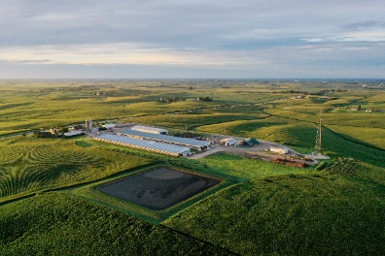
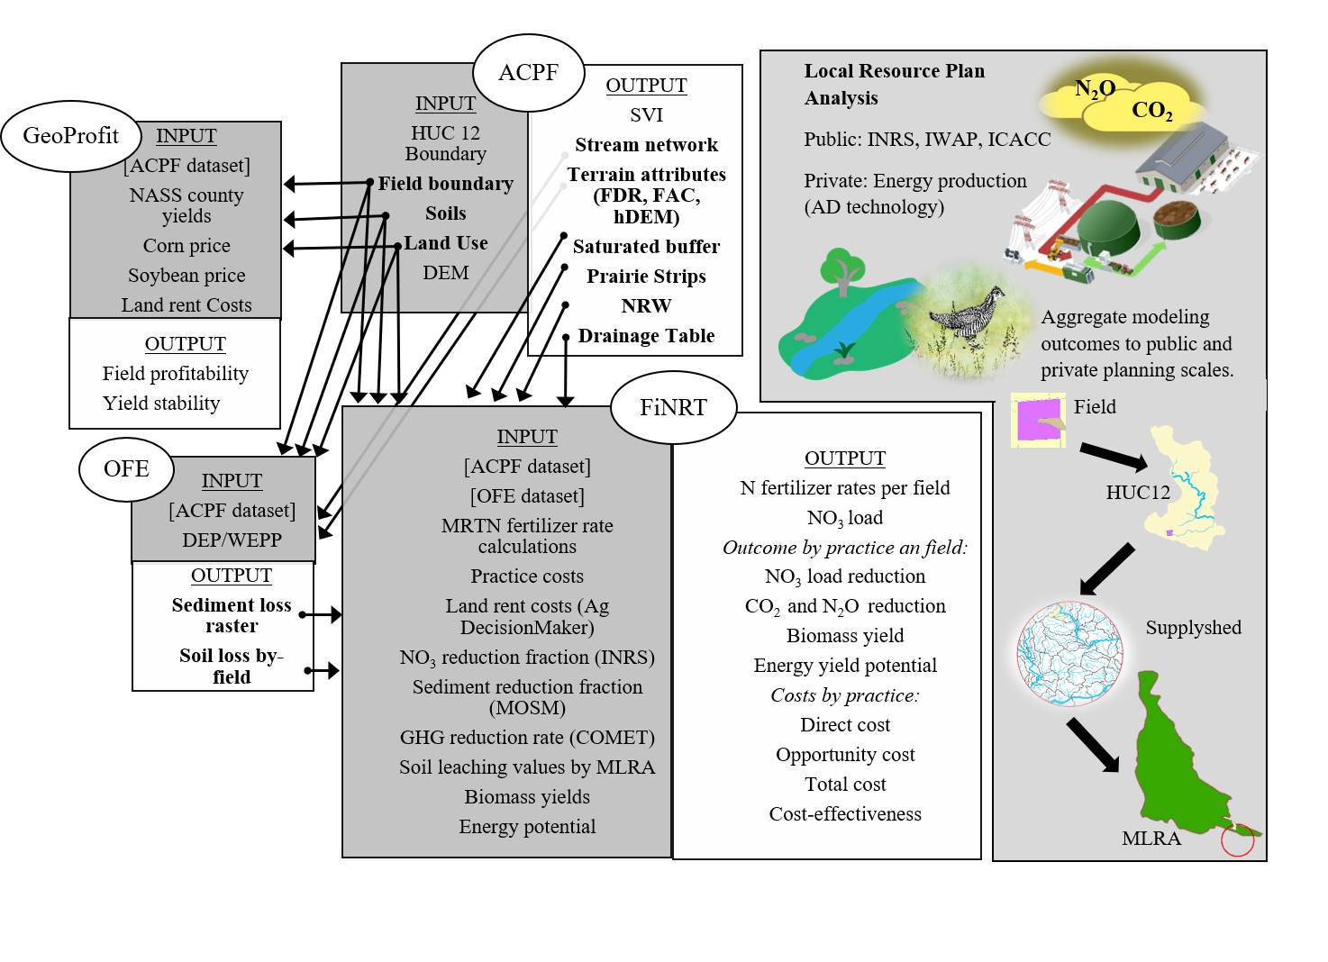






Figure 1. Study area and scale. Orient reader to nested reporting scales.

Table supplementary. Summary of spatial units.
Scale | # of units | Area (ha) | purpose
Practice | 4 | 115,547 | Biomass production + CP. Stacking outcomes.
Cropped fields in supplyshed | n | 8,627 | Targeting
HUC12 | 48 | 1,061,528 | Watershed reporting & targeting
MLRA | 4 | 6,791,107 | Regional pattern and recommendations from INRS
Radial Supplyshed | 4 | 313,962 | Bioeconomic outcomes

Results
Results [Practice Scale] Table 1. Conservation practice (CP) performance. What does intervention do? Median and IQR where possible, and % of total supplyshed occupied/converted by each practice. Referenced first in results to anchor downstream aggregation figures. Outcome per conservation practice (CP). TCE includes structural, vegetation, management, harvest and opportunity costs. Add establishment vs. annual costs distinction?
 | Annual Crop: Winter Rye | Perennial Crop: Prairie
 |  | NRW | Riparian Buffer³ |  | PS | PCP
 |  |  | STB | RIB
Total Area (ha) | 68,539 | 2,196 | 584 | 147 | 6,789 | 27,153
% of fields | 33% | 5% |  |  | 35%
Direct Costs¹ ($ ha⁻¹ yr⁻¹) per CP
Struc + Veg | $230 | $6,137 | $486 | $149 | $173
Veg |  | $788 | $149
Ecosystem Service Outcomes per CP
Biomass Yield  (Mg) | 77.3  (43.3-126.2) | 21.4  (14.3-32.6) | 5.7  (5.3-6.1) | 5.6  (5.3-6.2) | 21.8  (13.6-35.2) | 139.8  (71.7-242.5)
NO₃ Load  (Mg) | 0.17  (0.1-0.3) | 1.4  (1.0-2.2) | 0.3  (0.2-0.8) | 0.6  (0.3-1.2) | 0.2  (0.1-0.4) | 0.5  (0.3-0.8)
Sediment Load  (Mg) | 34.1  (16.2-63.8) | 134.8  (86.0-236.4) | 41.4  (19.5-83.5) | 51.8  (24.6-98.2) | 30.3  (13.3-58.1) | 28.8  (14.3-57.7)
CO₂ Emissions  (Mg CO₂) | 15.2  (8.5-24.7) | 6.8  (4.6-10.4) | 0.9  (0.8-1.0) | 0.9  (0.8-1.0) | 7.0  (4.4-11.3) | 44.7  (22.9-77.5)
N₂O Emissions  (Mg CO₂ _{e}) | 2.4  (1.3-3.9) | 2.4  (1.3-3.9) | 0.3  (0.2-0.3) | 0.3  (0.2-0.3) | 2.0  (1.2-3.2) | 12.8  (6.6-22.1)
Core Habitat Patch | o | o | o | o | o | +
Linear Habitat | o | o | + | + | + | o
Total Cost-effectiveness² per CP
Biomass  ($ Mg⁻¹) | $141* | $2,911  ($2,738-$3,143) | $345  ($325-$358) | $276  ($172-$295) | $129  ($117-$140) | $140  ($120-$150)
Energy  ($ MMBtu⁻¹) | $12* | $227  ($213-$245) | $27  ($25-$28) | $21  ($13- $23) | $10  ($9-$11) | $11  ($9-$12)
NO₃  ($ kg NO₃ ⁻¹) | $66  ($61-$66) | $7  ($34-$55) | $8  ($2-$10) | $4  ($1-$4) | $12  ($11-$14) | $39  ($34-$44)
Sediment  ($ kg sed⁻¹) | $0.34  ($0.18-$0.61) | $0.46  ($0.26-$0.80) | $0.05  ($0.02-$0.09) | $0.03  ($0.01-$0.06) | $0.09  ($0.06-$0.20) | $0.86  ($0.48-$1.32)
CO₂  ($ kg CO₂ ⁻¹) | $0.72* | $2.68  ($2.65-$2.71) | $2.03  ($1.88-$2.06) | $1.76  ($1.11-$1.89) | $0.40  ($0.37-$0.44) | $0.44  ($0.38-$0.47)
N₂O  ($ kg CO_{2 eq}⁻¹) | $4.60* | $9.38  ($9.27-$9.47) | $7.13  ($6.58-$7.20) | $6.14  ($3.89-$6.61) | $1.41  ($1.28-$1.54) | $1.53  ($1.32-$1.64)
* There isn’t a threshold because it is a flat rate per hectare for implementation and the variability was not modeled for biomass yield, energy production and GHG emissions due to limitations in biophysical data at field-scales.
¹ The direct costs are annualized across 10 years at 6% discount rate. The direct costs are broken down into two different categories: 1. Structural and Vegetative, and 2. Vegetative. The Structural and Vegetative category includes direct costs associated with establishment, operation and maintenance of both the structural (i.e., control structures, basin creation) and vegetative components (e.g., buffer) of the conservation practice. The Vegetative category only includes costs for establishment, operation and maintenance of the vegetative component of the conservation practice, while the structural components are assumed to be covered through other funding sources (e.g., conservation payments). Site design in both categories is assumed to be completed by local technical assistance provider (e.g., NRCS) and the costs are left out of the budget. In the case of riparian buffer, the vegetative component incurs the same direct costs.
² The total cost-effectiveness accounts for direct costs in $2026 for structural and vegetative components of establishing, managing and harvesting biomass material from the conservation practice, in addition to the opportunity cost. The total cost is divided by the estimated environmental outcome associated with each conservation practice.
Results Table 2. Field-scale summary statistics. Aggregated descriptive statistics per field. Median and quartiles. Entire Supplyshed and all fields treated.
Metric | Sum |  | Median
 | Rye | Prairie | Rye | Prairie
Area | 68,539 | 36,870 | 19.16  (10.72 - 31.28) | 3.73  (1.65 - 9.16)
Biomass Yield (Mg) | 276,565 | 280,041 | 77.32  (43.27 - 126.22) | 27.66  (13.92 - 68.31)
NO₃ Load (Mg) | 3,746 |  | 0.35  (0.17 – 0.84)
Sediment Load (Mg) | 489,586 |  | 42.14  (17.16 – 104.60)
CO₂ (Mg) | 141,824 |  | 15.35  (6.69 - 31.92)
N₂O (Mg CO_{2 eq}) | 33,505 |  | 3.22  (1.48 - 6.55)
Distance (km) |  |  | 61.2  (43.3 –75.9)
Direct Costs | $38,953,731 | $23,371,824 | $10,890  ($6,095 – $17,778) | $1,741  ($666 – $5,559)
Total Costs |  | $47,878,740 |  | $4,561  (2,028 – 11,381)
Biomass Handling  (Loading/Unloading; $ per field) | $2,654,951 |  | $317  ($134 – $649)
Biomass Transport Costs (hauling + loading/unloading; $ per field) | $11,262,031 |  | $1,313  ($544 – $2,749)
Biomass Transport + Direct Costs ($ per field) | $67,912,856 |  | $8,974  ($3,307 - $18,653)
None of these account for the fact that they are partial loads. Aggregation would be valuable and could potentially reduce some of the transportation costs.
All transportation costs are directed to case study AD facility.
Handling costs are regardless of AD facility location. Only per bale costs.
Transport + loading/unloading costs only occur in years when harvest occurs.
Table x. Field scale economic inputs. Per field: Some fields have a combo platter of prairie and rye biomass material. Transportation costs only in years when biomass material is harvested. Median + quartiles. Handling is flat rate for bales

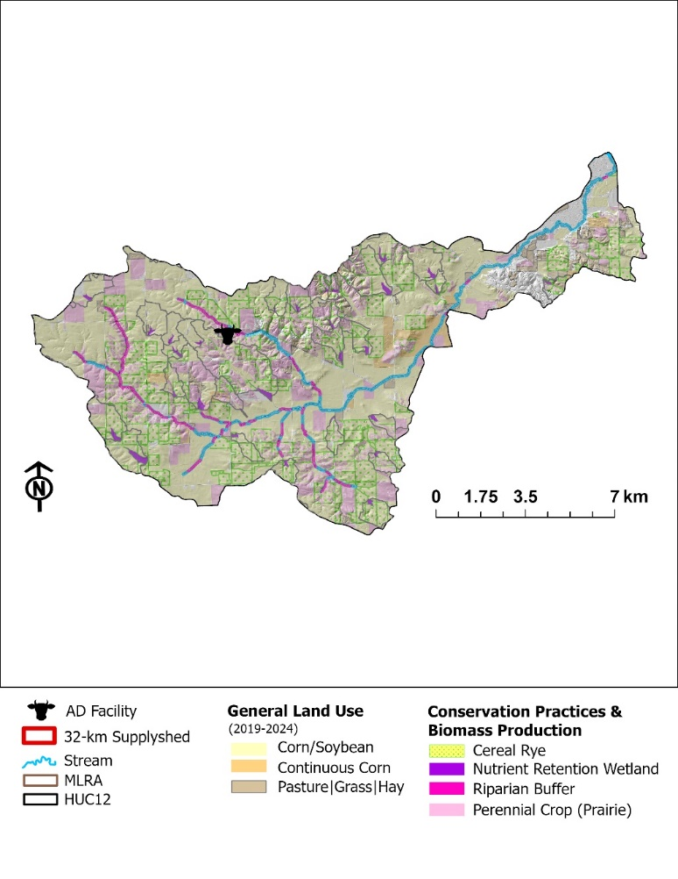
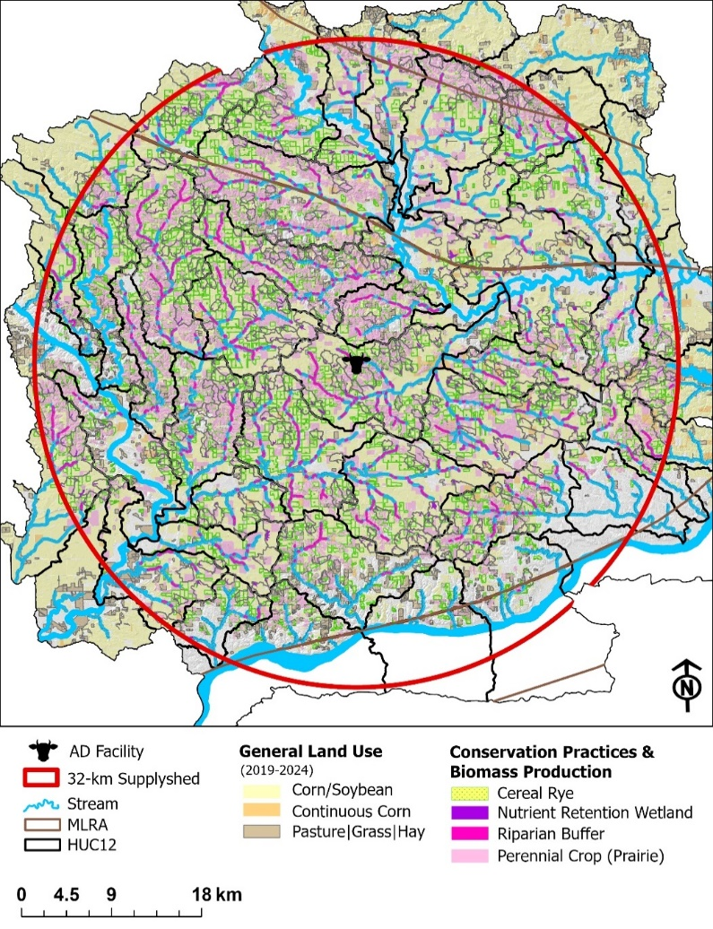
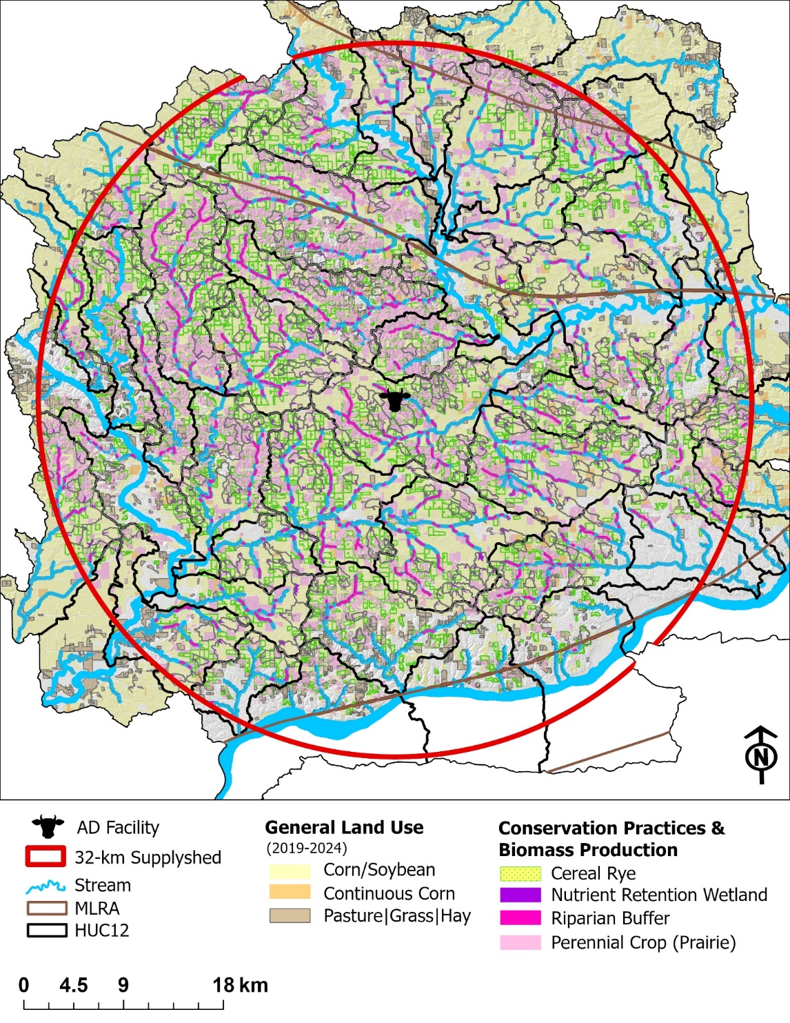
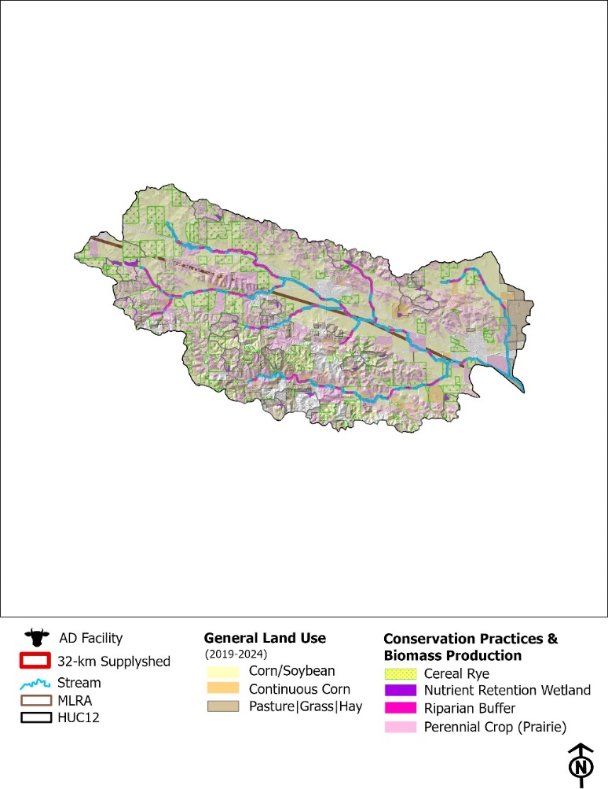
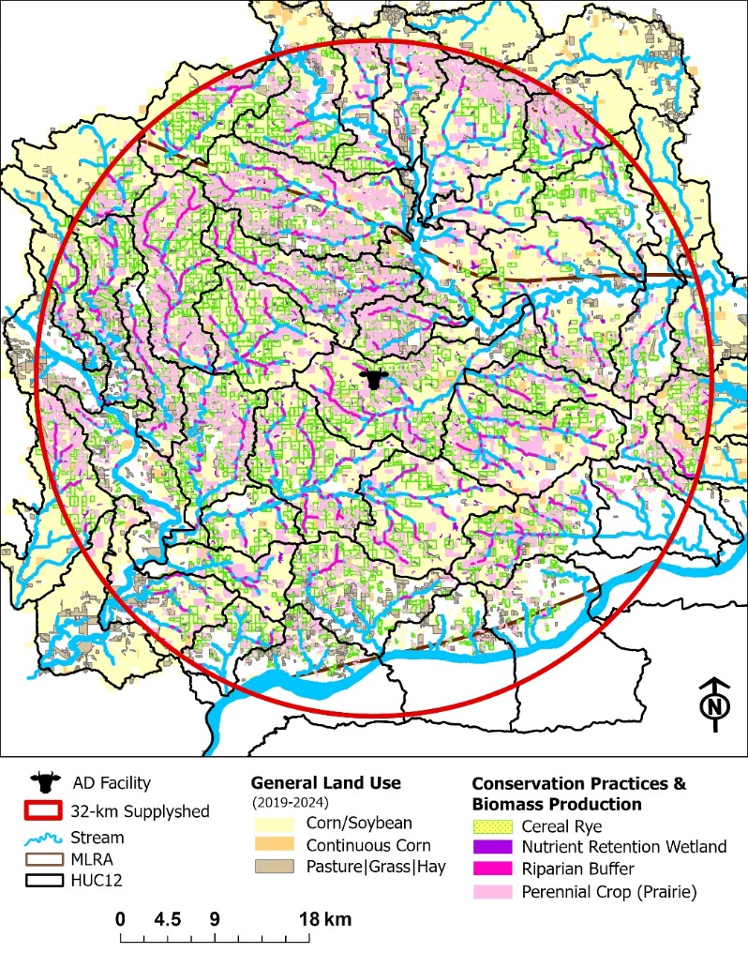

Results Figure 1. Field-scale spatial targeting. Where are practices placed and why? Field 3. Field-scale targeting and intervention (map panels). Prairie sitings, cereal rye, CP. The “where”
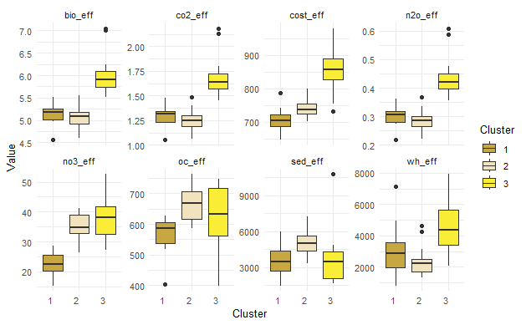
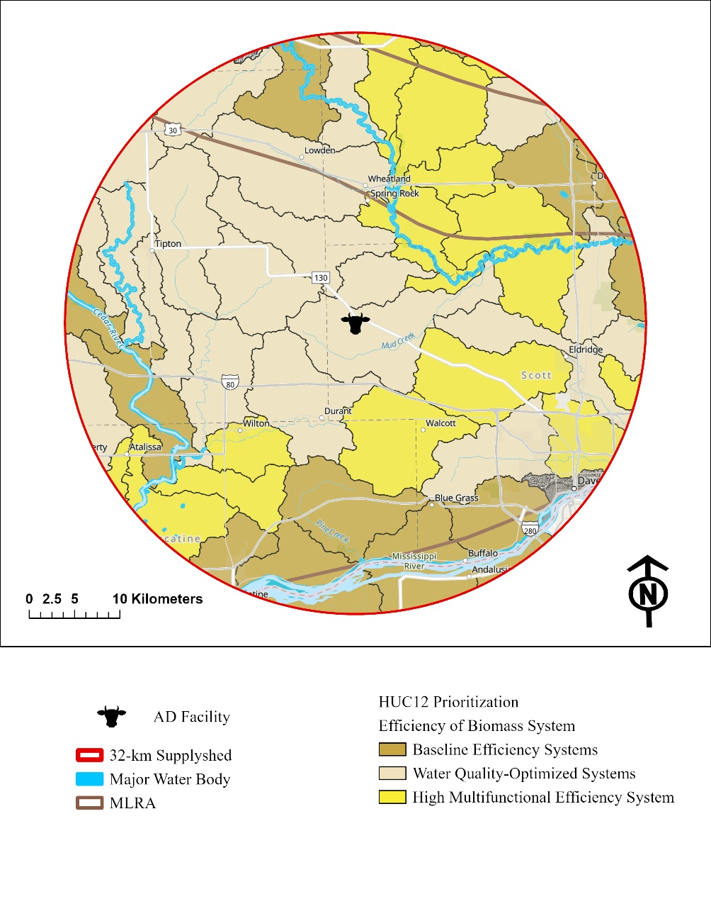
7
6
5
NO₃ Load (kg ha⁻¹)
50
40
30
20
CO₂ Emissions (Mg ha⁻¹)
Opportunity Costs ($ ha⁻¹)
Total Cost Efficiency ($)
Sediment Load (kg ha⁻¹)
N₂O Emissions (Mg ha⁻¹)
Habitat Patch (ha)
Biomass Yield (Mg)

Figure. HUC12 efficiency variability. Costs for this system only looks at biomass production costs + opportunity costs. The DC of implementation was excluded. We are focused on the biomass production side of things, and if people want to optimize practices, they can consider the implementation of structural practices (see table x).
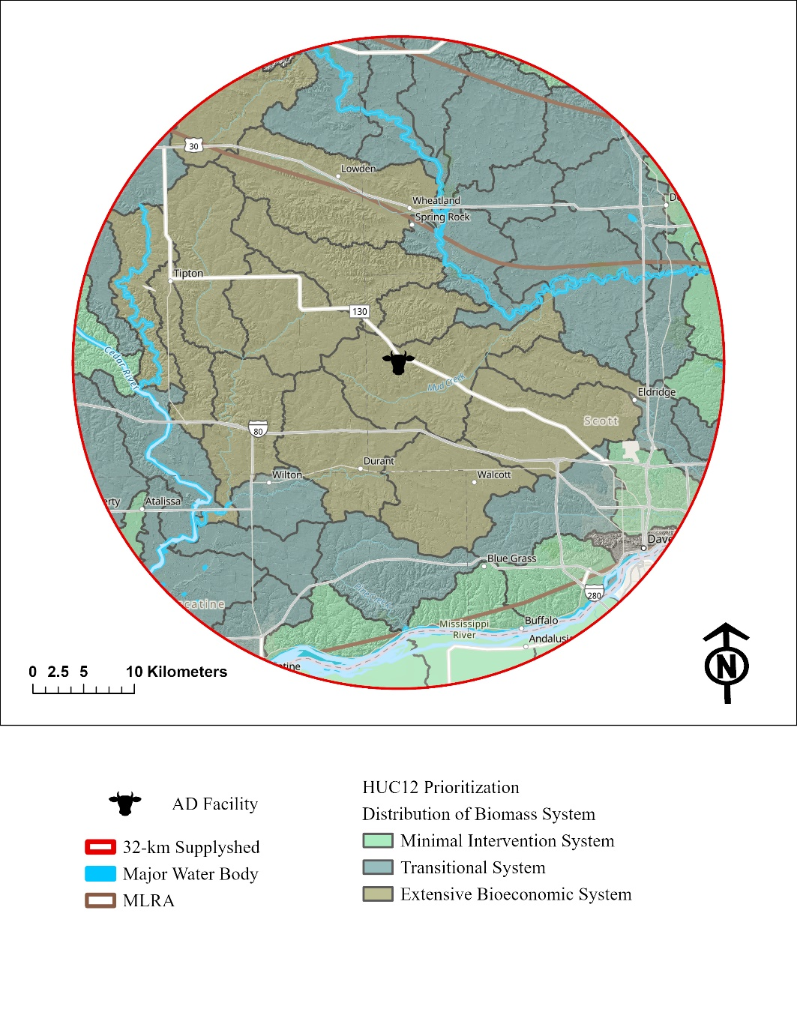

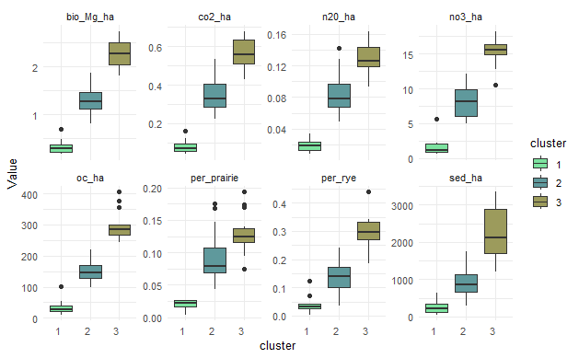
Figure. HUC12 extent variability. Costs for this system only looks at biomass production costs + opportunity costs. The DC of implementation was excluded. We are focused on the biomass production side of things, and if people want to optimize practices, they can consider the implementation of structural practices (see table x).
Bioeconomic Performance (field to HUC12 bridge) Add table after table 2…?
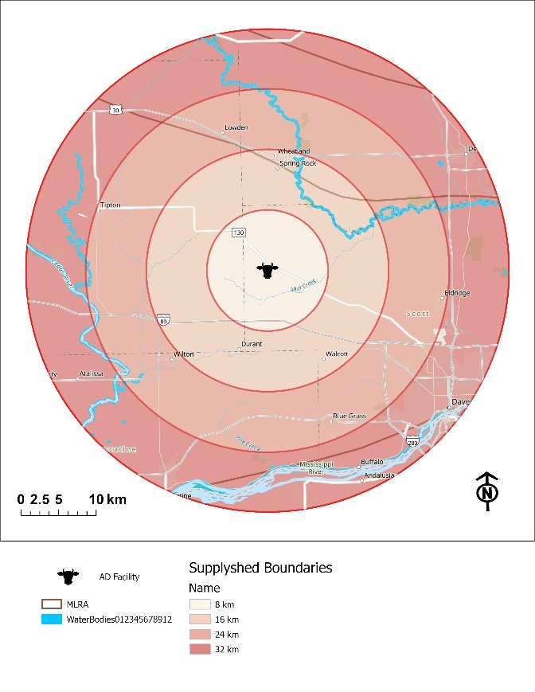
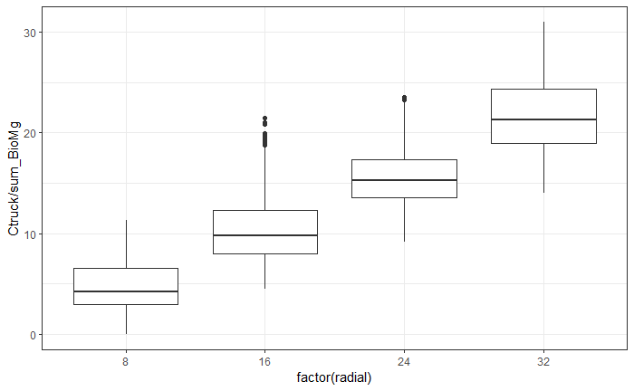
32 km
24 km
16 km
8 km

Supplyshed scale Table 4.: Area per band, not total for entire supplyshed. This is additive. Median + QRT; Biomass Yield, Cost of Production, Travel Distance, Transportation (truck+handling) Cost.
Figure. Illustration of radial supplyshed distances and summary/distribution of costs for transportation to each band. Each band is evaluated separately.
 |  | Total Area (ha) | n | Total Yield  (Mg) | Cost of Production ($) |  | TCE  ($ Mg⁻¹) | Round Trip (km) | Transportation Cost ($ Mg⁻¹)
 |  |  |  |  | DC | OC
8 km | R | 5,662 | 220 | 22,847 | $3,217,899 | - | $141 | 16.1  (11.1-24.7) | $9.05  ($7.72- $11.32)
 | P | 2,965 | 431 | 22,433 | $2,464,588 | $3,187,038 | $152
16 km | R | 15,911 | 660 | 64,204 | $9,042,981 | - | $141 | 37.1  (30.4-46.5) | $14.61  ($12.83-$17.11)
 | P | 8,958 | 1,385 | 68,364 | $8,980,515 | $12,126,378 | $159
24 km | R | 21,767 | 879 | 87,834 | $12,371,245 | - | $141 | 57.8  (51.3-65.6) | $20.09  ($18.37-$22.16)
 | P | 12,519 | 1,718 | 95,124 | $10,556,051 | $12,896,272 | $151
32 km | R | 25,199 | 1,071 | 101,681 | $14,321,606 | - | $141 | 80.2  (71.5-92.0) | $26.03  ($23.72-$29.16)
 | P | 12,428 | 1,855 | 94,121 | $10,062,286 | $11,572,548 | $140
Note: trucking is distance dependent. Loading/Unloading + farm-gate/direct costs are similar regardless of radial distance from AD facility.
However, there are some HUC12 watersheds that have different costs due to landscape features, soil types, productivity indices, etc.
Table x. Median and quartiles. Based on Mg of biomass material. Regardless of what that material is.
 | 8 | 16 | 24 | 32
Round Trip Distance (km) | 16.1  (11.1-24.7) | 37.1  (30.4-46.5) | 57.8  (51.3-65.6) | 80.2  (71.5-92.0)
Trucking Cost ($/Mg) | $4.27  ($2.94-$6.54) | $9.83  ($8.05-$12.33) | $15.31  ($13.59-$17.38) | $21.26  ($18.94-$24.38)
Handling Cost ($ per field) | $348.72  ($132.09-$742.46) | $342.71  ($140.15-$650.17) | $334.23  ($146.70- $668.00) | $289.39  ($119.22-$612.96)
Delivered Cost ($/Mg) | $128.84  ($65.13-$148.96) | $134.53  ($70.69-$154.29) | $139.04  ($76.40-$160.10) | $143.70  ($82.91-$164.74)
* handling costs are a flat rate: $4.7794 / Mg based on 2026 ISU Custom Rate Survey.

Figure 5a. Financial feasibility curves. Purpose: Under what conditions does this system work?
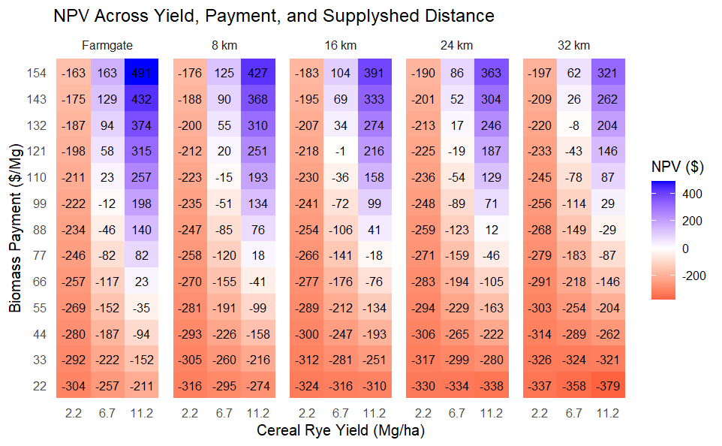
Breakeven
Farmgate: 2.2 Mg/ha = $309/ha; 6.7 Mg / ha = $103 per Mg; 11.2 Mg /ha = $62/Mg
8 km: 2.2 Mg/ha = $321/Mg; 6.7 Mg / ha = $116 per Mg; 11.2 Mg / ha = $74 per Mg
16 km: 2.2 Mg/ha = $327/Mg; 6.7 Mg / ha = $122 per Mg; 11.2 Mg / ha = $81 per Mg
24 km: 2.2 Mg/ha = $333/Mg; 6.7 Mg / ha = $128 per Mg; 11.2 Mg per ha = $86 per Mg
32 km: 2.2 Mg/ha = $341/Mg; 6.7 Mg / ha = $135 per Mg; 11.2 Mg per ha = $94 per Mg
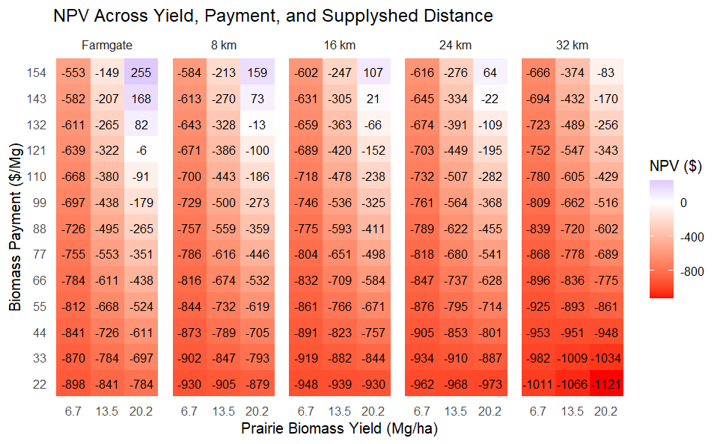
Breakeven
Farmgate: 6.7 Mg/ha = $375/ha; 13.5 Mg / ha = $181 per Mg; 20.2 Mg /ha = $122/Mg
8 km: 6.7 Mg/ha = $387/Mg; 13.5 Mg / ha = $197 per Mg; 20.2 Mg / ha = $135 per Mg
16 km: 6.7 Mg/ha = $394/Mg; 13.5 Mg / ha = $203 per Mg; 20.2 Mg / ha = $141 per Mg
24 km: 6.7 Mg/ha = $399/Mg; 13.5 Mg / ha = $209 per Mg; 20.2 Mg per ha = $147 per Mg
32 km: 6.7 Mg/ha = $407/Mg; 13.5 Mg / ha = $217 per Mg; 20.2 Mg per ha = $155 per Mg

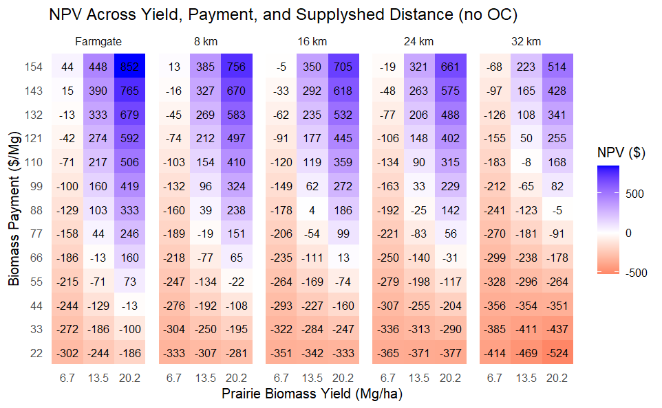
Breakeven
Farmgate: 6.7 Mg/ha = $140/ha; 13.5 Mg / ha = $69 per Mg; 20.2 Mg /ha = $46/Mg
8 km: 6.7 Mg/ha = $152/Mg; 13.5 Mg / ha = $82 per Mg; 20.2 Mg / ha = $58 per Mg
16 km: 6.7 Mg/ha = $158/Mg; 13.5 Mg / ha = $88 per Mg; 20.2 Mg / ha = $65 per Mg
24 km: 6.7 Mg/ha = $164/Mg; 13.5 Mg / ha = $94 per Mg; 20.2 Mg per ha = $70 per Mg
32 km: 6.7 Mg/ha = $172/Mg; 13.5 Mg / ha = $101 per Mg; 20.2 Mg per ha = $78 per Mg

