Multi-scale Systems Story
Narrative flow of results:
Work is decision-relevant instead of just descriptive.
Three tiers of questions:
- Biophysical (where and how much benefit?)
- Bioeconomic (What does it cost to achieve?)
- Financial viability (will anyone actually do this?)
Design principles:
- CP, field, HUC12 per ha
- Supplyshed Totals
- Avoid duplication
- Handle uneven HUC12s properly.
  - Use area-weighting
  - Use clipped HUC12s
  - Report both per ha efficiency and total contribution.
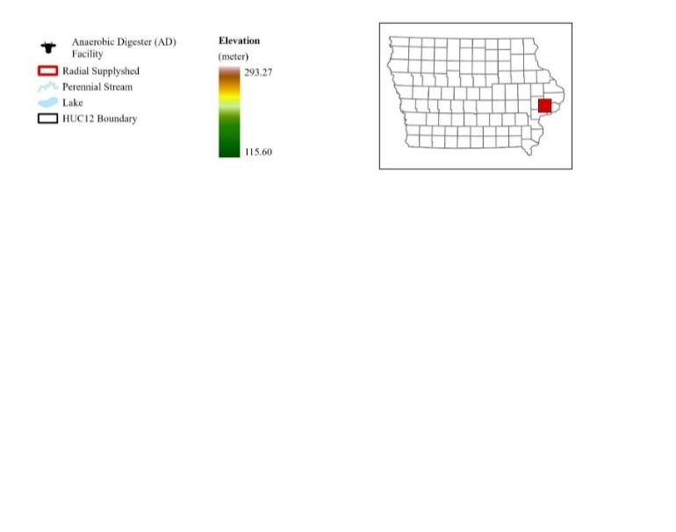
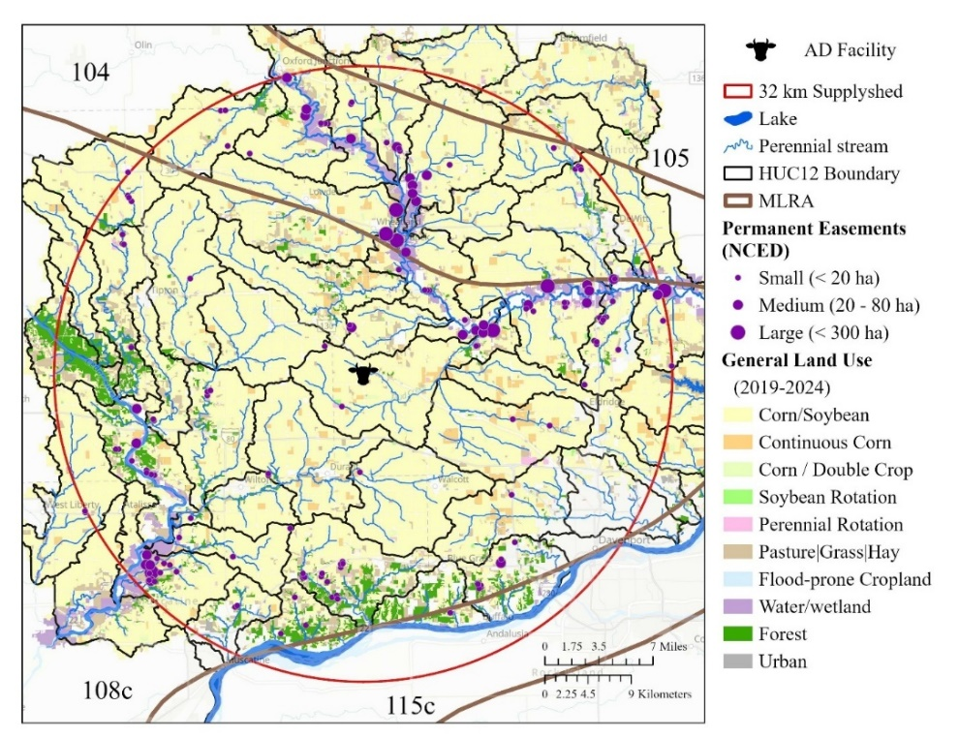
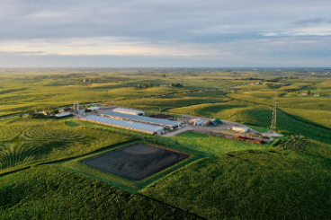





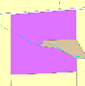
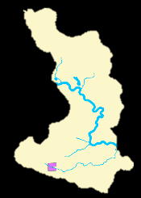
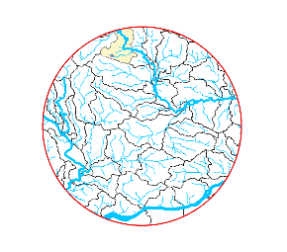
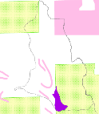
Field
HUC12
Supplyshed
Practice
Aggregate outcomes to public & private planning scales.

Figure 1. Location of the case study farm and anaerobic digester (AD) facility in east central Iowa. The 32 km supplyshed boundary intersects several regional, land planning units, including four major land resource areas (MLRA) and 48 HUC12 watersheds. The facility currently has 2,400 head cattle animal feedlot operation (AFO) adjacent to the digesters and closed-pit lagoons (upper right picture).The general land use between 2019 and 2024 is dominated by corn and soybeans. Based on data reported in the National Conservation Easement Databased (NCED), there are several existing permanent conservation easements of varying sizes distributed throughout the supplyshed; majority are near riparian corridors and floodplains.

Results
Results [Practice Scale] Table 1. Conservation practice (CP) performance. What does intervention do? Median and IQR where possible, and % of total supplyshed occupied/converted by each practice. Referenced first in results to anchor downstream aggregation figures. Outcome per conservation practice (CP). TCE includes structural, vegetation, management, harvest and opportunity costs. Add establishment vs. annual costs distinction?
 | Annual Crop: Winter Rye | Perennial Crop: Prairie
 |  | NRW | Riparian Buffer³ |  | PS | PCP
 |  |  | STB | RIB
Total Area (ha) | 68,539 | 2,196 | 584 | 147 | 6,789 | 27,153
% of fields | 33% | 5% |  |  | 35%
Direct Costs¹ ($ ha⁻¹ yr⁻¹) per CP
Struc + Veg | $230 | $6,137 | $486 | $149 | $173
Veg |  | $788 | $149
Ecosystem Service Outcomes per CP
Biomass Yield  (Mg) | 77.3  (43.3-126.2) | 21.4  (14.3-32.6) | 5.7  (5.3-6.1) | 5.6  (5.3-6.2) | 21.8  (13.6-35.2) | 139.8  (71.7-242.5)
NO₃ Load  (Mg) | 0.17  (0.1-0.3) | 1.4  (1.0-2.2) | 0.3  (0.2-0.8) | 0.6  (0.3-1.2) | 0.2  (0.1-0.4) | 0.5  (0.3-0.8)
Sediment Load  (Mg) | 34.1  (16.2-63.8) | 134.8  (86.0-236.4) | 41.4  (19.5-83.5) | 51.8  (24.6-98.2) | 30.3  (13.3-58.1) | 28.8  (14.3-57.7)
CO₂ Emissions  (Mg CO₂) | 15.2  (8.5-24.7) | 6.8  (4.6-10.4) | 0.9  (0.8-1.0) | 0.9  (0.8-1.0) | 7.0  (4.4-11.3) | 44.7  (22.9-77.5)
N₂O Emissions  (Mg CO₂ _{e}) | 2.4  (1.3-3.9) | 2.4  (1.3-3.9) | 0.3  (0.2-0.3) | 0.3  (0.2-0.3) | 2.0  (1.2-3.2) | 12.8  (6.6-22.1)
Core Habitat Patch | o | o | o | o | o | +
Linear Habitat | o | o | + | + | + | o
Total Cost-effectiveness² per CP
Biomass  ($ Mg⁻¹) | $141* | $2,911  ($2,738-$3,143) | $345  ($325-$358) | $276  ($172-$295) | $129  ($117-$140) | $140  ($120-$150)
Energy  ($ MMBtu⁻¹) | $12* | $227  ($213-$245) | $27  ($25-$28) | $21  ($13- $23) | $10  ($9-$11) | $11  ($9-$12)
NO₃  ($ kg NO₃ ⁻¹) | $66  ($61-$66) | $7  ($34-$55) | $8  ($2-$10) | $4  ($1-$4) | $12  ($11-$14) | $39  ($34-$44)
Sediment  ($ kg sed⁻¹) | $0.34  ($0.18-$0.61) | $0.46  ($0.26-$0.80) | $0.05  ($0.02-$0.09) | $0.03  ($0.01-$0.06) | $0.09  ($0.06-$0.20) | $0.86  ($0.48-$1.32)
CO₂  ($ kg CO₂ ⁻¹) | $0.72* | $2.68  ($2.65-$2.71) | $2.03  ($1.88-$2.06) | $1.76  ($1.11-$1.89) | $0.40  ($0.37-$0.44) | $0.44  ($0.38-$0.47)
N₂O  ($ kg CO_{2 eq}⁻¹) | $4.60* | $9.38  ($9.27-$9.47) | $7.13  ($6.58-$7.20) | $6.14  ($3.89-$6.61) | $1.41  ($1.28-$1.54) | $1.53  ($1.32-$1.64)
* There isn’t a threshold because it is a flat rate per hectare for implementation and the variability was not modeled for biomass yield, energy production and GHG emissions due to limitations in biophysical data at field-scales.
¹ The direct costs are annualized across 10 years at 6% discount rate. The direct costs are broken down into two different categories: 1. Structural and Vegetative, and 2. Vegetative. The Structural and Vegetative category includes direct costs associated with establishment, operation and maintenance of both the structural (i.e., control structures, basin creation) and vegetative components (e.g., buffer) of the conservation practice. The Vegetative category only includes costs for establishment, operation and maintenance of the vegetative component of the conservation practice, while the structural components are assumed to be covered through other funding sources (e.g., conservation payments). Site design in both categories is assumed to be completed by local technical assistance provider (e.g., NRCS) and the costs are left out of the budget. In the case of riparian buffer, the vegetative component incurs the same direct costs.
² The total cost-effectiveness accounts for direct costs in $2026 for structural and vegetative components of establishing, managing and harvesting biomass material from the conservation practice, in addition to the opportunity cost. The total cost is divided by the estimated environmental outcome associated with each conservation practice.
Results Table 2. Field-scale summary statistics. Aggregated descriptive statistics per field. Median and quartiles. Entire Supplyshed and all fields treated.
Metric | Sum |  | Median
 | Rye | Prairie | Rye | Prairie
Area | 68,539 | 36,870 | 19.16  (10.72 - 31.28) | 3.73  (1.65 - 9.16)
Biomass Yield (Mg) | 276,565 | 280,041 | 77.32  (43.27 - 126.22) | 27.66  (13.92 - 68.31)
NO₃ Load (Mg) | 3,746 |  | 0.35  (0.17 – 0.84)
Sediment Load (Mg) | 489,586 |  | 42.14  (17.16 – 104.60)
CO₂ (Mg) | 141,824 |  | 15.35  (6.69 - 31.92)
N₂O (Mg CO_{2 eq}) | 33,505 |  | 3.22  (1.48 - 6.55)
Distance (km) |  |  | 61.2  (43.3 –75.9)
Direct Costs | $38,953,731 | $23,371,824 | $10,890  ($6,095 – $17,778) | $1,741  ($666 – $5,559)
Total Costs |  | $47,878,740 |  | $4,561  (2,028 – 11,381)
Biomass Handling  (Loading/Unloading; $ per field) | $2,654,951 |  | $317  ($134 – $649)
Biomass Transport Costs (hauling + loading/unloading; $ per field) | $11,262,031 |  | $1,313  ($544 – $2,749)
Biomass Transport + Direct Costs ($ per field) | $67,912,856 |  | $8,974  ($3,307 - $18,653)
None of these account for the fact that they are partial loads. Aggregation would be valuable and could potentially reduce some of the transportation costs.
All transportation costs are directed to case study AD facility.
Handling costs are regardless of AD facility location. Only per bale costs.
Transport + loading/unloading costs only occur in years when harvest occurs.
Table x. Field scale economic inputs. Per field: Some fields have a combo platter of prairie and rye biomass material. Transportation costs only in years when biomass material is harvested. Median + quartiles. Handling is flat rate for bales

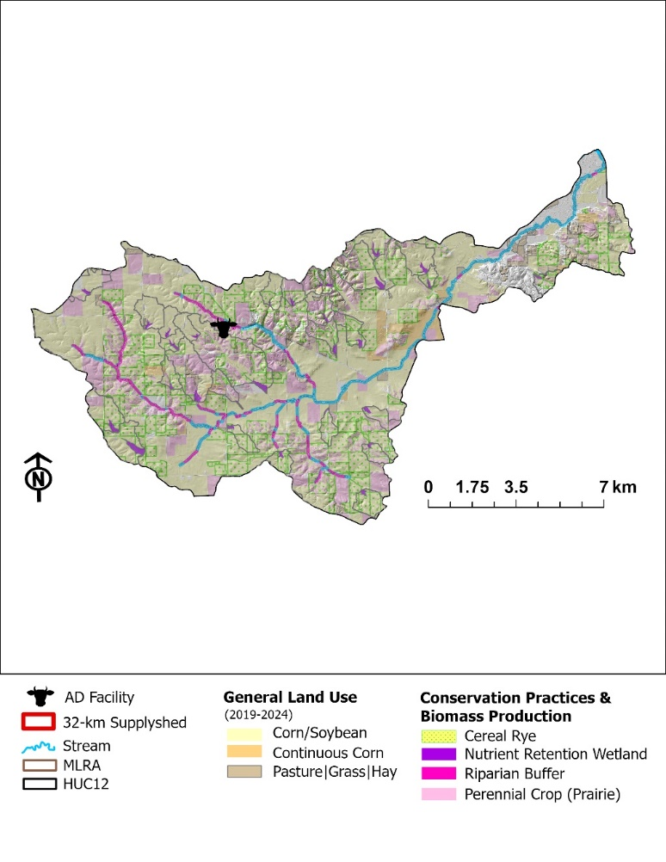
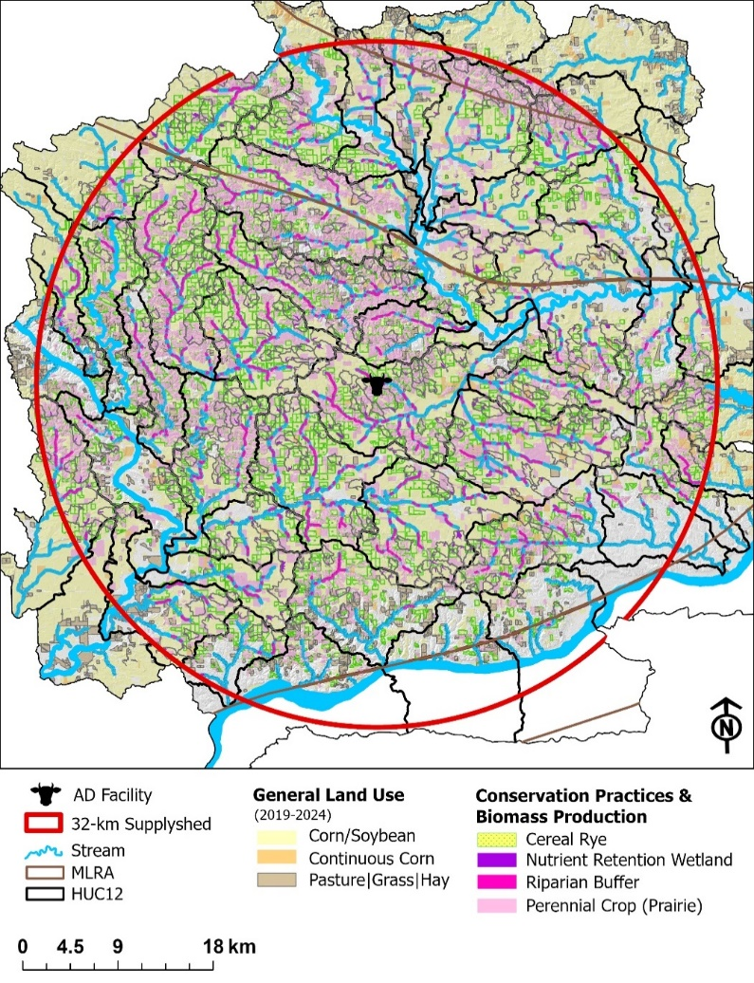
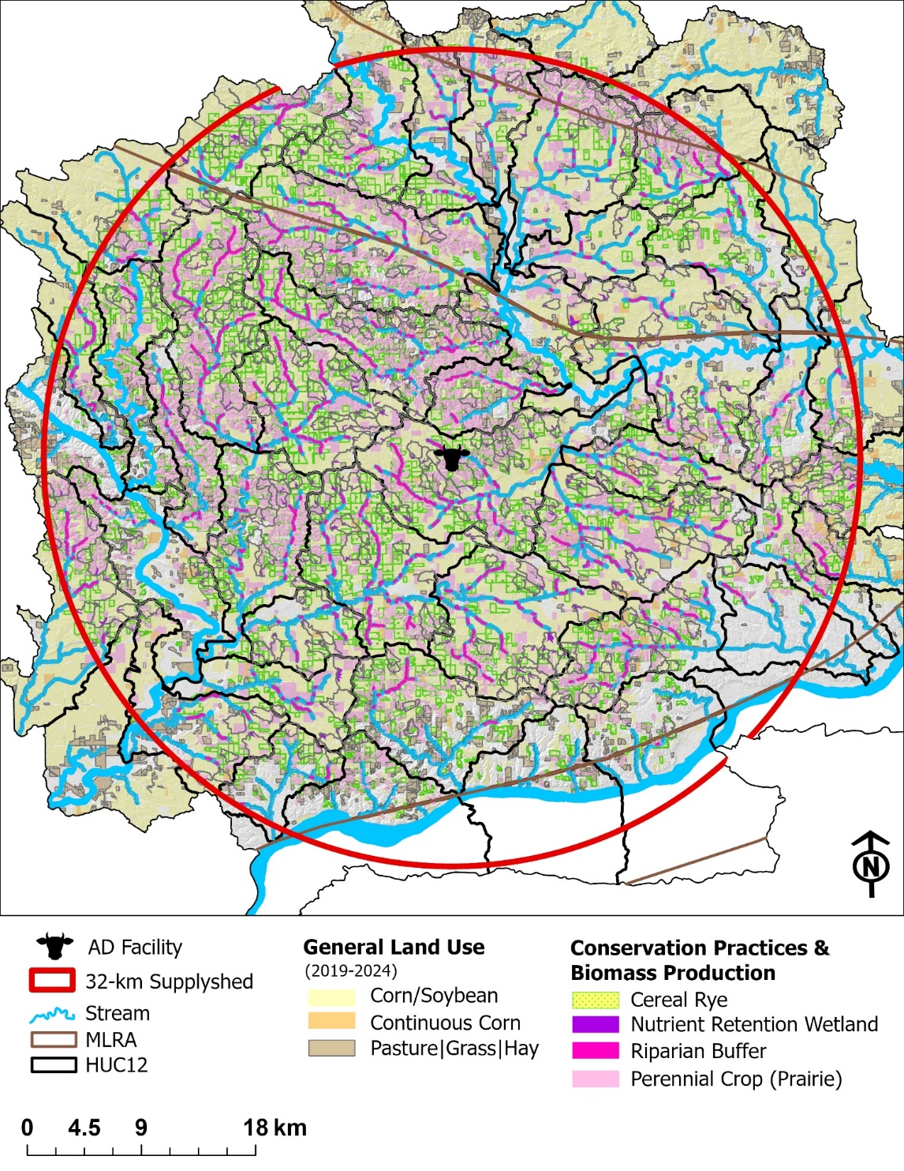
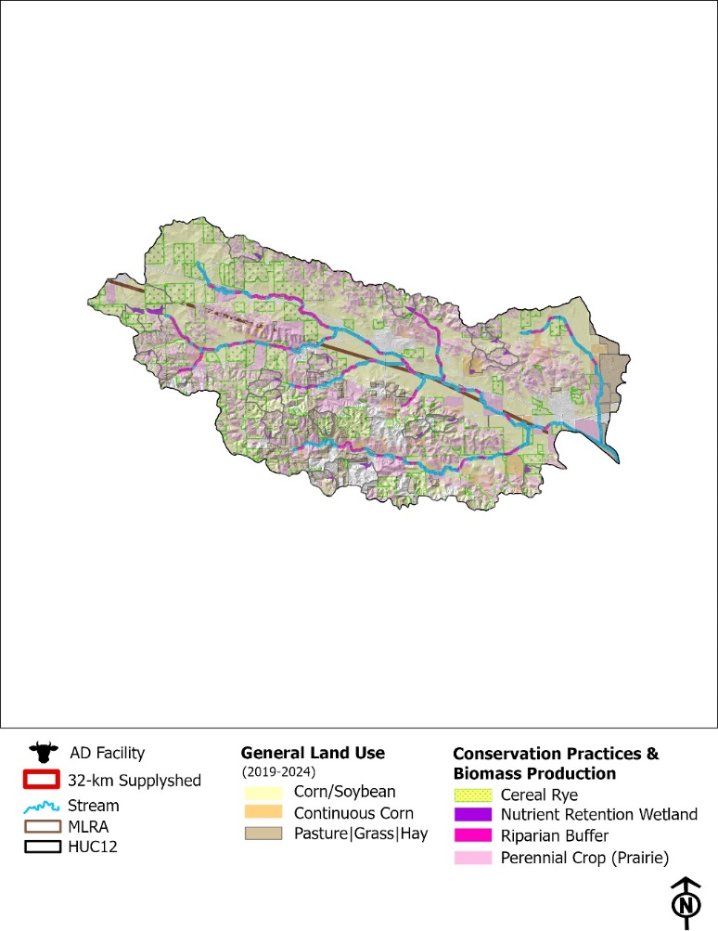
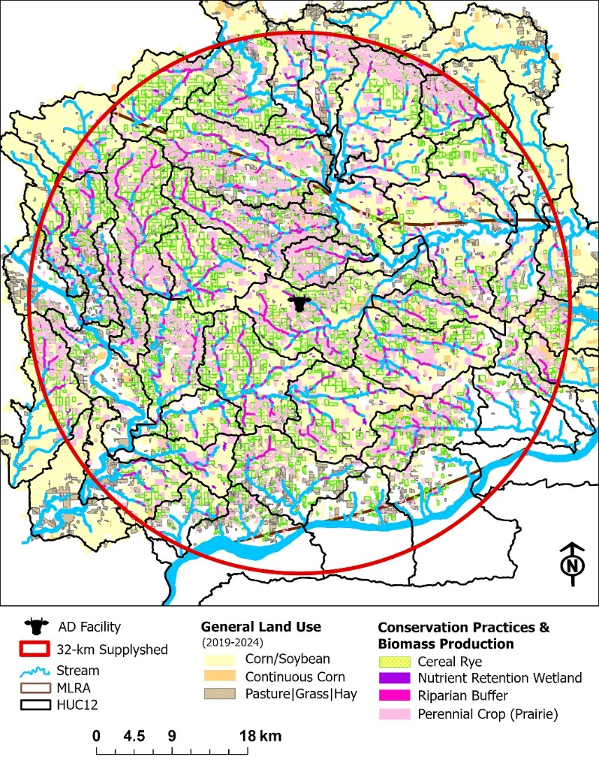

Results Figure 1. Field-scale spatial targeting. Where are practices placed and why? Field 3. Field-scale targeting and intervention (map panels). Prairie sitings, cereal rye, CP. The “where”
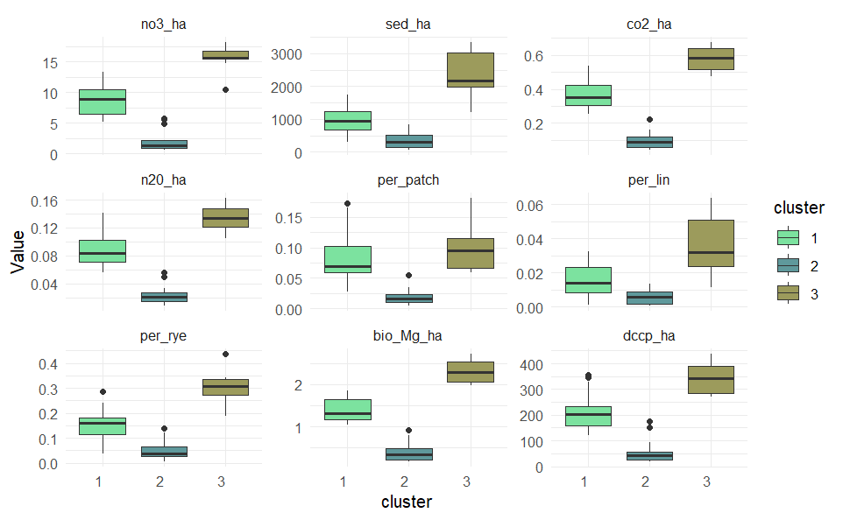
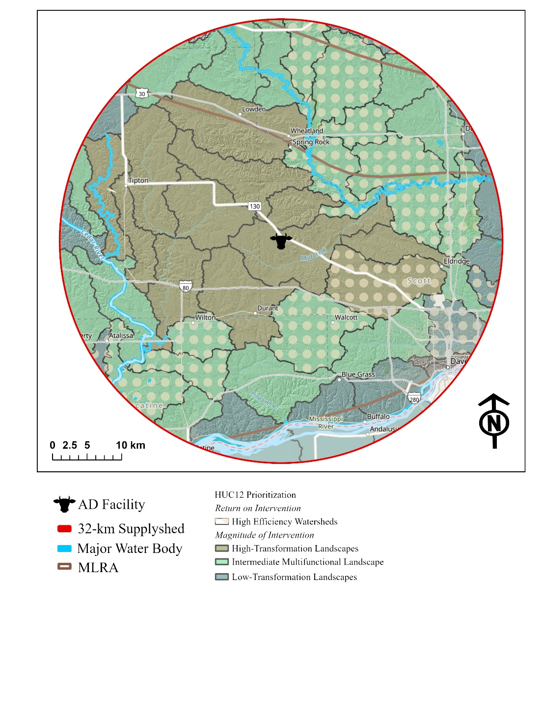

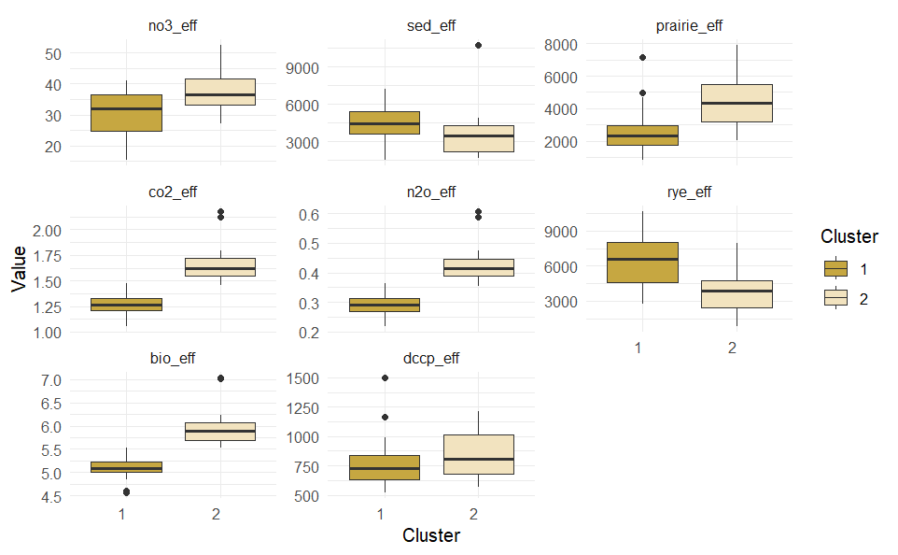
Figure. HUC12 efficiency variability. Costs for this system only looks at structural costs (associated with efficiency reduction potential) + biomass production costs. This map illustrates classification of HUC12 watersheds based on PCA to cluster them by similar environmental outcomes by magnitude and efficiency of land use. The dotted watersheds are estimated to have the highest return on intervention for costs, when only looking at cost of implementation for this multifunctional landscape.

Landscape | # HUC12 | UNSTB | UNP | OC ($/ha)
Magnitude of Intervention
High-Transformation | 12 | 88% | 34% | $2,348
Intermediate-Multifunctional | 22 | 75% | 47% | $1,859
Low-Transformation | 13 | 30% | 29% | $2,042
Return on Intervention
High Efficiency | 15 | 86% | 53% | $1,243
Less Efficiency | 32 | 75% | 34% | $2,406

Bioeconomic Performance (field to HUC12 bridge) Add table after table 2…?
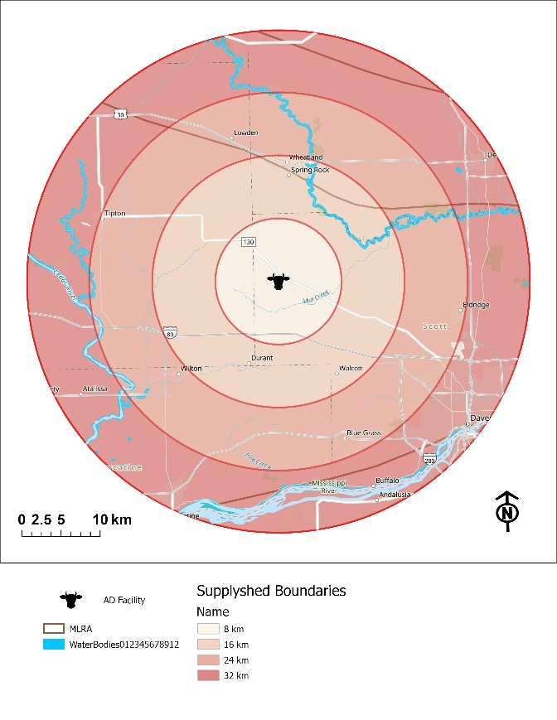
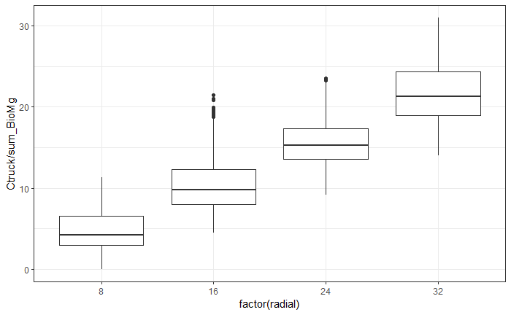
32 km
24 km
16 km
8 km

Supplyshed scale Table 4.: Area per band, not total for entire supplyshed. This is additive. Median + QRT; Biomass Yield, Cost of Production, Travel Distance, Transportation (truck+handling) Cost.
Figure. Illustration of radial supplyshed distances and summary/distribution of costs for transportation to each band. Each band is evaluated separately.
 |  | Total Area (ha) | n | Total Yield  (Mg) | Cost of Production ($) |  | TCE  ($ Mg⁻¹) | Round Trip (km) | Transportation Cost ($ Mg⁻¹)
 |  |  |  |  | DC | OC
8 km | R | 5,662 | 220 | 22,847 | $3,217,899 | - | $141 | 16.1  (11.1-24.7) | $9.05  ($7.72- $11.32)
 | P | 2,965 | 431 | 22,433 | $2,464,588 | $3,187,038 | $152
16 km | R | 15,911 | 660 | 64,204 | $9,042,981 | - | $141 | 37.1  (30.4-46.5) | $14.61  ($12.83-$17.11)
 | P | 8,958 | 1,385 | 68,364 | $8,980,515 | $12,126,378 | $159
24 km | R | 21,767 | 879 | 87,834 | $12,371,245 | - | $141 | 57.8  (51.3-65.6) | $20.09  ($18.37-$22.16)
 | P | 12,519 | 1,718 | 95,124 | $10,556,051 | $12,896,272 | $151
32 km | R | 25,199 | 1,071 | 101,681 | $14,321,606 | - | $141 | 80.2  (71.5-92.0) | $26.03  ($23.72-$29.16)
 | P | 12,428 | 1,855 | 94,121 | $10,062,286 | $11,572,548 | $140
Note: trucking is distance dependent. Loading/Unloading + farm-gate/direct costs are similar regardless of radial distance from AD facility.
However, there are some HUC12 watersheds that have different costs due to landscape features, soil types, productivity indices, etc.
Table x. Median and quartiles. Based on Mg of biomass material. Regardless of what that material is.
 | 8 | 16 | 24 | 32
Round Trip Distance (km) | 16.1  (11.1-24.7) | 37.1  (30.4-46.5) | 57.8  (51.3-65.6) | 80.2  (71.5-92.0)
Trucking Cost ($/Mg) | $4.27  ($2.94-$6.54) | $9.83  ($8.05-$12.33) | $15.31  ($13.59-$17.38) | $21.26  ($18.94-$24.38)
Handling Cost ($ per field) | $348.72  ($132.09-$742.46) | $342.71  ($140.15-$650.17) | $334.23  ($146.70- $668.00) | $289.39  ($119.22-$612.96)
Delivered Cost ($/Mg) | $128.84  ($65.13-$148.96) | $134.53  ($70.69-$154.29) | $139.04  ($76.40-$160.10) | $143.70  ($82.91-$164.74)
* handling costs are a flat rate: $4.7794 / Mg based on 2026 ISU Custom Rate Survey.

Figure 5a. Financial feasibility curves. Purpose: Under what conditions does this system work?
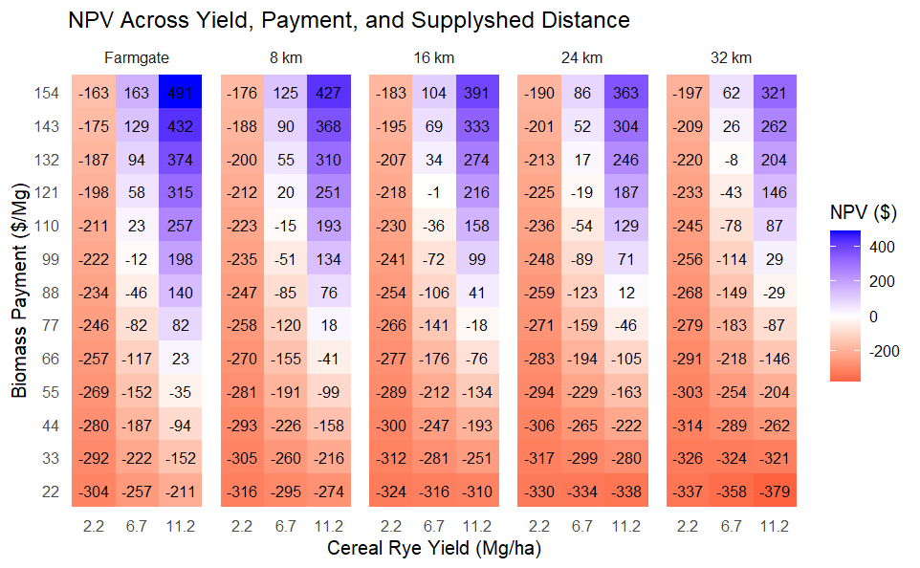
Breakeven
Farmgate: 2.2 Mg/ha = $309/ha; 6.7 Mg / ha = $103 per Mg; 11.2 Mg /ha = $62/Mg
8 km: 2.2 Mg/ha = $321/Mg; 6.7 Mg / ha = $116 per Mg; 11.2 Mg / ha = $74 per Mg
16 km: 2.2 Mg/ha = $327/Mg; 6.7 Mg / ha = $122 per Mg; 11.2 Mg / ha = $81 per Mg
24 km: 2.2 Mg/ha = $333/Mg; 6.7 Mg / ha = $128 per Mg; 11.2 Mg per ha = $86 per Mg
32 km: 2.2 Mg/ha = $341/Mg; 6.7 Mg / ha = $135 per Mg; 11.2 Mg per ha = $94 per Mg
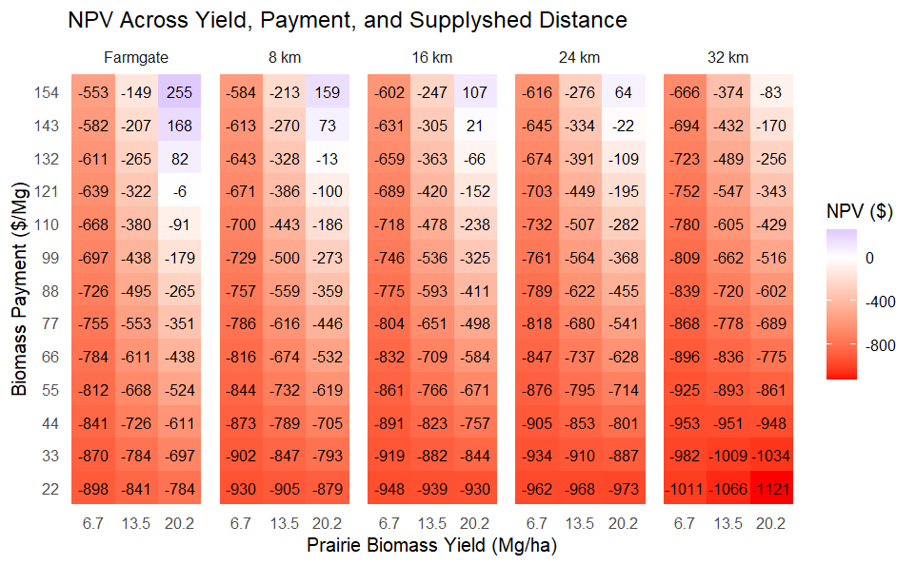
Breakeven
Farmgate: 6.7 Mg/ha = $375/ha; 13.5 Mg / ha = $181 per Mg; 20.2 Mg /ha = $122/Mg
8 km: 6.7 Mg/ha = $387/Mg; 13.5 Mg / ha = $197 per Mg; 20.2 Mg / ha = $135 per Mg
16 km: 6.7 Mg/ha = $394/Mg; 13.5 Mg / ha = $203 per Mg; 20.2 Mg / ha = $141 per Mg
24 km: 6.7 Mg/ha = $399/Mg; 13.5 Mg / ha = $209 per Mg; 20.2 Mg per ha = $147 per Mg
32 km: 6.7 Mg/ha = $407/Mg; 13.5 Mg / ha = $217 per Mg; 20.2 Mg per ha = $155 per Mg

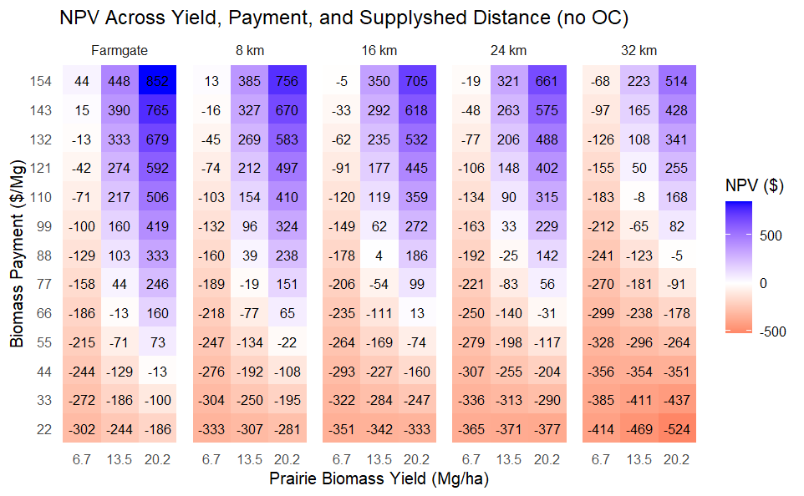
Breakeven
Farmgate: 6.7 Mg/ha = $140/ha; 13.5 Mg / ha = $69 per Mg; 20.2 Mg /ha = $46/Mg
8 km: 6.7 Mg/ha = $152/Mg; 13.5 Mg / ha = $82 per Mg; 20.2 Mg / ha = $58 per Mg
16 km: 6.7 Mg/ha = $158/Mg; 13.5 Mg / ha = $88 per Mg; 20.2 Mg / ha = $65 per Mg
24 km: 6.7 Mg/ha = $164/Mg; 13.5 Mg / ha = $94 per Mg; 20.2 Mg per ha = $70 per Mg
32 km: 6.7 Mg/ha = $172/Mg; 13.5 Mg / ha = $101 per Mg; 20.2 Mg per ha = $78 per Mg

