
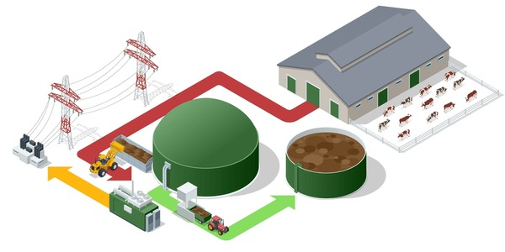

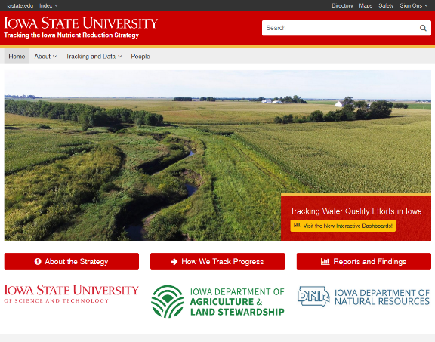
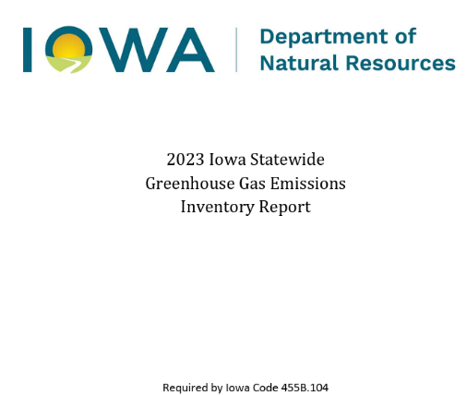
Aggregate outcomes to planning spatial scales (MLRA, HUC12, Supplyshed) to determine contributions to outcomes and
Outcomes
Loads
ACPF
Select fields + BMP
Elevation
Hydrography
NASS / Land Use
Soils
Public: There are a lot of environmental problems in Iowa. Several groups and taskforces have been created to define a path forward. There is some spatial guidance, but nothing explicit.

Private: Energy production via AD; perennial biomass
ACPF characterize the landscape at HUC12 levels. All HUC12 watersheds that intersect the supplyshed.
GeoProfit estimate field profitability + yield stability (2015-2024) in the supplyshed.
Determine an EBI proxy for siting biomass opportunities.
- Soil Vulnerability Index (SVI)
- Permanent cover (NCED)
- Tile drained fields (saturated buffers, NRW)
- Use recommendations from public plans
Determine NO₃ loads (FiNRT) and sediment loads (OFE) from fields.
Summarize the outcomes & aggregate to planning scales (MLRA, supplyshed, and HUC12):
Calculate load (NO₃, sediment, GHG) reductions, wildlife patch size and connectivity, direct costs, opportunity costs, and consequently cost-effectiveness for each field and landscape change Aggregate HUC12 outcomes to a supplyshed / bioeconomy for harvestable biomass. Yield stability + unprofitable acres.

References:
Ad facility: https://www.shutterstock.com/image-vector/isometric-modern-biogas-plant-environmentally-friendly-2499627605?trackingId=6c3b74db-87b7-45a5-990b-2f239bcca3af&listId=searchResults.
INRS: https://www.nutrientstrategy.iastate.edu/documents
Iowa wildlife action plan: https://www.adaptationclearinghouse.org/resources/iowa-wildlife-action-plan-securing-a-future-for-fish-and-wildlife-a-conservation-legacy-for-iowans.html
Idnr climate change advisory council: https://www.legis.iowa.gov/committees/committee?ga=84&groupID=173&view=redbook
Funnel: https://www.istockphoto.com/vector/infographic-5-level-modern-sales-funnel-diagram-with-arrows-presentation-vector-gm1481597887-508858264

