
Local resource plan analysis
- Public: INRS, IWAP, ICACC
- Private: Energy production
(AD technology)
Characterize spatial patterns of landscape & distribution of conservation practices (ACPF)
Input: NASS, SSURGO, field boundaries, hDEM
Output: soil drainage, SVI, updated stream networks, saturated buffers, contour buffer strips, nutrient removal wetlands, prairie, winter rye
Building the bioeconomy scenario
Filtering ACPF conservation practice output locations based on overlapping objectives.

NO₃ load (FiNRT)
Input: field boundaries, land use, and MRTN rates
Output: NO₃ load per agricultural field
Sediment load (OFE Tool)
Input: hDEM derivatives, SSURGO, land use
Output: Sediment loss raster

Quantify environmental & financial outcomes (FiNRT)
Input: NO₃ loads, sediment loss raster, ACPF conservation practice output, IPCC CO₂ and N₂O EF, direct cost
Output: Pollutant reductions, wildlife habitat patches increase, opportunity cost, total cost of land management changes, cost-effectiveness

Yield & profit trends (GeoProfit Tool)
Input: cropping history, annual corn and soybean production costs, annual crop market prices, CSR2, county average yields
Output: profitability and yield stability




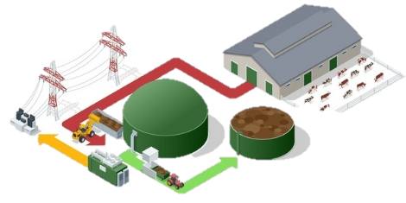
CO₂
N₂O
Outcomes (field-scale):
NO_{3,} sediment, GHG, wildlife habitat, costs
FiNRT + GeoProfit
ACPF
Soils

Conservation
practice + Biomass production
Aggregate outcomes to public and private planning scales
Elevation
Land Use
Hydrography
FiNRT + OFE
Field
HUC12
MLRA
supplyshed
Annual
Yield Data
Costs &
Returns
Calculate Pollutant Loads
Funnel: https://www.clipartmax.com/middle/m2H7G6m2K9Z5m2Z5_funnel-clipart-black-and-white/
Prairie chicken: https://www.rawpixel.com/image/6536785/image-vintage-public-domain-black
Grass background: https://www.publicdomainpictures.net/en/view-image.php?image=166522&picture=grass
Stream: https://freesvg.org/basic-stream

Calculate load (NO3, sediment, GHG) reductions, wildlife patch size and connectivity, direct costs, opportunity costs, and consequently cost-effectiveness for each field and landscape change Aggregate HUC12 outcomes to a supplyshed / bioeconomy for harvestable biomass. Yield stability + unprofitable acres.
List inputs and outputs here from each step. OFE Raster, BMP locations, nutrient load tables, etc. market prices, cost of production, cost to install and manage practice.
Summarize the outcomes & aggregate to planning scales (MLRA, supplyshed, and HUC12):
GeoProfit → estimate field profitability + yield stability (2015-2024) in the supplyshed.

