Linking Resource Protection to Bioeconomy Development in Iowa - DRAFT
Jessica Stephenson, John Tyndall, Lisa Schulte-Moore (?), Jim Jordahl (?)
Abstract
Expanded interest in the production of renewable natural gas in the state is fostering assessment of how this industry will navigate energy markets, explore feedstock choices, guide land use change, and strategically link to economic development, resource allocation, and climate goals. Incentives for cellulosic content from energy crops developed was an outcome of the 2007 Energy Independence and Security Act provides an opportunity to explore alternative cropping systems that could potentially diversify the landscape in order to address the problem of sustainability of existing monocropping systems in Iowa in the face of climate change and land degradation.
This paper is just to talk about growing biomass and what it would take to achieve supply side needs. Next paper we will focus on the business/financial needs to realize landscape changes.

Logic model for how everything connects. Change scenarios? Do a better job to filter outlier cost-effectiveness estimates. Page 88

Introduction
Agricultural landscapes across the U.S. Corn Belt are under increasing pressure to balance commodity production with goals for water quality, soil health, wildlife habitat, and greenhouse gas reduction. In Iowa, these challenges are addressed through multiple state-level initiatives, including the Iowa Nutrient Reduction Strategy (INRS; IDALS 2025), which aims to reduce nitrogen and phosphorus losses to waterways; the Iowa Wildlife Action Plan (IWAP; IDNR 2015), which identifies opportunities to conserve declining grassland species; and the Iowa Climate Change Advisory Council (ICCAC; ICCAC 2008) Final Report, which highlights strategies to cut emissions from agriculture and energy systems. Meeting these diverse goals requires innovative, integrated approaches that provide both environmental and economic benefits for producers and communities (Krieg et al., 2019; Dangol et al., 2025). Cropland comprises 85.7% of Iowa (NASS, 2024), and as such, is the most significant contributor to water impairments, habitat degradation and loss of biodiversity, and greenhouse gas emissions (GHG) within the state.
Nutrient pollution in surface water and well water is one of Iowa’s most pressing resource concerns. A study in Minnesota estimated the social costs of nitrogen (N) in drinking water to be 745 million (+/- 82) annually in the state (Keeler et al., 2025) and disproportionately affects poor and rural communities (Keeler et al., 2014); in other areas it has been linked to increased cancer rates (Jones et al., 2017; Gourevitch et al., 2018; Keeler et al., 2025), degradation and loss of native species due to nutrient enrichment (Galloway et al., 2004; Porter et al., 2013), and impairment of recreational use (Baron et al. 2012). <Talk more about agricultural habitat and low benefits + IA Ag impacts on GHG emissions?>. The INRS lays out a roadmap for Iowa’s success at reducing nutrient pollution, specifically NO3, by outlining land use and management changes to achieve water quality goals and resulting in additional environmental outcomes.
The planning frameworks in Iowa are primarily dependent on voluntary actions and incentives for farm businesses to change their management practices. Voluntary conservation by farmers has been a cornerstone of U.S. agricultural policy for decades, supported through cost-share and technical assistance programs. These efforts have successfully demonstrated that conservation practices such as cover crops, prairie strips, and wetland restoration can reduce nutrient losses, improve soil function, and provide wildlife habitat. There is a perceived financial and crop yield risk associated with incorporating conservation farming practices, as improvements are not always immediately observable on the farm. The perception can be enough to deter people from into their operation. However, the benefits to the farm are often realized over longer time horizons and can significantly improve in-field soil fertility and structure, resulting in better profits. Shipley et al. (2022) reported that efficiency is a primary concern of farmers and they will “…do anything and everything to try to maximize the profit potential of every acre and utilize [their] inputs to the most efficient way.” Farm decisions are frequently limited by the bottom line: profits (Shipley et al., 2022; Roesch-McNally et al., 2017; etc.).
Establishing perennial biomass systems—such as prairie grasses harvested for bioenergy—faces additional barriers, including the opportunity cost of converting cropland, uncertainties about market demand, and the logistics of feedstock collection. Incentive payments and stable markets can help reduce these barriers, creating financial conditions that make conservation-compatible biomass systems more attractive and durable for producers. Anaerobic digestion (AD) represents one such opportunity, offering renewable energy production, greenhouse gas mitigation, and improved nutrient management. While AD development has historically relied on manure or food-processing wastes, there is growing interest in supplementing feedstocks with purpose-grown biomass such as prairie grasses and winter cereal rye. These feedstocks provide dual benefits: they contribute to AD’s renewable energy supply while also enhancing soil cover, improving water quality, and providing wildlife habitat when strategically sited. When paired with targeted incentives, perennial and cover crop feedstocks can link farmer adoption decisions directly to statewide environmental and climate goals.
An AD facility in east central Iowa has been operating since 2013, co-digesting corn stover, cattle manure, and locally sourced food wastes. In 2019, they committed to incentivizing alternative grassy feedstocks to perennialize the landscape. The farm has partnered with a private midwestern energy company and Iowa State University to research how to maximize the energy potential of diverse bioenergy feedstocks, including winter rye (Secale cereale) and native prairie species (C-CHANGE). A fundamental analysis was conducted to explore the economics of operating a profitability AD facility, determining a payment scheme for prairie biomass and winter rye biomass, and is described in Chapter x of this dissertation.
Developing a bioeconomy with biomass that sustains an AD facility can follow state-level policy and planning efforts to target fields based on their expected environmental outcomes and contribution to achieve water quality, wildlife habitat and connectivity, and climate goals. This study leverages the land use and management recommendations outlined in the INRS and IWAP to site locations for biomass within a 32 km supplyshed of the AD facility. Additional guidance used from other plans and research, including STRIPS recommendations of a minimum of 10% prairie practices, and sub-field crop profitability and yield stability estimates (Summers et al. unpublished; Herbstritt et al., 2022). These plans will be displayed at the field level, which has never been done before, and linked to the local market, incentivizing the perennialization of the landscape by paying farmers for harvested biomass material to be digested at the AD Facility. An AD facility willing to compensate farmers for growing alternative feedstocks, such as corn stover, presents a unique opportunity to leverage biomass payments that can be stacked, or bundled, with environmental market-based approaches. Biomass payments could provide a diversified income source for many farmers, helping with the transition to include a winter crop or convert to a prairie biomass. Often, the upfront costs of implementing conservation practices and changing cropping systems can be a barrier to adoption; therefore, finding ways to help farmers overcome these costs is imperative to realize changes on the landscape (Roesch-McNally et al., 2017; Banjeree et al., 2025). Examples of PES include: water quality credit trading, habitat banking programs, and carbon markets. Other options could include public payment programs, such as EQIP, which compensate for the opportunity cost of changing land use and management.
The principle of additionality is at the core of designing a bioeconomy within the context of a 32 km supplyshed for an AD facility. To achieve additionality, “a proposed activity will produce some ‘extra good’ in the future relative to a reference scenario, which we refer to as a baseline. In other words, additionality is the process of determining whether a proposed activity is better than a specified baseline” (Gilleman 2012). The baseline for this project scenario represents current behavior (e.g., conventional corn farming), and additionality was the outcome due to the implementation of rye and prairie biomass crops. The management practices include edge-of-field practices (buffers around nutrient removal wetlands and riparian buffers), changes in crop rotations (including winter crops such as cereal rye), and the transformation of land from annual crops to native prairie (with a conversion rate of greater than or equal to 10% of a field). The Agricultural Conservation Planning Framework (ACPF; Porter et al., 2024), Financial Nutrient Reduction Tool (FiNRT; Bravard et al., 2022), and companion GIS tools were used to site opportunities for behavior change and assess the outcomes in terms of water quality reductions, wildlife habitat improvements, and GHG emission reductions. The FiNRT tool also calculates the costs for a landowner to implement the change to baseline conditions. Our approach enables planners to be more intentional about where funds are invested in the landscape and potentially supports stacked payments, leveraging emerging biomass markets and payment for ecosystem services (PES) markets. This paper describes a framework to target opportunity acres in Iowa row crop fields for perennialization by weaving together intersecting land management priorities with an AD facility’s enterprise. Some publications allude to the myriad environmental outcomes that could be achieved with energy-based cropping systems (references); however, none evaluate the individual field impacts and aggregate them to a landscape scale. Here, we report field-scale pollutant load reductions resulting from a change in management to native prairie or a winter crop, as well as the respective cost-effectiveness of the reduced pollutant load.
Methods
Context
The AD facility is located in east-central Iowa (Figure 1) and provides energy to operate its commercial farm operation. The AD facility sources biomass material from an animal feedlot operation (AFO) onsite and corn stover. The farm manages 2,400 head of cattle and approximately 2,200 acres of cropland. Additional information on the farm operation can be found in Villarino et al. (2025) paper. To transition from annual feedstocks (i.e., corn stover) to feedstocks that perennialize the landscape, the AD facility proposes harvesting residues from 809 hectares of prairie and 809 hectares of winter cereal rye to achieve energy production goals (Schulte, 2025). We evaluated a 32 km radial supplyshed around the AD facility to site prairie and winter rye biomass opportunities based on hydrologic characteristics, state and regional resource plans, and publicly available data on crop rotations and existing permanent prairie. The environmental and cost outcomes were calculated. There are opportunities to expand AD markets within the supplyshed . There are 91 AFOs meeting criteria to generate energy within and surrounding the supplyshed economically. However, the expansion of AD markets was not further evaluated other than the recognition that they exist. There are trade-offs between local feedstock self-sufficiency and the development of regional biomass markets. As markets mature, it is assumed that the ideal state and supply will meet demand; therefore, biomass sources will be more readily available at more economical distances than 32 km.
There are four major land resource areas (MLRA) intersected, including Illinois and Iowa Deep Loess and Drift, West-Central part (108c), Eastern Iowa and Minnesota Till Prairies (104), Northern Mississippi Valley Loess Hills (105), and Central Mississippi Valley Wooded Slopes, Northern Pat (115c) (Prior 1991). The primary land use of the area is agriculture, specifically cropland, and the priority resource concerns include water quality (nutrients and e.coli), flooding, wildlife habitat, GHG emissions, and degraded land from erosion. A bioeconomic model, starting at a 32 km radial distance, is explored in this paper to leverage market opportunities that can change land use and management, addressing these resource concerns (Figure 1). A goal of this paper is to highlight opportunities to generate additionality within the supplyshed, so we are assuming these changes will not result in an increase in animal units at AFOs and complete recycling of wastes in a responsible manner. Another assumption is that land use and management changes will involve converting row-cropped fields to prairie for harvesting or incorporating cereal rye as a winter crop. Locations for prairie and cereal rye biomass based on state strategies to improve water quality and support wildlife habitat, greenhouse gas emissions, and erosion. The state-level strategies with specific land use and management recommendations were compiled and evaluated to identify overlaps. Within a field, yield stability and profitability were assessed and determined over 10 years (2015-2024). There was a series of selection criteria to ensure maximum environmental outcomes, meaning prioritized resource allocation, which will be reported.
The planning process for siting biomass opportunities was intertwined with many resource concerns. However, for clarity, the methods were broken down into overarching themes (nitrate load, wildlife habitat patch size and connectivity, sediment transport and delivery, and GHG emissions). This organization of AgBMPs into themes does not mean that practices do not achieve other resource management goals. The placement of them is based on the primary resource concern they are addressing and how data layers were used to prioritize locations on the landscape. An example of this is the relationship between cereal rye, water quality, and erosion. The winter rye crop is a scenario in the INRS, and only modeled on no-till fields. No-till on cropland will likely address erosion issues in the spring by providing high ground cover, increasing soil structure, and minimizing surface soil disturbance. Consequently, cover crops were planted with the goal of improving water quality, rather than reducing sediment transport and delivery.
GIS Tools
In this paper, we illustrate what a regional bioeconomy plan looks like using ArcGIS Pro 3.3.1 and spatial tools, including the Agricultural Conservation Planning Framework (ACPF), the Financial Nutrient Reduction Tool (FiNRT), and the Overland Flow Element (OFE) tool. The GIS tools used in this study were developed as conservation planning tools that follow NRCS conservation practice (CP) guidance and align with federal funding programs. Often, funding programs prevent CPs from being managed as a production system, so time is spent adapting the tools to account for harvesting logistics (i.e., machine size, accessibility) and site biomass location opportunities. This is the first time these GIS tools have been applied to generate a regional bioeconomy; however, the data layers and tools are versatile and align with the conservation ethic of regional end-users and planners within the AD industry, as well as other state and regional plans. Changes in the supplyshed were applied to cropland. In a corn and soybean rotation, the annual rye is assumed to be planted following corn, and harvested in June, after soybeans have been planted into the biomass stand. In a continuous corn system, the cereal rye is planted annually but harvested earlier (Ruis et al., 2023).
The ACPF uses spatial datasets organized by HUC12 watershed boundaries to site opportunities for conservation interventions on agricultural land (Porter et al., 2025). The ACPF core dataset includes 10-m gSSURGO, which is updated annually, annual cropland data layers (CDL) from NASS, HUC12 watershed boundaries, and tables summarizing soil and land use for each field. The field boundary dataset is based on common land unit (CLU) and, due to time restrictions, was not manually updated to reflect more recent field boundary delineations. Since the toolset is watershed-based, it depends on hydroconditioned datasets to model surface flowpaths and determine the most suited agriculture best management practice (AgBMP) to intercept runoff within the field, at the edge-of-field, and in the riparian zone. The ACPF depends on accurate surface flow paths, so watersheds intersecting the supplyshed had hydroconditioned digital elevation models (DEM) at the 2-meter resolution prepared. There were 48 HUC12 watersheds intersecting the 32 km supplyshed that were modeled (Figure 1). The locations for biomass were co-located with ACPF output practices that include filter or buffer strips as part of the CP design and were indicated as high-priority areas. These AgBMPs include nutrient removal wetlands, contour buffer strips, and saturated buffers. The biomass generated from the site-specific structural practices did not meet the INRS and IWAP land area goals, so whole fields were dedicated to prairie and cereal rye biomass, determined based on soil loss vulnerability and proximity to existing wildlife habitat complexes. The HUC12 watershed-scale is the reporting unit for hydrologically based resource concerns (e.g., water quality, erosion, flooding), and other spatial tools report environmental and financial outcomes at the field scale. ACPF output, in turn, is input to FiNRT.
OFE. The OFE uses the Daily Erosion Project (DEP; https://www.dailyerosion.org/) estimates for soil displacement along hillslopes at the HUC12 watershed-scale and scales them down to field estimates of average runoff and soil displacement. The model uses the Water Erosion Prediction Project (WEPP) and an event-based modelling approach to evaluate precipitation, hillslope, and soil detachment characteristics. OFE Tool inputs include ACPF core datasets, a hydroconditioned DEM, and a tillage raster generated from seasonal aerial imagery to estimate residue management. The OFE output, in turn, is input to FiNRT.
FiNRT. Nitrate and sediment were the pollutants of concern in this framework because they align with INRS priorities and are well-studied in Iowa. Using FINRT, the nitrate load and sediment transport for each field and practice were estimated based on the six-year historical crop rotation (2019-2024). The contributing area to each practice was calculated, and the area-weighted estimate of nitrate load and sediment load reduced per practice within a field was reported. In the case of this study, the cost-effectiveness is calculated as the cost of establishing and managing a biomass system, divided by the estimated reduction in nitrate load and sediment load. Additionally, the cost information was updated within FiNRT to include the additional management and harvest costs (see the Supplementary Materials for the enterprise budgets, which need to be added).
Water Quality
Several best management practices are highlighted in the INRS, and we have only represented those relevant to producing biomass material that supports the AD facility’s business plan. INRS has detailed and scientifically backed recommendations for achieving nitrate reduction goals; therefore, we used the INRS as a template to determine how many acres of corn and soybeans would receive a biomass treatment. The INRS lists land use changes as a percentage of cropland within an MLRA that is subject to a change in management, and this percentage is applied to the MLRAs that intersect the supplyshed. Four strategies in the INRS directly supported the production of biomass material for co-digestion at the AD facility to produce energy, and those included:
- Plant a rye cover crop on all no-till acres. (INRS Section 2, p. 32)
- Installing wetlands to treat 45% of the ag land. (INRS Section 2, p. 33)
- Installing [saturated] buffers on all applicable acres. (INRS Section 2, p. 35)
- Perennial crops (energy crops) to equal pasture/hay acreage in 1987. (INRS Section 2, p. 39)
Data for the location of no-till fields is not readily accessible, so the location of no-till was randomly assigned to fields that include corn in the 6-year rotation using a Python script in ArcGIS Pro. The INRS assumed a percentage of no-till area for continuous corn and corn-soybean fields within each MLRA. The percentage for both cropping systems was multiplied by the total area in that specific crop rotation for each MLRA, and then fields were selected to achieve the land area goal (Table 2). In consideration of the complex nature and spontaneity of adoption, fields that received a winter cereal rye treatment were randomly selected, with priority given to cropped fields with high to moderate SVI classes, suggesting significant potential for surface runoff or leaching.
The Nutrient Removal Wetland (NRW) siting tool in the ACPF GIS toolbox was used to determine locations for installing wetlands. The assumption for NRW was that the buffer surrounding the wetland would be designed in a way that could be harvested for prairie biomass. Some studies suggest that paludiculture can be an effective way to remove N and P from the landscape by preventing the nutrients from cycling back into the system after biomass material decomposes (Zak et al., 2014; Jabłońska et al., 2021), and while this region is not known to have significant peatlands, the concepts could be translated to wetlands here. To simplify harvesting prairie biomass from the wetland buffer, NRW that coincided with multiple fields (i.e., multiple landowners) were removed, and only NRW that had the majority of a practice footprint in one field were retained.
The strategy for riparian buffer implementation was adjusted to focus on locations suitable for saturated buffers, which optimizes the potential for nitrate reduction before it reaches a stream. Currently, INRS does not include this as a strategy. Still, several studies have noted the significant nitrate reduction potential of saturated buffers and suggest that if a buffer were installed, the cost would not be significantly more to add a lateral tile line, allowing subsurface water to diffuse through the buffer and filter nutrients (Johnson et al., 2024). The denitrifying practice tool in the ACPF GIS toolbox was used to determine locations for the saturated buffers. Saturated buffers that had the majority of the feature on cropland were retained, and buffers that were centered on pastureland were removed from the analysis. All locations were retained with the assumption that the site design would primarily deal with one landowner. The buffer width was 30.5 meters to accommodate harvest machinery without getting too close to the buffer edge and potentially destabilizing the streambank. This width would also support populations of area-sensitive wildlife species (Brittingham & DeCecco, 2025).
The nitrate reduction outcome of the change in land use and management was determined using FiNRT and reported as kg nitrate (NO3) ha-1 yr-1. A limitation of this study is that we assume farms are using the agronomic optimum rate of fertilizer, so we do not consider the overapplication of nutrients that is typical when livestock manure and cropland are managed together (Porter & James, 2021).
Wildlife Habitat
The fourth INRS strategy highlighted in this paper is to increase perennial cover, which was dovetailed with the IWAP land use change recommendation calling for 4% of Iowa to be permanently protected. The combination of the INRS and IWAP plans was translated into converting whole crop fields near known locations of permanent conservation easements. To optimize outcomes for wildlife, we are considering a “wildlife-friendly farming” approach, drawing on concepts from Fischer et al. (2008) to determine the most effective allocation of land resources dedicated to prairie biomass locations that increases heterogeneity on the landscape, thereby connecting farmed and unfarmed areas. In doing this, we can create a continuum across the landscape that recognizes some of the Iowa prairie species-specific habitat contours (Fischer et al., 2004; Fischer & Lindenmayer, 2006; Fischer et al., 2006). Tall grass prairie once dominated this landscape and provided critical ecosystem services (air and water purification, nutrient cycling, regulating GHG, and biodiversity); therefore, prairie will be assumed for all permanent cover increases.
The National Conservation Easement Database (NCED; 2024) was used to estimate locations of existing permanently protected land, suggesting high-quality habitat patches. Cropped fields that are the closest radial distance from the NCED sited location for permanent easements were selected to achieve the 4% land area goal in the supplyshed, translating to 9,073 hectares in the 32 km supplyshed. The closest radial distance from existing permanent easements was used to determine locations to support the expansion of existing permanent habitat patches and improve habitat connectivity for native prairie species. Other locations on the landscape are permanently protected; however, we relied on publicly available data to ensure that other bioeconomy planners could replicate this process.
The wildlife outcome was quantified based on the following parameters: patch size (in hectares), connectivity, and the number of species that could be supported within the landscape. The number of species supported is based on a literature review of known habitat requirements of pollinators, birds, mammals, and insects. The harvest regime of the prairie is assumed to be conducted in a manner that is sensitive to the life cycles of native prairie species, thereby supporting high-quality habitat for wildlife and insects. The assumed harvest regime incorporates principles from Palik et al. (2021) ecological silviculture to mimic the natural, frequent, low-severity disturbance regime of prairie systems, which is created by grazing and fire, and will occur in late summer to fall. Ecological silviculture manages perennial production systems with comparable goals to a prairie bioenergy system, where the management of biomass and wildlife is deeply intertwined. The assumed harvest regime is similar to a variable retention harvesting approach, which supports heterogeneity and continuity. However, the age of a prairie patch will be considered above the age of an individual plant species. The proportion retained each year will be a minimum of 33%, as recommended by the Minnesota Department of Natural Resources (Garms et al., 2009), to 50% (RAE, 2024).
Sediment Transport and Delivery
The remainder prairie biomass area to achieve INRS goals [SJA10] for perennial crops in the supplyshed was determined to reduce erosion and sediment transport from fields. The INRS does not prioritize erosion; however, many of the practices can be targeted to reduce erosion. This resource concern was addressed in two different ways—one of those leveraged the ACPF Contour Buffer Strip (CBS) tool. Fields where CBS were 18.3 meters wide, and the total prairie strip area occupied was greater than or equal to 10 percent of the field area. The 18.3-meter width was determined based on the assumed size of a commercial windrower used to cut prairie biomass before baling (ISU) and recommendations from the NRCS to optimize wildlife benefits (NRCS, 2014). The STRIPS team reports that the buffer area should occupy a minimum of 10 percent of the field to ensure optimal environmental outcomes, including a significant reduction in sediment transport (Schulte et al., 2017). The final design of the prairie strips can be adjusted to meet the landowner's management needs, allowing for adjustments to the widths and placement of the strips. The ACPF only provides an estimate of the area and suitable locations for prairie strips based on available LiDAR data and requires fieldwork to verify suitability and design the practice. The area of the prairie buffer strips was summed, and the remaining perennial energy cropping area was selected from fields with a soil vulnerability index (SVI) greater than or equal to two. The SVI can be used to identify fields with high soil loss due to surface flows and slopes (Lohani et al., 2020; Porter et al., 2025). The sediment transport and delivery outcomes was estimated for each field using the OFE tool and reported as kg sediment ha-1 (Luquin et al., 2024).
Greenhouse Gas Emissions
The location of perennial and rye biomass did not hinge on greenhouse gas emission reductions, but the outcomes related to C and N2O were estimated for each practice. The amount of CO2 was reported (Mg CO2 eq ha-1). Additionally, fields identified as hotspots were determined based on drainage class, crop rotation, landscape position, and rainfall patterns. Hot spots are important locations to prioritize in the landscape, allowing us to reduce some of the leakiness in the nutrient cycle and potentially invest more resources in actions that will reduce emissions. The IPCC reduction factors were used to estimate emission reduction; however, we acknowledge that this may not be the most accurate assessment, and we may be underestimating N2O emissions by at least 40%, according to some studies (Elberling et al., 2023). [SJA11]
Total Costs & Cost-Effectiveness
The cost-effectiveness of land management changes relative to the expected environmental outcome was calculated using FiNRT for each sited location within the supplyshed for adding prairie or cereal rye to conventionally row-cropped acres. The cost data within FiNRT was developed to account only for implementing cereal rye as a cover crop and prairie-based practices as conservation measures; therefore, the cost data was updated within the FiNRT code to reflect additional management activities associated with growing prairie and cereal rye for bioenergy production systems in east central Iowa. Enterprise budgets were created for each land management change (e.g., prairie strips, NRW, saturated buffer, cereal rye winter crop, or whole field conversion to prairie), and accounted for any costs incurred by the crop farmer, including establishment costs, crop management (e.g. fertilizer), harvest and baling, and opportunity costs (Supplementary Materials: Enterprise Budget). The cost for transportation and storage is anticipated to be either the AD facility operator’s cost or a third-party aggregator for biomass. In this study, it is assumed that the farmer will harvest the biomass and bale it in the case of prairie. Some logistics need to be sorted out when sourcing feedstocks from farms that are not operated by the AD facility, which are not covered in this assessment.
The enterprise budgets for the prairie-based practices were developed following guidance from the Tall Grass Prairie Center and the NRCS on establishing high-quality prairie, as well as input from the MN DNR and independent haying operations to establish a maintenance and harvest protocol. The fertilization schedule was based on the current management of the AD operator on their cropped fields. The cost data for each activity was derived from Iowa State University Ag Decision Maker $2024 custom rate surveys. The budgets were annualized over a 20-year period with a discount rate of 7%. The cost of establishment, maintenance, and harvest was spread out over 20 years, and the annual cost was used to determine the cost-effectiveness of perennializing the landscape for a unit of pollutant reduction (i.e., nitrate, sediment, wildlife habitat acres, GHG emissions). For comparison, the costs of implementing these practices as conservation practices, rather than a cropping system, were generated. The costs of these practices, serving purely as conservation practices, are annualized over 30 years with a 2% discount rate, reflecting the life of conservation practices and assuming low future earnings, as there is no harvested biomass or market. In the biomass-based budget, a shorter project lifespan and a higher discount rate were employed to account for the higher risk and inflation potential associated with bioenergy crop inputs and management in the proposed system, compared to the more familiar conservation programs.
Results & Discussion
The purpose of this research paper is to demonstrate a process that integrates disparate planning frameworks and strategies to achieve environmental and agronomic goals. INRS, IWAP, IACC, and soil health NRCS soil health initiatives align with potential biomass feedstock systems for AD. The multi-objective analytical framework presented in this paper can be readily applied in other agricultural landscapes in the U.S. where ACPF core data is available, and land management goals are available. AD bioeconomic planners can be intentional and leverage agricultural land to achieve co-benefits, sequester a significant amount of carbon (Verge et al., 2007; Paustain et al., 2019; Bossio et al., 2020), build wildlife habitat complexes, improve soil health, and reduce nutrient runoff. In Iowa, the INRS defines how to improve water quality by MLRA, which translates to 72,656 ha of cereal rye and 42,891 ha of prairie within the 32 km supplyshed (Table 1), and 9,052 ha of that prairie is strategically located to support IWAP goals to increase permanent cover and habitat quality.
This approach integrates landscape resilience and productivity – reducing nutrient losses and improving soil function without displacing food production on prime farmland. The environmental outcomes produced include an annual reduction of 8,279 tonnes of nitrate loading to surface water and 10,350 tonnes of sediment transported (Table 2). In addition, we can expect approximately 5 million metric tons of CO2 equivalent to be reduced annually. The IWAP goal of 4% in permanent cover in the supplyshed (approximately 9,059 ha) would be exceeded, comprising several small to large patches (>10 ha and less than 2,000 ha), prairie strips, and saturated buffers that serve as habitat patches and corridors. To determine where in the supplyshed may be the best place to target efforts and potentially align with local watershed groups and conservation planners, the watersheds with the highest environmental outcomes produced, lowest costs of production, and shortest drive time distance were identified (Figure 2 and Table 5). These watersheds show the most promise for opportunities to leverage agricultural land for co-benefits and sequester a significant amount of carbon (Verge et al., 2007; Paustain et al., 2019; Bossio et al., 2020), build wildlife habitat complexes, improve soil health, and reduce nutrients in runoff.
Currently, corn stover is the most common crop residue digested at AD facilities because it is readily available; however, some research shows that 100% harvest of stover can decrease grain yields (Boehmel et al., 2008; Karlen et al., 2011; Adler et al., 2015) and negatively impact water quality (Khanal et al., 2014) as well as potentially increase synthetic nutrient amendments within the field since organic material is being removed (Becerra-Pérez et al., 2022). Despite Iowa leading the nation in some aspects of cellulosic ethanol and wind energy, cropland continues to be managed using resource intensive monocrops – planting same annual crop over two or more consecutive years – that are degrading soils (Cruse, 2016; Borrelli et al., 2017; Battagalia et al., 2021; Thaler et al., 2021), water quality (Secchi et al., 2011) and wildlife habitat (Tilman, 1999; Altieri, 2009; St. Clair et al., 2020) as well as contributing to climate change (EPA, 2023; Eberling et al., 2024). Since 2005, corn production and prices have increased (Wang & Ortiz-Bobea, 2019), resulting in smaller profit margins. According to the National Corn Growers Association (NGCA, 2025), average production costs have decreased by three percent, and corn prices have dropped by over 50% since 2022. The trends in production costs and crop prices have led to a continued trend of negative profit margins, with 2026 forecasted to be even worse (NCGA 2025). As a result, row crop farms have had to increasingly rely on supplemental income from government subsidies (EWG, 2025).
FiNRT calculated the direct and opportunity costs annualized across 20 years with a 7% discount rate for ACPF sited biomass locations and estimated the total cost to achieve INRS within the 32 km supplyshed is $74,917,432 per year (DC: $52,708,361; OC: $22,209,070), and $28,865,862 per year (DC: $11,297,693; OC: $17,568,169) overlaps with IWAP goals (Table 3). <Cost effectiveness Table 4> If we were to evaluate these land management and cover changes without the expectation of having harvestable prairie and cereal rye biomass, the total cost to achieve the INRS would be $53,809,271 per year (DC: $29,416,503), where $20,409,920 (DC: $2,841,751) supports IWAP. The OC costs are assumed to remain the same in both the harvestable biomass model and the strictly conservation implementation model, as the OC represents the cash rental value of the land’s inherent production potential and is unaffected by specific management actions.
A more in-depth financial analysis is needed to evaluate benefit opportunities and explore market opportunities, such as environmental markets and the expansion of AD technology in the region that incentivizes the use of prairie and cereal rye biomass. The sum of annual direct costs within the 32 km supplyshed is 28% higher in the case of the harvestable biomass model compared to the conservation practice model when looking at the first 20 years from establishment. The added management and inputs under the harvestable biomass model can be attributed to this difference in management. There may be opportunities to leverage land coming out of limited-term easement programs (e.g., CRP) or payment for conservation programs like EQIP, which could help offset some of the upfront establishment costs and risk associated with farmers pursuing harvestable biomass models using herbaceous material that perennializes the landscape. The AD facility at the center of this study requires only 809 ha of prairie and cereal rye, which is substantially lower than what the 32 km supplyshed should be producing to achieve water quality and wildlife goals. Therefore, exploring more market opportunities to unite environmental and agronomic goals in the region is a worthy effort. By aligning conversation goals with market-based bioenergy opportunities, regions can strengthen environmental outcomes while building new agricultural value chains.
References
Banjaree et al. 2017. Transaction costs, communication and spatial coordination in Payment for Ecosystem Services Schemes
Baron, J.S., Hall, E.K., Nolan, B.T., Finlay, J.C., Bernhardt, E.S., Harrison, J.A., Chan, F., and Boyer, E.W. 2013. The interactive effects of excess reactive nitrogen and climate change on aquatic ecosystems and water resources of the United States. Biogeochemistry 114: 71-92. DOI 10.1007/s10533-012-9788-y.
Bravard, E., James, D.E., Zimmerman, E., Bowman, T. and J.C. Tyndall. 2022. Financial analysis for the use with the Agricultural Conservation Planning Framework: Data for the State of Iowa. Distributed by the ACPF National Hub, Iowa Water Center, Iowa State University, Ames, Iowa.
Brittingham, M.C. and J.A. DeCecco. 2024. Riparian buffers for wildlife. The Pennsylvania State University. https://extension.psu.edu/riparian-buffers-for-wildlife.
Dangol, S., Zhang, X., Sun, C., Liang, K., & Liang, X. Z. (2025). Impacts of bioenergy crop cultivation on regional climate, hydrology, and water quality in the US Northern high plains. Water Resources Research, 61(2), e2024WR037782.
Elberling, B.B. Kovács, G.M., Hansen, H.F.E., Fensholt, R. Ambus, P., Tong, X., Gominski, D., Mueller, C.W., Poultney, D.M.N. and S. Oehmcke. 2023. High nitrous oxide emissions from temporary flooded depressions within croplands. Communications Earth & Environment, 4: 463. https://www.nature.com/articles/s43247-023-01095-8.
EWG (Environmental Working Group). 2025. https://www.ewg.org/news-insights/news/2025/05/almost-10000-farmers-have-received-subsidies-40-straight-years
Fischer, J., Lindenmayer, D.B. and Fazey, I. 2004. Appreciating ecological complexity: habitat contours as a conceptual landscape model. Conservation Biology, 18, 1245–1253.
Fischer, J. Lindenmayer, D.B. 2006. Beyond fragmentation: the continuum model for fauna research and conservation in human-modified landscapes. Oikos, 112, 473–480. https://doi.org/10.1111/j.0030-1299.2006.14148.x
Fischer, J., Lindenmayer, D.B. & Manning, A.D. 2006. Biodiversity, ecosystem function and resilience: ten guiding principles for commodity production landscapes. Frontiers in Ecology and the Environment, 4, 80–86.
Fischer, J., Brosi, B., Daily, G.C., Ehrlich, P.R., Goldman, R., Goldstein, J., Lindenmayer, D.B., Manning, A.D., Mooney, H.A., Pejchar, L, Ranganathan, J., and H. Tallis. 2008. Should agricultural policies encourage land sparing or wildlife-friendly farming? Frontiers in Ecology and the Environment, 6(7): 380-385. https://doi.org/10.1890/070019.
Galloway, J.N., Dentener, F.J., Capone, D.G., Boyer, E.W., Howarth, R.W., Seitzinger, S.P., Asner, G.P., Cleveland, C., Green, P., Holland, E., Karl D.M., Michaels, A.F., Porter, J.H., Townsend, A., and Vorosmarty, C. 2004. Nitrogen cycles: past, present, and future. Biogeochemistry 70: 153-226.
Garms, J., Lindquist, M., and K. Varland. 2009. Prairie vegetation and energy production harvest plan for WMAs. A report to the Minnesota Legislature, Environment and Natural Resource Committees. Minnesota Session Laws 2008, Chapter 179, Section 7. Subdivision 14. https://files.dnr.state.mn.us/aboutdnr/reports/legislative/prairie_veg_wma.pdf
Gourevitch, J.D., Keeler, B.L., and Ricketts, T.H. 2018. Determining socially optimal rates of nitrogen fertilizer application. Agricultural Ecosystem Environment 254: 292-299.
Hahn, R.W. and R.N. Stavins. 1991. Incentive-based environmental regulation: A new era from an old idea? Ecology Law Quarterly, 18(1): 1-42.
ICCAC (Iowa Climate Change Advisory Council). 2008. Iowa Climate Change Advisory Council: Final Report. https://www.legis.iowa.gov/docs/publications/DF/9650.pdf.
IDALS (Iowa Department of Agriculture and Land Stewardship), IDNR (Iowa Department of Natural Resources), and ISU CALS (Iowa State University College of Agriculture and Life Sciences). 2025. Iowa Nutrient Reduction Strategy: A science and technology-based framework to assess and reduce nutrients to Iowa waters and the Gulf of America. https://www.nutrientstrategy.iastate.edu/sites/default/files/documents/2025%20INRS%20Complete%20Feb%202025.pdf.
IDNR (Iowa Department of Natural Resources). 2015. Iowa Wildlife Action Plan: Securing a future for fish and wildlife – A conservation legacy of Iowans. https://www.iowadnr.gov/media/1778/download?inline
Jabłońska, E., Winkowska, M., Wiśniewska, M., Geurts, J., Zak, D., and W. Kotowski. 2021. Impact of vegetation harvesting on nutrient removal and plant biomass quality in wetland and buffer zones. Wetland Ecosystems, 848: 3273-3289. https://link.springer.com/article/10.1007/s10750-020-04256-4.
Jackson, J.J. and M.D. Montross. 2021. Case study of transportation benefits using GIS in distributed preprocessing of corn stover into crude biobutanol. Transactions of the ASABE 64(1): 161-175. https://doi.org/10.13031/trans.13896
Johnson, G., Christianson, L., Christianson, R., Davis, M., Díaz-García, C., Groh, T., Isenhart, T., Kjaersgaard, J., Malone, R., Pease, L.A., and N. Rogovska. 2024. Effectiveness of saturated buffers on water pollutant reduction from agricultural drainage. Journal of Natural Resources and Agricultural Ecosystems, 1(1): 49-62. https://doi.org/10.13031/jnrae.15516.
Jones, R.R., Weyer, P.J., DellaValle, C.T., Robien, K., Canto, K.P., Krasner, S., Beane Freeman, L.E., and M.H. Ward. 2017. Ingested nitrate, disinfection by-products, and kidney cancer risk in older women. Epidemiology, 28(5): 703-711. https://doi.org/10.1097/EDE.0000000000000647
Keeler, L.B. and Polasky, S. 2014. Land-use change and costs to rural households: a case study in groundwater nitrate contamination. Environmental Research Letters, 9(7): 074002.
Kreig, J. A., Ssegane, H., Chaubey, I., Negri, M. C., & Jager, H. I. (2019). Designing bioenergy landscapes to protect water quality. Biomass and Bioenergy, 128, 105327.
Kumarappan, S. and S. Joshi. 2014. Biomass procurement. BioResources 9(2): 2069-2089.
Lohani, S., Baffaut, C., Thompson, A.L., Aryal, N., Bingner, R.L., Bjorneberg, D.L., Bosch, D.D., Bryant, R.B, Buda, A., Dabney, S.M., Davis, A.R., Duriancik, L.F., James, D.E., King, K.W., Kleinman, P.J.A., Locke, M., McCarty, G.W. , Pease, L.A., Reba, M.L., Smith, D.R, Tomer, M.D., Veith, T.L., Williams, M.R. and L.M.W. Yasarer. 2020. Performance of the Soil Vulnerability Index with respect to slope, digital elevation model resolution, and hydrologic soil group. Journal of Soil and Water Conservation, 75:1, 12-27, DOI: 10.2489/jswc.75.1.12
Luquin, E., Ferrie, C., Gelder, B., Herzmann, D., Zimmerman, E., James, D., Cruse, R. and T. Isenhart. 2024. Estimating erosion vulnerability within agricultural fields by downscaling the Daily Erosion Project (DEP): The OFEtool. Earth Surface Processes Landforms, 49: 4444-4454. https://doi.org/10.1002/esp.5978.
Myers, G.M., Anderson, D.S., Martens, B.J., and D.R. Raman. 2023. Cost assessment of centralizing swine manure and corn stover co-digestion systems. Energies 16(11): 4315. https://doi.org/10.3390/en16114315.
NCGA (National Corn Growers Association). 2025. https://ncga.com/stay-informed/media/the-corn-economy/article/2025/08/high-production-cost-series-part-1
Palik, B.J., D’Amato, A.W., Franklin, J.F., and K.N. Johnson. 2021. Ecological silviculture: Foundations and applications. Waveland Press, Inc. https://www.waveland.com/browse.php?t=747.
Paulson, N., Schnitkey, G., and C. Zulauf. 2024. Variability in trend estimates for US corn yields. farmdoc daily, 14:72, Department of Agricultural and Consumer Economics, University of Illinois at Urbana-Champaign. https://farmdocdaily.illinois.edu/2024/04/variability-in-trend-estimates-for-us-corn-yields.html.
Porter, E.M., Bowman, W.D., Clark, C.M., Compton, J.E., Pardo, L.H., and K.L. Soong. 2013. Interactive effects of anthropogenic nitrogen enrichment and climate change on terrestrial and aquatic biodiversity. Biogeochemistry 114: 93-120. DOI 10.1007/s10533-012-9803-3.
Porter, S.A., Tomer, M.D., James, D.E., Van Horn, J.D., and C.M.J. Sandoval-Green. 2025. Agricultural Conservation Planning Framework ArcGIS toolbox user’s manual version 7.0. Distributed by the ACPF National Hub, Iowa Water Center, Iowa State University, Ames, Iowa.
Prior, J.C. 1991. Landforms of Iowa. Iowa City, Iowa: Department of Natural Resources, University of Iowa Press.
RAE (Roeslein Alternative Energy). 2024. Personal account.
Roesch-McNally, G.E., Basche, A.D., Arbuckle, J.G., Tyndall, J.C., Miguez, F.E., Bowman, T., and Clay, R. 2017. The trouble with cover crops: Farmers’ experiences with overcoming barriers to adoption. Renewable Agriculture and Food Systems 33(4): 322-333. doi:10.1017/S1742170517000096
Ruis, S.J., Blanco-Canqui, H., Jasa, P.J., Slater, G., and R.B. Ferguson. 2023. Increasing rye cover crop biomass production after corn residue removal to balance economics and soil health. Field Crops Research, 302: 109076. https://www.sciencedirect.com/science/article/pii/S0378429023002691
Schulte, LA, et al. 2017. https://www.pnas.org/doi/full/10.1073/pnas.1620229114
Schulte, LA. 2025. Personal interview.
Shipley, N.J., Stewart, W.P., and van Riper, C.J. 2022. Negotiating agricultural change in the Midwestern US: Seeking compatibility between farmer narratives of efficiency and legacy. Agriculture and Human Values. https://doi.org/10.1007/s10460-022-10339-w.
USDA (United States Department of Agriculture). 2019. NRCS cover crop termination guidelines version 4. https://www.nrcs.usda.gov/sites/default/files/2022-09/Termination_Guidelines_Designed_6.28_10.24am_%28002%29.pdf
US EPA (United States Environmental Protection Agency). 2025. Success stories about restoring and protecting water bodies impaired by nonpoint source pollution. https://www.epa.gov/nps/success-stories-about-restoring-and-protecting-water-bodies-impaired-nonpoint-source-pollution.
https://stavins.scholars.harvard.edu/sites/g/files/omnuum8111/files/stavins/files/incentive-based_environmental_regulation.pdf.
Villarino, S.H., McDaniel, M.D., Blauwet M.J., Sievers, B., Sievers, L., Schulte, L.A., and F.E. Miguez. 2025. Adding anaerobic digestate to commercial farm fields increases soil organic carbon. Journal of Agriculture and Food Resarch, 21: 101942. https://www.sciencedirect.com/science/article/pii/S2666154325003138?via%3Dihub
Zak, D., Gelbrecht, J., Zerbe, S., Shatwell, T., Barth, M., Cabezas, A., and P. Steffenhagen. 2014. How helophytes influence the phosphorus cycle in degraded inundated peat soils: implications for fen restoration. Ecological Engineering, 66: 82-90. https://doi.org/10.1016/j.ecoleng.2013.10.003.

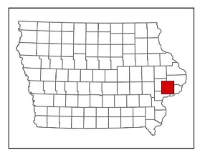
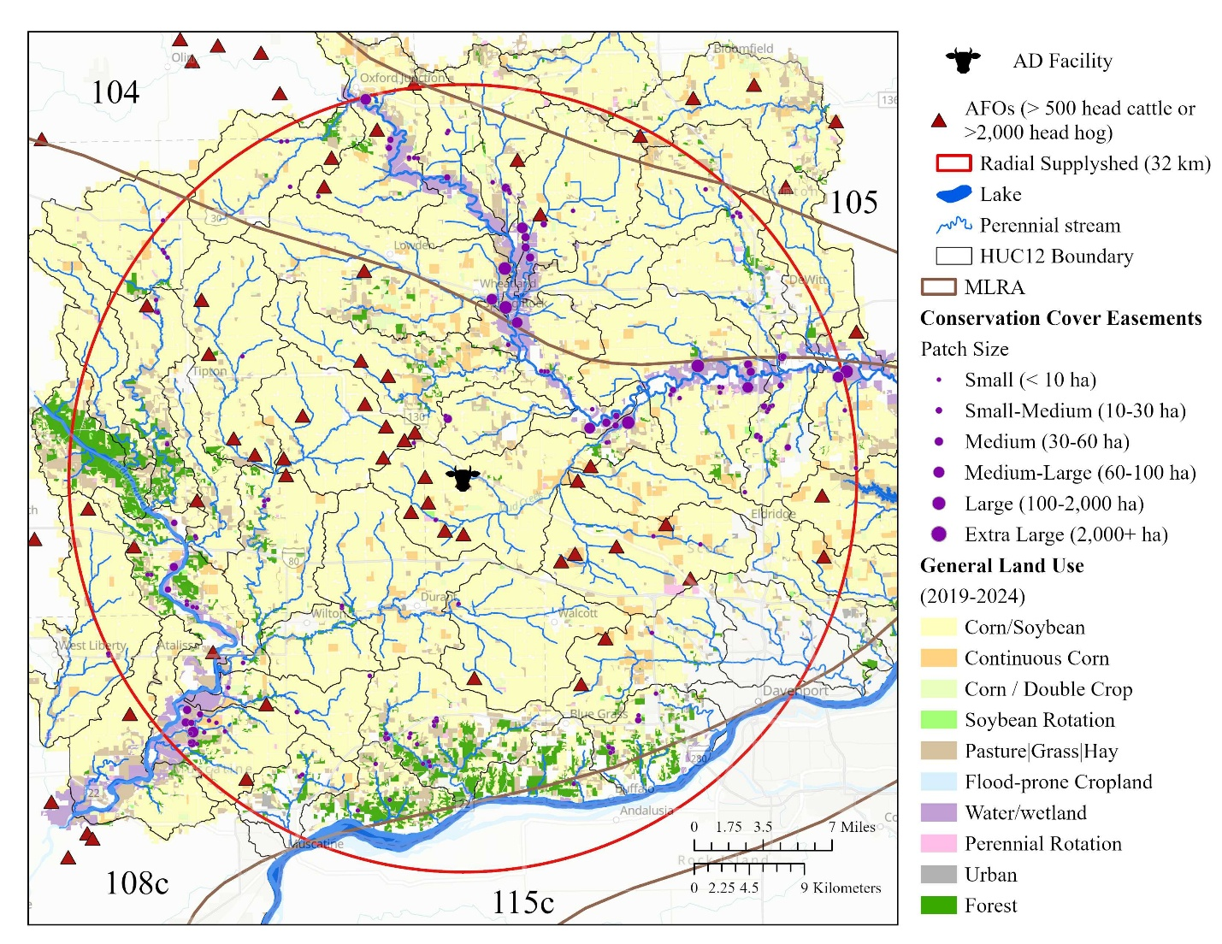

Figure 1. [Methods] Location of AD facility, 32 km supplyshed boundary, MLRA, HUC12 watersheds, locations of other AFOs, general land use (2019-2024), existing permanent habitat locations. Resource inventory added to this paper.

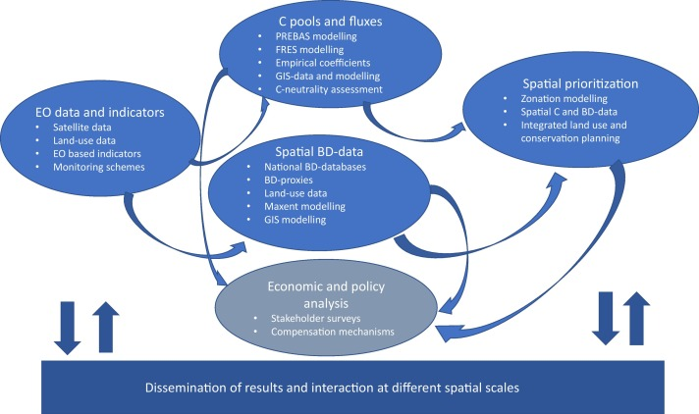
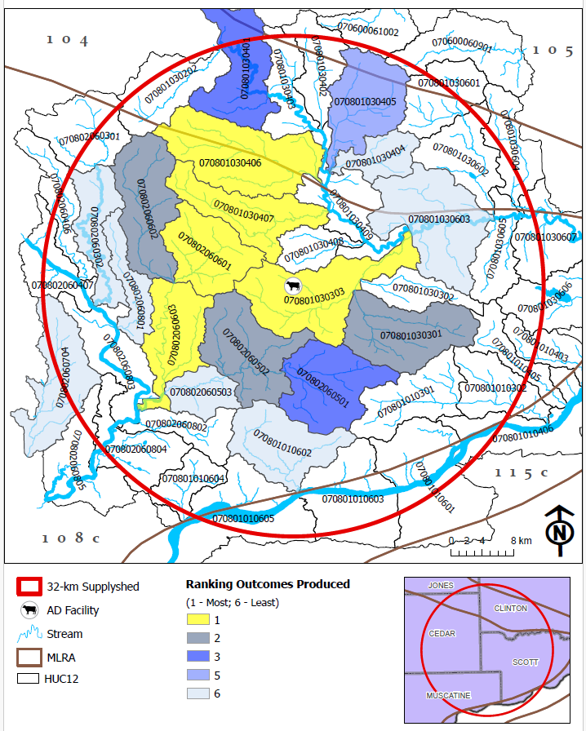
Figure 3. [Results]
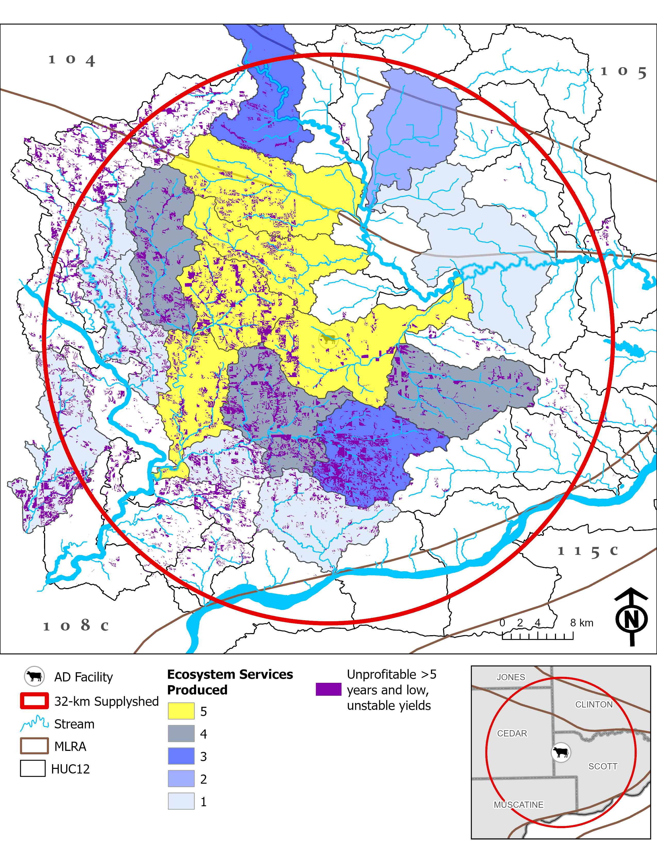
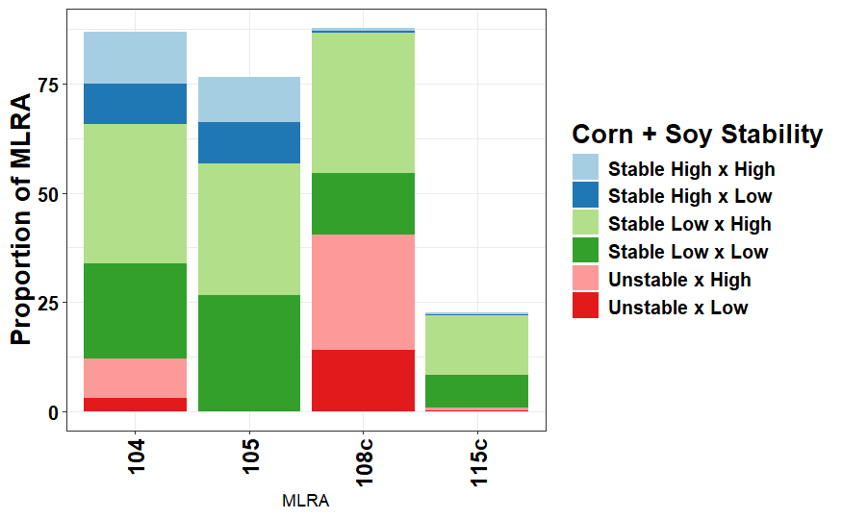

Itemized receipt provider has 180 days to submit a claim.
Figure 4. [Results]
- Figure 4. Final map showing the highest priority watersheds and where the lowest yield stability and profitability locations are in the supplyshed.

Table 1. [Methods] Summary of land in 32 km supplyshed and land requirements to achieve the AD facility, INRS and IWAP goals for permanent cover and rye. Area in hectares.
Land Use and Land Cover | MLRA |  |  |  |  |  |  |  | Supplyshed
Land Use and Land Cover | 104 |  | 105 |  | 108c |  | 115c
Area within supplyshed | 66,525 |  | 5,341 |  | 235,690 |  | 6,406² |  | 313,962
Total cropped area¹ | 52,873 |  | 5,208 |  | 170,354 |  | 667 |  | 229,102
Continuous corn (CC)¹ | 2,730 |  | 345 |  | 13,171 |  | 24 |  | 16,270
Corn rotation (CS)¹ | 50,143 |  | 4,863 |  | 157,183 |  | 643 |  | 212,832
Existing permanent cover based on NCED | 1,110 |  | 0 |  | 1,109 |  | 16 |  | 2,235
LAND AREA GOALS (ha)
IWAP
4% of supplyshed in permanent cover. | 1,765 |  | 352 |  | 6,898 |  | 44 |  | 9,059
INRS
Plant a rye cover crop on all no-till acres | CC | CS | CC | CS | CC | CS | CC | CS | CC | CS
Plant a rye cover crop on all no-till acres | 300 | 12,034 | 38 | 1,508 | 1,976 | 56,586 | 2 | 212 | 2,316 | 70,340
Installing wetlands to treat 45% of the ag land.³ | 522 |  | 53 |  | 1,849 |  | 6 |  | 2,430
Installing [saturated] buffers on all applicable acres. | 184 |  | 12 |  | 1,341 |  | 36 |  | 1,573
Perennial crops (energy crops) to equal pasture/hay acreage in 1987. | 7,231 |  | 1,751 |  | 29,820 |  | 86 |  | 38,888
AD Facility
Prairie |  |  |  |  |  |  |  |  | 809
Cereal Rye |  |  |  |  |  |  |  |  | 809
¹ The total cropped area was estimated using NASS data compiled by ACPF and based on a six-year (2019-2024) crop rotation for a field.
² The area of 115c in the 32 km supplyshed is only reported for Iowa and the Illinois land was subtracted from the total.
³ There were NRW sited that achieved treatment of 45% of agricultural land in the supplyshed, however, the number of NRW were pared down to remove some of the larger wetland complexes that would require agreement from multiple landowners.

Perennial crops as prairie strips and whole field conversion.
Table 3. [Results] Costs to achieve INRS & IWAP recommendations in the supplyshed. Should I report mean and range? Or median and confidence interval? How much of these costs are establishment and how much are management?
Assuming a harvested biomass. These costs would look different if these aren’t all managed as a biomass system. Look at enterprise budget. 20 years @ 7% discount rate.
Everything from NO₃ except STB. Assuming OC is the same for each MLRA and practice. THe same number of acres. DC and TC will change. CPs are annualized over 20 years @ 6% discount rate. Assuming different returns and impacts financially. Saturated buffers OC could be less because they are only planning for BMP and could be designed to be smaller instead of trying to maintain a harvestable buffer width, however, we are assuming same width (100’). Rye cover crop has no OC since no land is being taken out of production, however, I just wanted to report the land rental value for demonstrative purposes.
Report costs per practice/acre in the footnotes.
 | MLRA |  |  |  |  |  |  |  |  |  |  |  |  | Supplyshed
 | 104 |  |  | 105 |  |  | 108c |  |  |  | 115c
 | DC | OC | TC | DC | OC | TC |  | DC | OC | TC | DC | OC | TC | DC | OC | TC
INRS
Plant a rye cover crop on all no-till acres. | $5,419,144 | $7,779,864 | $5,419,144 | $640,133 | $682,460 | $640,133 |  | $25,230,779 | $35,811,689 | $25,230,779 | $84,105 | $98,034 | $84,105 | $31,374,161 | $44,372,047 | $31,374,161
CP | $1,678,239 | $7,779,864 | $1,678,239 | $191,993 | $682,460 | $191,993 |  | $7,767,089 | $35,811,689 | $7,767,089 | $28,430 | $98,034 | $28,430 | $9,665,751 | $44,372,047 | $9,665,751
Installing wetlands to treat 45% of the agricultural land. | $3,737,007 | $245,791 | $3,982,798 | $371,725 | $22,859 | $394,585 |  | $16,589,650 | $1,143,352 | $17,733,002 | $22,661 | $1,161 | $23,822 | $20,721,043 | $1,413,163 | $22,134,207
CP | $2,695,578 | $245,791 | $2,941,369 | $268,133 | $22,859 | $300,631 |  | $11,966,447 | $1,143,352 | $13,109,800 | $16,346 | $1,161 | $17,507 | $14,946,504 | $1,413,163 | $16,369,307
Installing [saturated] buffers on applicable acres. | $131,985 | $334,352 | $466,337 | $3,150 | $7,752 | $10,902 |  | $820,523 | $2,042,864 | $2,863,387 | - | - | - | $955,658 | $2,384,684 | $3,340,626
CP | $103,240 | $334,352 | $437,592 | $2,464 | $7,752 | $10,216 |  | $641,820 | $2,042,864 | $2,684,684 | - | - | - | $747,524 | $2,384,684 | $3,132,491
Perennial crops (energy crops) to equal pasture/hay acreage in 1987. | $2,586,467 | $3,154,069 | $5,740,536 | $564,695 | $625,021 | $1,189,716 |  | $10,668,163 | $16,869,746 | $27,537,909 | $25,537 | $33,073 | $58,610 | $13,844,862 | $20,594,638 | $34,526,771
CP | $667,041 | $3,154,069 | $3,956,884 | $146,089 | $625,021 | $801,130 |  | $2,699,471 | $16,869,746 | $19,911,607 | $6,830 | $33,073 | $41,938 | $3,519,431 | $20,594,638 | $24,114,069
Sum of all management options. | $9,395,257 | $3,734,212 | $14,054,826 | $1,310,582 | $655,632 | $2,109,328 |  | $41,870,596 | $20,055,962 | $65,921,746 | $131,926 | $34,234 | $173,585 | $52,708,361 | $24,392,485 | $82,259,485
CP | $5,240,998 | $3,734,212 | $9,110,984 | $618,318 | $655,632 | $1,303,970 |  | $23,504,993 | $20,055,962 | $43,903,345 | $52,194 | $34,234 | $88,463 | $29,416,503 | $24,392,485 | $54,406,762
IWAP
4% of Iowa in permanent cover | $2,162,264 | $2,624,285 | $4,786,549 | $313,263 | $349,709 | $662,972 |  | $8,649,731 | $14,105,302 | $22,755,033 | $18,041 | $25,145 | $43,186 | $11,143,299 | $17,104,441 | $28,247,740
CP | $534,053 | $2,624,285 | $3,158,338 | $77,372 | $349,709 | $427,082 |  | $2,136,379 | $14,105,302 | $16,241,682 | $4,456 | $25,145 | $29,601 | $2,752,260 | $17,104,441 | $19,856,703
Side fact….$3,745,871,600 per year over 20 years for all of Iowa. Assuming 30 million acres of land and supplyshed is 2% of land in Iowa.

Table 2. [Results] Estimated leachable nitrate (NO₃) and sediment transport reduction results (FiNRT). Total reductions in nitrate load (tonnes yr⁻¹) and sediment transported (tonnes yr⁻¹) for each MLRA and the 32 km supplyshed. Greenhouse gas reduction summary. Estimated CO₂ and N₂O emission reductions (t CO₂e ha⁻¹ yr ⁻¹) for each MLRA and the 32 km supplyshed. Wildlife habitat mean, minimum and maximum patch size and area of assumed corridors connecting patches (ha). To see a list of potential species supported based on patch size and connectivity, see Supplementary Materials.
 | MLRA |  |  |  | Supplyshed
 | 104 | 105 | 108c | 115c | Supplyshed
Water Quality Improvements | Load Reduced (tonnes per year)
Nitrate (NO₃) Load | 1,766 | 725 | 5755 | 33 | 8,279
Sediment Load | 1,254 | 1,687 | 7286 | 123 | 10,350
Greenhouse Gas Emissions | Emissions Reduced (Mg CO_{2 eq} per year)
Carbon Dioxide (CO₂) | 18,037 | 3,509 | 80,222 | 285 | 102,053
Nitrous Oxide (N₂O) | 868,010 | 114,080 | 3,791,874 | 12,873 | 4,786,837
Wildlife | Quality Habitat Established (acres)
Patch Size (Average field size) | 77 (16 - 307)  n = 67 | 54 (3 - 194)  n = 19 | 62 (4 - 375)  n = 274 | 27 (15 - 46)  n = 4 | 64  n = 364
Connectivity¹ (Total area) | 2,782 | 1,477 | 13,546 | 58 | 17,863
¹ assumes that saturated buffers and CBS provide corridors between patch sizes and they are all connected.

3.12% of the INRS load reduction
264917.9021
Table 4. [Results] Cost-effectiveness. Cost per kg of pollutant reduced. Are confidence intervals better here? Median seems more appropriate since the range is so wide.
 |  | Major Land Resource Area |  |  |  |  |  |  |  |  |  | Supplyshed
 |  | 104 |  | 105 |  |  | 108c |  |  | 115c
Cost-Effectiveness |  | DC | TC | DC | TC | DC |  | TC | DC |  | TC | DC | TC
Plant a rye cover crop on all no-till acres. | NO₃ | $51.56  ($51.30 - $51.81) |  | $51.97  ($51.40 - $52.54) |  |  | $51.81  ($51.70 - $51.93) |  |  | $53.36  ($52.85 - $53.88) |  | $51.79  ($51.69 - $51.89)
Plant a rye cover crop on all no-till acres. | Sed | $0.55  ($0.51 - $0.58) |  | $0.23  ($0.19 - $0.27) |  |  | $0.35  ($0.33 - $0.36) |  |  | $0.23  ($0.11 - $0.34) |  | $0.37  ($0.36 - $0.38)
Installing wetlands to treat 45% of the agricultural land. | NO₃ | $29.65  ($26.66 - $32.65) | $31.57  ($28.38 - $34.77) | $31.91  ($22.81 - $41.01) | $33.88  ($24.27 - $43.48) | $29.05  ($27.88 - $30.22) |  | $31.03  ($29.77 - $32.28) | $33.94 |  | $35.68 | $29.23  ($28.15 - $30.31) | $31.20  ($30.04 - $32.35)
Installing wetlands to treat 45% of the agricultural land. | Sed | $0.51  ($0.41 - $0.61) | $0.54  ($0.44 - $0.65) | $0.15  ($0.11 - $0.20) | $0.16  ($0.12 - $0.21) | $0.35  ($0.33 - $0.38) |  | $0.38  ($0.35 - $0.41) | $0.19 |  | $0.20 | 0.37  (0.35 - 0.40) | $0.40  ($0.37 - $0.43)
Installing [saturated] buffers on applicable acres.¹ | NO₃ | $2.76  ($2.55 - $2.96) | $9.66  ($8.95 - $10.37) | - | - | $1.99  ($1.92 - $2.06) |  | $7.19  ($6.93 - $7.45) | - |  | - | $2.13  ($2.06 - $2.20) | $7.65  ($7.40 - $7.90)
Installing [saturated] buffers on applicable acres.¹ | Sed | $1.15  ($0.64 - $1.67) | $4.11  ($2.24 - $5.97) | $0.08  ($(0.08) - $0.25) | $0.28  ($(0.27) - $0.84) | $1.69  ($0.11 - $3.26) |  | $5.45  ($0.14 - $10.77) | - |  | - | 1.60  (0.25 - 2.96) | $5.25  ($0.67 - $9.83)
Perennial crops (energy crops) to equal pasture/hay acreage in 1987. | NO₃ | $10.00  ($9.50 - $10.49) | $21.79  ($20.69 - $22.90) | $7.38  ($6.79 - $7.96) | $15.80  ($14.43 - $17.17) | $8.92  ($8.71 - $9.13) |  | $22.34  ($21.75 - $22.92) | $8.25  ($5.52 - $10.99) |  | $18.29  ($11.27 - $25.31) | $8.97  ($8.79 - $9.15) | $21.78  ($21.28 - $22.28)
 | Sed | $0.31  ($0.28 - $0.34) | $0.67  ($0.60 - $0.74) | $0.10  ($0.07 - $0.12) | $0.23  ($0.17 - $0.29) | $0.16  ($0.16 - $0.17) |  | $0.42  ($0.40 - $0.44) | $0.06  ($0.03 - $0.09) |  | $0.13  ($0.06 - $0.20) | $0.18  ($0.17 - $0.19) | $0.44  ($0.42 - $0.47)
¹ no tile drained fields to this practice, so NO₃ load reductions are not estimated. We assume some surface runoff is intercepted so there is a sediment reduction value.

Table 5. [Results] From a watershed perspective, where should we prioritize? Should this be supplementary material?
Biomass costs
Top 10 most beneficial environmentall. From a transportation perspective, where should we prioritize?
NEXT STEPS pick out the top 10 watersheds for each pollutant of concern and most cost-effective. See if there is any overlap.
HUC12 | NO₃  (Mg) | Sediment (Mg) | Wildlife  (ha) | GHG (Mg CO_{2 eq}) |  | Summary of Costs |  | Cost-Effectiveness ($ per kg NO₃) |  | Cost-Effectiveness  ($ per kg sediment) |  | Yield of Biomass (Mg) | Energy Potential  (GW) | Mean Travel Distance (km) | Mean Travel Time (min)
 |  |  |  | CO₂ | N₂O | DC | TC | DC | TC | DC | TC
070600060901 | 9 | 2,640 | 52 | 348 | 11,338 | $152,706 | $209,826 | $21.03 | $25.78 | $0.09 | $0.13 | 1167 | 7231 | 60 | 46
070600061002 | 8 | 2,409 | 13 | 412 | 18,534 | $181,632 | $235,298 | $26.77 | $31.11 | $0.10 | $0.13 | 1321 | 11016 | 51 | 43
070801010301 | 78 | 12,978 | 262 | 2,935 | 138,633 | $1,941,070 | $2,539,412 | $30.39 | $35.47 | $0.20 | $0.26 | 10161 | 83058 | 29 | 20
070801010302 | 11 | 1,222 | - | 414 | 20,402 | $230,432 | $354,625 | $28.62 | $37.29 | $0.39 | $0.59 | 1441 | 12169 | 33 | 22
070801010403 | 23 | 3,499 | - | 693 | 30,885 | $416,343 | $698,430 | $23.55 | $31.02 | $0.15 | $0.22 | 2462 | 18746 | 40 | 25
070801010405 | 23 | 3,081 | 32 | 1,125 | 53,804 | $611,908 | $826,076 | $28.38 | $35.11 | $0.23 | $0.36 | 3776 | 32000 | 38 | 24
070801010601 | 13 | 2,806 | 70 | 636 | 32,012 | $325,963 | $502,072 | $32.05 | $39.87 | $0.15 | $0.25 | 2083 | 18941 | 36 | 23
070801010602 | 53 | 10,387 | 397 | 2,521 | 125,357 | $1,452,275 | $1,981,225 | $33.30 | $38.89 | $0.20 | $0.26 | 8472 | 74214 | 27 | 25
070801010603 | 6 | 1,277 | 85 | 443 | 22,050 | $167,380 | $227,111 | $34.18 | $39.77 | $0.23 | $0.31 | 1425 | 12954 | 33 | 27
070801010604 | 21 | 2,585 | 81 | 973 | 50,713 | $582,274 | $808,414 | $34.36 | $40.71 | $0.28 | $0.39 | 3255 | 29833 | 39 | 27
070801010605 | 17 | 2,472 | 169 | 844 | 39,199 | $391,582 | $561,214 | $31.31 | $36.51 | $0.24 | $0.31 | 2719 | 23226 | 40 | 30
070801030202 | 84 | 9,852 | 252 | 2,888 | 148,531 | $2,351,483 | $2,832,225 | $34.21 | $38.38 | $0.41 | $0.53 | 10216 | 88360 | 43 | 33
070801030203 | - | - | - | 65 | 2,665 | - | - | - | - | - | - | 208 | 1603 | 49 | 36
070801030301 | 144 | 11,309 | - | 4,017 | 215,041 | $3,408,940 | $5,166,811 | $29.91 | $39.77 | $3.38 | $4.89 | 14329 | 127476 | 19 | 15
070801030302 | 51 | 6,760 | 276 | 1,798 | 89,325 | $1,276,898 | $1,732,805 | $30.09 | $36.81 | $0.36 | $0.50 | 6056 | 51482 | 23 | 19
070801030303 | 160 | 25,371 | 38 | 5,439 | 261,842 | $3,943,428 | $5,192,142 | $29.40 | $35.75 | $0.28 | $0.41 | 18936 | 156647 | 10 | 8
070801030401 | 68 | 7,935 | 428 | 3,070 | 152,815 | $1,890,025 | $2,309,246 | $33.02 | $37.50 | $0.45 | $0.57 | 10344 | 90500 | 41 | 35
070801030402 | 39 | 5,009 | 300 | 1,580 | 62,974 | $708,469 | $1,155,299 | $22.34 | $31.26 | $0.32 | $0.59 | 5143 | 38153 | 49 | 44
070801030403 | 46 | 6,967 | 189 | 1,859 | 82,566 | $1,055,125 | $1,362,798 | $24.98 | $30.82 | $1.06 | $1.52 | 6211 | 49539 | 40 | 37
070801030404 | 22 | 750 | 64 | 800 | 45,391 | $461,072 | $778,855 | $26.12 | $37.32 | $0.58 | $0.98 | 2671 | 26519 | 37 | 32
070801030405 | 85 | 10,335 | 385 | 3,010 | 127,002 | $1,744,427 | $2,380,602 | $23.48 | $29.77 | $0.38 | $0.57 | 9981 | 76620 | 46 | 40
070801030406 | 155 | 30,598 | 400 | 6,584 | 263,367 | $3,458,144 | $4,480,550 | $26.40 | $31.09 | $0.25 | $0.34 | 22197 | 160650 | 30 | 24
070801030407 | 115 | 27,543 | 831 | 4,566 | 191,961 | $2,651,170 | $3,400,214 | $27.78 | $32.56 | $0.22 | $0.30 | 15578 | 116537 | 18 | 15
070801030408 | 49 | 11,324 | 344 | 2,228 | 91,635 | $1,009,410 | $1,423,298 | $25.57 | $30.81 | $0.20 | $0.26 | 7403 | 55504 | 11 | 10
070801030409 | 52 | 5,824 | 300 | 1,609 | 82,209 | $1,402,996 | $1,907,726 | $28.61 | $35.23 | $0.35 | $0.53 | 5635 | 48859 | 27 | 23
070801030601 | 52 | 8,514 | 275 | 1,918 | 77,384 | $1,178,696 | $1,430,512 | $27.99 | $31.56 | $0.55 | $0.73 | 6605 | 47357 | 54 | 41
070801030602 | 32 | 2,089 | 109 | 1,496 | 81,797 | $872,938 | $1,165,945 | $35.32 | $40.61 | $0.59 | $0.79 | 4955 | 47781 | 53 | 37
070801030603 | 100 | 9,513 | 176 | 2,443 | 120,490 | $2,468,706 | $3,212,518 | $27.32 | $33.90 | $0.40 | $0.57 | 9225 | 75869 | 33 | 27
070801030604 | 6 | 560 | 246 | 213 | 11,634 | $274,464 | $299,708 | $39.75 | $44.54 | $0.52 | $0.66 | 793 | 6930 | 61 | 37
070801030605 | 38 | 5,148 | 7 | 1,287 | 57,288 | $829,951 | $1,079,059 | $26.01 | $31.59 | $0.22 | $0.32 | 4341 | 34424 | 44 | 29
070801030606 | 47 | 5,398 | 157 | 1,262 | 58,087 | $1,124,780 | $1,289,451 | $30.63 | $34.47 | $0.28 | $0.35 | 4367 | 34919 | 45 | 29
070801030607 | 21 | 3,489 |  | 818 | 35,490 | $397,132 | $553,346 | $24.85 | $29.88 | $0.22 | $0.34 | 2672 | 21267 | 51 | 33
070802060301 | 35 | 6,445 | 118 | 1,550 | 78,175 | $1,049,554 | $1,339,491 | $34.73 | $39.95 | $0.47 | $0.66 | 5218 | 45899 | 41 | 32
070802060302 | 61 | 14,168 | 115 | 2,823 | 133,212 | $1,616,668 | $2,024,905 | $30.54 | $35.51 | $0.22 | $0.28 | 9576 | 79837 | 35 | 27
070802060406 | 26 | 6,137 | 161 | 1,237 | 58,828 | $605,695 | $807,172 | $27.73 | $32.15 | $4.20 | $6.10 | 4215 | 35109 | 38 | 30
070802060407 | 10 | 3,169 | 28 | 624 | 27,856 | $282,917 | $344,284 | $30.39 | $34.42 | $0.17 | $0.20 | 2040 | 16635 | 43 | 29
070802060501 | 117 | 13,000 | 73 | 3,342 | 175,968 | $3,000,286 | $4,138,423 | $29.60 | $37.04 | $0.32 | $0.49 | 12034 | 103919 | 17 | 15
070802060502 | 128 | 15,720 | 289 | 4,917 | 261,035 | $3,801,141 | $4,990,143 | $33.50 | $40.98 | $0.34 | $0.48 | 17493 | 155611 | 18 | 14
070802060503 | 45 | 2,829 | 174 | 1,246 | 70,884 | $1,117,525 | $1,595,795 | $33.87 | $42.93 | $0.47 | $0.70 | 4398 | 41643 | 26 | 21
070802060601 | 115 | 17,348 | 359 | 4,155 | 217,776 | $3,199,191 | $4,246,383 | $34.05 | $40.06 | $0.27 | $0.37 | 14687 | 129230 | 17 | 14
070802060602 | 144 | 31,121 | 456 | 6,373 | 289,444 | $3,793,187 | $4,755,735 | $31.24 | $35.81 | $0.28 | $0.38 | 17051 | 142267 | 30 | 23
070802060603 | 106 | 16,740 | 326 | 4,034 | 186,421 | $2,697,144 | $3,502,174 | $30.47 | $36.16 | $0.24 | $0.33 | 18607 | 143512 | 28 | 19
070802060704 | 85 | 13,853 | 484 | 2,601 | 113,306 | $1,955,362 | $2,409,984 | $28.48 | $33.29 | $0.26 | $0.35 | 9117 | 68812 | 45 | 29
070802060801 | 51 | 11,539 | 8 | 2,377 | 103,775 | $1,121,965 | $1,613,718 | $26.77 | $33.42 | $0.20 | $0.27 | 7826 | 62232 | 34 | 24
070802060802 | 49 | 3,211 | 566 | 1,348 | 76,657 | $1,357,472 | $2,049,017 | $32.86 | $44.51 | $0.39 | $0.62 | 4859 | 44848 | 33 | 22
070802060803 | 46 | 7,313 | 70 | 1,871 | 88,883 | $1,092,183 | $1,538,929 | $29.32 | $36.16 | $4.79 | $5.48 | 6402 | 53438 | 37 | 24
070802060804 | 44 | 3,201 | 201 | 1,467 | 79,553 | $1,123,620 | $1,659,827 | $28.33 | $38.65 | $0.86 | $1.24 | 5011 | 46912 | 41 | 27
070802060805 | 8 | 509 | 105 | 261 | 14,362 | $145,009 | $304,484 | $27.19 | $37.87 | $0.38 | $0.68 | 856 | 8371 | 42 | 28

Is this a meaningful table?. [Results] Mean Establishment + Management + Land Costs of biomass systems annualized over time. Mean Establishment + Management Costs of biomass systems annualized over 20 years @ 7 % discount. Maybe useful when looking at potential taxes, or ways to pay for this across a larger area. WTP surveys? This is spread across all land uses, not just cropland.
 | MLRA |  |  |  | Supplyshed
 | 104 | 105 | 108c | 115c | Supplyshed
Total area | 66,525 ha | 5,341 ha | 235,690 ha | 6,406 ha | 313,962 ha
TC | $194.76/ha | $371.60/ha | $253.76/ha | $26.25/ha | $238.62 / ha
DC | $141.23 / ha | $245.38 / ha | $177.65 / ha | $20.59 / ha | $167.88 / ha
Cropped area | 52,873 ha | 5,208 ha | 170,354 ha | 667 ha | 229,012 ha
TC | $245.04 / ha | $381.09 / ha | $351.08 / ha | $252.17 / ha | $327.13 / ha
DC | $177.69 / ha | $251.65 / ha | $245.79 / ha | $197.79 / ha | $230.16 / ha
Treated Area | 20,271 ha | 3,362 ha | 91,572 ha | 342 ha | 115,547 ha
TC | $639.15 / ha | $590.33 / ha | $653.13 / ha | $491.80 / ha | $648.37 / ha
DC | $463.48 / ha | $389.82 / ha | $457.24 / ha | $385.75 / ha | $456.16 / ha

Supplementary Material: Costs

Enterprise budgets
Riparian buffer (mix-species) enterprise budget. assume harvest of 50% of buffer and exclude the first 16.5 ft from streambank
Cost Activities/Items | Year Cost Incurred | Range of Costs |  | Mean cost  ($/acre) | Notes | Data Sources
Cost Activities/Items | Year Cost Incurred | min | max | Mean cost  ($/acre) | Notes
NRW Construction
Buffer site design | 0 | - | $300.00 | $300.00 |  | Christianson et al. 2013, inflated to 2024$
Site preparation | 0 | $117.00 | $162.00 | $140.00 |  | 2024 Iowa Farming Custom Rate Survey, File A3-10; Schultz et al. 2000
Grass seed | 0 | $90.00 | $300.00 | $119.00 |  | Seed cost: Iowa Pheasants Forever Native Seed Program, http://www.iowapf.net/native-seed-program/
Drilling grass seed | 0 | $12.00 | $25.00 | $18.70 |  | 2024 Iowa Farming Custom Rate Survey, File A3-10
MSB Biomass Establishment - Year 1
Mowing | 1 | $30.00 | $54.00 | $41.55 |  | 2024 Iowa Farming Custom Rate Survey, File A3-10; Christianson et al. 2013
Prairie Biomass Crop Management
Manure application - Fall | 2-n |  |  |  | No fertilizer applied within 35 ft of stream | (<source>)
Mowing/Conditioning | 2-n | $14.00 | $25.00 | $18.10 |  | 2024 Iowa Farming Custom Rate Survey, File A3-10
Raking | 2-n | $7.00 | $9.00 | $8.15 |  | 2024 Iowa Farming Custom Rate Survey, File A3-10
Silage - chopping | 2-n | $20.40 | $27.20 | $24.14 |  | 2024 Iowa Farming Custom Rate Survey, File A3-10
Straw or corn stalk baling - large round or square bales without wrap | 2-n | $67.95 | $81.54 | $70.67 |  | 2024 Iowa Farming Custom Rate Survey, File A3-10
Overall Management Impact
Land rent | A | Variable |  |  |  | Plastina et al., 2023.
General operating costs | A | 1-3% upfront |  | Variable |  | Bravard et al., 2022.

References
Plastina, A. and A.M. Johanns. 2024. 2024 Iowa Farm Custom Rate Survey, File A3-10. Iowa State University, Ames, IA.
Accessed on 9/11/2024 | https://www.extension.iastate.edu/agdm/crops/html/a3-10.html
Accessed on 9/11/2024 | https://www.sciencedirect.com/science/article/pii/S0961953416303208.

Nutrient removal wetland enterprise budget.
Cost Activities/Items | Year Cost  Incurred | Range of Costs (per wetland) |  | Mean cost (per acre of wetland) | Notes (JT 2024)  Notes (JS 2024) | Data Sources
Cost Activities/Items | Year Cost  Incurred | min | max | Mean cost (per acre of wetland) | Notes (JT 2024)  Notes (JS 2024) | Data Sources
NRW Construction
Wetland design cost (engineer) | 0 | - | $4,000.00 | $800.00 | Assumption: 20 hours at ~$200/hr for a 5-acre wetland site (treating 500 acres of drainage) The total amount of this cost will depend on the context for wetland use and or program tie-in (e.g., USDA CREP wetland program). This cost variable assumes a 1/5 cost factor for 1 acre of wetland construction. Cost may be significantly reduced by working with the NRCS. | Christianson et al. 2013, inflated to 2024$.
Constructing basin | 0 |  | $140,000.00 | $2,800.00 | Building ponds ~100 hours at ~$250/hr for a 5-acre wetland (encompasses range of activities for excavation, berm building, structure placement, etc.). Moving/ transporting earth and rock offsite, $2.00 to $3.00 per cubic yard of material. Assume ~ 10,000 cubic yards of earth material per acre of wetland (~0.5 % rock). Note that excavation and material removal costs increase significantly as percent rock increases beyond > 1%. This cost variable assumes a 1/5 cost factor for 1 acre of wetland. | Christianson et al. 2013, inflated to 2024$.
Control structure and installation | 0 |  | $8,300.00 | $1,660.00 | One 10ft deep, 24-inch pipe control structure costs ~ $5,500 (plus ~$300 shipping costs). 1 structure per 500 to 1000 acre drainage area (Buffer area assumption: Helmers, M. 2014 Personal communication). Assume 10 hours for installation @ $250/ hour. This cost variable assumes a 1/5 cost factor for 1 acre of wetland. | Control structure cost: Agri drain 2024 catalog price; The Pond Report 2021.
Wetland plants (seeds and plugs) and planting | 0 | - | $12,800.00 | $1,889.00 | For shallow wetland systems, 50-100 plugs per 100 ft2 will help ensure sufficient establishment in open water areas. Assume ~ 3,500 ft2 of shore area per 5 acre wetland. A wetland seed mix that covers wetland banks (~1/3 of the basin area) is also advisable. Wetland plant species regionally sell in bulk for ~$1.50 to $4.00 per plug; wetland seed mixes range $140 - $175 per acre (e.g., sufficient for CP 25 or CP 42 plantings). Planting a plug costs ~ $0.50 per plug. So, ($3.25 per planted plug * 2,625 plugs per 5 acre wetland = $8,531 for planted plugs + (~$158/ acre for wet prairie seed * ~6 acres of shore area). This cost variable assumes a 1/5 cost factor for 1 acre of wetland. It is possible that there is a viable wetland plant seedbed that would revegetate the wetland basin without additional seed/plants; such outcomes are uncertain and variable. | 2024 survey of regional bulk wetland plant catalog prices (n=4).
Wetland buffer seed | 0 | 2,450.00 | $3,063.00 | $553.00 | Wetland seed mixes range $140 - $175 per acre (e.g., sufficient for CP 25 or CP 42 plantings). Total Wetland buffer area = 3.5% of the total drainage area; 500 acres is minimum drainage area or 5 acres of wetland. Or 17.5 acres of buffer needed. Buffer area assumption: Helmers, M. 2014 Personal communication. This cost variable assumes a 1/5 cost factor to represent 1 acre of wetland. | Seed cost: 2024 Iowa Pheasants Forever Native Seed Program.
Seeding buffer (seed drilling and cultipacking) | 0 | $525.00 | $1,440.00 | $200.00 | $30.00 - $48.00 per acre of buffer Total Wetland buffer area = 3.5% of the total drainage area; One acre of wetland treats 100 acres of drainage area. This cost variable assumes a 1/5 cost factor to represent 1 acre of wetland. | Plastina et al., 2024b.
Weir plate | 0 | Variable |  | $800.00 | Assumption: $40 per sq. ft sheet pile plate. Assume 0.2 square feet of weir plate for every acre of drainage; minimum of 500 acres drainage. One acre of wetland treats 100 acres of drainage area. (0.2 sq. ft. * 500 acres drainage * $40/ sq.ft of plate = $4000. This cost variable assumes a 1/5 cost factor to represent 1 acre of wetland. | Christiansen, et al., 2013, inflated to 2024$.
Prairie Biomass Establishment - Year 1-3
Mowing | 1 | $350.00 | $630.00 | $96.95 | Accounts for mowing 2x per year, raking and baling once per year. | Plastina et al., 2024b.
Mowing / Conditioning | Yr 2-3 | $490.00 | $875.00 | $126.70 | Accounts for mowing 2x per year, raking and baling once per year. | Plastina et al., 2024b.
Raking | Yr 1-3 | $472.50 | $157.50 | $28.53 | Accounts for mowing 2x per year, raking and baling once per year. | Plastina et al., 2024b.
Herbicide & Application | 2 | $181.13 | $242.38 | $43.23 |  | Plastina et al., 2024b.
Burn | Yr 3 | $875.00 | $1,645.00 | $255.50
Prairie Biomass Crop Management
Manure application - Fall | 4-n
Mowing/Conditioning | 4-n | $122.50 | $218.75 | $31.68 |  | Plastina et al., 2024b.
Raking | 4-n | $61.25 | $78.75 | $14.26 |  | Plastina et al., 2024b.
Silage - chopping | 4-n | $178.50 | $238.00 | $42.25 |  | Plastina et al., 2024b.
Straw or corn stalk baling - large round or square bales without wrap | 4-n | $594.56 | $713.48 | $123.67 |  | Plastina et al., 2024b.
Mowing (unharvested portion of buffer) | 4-4n | $87.50 | $157.50 | $24.24 | Total Wetland buffer area = 3.5% of the total drainage area; One acre of wetland treats 100 acres of drainage area. Assume $12 - $65 per acre to mow CRP. This cost variable assumes a 1/5 cost factor to represent 1 acre of wetland. Note: Periodic burning is a common alternative. Burning prairie costs ~ $32 per acre, or $560 every 5 years. | Plastina et al., 2024b.
Overall Management Impact
Replace control structure gates | 8n |  | $148.00 | $30.00 | Every 8 years, the gates within the control structures must be replaced to maintain correct operation. 5 Gates per structure ($18.50 ea. for 15 cm structure) | Christianson et al. 2013, inflated to 2024$.
Land rent for wetland acre | A | 1,150.00 | $1,650.00 | $277.00 | In Iowa, GIS calculated area-weighted average rent based on CSR2 for land used by practice. Based on the 2023 Iowa Land rent survey, average land rent for crop ground in Iowa ranged from a low of $230 to $330 per acre. This cost variable assumes a 1/5 cost factor to represent 1 acre of wetland. | Plastina et al., 2023.
Land rent for buffer acre | A | $ 4,000.00 | $ $5,775.00 | $970.00 | In Iowa, GIS calculated area-weighted average rent based on CSR2 for land used by practice. Total Wetland buffer area = 3.5% of the total drainage area; One acre of wetland treats 100 acres of drainage area | Plastina et al., 2023.
General operating costs | A | 1-3% upfront |  | Variable | This would involve general monitoring of the wetland, record keeping, wetland specific equipment storage, general energy cost. | Bravard et al., 2022.
Replace control structure and weir | 30+ years | $4,720.00 | 10,020.00 | $14,740.00 | One control structure ranging from 5 ft deep, 18-inch pipe ($2,356- $5,000 per structure) to 10ft deep, 24-inch pipe. 2 structures per 50 acres drainage area. One acre of wetland treats ~100 acres of drainage area (Buffer area assumption: Helmers, M. 2014 Personal communication). Assumes 0.005% real compounded increase in cost. Note this cost is not accounted for in the assessment presented here. It is included for reference. | Christianson et al. 2013; inflated to 2024$.

References
Accessed on 9/11/2024
NRCS. 2020. Iowa Native Prairie Planting Guide. Natural Resource Conservation Service, Des Moines, IA.
Accessed on 9/11/2024
Akron Services, Inc. 2023. 2024 Pesticide Prices. Illinois.
Accessed on 9/11/2024
Edwards, W. 2020. Estimating Value of Corn Stover, File A3-10. Iowa State University, Ames, IA.
Accessed on 9/11/2024
Accessed on 9/11/2024

Saturated buffer enterprise budget. assume harvest of 50% of buffer and exclude the first 16.5 ft from streambank
Cost Activities/Items | Year Cost Incurred | Range of Costs |  | Mean cost (per 1,000’) | Notes (JT 2024)  Notes (JS 2024) | Data Sources
Cost Activities/Items | Year Cost Incurred | min | max | Mean cost (per 1,000’) | Notes (JT 2024)  Notes (JS 2024) | Data Sources
STB Design
Buffer site design | 0 | - | - | $2,000.00 | Typically, buffer designs will be gratis from NRCS, but more complex buffers may need outside assistance. | Christianson et al. 2013, inflated to 2024$.
Site preparation | 0 | $117.00 | $162.00 | $140.00 | Includes disking, harrowing, site clearing, herbicide (various) and fertilizer application (lime, K, P). The fall prior to buffer establishment, the site is disked and planted to a winter cover (e.g., winter rye or timothy). | 2024 Iowa Farming Custom Rate Survey, File A3-10; Schultz et al. 2000
Control structure | 0 | - | - | $3,500.00 | 20 to 40-acre drainage area; other materials included in this.
Control gate replacement | 8n | - | - | $206.00
Grass seed | 0 | $90.00 | $300.00 | $119.00 | This example uses a 2020 Iowa CP 21 Buffer mix from Pheasants Forever. | Seed cost: Iowa Pheasants Forever Native Seed Program, http://www.iowapf.net/native-seed-program/
Drilling grass seed | 0 | $12.00 | $25.00 | $18.70 |  | 2024 Iowa Farming Custom Rate Survey, File A3-10
MSB Biomass Establishment - Year 1
Mowing | 1 | $30.00 | $54.00 | $41.55 | Mow 3 x in yr 1 during stand establishment phase; annually after. Material does not necessarily need to be baled. | 2024 Iowa Farming Custom Rate Survey, File A3-10; Christianson et al. 2013
Prairie Biomass Crop Management
Manure application - Fall | 2-n |  |  |  | No fertilizer applied within 35 ft of stream | (<source>)
Mowing/Conditioning | 2-n | $14.00 | $25.00 | $18.10 | Mow, rake, and bale materials at least once per year after year 1. This management is an alternative to periodic burning. Assumption is land manager would either mow/bale or burn. | 2024 Iowa Farming Custom Rate Survey, File A3-10
Raking | 2-n | $7.00 | $9.00 | $8.15 | Mow, rake, and bale materials at least once per year after year 1. This management is an alternative to periodic burning. Assumption is land manager would either mow/bale or burn. | 2024 Iowa Farming Custom Rate Survey, File A3-10
Silage - chopping | 2-n | $20.40 | $27.20 | $24.14 | Mow, rake, and bale materials at least once per year after year 1. This management is an alternative to periodic burning. Assumption is land manager would either mow/bale or burn. | 2024 Iowa Farming Custom Rate Survey, File A3-10
Straw or corn stalk baling - large round or square bales without wrap | 2-n | $67.95 | $81.54 | $70.67 |  | 2024 Iowa Farming Custom Rate Survey, File A3-10
Overall Management Impact
Land rent | A | Variable |  |  | GIS calculated area-weighted average rent based on CSR2 for land used by practice. | Plastina et al., 2023.
General operating costs | A | 1-3% upfront |  | Variable | This would involve general monitoring of the buffer and record keeping. | Bravard et al., 2022.

References
Plastina, A. and A.M. Johanns. 2024. 2024 Iowa Farm Custom Rate Survey, File A3-10. Iowa State University, Ames, IA.
Accessed on 9/11/2024 | https://www.extension.iastate.edu/agdm/crops/html/a3-10.html
Accessed on 9/11/2024 | https://www.sciencedirect.com/science/article/pii/S0961953416303208.

Prairie cover enterprise budget. For both contour buffer strips and prairie fields.
Cost Activities/Items | Year Cost Incurred | Range of Costs |  | Mean cost ($/acre) | Notes (JT 2021)  Notes (JS 2024) |  | Data Sources
Cost Activities/Items | Year Cost Incurred | min | max | Mean cost ($/acre) |  |  | Data Sources
Prairie Biomass Bed Prep - Fall
Mowing | 0 | $10.00 | $18.00 | $13.85 | Mowing will make it easier for the sod to be disked but won’t be as advantageous as the removal of the vegetation prior to disking. Prescribed fire or grazing could also be completed in lieu of mowing or haying. |  | 2024 Iowa Farming Custom Rate Survey, File A3-10
AND/OR
Straw or corn stalk baling - large round or square bales without wrap | 0 | $40.00 | $60.00 | $54.40 | Mowing will make it easier for the sod to be disked but won’t be as advantageous as the removal of the vegetation prior to disking. Prescribed fire or grazing could also be completed in lieu of mowing or haying. Assuming 4 bales per acre. |  | 2024 Iowa Farming Custom Rate Survey, File A3-10
AND
Tillage - Disk/Chiseling | 0 | $36.00 | $87.00 | $63.75 | Tillage needs vary from site to site. This captures a range of options. Cost could be zero if drilling into a bean field, and up to 6 times. Assumed 3 passes since it could be anywhere between 0 and 6 passes. |  | 2024 Iowa Farming Custom Rate Survey, File A3-10; Following NRCS Iowa Native Prairie Guide document for BMPs to establish prairie.
Prairie Biomass Planting
Seed | 0 | $85.00 | $183.00 | $138.40 | Average from multiple sources |  | see "seed_nutrient_costs" worksheet
Planting - Broadcast | 0 | $35.00 | $49.00 | $41.65 |  |  | https://tallgrassprairiecenter.org/resources/prairie-reconstruction/seed-and-service-providers
Land roll | 0 | $4.00 | $15.00 | $8.40 | Perform this in the fall after seeding prairie |  | 2024 Iowa Farming Custom Rate Survey, File A3-10; https://www.prairienursery.com/media/pdf/site-preparation-and-prairie-seeding-methods.pdf
OR
Seed | 0 | $85.00 | $183.00 | $138.40 | Average from multiple sources |  | see "seed_nutrient_costs" worksheet
Planting - Drill | 0 | $43.00 | $62.00 | $52.50 |  |  | https://tallgrassprairiecenter.org/resources/prairie-reconstruction/seed-and-service-providers
Prairie Biomass Establishment - Year 1-3
Mowing | 1 | $30.00 | $54.00 | $41.55 | Mow 3 x in yr 1 during stand establishment phase. Material does not necessarily need to be baled.
Mowing / Conditoning | Yr 2-3 | $14.00 | $25.00 | $18.10 | Mow, rake, and bale materials at least once per year after year 1. This management is an alternative to periodic burning. Assumption is land manager would either mow/bale or burn. |  | 2024 Iowa Farming Custom Rate Survey, File A3-10
Raking | Yr 1-3 | $7.00 | $9.00 | $8.15 | Mow, rake, and bale materials at least once per year after year 1. This management is an alternative to periodic burning. Assumption is land manager would either mow/bale or burn. |  | 2024 Iowa Farming Custom Rate Survey, File A3-10
Herbicide & Application | 2 | $10.35 | $13.85 | $12.35 | Chemical Mix for Site or Seedbed Prep or Weed Control (Glyphosate $15 to $30/gal. Application rate ~ 1 qt/ac); One application.  Roundup PowerMax 3 Bulk: $5.35/ac; Spraying without incorporation using a tractor |  | Herbicide Cost: 2024 Pesticide Prices; Spray Application Cost: 2024 Iowa Farming Custom Rate Survey, File A3-10
Burn | Yr 3 | $50.00 | $94.00 | $73.00 | Burning the grass is an alternative to mowing and baling; . Assumption is land manager would either mow/bale or burn. Burn every 3 – 5 yrs after establishment.  https://tallgrassprairiecenter.org/resources/prairie-reconstruction/seed-and-service-providers |  | 2024 Iowa Farming Custom Rate Survey, File A3-10
Prairie Biomass Crop Management
N application - Spring (100 lbs of total N per acre) | A | $36.25 | $41.75 | $38.50 | liquid side dressing + other operations / hour; assumed that it takes 60 hours (bulk fertilizer/spreader); Spring application: (100-120) lbs of total N per acre |  | See links in "seed_nutrient_costs" tab
Mowing/Conditioning | 4-n | $14.00 | $25.00 | $18.10 |  |  | 2024 Iowa Farming Custom Rate Survey, File A3-10
Raking | 4-n | $7.00 | $9.00 | $8.15 |  |  | 2024 Iowa Farming Custom Rate Survey, File A3-10
Silage - chopping | 4-n | $20.40 | $27.20 | $24.14 | Assuming 3.4 tons per acre (fertilized; Nichols et al. 2014); multiplied the average cost by 3.4 |  | Costs data: 2024 Iowa Farming Custom Rate Survey, File A3-10; Methods for harvest: https://www.sciencedirect.com/science/article/pii/S0961953416303208.
Straw or corn stalk baling - large round or square bales without wrap | 4-n | $67.95 | $81.54 | $70.67 | Assuming large hay bale (5x6) dry weight is 0.75 ton, therefore there are 4.53 bales per acre (3.4 / 0.75) and the cost of baling is $13.60 per bale. The bales are estimated to weigh 0.75 tons (Hart et al. 2015) |  | Cost Data: 2024 Iowa Farming Custom Rate Survey, File A3-10; Methods for Harvest: Estimating a Value for Corn Stover
Overall Management Impact
Land Rent | A | 3% upfront costs |  |  | GIS calculated area-weighted average rent based on CSR2 for land used by practice.
Increased Crop Management | A | Variable |  | $21.44 | Increased Management cost is a general category; includes extra time spent: walking fields to assess prairie crop progress, adjusting equipment, etc. Assumed to be 4% of establishment & Mgt cost. |  | Tyndall et. al,2014

References
Plastina, A. and A.M. Johanns. 2024. 2024 Iowa Farm Custom Rate Survey, File A3-10. Iowa State University, Ames, IA.
Accessed on 9/11/2024 | https://www.extension.iastate.edu/agdm/crops/html/a3-10.html
NRCS. 2020. Iowa Native Prairie Planting Guide. Natural Resource Conservation Service, Des Moines, IA.
Accessed on 9/11/2024 | https://www.nrcs.usda.gov/sites/default/files/2022-09/IncreasingForbDiversity.pdf
Akron Services, Inc. 2023. 2024 Pesticide Prices. Illinois.
Accessed on 9/11/2024 | https://s3.amazonaws.com/media.agricharts.com/sites/2507/PDF/ASI_Chemical_Prices.pdf
Edwards, W. 2020. Estimating Value of Corn Stover, File A3-10. Iowa State University, Ames, IA.
Accessed on 9/11/2024 | https://www.extension.iastate.edu/agdm/crops/html/a1-29.html
Accessed on 9/11/2024 | https://www.sciencedirect.com/science/article/pii/S0961953416303208.

Winter rye enterprise budget.
Cost Activities/Items | Year Cost Incurred | Range of Costs |  | Mean cost ($/ac) | Notes | Data Sources
Cost Activities/Items | Year Cost Incurred | min | max | Mean cost ($/ac) | Notes | Data Sources
Winter Rye Biomass Planting
Seed | 0 | $0.31 | $0.44 | $40.32 | 112 lbs per acre seeding rate
Planting - Aerial | 0 | $11.00 | $18.00 | $ 14.30 |  | 2024 Iowa Farming Custom Rate Survey, File A3-10
OR
Seed | 0 | $0.31 | $0.44 | $40.32 | 112 lbs per acre seeding rate
Planting - Broadcast | 0 | $10.00 | $15.00 | $14.35 |  | 2024 Iowa Farming Custom Rate Survey, File A3-10
OR
Seed | 0 | $0.31 | $0.44 | $40.32 | 112 lbs per acre seeding rate
Planting - Drill | 0 | $10.00 | $35.00 | $19.90 |  | 2024 Iowa Farming Custom Rate Survey, File A3-10
Winter Rye Nutrient Management
Digestate application - Fall | A |  |  | TBD | using digestate from AD facility. 4-5 tons beef manure (100-125 lb N; 72-90 lb P; 88-100 lb K)
OR
N application - Fall (20 lbs of total N per acre) | A | $7.25 | $8.35 | $7.70 | liquid side dressing + other operations / hour; assumed that it takes 60 hours (bulk fertilizer/spreader); Fall application: 20-40 lbs of total N per acre.
N application - Spring (80 lbs of total N per acre) | A | $29.00 | $33.40 | $30.80 | liquid side dressing + other operations / hour; assumed that it takes 60 hours (bulk fertilizer/spreader); Spring application: 80-100 lbs of total N per acre.
OR
N application - Spring (100 lbs of total N per acre) | A | $36.25 | $41.75 | $38.50 | liquid side dressing + other operations / hour; assumed that it takes 60 hours (bulk fertilizer/spreader); Spring application: (100-120) lbs of total N per acre)
AND (if using N application)
P application - (25 lbs of P per acre) |  | $9.98 | $11.43 | $10.54
K application - (40-50 lbs of K per acre) |  | $8.90 | $11.82 | $10.88
Winter Rye Biomass Harvest
Mowing/Conditioning | A | $14.00 | $25.00 | $18.10 |  | 2024 Iowa Farming Custom Rate Survey, File A3-10
Raking | A | $7.00 | $9.00 | $8.15 |  | 2024 Iowa Farming Custom Rate Survey, File A3-10
Silage - chopping | A | $6.00 | $8.00 | $8.09 | assuming 1.14 tons per acre (fertilized; Nichols et al. 2014); multiplied the average cost by 1.14 | Cost data: 2024 Iowa Farming Custom Rate Survey, File A3-10 Methods for harvest: Igos et al. 2016; Sievers 2024
Straw or corn stalk baling - large round or square bales without wrap | A | $22.80 | $27.36 | $23.71 | Assuming large hay bale (5x6) dry weight is 0.75 ton, therefore there are 1.52 bales per acre (1.14 / 0.75) and the cost of baling is $13.60 per bale. The bales are estimated to weigh 0.75 tons (Hart et al. 2015) | 2024 Iowa Farming Custom Rate Survey, File A3-10
OR
Small grain combining | 4-n | $32.00 | $45.00 | $37.65 | Currently Sievers Farm combines into a grain cart and hauling to farm for storage. | 2024 Iowa Farming Custom Rate Survey, File A3-10
Cash Crop Impact
Increased Crop Management | 0 | Var |  | $5.96 | Assuming seeds will be broadcasted. Nutrient amendment costs assume split application (fall and spring). Costs and nutrient credits for digestate are still be investigated and will eventually be incorporated.
Impacts on Crop Yield | 0 | Var |  | - |  | Yield trial data: Iowa Learning Farms & PFI 2014; http://practicalfarmers.org/farmerknowledge/research-reports/2014/winter-cerealrye-cover-crop-effect-cash-crop-yield/

Seed and nutrient costs for Iowa.
Winter rye seed costs.
Seed Description | Cost per lb | Seedings Rates  (lbs / ac PLS) |  | Dealer Rates  ($ / ac) |  | Yield  (bu/ac) | Source | Recommended Seeding Rates
Seed Description | Cost per lb | Cons. | Prod. | Cover Crop | Grazing/Silage | Yield  (bu/ac) | Source | Recommended Seeding Rates
Winter Rye
Welter Seed - Winter Rye (Secale cereale) | 0.31 | 56 | 112 | $17.25 | $34.50 | 30-60 | https://welterseed.com/inventory/winter-rye/ | 2 bushels for stand alone.
Albert Lea Seed - Winter Rye (Secale cereale) | 0.38 | 56 | 112 | $21.28 | $42.56 | 30-60 | https://alseed.com/product/winter-rye-2/ | 2 bushels for grain production  1 bushel for cover crop
Sustain Farm (formerly Center Seeds) - Winter Rye | 0.33 | 56 | 112 | $18.48 | $36.96 | - | https://sustain.farm/collections/grasses/products/cereal-rye-vns?variant=41817116049558 | Recommended 70 lb/ac, but I updated it to be consistent with the other cereal rye seeding rates.
Elk Mound Seed - Winter Rye | 0.44 | 56 | 112 | $24.63 | $49.26 | 30-60 | https://www.elkmoundseed.com/products/vns-winter-rye-seed | *1.5-3 bushels per acre
NRCS Cereal Rye Cover Crop Fact Sheet - Broadcast | - | 50 | 50 | see below | - | 45-107 | https://www.nrcs.usda.gov/resources/tech-tools/iowa-cover-crop-fact-sheets | increase seeding rate if grazing or weed suppression is the goal.
NRCS Cereal Rye Cover Crop Fact Sheet - Aerial | - | 55 | 55 | see below | - | 45-107 | https://www.nrcs.usda.gov/resources/tech-tools/iowa-cover-crop-fact-sheets | increase seeding rate if grazing or weed suppression is the goal.

Cost per lb | Cost per acre (NRCS rates)
Cost per lb | Broadcast | Aerial
0.31 | $15.40 | $16.94
0.38 | $19.00 | $20.90
0.33 | $16.50 | $18.15
0.44 | $21.99 | $24.19

Prairie seed costs.
Seed Description | Cost per ac | Source
IA CP43 20/20 Mix (Prairie Strips) | $62.00 | https://www.pfhabitatstore.com/store/17801/IA/IA-CP43-2020-Mix-Prairie-Strips
Albert Lea Seed - MN CP43 Prairie Strips Mix | $100.00 | https://alseed.com/product/mn-cp43-prairie-strips-mix/
Allendan Seed Company - CP43 Mesic Prairie | $162.00 | https://www.allendanseed.com/seed/shop-crp-mixes/cp43-mesic-prairie
Renovo Seed | $85.00 | https://www.renovoseed.com/product/il-cp43-prairie-buffer/?srsltid=AfmBOorNdo4cvZotXD_PvuCKNAzsvgluEMXn75MKccYWodcIG2r94Vsj
Taylor Creek Nursery - IA 327 Conservation Cover | $183.00 | https://www.taylorcreeknurseries.com/product/327-conservation-cover-cp43-prairie-strips-dry-mesic-20-20/

Fertilizer Costs
Nutrient amendment costs (2024).
Nutrient Amendment Description | Cost per lb | Source | Reference
Anhydrous ammonia (min) | 0.3625 | Farm Production Cost Report (usda.gov) | Iowa Production Cost Report (5/3/2024)
Anhydrous ammonia (max) | 0.4175 | Farm Production Cost Report (usda.gov) | Iowa Production Cost Report (5/3/2024)
Anhydrous ammonia (mean) | 0.385 | Farm Production Cost Report (usda.gov) | Iowa Production Cost Report (5/3/2024)
MAP (monoammonium phosphate) (min) | 0.399 | Farm Production Cost Report (usda.gov) | Iowa Production Cost Report (5/3/2024)
MAP (max) | 0.457 | Farm Production Cost Report (usda.gov) | Iowa Production Cost Report (5/3/2024)
MAP (mean) | 0.42157 | Farm Production Cost Report (usda.gov) | Iowa Production Cost Report (5/3/2024)
Potash (min) | 0.2225 | Farm Production Cost Report (usda.gov) | Iowa Production Cost Report (5/3/2024)
Potash (max) | 0.2955 | Farm Production Cost Report (usda.gov) | Iowa Production Cost Report (5/3/2024)
Potash (mean) | 0.27194 | Farm Production Cost Report (usda.gov) | Iowa Production Cost Report (5/3/2024)

Baling costs
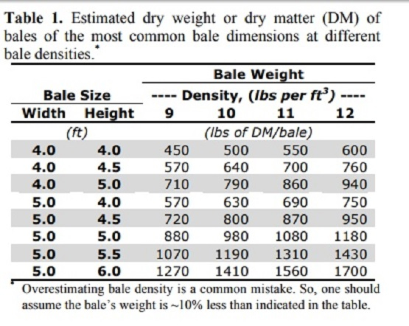
https://hayandforage.com/article-2726-we%E2%80%99ve-got-a-(bale)-weight-problem.html
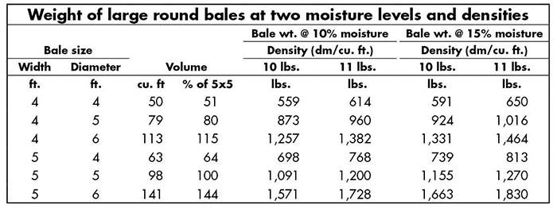

https://www.agweb.com/news/crops/hay/hay-bale-size-really-does-matter
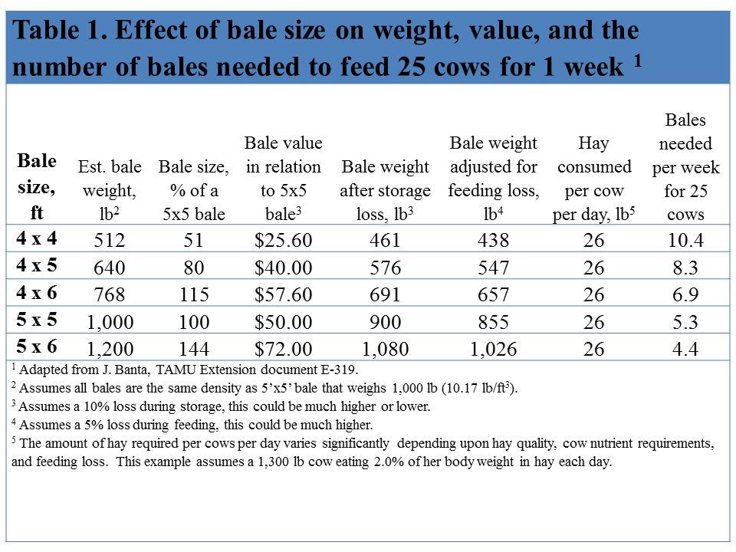
https://beeffax.tamu.edu/files/2013/09/2012-Bale-weight-how-important-is-it-Banta-E-319-.pdf
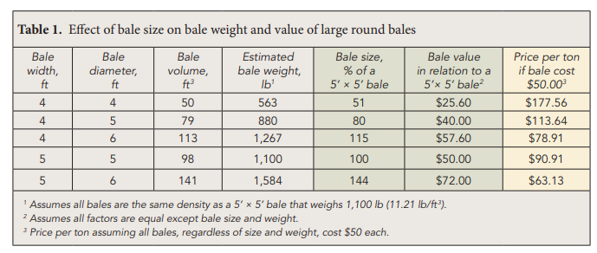

https://agtech.folio3.com/blogs/how-much-does-a-bale-of-hay-weigh/
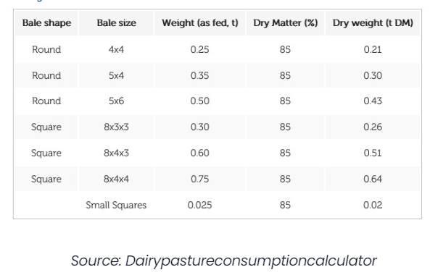

Supplementary Material: Data Limitations
- Since this is a spatial analysis using the best available data, there are limitations in our assumptions. Baled and stored for indeterminate amount of time either at field edge or at AD facility.
- Each siting needs to be field verified and meet with landowner.
- These plans are not spatially explicit beyond MLRA, in the case of the INRS, so we are taking resource planning goals to a new spatial scale and resolution that has never been done before. We only take data at face value and report on those since that is what other regional plans use.
- We don’t take into consideration the over application of manure and synthetic fertilizer on fields and the impacts of that environmentally. This is not a well reported phenomenon, but it is anecdotally understood to be common. In a winter rye system, farmers need to follow the 4Rs to prevent unnecessary runoff events. There is data out there that shows prairie systems can take a lot of fertilizer and still have water quality benefits and doesn’t compromise the integrity of the prairie (COBS data).

Supplementary Material: Prairie Wildlife Habitat Preferences & Requirements

