Linking Resource Protection to Bioeconomy Development in Iowa - DRAFT
Jessica Stephenson, John Tyndall, Lisa Schulte-Moore (?), Jim Jordahl (?)

Abstract
Hydrologic modeling and empirical datasets were used to estimate potential changes in environmental outcomes (nutrients, sediment loss, habitat patch size and connectivity, and greenhouse gas emissions) in biomass production scenarios with conservation practices under different landscape designs. East central Iowa was selected for this study due to overlapping public and private planning objectives to increase perennialization of the landscape. The Iowa Nutrient Reduction Strategy (2024), Iowa Wildlife Action Plan (2015), Iowa Climate Action Advisory Council (2007), and an anaerobic digestion (AD) facility guided decision-making and scale of change. A geospatial-based, empirical model, the Agricultural Conservation Planning Framework, was used to translate the objective into a spatially-explicit scenario for conservation practices and biomass production for 48 HUC12 watersheds that intersect the 32-km radial supplyshed for the AD facility. The model evaluates hydrology, topographic features, soils and historical land within a HUC12 watershed to site optimal locations to make land management changes. Conservation practices and biomass production that perennialize the landscape was identified; saturated buffers, prairie strips, nutrient removal wetlands, winter crop (cereal rye; Secale cereale), and whole field conversion to prairie. The environmental outcomes, biomass outcomes, and the direct cost of each management change and opportunity costs were calculated for a 20-year time horizon and annualized. The combination of planning objectives translated to 42,891 ha prairie and 72,656 ha cereal rye. Approximately 172,769 Mg of biomass (dry weight) could be produced annually, potentially generating 1,429,330 MWh of energy. The increase in land cover resulted in 8,279 Mg NO₃ reduced, 10,350 Mg sediment reduced, 4,888,890 Mg CO2 eq reduced, and create 364 habitat patches that are >15 ha and approximately 17,863 ha of linear strips of prairie (prairie strips and saturated buffers) serving as corridors. Assuming all acres are managed for biomass production, it will cost $82,259,485 per year over 20 years at 10% discount rate for establishment and biomass production (fertilizer and harvest costs) costs, and $24,392,485 per year for opportunity costs. If only considering these as conservation practices then this scenario would cost $54,406,762 per year over 20 years at 6% discount rate, while opportunity costs would remain the same. While the conservation practice cost is lower, the market opportunity for biomass payments could provide financial incentive for farmers to sustain perennialization of the landscape, in addition to opportunities to participate in environmental markets. By identifying and pursuing alignment for land management we may be able to achieve transformation of the landscape that results in significant additionality and co-benefits that help diversify income sources for farmers and transition away from conventional, annual cropping systems.

Introduction
Agricultural landscapes across the U.S. Corn Belt are under increasing pressure to balance commodity production with social costs of degraded water quality, soil health, wildlife habitat, and greenhouse gas reduction. In Iowa, there are multiple public and private entities pursuing solutions for overlapping objectives, however, they are often acting independent of one another. Meeting these diverse goals requires innovative, integrated approaches that provide both environmental and economic benefits for producers and communities (Krieg et al., 2019; Dangol et al., 2025). Cropland comprises 85.7% of Iowa (NASS, 2024), and as such, is the most significant contributor to water impairments, habitat degradation and loss of biodiversity, and greenhouse gas emissions (GHG) within the state. The Iowa Nutrient Reduction Strategy (INRS; IDALS 2025), aims to reduce nitrogen and phosphorus losses to waterways from cropland; the Iowa Wildlife Action Plan (IWAP; IDNR 2015), which identifies opportunities to conserve declining grassland species by increasing permanent cover; and the Iowa Climate Change Advisory Council (ICCAC; ICCAC 2008) Final Report, which highlights strategies to cut emissions from agriculture and energy systems as well as crop producers and anaerobic digestion (AD) to pursue perennial biomass production systems.
Agriculture is one of the leading causes for land-use change in Iowa. Approximately 74% of Iowa’s landscape pre-settlement has been converted to cropland, and as a consequence of this transfer of productivity from diverse ecological function to crops, there is significant degradation in water quality from nutrients in agricultural drainage, soil quality, biodiversity, increased flooding, and GHG emissions, even human health. When nitrogen fertilizer is used in excess, or the timing is inappropriate, nitrogen has two damaging pathways: leaching and atmospheric. A study in Minnesota estimated the social costs of nitrogen (N) in drinking water to be 745 million (+/- 82) annually in the state (Keeler et al., 2025) and disproportionately affects poor and rural communities (Keeler et al., 2014); in other areas it has been linked to increased cancer rates (Jones et al., 2017; Gourevitch et al., 2018; Keeler et al., 2025), degradation and loss of native species due to nutrient enrichment (Galloway et al., 2004; Porter et al., 2013), and impairment of recreational use (Baron et al. 2012). When nitrogen is released to the atmosphere as nitrous oxide (N₂O) it has significant adverse effects on climate change, with nearly 300 times the warming potential of carbon dioxide (CO₂) and can persist for over a century in the atmosphere (EPA 2025). Historical prairie land use was a significant sink for GHG emissions, and now Iowa has become a significant source for GHG emissions in the agricultural sector (Verge et al., 2007; ICCAC 2007; Paustian et al., 2019; Bossio et al., 2020).
The planning frameworks in Iowa are primarily dependent on voluntary actions and incentives for farm businesses to change their management practices. Voluntary conservation by farmers has been a cornerstone of U.S. agricultural policy for decades, supported through cost-share and technical assistance programs. These efforts have successfully demonstrated that conservation practices such as cover crops, prairie strips, and wetland restoration can reduce nutrient losses, improve soil function, and provide wildlife habitat. There is a perceived financial and crop yield risk associated with incorporating conservation practices, like cover crops, and improvements are not always immediately observable on the farm or efficient (Shipley et al., 2022; Roesch-McNally et al., 2017; etc.). However, the benefits to the farm are often realized over longer time horizons through significant improvement of in-field soil fertility and structure, resulting in better profits. Shipley et al. (2022) reported that farmers will “…do anything and everything to try to maximize the profit potential of every acre and utilize [their] inputs to the most efficient way.” Often, the upfront costs of implementing conservation practices and changing cropping systems can be a barrier to adoption; therefore, finding ways to help farmers overcome these costs is imperative to realize changes on the landscape (Roesch-McNally et al., 2017; Banjeree et al., 2025).
In East Central Iowa, an AD facility represents a market opportunity to alleviate some of the perceived risks of incorporating conservation practices on farms. While AD development has historically relied on manure or food-processing wastes, there is growing interest in supplementing conventional feedstocks with biomass such as prairie grasses and winter cereal rye. Conservation practice biomass feedstocks provide co-benefits, and facilitates alignment between farm business decisions with statewide environmental and climate goals. Historically, establishing perennial biomass systems has failed to launch and expand due to limitations in program design, understanding of environmental outcomes, and cost-effectiveness of production at large-scales (Miao and Khanna 2017; Hellfeld et al. 2022), however, intersecting AD technology and public planning efforts provide a unique opportunity to help reduce barriers and perceived risks. Incentive payments and stable markets can create financial conditions that make conservation-compatible biomass systems more attractive and durable for producers (Theuerl et al. 2019).
Developing a bioeconomy with biomass that sustains an AD facility can follow state-level policy and planning efforts to target fields based on their expected environmental outcomes. This study leverages the public and private efforts with overlapping objectives to perennialize the landscape to display conservation practice and biomass production at the field level. An AD facility willing to compensate farmers for growing alternative feedstocks, such as corn stover, presents a unique opportunity to leverage biomass payments that can be stacked, or bundled, with environmental market-based approaches. Biomass payments could provide a diversified income source for many farmers, helping with the transition to include a winter crop or convert to a prairie biomass.
The principle of additionality and generation of co-benefits is at the core of designing a bioeconomy that aligns public and private objectives. To achieve additionality, “a proposed activity will produce some ‘extra good’ in the future relative to a reference scenario, which we refer to as a baseline. In other words, additionality is the process of determining whether a proposed activity is better than a specified baseline” (Gilleman 2012). The baseline for this project scenario represents current behavior (e.g., conventional corn farming), and additionality was the outcome due to the implementation of rye and prairie biomass crops. The management practices include edge-of-field practices (nutrient removal wetlands and saturated buffers), changes in crop rotations (including winter cereal rye), and the transformation of land from annual crops to native prairie (with a conversion rate of greater than or equal to 10% of a field). The Agricultural Conservation Planning Framework (ACPF; Porter et al., 2024), Financial Nutrient Reduction Tool (FiNRT; Bravard et al., 2022), and companion GIS tools were used to site opportunities for land management change and assess the outcomes in terms of water quality reductions, wildlife habitat improvements, and GHG emission reductions. The FiNRT tool calculates the average cost incurred by a landowner to implement the change to baseline conditions. Our approach enables planners to be more intentional about where funds are invested in the landscape and highlights opportunities for stacked payments, leveraging emerging biomass markets and payment for ecosystem services (PES) markets. This paper proposed a framework to target opportunity areas in row crop fields in Iowa for perennialization by identifying overlapping land management objectives and translating that into spatially-explicit geospatial outputs. Some publications allude to the myriad environmental outcomes that could be achieved with energy-based cropping systems (references); however, none evaluate the individual field impacts and aggregate them to multiple planning scales.

Methods

Context
There are four major land resource areas (MLRA) intersected, including Illinois and Iowa Deep Loess and Drift, West-Central part (108c), Eastern Iowa and Minnesota Till Prairies (104), Northern Mississippi Valley Loess Hills (105), and Central Mississippi Valley Wooded Slopes, Northern Pat (115c) (Prior 1991). The primary land use of the area is agriculture, specifically cropland, and the priority resource concerns include water quality (nutrients and e.coli), flooding, wildlife habitat, GHG emissions, and degraded land from erosion. The AD facility is located in east-central Iowa (Figure 1) and provides energy to operate its commercial farm operation. The AD facility sources biomass material from an animal feedlot operation (AFO) onsite and corn stover. The farm manages 2,400 head of cattle and approximately 890 ha of cropland. Additional information on the farm operation can be found in Villarino et al. (2025) paper. To transition from annual feedstocks (i.e., corn stover) to feedstocks that perennialize the landscape.
A bioeconomic model, starting at a 32 km radial distance from the AD facility, is explored in this paper to leverage market opportunities that can change land use and management, addressing these resource concerns (Figure 1). The supplyshed is 2% of cropland in Iowa. A goal of this paper is to highlight opportunities to generate additionality within the supplyshed, so we are assuming conservation practices and biomass production will only replace or enhance currently cropped fields. The planning process for siting conservation practices and biomass production was intertwined with many resource concerns. However, for clarity, the methods were broken down into overarching themes (nitrate load, wildlife habitat patch size and connectivity, sediment transport and delivery, and GHG emissions). This organization of conservation practices leveraged for biomass production are organized into themes does not mean that practices do not achieve other resource management goals. The placement of them is based on the primary resource concern they are addressing and how data layers were used to prioritize locations on the landscape. An example of this is the relationship between cereal rye, water quality, and erosion. The winter rye crop is a scenario in the INRS, and only modeled on no-till fields. No-till on cropland will likely address erosion issues in the spring by providing high ground cover, increasing soil structure, and minimizing surface soil disturbance. Consequently, cover crops were planted with the goal of improving water quality, rather than reducing sediment transport and delivery.
In this paper, we illustrate what a multi-objective bioeconomy plan looks like using ArcGIS Pro 3.3.1 and spatial tools, including the ACPF, FiNRT, the Overland Flow Element (OFE) tool, and GeoProfit Tool. The GIS tools used in this study are decision-support tools for conservation planning and follow the Natural Resource Conservation Service (NRCS) conservation practice guidance and align with federal funding programs. Often, funding programs prevent conservation practices from being managed as a production system, so these tools were adapted to account for harvesting logistics (i.e., machine size, accessibility). This is the first time these GIS tools have been applied to generate a regional bioeconomy; however, the data layers and tools are versatile and align with the shared public and private objectives. The flow of data between tools was summarized in Figure 2.

Characterizing spatial patterns
The ACPF uses spatial datasets organized by HUC12 watershed boundaries to site opportunities for conservation interventions on agricultural land (Porter et al., 2025). The ACPF core dataset includes 10-m gSSURGO, annual cropland data layers (CDL) from NASS, HUC12 watershed boundaries, and tables summarizing soil and land use for each field. The field boundary dataset is based on common land unit (CLU). The ACPF depends on accurate surface flow paths, so watersheds intersecting the supplyshed had hydroconditioned digital elevation models (DEM) at the 2-meter resolution prepared. Forty-eight (48) HUC12 watersheds intersect the 32 km supplyshed and were included in the model (Figure 1). The locations for biomass were co-located with ACPF output conservation practices, including nutrient removal wetlands, contour buffer strips, and saturated buffers. The biomass generated from the site-specific structural practices did not meet the INRS and IWAP land area goals, so whole fields were dedicated to prairie and cereal rye biomass, determined based on soil loss vulnerability and proximity to existing wildlife habitat complexes. The HUC12 watershed-scale is the reporting unit for hydrologically based resource concerns (e.g., water quality, erosion, flooding), and other spatial tools report environmental and financial outcomes at the field scale. The conservation practice and biomass production sitings from ACPF were more than needed to achieve planning objectives; therefore, a series of criteria was applied to filter results to be targeted where possible, while also recognizing the spontaneity of adoption that can occur by using some randomization to select fields. The soil loss vulnerability index (SVI) output from ACPF was used to give priority to cropped fields with high to moderate SVI classes, suggesting significant potential for surface runoff or leaching. The SVI can be used to identify fields with high soil loss due to surface flows and slopes (Lohani et al., 2020; Porter et al., 2025).
Qualifying metrics for multi-objective planning
To begin filtering the ACPF results, the first qualifying criteria was based on INRS strategies that also aligned with biomass production for energy generation at the AD facility and IWAP goals for an increase in permanent cover. Four strategies in the INRS directly supported the production of biomass material for co-digestion at the AD facility to produce energy, and those included:
- Plant a rye cover crop on all no-till acres. (INRS Section 2, p. 32)
- Installing wetlands to treat 45% of the ag land. (INRS Section 2, p. 33)
- Installing [saturated] buffers on all applicable acres. (INRS Section 2, p. 35)
- Perennial crops (energy crops) to equal pasture/hay acreage in 1987. (INRS Section 2, p. 39)
The strategies identify specific land area changes by MLRA for the entire state, and where used to scale area treated by strategy within the supplyshed and this was used as the goal for prairie and cereal rye (Table 2). The first strategy requires siting no-till fields to place rye, however, data for the location of no-till fields is not readily accessible, so the location of no-till was randomly assigned to fields that include corn in the 6-year rotation. Fields that received a cereal rye treatment were randomly chosen from a sub-selection of fields that had a high to moderate SVI class, to recognize that farmers experiencing higher soil loss may be more likely to employ a series of soil health practices such as no-till and a winter crop. In a corn and soybean rotation, the annual rye is assumed to be planted following corn, and harvested in June, after soybeans have been planted into the biomass stand. In a continuous corn system, the cereal rye is planted annually but harvested earlier than June to prevent adverse yield effects to the summer crop (Ruis et al., 2023).
Nutrient Removal Wetland (NRW). The NRW output from ACPF was used to determine locations for installing wetlands. The assumption for NRW was that the buffer surrounding the wetland would be designed in a way that could be harvested for prairie biomass. Some studies suggest that paludiculture can be an effective way to remove N and P from the landscape by preventing the nutrients from cycling back into the system after biomass material decomposes (Zak et al., 2014; Jabłońska et al., 2021), and while this region is not known to have significant peatlands, the concepts can be translated to wetlands here (reference?). To simplify social dynamics around NRW ownership and harvesting prairie biomass, NRWs that coincided with multiple fields (i.e., multiple landowners) were removed, and an NRW that had the majority of the practice footprint in one field were retained.
Saturated Buffer. The strategy for riparian buffer implementation was adjusted to focus on locations suitable for saturated buffers, which optimizes the potential for nitrate reduction before it reaches a stream. Currently, INRS does not include this as a strategy. Still, several studies have noted the significant nitrate reduction potential of saturated buffers and suggest that if a buffer were installed, the cost would not be significantly more to add a lateral tile line, allowing subsurface water to diffuse through the buffer and filter nutrients (Johnson et al., 2024). The denitrifying practice tool in the ACPF GIS toolbox was used to determine locations for the saturated buffers. Saturated buffers that had the majority of the feature on cropland were retained, and buffers that were centered on pastureland were removed from the analysis. All locations were retained with the assumption that the site design would primarily deal with one landowner. The buffer width was 30.5 meters to accommodate harvest machinery without getting too close to the buffer edge and potentially destabilizing the streambank. This width would also support populations of area-sensitive wildlife species (Brittingham & DeCecco, 2025).
Perennial Energy Crops. The fourth INRS strategy highlighted in this paper is to increase perennial cover, which was dovetailed with the IWAP land use change recommendation calling for 4% of Iowa to be permanently protected. The National Conservation Easement Database (NCED; 2024) was used to estimate locations of existing permanently protected land, suggesting high-quality habitat patches. Cropped fields that are the closest radial distance from the NCED sited location for permanent easements were selected to achieve the 4% land area goal in the supplyshed, translating to 9,073 hectares in supplyshed; approximately a quarter of the total area needed to achieve the fourth strategy (Table 1). To optimize outcomes for wildlife, we are considering a “wildlife-friendly farming” approach, drawing on concepts from Fischer et al. (2008) to determine the most effective allocation of land resources dedicated to prairie biomass locations that increases heterogeneity on the landscape, thereby connecting farmed and unfarmed areas. In doing this, we can create a continuum across the landscape that recognizes some of the Iowa prairie species-specific habitat contours (Fischer et al., 2004; Fischer & Lindenmayer, 2006; Fischer et al., 2006). Tall grass prairie once dominated this landscape aligns with the AD facilities biomass portfolio; therefore, prairie will be assumed for all permanent cover increases.
The remainder 75% of prairie biomass area was located as prairie strips and whole field transformation to from annual crop to prairie. While the INRS does not prioritize erosion, these practices where targeted following information from SVI to provide multiple water quality benefits. The ACPF Contour Buffer Strip (CBS) tool siting criteria was customized to site CBS locations with 18.3-meter buffer width and assumed to be planted with prairie seed mix. The buffer width was chosen based on the assumed size of a commercial windrower used to cut prairie biomass before baling and recommendations from the NRCS to optimize wildlife benefits (NRCS, 2014). Additional filtering of the results was completed to only retain CBS where the total practice area occupied greater than or equal to 10 percent of the field impacted to ensure optimal environmental outcomes, including a significant reduction in sediment transport, nitrate load and increase in wildlife habitat (Schulte et al., 2017). The area of the prairie buffer strips was summed, and the remaining perennial energy cropping area needed to achieve strategy 4 was selected from fields with a soil vulnerability index (SVI) greater than or equal to two.

Quantifying outcomes
To estimate sediment loads, the OFE tool uses the Daily Erosion Project (DEP; https://www.dailyerosion.org/) to quantify soil displacement along hillslopes to estimate average runoff and soil displacement at the field-scale. The model uses the Water Erosion Prediction Project (WEPP) and an event-based modelling approach to evaluate precipitation, hillslope, and soil detachment characteristics. OFE Tool inputs include ACPF core datasets, a hydroconditioned DEM, and a tillage raster generated from seasonal aerial imagery to estimate residue management. The sediment transport and delivery outcomes were estimated for each field using the OFE tool and reported as kg sediment ha⁻¹ (Luquin et al., 2024).
Using FINRT, the nitrate load from each field based on cropping history between 2019 to 2024, and the assumed fertilizer rate following guidance from maximum return to N (MRTN). Nitrate and sediment load were modeled in this study to address water quality in this framework because they align with INRS priorities and are well-studied in Iowa. The contributing area to each practice was calculated, and the area-weighted estimate of nitrate load and sediment load reduced per practice within a field was reported. The OFE tool output for sediment loads is used to determine baseline loads. The annual load data was aggregated and reported at multiple planning scales, including field, HUC12, MLRA and supplyshed.
In addition to calculating reduction efficiencies, FiNRT reports direct costs, opportunity costs, and total costs of each conservation practice and biomass production location derived from ACPF outputs. To determine direct costs, enterprise budgets were created for each land management change (e.g., prairie strips, NRW, saturated buffer, cereal rye winter crop, or whole field conversion to prairie) and updated in the FiNRT code. The budgets accounted for any costs incurred by the crop farmer, including establishment costs, crop management (e.g. fertilizer), harvest and baling, and opportunity costs (Supplementary Materials: Enterprise Budget). The management activities for the prairie-based practices were developed following guidance from the Tall Grass Prairie Center and the NRCS on establishing high-quality prairie, as well as input from the MN DNR and independent haying operations to establish a maintenance and harvest protocol. The proportion retained each year will be a minimum of 33%, as recommended by the Minnesota Department of Natural Resources (Garms et al., 2009) to 50% (RAE, 2024). The harvest regime of the prairie is assumed to be conducted in a manner that is sensitive to the life cycles of native prairie species, thereby supporting high-quality habitat for wildlife and insects.
The cost data for each budgeted activity was derived from Iowa State University Ag Decision Maker $2024 custom rate surveys and Tall Grass Prairie Center. The budgets were annualized over a 20-year period with a discount rate of 10%. In this study, it is assumed that the farmer will harvest the biomass and bale it in the case of prairie. The cost for transportation and storage is anticipated to be either the AD facility operator’s cost or a third-party aggregator for biomass. The opportunity cost accounts for potential loss in revenue from land rent that a landowner might receive. This value is weighted by county average rent data reported in ISU Ag Decision Maker,
For comparison of a biomass production system to a purely conservation-focused land management strategy, the costs of implementing these practices as conservation practices were generated. The costs of these practices, serving purely as conservation practices, are annualized over 20 years with a 6% discount rate, reflecting the life of conservation practices and assuming low future earnings, as there is no harvested biomass or market. In the biomass-based budget, a higher discount rate was employed to account for the higher risk and inflation potential associated with bioenergy crop inputs and management in the proposed system, compared to the more familiar conservation programs.
The direct and total costs were used to determine the cost-effectiveness of perennializing the landscape for a unit of pollutant reduction (i.e., nitrate, sediment, wildlife habitat acres, GHG emissions). In the case of this study, the cost-effectiveness is calculated as the cost of establishing and managing a biomass system, divided by the estimated reduction in nitrate load and sediment load. The cost-effectiveness using direct costs represents a scenario where the farmer owns the land, whereas using total costs would suggest that the landowner was renting the land out to a corn farmer and may need to consider that loss of income (i.e., opportunity cost).
The previous methods focused on environmental outcomes to identify where to focus efforts, and addition factor is looking at long-term corn yields and profitability at the field-scale. The GeoProfit tool provided a framework to assess yield stability and profitability of fields in the supplyshed for any time period of interest. The tool can be used to identify low yielding, low profit areas within a field, however, the data is limited to soil productivity indices (Corn Suitability Rating; CSR2) and reported averages at the county-scale since field-level yield monitoring data is scarce and not publicly available.
This study looked at a ten-year window (2015 and 2024). The window of time used to assess yields and profits can strongly influence the trends and be misleading (Paulson et al. 2024), so ten years was used to capture some of the variability across years but also have a large snapshot of different environmental and market events impacting cost of production and crop prices. Crop insurance uses ten years as well to assess farm yields and many other studies indicate that greater five years are ideal to achieve a thorough look at yield potentials and profits. An additional step was taken calculate standard deviation to determine yield stability across the ten years for each subfield zone. Using profitability from the GeoProfit Tool and the calculated yield stability, the opportunity acres for prairie were identified as areas where the field has low yield stability and unprofitable for six or more years. The assumption is that these farmers might be interested in alternative sources of income and cropping systems that provide more yield stability and improve their farm businesses profitability. Opportunity acres for cereal rye would be ideal regardless of yield stability and profit potential, and would be beneficial on degraded fields with high runoff.
Wildlife outcomes were quantified based on the following parameters: patch size (in hectares) and connectivity. The assumed harvest regime incorporates principles from Palik et al. (2021) ecological silviculture to mimic the natural, frequent, low-severity disturbance regime of prairie systems, which is created by grazing and fire, and will occur in late summer to fall. Ecological silviculture manages perennial production systems with comparable goals to a prairie bioenergy system, where the management of biomass and wildlife is deeply intertwined. The assumed harvest regime is similar to a variable retention harvesting approach, which supports heterogeneity and continuity.
The location of perennial and rye biomass was not targeted based on GHG emission reductions, but the outcomes related to changes in land management were estimated for each practice. The amount of CO₂ and N₂O was reported (Mg CO₂ _{eq} ha⁻¹). The IPCC reduction factors were used to estimate emission reduction; however, we acknowledge that this may not be the most accurate assessment, and we may be underestimating N₂O emissions by at least 40%, according to some studies (Elberling et al., 2023).

Results & Discussion
The purpose of this research paper is to demonstrate a process that integrates disparate public and private planning frameworks and strategies to generate additionality at multiple planning scales and goal areas. The multi-objective analytical framework presented in this paper can be readily applied in other agricultural landscapes in the U.S. where ACPF core data is available, and land management goals are available. AD bioeconomic planners can be intentional and leverage agricultural land to achieve co-benefits by sequestering a significant amount of carbon (Verge et al., 2007; Paustian et al., 2019; Bossio et al., 2020), build wildlife habitat complexes, improve soil health, and reduce nutrient runoff. The INRS is unique in that it provides specific land area goals to improve water quality by MLRA, which translates to 72,656 ha of cereal rye and 42,891 ha of prairie within the 32 km supplyshed (Table 1), and 9,052 ha of that prairie is strategically located to align with IWAP.
The approach demonstrated in this paper integrates landscape resilience and productivity – reducing nutrient losses and improving soil function without displacing food production on prime farmland. The environmental outcomes from this plan include: annual reduction of 8,279 Mg of nitrate loading to surface water, 10,350 Mg of sediment transported, and approximately 5 million Mg of CO₂ _{eq} to be reduced annually (Table 2). By treating 2% of Iowa’s cropland, we achieve roughly a 3% reduction in baseline nitrogen load used by the INRS (264,918 Mg annually). The IWAP goal of was exceeded, and includes several small (< 10 ha) to large patches (< 2,000 ha), prairie strips and saturated buffers that serve as habitat patches and corridors (7,229 ha).
To determine where in the supplyshed may be the best place to begin targeting the outcomes of this multi-objective planning effort, and potentially align with local watershed groups and conservation planners, the field-scale results were aggregated to HUC12 watershed. The watersheds were ranked to determine where the most environmental outcomes were produced, lowest costs of biomass production, unstable yields and profitability impacts between 2015-2024 were reported (Table 5). The top ten HUC12 watersheds for environmental outcomes were selected to help with prioritization and there are 17 watersheds with at least one environmental outcome that has the most benefits (Figure 3). Nine of the 17 watersheds were identified has having the most unstable yields and unprofitable fields. These nine watersheds should be targeted initially to leverage agricultural land for conservation practices and biomass production to produce co-benefits and sequester a significant amount of carbon, build wildlife habitat complexes, improve soil health, and reduce nutrients in runoff.
The total costs for conservation practice and biomass production in this bioeconomy scenario within 32 km supplyshed are $74,917,432 per year (DC: $52,708,361; OC: $22,209,070), and $28,865,862 per year (DC: $11,297,693; OC: $17,568,169) overlaps with IWAP goals (Table 3). The total land management and cover changes without the expectation of having harvestable prairie and cereal rye biomass, the total cost to achieve the INRS goals per MLRA in the supplyshed would be $53,809,271 per year (DC: $29,416,503), where $20,409,920 (DC: $2,841,751) supports IWAP. The OC costs remain the same in both the harvestable biomass model and the strictly conservation implementation model, as the OC represents the cash rental value of the land’s inherent production potential and is unaffected by specific management actions.
The sum of annual direct costs within the 32 km supplyshed is 28% higher in the case of the harvestable biomass model compared to the conservation practice model when looking at the first 20 years from establishment. The added management and inputs under the harvestable biomass model can be attributed to this difference in costs. A more in-depth financial analysis is needed to evaluate benefit opportunities and explore market opportunities, such as environmental markets and the expansion of AD technology in the region that incentivizes the use of prairie and cereal rye biomass. There may be opportunities to leverage land coming out of limited-term easement programs (e.g., CRP) or payment for conservation programs like EQIP, which could help offset some of the upfront establishment costs and risk associated with farmers pursuing harvestable biomass models. The AD facility at the center of this study requires only 809 ha of prairie and cereal rye, which is substantially lower than what the 32 km supplyshed should be producing to achieve water quality and wildlife goals. Therefore, exploring more market opportunities to unite environmental and agronomic goals in the region is a worthy effort.
Currently, corn stover is the most common crop residue digested at AD facilities because it is readily available; however, some research shows that 100% harvest of stover can decrease grain yields (Boehmel et al., 2008; Karlen et al., 2011; Adler et al., 2015) and negatively impact water quality (Khanal et al., 2014) as well as potentially increase synthetic nutrient amendments within the field since organic material is being removed (Becerra-Pérez et al., 2022). Despite Iowa leading the nation in some aspects of cellulosic ethanol and wind energy, cropland continues to be managed using resource intensive monocrops – planting same annual crop over two or more consecutive years – that are degrading soils (Cruse, 2016; Borrelli et al., 2017; Battagalia et al., 2021; Thaler et al., 2021), water quality (Secchi et al., 2011) and wildlife habitat (Tilman, 1999; Altieri, 2009; St. Clair et al., 2020) as well as contributing to climate change (EPA, 2023; Eberling et al., 2024). Since 2005, corn production and prices have increased (Wang & Ortiz-Bobea, 2019), resulting in smaller profit margins. According to the National Corn Growers Association (NGCA, 2025), average production costs have decreased by three percent, and corn prices have dropped by over 50% since 2022. The trends in production costs and crop prices have led to a continued trend of negative profit margins, with 2026 forecasted to be even worse (NCGA 2025). As a result, row crop farms have had to increasingly rely on supplemental income from government subsidies (EWG, 2025). By aligning conversation goals with market-based bioenergy opportunities, regions can strengthen environmental outcomes while building new agricultural value chains.
References
Banjaree et al. 2017. Transaction costs, communication and spatial coordination in Payment for Ecosystem Services Schemes
Baron, J.S., Hall, E.K., Nolan, B.T., Finlay, J.C., Bernhardt, E.S., Harrison, J.A., Chan, F., and Boyer, E.W. 2013. The interactive effects of excess reactive nitrogen and climate change on aquatic ecosystems and water resources of the United States. Biogeochemistry 114: 71-92. DOI 10.1007/s10533-012-9788-y.
Bravard, E., James, D.E., Zimmerman, E., Bowman, T. and J.C. Tyndall. 2022. Financial analysis for the use with the Agricultural Conservation Planning Framework: Data for the State of Iowa. Distributed by the ACPF National Hub, Iowa Water Center, Iowa State University, Ames, Iowa.
Brittingham, M.C. and J.A. DeCecco. 2024. Riparian buffers for wildlife. The Pennsylvania State University. https://extension.psu.edu/riparian-buffers-for-wildlife.
Dangol, S., Zhang, X., Sun, C., Liang, K., & Liang, X. Z. (2025). Impacts of bioenergy crop cultivation on regional climate, hydrology, and water quality in the US Northern high plains. Water Resources Research, 61(2), e2024WR037782.
Elberling, B.B. Kovács, G.M., Hansen, H.F.E., Fensholt, R. Ambus, P., Tong, X., Gominski, D., Mueller, C.W., Poultney, D.M.N. and S. Oehmcke. 2023. High nitrous oxide emissions from temporary flooded depressions within croplands. Communications Earth & Environment, 4: 463. https://www.nature.com/articles/s43247-023-01095-8.
EWG (Environmental Working Group). 2025. https://www.ewg.org/news-insights/news/2025/05/almost-10000-farmers-have-received-subsidies-40-straight-years
Fischer, J., Lindenmayer, D.B. and Fazey, I. 2004. Appreciating ecological complexity: habitat contours as a conceptual landscape model. Conservation Biology, 18, 1245–1253.
Fischer, J. Lindenmayer, D.B. 2006. Beyond fragmentation: the continuum model for fauna research and conservation in human-modified landscapes. Oikos, 112, 473–480. https://doi.org/10.1111/j.0030-1299.2006.14148.x
Fischer, J., Lindenmayer, D.B. & Manning, A.D. 2006. Biodiversity, ecosystem function and resilience: ten guiding principles for commodity production landscapes. Frontiers in Ecology and the Environment, 4, 80–86.
Fischer, J., Brosi, B., Daily, G.C., Ehrlich, P.R., Goldman, R., Goldstein, J., Lindenmayer, D.B., Manning, A.D., Mooney, H.A., Pejchar, L, Ranganathan, J., and H. Tallis. 2008. Should agricultural policies encourage land sparing or wildlife-friendly farming? Frontiers in Ecology and the Environment, 6(7): 380-385. https://doi.org/10.1890/070019.
Galloway, J.N., Dentener, F.J., Capone, D.G., Boyer, E.W., Howarth, R.W., Seitzinger, S.P., Asner, G.P., Cleveland, C., Green, P., Holland, E., Karl D.M., Michaels, A.F., Porter, J.H., Townsend, A., and Vorosmarty, C. 2004. Nitrogen cycles: past, present, and future. Biogeochemistry 70: 153-226.
Garms, J., Lindquist, M., and K. Varland. 2009. Prairie vegetation and energy production harvest plan for WMAs. A report to the Minnesota Legislature, Environment and Natural Resource Committees. Minnesota Session Laws 2008, Chapter 179, Section 7. Subdivision 14. https://files.dnr.state.mn.us/aboutdnr/reports/legislative/prairie_veg_wma.pdf
Gourevitch, J.D., Keeler, B.L., and Ricketts, T.H. 2018. Determining socially optimal rates of nitrogen fertilizer application. Agricultural Ecosystem Environment 254: 292-299.
Hahn, R.W. and R.N. Stavins. 1991. Incentive-based environmental regulation: A new era from an old idea? Ecology Law Quarterly, 18(1): 1-42.
ICCAC (Iowa Climate Change Advisory Council). 2008. Iowa Climate Change Advisory Council: Final Report. https://www.legis.iowa.gov/docs/publications/DF/9650.pdf.
IDALS (Iowa Department of Agriculture and Land Stewardship), IDNR (Iowa Department of Natural Resources), and ISU CALS (Iowa State University College of Agriculture and Life Sciences). 2025. Iowa Nutrient Reduction Strategy: A science and technology-based framework to assess and reduce nutrients to Iowa waters and the Gulf of America. https://www.nutrientstrategy.iastate.edu/sites/default/files/documents/2025%20INRS%20Complete%20Feb%202025.pdf.
IDNR (Iowa Department of Natural Resources). 2015. Iowa Wildlife Action Plan: Securing a future for fish and wildlife – A conservation legacy of Iowans. https://www.iowadnr.gov/media/1778/download?inline
Jabłońska, E., Winkowska, M., Wiśniewska, M., Geurts, J., Zak, D., and W. Kotowski. 2021. Impact of vegetation harvesting on nutrient removal and plant biomass quality in wetland and buffer zones. Wetland Ecosystems, 848: 3273-3289. https://link.springer.com/article/10.1007/s10750-020-04256-4.
Jackson, J.J. and M.D. Montross. 2021. Case study of transportation benefits using GIS in distributed preprocessing of corn stover into crude biobutanol. Transactions of the ASABE 64(1): 161-175. https://doi.org/10.13031/trans.13896
Johnson, G., Christianson, L., Christianson, R., Davis, M., Díaz-García, C., Groh, T., Isenhart, T., Kjaersgaard, J., Malone, R., Pease, L.A., and N. Rogovska. 2024. Effectiveness of saturated buffers on water pollutant reduction from agricultural drainage. Journal of Natural Resources and Agricultural Ecosystems, 1(1): 49-62. https://doi.org/10.13031/jnrae.15516.
Jones, R.R., Weyer, P.J., DellaValle, C.T., Robien, K., Canto, K.P., Krasner, S., Beane Freeman, L.E., and M.H. Ward. 2017. Ingested nitrate, disinfection by-products, and kidney cancer risk in older women. Epidemiology, 28(5): 703-711. https://doi.org/10.1097/EDE.0000000000000647
Keeler, L.B. and Polasky, S. 2014. Land-use change and costs to rural households: a case study in groundwater nitrate contamination. Environmental Research Letters, 9(7): 074002.
Kreig, J. A., Ssegane, H., Chaubey, I., Negri, M. C., & Jager, H. I. (2019). Designing bioenergy landscapes to protect water quality. Biomass and Bioenergy, 128, 105327.
Kumarappan, S. and S. Joshi. 2014. Biomass procurement. BioResources 9(2): 2069-2089.
Lohani, S., Baffaut, C., Thompson, A.L., Aryal, N., Bingner, R.L., Bjorneberg, D.L., Bosch, D.D., Bryant, R.B, Buda, A., Dabney, S.M., Davis, A.R., Duriancik, L.F., James, D.E., King, K.W., Kleinman, P.J.A., Locke, M., McCarty, G.W. , Pease, L.A., Reba, M.L., Smith, D.R, Tomer, M.D., Veith, T.L., Williams, M.R. and L.M.W. Yasarer. 2020. Performance of the Soil Vulnerability Index with respect to slope, digital elevation model resolution, and hydrologic soil group. Journal of Soil and Water Conservation, 75:1, 12-27, DOI: 10.2489/jswc.75.1.12
Luquin, E., Ferrie, C., Gelder, B., Herzmann, D., Zimmerman, E., James, D., Cruse, R. and T. Isenhart. 2024. Estimating erosion vulnerability within agricultural fields by downscaling the Daily Erosion Project (DEP): The OFEtool. Earth Surface Processes Landforms, 49: 4444-4454. https://doi.org/10.1002/esp.5978.
Myers, G.M., Anderson, D.S., Martens, B.J., and D.R. Raman. 2023. Cost assessment of centralizing swine manure and corn stover co-digestion systems. Energies 16(11): 4315. https://doi.org/10.3390/en16114315.
NCGA (National Corn Growers Association). 2025. https://ncga.com/stay-informed/media/the-corn-economy/article/2025/08/high-production-cost-series-part-1
Palik, B.J., D’Amato, A.W., Franklin, J.F., and K.N. Johnson. 2021. Ecological silviculture: Foundations and applications. Waveland Press, Inc. https://www.waveland.com/browse.php?t=747.
Paulson, N., Schnitkey, G., and C. Zulauf. 2024. Variability in trend estimates for US corn yields. farmdoc daily, 14:72, Department of Agricultural and Consumer Economics, University of Illinois at Urbana-Champaign. https://farmdocdaily.illinois.edu/2024/04/variability-in-trend-estimates-for-us-corn-yields.html.
Porter, E.M., Bowman, W.D., Clark, C.M., Compton, J.E., Pardo, L.H., and K.L. Soong. 2013. Interactive effects of anthropogenic nitrogen enrichment and climate change on terrestrial and aquatic biodiversity. Biogeochemistry 114: 93-120. DOI 10.1007/s10533-012-9803-3.
Porter, S.A., Tomer, M.D., James, D.E., Van Horn, J.D., and C.M.J. Sandoval-Green. 2025. Agricultural Conservation Planning Framework ArcGIS toolbox user’s manual version 7.0. Distributed by the ACPF National Hub, Iowa Water Center, Iowa State University, Ames, Iowa.
Prior, J.C. 1991. Landforms of Iowa. Iowa City, Iowa: Department of Natural Resources, University of Iowa Press.
RAE (Roeslein Alternative Energy). 2024. Personal account.
Roesch-McNally, G.E., Basche, A.D., Arbuckle, J.G., Tyndall, J.C., Miguez, F.E., Bowman, T., and Clay, R. 2017. The trouble with cover crops: Farmers’ experiences with overcoming barriers to adoption. Renewable Agriculture and Food Systems 33(4): 322-333. doi:10.1017/S1742170517000096
Ruis, S.J., Blanco-Canqui, H., Jasa, P.J., Slater, G., and R.B. Ferguson. 2023. Increasing rye cover crop biomass production after corn residue removal to balance economics and soil health. Field Crops Research, 302: 109076. https://www.sciencedirect.com/science/article/pii/S0378429023002691
Schulte, LA, et al. 2017. https://www.pnas.org/doi/full/10.1073/pnas.1620229114
Schulte, LA. 2025. Personal interview.
Shipley, N.J., Stewart, W.P., and van Riper, C.J. 2022. Negotiating agricultural change in the Midwestern US: Seeking compatibility between farmer narratives of efficiency and legacy. Agriculture and Human Values. https://doi.org/10.1007/s10460-022-10339-w.
USDA (United States Department of Agriculture). 2019. NRCS cover crop termination guidelines version 4. https://www.nrcs.usda.gov/sites/default/files/2022-09/Termination_Guidelines_Designed_6.28_10.24am_%28002%29.pdf
US EPA (United States Environmental Protection Agency). 2025. Success stories about restoring and protecting water bodies impaired by nonpoint source pollution. https://www.epa.gov/nps/success-stories-about-restoring-and-protecting-water-bodies-impaired-nonpoint-source-pollution.
https://stavins.scholars.harvard.edu/sites/g/files/omnuum8111/files/stavins/files/incentive-based_environmental_regulation.pdf.
Villarino, S.H., McDaniel, M.D., Blauwet M.J., Sievers, B., Sievers, L., Schulte, L.A., and F.E. Miguez. 2025. Adding anaerobic digestate to commercial farm fields increases soil organic carbon. Journal of Agriculture and Food Resarch, 21: 101942. https://www.sciencedirect.com/science/article/pii/S2666154325003138?via%3Dihub
Zak, D., Gelbrecht, J., Zerbe, S., Shatwell, T., Barth, M., Cabezas, A., and P. Steffenhagen. 2014. How helophytes influence the phosphorus cycle in degraded inundated peat soils: implications for fen restoration. Ecological Engineering, 66: 82-90. https://doi.org/10.1016/j.ecoleng.2013.10.003.

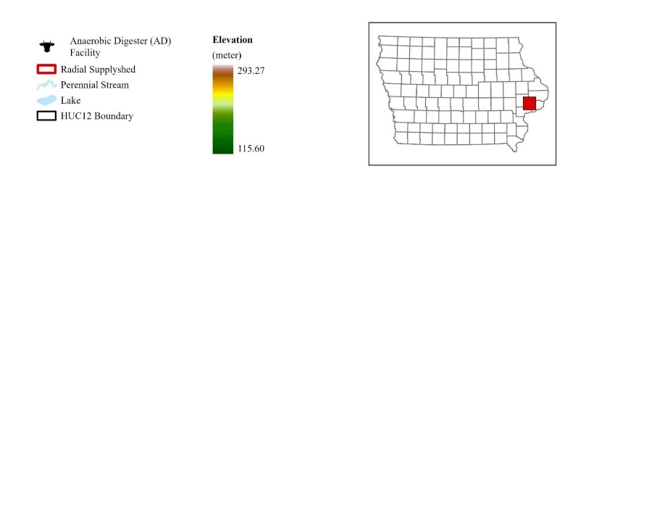
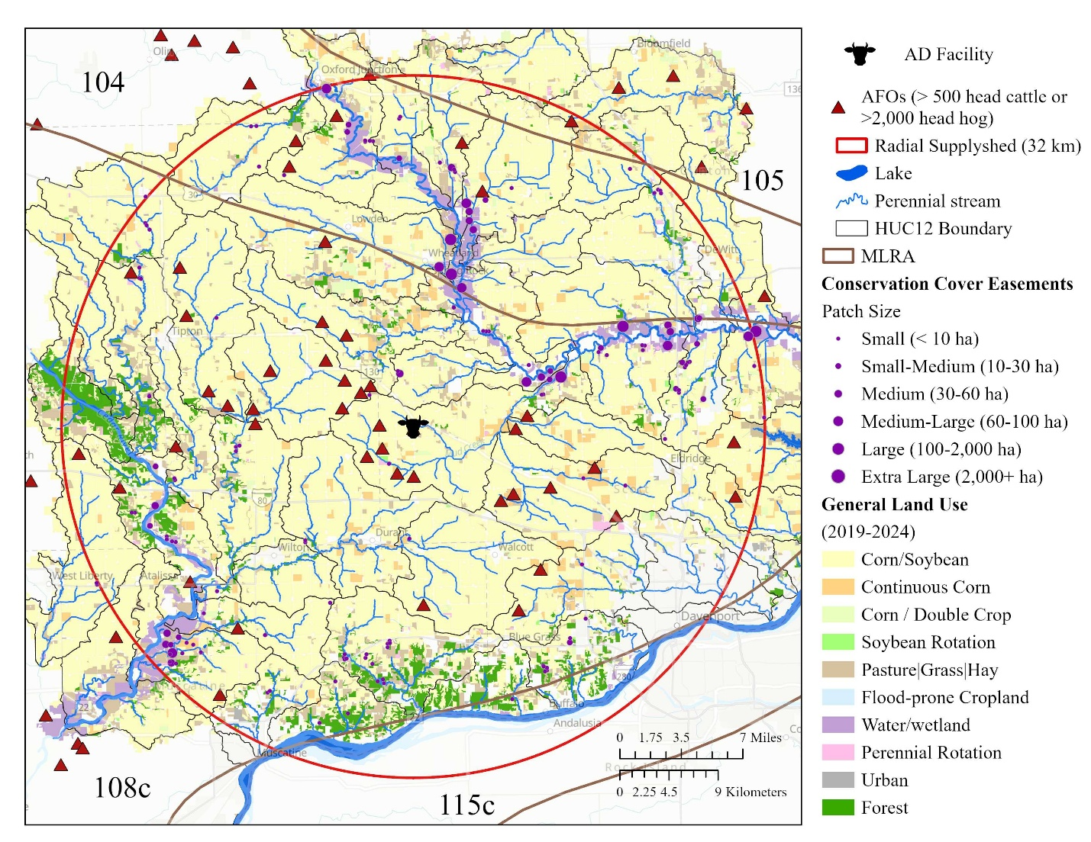

Figure 1. [Methods] Location of AD facility, 32 km supplyshed boundary, MLRA, HUC12 watersheds, general land use (2019-2024), existing permanent habitat locations. Resource inventory added to this paper. I plan to remove AFOs and save that for the financial analysis chapter.

Figure. 2. Conceptual framework and flow of data for modelling and evaluation. Results of the analysis are not presented in detail in this figure..
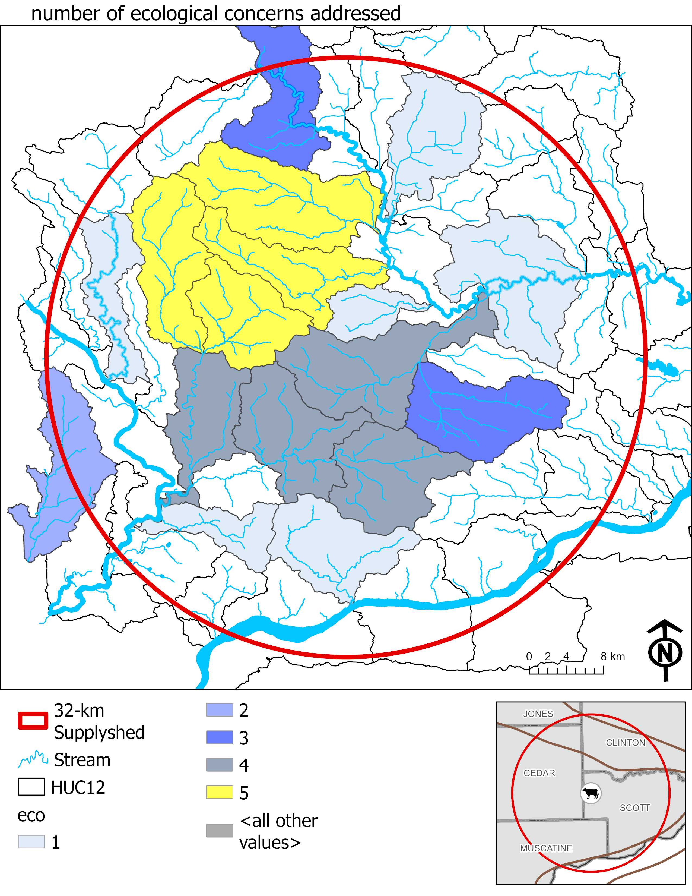
Figure 3. Summary of HUC12 watersheds with the highest environmental outcomes
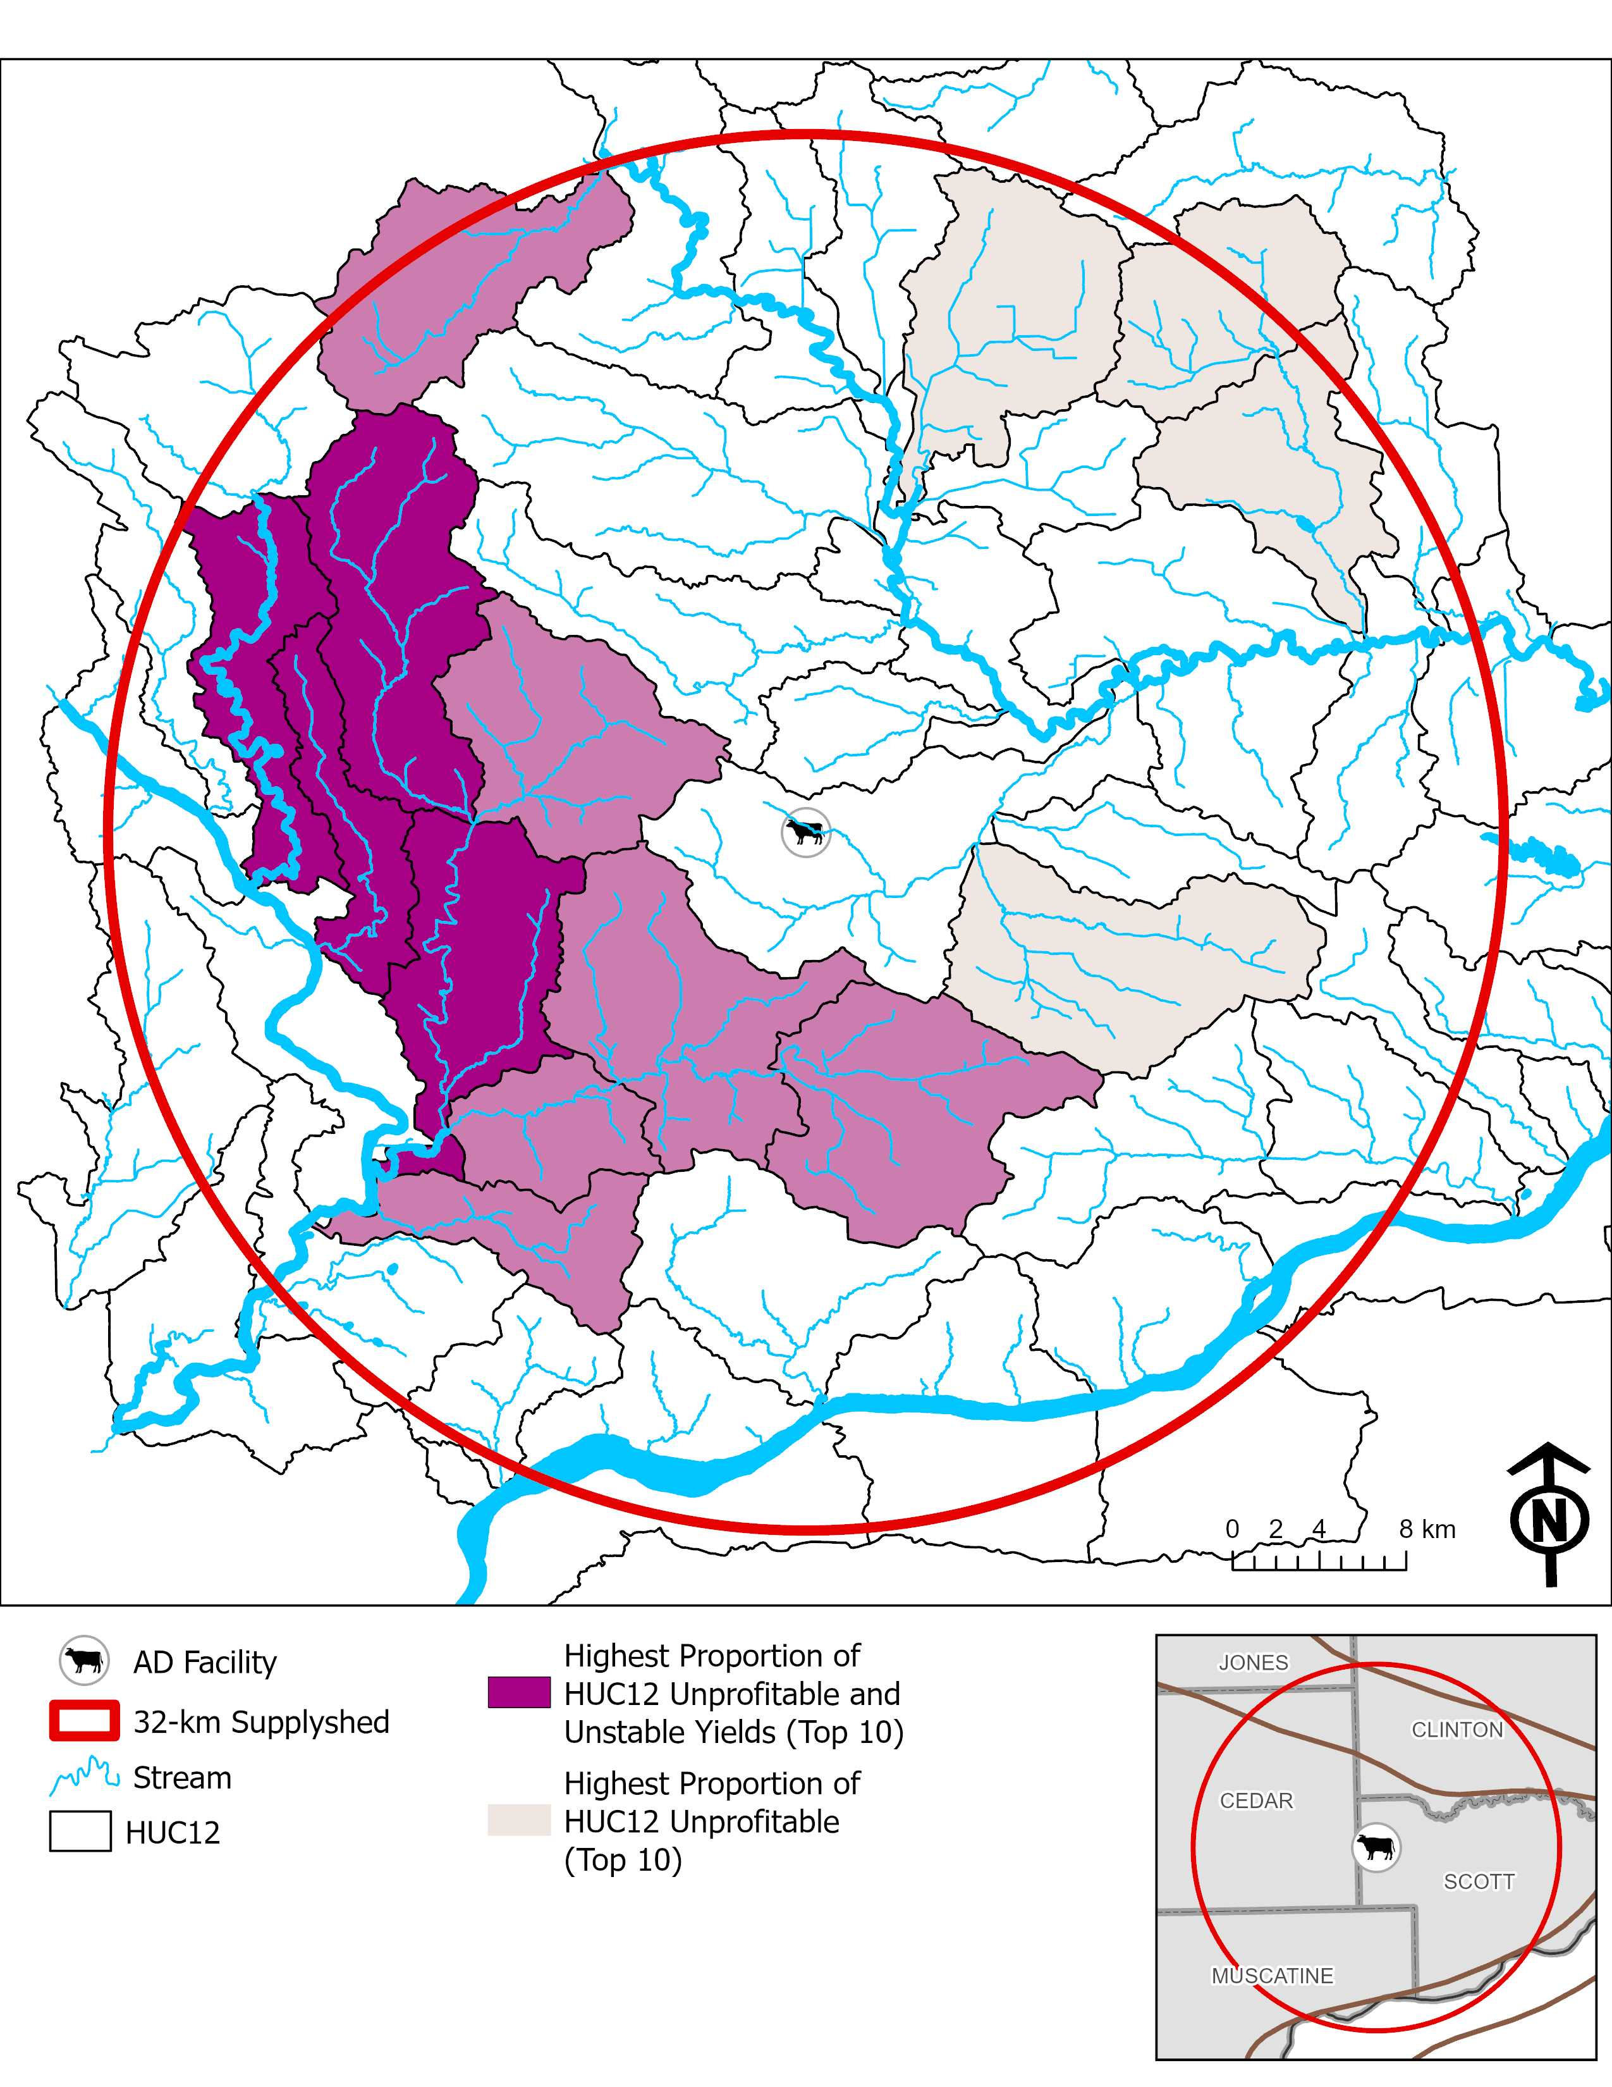
Figure 4. Summary of HUC12 watersheds with the highest proportion of watershed that has unstable yields and unprofitable for more than 5 out of 10 years evaluated between 2015-2024.
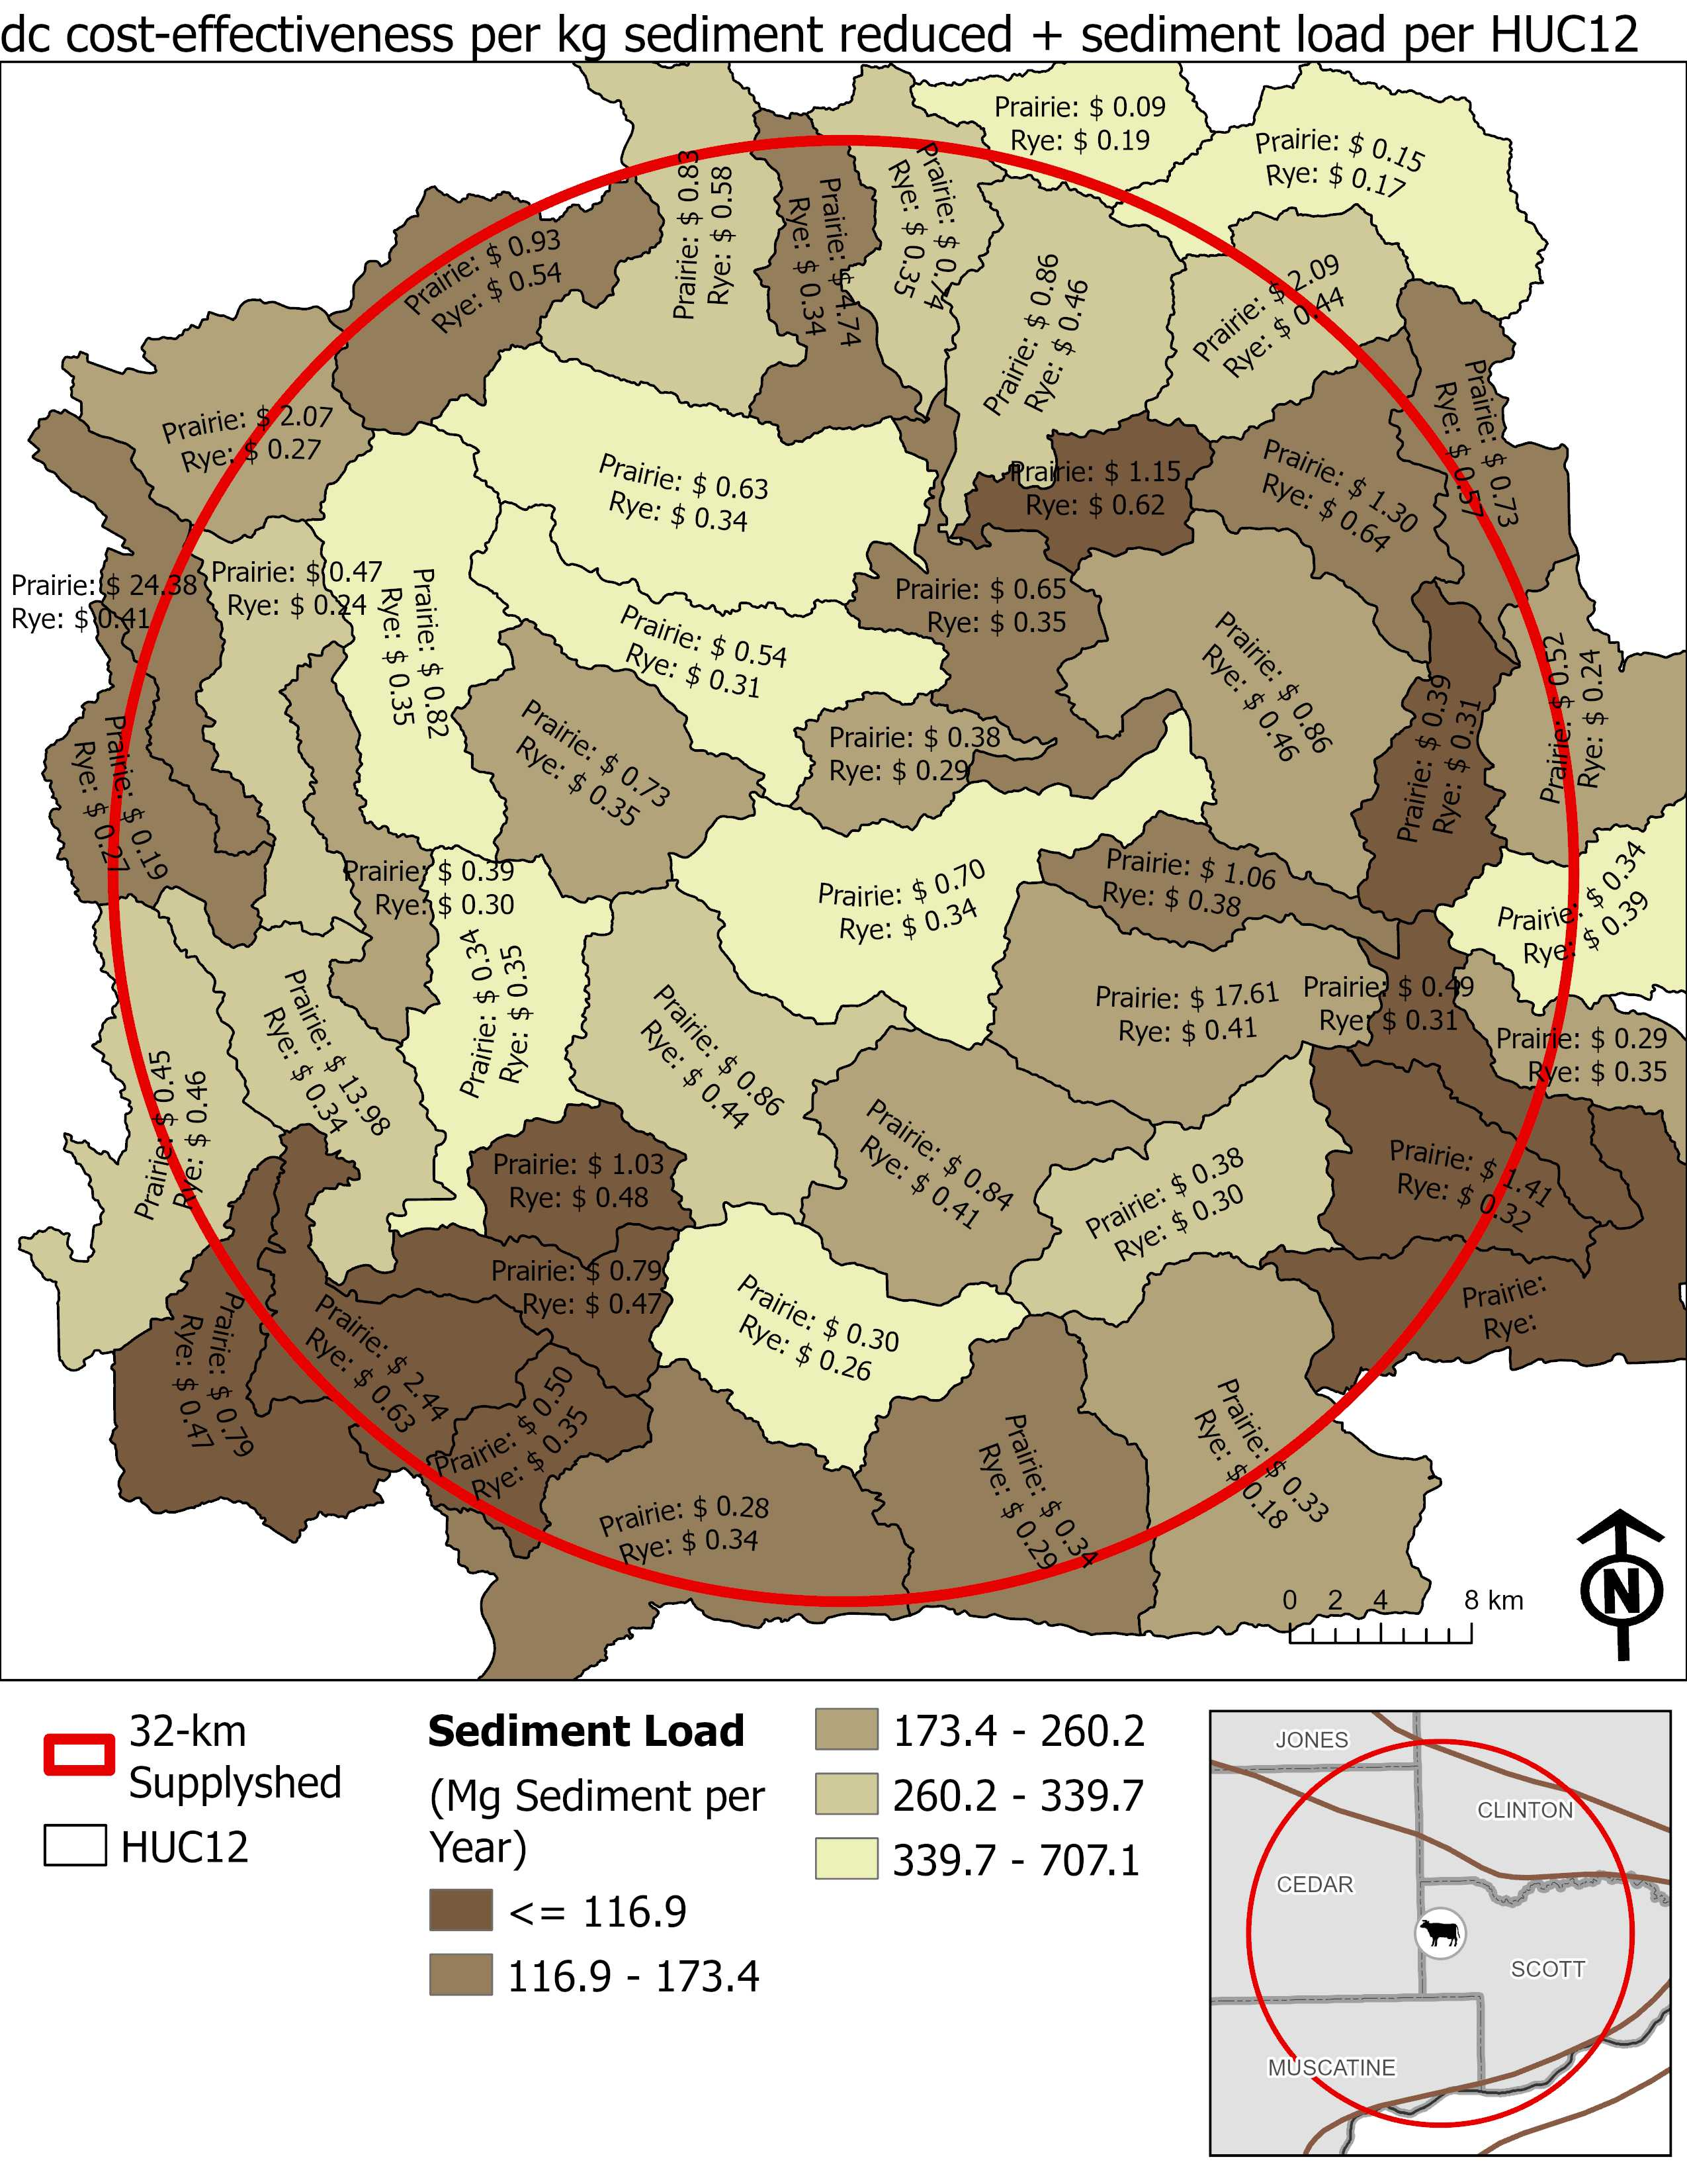
Figure 5. sediment load. Average total cost-effectiveness per kg sediment load reduced per HUC12 for both prairie-converted fields and winter rye managed fields.
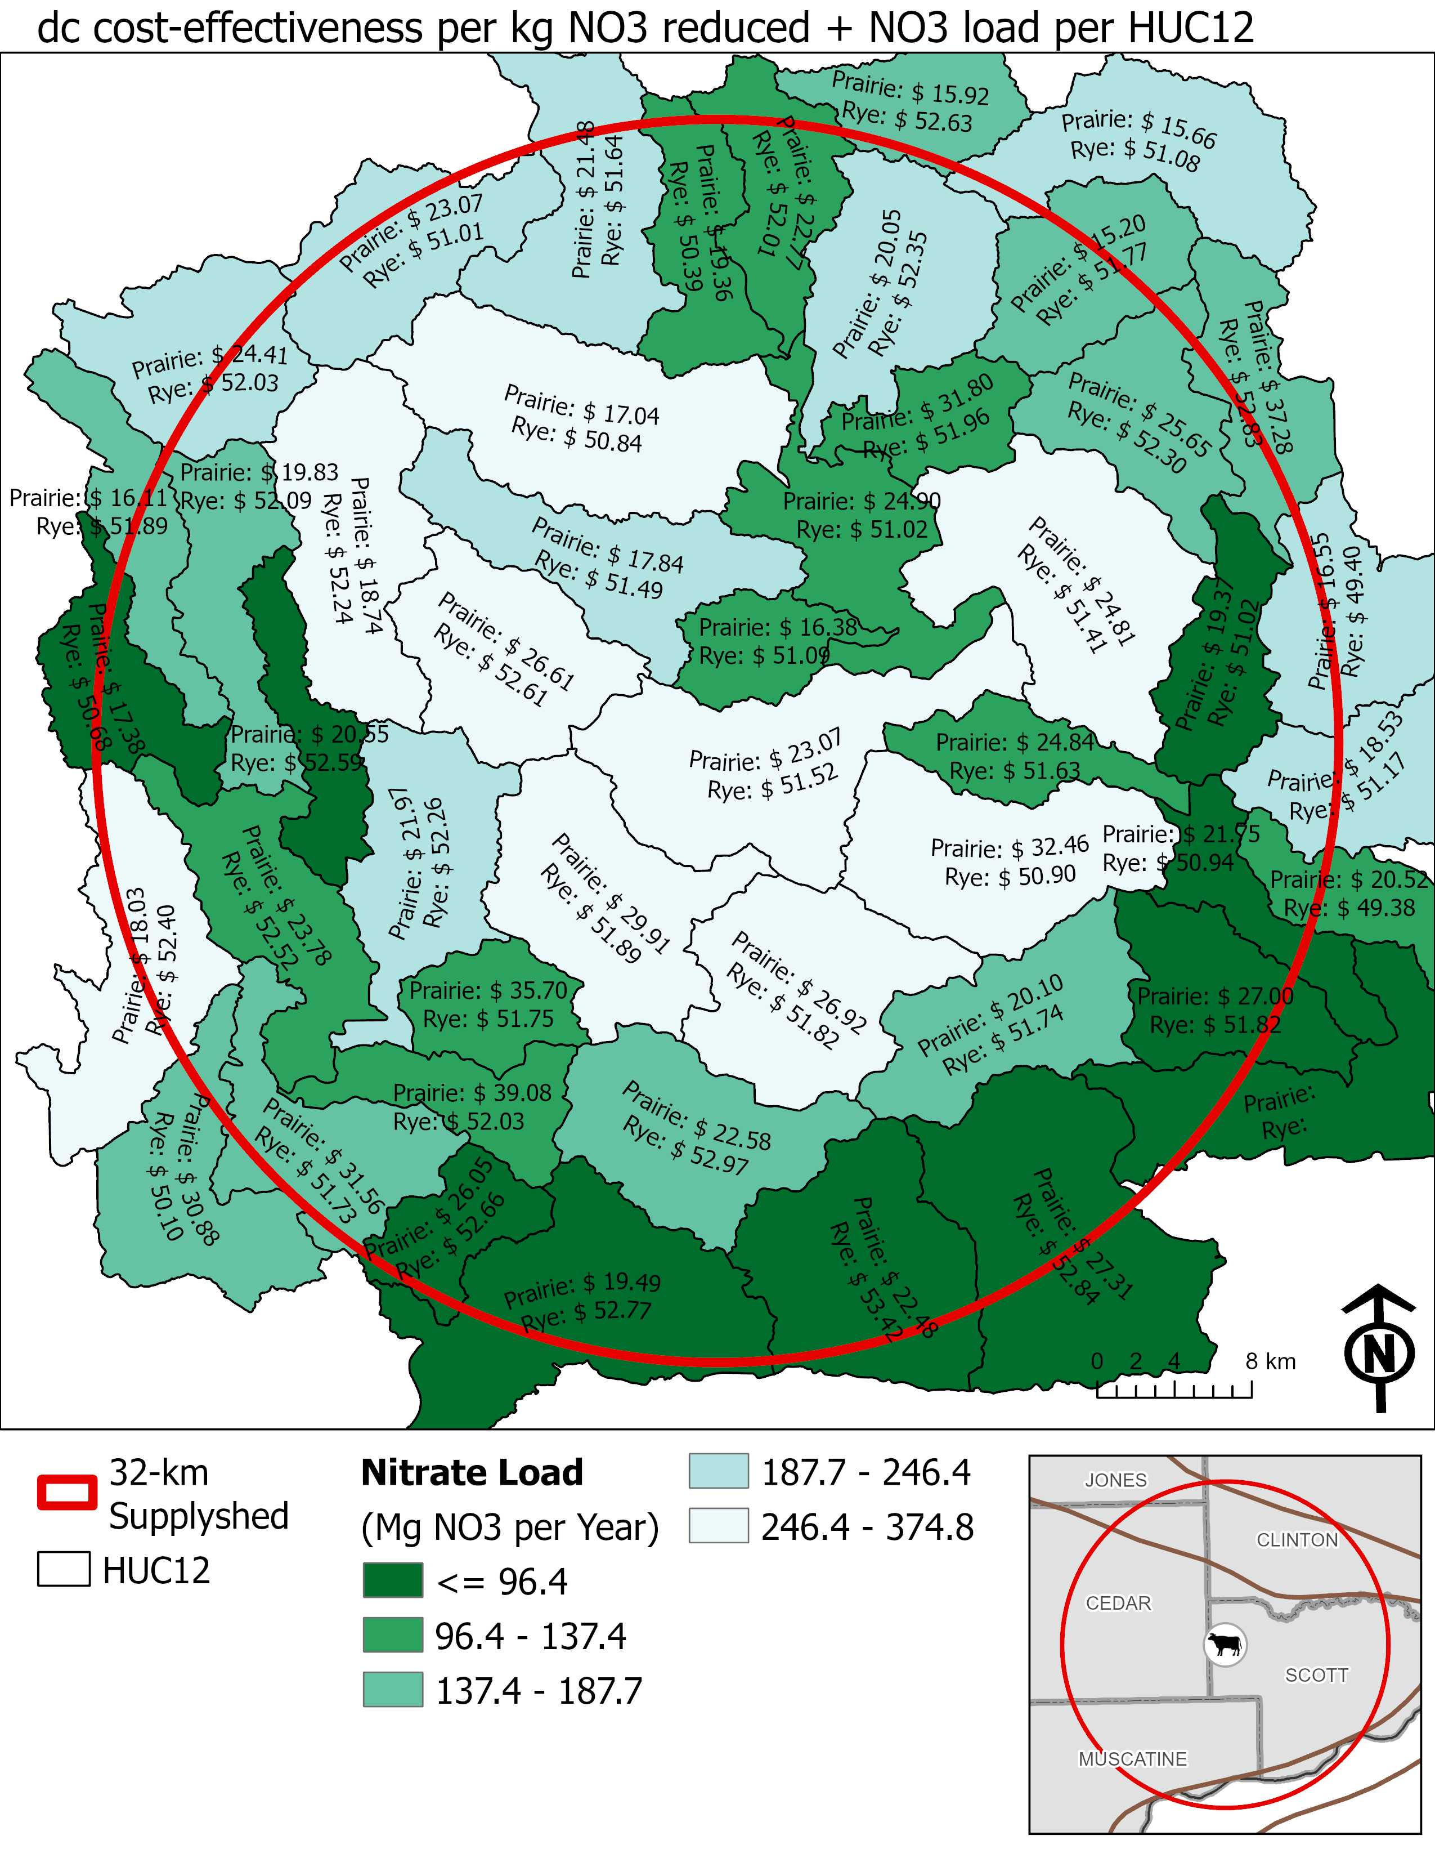
Figure 6. nitrate load. Average total cost-effectiveness per kg sediment load reduced per HUC12 for both prairie-converted fields and winter rye managed fields.
Table 1. [Methods] Summary of land in 32 km supplyshed and land requirements to achieve the AD facility, INRS and IWAP goals for permanent cover and rye. Area in hectares.
Land Use and Land Cover | MLRA |  |  |  |  |  |  |  | Supplyshed
 | 104 |  | 105 |  | 108c |  | 115c
Area within supplyshed | 66,525 |  | 5,341 |  | 235,690 |  | 6,406² |  | 313,962
Total cropped area¹ | 52,873 |  | 5,208 |  | 170,354 |  | 667 |  | 229,102
Continuous corn (CC)¹ | 2,730 |  | 345 |  | 13,171 |  | 24 |  | 16,270
Corn rotation (CS)¹ | 50,143 |  | 4,863 |  | 157,183 |  | 643 |  | 212,832
Existing permanent cover based on NCED | 1,110 |  | 0 |  | 1,109 |  | 16 |  | 2,235
LAND AREA GOALS (ha)
IWAP
4% of supplyshed in permanent cover. | 1,765 |  | 352 |  | 6,898 |  | 44 |  | 9,059
INRS
Plant a rye cover crop on all no-till acres | CC | CS | CC | CS | CC | CS | CC | CS | CC | CS
 | 300 | 12,034 | 38 | 1,508 | 1,976 | 56,586 | 2 | 212 | 2,316 | 70,340
Installing wetlands to treat 45% of the ag land.³ | 522 |  | 53 |  | 1,849 |  | 6 |  | 2,430
Installing [saturated] buffers on all applicable acres. | 184 |  | 12 |  | 1,341 |  | 36 |  | 1,573
Perennial crops (energy crops) to equal pasture/hay acreage in 1987. | 7,231 |  | 1,751 |  | 29,820 |  | 86 |  | 38,888
AD Facility
Prairie |  |  |  |  |  |  |  |  | 809
Cereal Rye |  |  |  |  |  |  |  |  | 809
¹ The total cropped area was estimated using NASS data compiled by ACPF and based on a six-year (2019-2024) crop rotation for a field.
² The area of 115c in the 32 km supplyshed is only reported for Iowa and the Illinois land was subtracted from the total.
³ There were NRW sited that achieved treatment of 45% of agricultural land in the supplyshed, however, the number of NRW were pared down to remove some of the larger wetland complexes that would require agreement from multiple landowners.

Perennial crops as prairie strips and whole field conversion.
Table 2. [Results] Costs to achieve INRS & IWAP recommendations in the supplyshed. Should I report mean and range? Or median and confidence interval? How much of these costs are establishment and how much are management?
Assuming a harvested biomass. These costs would look different if these aren’t all managed as a biomass system. Look at enterprise budget. 20 years @ 7% discount rate.
Everything from NO₃ except STB. Assuming OC is the same for each MLRA and practice. THe same number of acres. DC and TC will change. CPs are annualized over 20 years @ 6% discount rate. Assuming different returns and impacts financially. Saturated buffers OC could be less because they are only planning for BMP and could be designed to be smaller instead of trying to maintain a harvestable buffer width, however, we are assuming same width (100’). Rye cover crop has no OC since no land is being taken out of production, however, I just wanted to report the land rental value for demonstrative purposes.
Report costs per practice/acre in the footnotes.
 | MLRA |  |  |  |  |  |  |  |  |  |  |  |  | Supplyshed
 | 104 |  |  | 105 |  |  | 108c |  |  |  | 115c
 | DC | OC | TC | DC | OC | TC |  | DC | OC | TC | DC | OC | TC | DC | OC | TC
INRS
Plant a rye cover crop on all no-till acres. | $5,419,144 | $7,779,864 | $5,419,144 | $640,133 | $682,460 | $640,133 |  | $25,230,779 | $35,811,689 | $25,230,779 | $84,105 | $98,034 | $84,105 | $31,374,161 | $44,372,047 | $31,374,161
CP | $1,678,239 |  | $1,678,239 | $191,993 |  | $191,993 |  | $7,767,089 |  | $7,767,089 | $28,430 |  | $28,430 | $9,665,751 |  | $9,665,751
Installing wetlands to treat 45% of the agricultural land. | $3,737,007 | $245,791 | $3,982,798 | $371,725 | $22,859 | $394,585 |  | $16,589,650 | $1,143,352 | $17,733,002 | $22,661 | $1,161 | $23,822 | $20,721,043 | $1,413,163 | $22,134,207
CP | $2,695,578 |  | $2,941,369 | $268,133 |  | $300,631 |  | $11,966,447 |  | $13,109,800 | $16,346 |  | $17,507 | $14,946,504 |  | $16,369,307
Installing [saturated] buffers on applicable acres. | $131,985 | $334,352 | $466,337 | $3,150 | $7,752 | $10,902 |  | $820,523 | $2,042,864 | $2,863,387 | - | - | - | $955,658 | $2,384,684 | $3,340,626
CP | $103,240 |  | $437,592 | $2,464 |  | $10,216 |  | $641,820 |  | $2,684,684 | - | - | - | $747,524 |  | $3,132,491
Perennial crops (energy crops) to equal pasture/hay acreage in 1987. | $2,586,467 | $3,154,069 | $5,740,536 | $564,695 | $625,021 | $1,189,716 |  | $10,668,163 | $16,869,746 | $27,537,909 | $25,537 | $33,073 | $58,610 | $13,844,862 | $20,594,638 | $34,526,771
CP | $667,041 |  | $3,956,884 | $146,089 |  | $801,130 |  | $2,699,471 |  | $19,911,607 | $6,830 |  | $41,938 | $3,519,431 |  | $24,114,069
Sum of all management options. | $9,395,257 | $3,734,212 | $14,054,826 | $1,310,582 | $655,632 | $2,109,328 |  | $41,870,596 | $20,055,962 | $65,921,746 | $131,926 | $34,234 | $173,585 | $52,708,361 | $24,392,485 | $82,259,485
CP | $5,240,998 |  | $9,110,984 | $618,318 |  | $1,303,970 |  | $23,504,993 |  | $43,903,345 | $52,194 |  | $88,463 | $29,416,503 |  | $54,406,762
IWAP
4% of Iowa in permanent cover | $2,162,264 | $2,624,285 | $4,786,549 | $313,263 | $349,709 | $662,972 |  | $8,649,731 | $14,105,302 | $22,755,033 | $18,041 | $25,145 | $43,186 | $11,143,299 | $17,104,441 | $28,247,740
CP | $534,053 |  | $3,158,338 | $77,372 |  | $427,082 |  | $2,136,379 |  | $16,241,682 | $4,456 |  | $29,601 | $2,752,260 |  | $19,856,703
Side fact….$3,745,871,600 per year over 20 years for all of Iowa. Assuming 30 million acres of land and supplyshed is 2% of land in Iowa.

Table 3. [Results] Estimated leachable nitrate (NO₃) and sediment transport reduction results (FiNRT). Total reductions in nitrate load (tonnes yr⁻¹) and sediment transported (tonnes yr⁻¹) for each MLRA and the 32 km supplyshed. Greenhouse gas reduction summary. Estimated CO₂ and N₂O emission reductions (t CO₂e ha⁻¹ yr ⁻¹) for each MLRA and the 32 km supplyshed. Wildlife habitat mean, minimum and maximum patch size and area of assumed corridors connecting patches (ha). To see a list of potential species supported based on patch size and connectivity, see Supplementary Materials.
 | MLRA |  |  |  | Supplyshed
 | 104 | 105 | 108c | 115c
Water Quality Improvements | Load Reduced (Mg per year)
Nitrate (NO₃) Load | 1,766 | 725 | 5755 | 33 | 8,279
Sediment Load | 1,254 | 1,687 | 7286 | 123 | 10,350
Greenhouse Gas Emissions | Emissions Reduced (Mg CO_{2 eq} per year)
Carbon Dioxide (CO₂) | 18,037 | 3,509 | 80,222 | 285 | 102,053
Nitrous Oxide (N₂O) | 868,010 | 114,080 | 3,791,874 | 12,873 | 4,786,837
Wildlife | Quality Habitat Established (ha)
Patch Size (Average field size) | 31 (6 - 124)  n = 67 | 22 (1 - 79)  n = 19 | 62 (2 - 152)  n = 274 | 27 (6 - 19)  n = 4 | 26  n = 364
Connectivity¹ (Total area) | 1,126 | 598 | 5,482 | 23 | 7,229
¹ assumes that saturated buffers and CBS provide corridors between patch sizes and they are all connected.

Table 4. [Results] Cost-effectiveness. Cost per kg of pollutant reduced. Are confidence intervals better here? Median seems more appropriate since the range is so wide.
 |  | Major Land Resource Area |  |  |  |  |  |  |  |  |  | Supplyshed
 |  | 104 |  | 105 |  |  | 108c |  |  | 115c
Cost-Effectiveness |  | DC | TC | DC | TC | DC |  | TC | DC |  | TC | DC | TC
Plant a rye cover crop on all no-till acres. | NO₃ | $51.56  ($51.30 - $51.81) |  | $51.97  ($51.40 - $52.54) |  |  | $51.81  ($51.70 - $51.93) |  |  | $53.36  ($52.85 - $53.88) |  | $51.79  ($51.69 - $51.89)
 | Sed | $0.55  ($0.51 - $0.58) |  | $0.23  ($0.19 - $0.27) |  |  | $0.35  ($0.33 - $0.36) |  |  | $0.23  ($0.11 - $0.34) |  | $0.37  ($0.36 - $0.38)
Installing wetlands to treat 45% of the agricultural land. | NO₃ | $29.65  ($26.66 - $32.65) | $31.57  ($28.38 - $34.77) | $31.91  ($22.81 - $41.01) | $33.88  ($24.27 - $43.48) | $29.05  ($27.88 - $30.22) |  | $31.03  ($29.77 - $32.28) | $33.94 |  | $35.68 | $29.23  ($28.15 - $30.31) | $31.20  ($30.04 - $32.35)
 | Sed | $0.51  ($0.41 - $0.61) | $0.54  ($0.44 - $0.65) | $0.15  ($0.11 - $0.20) | $0.16  ($0.12 - $0.21) | $0.35  ($0.33 - $0.38) |  | $0.38  ($0.35 - $0.41) | $0.19 |  | $0.20 | 0.37  (0.35 - 0.40) | $0.40  ($0.37 - $0.43)
Installing [saturated] buffers on applicable acres.¹ | NO₃ | $2.76  ($2.55 - $2.96) | $9.66  ($8.95 - $10.37) | - | - | $1.99  ($1.92 - $2.06) |  | $7.19  ($6.93 - $7.45) | - |  | - | $2.13  ($2.06 - $2.20) | $7.65  ($7.40 - $7.90)
 | Sed | $1.15  ($0.64 - $1.67) | $4.11  ($2.24 - $5.97) | $0.08  ($(0.08) - $0.25) | $0.28  ($(0.27) - $0.84) | $1.69  ($0.11 - $3.26) |  | $5.45  ($0.14 - $10.77) | - |  | - | 1.60  (0.25 - 2.96) | $5.25  ($0.67 - $9.83)
Perennial crops (energy crops) to equal pasture/hay acreage in 1987. | NO₃ | $10.00  ($9.50 - $10.49) | $21.79  ($20.69 - $22.90) | $7.38  ($6.79 - $7.96) | $15.80  ($14.43 - $17.17) | $8.92  ($8.71 - $9.13) |  | $22.34  ($21.75 - $22.92) | $8.25  ($5.52 - $10.99) |  | $18.29  ($11.27 - $25.31) | $8.97  ($8.79 - $9.15) | $21.78  ($21.28 - $22.28)
 | Sed | $0.31  ($0.28 - $0.34) | $0.67  ($0.60 - $0.74) | $0.10  ($0.07 - $0.12) | $0.23  ($0.17 - $0.29) | $0.16  ($0.16 - $0.17) |  | $0.42  ($0.40 - $0.44) | $0.06  ($0.03 - $0.09) |  | $0.13  ($0.06 - $0.20) | $0.18  ($0.17 - $0.19) | $0.44  ($0.42 - $0.47)
¹ no tile drained fields to this practice, so NO₃ load reductions are not estimated. We assume some surface runoff is intercepted so there is a sediment reduction value.

Table 5. [Results] From a watershed perspective, where should we prioritize? Should this be supplementary material? Table needs to be updated to reflect current data that is illustrated in figures.
Biomass costs. Top 10 most beneficial environmentall. From a transportation perspective, where should we prioritize?
HUC12 | NO₃  (Mg) | Sediment (Mg) | Wildlife  (ha) | GHG (Mg CO_{2 eq}) |  | Summary of Costs |  | Cost-Effectiveness ($ per kg NO₃) |  | Cost-Effectiveness  ($ per kg sediment) |  | Yield of Biomass (Mg) | Energy Potential  (MWh)
 |  |  |  | CO₂ | N₂O | DC | TC | DC | TC | DC | TC
070600060901 | 9 | 2,640 | 52 | 348 | 11,338 | $152,706 | $209,826 | $21.03 | $25.78 | $0.09 | $0.13 | 1167 | 7231
070600061002 | 8 | 2,409 | 13 | 412 | 18,534 | $181,632 | $235,298 | $26.77 | $31.11 | $0.10 | $0.13 | 1321 | 11016
070801010301 | 78 | 12,978 | 262 | 2,935 | 138,633 | $1,941,070 | $2,539,412 | $30.39 | $35.47 | $0.20 | $0.26 | 10161 | 83058
070801010302 | 11 | 1,222 | - | 414 | 20,402 | $230,432 | $354,625 | $28.62 | $37.29 | $0.39 | $0.59 | 1441 | 12169
070801010403 | 23 | 3,499 | - | 693 | 30,885 | $416,343 | $698,430 | $23.55 | $31.02 | $0.15 | $0.22 | 2462 | 18746
070801010405 | 23 | 3,081 | 32 | 1,125 | 53,804 | $611,908 | $826,076 | $28.38 | $35.11 | $0.23 | $0.36 | 3776 | 32000
070801010601 | 13 | 2,806 | 70 | 636 | 32,012 | $325,963 | $502,072 | $32.05 | $39.87 | $0.15 | $0.25 | 2083 | 18941
070801010602 | 53 | 10,387 | 397 | 2,521 | 125,357 | $1,452,275 | $1,981,225 | $33.30 | $38.89 | $0.20 | $0.26 | 8472 | 74214
070801010603 | 6 | 1,277 | 85 | 443 | 22,050 | $167,380 | $227,111 | $34.18 | $39.77 | $0.23 | $0.31 | 1425 | 12954
070801010604 | 21 | 2,585 | 81 | 973 | 50,713 | $582,274 | $808,414 | $34.36 | $40.71 | $0.28 | $0.39 | 3255 | 29833
070801010605 | 17 | 2,472 | 169 | 844 | 39,199 | $391,582 | $561,214 | $31.31 | $36.51 | $0.24 | $0.31 | 2719 | 23226
070801030202 | 84 | 9,852 | 252 | 2,888 | 148,531 | $2,351,483 | $2,832,225 | $34.21 | $38.38 | $0.41 | $0.53 | 10216 | 88360
070801030203 | - | - | - | 65 | 2,665 | - | - | - | - | - | - | 208 | 1603
070801030301 | 144 | 11,309 | - | 4,017 | 215,041 | $3,408,940 | $5,166,811 | $29.91 | $39.77 | $3.38 | $4.89 | 14329 | 127476
070801030302 | 51 | 6,760 | 276 | 1,798 | 89,325 | $1,276,898 | $1,732,805 | $30.09 | $36.81 | $0.36 | $0.50 | 6056 | 51482
070801030303 | 160 | 25,371 | 38 | 5,439 | 261,842 | $3,943,428 | $5,192,142 | $29.40 | $35.75 | $0.28 | $0.41 | 18936 | 156647
070801030401 | 68 | 7,935 | 428 | 3,070 | 152,815 | $1,890,025 | $2,309,246 | $33.02 | $37.50 | $0.45 | $0.57 | 10344 | 90500
070801030402 | 39 | 5,009 | 300 | 1,580 | 62,974 | $708,469 | $1,155,299 | $22.34 | $31.26 | $0.32 | $0.59 | 5143 | 38153
070801030403 | 46 | 6,967 | 189 | 1,859 | 82,566 | $1,055,125 | $1,362,798 | $24.98 | $30.82 | $1.06 | $1.52 | 6211 | 49539
070801030404 | 22 | 750 | 64 | 800 | 45,391 | $461,072 | $778,855 | $26.12 | $37.32 | $0.58 | $0.98 | 2671 | 26519
070801030405 | 85 | 10,335 | 385 | 3,010 | 127,002 | $1,744,427 | $2,380,602 | $23.48 | $29.77 | $0.38 | $0.57 | 9981 | 76620
070801030406 | 155 | 30,598 | 400 | 6,584 | 263,367 | $3,458,144 | $4,480,550 | $26.40 | $31.09 | $0.25 | $0.34 | 22197 | 160650
070801030407 | 115 | 27,543 | 831 | 4,566 | 191,961 | $2,651,170 | $3,400,214 | $27.78 | $32.56 | $0.22 | $0.30 | 15578 | 116537
070801030408 | 49 | 11,324 | 344 | 2,228 | 91,635 | $1,009,410 | $1,423,298 | $25.57 | $30.81 | $0.20 | $0.26 | 7403 | 55504
070801030409 | 52 | 5,824 | 300 | 1,609 | 82,209 | $1,402,996 | $1,907,726 | $28.61 | $35.23 | $0.35 | $0.53 | 5635 | 48859
070801030601 | 52 | 8,514 | 275 | 1,918 | 77,384 | $1,178,696 | $1,430,512 | $27.99 | $31.56 | $0.55 | $0.73 | 6605 | 47357
070801030602 | 32 | 2,089 | 109 | 1,496 | 81,797 | $872,938 | $1,165,945 | $35.32 | $40.61 | $0.59 | $0.79 | 4955 | 47781
070801030603 | 100 | 9,513 | 176 | 2,443 | 120,490 | $2,468,706 | $3,212,518 | $27.32 | $33.90 | $0.40 | $0.57 | 9225 | 75869
070801030604 | 6 | 560 | 246 | 213 | 11,634 | $274,464 | $299,708 | $39.75 | $44.54 | $0.52 | $0.66 | 793 | 6930
070801030605 | 38 | 5,148 | 7 | 1,287 | 57,288 | $829,951 | $1,079,059 | $26.01 | $31.59 | $0.22 | $0.32 | 4341 | 34424
070801030606 | 47 | 5,398 | 157 | 1,262 | 58,087 | $1,124,780 | $1,289,451 | $30.63 | $34.47 | $0.28 | $0.35 | 4367 | 34919
070801030607 | 21 | 3,489 |  | 818 | 35,490 | $397,132 | $553,346 | $24.85 | $29.88 | $0.22 | $0.34 | 2672 | 21267
070802060301 | 35 | 6,445 | 118 | 1,550 | 78,175 | $1,049,554 | $1,339,491 | $34.73 | $39.95 | $0.47 | $0.66 | 5218 | 45899
070802060302 | 61 | 14,168 | 115 | 2,823 | 133,212 | $1,616,668 | $2,024,905 | $30.54 | $35.51 | $0.22 | $0.28 | 9576 | 79837
070802060406 | 26 | 6,137 | 161 | 1,237 | 58,828 | $605,695 | $807,172 | $27.73 | $32.15 | $4.20 | $6.10 | 4215 | 35109
070802060407 | 10 | 3,169 | 28 | 624 | 27,856 | $282,917 | $344,284 | $30.39 | $34.42 | $0.17 | $0.20 | 2040 | 16635
070802060501 | 117 | 13,000 | 73 | 3,342 | 175,968 | $3,000,286 | $4,138,423 | $29.60 | $37.04 | $0.32 | $0.49 | 12034 | 103919
070802060502 | 128 | 15,720 | 289 | 4,917 | 261,035 | $3,801,141 | $4,990,143 | $33.50 | $40.98 | $0.34 | $0.48 | 17493 | 155611
070802060503 | 45 | 2,829 | 174 | 1,246 | 70,884 | $1,117,525 | $1,595,795 | $33.87 | $42.93 | $0.47 | $0.70 | 4398 | 41643
070802060601 | 115 | 17,348 | 359 | 4,155 | 217,776 | $3,199,191 | $4,246,383 | $34.05 | $40.06 | $0.27 | $0.37 | 14687 | 129230
070802060602 | 144 | 31,121 | 456 | 6,373 | 289,444 | $3,793,187 | $4,755,735 | $31.24 | $35.81 | $0.28 | $0.38 | 17051 | 142267
070802060603 | 106 | 16,740 | 326 | 4,034 | 186,421 | $2,697,144 | $3,502,174 | $30.47 | $36.16 | $0.24 | $0.33 | 18607 | 143512
070802060704 | 85 | 13,853 | 484 | 2,601 | 113,306 | $1,955,362 | $2,409,984 | $28.48 | $33.29 | $0.26 | $0.35 | 9117 | 68812
070802060801 | 51 | 11,539 | 8 | 2,377 | 103,775 | $1,121,965 | $1,613,718 | $26.77 | $33.42 | $0.20 | $0.27 | 7826 | 62232
070802060802 | 49 | 3,211 | 566 | 1,348 | 76,657 | $1,357,472 | $2,049,017 | $32.86 | $44.51 | $0.39 | $0.62 | 4859 | 44848
070802060803 | 46 | 7,313 | 70 | 1,871 | 88,883 | $1,092,183 | $1,538,929 | $29.32 | $36.16 | $4.79 | $5.48 | 6402 | 53438
070802060804 | 44 | 3,201 | 201 | 1,467 | 79,553 | $1,123,620 | $1,659,827 | $28.33 | $38.65 | $0.86 | $1.24 | 5011 | 46912
070802060805 | 8 | 509 | 105 | 261 | 14,362 | $145,009 | $304,484 | $27.19 | $37.87 | $0.38 | $0.68 | 856 | 8371

Supplementary Material: Costs

Enterprise budgets
SA.1. Riparian buffer (mix-species) enterprise budget. assume harvest of 50% of buffer and exclude the first 16.5 ft from streambank
Cost Activities/Items | Year Cost Incurred | Range of Costs |  | Mean cost  ($/acre) | Notes | Data Sources
 |  | min | max
NRW Construction
Buffer site design | 0 | - | $300.00 | $300.00 |  | Christianson et al. 2013, inflated to 2024$
Site preparation | 0 | $117.00 | $162.00 | $140.00 |  | 2024 Iowa Farming Custom Rate Survey, File A3-10; Schultz et al. 2000
Grass seed | 0 | $90.00 | $300.00 | $119.00 |  | Seed cost: Iowa Pheasants Forever Native Seed Program, http://www.iowapf.net/native-seed-program/
Drilling grass seed | 0 | $12.00 | $25.00 | $18.70 |  | 2024 Iowa Farming Custom Rate Survey, File A3-10
MSB Biomass Establishment - Year 1
Mowing | 1 | $30.00 | $54.00 | $41.55 |  | 2024 Iowa Farming Custom Rate Survey, File A3-10; Christianson et al. 2013
Prairie Biomass Crop Management
Manure application - Fall | 2-n |  |  |  | No fertilizer applied within 35 ft of stream | (<source>)
Mowing/Conditioning | 2-n | $14.00 | $25.00 | $18.10 |  | 2024 Iowa Farming Custom Rate Survey, File A3-10
Raking | 2-n | $7.00 | $9.00 | $8.15 |  | 2024 Iowa Farming Custom Rate Survey, File A3-10
Silage - chopping | 2-n | $20.40 | $27.20 | $24.14 |  | 2024 Iowa Farming Custom Rate Survey, File A3-10
Straw or corn stalk baling - large round or square bales without wrap | 2-n | $67.95 | $81.54 | $70.67 |  | 2024 Iowa Farming Custom Rate Survey, File A3-10
Overall Management Impact
Land rent | A | Variable |  |  |  | Plastina et al., 2023.
General operating costs | A | 1-3% upfront |  | Variable |  | Bravard et al., 2022.

References
Plastina, A. and A.M. Johanns. 2024. 2024 Iowa Farm Custom Rate Survey, File A3-10. Iowa State University, Ames, IA.
Accessed on 9/11/2024 | https://www.extension.iastate.edu/agdm/crops/html/a3-10.html
Accessed on 9/11/2024 | https://www.sciencedirect.com/science/article/pii/S0961953416303208.

SA.2. Nutrient removal wetland enterprise budget.
Cost Activities/Items | Year Cost  Incurred | Range of Costs (per wetland) |  | Mean cost (per acre of wetland) | Notes (JT 2024)  Notes (JS 2024) | Data Sources
 |  | min | max
NRW Construction
Wetland design cost (engineer) | 0 | - | $4,000.00 | $800.00 | Assumption: 20 hours at ~$200/hr for a 5-acre wetland site (treating 500 acres of drainage) The total amount of this cost will depend on the context for wetland use and or program tie-in (e.g., USDA CREP wetland program). This cost variable assumes a 1/5 cost factor for 1 acre of wetland construction. Cost may be significantly reduced by working with the NRCS. | Christianson et al. 2013, inflated to 2024$.
Constructing basin | 0 |  | $140,000.00 | $2,800.00 | Building ponds ~100 hours at ~$250/hr for a 5-acre wetland (encompasses range of activities for excavation, berm building, structure placement, etc.). Moving/ transporting earth and rock offsite, $2.00 to $3.00 per cubic yard of material. Assume ~ 10,000 cubic yards of earth material per acre of wetland (~0.5 % rock). Note that excavation and material removal costs increase significantly as percent rock increases beyond > 1%. This cost variable assumes a 1/5 cost factor for 1 acre of wetland. | Christianson et al. 2013, inflated to 2024$.
Control structure and installation | 0 |  | $8,300.00 | $1,660.00 | One 10ft deep, 24-inch pipe control structure costs ~ $5,500 (plus ~$300 shipping costs). 1 structure per 500 to 1000 acre drainage area (Buffer area assumption: Helmers, M. 2014 Personal communication). Assume 10 hours for installation @ $250/ hour. This cost variable assumes a 1/5 cost factor for 1 acre of wetland. | Control structure cost: Agri drain 2024 catalog price; The Pond Report 2021.
Wetland plants (seeds and plugs) and planting | 0 | - | $12,800.00 | $1,889.00 | For shallow wetland systems, 50-100 plugs per 100 ft2 will help ensure sufficient establishment in open water areas. Assume ~ 3,500 ft2 of shore area per 5 acre wetland. A wetland seed mix that covers wetland banks (~1/3 of the basin area) is also advisable. Wetland plant species regionally sell in bulk for ~$1.50 to $4.00 per plug; wetland seed mixes range $140 - $175 per acre (e.g., sufficient for CP 25 or CP 42 plantings). Planting a plug costs ~ $0.50 per plug. So, ($3.25 per planted plug * 2,625 plugs per 5 acre wetland = $8,531 for planted plugs + (~$158/ acre for wet prairie seed * ~6 acres of shore area). This cost variable assumes a 1/5 cost factor for 1 acre of wetland. It is possible that there is a viable wetland plant seedbed that would revegetate the wetland basin without additional seed/plants; such outcomes are uncertain and variable. | 2024 survey of regional bulk wetland plant catalog prices (n=4).
Wetland buffer seed | 0 | 2,450.00 | $3,063.00 | $553.00 | Wetland seed mixes range $140 - $175 per acre (e.g., sufficient for CP 25 or CP 42 plantings). Total Wetland buffer area = 3.5% of the total drainage area; 500 acres is minimum drainage area or 5 acres of wetland. Or 17.5 acres of buffer needed. Buffer area assumption: Helmers, M. 2014 Personal communication. This cost variable assumes a 1/5 cost factor to represent 1 acre of wetland. | Seed cost: 2024 Iowa Pheasants Forever Native Seed Program.
Seeding buffer (seed drilling and cultipacking) | 0 | $525.00 | $1,440.00 | $200.00 | $30.00 - $48.00 per acre of buffer Total Wetland buffer area = 3.5% of the total drainage area; One acre of wetland treats 100 acres of drainage area. This cost variable assumes a 1/5 cost factor to represent 1 acre of wetland. | Plastina et al., 2024b.
Weir plate | 0 | Variable |  | $800.00 | Assumption: $40 per sq. ft sheet pile plate. Assume 0.2 square feet of weir plate for every acre of drainage; minimum of 500 acres drainage. One acre of wetland treats 100 acres of drainage area. (0.2 sq. ft. * 500 acres drainage * $40/ sq.ft of plate = $4000. This cost variable assumes a 1/5 cost factor to represent 1 acre of wetland. | Christiansen, et al., 2013, inflated to 2024$.
Prairie Biomass Establishment - Year 1-3
Mowing | 1 | $350.00 | $630.00 | $96.95 | Accounts for mowing 2x per year, raking and baling once per year. | Plastina et al., 2024b.
Mowing / Conditioning | Yr 2-3 | $490.00 | $875.00 | $126.70 | Accounts for mowing 2x per year, raking and baling once per year. | Plastina et al., 2024b.
Raking | Yr 1-3 | $472.50 | $157.50 | $28.53 | Accounts for mowing 2x per year, raking and baling once per year. | Plastina et al., 2024b.
Herbicide & Application | 2 | $181.13 | $242.38 | $43.23 |  | Plastina et al., 2024b.
Burn | Yr 3 | $875.00 | $1,645.00 | $255.50
Prairie Biomass Crop Management
Manure application - Fall | 4-n
Mowing/Conditioning | 4-n | $122.50 | $218.75 | $31.68 |  | Plastina et al., 2024b.
Raking | 4-n | $61.25 | $78.75 | $14.26 |  | Plastina et al., 2024b.
Silage - chopping | 4-n | $178.50 | $238.00 | $42.25 |  | Plastina et al., 2024b.
Straw or corn stalk baling - large round or square bales without wrap | 4-n | $594.56 | $713.48 | $123.67 |  | Plastina et al., 2024b.
Mowing (unharvested portion of buffer) | 4-4n | $87.50 | $157.50 | $24.24 | Total Wetland buffer area = 3.5% of the total drainage area; One acre of wetland treats 100 acres of drainage area. Assume $12 - $65 per acre to mow CRP. This cost variable assumes a 1/5 cost factor to represent 1 acre of wetland. Note: Periodic burning is a common alternative. Burning prairie costs ~ $32 per acre, or $560 every 5 years. | Plastina et al., 2024b.
Overall Management Impact
Replace control structure gates | 8n |  | $148.00 | $30.00 | Every 8 years, the gates within the control structures must be replaced to maintain correct operation. 5 Gates per structure ($18.50 ea. for 15 cm structure) | Christianson et al. 2013, inflated to 2024$.
Land rent for wetland acre | A | 1,150.00 | $1,650.00 | $277.00 | In Iowa, GIS calculated area-weighted average rent based on CSR2 for land used by practice. Based on the 2023 Iowa Land rent survey, average land rent for crop ground in Iowa ranged from a low of $230 to $330 per acre. This cost variable assumes a 1/5 cost factor to represent 1 acre of wetland. | Plastina et al., 2023.
Land rent for buffer acre | A | $ 4,000.00 | $ $5,775.00 | $970.00 | In Iowa, GIS calculated area-weighted average rent based on CSR2 for land used by practice. Total Wetland buffer area = 3.5% of the total drainage area; One acre of wetland treats 100 acres of drainage area | Plastina et al., 2023.
General operating costs | A | 1-3% upfront |  | Variable | This would involve general monitoring of the wetland, record keeping, wetland specific equipment storage, general energy cost. | Bravard et al., 2022.
Replace control structure and weir | 30+ years | $4,720.00 | 10,020.00 | $14,740.00 | One control structure ranging from 5 ft deep, 18-inch pipe ($2,356- $5,000 per structure) to 10ft deep, 24-inch pipe. 2 structures per 50 acres drainage area. One acre of wetland treats ~100 acres of drainage area (Buffer area assumption: Helmers, M. 2014 Personal communication). Assumes 0.005% real compounded increase in cost. Note this cost is not accounted for in the assessment presented here. It is included for reference. | Christianson et al. 2013; inflated to 2024$.

References
Accessed on 9/11/2024
NRCS. 2020. Iowa Native Prairie Planting Guide. Natural Resource Conservation Service, Des Moines, IA.
Accessed on 9/11/2024
Akron Services, Inc. 2023. 2024 Pesticide Prices. Illinois.
Accessed on 9/11/2024
Edwards, W. 2020. Estimating Value of Corn Stover, File A3-10. Iowa State University, Ames, IA.
Accessed on 9/11/2024
Accessed on 9/11/2024

SA.3. Saturated buffer enterprise budget. assume harvest of 50% of buffer and exclude the first 16.5 ft from streambank
Cost Activities/Items | Year Cost Incurred | Range of Costs |  | Mean cost (per 1,000’) | Notes (JT 2024)  Notes (JS 2024) | Data Sources
 |  | min | max
STB Design
Buffer site design | 0 | - | - | $2,000.00 | Typically, buffer designs will be gratis from NRCS, but more complex buffers may need outside assistance. | Christianson et al. 2013, inflated to 2024$.
Site preparation | 0 | $117.00 | $162.00 | $140.00 | Includes disking, harrowing, site clearing, herbicide (various) and fertilizer application (lime, K, P). The fall prior to buffer establishment, the site is disked and planted to a winter cover (e.g., winter rye or timothy). | 2024 Iowa Farming Custom Rate Survey, File A3-10; Schultz et al. 2000
Control structure | 0 | - | - | $3,500.00 | 20 to 40-acre drainage area; other materials included in this.
Control gate replacement | 8n | - | - | $206.00
Grass seed | 0 | $90.00 | $300.00 | $119.00 | This example uses a 2020 Iowa CP 21 Buffer mix from Pheasants Forever. | Seed cost: Iowa Pheasants Forever Native Seed Program, http://www.iowapf.net/native-seed-program/
Drilling grass seed | 0 | $12.00 | $25.00 | $18.70 |  | 2024 Iowa Farming Custom Rate Survey, File A3-10
MSB Biomass Establishment - Year 1
Mowing | 1 | $30.00 | $54.00 | $41.55 | Mow 3 x in yr 1 during stand establishment phase; annually after. Material does not necessarily need to be baled. | 2024 Iowa Farming Custom Rate Survey, File A3-10; Christianson et al. 2013
Prairie Biomass Crop Management
Manure application - Fall | 2-n |  |  |  | No fertilizer applied within 35 ft of stream | (<source>)
Mowing/Conditioning | 2-n | $14.00 | $25.00 | $18.10 | Mow, rake, and bale materials at least once per year after year 1. This management is an alternative to periodic burning. Assumption is land manager would either mow/bale or burn. | 2024 Iowa Farming Custom Rate Survey, File A3-10
Raking | 2-n | $7.00 | $9.00 | $8.15 | Mow, rake, and bale materials at least once per year after year 1. This management is an alternative to periodic burning. Assumption is land manager would either mow/bale or burn. | 2024 Iowa Farming Custom Rate Survey, File A3-10
Silage - chopping | 2-n | $20.40 | $27.20 | $24.14 | Mow, rake, and bale materials at least once per year after year 1. This management is an alternative to periodic burning. Assumption is land manager would either mow/bale or burn. | 2024 Iowa Farming Custom Rate Survey, File A3-10
Straw or corn stalk baling - large round or square bales without wrap | 2-n | $67.95 | $81.54 | $70.67 |  | 2024 Iowa Farming Custom Rate Survey, File A3-10
Overall Management Impact
Land rent | A | Variable |  |  | GIS calculated area-weighted average rent based on CSR2 for land used by practice. | Plastina et al., 2023.
General operating costs | A | 1-3% upfront |  | Variable | This would involve general monitoring of the buffer and record keeping. | Bravard et al., 2022.

References
Plastina, A. and A.M. Johanns. 2024. 2024 Iowa Farm Custom Rate Survey, File A3-10. Iowa State University, Ames, IA.
Accessed on 9/11/2024 | https://www.extension.iastate.edu/agdm/crops/html/a3-10.html
Accessed on 9/11/2024 | https://www.sciencedirect.com/science/article/pii/S0961953416303208.

SA.4. Prairie cover enterprise budget. For both contour buffer strips and prairie fields.
Cost Activities/Items | Year Cost Incurred | Range of Costs |  | Mean cost ($/acre) | Notes (JT 2021)  Notes (JS 2024) |  | Data Sources
 |  | min | max
Prairie Biomass Bed Prep - Fall
Mowing | 0 | $10.00 | $18.00 | $13.85 | Mowing will make it easier for the sod to be disked but won’t be as advantageous as the removal of the vegetation prior to disking. Prescribed fire or grazing could also be completed in lieu of mowing or haying. |  | 2024 Iowa Farming Custom Rate Survey, File A3-10
AND/OR
Straw or corn stalk baling - large round or square bales without wrap | 0 | $40.00 | $60.00 | $54.40 | Mowing will make it easier for the sod to be disked but won’t be as advantageous as the removal of the vegetation prior to disking. Prescribed fire or grazing could also be completed in lieu of mowing or haying. Assuming 4 bales per acre. |  | 2024 Iowa Farming Custom Rate Survey, File A3-10
AND
Tillage - Disk/Chiseling | 0 | $36.00 | $87.00 | $63.75 | Tillage needs vary from site to site. This captures a range of options. Cost could be zero if drilling into a bean field, and up to 6 times. Assumed 3 passes since it could be anywhere between 0 and 6 passes. |  | 2024 Iowa Farming Custom Rate Survey, File A3-10; Following NRCS Iowa Native Prairie Guide document for BMPs to establish prairie.
Prairie Biomass Planting
Seed | 0 | $85.00 | $183.00 | $138.40 | Average from multiple sources |  | see "seed_nutrient_costs" worksheet
Planting - Broadcast | 0 | $35.00 | $49.00 | $41.65 |  |  | https://tallgrassprairiecenter.org/resources/prairie-reconstruction/seed-and-service-providers
Land roll | 0 | $4.00 | $15.00 | $8.40 | Perform this in the fall after seeding prairie |  | 2024 Iowa Farming Custom Rate Survey, File A3-10; https://www.prairienursery.com/media/pdf/site-preparation-and-prairie-seeding-methods.pdf
OR
Seed | 0 | $85.00 | $183.00 | $138.40 | Average from multiple sources |  | see "seed_nutrient_costs" worksheet
Planting - Drill | 0 | $43.00 | $62.00 | $52.50 |  |  | https://tallgrassprairiecenter.org/resources/prairie-reconstruction/seed-and-service-providers
Prairie Biomass Establishment - Year 1-3
Mowing | 1 | $30.00 | $54.00 | $41.55 | Mow 3 x in yr 1 during stand establishment phase. Material does not necessarily need to be baled.
Mowing / Conditoning | Yr 2-3 | $14.00 | $25.00 | $18.10 | Mow, rake, and bale materials at least once per year after year 1. This management is an alternative to periodic burning. Assumption is land manager would either mow/bale or burn. |  | 2024 Iowa Farming Custom Rate Survey, File A3-10
Raking | Yr 1-3 | $7.00 | $9.00 | $8.15 | Mow, rake, and bale materials at least once per year after year 1. This management is an alternative to periodic burning. Assumption is land manager would either mow/bale or burn. |  | 2024 Iowa Farming Custom Rate Survey, File A3-10
Herbicide & Application | 2 | $10.35 | $13.85 | $12.35 | Chemical Mix for Site or Seedbed Prep or Weed Control (Glyphosate $15 to $30/gal. Application rate ~ 1 qt/ac); One application.  Roundup PowerMax 3 Bulk: $5.35/ac; Spraying without incorporation using a tractor |  | Herbicide Cost: 2024 Pesticide Prices; Spray Application Cost: 2024 Iowa Farming Custom Rate Survey, File A3-10
Burn | Yr 3 | $50.00 | $94.00 | $73.00 | Burning the grass is an alternative to mowing and baling; . Assumption is land manager would either mow/bale or burn. Burn every 3 – 5 yrs after establishment.  https://tallgrassprairiecenter.org/resources/prairie-reconstruction/seed-and-service-providers |  | 2024 Iowa Farming Custom Rate Survey, File A3-10
Prairie Biomass Crop Management
N application - Spring (100 lbs of total N per acre) | A | $36.25 | $41.75 | $38.50 | liquid side dressing + other operations / hour; assumed that it takes 60 hours (bulk fertilizer/spreader); Spring application: (100-120) lbs of total N per acre |  | See links in "seed_nutrient_costs" tab
Mowing/Conditioning | 4-n | $14.00 | $25.00 | $18.10 |  |  | 2024 Iowa Farming Custom Rate Survey, File A3-10
Raking | 4-n | $7.00 | $9.00 | $8.15 |  |  | 2024 Iowa Farming Custom Rate Survey, File A3-10
Silage - chopping | 4-n | $20.40 | $27.20 | $24.14 | Assuming 3.4 tons per acre (fertilized; Nichols et al. 2014); multiplied the average cost by 3.4 |  | Costs data: 2024 Iowa Farming Custom Rate Survey, File A3-10; Methods for harvest: https://www.sciencedirect.com/science/article/pii/S0961953416303208.
Straw or corn stalk baling - large round or square bales without wrap | 4-n | $67.95 | $81.54 | $70.67 | Assuming large hay bale (5x6) dry weight is 0.75 ton, therefore there are 4.53 bales per acre (3.4 / 0.75) and the cost of baling is $13.60 per bale. The bales are estimated to weigh 0.75 tons (Hart et al. 2015) |  | Cost Data: 2024 Iowa Farming Custom Rate Survey, File A3-10; Methods for Harvest: Estimating a Value for Corn Stover
Overall Management Impact
Land Rent | A | 3% upfront costs |  |  | GIS calculated area-weighted average rent based on CSR2 for land used by practice.
Increased Crop Management | A | Variable |  | $21.44 | Increased Management cost is a general category; includes extra time spent: walking fields to assess prairie crop progress, adjusting equipment, etc. Assumed to be 4% of establishment & Mgt cost. |  | Tyndall et. al,2014

References
Plastina, A. and A.M. Johanns. 2024. 2024 Iowa Farm Custom Rate Survey, File A3-10. Iowa State University, Ames, IA.
Accessed on 9/11/2024 | https://www.extension.iastate.edu/agdm/crops/html/a3-10.html
NRCS. 2020. Iowa Native Prairie Planting Guide. Natural Resource Conservation Service, Des Moines, IA.
Accessed on 9/11/2024 | https://www.nrcs.usda.gov/sites/default/files/2022-09/IncreasingForbDiversity.pdf
Akron Services, Inc. 2023. 2024 Pesticide Prices. Illinois.
Accessed on 9/11/2024 | https://s3.amazonaws.com/media.agricharts.com/sites/2507/PDF/ASI_Chemical_Prices.pdf
Edwards, W. 2020. Estimating Value of Corn Stover, File A3-10. Iowa State University, Ames, IA.
Accessed on 9/11/2024 | https://www.extension.iastate.edu/agdm/crops/html/a1-29.html
Accessed on 9/11/2024 | https://www.sciencedirect.com/science/article/pii/S0961953416303208.

SA.5. Winter rye enterprise budget.
Cost Activities/Items | Year Cost Incurred | Range of Costs |  | Mean cost ($/ac) | Notes | Data Sources
 |  | min | max
Winter Rye Biomass Planting
Seed | 0 | $0.31 | $0.44 | $40.32 | 112 lbs per acre seeding rate
Planting - Aerial | 0 | $11.00 | $18.00 | $ 14.30 |  | 2024 Iowa Farming Custom Rate Survey, File A3-10
OR
Seed | 0 | $0.31 | $0.44 | $40.32 | 112 lbs per acre seeding rate
Planting - Broadcast | 0 | $10.00 | $15.00 | $14.35 |  | 2024 Iowa Farming Custom Rate Survey, File A3-10
OR
Seed | 0 | $0.31 | $0.44 | $40.32 | 112 lbs per acre seeding rate
Planting - Drill | 0 | $10.00 | $35.00 | $19.90 |  | 2024 Iowa Farming Custom Rate Survey, File A3-10
Winter Rye Nutrient Management
Digestate application - Fall | A |  |  | TBD | using digestate from AD facility. 4-5 tons beef manure (100-125 lb N; 72-90 lb P; 88-100 lb K)
OR
N application - Fall (20 lbs of total N per acre) | A | $7.25 | $8.35 | $7.70 | liquid side dressing + other operations / hour; assumed that it takes 60 hours (bulk fertilizer/spreader); Fall application: 20-40 lbs of total N per acre.
N application - Spring (80 lbs of total N per acre) | A | $29.00 | $33.40 | $30.80 | liquid side dressing + other operations / hour; assumed that it takes 60 hours (bulk fertilizer/spreader); Spring application: 80-100 lbs of total N per acre.
OR
N application - Spring (100 lbs of total N per acre) | A | $36.25 | $41.75 | $38.50 | liquid side dressing + other operations / hour; assumed that it takes 60 hours (bulk fertilizer/spreader); Spring application: (100-120) lbs of total N per acre)
AND (if using N application)
P application - (25 lbs of P per acre) |  | $9.98 | $11.43 | $10.54
K application - (40-50 lbs of K per acre) |  | $8.90 | $11.82 | $10.88
Winter Rye Biomass Harvest
Mowing/Conditioning | A | $14.00 | $25.00 | $18.10 |  | 2024 Iowa Farming Custom Rate Survey, File A3-10
Raking | A | $7.00 | $9.00 | $8.15 |  | 2024 Iowa Farming Custom Rate Survey, File A3-10
Silage - chopping | A | $6.00 | $8.00 | $8.09 | assuming 1.14 tons per acre (fertilized; Nichols et al. 2014); multiplied the average cost by 1.14 | Cost data: 2024 Iowa Farming Custom Rate Survey, File A3-10 Methods for harvest: Igos et al. 2016; Sievers 2024
Straw or corn stalk baling - large round or square bales without wrap | A | $22.80 | $27.36 | $23.71 | Assuming large hay bale (5x6) dry weight is 0.75 ton, therefore there are 1.52 bales per acre (1.14 / 0.75) and the cost of baling is $13.60 per bale. The bales are estimated to weigh 0.75 tons (Hart et al. 2015) | 2024 Iowa Farming Custom Rate Survey, File A3-10
OR
Small grain combining | 4-n | $32.00 | $45.00 | $37.65 | Currently Sievers Farm combines into a grain cart and hauling to farm for storage. | 2024 Iowa Farming Custom Rate Survey, File A3-10
Cash Crop Impact
Increased Crop Management | 0 | Var |  | $5.96 | Assuming seeds will be broadcasted. Nutrient amendment costs assume split application (fall and spring). Costs and nutrient credits for digestate are still be investigated and will eventually be incorporated.
Impacts on Crop Yield | 0 | Var |  | - |  | Yield trial data: Iowa Learning Farms & PFI 2014; http://practicalfarmers.org/farmerknowledge/research-reports/2014/winter-cerealrye-cover-crop-effect-cash-crop-yield/

Seed and nutrient costs for Iowa.
SB.1. Winter rye seed costs.
Seed Description | Cost per lb | Seedings Rates  (lbs / ac PLS) |  | Dealer Rates  ($ / ac) |  | Yield  (bu/ac) | Source | Recommended Seeding Rates
 |  | Cons. | Prod. | Cover Crop | Grazing/Silage
Winter Rye
Welter Seed - Winter Rye (Secale cereale) | 0.31 | 56 | 112 | $17.25 | $34.50 | 30-60 | https://welterseed.com/inventory/winter-rye/ | 2 bushels for stand alone.
Albert Lea Seed - Winter Rye (Secale cereale) | 0.38 | 56 | 112 | $21.28 | $42.56 | 30-60 | https://alseed.com/product/winter-rye-2/ | 2 bushels for grain production  1 bushel for cover crop
Sustain Farm (formerly Center Seeds) - Winter Rye | 0.33 | 56 | 112 | $18.48 | $36.96 | - | https://sustain.farm/collections/grasses/products/cereal-rye-vns?variant=41817116049558 | Recommended 70 lb/ac, but I updated it to be consistent with the other cereal rye seeding rates.
Elk Mound Seed - Winter Rye | 0.44 | 56 | 112 | $24.63 | $49.26 | 30-60 | https://www.elkmoundseed.com/products/vns-winter-rye-seed | *1.5-3 bushels per acre
NRCS Cereal Rye Cover Crop Fact Sheet - Broadcast | - | 50 | 50 | see below | - | 45-107 | https://www.nrcs.usda.gov/resources/tech-tools/iowa-cover-crop-fact-sheets | increase seeding rate if grazing or weed suppression is the goal.
NRCS Cereal Rye Cover Crop Fact Sheet - Aerial | - | 55 | 55 | see below | - | 45-107 | https://www.nrcs.usda.gov/resources/tech-tools/iowa-cover-crop-fact-sheets | increase seeding rate if grazing or weed suppression is the goal.

Cost per lb | Cost per acre (NRCS rates)
 | Broadcast | Aerial
0.31 | $15.40 | $16.94
0.38 | $19.00 | $20.90
0.33 | $16.50 | $18.15
0.44 | $21.99 | $24.19

SB.2. Prairie seed costs.
Seed Description | Cost per ac | Source
IA CP43 20/20 Mix (Prairie Strips) | $62.00 | https://www.pfhabitatstore.com/store/17801/IA/IA-CP43-2020-Mix-Prairie-Strips
Albert Lea Seed - MN CP43 Prairie Strips Mix | $100.00 | https://alseed.com/product/mn-cp43-prairie-strips-mix/
Allendan Seed Company - CP43 Mesic Prairie | $162.00 | https://www.allendanseed.com/seed/shop-crp-mixes/cp43-mesic-prairie
Renovo Seed | $85.00 | https://www.renovoseed.com/product/il-cp43-prairie-buffer/?srsltid=AfmBOorNdo4cvZotXD_PvuCKNAzsvgluEMXn75MKccYWodcIG2r94Vsj
Taylor Creek Nursery - IA 327 Conservation Cover | $183.00 | https://www.taylorcreeknurseries.com/product/327-conservation-cover-cp43-prairie-strips-dry-mesic-20-20/

Fertilizer Costs
SC.1. Nutrient amendment costs (2024).
Nutrient Amendment Description | Cost per lb | Source | Reference
Anhydrous ammonia (min) | 0.3625 | Farm Production Cost Report (usda.gov) | Iowa Production Cost Report (5/3/2024)
Anhydrous ammonia (max) | 0.4175 | Farm Production Cost Report (usda.gov) | Iowa Production Cost Report (5/3/2024)
Anhydrous ammonia (mean) | 0.385 | Farm Production Cost Report (usda.gov) | Iowa Production Cost Report (5/3/2024)
MAP (monoammonium phosphate) (min) | 0.399 | Farm Production Cost Report (usda.gov) | Iowa Production Cost Report (5/3/2024)
MAP (max) | 0.457 | Farm Production Cost Report (usda.gov) | Iowa Production Cost Report (5/3/2024)
MAP (mean) | 0.42157 | Farm Production Cost Report (usda.gov) | Iowa Production Cost Report (5/3/2024)
Potash (min) | 0.2225 | Farm Production Cost Report (usda.gov) | Iowa Production Cost Report (5/3/2024)
Potash (max) | 0.2955 | Farm Production Cost Report (usda.gov) | Iowa Production Cost Report (5/3/2024)
Potash (mean) | 0.27194 | Farm Production Cost Report (usda.gov) | Iowa Production Cost Report (5/3/2024)

Baling costs
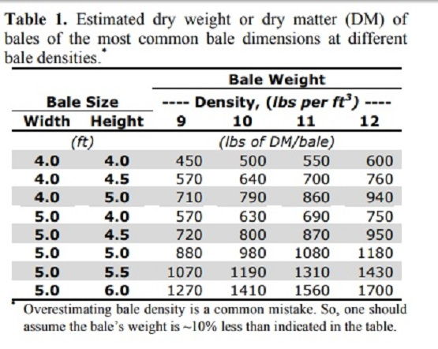
https://hayandforage.com/article-2726-we%E2%80%99ve-got-a-(bale)-weight-problem.html
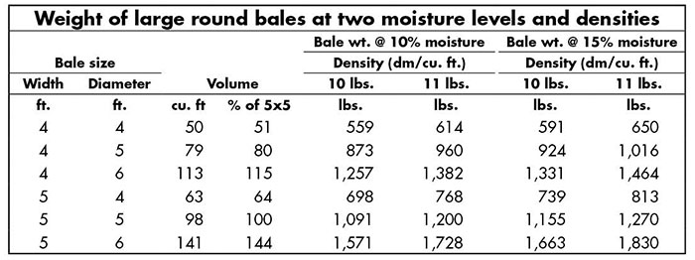

https://www.agweb.com/news/crops/hay/hay-bale-size-really-does-matter
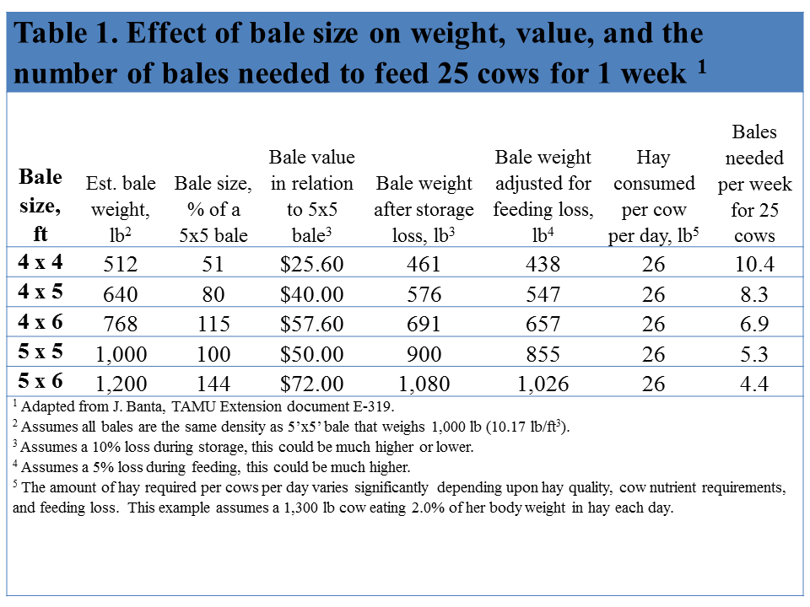
https://beeffax.tamu.edu/files/2013/09/2012-Bale-weight-how-important-is-it-Banta-E-319-.pdf
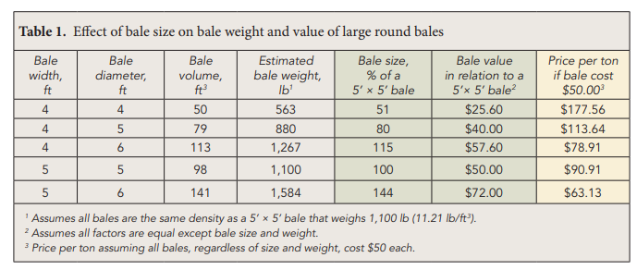

https://agtech.folio3.com/blogs/how-much-does-a-bale-of-hay-weigh/
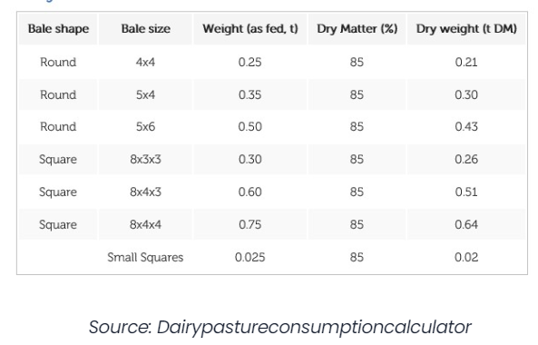

Supplementary Material: Data Limitations
- Since this is a spatial analysis using the best available data, there are limitations in our assumptions. Baled and stored for indeterminate amount of time either at field edge or at AD facility.
- Each siting needs to be field verified and meet with landowner.
- These plans are not spatially explicit beyond MLRA, in the case of the INRS, so we are taking resource planning goals to a new spatial scale and resolution that has never been done before. We only take data at face value and report on those since that is what other regional plans use.
- We don’t take into consideration the over application of manure and synthetic fertilizer on fields and the impacts of that environmentally. This is not a well reported phenomenon, but it is anecdotally understood to be common. In a winter rye system, farmers need to follow the 4Rs to prevent unnecessary runoff events. There is data out there that shows prairie systems can take a lot of fertilizer and still have water quality benefits and doesn’t compromise the integrity of the prairie (COBS data).
- A limitation of this study is that we assume farms are using the agronomic optimum rate of fertilizer, so we do not consider the overapplication of nutrients that is typical when livestock manure and cropland are managed together (Porter & James, 2021).

Supplementary Material: Prairie Wildlife Habitat Preferences & Requirements

