Linking Resource Protection to Bioeconomy Development in Iowa – DRAFT
Biomass Supplyshed Performance, Cost-Effectiveness, and Implications for RNG Feedstock Systems
Implications for systematic conservation and bioeconomic planning
Jessica Stephenson, John Tyndall, Lisa Schulte-Moore (?), Jim Jordahl

Abstract
Agricultural landscapes face growing pressure to simultaneously support commodity production and renewable energy, while reducing water quality, habitat, and climate impacts—challenges faced by producers, conservation planners, and bioenergy developers. This research developed a spatially explicit, multi-objective planning framework to align public conservation goals with private agricultural and bioenergy investments. We demonstrated this approach in east-central Iowa by designing a 32-km biomass supplyshed using recommendations from statewide nutrient, wildlife, and climate initiatives, for native prairie and winter cereal rye (Secale cereale) implementation that can be harvested and used as feedstocks at an anaerobic digestion (AD) facility to generate renewable natural gas (RNG). Using watershed-scale planning GIS tools, including Agricultural Conservation Planning Framework (ACPF) and companion tools, 47 HUC12 watersheds intersecting the supplyshed were modeled to target placement of vegetative-based practices—saturated buffers, nutrient removal wetlands, prairie strips, native prairie conservation cover patches, and cover crops—for biomass production. Environmental outcomes, biomass and energy yields, and direct and opportunity costs were quantified at the practice scale and aggregated to watershed and supplyshed scales. At the supplyshed-scale, 42,891 ha of cropland converted to prairie and winter cereal rye planted in 72,656 ha of corn–soybean fields, reducing annual nitrate and sediment loads by 8,279 Mg and 10,350 Mg, respectively, and avoiding approximately 1.5 million Mg CO₂_{e}. Annual biomass production supports approximately 5 million MMBtu of RNG yr⁻¹. The total annualized cost to implement and manage these practices for biomass is estimated at $92.6 million yr⁻¹ over 20 years (direct: $67.6 million; opportunity: $25.0 million). The multiple environmental outcomes and production value, could provide opportunities through public conservation payments and private biomass markets for landowners to diversify income. This work demonstrated that aligning public conservation objectives with private bioenergy markets can accelerate perennialization, deliver substantial environmental and economic co-benefits, and support scalable agricultural RNG supply chains. Future implementation with producers, conservation agencies, and AD developers will be critical to advancing on-the-ground adoption and regional scaling.

Introduction
Agricultural landscapes across the U.S. Corn Belt are under increasing pressure to balance commodity production and renewable energy with social costs of degraded water quality, soil health, wildlife habitat, and greenhouse gas reduction (Prokopy et al., 2020). In Iowa, multiple public and private entities are pursuing solutions to overlapping objectives; however, they often act independently of one another. Meeting these diverse goals requires innovative, integrated approaches that provide both environmental and economic benefits for producers and communities (Kreig et al., 2019; Dangol et al., 2025). Cropland comprises 85.7% of Iowa (NASS, 2024) and, as such, is the most significant contributor to water impairments, habitat degradation and loss of biodiversity, and greenhouse gas (GHG) emissions within the state.
Agriculture is one of the leading causes for land-use change in Iowa. Approximately 74% of Iowa's landscape pre-settlement has been converted to cropland. As a consequence of this transfer of productivity from diverse ecological functions to crops, there is significant degradation of water quality from nutrient-rich agricultural drainage, soil quality, biodiversity, increased flooding, and GHG emissions, as well as human health. When nitrogen fertilizer is applied in excess or at an inappropriate time, nitrogen can follow two damaging pathways: leaching and atmospheric loss. A study in Minnesota estimated the social costs of nitrogen (N) in drinking water to be 745 million (+/- 82) annually in the state (Keeler et al., 2025) and disproportionately affects poor and rural communities (Keeler et al., 2014); in other areas it has been linked to increased cancer rates (Jones et al., 2017; Gourevitch et al., 2018; Keeler et al., 2025), degradation and loss of native species due to nutrient enrichment (Galloway et al., 2004; Porter et al., 2013), and impairment of recreational use (Baron et al. 2012). When nitrogen is released to the atmosphere as nitrous oxide (N₂O), it has significant adverse effects on climate change, with a nearly 300-times greater warming potential than carbon dioxide (CO₂). It can persist in the atmosphere for over a century (EPA 2025). Historical prairie land use was a significant sink for GHG emissions, and now Iowa has become a significant source for GHG emissions in the agricultural sector (Verge et al., 2007; ICCAC 2007; Paustian et al., 2019; Bossio et al., 2020).
The Iowa Nutrient Reduction Strategy (INRS; IDALS 2025), aims to reduce nitrogen and phosphorus losses to waterways from cropland; the Iowa Wildlife Action Plan (IWAP; IDNR 2015), which identifies opportunities to conserve and enhance declining grassland species by increasing permanent cover; and the Iowa Climate Change Advisory Council Final Report (ICCAC 2008), which highlights strategies to cut emissions from agriculture and energy systems as well as crop producers and anaerobic digestion (AD) to pursue perennial biomass production systems. The plans have specialized objectives and were developed independently; however, they share overarching, implicitly overlapping outcomes that prioritize the perennialization of the landscape and increased biodiversity. Nevertheless, in recent years these initiatives have experienced budgetary stagnation, boom-and-bust cycles, and significant oversubscription (Kling et al., 2025), and participation often entails significant transaction costs (McCann and Clausen, 2016; Coppess, 2023). The plans also depend on voluntary actions and the suite of current governmental incentive programs meant to offset the adoption costs of specific conservation practices, since there is no regulatory or enforcement policy attached to the plans (ICCAC 2008, IWAP 2015, IDALS 2025). Voluntary conservation by farmers has been a cornerstone of U.S. agricultural policy for decades, largely supported through cost-share and technical assistance programs. A near-universal and persistent barrier to conservation adoption and persistent use is cost, both the direct and lost opportunity costs of establishing, implementing, and managing a given practice over the long run (Pannell et al., 2006; Tyndall and Roesch, 2014; Roesch-McNally et al., 2018). There is a complicated history of ineffective application of conservation practices at broad scales (Tomer and Locke, 2011; Secchi, 2023), despite strong evidence that specific conservation practices such as buffers and cover crops are effective at field scales in reducing nutrient and sediment loss and enhancing habitat (Prokopy et al., 2008).
Farmer and landowner motivations and decision processing regarding the adoption and continuation of conservation practices are nuanced and heterogeneous (Lu et al., 2022; Plastina et al., 2024; Ferraro et al., 2025). There is a perceived financial and crop yield risk associated with incorporating conservation practices, and improvements are not always immediately observable on the farm or efficient (Shipley et al., 2022; Roesch-McNally et al., 2017). However, farmers may not be aware that the benefits are often realized over longer time horizons, such as in-field soil fertility, water quality, and wildlife (Prokopy et al., 2008), particularly with cover crops or practices that increase biodiversity on the landscape (Roesch-McNally et al., 2017). Often, the upfront costs of implementing conservation practices and changing cropping systems can be a barrier to adoption; therefore, finding ways to help farmers overcome these costs is imperative to realize landscape-scale change (Roesch-McNally et al., 2017; Banjeree et al., 2025). One possible pathway in Iowa to implement the various statewide action plans is through systematic conservation planning (SCP), meaning cooperative behavior among organizations and efforts where there are similar spatial distributions but different conservation objectives (Chan et al. 2006; Turner et al. 2007; Bode et al. 2011), using a spatial decision support system (SDSS) framework to target locations for overlapping conservation practices that achieve different objectives (Bodrud-Doza et al. 2023). Multiple organizations with different objectives can complicate conservation planning and contribute to ineffective resource distribution and efforts, however, SCP using an SDSS as a framework can lead to improved conservation delivery efficiency (Bode et al. 2011; Bodrud-Doza et al. 2023) by pooling resources to create new, additional, and sustainable incentives to landowners and farmers that may alleviate financial barriers to conservation is through expanded renewable natural gas production predicated on perennial biomass digestion feedstock (Kreig et al., 2019; Jo and Plastina, 2025; Wild et al. 2025).
For this study, we use an existing anaerobic digestion (AD) facility located in east central Iowa as a case study market opportunity for area biomass producers within a 32-km radial "supplyshed" to alleviate perceived financial risks of incorporating conservation practices on farms. The supplyshed represents a circular region centered on the AD facility, within which biomass resources are produced and inventoried, all relevant infrastructure necessary to account for the supply chain needs of biomass end users, in this case, an AD facility. While AD development has historically relied on manure or food-processing wastes, there is growing interest in supplementing conventional feedstocks with biomass such as prairie grasses and winter cereal rye (Jo and Plastina 2025). Conservation practice biomass feedstocks provide co-benefits and facilitate alignment between farm business decisions with statewide environmental and climate goals (Launay et al., 2022; Wild et al., 2025). Historically, establishing perennial biomass systems has failed to launch and expand due to limitations in program design, understanding of environmental outcomes, and cost-effectiveness of production at large-scales (Miao and Khanna 2017; Hellfeld et al. 2022); however, intersecting AD technology and public planning efforts provide a unique opportunity to help reduce barriers and perceived risks. Incentive payments and stable markets can create financial conditions that make conservation-compatible biomass systems more attractive and durable for producers (Theuerl et al. 2019).
Developing a bioeconomy with biomass that sustains the emergence and expansion of renewable natural gas can be guided by state-level policy and planning efforts that target fields based on their expected environmental outcomes at both field and watershed scales. This study leverages existing public and private efforts with overlapping objectives to demonstrate how a landscape can be variously perennialized through the strategic integration of conservation practices and biomass production at field levels, thereby enhancing both hydrologic and habitat connectivity and response at watershed scales. An AD facility willing to compensate farmers for growing alternative feedstocks, such as prairie or cereal rye, presents a unique opportunity to leverage biomass payments that can be stacked, or bundled, with environmental market-based approaches. Market payments for biomass production could provide a diversified income source for many farmers, helping with the transition to include a winter crop or convert areas within fields to a prairie biomass. Coupling biomass payments with both conservation funding and emerging environmental markets offers unique opportunities to stack or bundle payments to landowners and/or farmers (Majeed et al., 2023).
The principles of additionality and co-benefit generation are at the core of designing a bioeconomy that aligns public and private objectives. This paper presents a framework and demonstrates how to spatially target Iowa row crop fields in 47 contiguous HUC 12 watersheds for biomass perennialization by integrating state-of-the-art geospatial tools to identify spatially explicit opportunities to combine environmental goals with biomass production in cost-effective ways. By comparing the current corn and soybean production landscape to planned biomass-oriented land cover scenarios featuring vegetative conservation practices such as native prairie conversion and winter rye at field-to-watershed scales, the approach demonstrates ways to measure improvements in water quality, habitat enhancement, and greenhouse gas reductions. The methodology enables spatially targeted, cost-effective, and stacked-payment strategies for landowners, bridging the gap between field-level impacts and broader, multiple-scale planning.
The focus of this study is the integration of multi-objective conservation planning and the SDSS framework, the Agricultural Conservation Planning Framework (ACPF; Porter et al., 2024), the Financial Nutrient Reduction Tool (FiNRT; Bravard et al., 2022), and companion GIS tools to evaluate ecosystem outcomes, including water quality, erosion, wildlife habitat, GHG emissions, and biomass production, and costs, of vegetative-based conservation practices and biomass production at a supplyshed and watershed-scale. A 32-km supplyshed for an AD facility producing RNG was selected to simulate and evaluate environmental impacts and biomass production of vegetative-based practices that align conservation practices and biomass production. The analysis presented here included planting prairie and cereal rye based on a criterion, essentially marginal landscape positions, to maximize planning objectives achieved. The concept of using marginal landscapes positions– land vulnerable to environmental risks, degradation, and limited economic value –in agricultural landscapes for bioenergy and conservation is discussed often in land management planning but still not well implemented (Kang et al. 2013; Jumaniyazova et al. 2023). The unique contribution of this work is as follows: (1) it presents a way to evaluate conservation practices incorporated into a landscape in a SDSS framework that uses ACPF, FiNRT, and companion tools, and (2) it evaluates the cost-effectiveness of water quality, erosion, wildlife and GHG emission implications using a bioeconomy scenario to interface multiple conservation objectives with biomass production in strategic locations.

Methods

Context
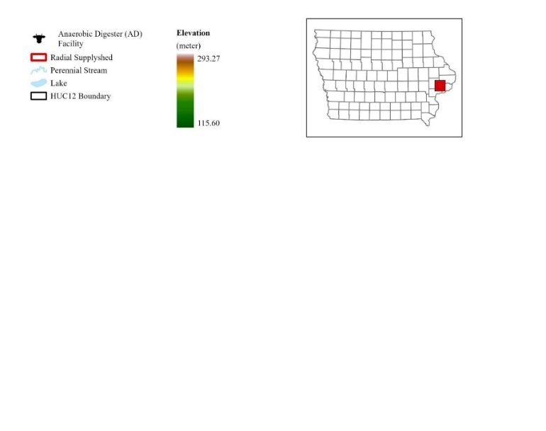
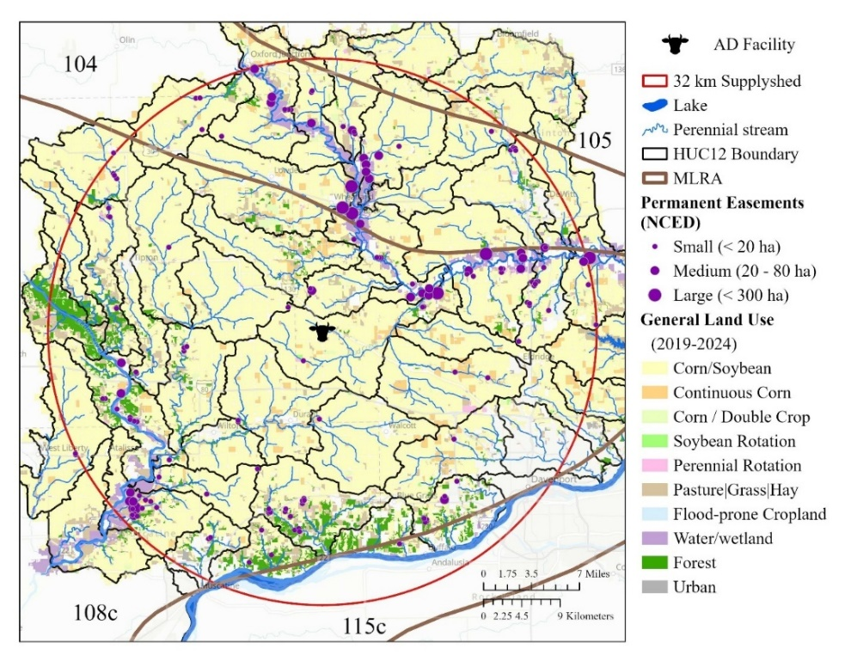
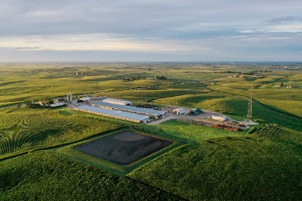
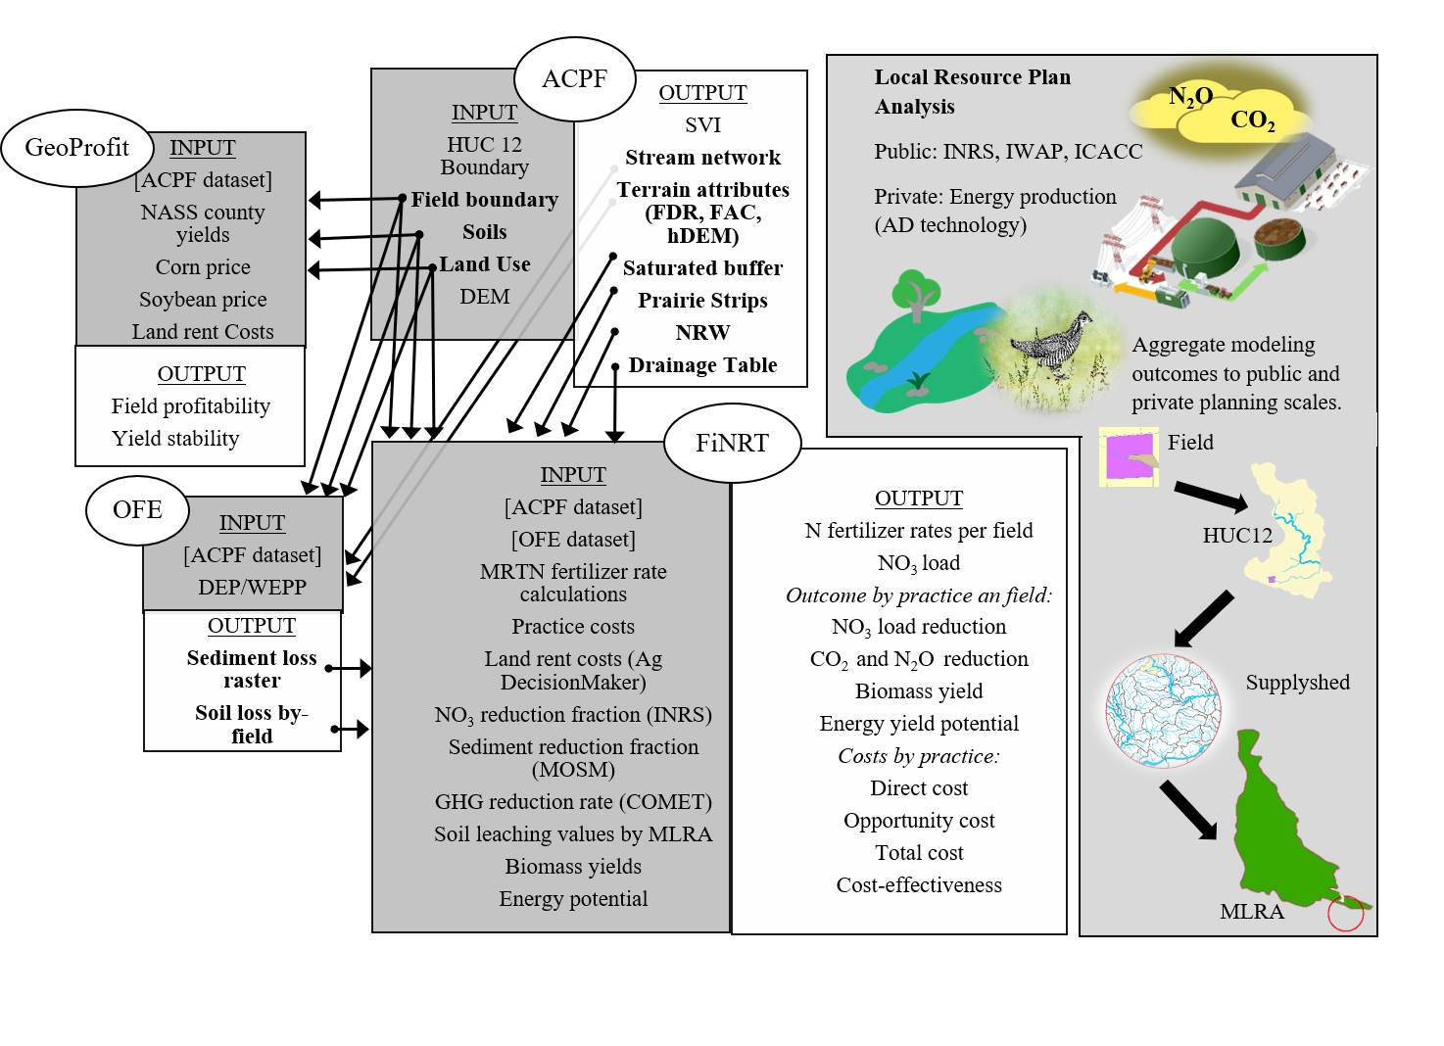





The supplyshed selected is part of the scope of a multi-institute, multiple organization project that focuses on using perennial and winter crops as feedstocks for AD to produce RNG. The supplyshed study area is based on a 32 km radial distance from the case study AD facility that intersects 48 HUC12 watersheds. The total area of the supplyshed is 313,962 ha, of which 73.0% is row crop agriculture (e.g., corn-soybean), 7.6% pasture, and 0.3% urban development (NASS 2024; Figure 1). The area cropped in the supplyshed is 2% of the total cropland in Iowa. There are four major land resource areas (MLRA) intersected, including Illinois and Iowa Deep Loess and Drift, West-Central part (108c), Eastern Iowa and Minnesota Till Prairies (104), Northern Mississippi Valley Loess Hills (105), and Central Mississippi Valley Wooded Slopes, Northern Pat (115c) (Prior 1991). Given the soil and slope characteristics, it is highly likely that initial subsurface tile drainage was installed over a century ago, and the tile drainage networks have continued to expand and intensify. These tile-drained systems have greatly altered the hydrologic characteristics of the study watersheds and have provided a foundation for consistent, high-yield crop production (Adelsperger et al. 2023). However, the tile drain networks are also major sources of nitrate in stream systems (Schilling and Libra 2000; Schilling and Spooner 2006; INRS 2025). In addition, application of inorganic fertilizer and livestock manure to row crops is a major source of nitrogen in the region (INRS 2025). The change from pre-European settlement land cover to conventional cropping systems has removed wildlife habitat and degraded the remaining habitat from agricultural runoff and sedimentation, however, there are is at least 2,235 ha of permanent cover protected by conservation easements, as reported in the National Conservation Easement Database (NCED; https://www.conservationeasement.us/ about/), and 16,800 ha of forested land (NASS 2024), primarily along riparian corridors (Figure 1).
Figure 1. Location of the case study farm and anaerobic digester (AD) facility in east central Iowa. The 32 km supplyshed boundary intersects several regional, land planning units, including four major land resource areas (MLRA) and 48 HUC12 watersheds. The facility currently has 2,400 head cattle animal feedlot operation (AFO) adjacent to the digesters and closed-pit lagoons (upper right picture).The general land use between 2019 and 2024 is dominated by corn and soybeans. Based on data reported in the National Conservation Easement Databased (NCED), there are several existing permanent conservation easements of varying sizes distributed throughout the supplyshed; majority are near riparian corridors and floodplains.
Table 1. Summary of current land use and cover within the 32 km supplyshed that is evaluated following the SDSS framework described in this paper to propose a bioeconomic plan for the region. The current land use and land cover are organized by the Iowa Nutrient Reduction Strategy’s regional land planning units, (e.g., major land resource area (MLRA))and the AD facility planning unit (e.g., supplyshed area). To achieve additionality, the bioeconomy plan targets land currently cropped in continuous corn (CC) or in a corn-soybean rotation (CS), and prioritizes prairie biomass near existing permanent easement covers to support a connected habitat matrix.
Current Land Use and Land Cover | MLRA AREA INTERSECTED (hectares) |  |  |  | Supplyshed
 | 104 | 105 | 108c | 115c
Total Area | 66,525 | 5,341 | 235,690 | 6,406² | 313,962
Total cropped area¹ | 52,873 | 5,208 | 170,354 | 667 | 229,102
CC | 2,730 | 345 | 13,171 | 24 | 16,270
CS | 50,143 | 4,863 | 157,183 | 643 | 212,832
Current permanent easements (NCED) | 1,110 | 0 | 1,109 | 16 | 2,235
¹ The total cropped area was estimated using NASS data compiled by ACPF and based on a six-year (2019-2024) crop rotation for a field
Our case study AD facility is located in east-central Iowa (Figure 1) and generates energy to maintain its commercial farm operation. The 32 km supplyshed for the AD facility is explored in this paper to leverage market opportunities for a new and developing bioeconomy that perennializes the landscape. Currently, feedstock materials are sourced from an onsite 2,400-head cattle feedlot operation (AFO), corn stover, and winter rye. The AD facility operator also manages approximately 890 ha of cropland to fully transition from annual feedstocks (e.g., corn stover) to perennial feedstocks that perennialize the landscape and generate ecological uplift in the region. The facility anticipates requiring 809 ha yr⁻¹ of prairie and 809 ha yr⁻¹ of cereal rye biomass to co-digest with the cattle manure produced onsite to meet energy production targets and achieve the D3 Renewable Identification Numbers (RINs) pricing minimum requirement of 75% cellulosic content (reference). Additional information on the farm operation can be found in Villarino et al. (2025) paper. A multi-objective, spatially explicit bioeconomy plan is demonstrated that aligned vegetative conservation practices with biomass production goals using ArcGIS Pro 3.3.1 and geospatial tools, including the ACPF, FiNRT, the Overland Flow Element (OFE) tool, and the GeoProfit Tool. The GIS tools were developed specifically for conservation planning and default to the Natural Resources Conservation Service (NRCS) conservation practice guidance to align with federal funding programs (Porter et al. 2025). Often, vegetative-based conservation practices are not designed to be managed as a production system, so these tools were adapted to determine locations of practices to account for harvesting logistics (i.e., planting and harvest machine size, accessibility). To our knowledge, this integrated suite of GIS tools has been applied for the first time to generate a regional bioeconomy; however, the data layers and tools are versatile and align with shared public and private objectives in any region where data are available (https://acpf4watersheds.org/toolbox). The flow of data between tools was summarized in Figure 2.
This study identifies opportunities to generate additionality within the supplyshed by assuming that conservation practices and biomass production systems replace or augment cropped fields exhibiting elevated environmental risk. The SDSS framework spatially allocates vegetative-based practices for biomass production in accordance with state-level conservation objectives, structured into four non-mutually exclusive analytical domains: nitrate load reduction, wildlife habitat enhancement, sediment transport and delivery reduction, and GHG emission mitigation. This classification does not imply functional exclusivity; rather, practices are assigned based on their primary planning objective and the geospatial data layers used to parameterize and target their placement.
The interaction between cereal rye, water quality, and erosion control provides a representative example. Within the INRS, winter rye is modeled exclusively on no-till systems. No-till management reduces erosion by maintaining surface residue, enhancing soil structure, and minimizing disturbance (Aziz et al. 2013; Blanco-Canqui & Ruis 2018). Accordingly, cover crop placement is targeted to leverage synergistic effects between no-till and winter cover, thereby improving water quality outcomes (Waring et al. 2020).

Characterizing spatial patterns
The ACPF uses spatial datasets organized by HUC12 watershed boundaries to site spatially explicit opportunities for conservation interventions on agricultural land (Porter et al., 2025). The ACPF core dataset includes 10-m gSSURGO, annual cropland data layers (CDL) from NASS, HUC12 watershed boundaries, and tables summarizing soil and land use for each field. The field boundary dataset is based on a common land unit (CLU). The ACPF depends on accurate surface flow paths, so watersheds intersecting the supplyshed had hydroconditioned digital elevation models (DEM) prepared at a 2-meter resolution. Forty-eight (48) HUC12 watersheds intersect the 32 km supplyshed and were included in the model (Figure 1). Biomass production sites were co-located with vegetative conservation practices identified through ACPF outputs, including nutrient removal wetland buffer areas, contour buffer strips, and riparian buffers collocated with saturated buffers. When biomass generated from site-specific structural practices is insufficient to meet INRS and IWAP land area targets, additional whole fields are allocated to prairie and cereal rye production based on soil loss vulnerability and proximity to existing wildlife habitat complexes. The HUC12 watershed scale is the reporting unit for hydrologically based resource concerns (e.g., water quality, erosion, flooding), while other spatial tools report environmental and financial outcomes at the field scale. The conservation practice and biomass production sites from ACPF were more than needed to achieve planning objectives; therefore, a series of criteria was applied to filter results to target maximum environmental outcomes (See supplementary materials). These criteria provided more than enough targeted opportunities, so a randomization protocol was implemented to randomly subselect opportunities to acknowledge the spontaneity of adoption in this context.

The soil loss vulnerability index (SVI) output from ACPF was used to prioritize cropped fields with high-to-moderate SVI classes, suggesting significant potential for surface runoff or leaching. The SVI can be used to identify fields with high soil loss from surface flows and steep slopes (Lohani et al., 2020; Porter et al., 2025). From the areas meeting the criteria, a randomization process was used to select fields that would receive a prairie or cereal rye treatment, thereby illustrating the spontaneity of adoption that often occurs in real-world applications.
Figure. 2. Conceptual framework for integrating ACPF-based spatial planning with bioeconomic evaluation to support RNG feedstock system design.

Multi-objective planning framework
To begin filtering the ACPF results, the first qualifying criterion was INRS nitrate-reduction strategies that also aligned with the biomass production needs of the case study AD facility and IWAP goals for increased permanent cover. Four MLRA-specific scenarios in the INRS relevant to the study area directly support the production of biomass material for co-digestion at the AD facility to produce energy, and those included (Table 1):
- Rye cover crops on all no-till acres. (INRS Section 2, p. 32)
- Appropriately scaled nutrient retention wetlands and concomitant buffers that treat 45% of the agricultural land (INRS Section 2, p. 33)
- Herbaceous riparian buffers with accompanying saturated buffers on all suitable cropped riparian areas. (INRS Section 2, p. 35)
- Perennial energy crops (native prairie) were established to equal pasture/hay acreage in 1987. (INRS Section 2, p. 39)
The first scenario does not have a built-in workflow in ACPF for siting cereal rye fields; however, the datasets available from ACPF could be stacked to manually sit fields based on a combination of SVI, land use between 2019 and 2024, and field boundaries. Fields classified as corn rotation were selected and further filtered to include only no-till fields. A limitation of our methods is that data for the exact location of no-till fields is not readily accessible, so the location of no-till was randomly assigned to fields based on the proportion of MLRA 104, 105, 108c, and 115c in no-till reported by the INRS using the Conservation Technology Information Center (CTIC) database (Table 2). From the queried fields, outputs from the SVI were stacked, and fields that had a high to moderate SVI class were selected to receive a cereal rye treatment. Target hillslopes vulnerable to higher soil loss may be more likely to adopt a series of soil health practices, such as no-till and winter crops.
In the second scenario, the Nutrient Retention Wetland (NRW) is a direct output of ACPF and is used to determine locations for installing wetlands (Porter et al. 2025). The assumption for NRWs is that the total vegetative buffer area equals 3.5% of a given wetland's drainage area (Bravard et al., 2022) and will be designed to be harvested for prairie biomass. To simplify socio-economic dynamics around NRW ownership and harvesting prairie biomass, NRWs that coincided with multiple fields (i.e., multiple landowners) were removed, and an NRW with the majority of the practice footprint in a single field was retained.
The scenario for riparian buffer implementation was adjusted to focus on locations also suitable for saturated buffers, which optimizes the potential for nitrate reduction before it reaches a stream by accounting for both pathways of nutrient loss (runoff and subsurface flow). The denitrifying practice tool in the ACPF GIS toolbox was used to determine locations for the saturated buffers. Saturated buffers that had the majority of the feature on cropland were retained, and buffers that were centered on pastureland were removed from the analysis. All locations were retained under the assumption that the site design would primarily address one landowner. The buffer width was 30.5 meters to accommodate harvest machinery without getting too close to the buffer edge and potentially destabilizing the streambank. This width would also support populations of area-sensitive wildlife species (Brittingham & DeCecco, 2025).
The fourth INRS scenario highlighted in this paper was to increase perennial cover in the form of "energy crops," here assumed to be native tall grass prairie. This scenario also aligns with the IWAP land-use change recommendation, which calls for 4% of Iowa to be permanently protected. Cropped fields with the closest Euclidean distance to NCED-reported permanent easement locations were selected to achieve the 4% land area goal in the supplyshed. NCED (2024) was used to estimate the locations of existing permanently protected land. The IWAP recommendations equated to a quarter of the total area needed to achieve the fourth INRS scenario. The remaining area to achieve the perennial bioenergy scenario was divided between prairie strips and whole field transformation from annual cropping systems to prairie. The INRS explicitly factors in erosion and sediment management by emphasizing soil and sediment retention techniques to manage for phosphorus loss. As such, practices were targeted based on SVI information to provide context for soil loss vulnerability.
The ACPF Contour Buffer Strip (CBS) tool's siting criteria were customized to site CBS locations with an 18.3-meter buffer width and were assumed to be planted with the 2020 Iowa CP 21 Buffer mix from Pheasants Forever (https://www.pfhabitatstore.com/store/items/IA/). The buffer width was chosen based on the assumed size of a commercial windrower used to cut prairie biomass before baling and recommendations from the NRCS to optimize wildlife benefits (NRCS, 2014). The CBS outputs were filtered to ensure that the total CBS area occupied was greater than or equal to 10 percent of the field impacted, to achieve optimal environmental outcomes, including a significant reduction in sediment transport and nitrate load, and increased wildlife habitat (Schulte et al., 2017). The area of the prairie buffer strips was summed, and the remaining perennial energy cropping area needed to achieve scenario four was selected from fields with an SVI class equal to moderate, moderately high, or high.

Quantifying ecosystem service outcomes
To estimate sediment loads, the OFE tool uses the Daily Erosion Project (DEP; https://www.dailyerosion.org/) to quantify soil displacement along hillslopes and estimate average runoff and soil displacement at the field scale. The model uses the Water Erosion Prediction Project (WEPP) and an event-based modeling approach to evaluate precipitation, hillslope, and soil detachment characteristics. OFE Tool inputs include ACPF core datasets, a hydroconditioned DEM, and a tillage raster generated from seasonal aerial imagery to estimate residue management. The sediment transport and delivery outcomes were estimated for each field using the OFE tool and reported as kg sediment ha⁻¹ (Luquin et al., 2024).
Using FiNRT, the nitrate load from each field is based on cropping history from 2019 to 2024, and the assumed fertilizer rate is based on maximum return to N (MRTN) guidance. FiNRT quantifies the nitrogen requirements for each field, based on 6-year land-use data, and evaluates the proportion of that nitrogen likely to be lost from the field as nitrate load via leaching (Bravard et al., 2022). FiNRT used the OFE tool's sediment load output to determine baseline loads. The contributing area to each practice was calculated, and the area-weighted estimate of nitrate and sediment load reduced per practice within a field was reported. The annual load data was aggregated and reported at multiple planning scales, including field, HUC12, MLRA, and supplyshed.
Principles from landscape matrix management to generate habitat in agricultural landscapes were used to enhance biodiversity and estimate wildlife outcomes (Franklin & Lindenmayer, 2009). Whole-field prairie conversions were treated as core habitat patches (that contain areas within unaffected by edge conditions) (Gilbert-Norton et al. 2010), riparian buffers as linear habitat and corridor elements (Fischer & Fischenich 2000), and prairie strips as stepping-stone features that increase landscape permeability (Gilbert-Norton et al. 2010; Resasco 2019). A weighted prairie density map was generated as a quick exploratory visualization of potential wildlife habitat concentration; however, it is not a measure of functional connectivity and is only an evaluation of where the proposed new prairie is concentrated on the landscape relative to existing permanent habitat locations reported in NCED. Each whole-field prairie conversion, prairie strip, and saturated buffer was weighted differently (3, 2, and 1, respectively) based on their assumed functions and values in providing nesting, forage, and corridors for prairie species.
Nutrient removal wetlands were excluded from the prairie habitat analysis because they are engineered wetlands specifically designed to treat agricultural runoff, with ancillary benefits for wildlife (Tomer et al. 2015; Lenhart et al. 2017; Nietch et al. 2024). The weights were used to generate a prairie density map with focal statistics, assuming a 300 m radius, representing average local wildlife movement, at which multiple grassland bird species and other taxa have been shown to respond to landscape composition and habitat configuration (Mattsson et al. 2013; Guttery et al. 2017). Prairie density and hotspot analysis were used as initial screening metrics for planning in the bioeconomy context studied in this paper (Sussman et al. 2019).
Greenhouse gas (GHG) emission outcomes related to changes in land management were estimated for each practice. Ex ante GHG impacts were estimated using published meta-modeling COMET-Farm simulations across soils, climate, and management conditions within MLRAs as aligned with USDA farm-scale GHG inventory methods. As per Swan et al. (2020), we used the emission-reduction potential of prairie cover (1.08 and 0.31 Mg CO_{2 eq} ha⁻¹ yr⁻¹ for CO2 and N2O emissions, respectively) and cereal rye (0.79 and 0.12 Mg CO_{2 eq} ha⁻¹ yr⁻¹ for CO₂ and N₂O emissions, respectively). The total N₂O emissions from corn and soybean systems may be underestimated by at least 40%, according to some studies (Elberling et al., 2023), so the amount of emission reductions could be substantially more than what we report. Note that our emission reduction estimates do not account for the complexity of carbon and nitrogen cycling in saturated buffer and NRW contexts. Studies have reported that saturated buffers do not significantly increase N₂O and CO₂ emissions relative to agricultural land (Davis et al. 2019; Salimi et al. 2021; Mitchell et al. 2022; Ampe et al. 2025), so we assume emission reduction potential only for the herbaceous buffer area and that it is equivalent to converting land from cropland to prairie. Likewise, there is significant debate over whether NRWs are sinks or sources of GHG emissions, and this likely depends on basin design, weather patterns, and maintenance of the basin area (He et al., 2024).
In addition to estimating the environmental outcomes of implementing vegetative-based practices, biomass production was another ecosystem service quantified. Since this work uses high-resolution datasets to generate field-scale data, the area treated by each practice can be estimated, and the biomass produced in each field can be reported. We used standard yield factors of 7.59 Mg ha⁻¹ yr⁻¹ for prairie and cereal rye (Nichols et al. 2014; Giddens et al. 2017) and 1.8 Mg ha⁻¹ yr⁻¹ (Feyereisen et al. 2013; Malone et al. 2023), respectively. A limitation of this approach is that it does not account for potential subfield yield variability.

Quantifying the cost-effectiveness of ecosystem services
In addition to calculating nitrate reduction efficiencies, FiNRT calculates the total annual costs (direct and opportunity) of a given land-use scenario, the total number of fields affected, and the cost-effectiveness relative to reductions in nitrate, sediment, GHG emissions, and increases in habitat provision. Cost-effectiveness assessments are objective measures of allocative efficiency and, in this case, are calculated by dividing the annualized cost of a conservation-biomass practice by the total annual biophysical effect associated with its use. Comprehensive conservation practice enterprise budgets (in 2024 USD) and standard discounted cash flow techniques are used to calculate the direct, long-term, annualized costs for practice installation and management over 20 years, using a 10% real discount rate, as per Bravard et al. (2022). Where relevant, land-use opportunity costs are spatially determined using MLRA-relevant, area-weighted-average crop productivity indices and land-rent relationships (Zimmerman et al. 2019; Bravard et al. 2022). FiNRT financial data was modified to include biomass fertilization, harvest actions (cutting, windrowing, and baling), and farm-gate transportation of bales (Supplementary Materials: Enterprise Budget). The cost for off-site transportation and storage is anticipated to be either the AD facility operator's cost or a third-party biomass aggregator's cost.

Estimating field-scale profit and yield stability
The ACPF applies biophysical criteria to delineate suitable locations for conservation–biomass systems. These criteria were augmented with field-scale corn yield and profitability metrics derived from 2015–2024 data for further prioritization. As per Paulson et al. (2024), this study examined a 10-year window to capture variability across years, including market and weather events that affect production costs and crop prices. The GeoProfit tool provided a framework to assess the profitability and yield stability of fields in the supplyshed for any time period of interest. Profitability was determined for each year by calculating the difference between the average county cost of crop production (i.e., corn and soybeans) and the market price of the harvested crop. In years when market prices are lower than production costs, the year is considered unprofitable. To estimate crop yields, the tool uses the Iowa Corn Suitability Rating (CSR2). It weights it by reported county averages, since field-level yield-monitoring data are scarce and not publicly available (Sassman et al., 2015). The reported annual yields were averaged, and the standard deviation was calculated to quantify the coefficient of variation (CV). The CV value is a quick approach to determine yield stability across the ten years for each subfield zone, and it is aggregated to the field-scale. The CV was broken up into stability high (CV < 5%), stability low (CV < 5-10%), and unstable (> 10%). Yield stability assesses the consistency of agricultural input over time and across varying environmental conditions. The tool can be used to identify low-yielding, low-profit areas within a field. Using profitability from the GeoProfit Tool and calculated yield stability, potential prairie biomass locations to prioritize were identified as areas with low yield stability and 6 or more years of unprofitability.

Results & Discussion

Distribution of vegetative practices and biomass production
As demonstrated by this case study, achieving multi-objective change in the landscape will require systematic, spatially explicit planning. The results presented below should be interpreted as system-level outcomes, as variation in practice extent and function limits direct comparison across individual conservation strategies. The INRS presented varying levels of individual scenario adoption based on MLRA due to topographic characteristics (Table 2), and these values were used to determine the proportion of each MLRA within each supplyshed unit to be allocated to prairie and cereal rye biomass practices across spatially explicit vegetative practice outputs from ACPF. There was a fairly even distribution of prairie and cereal rye practices across MLRA 108c. In contrast, MLRA 105 has a high concentration of prairie biomass, and MLRA 104 has patches of concentrated prairie biomass, due to steeper elevations and soil types (Figure 3). Urban areas dominate MLRA 115c, so the distribution of biomass opportunities was sparse, with notably less area.

Table 2. The current land use and land cover as well as land area goals are organized following the Iowa Nutrient Reduction Strategy’s (INRS) regional land planning units, major land resource area (MLRA), and supplyshed area. To achieve additionality, the bioeconomy plan targets land currently cropped in continuous corn (CC) or in a corn-soybean rotation (CS). Land area goals for both the Iowa Wildlife Action Plan (IWAP) and INRS are reported in this table.
MLRA AREA INTERSECTED (hectares) |  |  |  |  |  |  |  |  |  |  |  |  |  | Supplyshed
 |  | 104 |  |  | 105 |  |  |  | 108c |  | 115c
IWAP Strategy
4% of supplyshed in permanent cover. | 1,765 |  |  | 352 |  |  | 6,898 |  |  |  | 44 |  | 9,059
INRS Strategy
Plant a rye cover crop on all no-till hectares. ³ | CC |  | CS | CC |  | CS |  | CC |  | CS | CC | CS | CC |  | CS
 | 300 |  | 12,034 | 38 |  | 1,508 |  | 1,976 |  | 56,586 | 2 | 212 | 2,316 |  | 70,340
Installing wetlands to treat 45% of the ag land.⁴ | 522 |  |  | 53 |  |  | 1,849 |  |  |  | 6 |  | 2,430
Installing [saturated] buffers on all applicable hectares.⁴ | 184 |  |  | 12 |  |  | 1,341 |  |  |  | 36 |  | 1,573
Perennial crops (energy crops) to equal pasture/hay acreage in 1987.⁵ | 7,231 |  |  | 1,751 |  |  | 29,820 |  |  |  | 86 |  | 38,888
² MLRA 115c in the 32 km supplyshed is only reported for Iowa; the Illinois portion of this MLRA is excluded from the bioeconomy analysis.
³ Proportion of no-till in MLRA 104, 105, 108c, and 115c is based on data reported in the Conservation Technology Information Center (CTIC) database. No-till on continuous corn fields is 11%, 11%, 15%, and 9%, respectively. No-till on corn-soybean fields is 24%, 31%, 36%, and 33%, respectively.
³ There were NRWs sited that achieved treatment of 45% of agricultural land in the supplyshed, however, the number of NRWs was pared down to remove some of the larger wetland complexes that would require agreement from multiple landowners.
⁵ Perennial crops are assumed to include prairie strips and whole field conversions.

Using ACPF-informed siting and FiNRT and OFE tools to quantify environmental outcomes, this bioeconomic planning case study explored how targeted deployment of harvestable conservation practices can contribute to statewide nutrient reduction, habitat, and climate goals. The modeled scenario illustrates the scale of environmental benefits achievable with strategic yet minimal land conversion, aligning with targets outlined in the INRS and IWAP. The environmental outcomes from the bioeconomic plan, as presented, include: an annual reduction of 8,279 Mg of nitrate loading to surface water, 10,350 Mg of sediment transported, and approximately 141,000 Mg of CO₂ and 33,316 Mg of CO₂ _{e} N₂O emissions reduced annually (Table 3). By treating 2% of Iowa's cropland, we achieve roughly a 3% reduction in baseline nitrogen load—264,918 Mg annually—targeted by the INRS (2024).
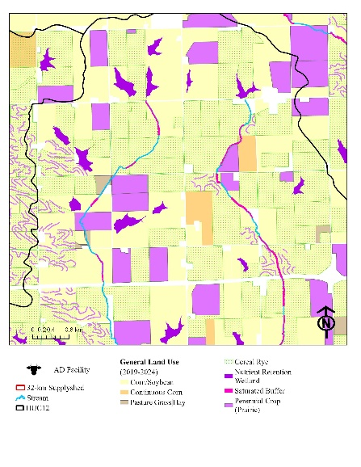
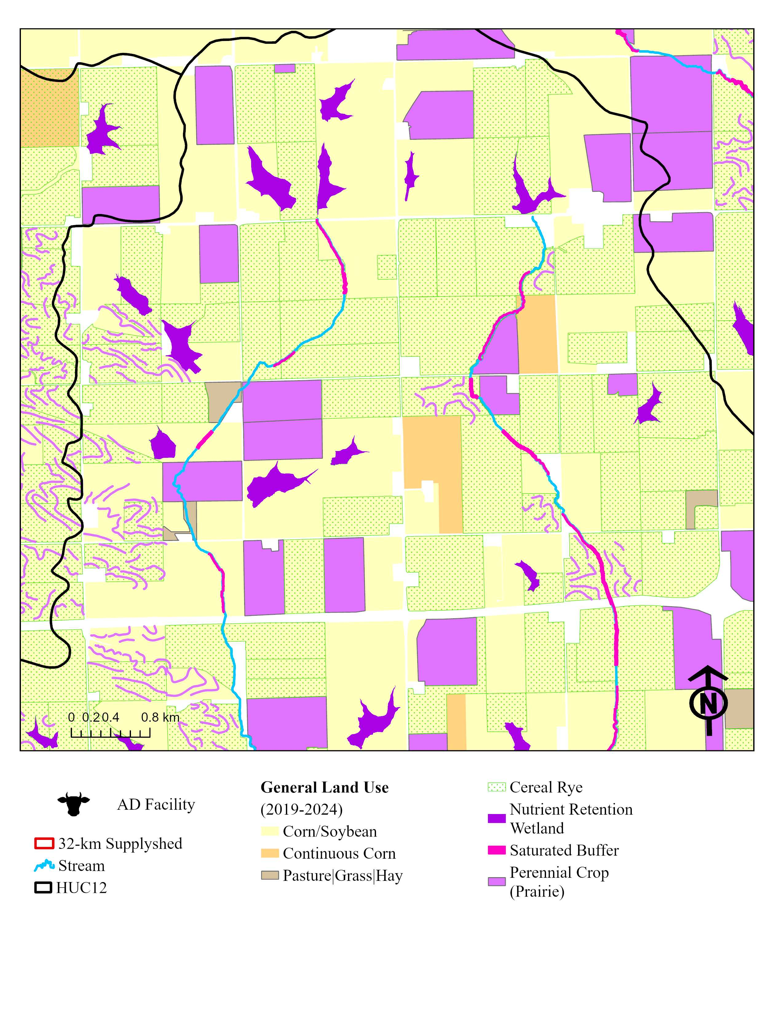
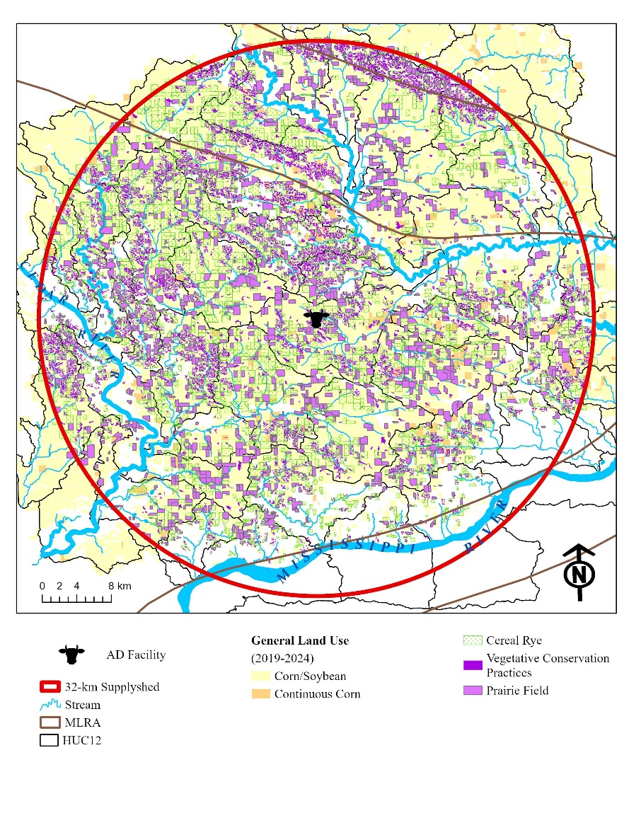
Figure 3. Conceptual framework for integrating ACPF-based spatial planning with bioeconomic evaluation to support RNG feedstock system design.
Table 3. Summary of the ecosystem service outcomes estimated from the bioeconomy plan developed using ACPF and companion tools, following a systematic conservation planning (SCP) and spatial decision support system (SDSS) framework. The resulting outcomes are organized by major land resource area (MLRA) and supplyshed for water quality—leachable nitrate load (Mg yr⁻¹) and sediment transported (Mg yr⁻¹)—and greenhouse gas (GHG) emissions—CO₂ and N₂O (Mg CO_{2 e} ha⁻¹ yr ⁻¹)—in addition to establishment of new habitat for wildlife, and biomass yields (Mg yr⁻¹).
Ecosystem Service | MLRA |  |  |  | Supplyshed
 | 104 | 105 | 108c | 115c
Water Quality | Load Reduced (Mg per year)
Nitrate (NO₃) load | 1,766 | 725 | 5755 | 33 | 8,279
Sediment load | 1,254 | 1,687 | 7286 | 123 | 10,350
GHG¹ | Emissions Reduced (Mg CO_{2 eq} per year)
Carbon Dioxide (CO₂) | 26,208 | 4,596 | 110,024 | 335 | 141,163
Nitrous Oxide (N₂O) | 6,275 | 1,171 | 25,796 | 74 | 33,316
Wildlife | Habitat Established (ha)
Core habitat patches (average and range of area; count) | 31 (6 - 124)  n = 67 | 22 (1 - 79)  n = 19 | 62 (2 - 152)  n = 274 | 27 (6 - 19)  n = 4 | 26  n = 364
Total linear habitat area² | 1,126 | 598 | 5,482 | 23 | 7,229
Biomass Yield | Total Biomass (Mg per year)
Prairie³ | 25,443 | 6,813 | 109,703 | 300 | 142,259
Cereal rye⁴ | 47,807 | 5,611 | 222,288 | 858 | 276,565
¹ GHG emissions reductions for CO₂ and N₂O are reduction fractions based on COMET values and do not account for the impacts of sub-field spatial heterogeneity that may occur following a landscape intervention (Swan et al. 2020).
² Includes the total area converted to saturated buffers and CBS, assuming this will serve as linear habitat and corridors to develop a habitat matrix.
³ Following biomass harvest guidelines that support wildlife habitat, the harvestable biomass for RNG would be 50% or less of the total biomass yield.
⁴ The total biomass yield for cereal rye assumed that farmers plant cereal rye every year, however, in a corn-soybean rotation it is common practice in Iowa to plant cereal rye in winters preceding soybeans. Thus, the annual harvestable biomass available in the supplyshed could be roughly 50% of the total estimated biomass.

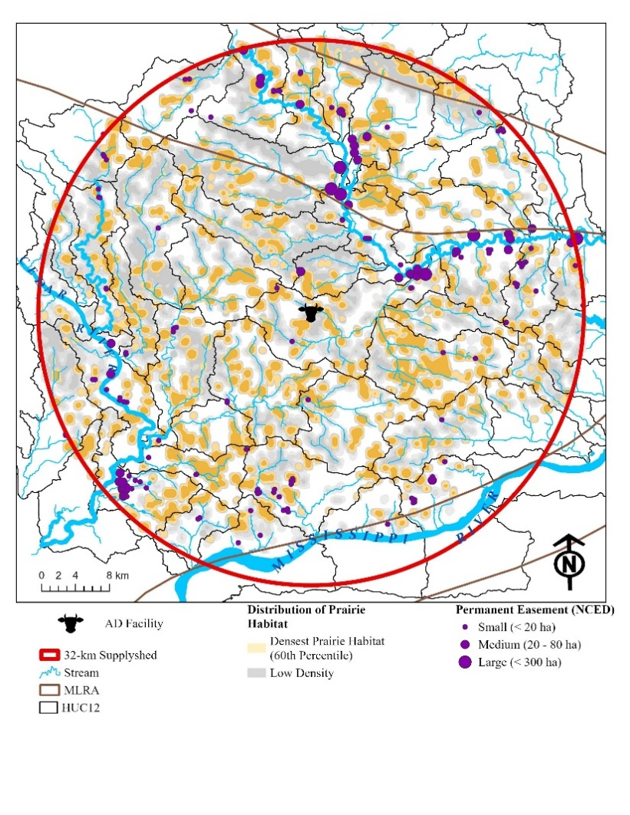
The IWAP (2015) 4% permanent cover goal was exceeded by following INRS recommendations, resulting in several small (< 20 ha) to large (< 300 ha) prairie patches that serve as core patches along with 7,229 ha of linear habitat in the form of prairie strips and herbaceous saturated buffers, and could serve as corridors (Table 3). A more in-depth analysis of landscape connectivity and functional patches is needed to determine them, and should be pursued to assess and quantify more detailed wildlife ecosystem services. In addition, functional wildlife groups, or specific species, should be identified to ensure the hotspots identified are prairie patch complexes supporting those targeted species (Sussman et al. 2019). The wildlife density map presented here illustrates a focal neighborhood radius of 300 m to represent local-scale habitat aggregation, reflecting the spatial scale at which adjacent prairie elements function collectively as usable habitat for multiple grassland bird species and smaller mammals in agricultural landscapes (Figure 3) (references).
Figure 3.
Throughout the entire supplyshed, 72,656 ha of cropland were treated with cereal rye, and a total of 42,891 ha of prairie biomass was produced. In this case study, the AD bioeconomy is a developing market with only one buyer, and the biomass generated using a multi-objective approach exceeds the AD facility demand (809 ha of cereal rye and 809 ha prairie). Biogas produced from agricultural residues provides the AD operator with flexibility regarding feedstocks, digester operation, and biogas output (Theurel et al. 2019). The surplus biomass from this bioeconomic plan provides the AD facility with some supply stability and flexibility. Additionally, the surplus supply provides opportunities for the herbaceous market to expand into other AD facilities in the supplyshed, grow the regional bioenergy system to support RNG infrastructure development in rural economies, and improve the landscape.

Evaluating Multi-Objective Achievements
The ecosystem services and cost-effectiveness of each land management intervention were quantified for each practice scenario and for each ecosystem service provided relative to the historical corn and soybean system on those same hectares. The data summarized for cost-effectiveness are total cost-effectiveness, and in prairie situations, the opportunity cost (e.g., land costs) is the most expensive part of implementing prairie biomass systems. The cost-effectiveness would look different if the farm operators were the landowners and did not receive rental income on those hectares. Despite high opportunity costs, the prairie-based practices had the best cost-effectiveness for ecosystem services produced, compared with cereal rye (Table 4). There were exceptions to this, though, specifically for CO₂ and N₂O emission reductions in the scenarios for NRW ($6.23 kg⁻¹ CO₂ and $21.81 kg-1 CO_{2 eq}, respectively) and saturated buffers ($2.33 kg⁻¹ CO₂ and $8.14 kg⁻¹ CO₂ _{eq}, respectively) were much higher than cereal rye ($0.58 kg⁻¹ CO₂ and $3.74 kg⁻¹ CO₂ _{eq}, respectively) (Table 4). However, NRW and saturated buffers are more cost-efficient at treating nitrate pollution. Cereal rye has the lowest nitrate reduction fraction (30%) among the other vegetative practices included in this paper and some of the highest total costs ($462.09 ha⁻¹). Thus, it is not the most cost-effective approach for nitrate reduction, given its negligible impact on wildlife habitat. From an AD and farm manager perspective, cereal rye could be an attractive vegetative conservation practice, as it offers the best cost-effectiveness per MMBtu generated and provides row crop farmers with the flexibility to maintain their cash summer crop rotation. Perennial energy crops, in the form of prairie strips and whole-field conversions, are among the most cost-effective scenarios across the entire bioeconomic plan and are even comparable to the cost per MMBtu potential of cereal rye. The scenario also provided the most opportunity to support biodiversity on the landscape through core habitat patches and linear habitat establishment.
Table 4. Environmental Outcomes + Cost Effectiveness using total costs.
Ecosystem Service | Outcome | INRS Scenario
 |  | Rye¹ | NRW | Sat Buff | Perennial
NO₃ | Load (Mg) | 614 | 774 | 61 | 1,254
 | TCE ($ kg⁻¹) | $ 51.79 | $ 31.20 | $ 7.65 | $ 21.78
Sediment | Load (Mg) | 140,278 | 84,126 | 50,273 | 126,903
 | TCE ($ kg⁻¹) | $ 0.37 | $ 0.40 | $ 5.25 | $0.44
CO₂ | Load (Mg) | 54,196 | 3,661 | 1,436 | 81,869
 | TCE ($ kg⁻¹) | $ 0.58 | $ 6.23 | $ 2.33 | $ 0.68
N₂O | Load (Mg) | 8,468 | 1,046 | 410 | 23,391
 | TCE ($ kg⁻¹ CO_{2 eq}) | $3.74 | $ 21.81 | $ 8.14 | $ 0.89
Biomass | Yield (Mg) | 276,565 | 11,456 | 9,331 | 256,160
 | TCE ($ MMBtu⁻¹) | $ 9.59 | $ 155.02 | $ 27.89 | $ 10.01
Wildlife² | Core Patch (ha)² | - | - | - | 27,153
 | Linear Habitat (ha)³ | - | - | 593 | 6,654
1 The contribution of cereal rye towards a establishing habitat is assumed to be negligible, therefore this is not a cost-effective and there is no cost per hectare established assigned to the practice.
² core habitats = vs linear habitat.

Mobilization of Bioeconomic Plan
We weave it into a shared vision, then redistribute the work in a coordinated effort to pool resources. Identify alignment, target it on the landscape, assign roles, determine who is best suited to have some conversations, and assign and pool resources. The primary stakeholders include: AD bioeconomy planners, watershed planners, conservation professionals, and wildlife managers. Following the explicit land management changes from corn and soybean systems described in the INRS and IWAP, the total costs for vegetative-based biomass production in the supplyshed to develop the multi-objective bioeconomy are $74,917,432 per year (DC: $52,708,361; OC: $22,209,070), where $28,865,862 per year (DC: $11,297,693; OC: $17,568,169) is attributed to IWAP goals alone (Table 3). The total cost for land management and cover changes, if managed exclusively as conservation practices, would be $53,809,271 per year (DC: $29,416,503) for the INRS, of which $20,409,920 (DC: $2,841,751) supports IWAP. The OC costs remain the same in both the harvestable biomass model and the strictly conservation implementation model, as the OC represents the cash rental value of the land's inherent production potential and is unaffected by specific management actions. To see the costs broken down by MLRA and HUC12, see the Supplementary Material X.
Table 6. Summary of direct (DC), opportunity (OC) and total (TC) costs within the 32-km supplyshed per vegetative-based conservation practice and biomass production strategy. The costs associated with these landscape interventions are reported under a biomass production (BP) cost scenario and a purely conservation practice (CP) cost scenario for comparison. The OC for cover crop is not included in total cost since there isn’t land being removed from corn and soybeans.
 | Supplyshed
 | DC | OC | TC
INRS
Plant a rye cover crop on all no-till [cropland].¹ | $31,374,161 | $44,372,047 | $31,374,161
Installing wetlands to treat 45% of the agricultural land. | $20,721,043 | $1,413,163 | $22,134,207
Installing [saturated] buffers on applicable hectares. | $955,658 | $2,384,684 | $3,340,626
Perennial crops (energy crops) to equal pasture/hay acreage in 1987. | $13,844,862 | $20,594,638 | $34,526,771
Sum of all management options. | $52,708,361 | $24,392,485 | $82,259,485
IWAP
4% of Iowa in permanent cover | $11,143,299 | $17,104,441 | $28,247,740
¹ Cereal rye doesn’t have an opportunity cost. Just general land rent value reports out

The purpose of this research paper is to demonstrate a process that integrates disparate public and private planning frameworks and strategies to generate additionality at multiple planning scales and goal areas within an AD bioeconomy context. Not only can RNG planners benefit from this approach, but also other stakeholders in the supplyshed, since the bioeconomy plan aligns with local watershed groups' and conservation planners' objectives. The field-scale biomass production results were aggregated to the HUC12 watershed level to identify priority watersheds for targeting in the supplyshed. The watersheds were ranked to determine where the greatest environmental outcomes were achieved, the lowest biomass production costs, the least unstable yields, and the least impacts on profitability between 2015 and 2024 were reported (Supplementary materials). The top ten HUC12 watersheds for environmental outcomes were selected to support prioritization, and 17 watersheds have at least one environmental outcome with the greatest benefits (Figure 5). Nine of the 17 watersheds were identified as having the most unstable yields and unprofitable fields (Figure 5). These nine watersheds should be targeted initially to leverage agricultural land for conservation practices and biomass production, generating co-benefits for health and reducing nutrient runoff. The framework presented in this paper uses SCP principles. It provides a replicable SDSS that can be readily applied in other agricultural landscapes where ACPF core data and land management goals are available.
Wildlife crosses watershed boundaries (Figure 3), targeting strategic wildlife habitat complexes and raising funds for them. Knocking on doors, ensuring it is done wisely. Prioritize areas with the most wildlife outcomes. Incorporating a mix of prairie strips, herbaceous riparian buffers and core habitat patches on the landscape created a continuum across the landscape that recognizes some of the Iowa prairie species-specific habitat contours and design a habitat matrix within the supplyshed (Fischer et al., 2004; Fischer & Lindenmayer, 2006; Fischer et al., 2006; Franklin & Lindenmayer 2009) while avoiding hostile habitat areas known for prairie species, such as forests (Guttery et al. 2017). To optimize outcomes for wildlife, we are considering a "wildlife-friendly farming" approach to identify areas dedicated to prairie biomass that increase landscape heterogeneity (Fischer et al. 2008).
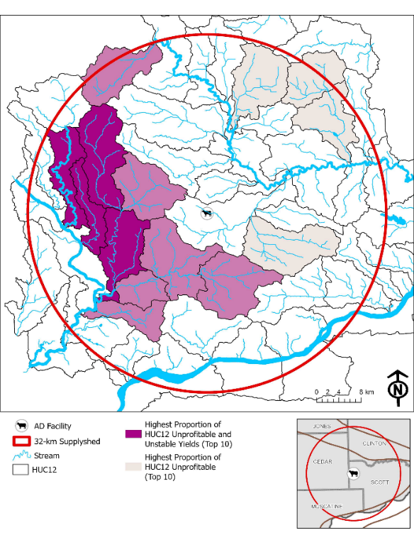
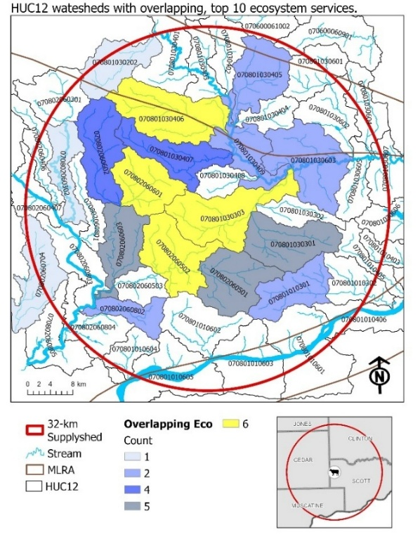
[Supplyshed approach à we have achieved the biomass goals. There may need to be some buffer here because we assume x, y, and z for harvestability, and these payments may not be annual if they are harvesting 50% of the prairie, or every other year for cereal rye. Prioritize watersheds that are closest and produce the most biomass. Emerging.]
Figure 5. Summary of HUC12 watersheds with the highest environmental outcomes Summary of HUC12 watersheds with the highest proportion of watershed that has unstable yields and unprofitable for more than 5 out of 10 years evaluated between 2015-2024.
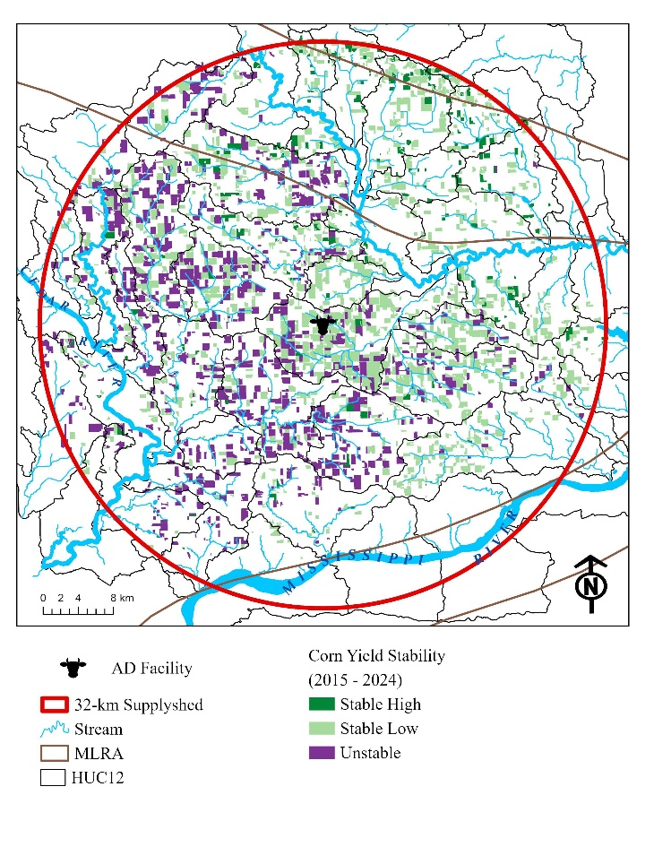
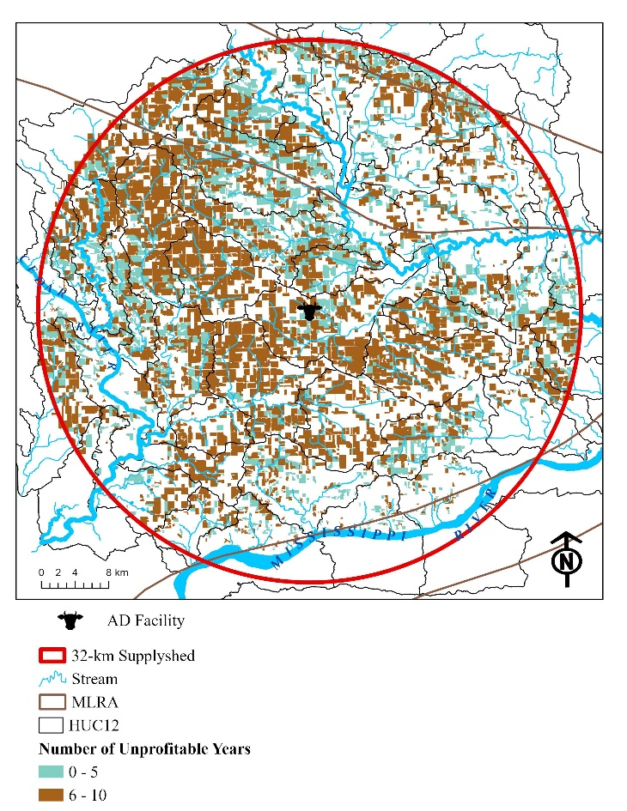
In this case study, the farmer has indicated that 50% of the prairie field would be harvested each year. Using this as a general rule of thumb, we can assume that of the total 142,259 Mg produced annually, 71,130 Mg would be harvested, resulting in 2,510,164 MMBTU yr⁻¹ of RNG (Table 2). The proportion retained each year will range from 33% (as recommended by the Minnesota Department of Natural Resources [Garms et al., 2009]) to 50% (RAE, 2024). The assumed harvest regime incorporates principles from Palik et al. (2021)'s ecological silviculture to mimic the natural, frequent, low-severity disturbance regime of prairie systems, created by grazing and fire, which occurs in late summer to fall. Ecological silviculture manages perennial production systems with goals comparable to those of a prairie bioenergy system, where the management of biomass and wildlife is deeply intertwined. In contrast, for corn stover—one of the most common crop residue digested at AD facilities in Iowa—the harvest regime is focused only on yield maximization—and studies have shown that 100% harvest of stover can decrease grain yields (Boehmel et al., 2008; Karlen et al., 2011; Adler et al., 2015) and negatively impact water quality (Khanal et al., 2014) as well as potentially increase synthetic nutrient amendments within the field since organic material is being removed (Becerra-Pérez et al., 2022).
Figure 6. Additional information to help with targeting and understanding the cropping systems and existing production systems. Help with the biomass outreach decision matrix for prioritizing outreach.
Table 5. Outreach strategy prioritization matrix.
 | Corn Yield Stability
 | Stable High | Stable Low | Unstable
Profitable more than 6 years | - | CR | CR/PR
Unprofitable more than 6 years | CR | CR/PR | PR

[Low-hanging fruit: Yield stability + profitability matrix for planners and outreach strategy. Table 5
Connect these landowners to market opportunities.
Prioritizing cereal rye areas is assumed to occur regardless of yield stability and profit potential, and is focused on the likelihood that a field will be degraded by high runoff. ]
A more in-depth financial analysis is needed to evaluate benefit opportunities and explore market opportunities, such as environmental markets and the expansion of AD technology in the region that incentivizes the use of prairie and cereal rye biomass. The direct cost and total cost of this bioeconomic plan are approximately $52.7 million and $82.3 million, respectively (Table 6). The case study AD facility cannot sustain this bioeconomic plan with its current feedstock demand; however, it can help develop infrastructure and markets for a perennial feedstock source to generate RNG while supporting overlapping conservation objectives. There may be opportunities to leverage land exiting limited-term easement programs (e.g., CRP) or through payment-for-conservation programs like EQIP, which could offset some of the upfront establishment costs and risk associated with farmers pursuing harvestable biomass models. Therefore, exploring additional market opportunities to align environmental and agronomic goals in the region is worthwhile.
The approach demonstrated in this paper integrates landscape resilience and productivity – reducing nutrient losses and improving soil function without displacing food production on prime farmland. A limitation in this study is that the ACPF and companion tools do not explicitly target and quantify wildlife benefits and connectivity. Additional analysis tools need to be developed to improve this process so planners can effectively target large patches and corridors targeted for species of concern. However, the proposed SDSS framework developed for this study could play an important role in regional RNG strategies by providing distributed, low-risk feedstock sources that enhance both environmental and economic performance over the long term.

References
Adelsperger, S.R., Ficklin, D.L., and S.M. Robeson. 2023. Tile drainage as a driver of streamflow flashiness in agricultural areas of the Midwest, USA. Hydrological Processes, 37(11): e15021. https://onlinelibrary.wiley.com/doi/full/10.1002/hyp.15021
Altieri, M.A., and C.A. 2007. Nicholis. Biodiversity and best management in agroecosystems, 2nd Edition. Food Products Press, Binghamton, NY.
Ampe, H.L., Crumpton, W.G., Stenback, G.A., and D.I.S. Green. 2025. Nitrous oxide and methane production and emission in wetlands receiving nonpoint source nitrate loads. Journal of Environmental Quality 54: 2048-2060. https://acsess.onlinelibrary.wiley.com/doi/pdf/10.1002/jeq2.70081
Aziz, I., Mahmood, T., and K.R. Islam. 2013. Effect of long term no-till and conventional tillage practices on soil quality. Soil and Tillage Research 131: 28-35. https://onlinelibrary.wiley.com/doi/pdfdirect/10.1111/ajae.12338
Banjaree et al. 2017. Transaction costs, communication and spatial coordination in Payment for Ecosystem Services Schemes
Baron, J.S., Hall, E.K., Nolan, B.T., Finlay, J.C., Bernhardt, E.S., Harrison, J.A., Chan, F., and Boyer, E.W. 2013. The interactive effects of excess reactive nitrogen and climate change on aquatic ecosystems and water resources of the United States. Biogeochemistry 114: 71-92. DOI 10.1007/s10533-012-9788-y.
Blanco-Canqui, H., and S.J. Ruis. 2018. No-tillage and soil physical environment. Geoderma, 326: 164-200. https://onlinelibrary.wiley.com/doi/pdfdirect/10.1111/ajae.12338.
Bravard, E., James, D.E., Zimmerman, E., Bowman, T. and J.C. Tyndall. 2022. Financial analysis for the use with the Agricultural Conservation Planning Framework: Data for the State of Iowa. Distributed by the ACPF National Hub, Iowa Water Center, Iowa State University, Ames, Iowa.
Brittingham, M.C. and J.A. DeCecco. 2024. Riparian buffers for wildlife. The Pennsylvania State University. https://extension.psu.edu/riparian-buffers-for-wildlife.
Bode et al. 2011. https://conbio.onlinelibrary.wiley.com/doi/pdf/10.1111/j.1523-1739.2010.01610.x?casa_token=lIuXWu7jRVMAAAAA%3Ad7Nda3MJJ-jh_i97wuaIueA-7TkkN-MjUTiH_zLEPk_ySGqbUIm4JxgUTdWaH37NCG-LZfIt7ykRHX_BKw
Bodrud-Doza, Md., Yang, W., Miranda, R.Q., Martin, A., DeVries, B., and E.D.G. Fraser. 2023. Towards implementing precision conservation practices in agricultural watersheds: A review of the use and prospects of spatial decision support systems and tools. Science of the Total Environment, 905: 167118. https://www.sciencedirect.com/science/article/pii/S0048969723057455?via%3Dihub.
Chan et al. 2006. Conservation planning for ecosystem services.
Coppess, J. "Farm Bill 2023: NRCS Backlogs and the Conservation Bardo." farmdoc daily (13):177, Department of Agricultural and Consumer Economics, University of Illinois at Urbana-Champaign, September 28, 2023.Dangol, S., Zhang, X., Sun, C., Liang, K., & Liang, X. Z. (2025). Impacts of bioenergy crop cultivation on regional climate, hydrology, and water quality in the US Northern high plains. Water Resources Research, 61(2), e2024WR037782.
Davis, M.P., Groh, T.A., Jaynes, D.B., Parkin, T.B., and T.M. Isenhart. 2019. Nitrous oxide emissions from saturated riparian buffers: Are we trading a water quality problem for an air quality problem? Journal of Environmental Quality, 48(2): 261-269. https://acsess.onlinelibrary.wiley.com/doi/abs/10.2134/jeq2018.03.0127
Elberling, B.B. Kovács, G.M., Hansen, H.F.E., Fensholt, R. Ambus, P., Tong, X., Gominski, D., Mueller, C.W., Poultney, D.M.N. and S. Oehmcke. 2023. High nitrous oxide emissions from temporary flooded depressions within croplands. Communications Earth & Environment, 4: 463. https://www.nature.com/articles/s43247-023-01095-8.
EWG (Environmental Working Group). 2025. https://www.ewg.org/news-insights/news/2025/05/almost-10000-farmers-have-received-subsidies-40-straight-years
Feyerseisen, G.W., Camargo, G.G.T., Baxter, R.E., Baker, J.M., and T.L. Richard. 2013. Cellulosic Biofuel Potential of a Winter Rye Double Crop across the U.S. Corn–Soybean Belt. Agronomy Journal, 105(3): 631-642. https://acsess.onlinelibrary.wiley.com/doi/abs/10.2134/agronj2012.0282
Fischer, J., Lindenmayer, D.B. and Fazey, I. 2004. Appreciating ecological complexity: habitat contours as a conceptual landscape model. Conservation Biology, 18, 1245–1253.
Fischer, J. Lindenmayer, D.B. 2006. Beyond fragmentation: the continuum model for fauna research and conservation in human-modified landscapes. Oikos, 112, 473–480. https://doi.org/10.1111/j.0030-1299.2006.14148.x
Fischer, J., Lindenmayer, D.B. & Manning, A.D. 2006. Biodiversity, ecosystem function and resilience: ten guiding principles for commodity production landscapes. Frontiers in Ecology and the Environment, 4, 80–86.
Fischer, J., Brosi, B., Daily, G.C., Ehrlich, P.R., Goldman, R., Goldstein, J., Lindenmayer, D.B., Manning, A.D., Mooney, H.A., Pejchar, L, Ranganathan, J., and H. Tallis. 2008. Should agricultural policies encourage land sparing or wildlife-friendly farming? Frontiers in Ecology and the Environment, 6(7): 380-385. https://doi.org/10.1890/070019.
Franklin, J.F., and D.B. Lindenmayer. 2009. Importance of matrix habitats in maintaining biological diversity. PNAS, 106(2): 349-350. https://www.pnas.org/doi/epdf/10.1073/pnas.0812016105
Galloway, J.N., Dentener, F.J., Capone, D.G., Boyer, E.W., Howarth, R.W., Seitzinger, S.P., Asner, G.P., Cleveland, C., Green, P., Holland, E., Karl D.M., Michaels, A.F., Porter, J.H., Townsend, A., and Vorosmarty, C. 2004. Nitrogen cycles: past, present, and future. Biogeochemistry 70: 153-226.
Garms, J., Lindquist, M., and K. Varland. 2009. Prairie vegetation and energy production harvest plan for WMAs. A report to the Minnesota Legislature, Environment and Natural Resource Committees. Minnesota Session Laws 2008, Chapter 179, Section 7. Subdivision 14. https://files.dnr.state.mn.us/aboutdnr/reports/legislative/prairie_veg_wma.pdf
Giddens, E., Jackson, L. and K. Enshayan. 2017. Linking nutrient reduction practices with biomass energy. Tallgrass Prairie Publications and Reports. 19. https://scholarworks.uni.edu/tpc_facpub/19
Gilbert-Norton, L., Wilson, R., Stevens, J.R., and K.H. Beard. 2010. A Meta-analytic review of corridor effectiveness. Conservation Biology, 24(3): 660-668.
Gourevitch, J.D., Keeler, B.L., and Ricketts, T.H. 2018. Determining socially optimal rates of nitrogen fertilizer application. Agricultural Ecosystem Environment 254: 292-299.
Guttery, M.R., Ribic, C.A., Sample, D.W., Paulios, A., Trosen, C., Dadisman, J., Schneider, D., and J.A. Horton. 2017. Scale-specific habitat relationships influence patch occupancy: defining neighborhoods to optimize the effectiveness of landscape-scale grassland bird conservation. Landscape Ecology, 32: 515-529. https://link.springer.com/article/10.1007/s10980-016-0462-y.
Hahn, R.W. and R.N. Stavins. 1991. Incentive-based environmental regulation: A new era from an old idea? Ecology Law Quarterly, 18(1): 1-42.
He, T., Ding, W., Cheng, X., Cai, Y., Zhang, Y., Xia, H., ... & Zhang, Q. (2024). Meta-analysis shows the impacts of ecological restoration on greenhouse gas emissions. Nature Communications, 15(1), 2668.
Hellfield, R., Hastings, A., Kam, J., Rowe, Clifton-Brow, J., Donnison, I., and A. Shepherd. 2022. Expanding Miscanthus market in the UK: Growers in profile and experience, benefits and drawbacks of the bioenergy crop. GCB Bioenergy, 14: 1205-1218. https://onlinelibrary.wiley.com/doi/pdf/10.1111/gcbb.12997.
ICCAC (Iowa Climate Change Advisory Council). 2008. Iowa Climate Change Advisory Council: Final Report. https://www.legis.iowa.gov/docs/publications/DF/9650.pdf.
IDALS (Iowa Department of Agriculture and Land Stewardship), IDNR (Iowa Department of Natural Resources), and ISU CALS (Iowa State University College of Agriculture and Life Sciences). 2025. Iowa Nutrient Reduction Strategy: A science and technology-based framework to assess and reduce nutrients to Iowa waters and the Gulf of America. https://www.nutrientstrategy.iastate.edu/sites/default/files/documents/2025%20INRS%20Complete%20Feb%202025.pdf.
IDNR (Iowa Department of Natural Resources). 2015. Iowa Wildlife Action Plan: Securing a future for fish and wildlife – A conservation legacy of Iowans. https://www.iowadnr.gov/media/1778/download?inline
Jabłońska, E., Winkowska, M., Wiśniewska, M., Geurts, J., Zak, D., and W. Kotowski. 2021. Impact of vegetation harvesting on nutrient removal and plant biomass quality in wetland and buffer zones. Wetland Ecosystems, 848: 3273-3289. https://link.springer.com/article/10.1007/s10750-020-04256-4.
Jackson, J.J. and M.D. Montross. 2021. Case study of transportation benefits using GIS in distributed preprocessing of corn stover into crude biobutanol. Transactions of the ASABE 64(1): 161-175. https://doi.org/10.13031/trans.13896
Jo and Plastina: https://raff.missouri.edu/wp-content/uploads/2025/10/2025-10-2-Policy-Brief.pdf
Johnson, G., Christianson, L., Christianson, R., Davis, M., Díaz-García, C., Groh, T., Isenhart, T., Kjaersgaard, J., Malone, R., Pease, L.A., and N. Rogovska. 2024. Effectiveness of saturated buffers on water pollutant reduction from agricultural drainage. Journal of Natural Resources and Agricultural Ecosystems, 1(1): 49-62. https://doi.org/10.13031/jnrae.15516.
Jones, R.R., Weyer, P.J., DellaValle, C.T., Robien, K., Canto, K.P., Krasner, S., Beane Freeman, L.E., and M.H. Ward. 2017. Ingested nitrate, disinfection by-products, and kidney cancer risk in older women. Epidemiology, 28(5): 703-711. https://doi.org/10.1097/EDE.0000000000000647
Jumaniyazov, I., Juliev, M., Reimov, M., Orazbaev, A., Reymov, T., and K. Bekanov. 2023. Marginal lands: a review of papers from the Scopus database published in English for the period of 1979-2022. Soil Science Annual, 74(2): 169657. https://www.soilsa.com/pdf-169657-96155?filename=96155.pdf.
Kang, S., Post, W.M., Nichols, J.A., Wang, D., West, T.O., Bandaru, V., R.C. Izaurralde. 2013. Marginal lands: Concept, assessment and management. Journal of Agricultural Science, 5(5): 10.5539. https://platformduurzamebiobrandstoffen.nl/wp-content/uploads/2020/05/2013_Kang-et-al_Marginal-Lands-Concept-Assessment-and-Management.pdf
Kantola, I.B., Masters, M.D., Blanc-Betes, E., Gomez-Casanovas, N., and E.H. DeLucia. 2022. Long-term yields in annual and perennial bioenergy crops in the Midwestern United States. GCB-Bioenergy, 14: 694-706. https://onlinelibrary.wiley.com/doi/pdf/10.1111/gcbb.12940.
Keeler, L.B. and Polasky, S. 2014. Land-use change and costs to rural households: a case study in groundwater nitrate contamination. Environmental Research Letters, 9(7): 074002.
Kling, C. L., Polasky, S., & Segerson, K. 2025. Changes in US environmental policy under the Trump Administration: An economic perspective1. Environmental and Resource Economics, 88(9), 2291-2317.
Kreig, J. A., Ssegane, H., Chaubey, I., Negri, M. C., & Jager, H. I. 2019. Designing bioenergy landscapes to protect water quality. Biomass and Bioenergy, 128, 105327.
Kumarappan, S. and S. Joshi. 2014. Biomass procurement. BioResources 9(2): 2069-2089.
Launay, C., Houot, S., Frédéric, S., Girault, R., Levavasseur, F., Marsac, S., & Constantin, J. (2022). Incorporating energy cover crops for biogas production into agricultural systems: benefits and environmental impacts. A review: Incorporating energy cover crops for biogas production into agricultural systems: benefits and environmental impacts. A review. Agronomy for Sustainable Development, 42(4), 57.
Lenhart, C, Gordon, B, Peterson, J, Eshenaur, W, Gifford, L, Wilson, B, Stamper, J, Krider, L .and Utt, N. 2017. Agricultural BMP Handbook for Minnesota, 2nd Edition. St. Paul, MN: Minnesota Department of Agriculture. https://wrl.mnpals.net/islandora/object/WRLrepository%3A2955.
Lohani, S., Baffaut, C., Thompson, A.L., Aryal, N., Bingner, R.L., Bjorneberg, D.L., Bosch, D.D., Bryant, R.B, Buda, A., Dabney, S.M., Davis, A.R., Duriancik, L.F., James, D.E., King, K.W., Kleinman, P.J.A., Locke, M., McCarty, G.W. , Pease, L.A., Reba, M.L., Smith, D.R, Tomer, M.D., Veith, T.L., Williams, M.R. and L.M.W. Yasarer. 2020. Performance of the Soil Vulnerability Index with respect to slope, digital elevation model resolution, and hydrologic soil group. Journal of Soil and Water Conservation, 75:1, 12-27, DOI: 10.2489/jswc.75.1.12
Lu, J., Ranjan, P., Floress, K., Arbuckle, J. G., Church, S. P., Eanes, F. R., ... & Prokopy, L. S. (2022). A meta-analysis of agricultural conservation intentions, behaviors, and practices: Insights from 35 years of quantitative literature in the United States. Journal of Environmental Management, 323, 116240.
Luquin, E., Ferrie, C., Gelder, B., Herzmann, D., Zimmerman, E., James, D., Cruse, R. and T. Isenhart. 2024. Estimating erosion vulnerability within agricultural fields by downscaling the Daily Erosion Project (DEP): The OFEtool. Earth Surface Processes Landforms, 49: 4444-4454. https://doi.org/10.1002/esp.5978.
Majeed, F., Khanna, M., Miao, R., Blanc‐Betes, E., Hudiburg, T., & DeLucia, E. (2023). Carbon mitigation payments can reduce the riskiness of bioenergy crop production. Journal of the Agricultural and Applied Economics Association, 2(2), 181-197.
Malone, R.W., Radke, A., Herbstritt, S., Wu, H., Qi, Z., Emmett, B.D., Helmers, M.J., Shulte, L.A., Feyerseisen, G.W., O’Brien, P.L., Kovar, J.L., Rogovska, N., Kladivko, E.J., Thorp, K.R., Kaspar, T.C., Jaynes, D.B., Karlen, D.L., and T.L. Richard. 2023. Harvested winter rye energy cover crop: multiple benefits for North Central US, Environmental Research Letters, 18: 074009. https://www.ars.usda.gov/ARSUserFiles/57795/Malone2023%20-%20harvested%20rye%20cover%20crop.pdf
Mattsson, B.J., Zipkin, E.F., Gardner, B., Blank, P.J., Sauer, J.R., and J.A. Royle. 2013. Explaining Local-Scale Species Distributions: Relative Contributions of Spatial Autocorrelation and Landscape Heterogeneity for an Avian Assemblage. PLoS One, 8(2): e55097. https://pmc.ncbi.nlm.nih.gov/articles/PMC3564802/?utm_source=chatgpt.com.
McCann, L., & Claassen, R. (2016). Farmer transaction costs of participating in federal conservation programs: Magnitudes and determinants. Land Economics, 92(2), 256-272.
Mitchell, M.E., Shifflett, S.D., Newcomer-Johnson, T., Hodaj, A., Crumpton, W., Christensen, J., Dyson, B., Canfield, T.J., Richmond, S., Helmers, M., Lemke, D., Lechtenberg, M., Taylor, C. and K.J. Forshay. 2022. Ecosystem services in Iowa agricultural catchments: Hypotheses for scenarios with water quality wetlands and improved tile drainage. Journal of Soil Water Conservation, 77(4): 426-440. doi: 10.2489/jswc.2022.00.
Myers, G.M., Anderson, D.S., Martens, B.J., and D.R. Raman. 2023. Cost assessment of centralizing swine manure and corn stover co-digestion systems. Energies 16(11): 4315. https://doi.org/10.3390/en16114315.
Nafziger, E.D., Villamil, M.B., Niekamp, J., Iutzi, F.W., and V.M. Davis. 2016. Bioenergy yields of several cropping systems in the U.S. Corn Belt. Agronomy Journal, 108(2): 559-565. https://acsess.onlinelibrary.wiley.com/doi/full/10.2134/agronj2015.0203?saml_referrer
Nichols, V.A., Miguez, F.E., Jarchow, M.E., Liebman, M.Z., and B.S. Dien. 2014. Comparison of Cellulosic Ethanol Yields from Midwestern Maize and Reconstructed Tallgrass Prairie Systems Managed for Bioenergy, 7: 1550-1560. https://dr.lib.iastate.edu/server/api/core/bitstreams/9ce557f3-c875-4f7d-9f40-87a45600d2c7/content.
Nietch, C.T., Hawley, R.J., Safwat, A., Christensen, J.R., Heberling, M.T., McManus, J., McClatchey, R., Lubbers, H., Smuckers, N.J., Onderak, E., and S. Macy. 2024. Implementing constructed wetlands for nutrient reduction at watershed scale: Opportunity to link models and real-world execution. Journal of Soil and Water Conservation, 79(3): 113-131. https://pmc.ncbi.nlm.nih.gov/articles/PMC11235211/#:~:text=A%20proposal%20to%20the%20H2Ohio,concept%20for%20enhancing%20nutrient%20removal.
Palik, B.J., D’Amato, A.W., Franklin, J.F., and K.N. Johnson. 2021. Ecological silviculture: Foundations and applications. Waveland Press, Inc. https://www.waveland.com/browse.php?t=747.
Pannell, D. J., Marshall, G. R., Barr, N., Curtis, A., Vanclay, F., & Wilkinson, R. (2006). Understanding and promoting adoption of conservation practices by rural landholders. Australian journal of experimental agriculture, 46(11), 1407-1424.
Paulson, N., Schnitkey, G., and C. Zulauf. 2024. Variability in trend estimates for US corn yields. farmdoc daily, 14:72, Department of Agricultural and Consumer Economics, University of Illinois at Urbana-Champaign. https://farmdocdaily.illinois.edu/2024/04/variability-in-trend-estimates-for-us-corn-yields.html.
Plastina, A., Sawadgo, W., & Okonkwo, E. (2024). Pervasive disadoption substantially offsets new adoption of cover crops and no-till. Choices, 39(2), 1-14.
Porter, E.M., Bowman, W.D., Clark, C.M., Compton, J.E., Pardo, L.H., and K.L. Soong. 2013. Interactive effects of anthropogenic nitrogen enrichment and climate change on terrestrial and aquatic biodiversity. Biogeochemistry 114: 93-120. DOI 10.1007/s10533-012-9803-3.
Porter, S.A., Tomer, M.D., James, D.E., Van Horn, J.D., and C.M.J. Sandoval-Green. 2025. Agricultural Conservation Planning Framework ArcGIS toolbox user’s manual version 7.0. Distributed by the ACPF National Hub, Iowa Water Center, Iowa State University, Ames, Iowa.
Prior, J.C. 1991. Landforms of Iowa. Iowa City, Iowa: Department of Natural Resources, University of Iowa Press.
Prokopy, L.S., Floress, K., Klotthor-Weinkauf, D., and A. Baumgart-Getz. 2008. Determinants of agricultural best management practice adoption: Evidence from the literature. Journal of Soil and Water Conservation, 63(5): 300-311. https://www.tandfonline.com/doi/epdf/10.2489/jswc.63.5.300?needAccess=true.
Prokopy, L. S., Gramig, B. M., Bower, A., Church, S. P., Ellison, B., Gassman, P. W., ... & Ulrich-Schad, J. D. (2020). The urgency of transforming the Midwestern US landscape into more than corn and soybean. Agriculture and Human Values, 37(3), 537-539.
RAE (Roeslein Alternative Energy). 2024. Personal account.
Resasco, J. 2019. Meta-analysis on a decade of testing corridor efficacy: What new have we learned? Current Landscape Ecology Reports, 4: 61-69. https://www.colorado.edu/lab/resasco/sites/default/files/attached-files/resasco_2019_cler.pdf
Roesch-McNally, G.E., Basche, A.D., Arbuckle, J.G., Tyndall, J.C., Miguez, F.E., Bowman, T., and Clay, R. 2017. The trouble with cover crops: Farmers’ experiences with overcoming barriers to adoption. Renewable Agriculture and Food Systems 33(4): 322-333. doi:10.1017/S1742170517000096
Roozeboom, K.L., Wang, D., McGowan, A.R., Propheter, J.L., Staggenborg, S.A., and C.W. Rice. 2018. Long-term biomass and potential ethanol yields of annual and perennial biofuel crops. Agronomy Journal, 110(5): 74-83. https://acsess.onlinelibrary.wiley.com/doi/pdf/10.2134/agronj2018.03.0172
Ruis, S.J., Blanco-Canqui, H., Jasa, P.J., Slater, G., and R.B. Ferguson. 2023. Increasing rye cover crop biomass production after corn residue removal to balance economics and soil health. Field Crops Research, 302: 109076. https://www.sciencedirect.com/science/article/pii/S0378429023002691
Salimi, S., Almuktar, S.A.A.A.N., and M. Scholz. 2021. Impact of climate change on wetland ecosystems: A critical review of experimental wetlands. Journal of Environmental Management, 286: 112160. https://www.sciencedirect.com/science/article/pii/S030147972100222X#:~:text=(2017)%20observed%20a%20positive%20correlation,et%20al.%2C%202009).
Sassman, Aaron M.; Burras, C. Lee; and Miller, Gerald A., "A Comparison of Iowa's Original Corn Suitability Rating to the New Corn Suitability Rating 2" (2015). Agronomy Conference Proceedings and Presentations. 57.
Schilling, K.E., and R.D. Libra. 2000. The relationship of nitrate concentrations in streams to row crop land use in Iowa. Journal of Environmental Quality, 29(6): 1846-1851. https://acsess.onlinelibrary.wiley.com/doi/abs/10.2134/jeq2000.00472425002900060016x#:~:text=The%20slope%20of%20nitrate%20concentration,Citing%20Literature
Schilling, K.E. and J. Spooner. 2006. Effects of watershed-scale land use change on stream nitrate concentrations. Journal of Environmental Quality, 35(6): 2132-2145. https://acsess.onlinelibrary.wiley.com/doi/full/10.2134/jeq2006.0157
Schulte, LA, et al. 2017. https://www.pnas.org/doi/full/10.1073/pnas.1620229114
Secchi, S. (2024). The role of conservation in United States’ agricultural policy from the Dust Bowl to today: A critical assessment. Ambio, 53(3), 421-434.
Shipley, N.J., Stewart, W.P., and van Riper, C.J. 2022. Negotiating agricultural change in the Midwestern US: Seeking compatibility between farmer narratives of efficiency and legacy. Agriculture and Human Values. https://doi.org/10.1007/s10460-022-10339-w.
Sussman, A.L., Gardner, B., Adams, E.M., Salas, L., Kenow, K.P., Luukkonen, D.R., Monfils, M.J., Mueller, W.P., Williams, K.A., Leduc-Lapierre, M., and E.F.Zipkin. 2019. A comparative analysis of common methods to identify waterbird hotspots. Methods in Ecology and Evolution, 10(9): 1454-1468. https://besjournals.onlinelibrary.wiley.com/doi/10.1111/2041-210X.13209
Swan, A., Williams, S.A., Brown, K., Chambers, A., Creque, J., Wick, J. and K. Paustian. 2020. COMET-Planner: Carbon and greenhouse gas evaluation for NRCS conservation practice planning. https://comet-planner.com/api/resource/pdf/COMET-Planner_Report_V1Legacy.pdf
Theuerl, S., Herrmann, C., Heirermann, M., Grundmann, P., Landwehr, N., Kreidenweis, U., and A. Prochnow. 2019. The future of agricultural biogas plant in Germany: A vision. Energies, 12(3): 396. https://www.mdpi.com/1996-1073/12/3/396.
Tomer, M.D., Porter, S.A., Boomer, K.M.B., James, D.E., Kostel, J.A., Helmers, M.J., Isenhart, T.M., and E. McLellan. 2015. Agricultural Conservation Planning Framework: 1. Developing Multipractice Watershed Planning Scenarios and Assessing Nutrient Reduction Potential. Journal of Environmental Quality, 44: 754-767. https://acsess.onlinelibrary.wiley.com/doi/pdfdirect/10.2134/jeq2014.09.0386
Turner et al. 2007. Global conservation of biodiversity and ecosystem services.
US EPA (United States Environmental Protection Agency). 2025. Success stories about restoring and protecting water bodies impaired by nonpoint source pollution. https://www.epa.gov/nps/success-stories-about-restoring-and-protecting-water-bodies-impaired-nonpoint-source-pollution.
USDA (United States Department of Agriculture). 2019. NRCS cover crop termination guidelines version 4. https://www.nrcs.usda.gov/sites/default/files/2022-09/Termination_Guidelines_Designed_6.28_10.24am_%28002%29.pdf
USDA ERS (U.S. Department of Agriculture, Economic Research Service). 2025. Commodity Costs and Returns. https://www.ers.usda.gov/data-products/commodity-costs-and-returns
https://stavins.scholars.harvard.edu/sites/g/files/omnuum8111/files/stavins/files/incentive-based_environmental_regulation.pdf.
Villarino, S.H., McDaniel, M.D., Blauwet M.J., Sievers, B., Sievers, L., Schulte, L.A., and F.E. Miguez. 2025. Adding anaerobic digestate to commercial farm fields increases soil organic carbon. Journal of Agriculture and Food Resarch, 21: 101942. https://www.sciencedirect.com/science/article/pii/S2666154325003138?via%3Dihub
Waring, E.R., Lagzdins, A., Pederson, C., and M.J. Helmers. 2020. Influence of no-till and a winter rye cover crop on nitrate losses from tile-drained row-crop agriculture in Iowa. Journal of Environmental Quality, 49: 292-303. https://acsess.onlinelibrary.wiley.com/doi/pdfdirect/10.1002/jeq2.20056?casa_token=xnblEva4bCsAAAAA:1i8S0q1f9y4rTuzSy8UIRAU5kn75TYtl0Wr1Lt8XBZx2mJiMVtoRnMbtZYcQRUE7GGeJy2ACyqmGvEKgRw
Wild, K., Dominguez, J. C., Moore, L. S., & Mba Wright, M. (2025). Advancing the predictive techno-economic and lifecycle assessment of prairie grass and manure co-digestion for renewable natural gas applications. Frontiers in Bioengineering and Biotechnology, 13, 1651510.
Zak, D., Gelbrecht, J., Zerbe, S., Shatwell, T., Barth, M., Cabezas, A., and P. Steffenhagen. 2014. How helophytes influence the phosphorus cycle in degraded inundated peat soils: implications for fen restoration. Ecological Engineering, 66: 82-90. https://doi.org/10.1016/j.ecoleng.2013.10.003

