Questions:
- Does/can an AD bioeconomy goal align with conservation goals?
  - What metrics or programs exist that span both private and public planning efforts?
- Do planning tools and frameworks exist to evaluate and target multi-objective?
  - What tools are available to identify and assess this question?
  - Spatial and theoretical tools and frameworks (SWAT, INVEST, Marxan, AgSolver…)
- Are there metrics that can translate private goals and public goals into a shared vision?
- [Discussion] who needs to be involved in these discussions? (Professionals + land ownership + costs)
- [Discussion] what/how do we implement this plan? What is successful?

Methods:
- Case study summary insert
Case study: AD Facility is EC Iowa, New Liberty
Feedstock portfolio:
History:
Biomass goals:
Supplyshed: 32 km, land use, resource inventory, cities
Overlapping/Regional Plans/Goals:
Groups in the Supplyshed:

- Resource plan analysis, stakeholder identification, define planning units
- Tool inventory/description, pros/cons, strengths/weaknesses, explain tools and limitations, constraints
- Terrain analysis and spatial targeting
- Quantify outcomes and costs
  - Unified cost-effectiveness metric

Stylistic considerations:
- Use consistent color coding for MLRA across panels
- Weighting HUC12 and MLRA results
- Small inset map showing MLRA boundaries with supplyshed overlay
- For Figure 3, keep HUC12-level metrics, but add small icons or color overlays showing dominant CP scenario in each watershed.

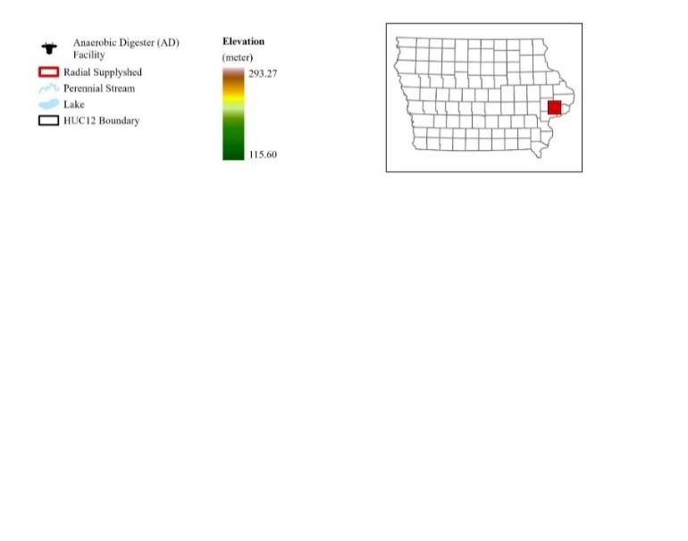
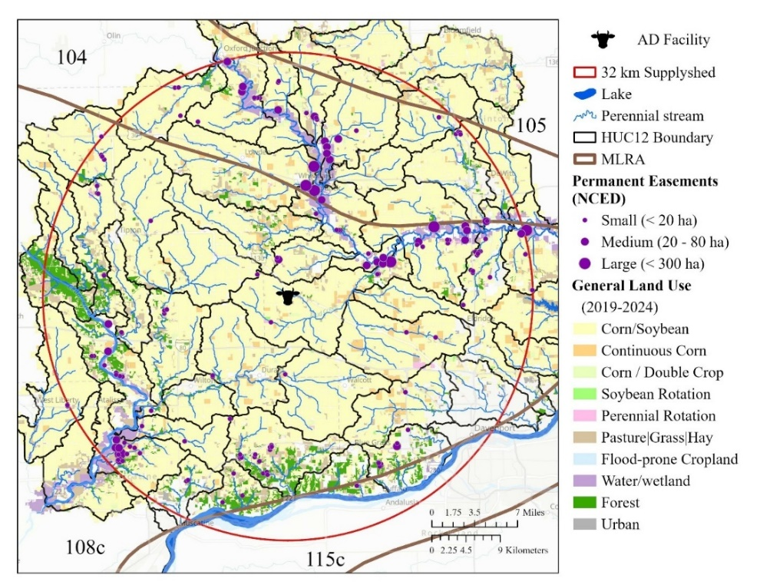
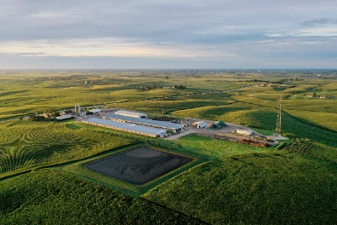
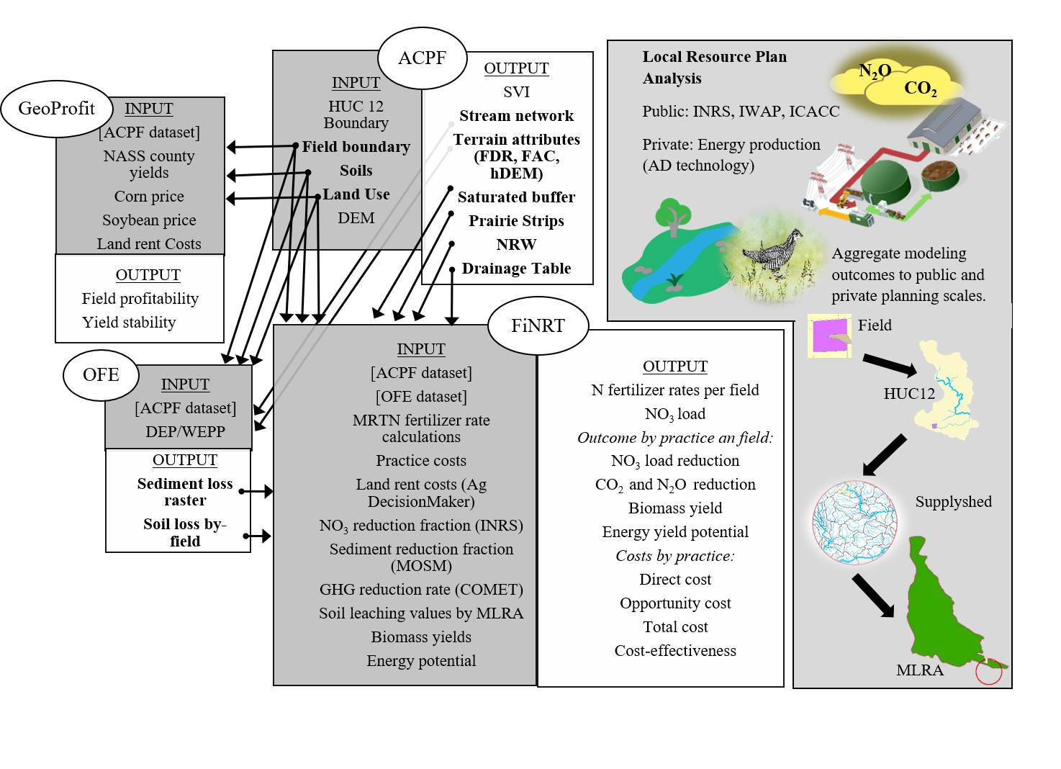






Figure 1. Study area and scale. Orient reader to nested reporting scales.
- Panel A: Regional map of Iowa location, 32 km supplyshed, AD location, MLRA boundaries, 48 HUC12 watersheds
- Panel B: Conceptual scale diagram. Field HUC12 MLRA Supplyshed

Table 1. Summary of spatial units.
Scale | # of units | Area (ha) | purpose
Practice | 4 | 115,547 | Biomass production + CP. Stacking outcomes.
Cropped fields in supplyshed | n | 8,627 | Targeting
HUC12 | 48 | 1,061,528 | Watershed reporting & targeting
MLRA | 4 | 6,791,107 | Regional pattern
Supplyshed | 1 | 313,962 | Total outcome

Results
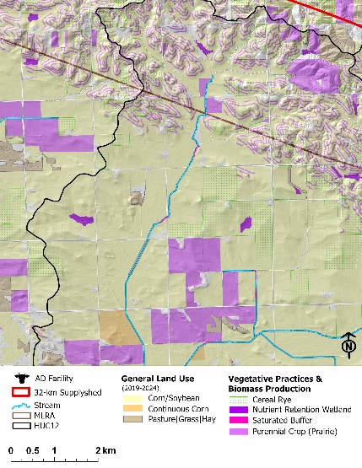
Figure 2. Map of a couple watersheds showing subfield CP placements (could be the highest ranked). Illustrative.
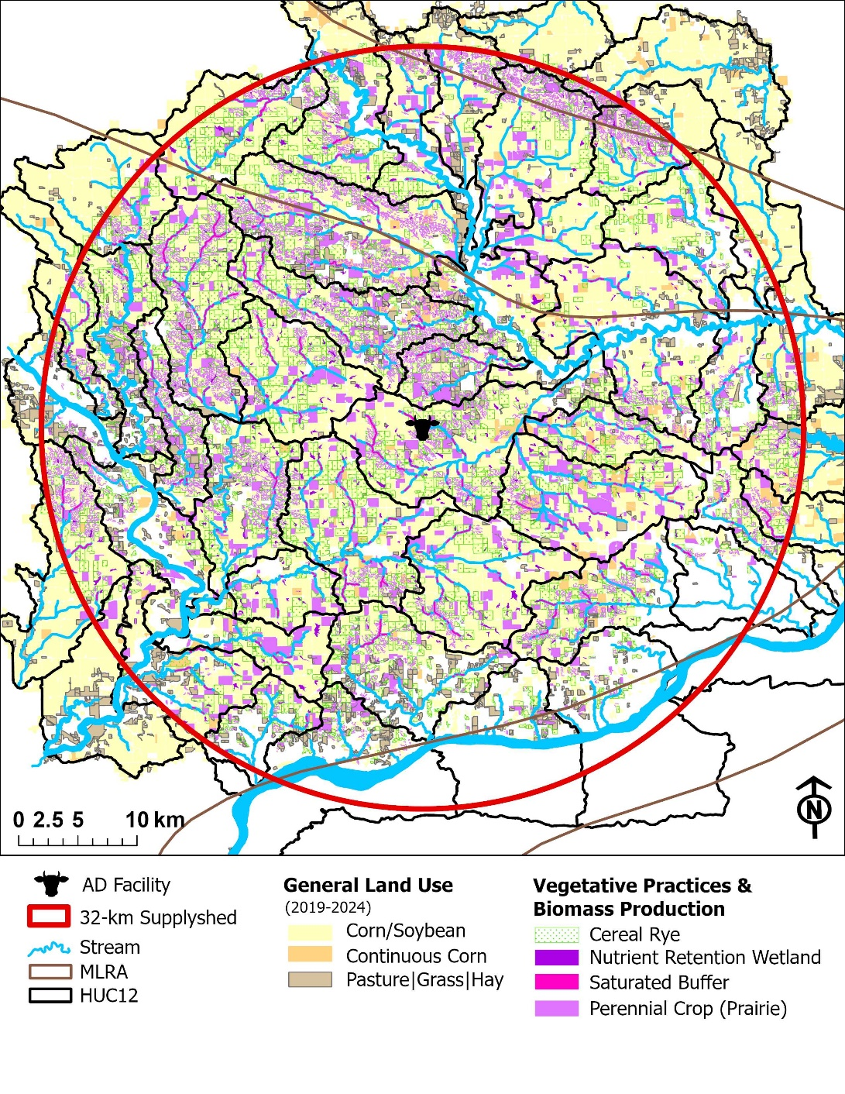

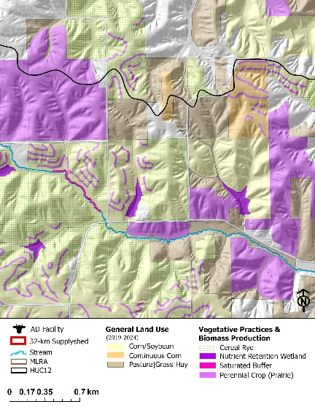
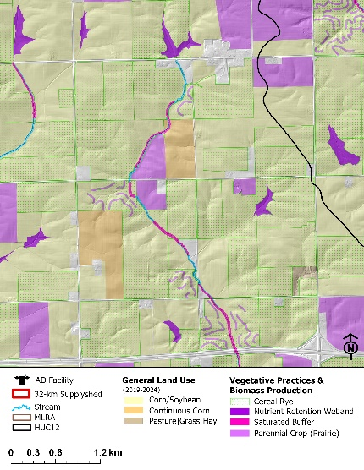

Table 2. CP Scenario summary. Include median and IQR where possible, and % of HUC12s using each practice. Referenced first in results to anchor downstream aggregation figures. Per field not per ha
Median + Q1 and Q2
CP | Rye | NRW | SatBuffer | Perennial
 |  |  |  | Patch | PS
Area (ha) | 72,656 | 2,430 | 1,573 | 38,888
% of field/subfield | 33% | 5% | 19% | 35%
Ecosystem Service Outcomes
Biomass yield (Mg per CP) | 77.3  (43.3 - 126.2) | 21.4  (14.3 - 32.6) | 5.6  (5.3 - 6.0) | 139.8  (71.7 - 242.5) | 21.5  (13.5 - 34.1)
N reduction (Mg per CP) | 0.2  (0.1 - 0.3) | 1.3  (1.0 - 2.2) | 0.3  (0.2 - 0.7) | 0.5  (0.3 - 0.8) | 0.2  (0.1 - 0.4)
Sediment reduction (Mg per CP) | 34.1  (16.2 - 63.8) | 134.8  (86.0 - 236.3) | 10.2  (2.5 - 32.8) | 28.7  (14.3 - 57.7) | 29.9  (13.1- 57.2)
CO₂ (Mg CO₂) | 15.2  (8.5 - 24.7) | 6.8  (4.6 - 10.4) | 0.9  (0.8 - 0.9) | 44.7  (22.9 - 77.5) | 6.9  (4.3 - 10.9)
N₂O (Mg (CO₂ _{e}) | 2.4  (1.3 - 3.9) | 2.0  (1.3 - 3.0) | 0.2  (0.2 - 0.3) | 12.8  (6.5 - 22.1) | 2.0  (1.2 - 3.1)
Wildlife core habitat (ha) | - | - | - | 27,153 | -
Linear Habitat (ha) | - | - | 593 |  | 6,654
Cost-effectiveness
Biomass  ($ Mg ⁻¹) | $114.52* | $1,949.86  ($1,832.77 -$2,104.32) | $369.63  ($350.92 - $385.34) | $139.71  ($120.05 -$149.82) | $126.43  ($114.74 - $138.13)
Energy Production  ($ MMBtu ⁻¹) | $9.59* | $151.75  ($142.64 -$163.77) | $28.77  ($27.31 - $29.99) | $10.87  ($9.34 - $11.66) | $9.84  ($8.93 - $10.75)
NO₃ ($ kg NO₃ ⁻¹) | $53.60  ($49.99 - $53.61) | $29.59  ($22.55 - $37.04) | $7.11  ($2.99 - $11.72) | $39.36  ($34.36 - $43.50) | $11.92  ($10.38 - $13.51)
Sediment  ($ kg sediment ⁻¹) | $0.28  ($0.15 - $0.50) | $0.31  ($0.18 - $0.54) | $0.19  ($0.06 - $0.79) | $0.86  ($0.48 - $1.32) | $0.09  ($0.05 - $0.19)
CO₂ ($ Mg CO₂ ⁻¹) | $584.37* | $6,100.95  ($5,734.59 - $6,584.24) | $2,395.10  ($2,306.40 -$2,505.98) | $437.13  ($375.63 - 468.78) | $395.59  ($359.00 - 432.18)
N₂O  ($ Mg N₂O ⁻¹) | $3,740.00* | $21,353.31  ($20,071.06 - $23,044.85) | $8,382.86  ($8,072.38 - $8,770.94) | $1,529.97 ($1,314.71 - $1,640.71) | $1,384.57  ($1,256.50 -$1,512.64)
* There isn’t a threshold because it is a flat rate and the variability cannot be captured for biomass yield, energy production and GHG emissions due to limitations in biophysical data at field-scales.

** Need to weight the results since we have unevenness
Field 3. Field-scale targeting and intervention (map panels). Prairie sitings, cereal rye, CP. The “where”
- Panel A: Conservation sitings (Figure 2)
- Panel B: Biomass yield potential
- Panel C: Costs
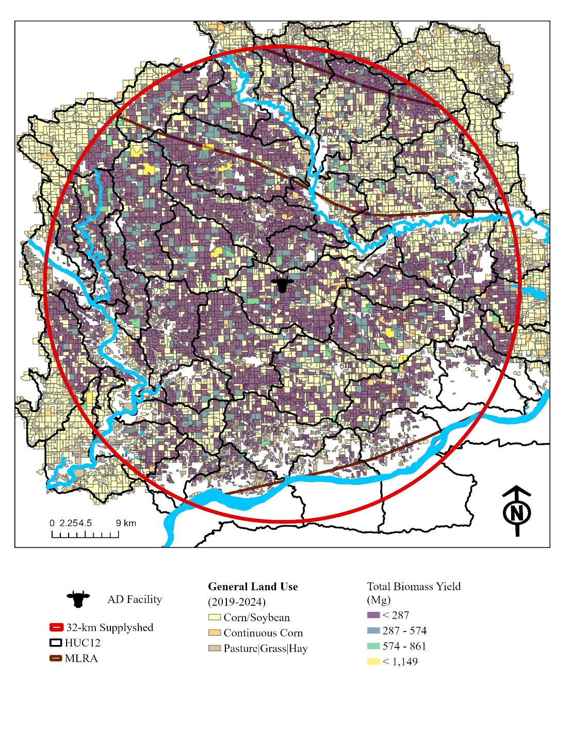

Table 3. Field-scale summary statistics. Aggregated descriptive statistics.
Metric | Mean |  | Median |  | range
Biomass Yield | 104 |  | 67  (29-136)
N reduction
Sediment
GHG
Yield
NPV

Figure 3. HUC12-scale aggregated outcomes. Multi-panel boxplots or violin boxplots with scatter distribution. X-axis is HUC12 or HUC12 grouped by quartile/MLRA. Highlight the top 10%. Y-axis is metric. Points are field results. Highlights field to watershed variability. Shows outliers, hotspots, or underperforming units. Useful for understanding heterogeneity. Shows fine-scale variability, hotspots, outliers. Fine-scale patterns, hotspots and variability.
- Panel A: Nitrate reduction
- Panel B: Sediment reduction
- Panel C: GHG reduction
- Panel D: Biomass yield
Example language: “Benefits were concentrated in HUC12s with x topography and greater marginal profitability loss.”
Table 3. HUC12 summary by quartile/typology.
HUC12 Class | n | Mean N red | Mean sed red | Mean GHG | Mean biomass | Mean habitat path | Mean linear habitat | Mean biomass | Mean Cost-effectiveness
High
Medium
Low

Figure 4. Aggregate HUC12s into broader regions for trend comparison. How do outcomes vary across broader landscape regions? Grouped boxplots to illustrate median, spread, outliers, and regional differences. X-axis = MLRA, y-axis = metric, points = HUC12 weighted mean inside the MLRA. Intended to tell the story of landscape controls. Shows median, spread, outliers, regional differences. Distribution of modeled environmental and economic outcomes aggregated from field-scale interventions to HUC12 watersheds and summarized by MLRA. Points represent individual HUC12 watersheds; boxplots show median, interquartile range, and outliers. Shows broader trends, regional contrasts, and general patterns. Regional aggregation to highlight trends and contrast MLRA performance.
- Panel A: Nitrate reduction
- Panel B: Sediment reduction
- Panel C: GHG reduction
- Panel D: Biomass yield
Purpose: Agg
Figure 5. supplyshed synthesis figure. Use a dashboard-style summary: TOTAL nitrate reduced, sediment CO2_{e}, biomass, RNG potential, annualized costs. What is the total system outcome at planning scale? Aggregate land use, environmental, and bioeconomic outcomes for the 32-km biomass supplyshed scenario. Field/subfield CP scenario outcomes. Title: Field-scale environmental and economic performance of major conservation practices. Highlights subfield-level intervention strategies, supporting both field-to-watershed and watershed-to-MLRA scaling narrative.
- Panel A: Nitrate reduction boxplot of field/subfield units by CP type (show median + quartiles; huc12s as jittered points.
- Panel B: Sediment reduction. Boxplot or violin plot by CP type. Optional color overlay for MLRA region
- Panel C: Biomass yield (stacked bars by CP type for representative HUC12s. Distinguish prairie, cereal rye, dedicated biomass
- Panel D: Cost-effectiveness. Scatter plot cost vs N or sediment reduction by CP type. Optional line connecting mean per practice.
- Use the same color scheme for CP types across all figures. Include small inset maprs for one or two watersheds showing field-level CP placement.
- Panel D can bridge environmental and economic outcomes, connecting field-scale interventions to higher-scale aggregation.
---------------------------------------------------------
| A. Land use transitions |
| Prairie converted | Rye in rotation |
| 42,891 ha | 72,656 ha |
|--------------------------------------------------------|
| B. Environmental outcomes |
| NO3 reduced | Sediment | GHG | Habitat |
| 8,279 Mg | 10,350 | 1.5M| xxxx ha |
|--------------------------------------------------------|
| C. Bioeconomy outcomes |
| Biomass yield | RNG | Total cost | NPV / returns |
| 172,769 Mg | 5M | $92.6M | scenario metric |
---------------------------------------------------------
Discussion
- What should we prioritize? How should we prioritize?

