Jeff Nelson

May 25, 2020

IT FDN 100 A

Assignment #6

<https://github.com/jnelson22/IntroToProg-Python-Mod06>

Functions & Classes

# Intro

In this paper, I will go over a few interesting and important items to remember that I learned from this week’s lecture. Lastly, I will show a program that allows the user to create a To-do list using functions.

# Week 6 Learnings

This week I learned about functions, classes, basic debugging in PyCharm, and the GitHub webpage. The main focus of this week was functions. Functions allow for easy organization and reuse of code. In python they have to be written above where they are called. Parameters are used to pass in values for the function to use and process. There is no limit to the number of parameters you can use. Once the processing is complete inside a function they can return values that can be used in other places in the program. One interesting use of arguments is naming them. Figure 1 shows the use of a named argument that links the variable name to the argument name. This allows them to placed in any order.

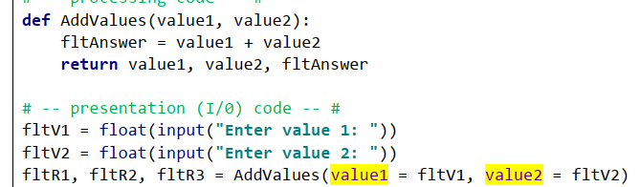

Figure 1: Screenshot of named arguments

Overloaded functions

Classes are a way of grouping functions, variables, and constants. In this assignment 6 I used the input/output (IO) and processor classes.

PyCharm comes with some powerful debugging features. These features allow for a much easier way to find and fix bugs in your code.

Commonplace to store and display your code is on GitHub. I went through the process of creating a basic web page on the site.

# Creating a To-do List Python Program using Functions

This program's problem statement is the same as last week but now everything has been created using functions. This allows for better organization and portability of the code. This is separated into two classes an input/output (IO) and processing.

First, the program was given with a basic outline and structure similar to last week’s assignment. See Figure 2 for an example of the starter code.

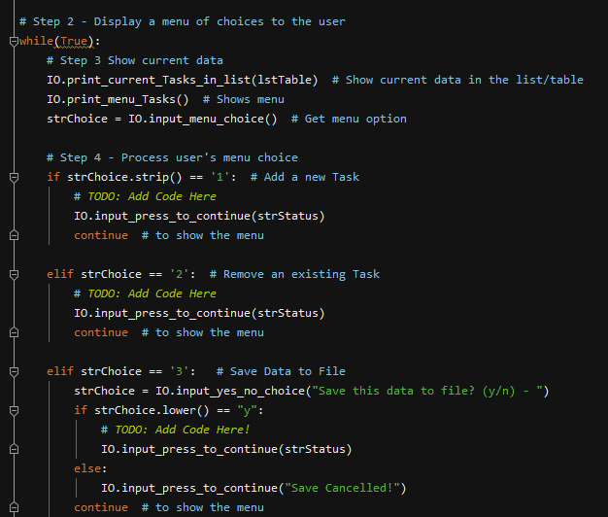

Figure 2: Starter code

The first section of code that needed to be added was the add a new task. Once the user selected “1” from the menu they need to be prompted and those inputs need to add to memory. In Figure 3 you see the code that was added to call the functions.

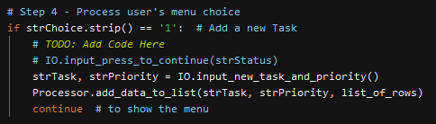

Figure 3: Add new task function calling code

The first function calls the IO to gather the user's input data. See Figure 4 for the detailed code. I copied this from my assignment 5 code and modified it to work within a function.

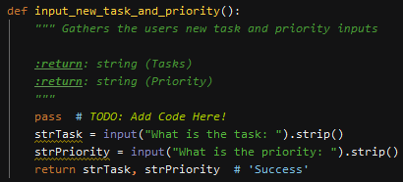

Figure 4: Function to ask the user for inputs

Next, the process function, in Figure 5, takes the user input and appends them to the dictionary list in memory. This code is the same as assignment 5 but modified to work in a function.

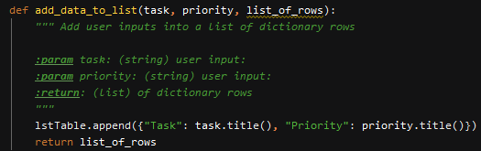

Figure 5: Function to write the user inputs to a dictionary of rows

Below, Figure 6 is the code running in PyCharm.

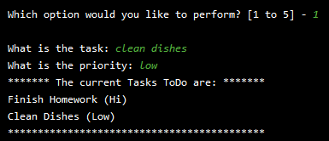

Figure 6: Example of working code

The second section of code that needed to added was the remove a task. Once the user inputs “2” from the menu they need to be prompted to enter the task name and then it is removed from memory. Below in Figure 7 is the code that was added to call those functions.

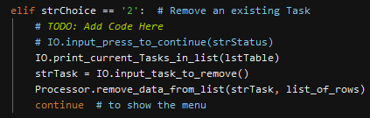

Figure 7: Add remove task function calling code

Figure 8 shows the code that presents the user with a message to input which task they would like to remove from memory.

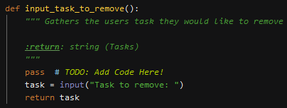

Figure 8: Function to ask the user which task to remove

Once the user has entered which task they want to remove. That input gets passes to the processor function, Figure 9, that then looks through the dictionary list and removes it if it finds it. If it’s not in the list then the user is presented with a message “Task not found”

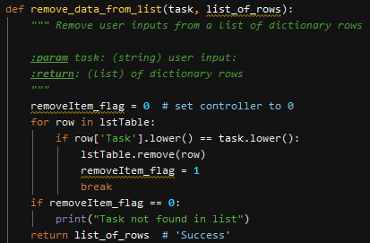

Figure 9: Function that takes the user input and removes it from the dictionary rows

Below, Figure 10, is an example of removing a task working in PyCharm.

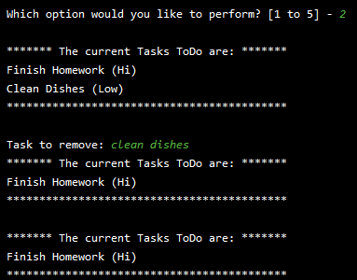

Figure 10: Example of removing task working code

The third section of code that needed to be added is to write the data in memory into a text file. Once the user input “3” they will be prompted if they want to save to a file. If they input “y” the data in memory will be written to a file. If they input “n” saving will be canceled. Figure 11, shows the code I added to call the functions need to accomplish this.

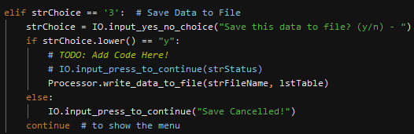

Figure 11: Save data to a file function call

Figure 12, shows the code used from assignment 5 to write the data in the list to a text file. This function takes the file name and current memory of data and writes them to a text file.

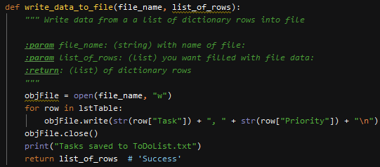

Figure 12: Function to write everything in memory to a text file

Below, Figure 13 and Figure 14, show the code running in PyCharm and the corresponding text file.

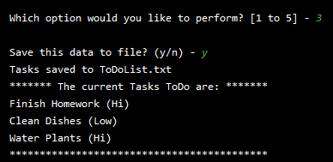

Figure 13: Example of adding data to a file working

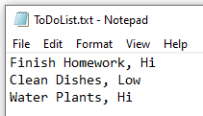

Figure 14: Example of text file after save

The final section that needed code added to it is the reload data from the file. Once the user inputs “4” they will be asked if they want to reload data from the file overwriting what is currently in memory. Figure 15, shows the functions calls I used to accomplish this. Using functions allowed for just calling already created functions that read the data from a file.

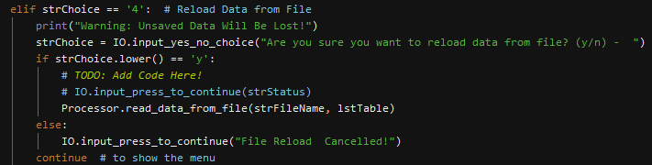

Figure 15: Function call to reload data from a file into memory

Below, Figure 16, shows the before and after reloading from a file in PyCharm.

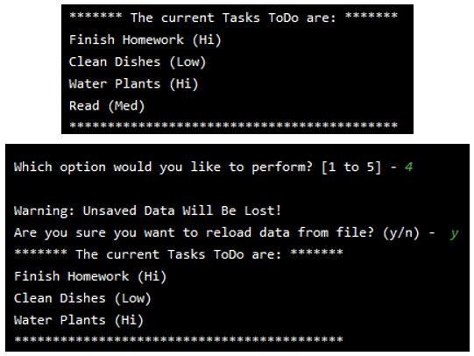

Figure 16: Example for reloading from a text file

Lastly, here is the code running in the command line.

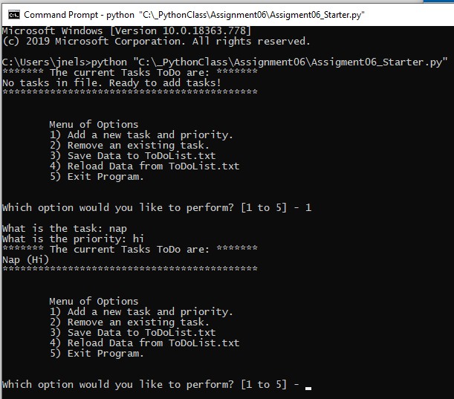

Figure 17: Example of code running in windows command prompt

# Summary

In summary, I learned about functions, classes, basic debugging in PyCharm, and GitHub webpage. I went through the process of how I added to the to-do list function code to allow the user to add, remove tasks, save them to a file, and reload from the file. I found this assignment a little more difficult than the last one. The functions caused me a little difficult trying to understand what was being passed from the calling statements but I was able to work through them using the debugger in PyCharm. Overall, I’m happy with this assignment and how the use of function has expanded my understanding of programming.