Jeff Nelson

June 10, 2020

IT FDN 100 A

Assignment #8

<https://github.com/jnelson22/IntroToProg-Python-Mod08>

Objects and Classes

# Intro

In this paper, I will go over a few interesting and important items to remember that I learned from this week’s lecture. Lastly, I will show a program uses the knowledge from this week to capture a products name and price then write it to a file.

# Week 8 Learnings

This week I learned more about objects and classes. Classes are used to help grouping of data and functions. Most of them are designed to with focus on data or processing. Data is class is defined using variables and constants. When they are used in a class, they are class Fields. Methods are used when you want to use a function. When using a class, you can either use it directly or indirectly.



When you use the code indirectly, you create an object as shown below.



This allow you to create multiple object each with a different address in memory. Calling a class directly is usually for processing data and indirectly for storing data.

A typical class is setup having Fields, Constructor, Attributes, Properties and Methods. Below you can see the structure for Python.

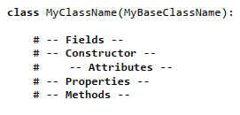

Fields are the data member of a class. Constructors are a special method that are automatically run when you create an object. They are often used to set the initial values of the Field data. In Python they use the notation of double underscore(“duder”) name of “__init__”. Opposite the constructor is the Destructor which is used to remove objects for memory. It uses the notation “__del__”. Within the constructor method you’ll see the keyword “self”. This refers to the data or functions found in an object instance, but no directly in the class. The next setup in the class is Attributes. These are “virtual” fields that hold internal data. Properties are functions used to manage fields or attributes. The last is Methods which are used to handle functions inside of the class.

# Product and Price Python Program Using Classes

This program's problem statement is similar to the previous weeks but we now use classes and object to help organize the code.

To start out the program was given with a basic outline and structure that was a starting point.

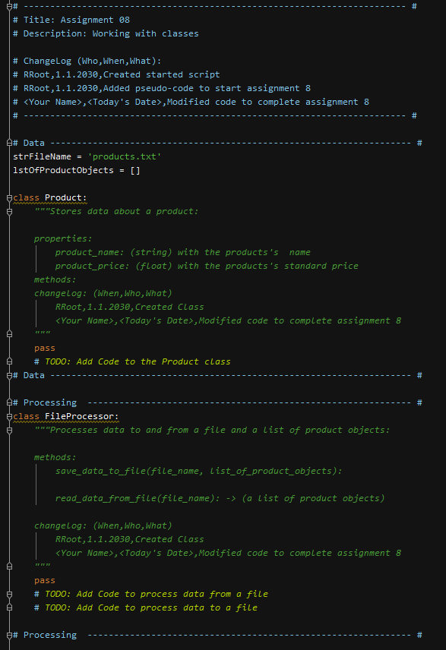

First section that I worked on what the “Product” class. This was the main addition to this week. I when through and created the constructor, attributes, properties and methods for the class.

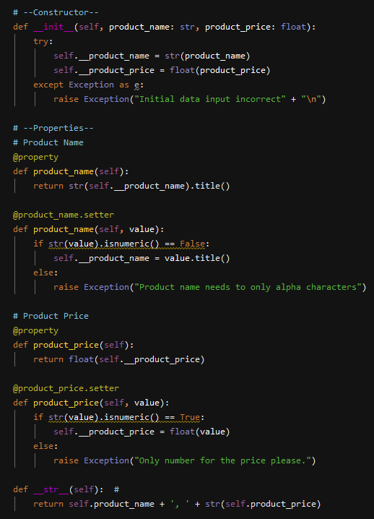

Next, I copied over some of my code for assignment 6 to read in the data from the file. Now that we are using objects, I had to change over how the data was being used in the for loop and calling the new product class in the process.

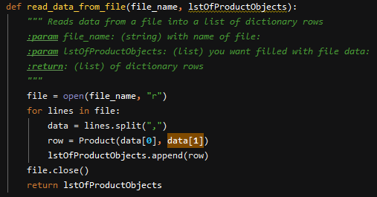

Then I went on to the write data to a file. I used the same process as reading gather an outline form my assignment 6 and modifying where needed.

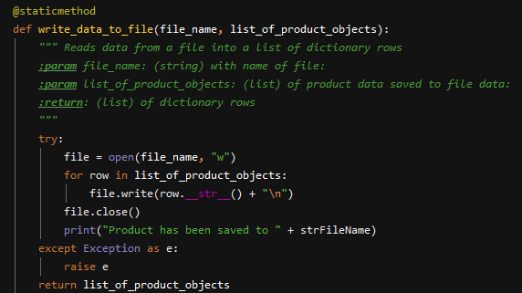

Here is the output in the text file.

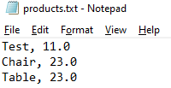

The next function was printing the current list. This was a copy from assignment 6 by with update to all the product objects.

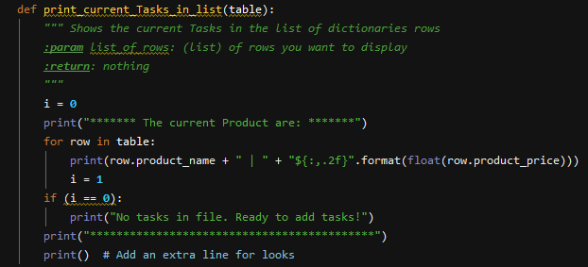

Here is an example of the print out from the text file.

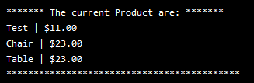

The next function was gathering the user’s input. This one I had some trouble with but was able to figure out how to use the product class and store the objects in a list.

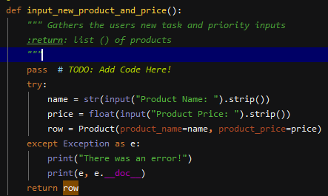

Here is an example of data the use input.

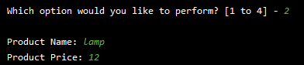

Here is the output of the current table.

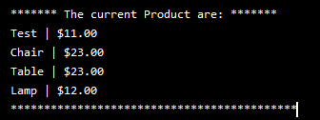

Finally, was the process of call all the functions. This code is very similar to assignment 6 with some modification for calling and using classes.

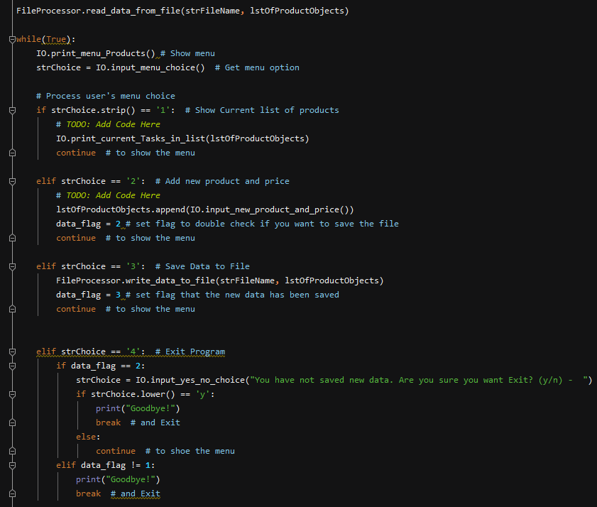

# Summary

In summary, I learned about objects and classes. I went through the process of how I created the classes and functions in product and price program. I found this assignment to be the most difficult so far. I really had trouble understand the concept of the classes. I really got stuck on the Product class part of the code. After doing some further reading and when professor Root said that “the objects were just a list” that really help it click for me. Overall, I’m happy with this assignment and the use of classes really shows the power of programming.