Farmland Classification 1

Script Breakdown 1

Insert identifier(s) string and WKT geometry for each area of interest (AOI) polygon 1

Create summary acres for each landunit 2

Populate intersected soil polygon table with geometry 2

Populate soil geometry with landunit attribute 2

Populate soil map unit acres, aggregated by mukey (merges polygons together) 3

Soil Map Unit Acres, Aggregated by Mukey Farm Class 3

Farm Class By Land Unit 4

# Farmland Classification

Jason Nemecek

2019-07-12

Farmland classification identifies map units as prime farmland, farmland of Statewide importance, farmland of local importance, or unique farmland. It identifies the location and extent of the soils that are best suited to food, feed, fiber, forage, and oilseed crops. NRCS policy and procedures on prime and unique farmlands are published in the “Federal Register,” Vol. 43, No. 21, January 31, 1978.

## Script Breakdown

#### Insert identifier(s) string and WKT geometry for each area of interest (AOI) polygon

SELECT @aoiGeom = GEOMETRY::STGeomFromText('MULTIPOLYGON (((-102.12335160658608 45.959173206572416, -102.13402890980223 45.959218442561564, -102.13386921506947 45.944643788188387, -102.12327175652177 45.944703605814198, -102.12335160658608 45.959173206572416)))', 4326);

SELECT @aoiGeomFixed = @aoiGeom.MakeValid().STUnion(@aoiGeom.STStartPoint());

INSERT INTO #AoiTable ( landunit, aoigeom )

VALUES ('T9981 Fld3', @aoiGeomFixed);

SELECT @aoiGeom = GEOMETRY::STGeomFromText('MULTIPOLYGON (((-102.1130336443976 45.959162795100383, -102.12335160658608 45.959173206572416, -102.12327175652177 45.944703605814198, -102.1128892282776 45.944710506326032, -102.1130336443976 45.959162795100383)))', 4326);

SELECT @aoiGeomFixed = @aoiGeom.MakeValid().STUnion(@aoiGeom.STStartPoint());

INSERT INTO #AoiTable ( landunit, aoigeom )

VALUES ('T9981 Fld4', @aoiGeomFixed);

| **aoiid** | **landunit** | **aoigeom** |
| --- | --- | --- |
| 1 | T9981 Fld3 | POLYGON ((-102.13386921506947 45.944643788188387, -102.12327175652177 45.9447036058142, -102.12335160658608 45.959173206572416, -102.13402890980223 45.959218442561564, -102.13386921506947 45.944643788188387)) |
| 2 | T9981 Fld4 | POLYGON ((-102.12327175652177 45.9447036058142, -102.1128892282776 45.944710506326032, -102.1130336443976 45.959162795100383, -102.12335160658608 45.959173206572416, -102.12327175652177 45.9447036058142)) |

#### Create summary acres for each landunit

CREATE TABLE #AoiAcres

( aoiid INT,

landunit CHAR(20),

landunit_acres FLOAT

);

INSERT INTO #AoiAcres (aoiid, landunit, landunit_acres )\

SELECT aoiid, landunit,

SUM( ROUND( ( ( GEOGRAPHY::STGeomFromWKB(aoigeom.STAsBinary(), 4326 ).STArea() ) / 4046.8564224 ), 3 ) ) AS landunit_acres

FROM #AoiTable

GROUP BY aoiid, landunit;

| **aoiid** | **landunit** | **landunit_acres** |
| --- | --- | --- |
| 1 | T9981 Fld3 | 328.952 |
| 2 | T9981 Fld4 | 318.722 |

#### Populate intersected soil polygon table with geometry

-- Create intersected soil polygon table with geometry

CREATE TABLE #AoiSoils

( polyid INT IDENTITY (1,1),

aoiid INT,

landunit CHAR(20),

mukey INT,

soilgeom GEOMETRY

);

INSERT INTO #AoiSoils (aoiid, landunit, mukey, soilgeom)

SELECT A.aoiid, A.landunit, M.mukey, M.mupolygongeo.STIntersection(A.aoigeom ) AS soilgeom

FROM mupolygon M, #AoiTable A

WHERE mupolygongeo.STIntersects(A.aoigeom) = 1;

#### Populate soil geometry with landunit attribute

-- Soil geometry with landunits

CREATE TABLE #AoiSoils2

( aoiid INT,

polyid INT,

landunit CHAR(20),

mukey INT,

poly_acres FLOAT,

soilgeog GEOGRAPHY

);

-- Populate Soil geometry with landunit attribute

INSERT INTO #AoiSoils2

SELECT aoiid, polyid, landunit, mukey, ROUND((( GEOGRAPHY::STGeomFromWKB(soilgeom.STAsBinary(), 4326 ).STArea() ) / 4046.8564224 ), 3 ) AS poly_acres, GEOGRAPHY::STGeomFromWKB(soilgeom.STAsBinary(), 4326 ) AS soilgeog

FROM #AoiSoils;

#### Populate soil map unit acres, aggregated by mukey (merges polygons together)

INSERT INTO #M2

SELECT DISTINCT M1.aoiid, M1.landunit, M1.mukey,

ROUND (SUM (M1.poly_acres) OVER(PARTITION BY M1.landunit, M1.mukey), 3) AS mapunit_acres

FROM #AoiSoils2 AS M1

GROUP BY M1.aoiid, M1.landunit, M1.mukey, M1.poly_acres;

### Soil Map Unit Acres, Aggregated by Mukey Farm Class

CREATE TABLE #FC

( aoiid INT,

landunit CHAR(20),

mukey INT,

mapunit_acres FLOAT,

farmlndclass CHAR(30)

);

INSERT INTO #FC

SELECT aoiid, landunit, mu.mukey, mapunit_acres, CASE WHEN (farmlndcl) IS NULL THEN ''

WHEN farmlndcl = 'All areas are prime farmland' THEN 'Prime farmland'

WHEN farmlndcl LIKE 'Prime if%' THEN 'Prime farmland if'

WHEN farmlndcl = 'Farmland of statewide importance' THEN 'State importance'

WHEN farmlndcl LIKE 'Farmland of statewide importance, if%' THEN 'State importance if'

WHEN farmlndcl = 'Farmland of local importance' THEN 'Local importance'

WHEN farmlndcl LIKE 'Farmland of local importance, if%' THEN 'Local importance if'

WHEN farmlndcl = 'Farmland of unique importance' THEN 'Unique importance' ELSE 'Not Prime farmland' END AS farmlndclass

FROM #M2 AS fcc

INNER JOIN mapunit AS mu ON mu.mukey=fcc.mukey;

* Farmland Classification was aggregated down from 28 classes down to 8 classes:
  + Prime farmland
  + Prime farmland if
  + State importance
  + State importance if
  + Local importance
  + Local importance if
  + Unique importance
  + Not Prime farmland

| **aoiid** | **landunit** | **mukey** | **mapunit_acres** | **farmlndclass** |
| --- | --- | --- | --- | --- |
| 1 | T9981 Fld3 | 354627 | 0.426 | Not Prime farmland |
| 1 | T9981 Fld3 | 354648 | 0.287 | State importance |
| 1 | T9981 Fld3 | 2494708 | 1.729 | Not Prime farmland |
| 1 | T9981 Fld3 | 2525720 | 56.699 | Not Prime farmland |
| 1 | T9981 Fld3 | 2525732 | 1.35 | Not Prime farmland |
| 1 | T9981 Fld3 | 2525733 | 0.129 | Not Prime farmland |
| 1 | T9981 Fld3 | 2525739 | 28.479 | State importance |
| 1 | T9981 Fld3 | 2525745 | 4.983 | State importance |
| 1 | T9981 Fld3 | 2525746 | 16.106 | State importance |
| 1 | T9981 Fld3 | 2525754 | 12.638 | Not Prime farmland |
| 1 | T9981 Fld3 | 2525764 | 17.691 | Not Prime farmland |
| 1 | T9981 Fld3 | 2525766 | 0.032 | Not Prime farmland |
| 1 | T9981 Fld3 | 2525769 | 181.356 | Not Prime farmland |
| 1 | T9981 Fld3 | 2755648 | 2.449 | Not Prime farmland |
| 1 | T9981 Fld3 | 2755654 | 4.599 | State importance |
| 2 | T9981 Fld4 | 2525720 | 8.623 | Not Prime farmland |
| 2 | T9981 Fld4 | 2525724 | 0.458 | State importance |
| 2 | T9981 Fld4 | 2525730 | 31.514 | State importance |
| 2 | T9981 Fld4 | 2525745 | 62.205 | State importance |
| 2 | T9981 Fld4 | 2525746 | 63.55 | State importance |
| 2 | T9981 Fld4 | 2525754 | 23.138 | Not Prime farmland |
| 2 | T9981 Fld4 | 2525767 | 3.86 | Not Prime farmland |
| 2 | T9981 Fld4 | 2525769 | 103.909 | Not Prime farmland |
| 2 | T9981 Fld4 | 2755639 | 0.443 | State importance |
| 2 | T9981 Fld4 | 2755643 | 9.641 | Not Prime farmland |
| 2 | T9981 Fld4 | 2755648 | 11.382 | Not Prime farmland |

### Farm Class By Land Unit

SELECT DISTINCT landunit, SUM (mapunit_acres) OVER(PARTITION BY aoiid, farmlndclass) AS rating_acres, farmlndclass,

CASE WHEN farmlndclass IS NULL THEN CONCAT ('Farm Class' , ':' , 1)

WHEN farmlndclass = 'Prime farmland' THEN CONCAT ('Farm Class' , ':' , 2)

WHEN farmlndclass = 'Prime farmland if' THEN CONCAT ('Farm Class' , ':' , 3)

WHEN farmlndclass = 'State importance' THEN CONCAT ('Farm Class' , ':' , 4)

WHEN farmlndclass = 'State importance if' THEN CONCAT ('Farm Class' , ':' , 5)

WHEN farmlndclass = 'Local importance' THEN CONCAT ('Farm Class' , ':' , 6)

WHEN farmlndclass = 'Local importance if' THEN CONCAT ('Farm Class' , ':' , 7)

WHEN farmlndclass = 'Not Prime farmland' THEN CONCAT ('Farm Class' , ':' , 8)

WHEN farmlndclass = 'Not rated' THEN CONCAT ('Farm Class' , ':' , 9)

END AS rating_key,

'Farm Class' AS attributename

FROM #FC

GROUP BY aoiid, landunit, mapunit_acres, farmlndclass;

| **landunit** | **rating_acres** | **farmlndclass** | **rating_key** | **attributename** |
| --- | --- | --- | --- | --- |
| T9981 Fld3 | 54.454 | State importance | Farm Class:4 | Farm Class |
| T9981 Fld3 | 274.499 | Not Prime farmland | Farm Class:8 | Farm Class |
| T9981 Fld4 | 158.17 | State importance | Farm Class:4 | Farm Class |
| T9981 Fld4 | 160.553 | Not Prime farmland | Farm Class:8 | Farm Class |

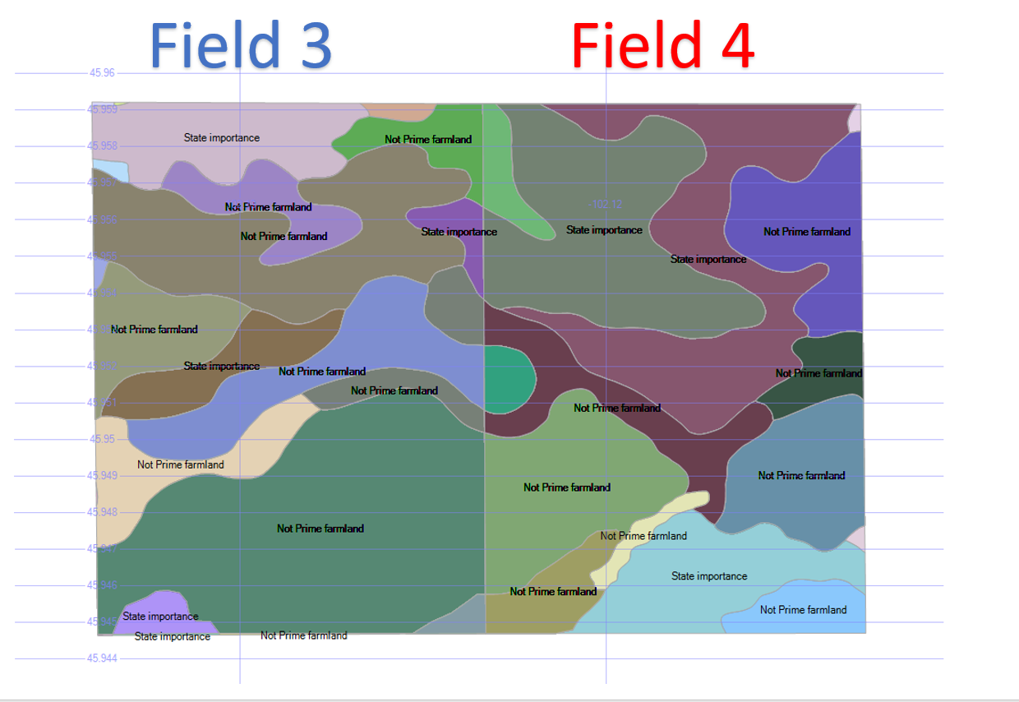

Figure 1.---Example of farm class by mapunit.