Soil Data Access Metrics 1

Soil Data Access Usage by Hour and Day 1

Hour 1

Day 1

Weekday (Monday to Friday with day undefined) 2

Metric Charts 2

Database Log SQL Script 5

# Soil Data Access Metrics

Jason Nemecek

2019-07-16

## Soil Data Access Usage by Hour and Day

Below are soil data access hits (usage) by hour and day. Typically, the median range per hour is about 2k and ranges between 500 to 7,300 queries (quartile).

The busiest days are Tuesdays and Thursdays; the median for a typical day is about 90,000 and ranges from 55,000 to 181,000 (quartile.) Note: There are some extreme values in the 95th percentile that might need to be considered for planning purposes. Also, the metrics don’t track the complexity of the queries hitting to soil data access. The complexity could impact the speed of the server.

### Hour

| **hour_05_percentile** | **hour_25_percentile** | **hour_50_percentile** | **hour_75_percentile** | **hour_95_percentile** | **min_hour_count** | **max_hour_count** | **avg_hour_count** |
| --- | --- | --- | --- | --- | --- | --- | --- |
| 69 | 527 | 2,048 | 7,342 | 32,426 | 5 | 565,322 | 10,767 |

### Day

| **day_05_percentile** | **day_25_percentile** | **day_50_percentile** | **day_75_percentile** | **day_95_percentile** | **min_day_count** | **max_day_count** | **avg_day_count** | **day** |
| --- | --- | --- | --- | --- | --- | --- | --- | --- |
| 7,561 | 13,923 | 21,118 | 66,996 | 559,737 | 5,149 | 4,817,860 | 192,513 | Sunday |
| 8,316 | 14,404 | 31,519 | 94,307 | 481,157 | 5,976 | 12,470,806 | 348,879 | Saturday |
| 19,659 | 52,537 | 84,785 | 159,574 | 585,673 | 16,667 | 7,420,868 | 295,437 | Monday |
| 33,516 | 52,546 | 85,026 | 188,906 | 1,273,597 | 27,143 | 2,319,515 | 256,262 | Friday |
| 34,573 | 61,290 | 105,323 | 172,092 | 557,934 | 14,992 | 1,563,087 | 183,311 | Thursday |
| 35,300 | 56,185 | 109,063 | 210,785 | 1,083,900 | 6,916 | 6,612,823 | 330,289 | Tuesday |
| 36,338 | 60,430 | 91,972 | 185,929 | 778,698 | 9,629 | 1,366,856 | 201,693 | Wednesday |

### Weekday (Monday to Friday with day undefined)

| **day_05_percentile** | **day_25_percentile** | **day_50_percentile** | **day_75_percentile** | **day_95_percentile** | **min_day_count** | **max_day_count** | **avg_day_count** |
| --- | --- | --- | --- | --- | --- | --- | --- |
| 32,390 | 55,504 | 89,681 | 181,065 | 867,614 | 6,916 | 7,420,868 | 253,409 |

### Metric Charts

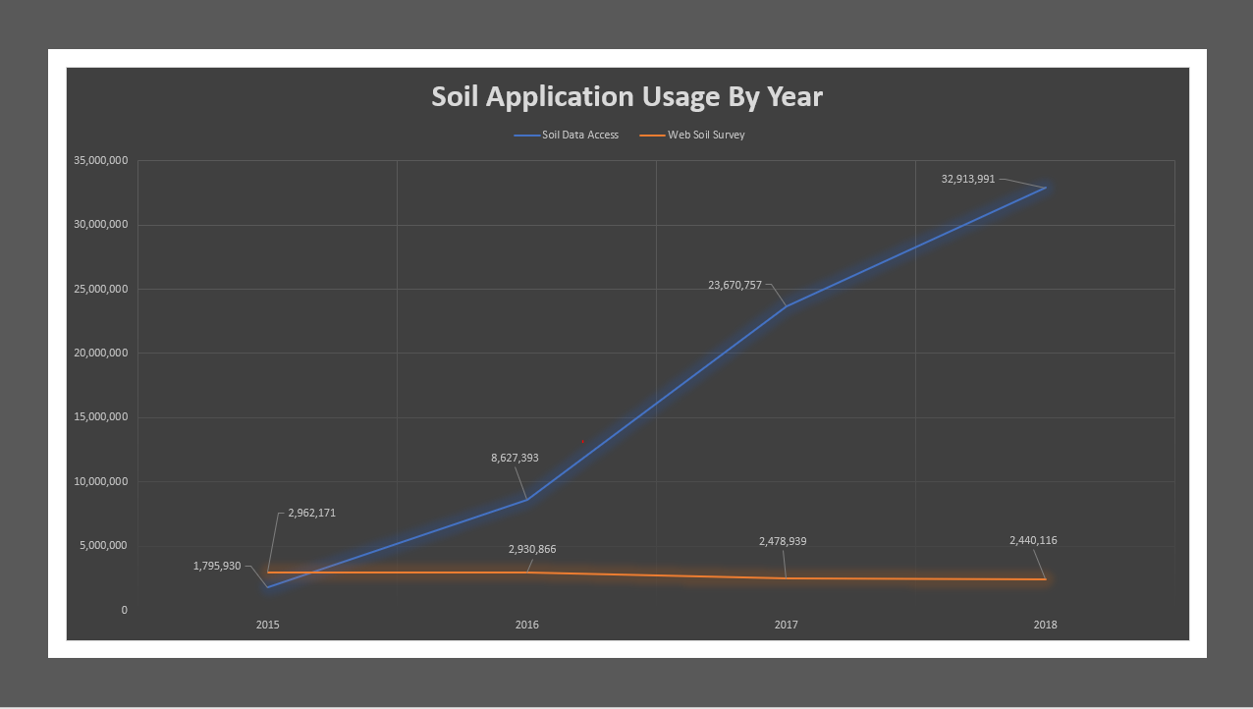

Figure 1.---Soil application usage by year.

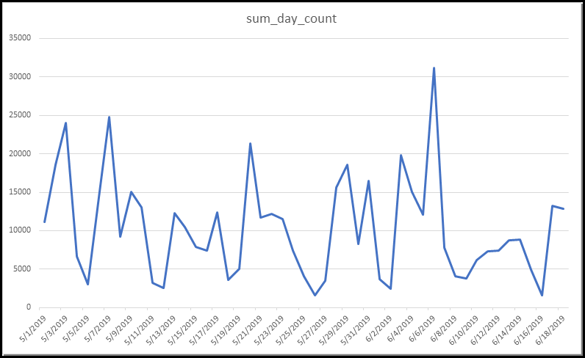

Figure 2.---Soil Data Access sum day count from 5/1/2019 to 6/18/2019.

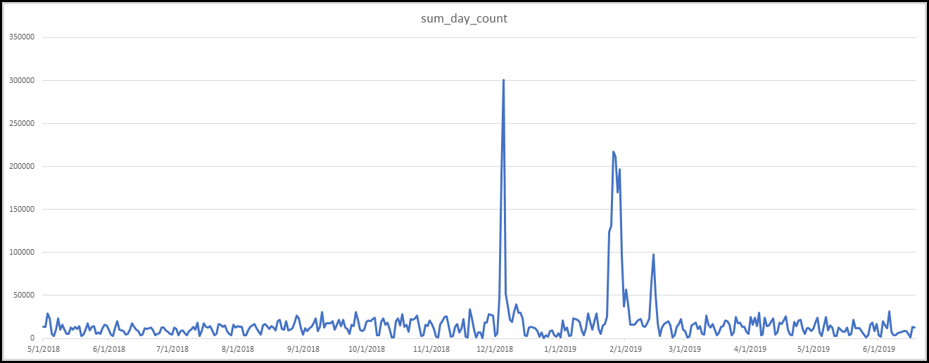

Figure 3.---Soil Data Access sum day count from 5/1/2018 to 6/18/2019.

## Database Log SQL Script

-- SDA Metrics by 'SDA Spatial Query','SDA Tabular Query','SDA User Interface'

use baflogrpt;

GO

SET STATISTICS IO ON

GO

DROP TABLE IF EXISTS #sdametrics_day

DROP TABLE IF EXISTS #sdametrics_hour

DROP TABLE IF EXISTS #sdametrics2

declare @startLogDateTime datetime

set @startLogDateTime = '2018-06-01T00:00:00'

declare @endLogDateTime datetime

set @endLogDateTime = '2019-06-01T00:00:00'

--Creates table

declare @t table(dt datetime, d varchar(50), h int, y int, m int , SDA_Log_Message varchar(50), SDA_Application_Name varchar(50), logCount int, app int );

insert into @t

--Grabs the log ids for Soil Data Access usage

select

FORMAT (Log.LogDateTime, 'd', 'en-US') AS dt,

FORMAT(Log.LogDateTime, 'dddd') AS d,

DATEPART(hour,Log.LogDateTime) AS h,

datepart(year, Log.LogDateTime) y,

datepart(month, Log.LogDateTime) m,

log.LogMessage AS SDA_Log_Message,

[Application].ApplicationName AS SDA_Application_Name,

log.LogID AS logCount,

1 AS app

from dbo.log AS Log with(nolock)

left outer join dbo.application AS Application with(nolock) on Application.ApplicationID = Log.ApplicationID

where Log.LogDateTime >= @startLogDateTime

and Log.LogDateTime <= @endLogDateTime

and Application.ApplicationName in ('SDA Spatial Query','SDA Tabular Query','SDA User Interface')

and Log.LogType = 'METRIC'

and Log.LogSubtype = 'SDA AUDIT'

;

--Aggregates by hour (24 hour format)

select dt, 1 AS id, d, h , y , m ,

count(DISTINCT logCount) as [hour_count]

INTO #sdametrics_hour

from @t

group by y, m, d, dt, h

order by y, m, d, dt, h

--Hour Metrics

SELECT TOP 1

percentile_cont (0.05) within group (order by hour_count)

over(partition by id) as hour_05_percentile,

percentile_cont (0.25) within group (order by hour_count)

over(partition by id) as hour_25_percentile,

percentile_cont (0.50) within group (order by hour_count)

over(partition by id) as hour_50_percentile,

percentile_cont (0.75) within group (order by hour_count)

over(partition by id) as hour_75_percentile,

percentile_cont (0.95) within group (order by hour_count)

over(partition by id) as hour_95_percentile,

MIN(hour_count) over(partition by id) as min_hour_count,

MAX(hour_count) over(partition by id) as max_hour_count,

AVG(hour_count) over(partition by id) as avg_hour_count

FROM #sdametrics_hour

--Aggregates and sums the log count by Date

SELECT app, dt,

count(DISTINCT logCount) AS sum_day_count,

d

INTO #sdametrics_day

FROM @t

GROUP BY app, dt, d

;

--Aggregates and sums the log count by Day of the week

SELECT DISTINCT

percentile_cont (0.05) within group (order by sum_day_count)

over(partition by d) as day_05_percentile,

percentile_cont (0.25) within group (order by sum_day_count)

over(partition by d) as day_25_percentile,

percentile_cont (0.50) within group (order by sum_day_count)

over(partition by d) as day_50_percentile,

percentile_cont (0.75) within group (order by sum_day_count)

over(partition by d) as day_75_percentile,

percentile_cont (0.95) within group (order by sum_day_count)

over(partition by d) as day_95_percentile,

MIN(sum_day_count) over(partition by d) as min_day_count,

MAX(sum_day_count) over(partition by d) as max_day_count,

AVG(sum_day_count) over(partition by d) as avg_day_count,

d AS [day]

FROM #sdametrics_day

;

--Aggregates and sums the log count for the weekday excluding Saturday and Sunda

SELECT DISTINCT

percentile_cont (0.05) within group (order by sum_day_count)

over(partition by app) as day_05_percentile,

percentile_cont (0.25) within group (order by sum_day_count)

over(partition by app) as day_25_percentile,

percentile_cont (0.50) within group (order by sum_day_count)

over(partition by app) as day_50_percentile,

percentile_cont (0.75) within group (order by sum_day_count)

over(partition by app) as day_75_percentile,

percentile_cont (0.95) within group (order by sum_day_count)

over(partition by app) as day_95_percentile,

MIN(sum_day_count) over(partition by app) as min_day_count,

MAX(sum_day_count) over(partition by app) as max_day_count,

AVG(sum_day_count) over(partition by app) as avg_day_count

FROM #sdametrics_day WHERE d NOT IN ('Saturday', 'Sunday')

;

DROP TABLE IF EXISTS #sdametrics_day

DROP TABLE IF EXISTS #sdametrics_hour

DROP TABLE IF EXISTS #sdametrics2

GO

SET STATISTICS IO OFF

GO