Nitrogen Leaching Potential 1

Evaluations and Rules for the NASIS Nitrate Leaching Potential Interpretation 3

AGR - Nitrate Leaching Potential, Nonirrigated 4

AGR - Nitrate Leaching Potential, Irrigated 6

Review and Testing 9

References 9

# Nitrogen Leaching Potential

Steve Campbell

July 3, 2019

The request for a soil interpretation to predict nitrate leaching potential originated from the former NRCS State Agronomist in Washington State, Joel Poore. The purpose of the interpretation is to provide a screening tool for conservation planning. It predicts the inherent potential for nitrate leaching based on soil and climate properties as stored in the NASIS database. The criteria for the interpretation do not include land use or management practices.

Nitrate contamination of groundwater is a significant issue in Washington State, especially in the irrigated cropland of the Columbia Basin (WSU, 1994). In some counties, more than 20 percent of the wells used for drinking water exceed the EPA maximum contaminant level (10 mg/l nitrate-nitrogen). In Franklin County, 32 percent of the wells exceed this level.

In response to the request for the interpretation, a review was conducted of research and university extension publications that address soil and climate properties that affect nitrate leaching. The tools that NRCS currently uses to assess nitrate leaching potential were also reviewed.

The Revised Universal Soil Loss Equation (RUSLE2) software contains a nitrate leaching index tool. The tool is based on the procedure developed by Williams and Kissel (1991). The tool uses the hydrologic soil group (A, B, C, or D), mean annual precipitation, and seasonal precipitation (October through March) to calculate a leaching index. Precipitation data is from the RUSLE2 climate database.

The largest concern about the RUSLE2 Nitrogen Leaching Index is that it uses only one factor based on soil properties. This factor, hydrologic soil group, is defined in the National Engineering Handbook (NEH), Part 630 Hydrology, Chapter 7 (<http://directives.sc.egov.usda.gov/viewerFS.aspx?hid=21422>). The groups are designed to determine the associated runoff curve number for a soil (NEH 630.09). Runoff curve numbers are used to estimate direct runoff from rainfall (NEH 630.10). Hydrologic soil groups were designed to predict surface runoff of precipitation, not to predict deep leaching of soil water.

All soils are assigned to a hydrologic soil group of A (lowest runoff potential), B, C, or D (highest runoff potential). Soils with very different properties can be assigned to the same hydrologic soil group. For example, the following three soils would all be assigned to hydrologic soil group D:

* An excessively drained, sandy, shallow soil that has fractured bedrock at a depth of 20 inches or less;
* A well drained, very deep, clayey soil that has very slow Ksat (permeability) (<= 0.06 inches/hr) in the upper 24 inches; and
* A poorly drained, very deep, loamy soil that has a water table at a depth less than 24 inches at some time during the year.

These three examples illustrate that soils may have similar potential for surface runoff of precipitation but not for deep leaching of nitrates.

After a review of the research and university extension publications on soil and climate properties that affect nitrate leaching, two nitrate leaching potential interpretations were developed in the National Soil Information System (NASIS): one for nonirrigated conditions and the other for irrigated conditions.

The following soil and climate factors are criteria in the NASIS interpretation.

1. **Mean annual precipitation minus potential evapotranspiration.---**This factor provides an estimate of the amount of water that is available to move through the soil profile on an annual basis. NASIS contains data for mean annual precipitation and mean annual air temperature. The NRCS National Soil Survey Center developed an algorithm that estimates this factor based on the Hamon potential evapotranspiration method (Hammon, 1961).
2. **Water travel time through entire soil profile.---**This factor uses the saturated hydraulic conductivity (Ksat) and thickness of each soil horizon to estimate the number of hours required for a given volume of water to move through the entire soil profile. One advantage of this method for accounting for the rate of water movement is that the properties and thickness of each soil horizon are accounted for, which is preferable to using an overall hydraulic conductivity or permeability class for the entire profile. This method accounts for subtle differences caused by texture, structure, horizon thickness, and depth to water-restricting layers. More discussion of this method is available in the Oregon State University Extension Publication at <http://ir.library.oregonstate.edu/xmlui/bitstream/handle/1957/15296/em8708.pdf?sequence=4> (Huddleston, 1998).
3. **Available water capacity.---**This factor accounts for the cumulative amount of plant-available water that the soil profile can hold at field capacity to a depth of 150 cm. The more water the soil profile can hold, the less water is available for deep leaching.
4. **Depth and duration of water table.---**This factor uses a water table index based on the minimum average depth to a water table and the number of months that the water table is present from April through October. It accounts for the loss of nitrates to the atmosphere as nitrous oxide or nitrogen gas from denitrification under anaerobic conditions caused by water saturation. The higher the water table and the longer it’s duration, the larger the quantity of nitrates that would potentially be lost to the atmosphere and therefore not be available for deep leaching.
5. **Slope gradient adjusted for hydrologic soil group.---**The steeper the slope gradient, the higher the potential surface runoff, and therefore the less water available to move through the soil profile. The following adjustments are made to the slope gradient by hydrologic group to account for potential differences in surface runoff:

* Hydrologic group A: Slope % x 0.75
* Hydrologic group B: Slope % x 0.85
* Hydrologic group C: Slope % x 0.95
* Hydrologic group D: No adjustment

1. **Anion exchange capacity (AEC) .---**This factor was added in the September 2016 revision to account for soils that generate anion exchange capacity under acidic conditions. Highly weathered Ultisols and Oxisols, volcanic Andisols, and organic Histosols have AEC under acidic conditions (University of Hawai’i, 2007). These soils become positively charged and attract, retain, and supply negatively charged anions, including nitrate, which therefore reduces the risk of nitrate leaching.

The following criteria are used to reduce the numerical ratings of nitrate leaching potential if the minimum representative pH in water is 5.5 or less in some part of the soil at a depth of 0-100 cm.

* Andisols: Subtract 0.30
* Oxisols: Subtract 0.25
* Histosols: Subtract 0.20
* Ultisols: Subtract 0.20

## Evaluations and Rules for the NASIS Nitrate Leaching Potential Interpretation

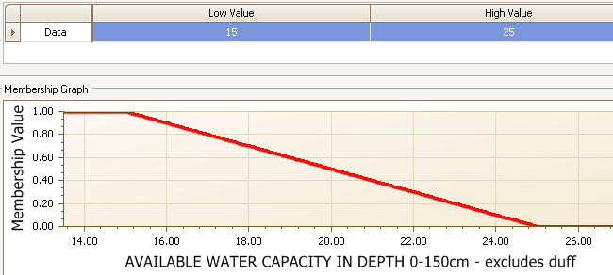

Figure 1.---Evaluation curve for available water capacity in the interpretation for nitrate leaching potential.

NASIS uses a concept known as “fuzzy logic” to assign a numerical value between 0.00 and 1.00 to each factor in the interpretation criteria and the overall rating. For interpretations that are designed to predict soil limitations for a particular use, the higher the value, the greater the limitation. The nitrate leaching potential interpretation is designed in this way. A curve is constructed for each criteria factor, which assigns a value between 0.00 and 1.00. These curves are known as “evaluations” in NASIS. Figure 1 is an example of the evaluation curve for the available water capacity (AWC) factor in the nitrate leaching potential interpretation.

A value of 1.00 (most limiting) is assigned if AWC is 15 cm or less. This corresponds to “low” and “very low” AWC classes. A value of 0.00 (not limiting) is assigned if AWC is 25 cm or greater, which corresponds to “high” and “very high” AWC classes. For an AWC greater than 15 but less than 25 cm, intermediate values are assigned according to the curve. Each evaluation curve is then used to create subrules that can be weighted to generate the overall interpretation rating. The following image displays the weighting factors and relationships of the subrules in the nonirrigated nitrate leaching potential interpretation.

### AGR - Nitrate Leaching Potential, Nonirrigated

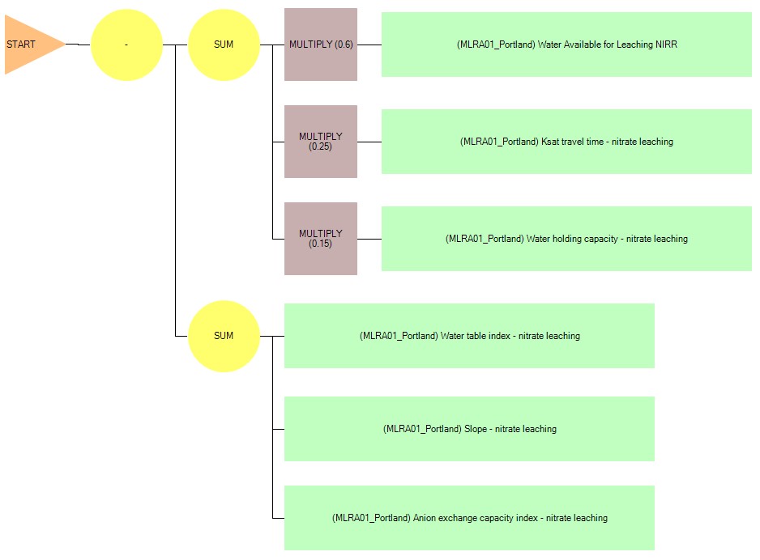

1. Each of the green boxes represents a subrule for the nitrate leaching potential, nonirrigated, interpretation.
2. The “water available for leaching” subrule is weighted by multiplying by 0.60.
3. The “Ksat travel time” subrule is weighted by multiplying by 0.25.
4. The “available water capacity” subrule is weighted by multiplying by 0.15.
5. The sum of these three weighted subrules results in a value between 0.00 and 1.00
6. Adjustments are then made for water table depth and duration, slope gradient adjusted for hydrologic group, and anion exchange capacity. The sum of the values from these subrules is subtracted from the sum in step 4 above. The maximum reduction is 0.5 for the water table index subrule, 0.3 for the slope gradient subrule, and 0.3 for the anion exchange capacity subrule.

### AGR - Nitrate Leaching Potential, Irrigated

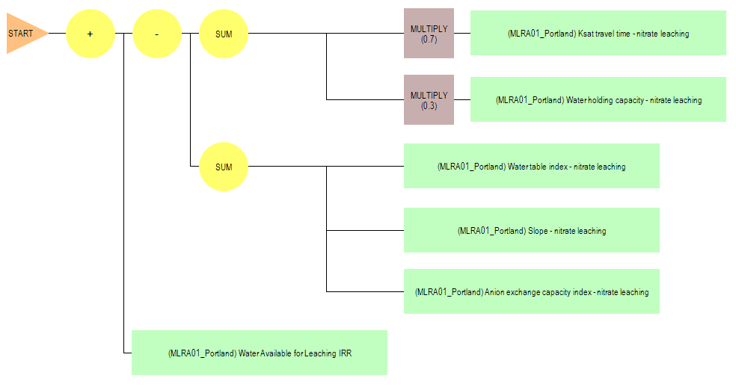

1. Each of the green boxes represents a subrule for the nitrate leaching potential, irrigated, interpretation.
2. The “Ksat travel time” subrule is weighted by multiplying by 0.7.
3. The “available water capacity” subrule is weighted by multiplying by 0.3.
4. The sum of these two weighted subrules results in a value between 0.00 and 1.00.
5. Adjustments are then made for water table depth and duration, slope gradient adjusted for hydrologic group, and anion exchange capacity. The sum of the values from these subrules is subtracted from the sum in step 4 above. The maximum reduction is 0.5 for the water table index subrule, 0.3 for the slope gradient subrule, and 0.3 for the anion exchange capacity.
6. A final adjustment is made based on the water available for leaching from precipitation. The value for this subrule is added to the results from steps 3 through 5 above. The maximum addition for this subrule is 0.6.

The following Nitrate Leaching Potential rating classes have been established based on the final calculation from the subrules above.

* Low: 0.00--0.25
* Moderate: 0.26--0.50
* Moderately high: 0.51--0.75
* High: 0.76--1.00

One valuable aspect of NASIS interpretations is that they provide both a narrative rating and a numerical rating. For example, a soil may be rated with a “moderately high” nitrate leaching potential. The numerical rating, however, may be 0.53, indicating that it is close to the break with the “moderate” class.

Example ratings for subrules and overall ratings for soil map unit components.

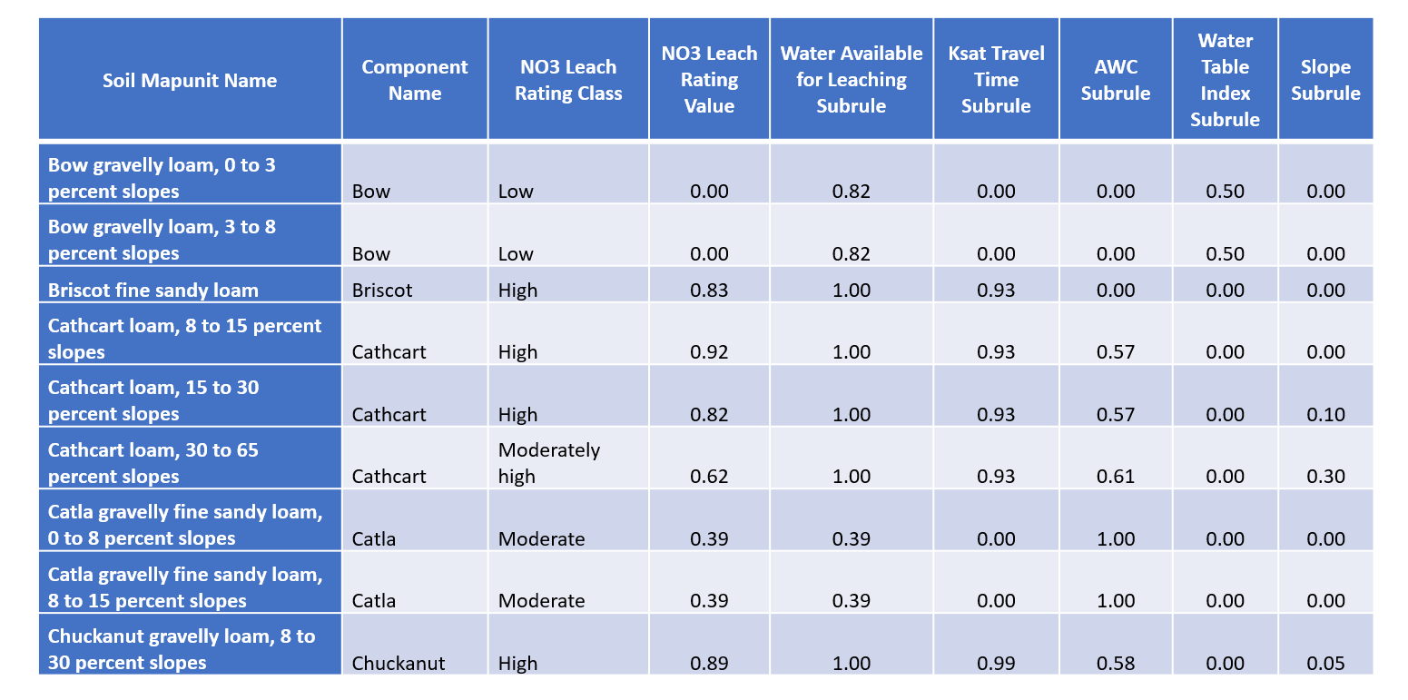

With any soil interpretation, professional judgment is involved in selecting the criteria, constructing the evaluation curves, assigning weights to the subrules, and assigning numerical class breaks to the rating classes. These decisions are made after a review of the available research on the subject.

## Review and Testing

The NRCS Washington State Office soils staff and the State resource conservationist met in August 2011 to review the nitrate leaching potential interpretation criteria and ratings for Washington soil map unit components. Based on this meeting, we made some minor adjustments to the criteria for the mean annual precipitation minus mean annual potential evapotranspiration factor. The next step was to review the nitrate leaching potential criteria and ratings with key NRCS Washington field office personnel. Counties where groundwater nitrate contamination is a significant issue were selected. The field office personnel reviewed maps and tabular reports with the nitrate leaching potential ratings. The personnel had some good questions about the interpretation criteria. Everyone agreed that, for the soils they are familiar with, the interpretation results identified the nitrate leaching potential they would expect.

Starting in fiscal year 2012, Washington State NRCS included the nitrate leaching potential ratings in their official soil survey information available on Web Soil Survey and in the Electronic Field Office Technical Guide. Field Office staff use the ratings as an assessment tool for conservation planning.

Contact for questions or comments:

Steve Campbell, Soil Scientist   
USDA Natural Resources Conservation Service   
West National Technology Support Center   
1201 NE Lloyd Blvd., Suite 801   
Portland, OR 97232–1208   
Phone: (503) 273–2421   
Email: [steve.campbell@por.usda.gov](mailto:steve.campbell@por.usda.gov)

## References

1. Washington State University. 1994. nc <https://pubs.wsu.edu/ItemDetail.aspx?ProductID=13779>
2. Williams, J. R., and D.E. Kissell. 1991. Water percolation---An indicator of N leaching potential. In: Follet, R.F., D.R. Keeney, and R.M. Cruse (eds) Managing nitrogen for groundwater quality and farm profitability. Soil Science of America, Inc. Madison, Wisconsin, USA.
3. Hamon, W.R. 1961. Estimating potential evapotranspiration: Proceedings of the American Society of Civil Engineers, Journal of the Hydraulic Division 87(HY3):107–120.
4. Huddleston, J.H., et al. 1998. Determination of soil sensitivity ratings for the Oregon Water Quality Decision Aid. Oregon State University Extension Publication EM 8708. <http://ir.library.oregonstate.edu/xmlui/bitstream/handle/1957/15296/em8708.pdf?sequence=4> (accessed September 2016).
5. Washington State University. 1984. Rating Eastern Washington soils for potential nitrogen losses. Extension Publication EB 1258. <https://pubs.wsu.edu/ListItems.aspx?Keyword=EB%201258>
6. ’, 2007. Soil nutrient management for Maui County; Soil mineralogy. <http://www.ctahr.hawaii.edu/mauisoil/a_factor_mineralogy.aspx> (accessed August 2016).