Soil Organic Matter Depletion

A fertile and healthy soil is the basis for healthy plants, animals, and humans. Soil organic matter is the very foundation for healthy and productive soils. Understanding the role of organic matter in maintaining a healthy soil is essential for developing ecologically sound agricultural practices. Perhaps just as important is identifying areas at greater risk of depleting that organic matter. The accumulation of organic matter in soil is the result of the processes that synthesize organic matter being able to generally out-produce the processes that destroy organic matter. These processes act on continental and local scales. Continental factors include the mean annual temperature which ultimately governs the rates of biological processes, both synthesizing and destroying organic matter. Another continental scale factor is the amount of moisture generally available for plants and soil microbes to use. This is governed by the amount of rainfall an area receives in relation to the potential evapotranspiration.

These continental scale factors are modified by local factors that influence organic matter accumulation or destruction. Oxygen is needed for both processes. Oxygen can be excluded from the soil by seasonal saturation, which generally favors the accumulation processes. The antecedent organic matter content is used as an indicator of the level of vulnerability of the soil to loss of organic matter. Well aerated soils, all other things being equal, tend to promote higher oxidation rates but may still accumulate organic matter depending on the other factors, ground cover, and management. The amount of clay-sized particles in the soil influences the protection of organic compounds and so tends to favor accumulation. The shape of the land surface also influences the organic matter content of soils. Concave areas tend to accumulate water and sediment while convex areas are material spreading.

Criteria Table

|  |  |  |  |  |
| --- | --- | --- | --- | --- |
| Site or Soil Feature | Degree of limitation | | | Impact |
|  | Low | Moderate | High |  |
| Organic matter loss sensitivity (%) | >6.0 | 0.5 to 6.0 | <0.5 | Soil is not able to accumulate organic matter |
| Mean annual air temperature (C) | <3 | 3-20 | >20 | Temperature drives the rates of accumulation and destruction |
| Depth to seasonal high water (cm) | 0 | 0-100 | >100 | Oxygen is excluded from saturated soils |
| Land surface shape | concave | linear | convex | Landform can gather or spread material |
| Surface clay content (%) | >40 | 15-40 | <15 | Organic matter is protected by clay particles |
| Moisture deficit (mm/yr) | >1000 | -1000 to 1000 | <-1000 | Mean annual rainfall minus the potential evapotranspiration |

Rule Diagram

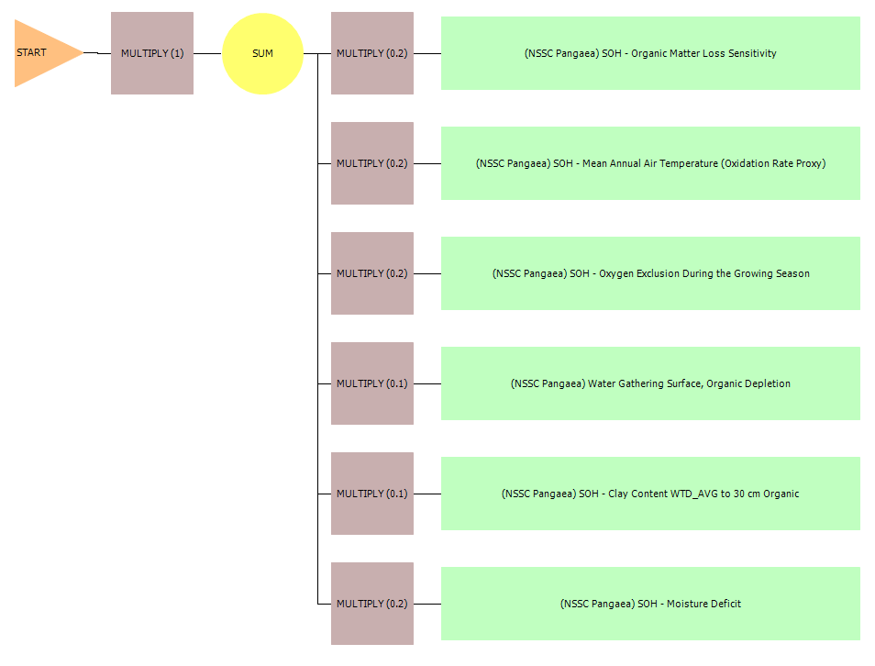

For this rule, each site or soil feature (green rectangles) is weighted as shown in the adjacent MULTIPLY hedges (squares). The resultant fuzzy numbers are then added to derive the overall index as indicated by the SUM operator. The MULTIPLY hedge to the right of START is a placeholder in case further manipulation of the fuzzy number is needed.

References

Owens P, Winzeler E, Libohova Z, Waltman S, Miller D, and Waltman B. Evaluating U.S. Soil Taxonomy Soil Climate Regimes: Application Across Scales. https://www.nrcs.usda.gov/Internet/FSE_DOCUMENTS/nrcs142p2_053084.pdf. Accessed 1 March 2018.

Page-Dumrose, Deborah S. 1993. Susceptibility of Volcanic Ash Influenced Soils in Northern Idaho to Mechanical Compaction. U.S. Forest Service Intermountain Research Station. Research Note INT-409.

Pimentel, D. 2006. Soil erosion: A food and environmental threat. Environment, Development and Sustainability 8:119-137.

Schmidt, M. W. I., Torn, M. S., Abiven, S., Dittmar, T., Guggenberger, G., Janssens, I. A., Trumbore, S. E. (2011). Persistence of soil organic matter as an ecosystem property. Nature, 478, 49. Retrieved from http://dx.doi.org/10.1038/nature10386

Schmitt, A., & Glaser, B. (2011). Organic matter dynamics in a temperate forest as influenced by soil frost. Journal of Plant Nutrition and Soil Science, 174(5), 754–764. https://doi.org/10.1002/jpln.201100009

Soil Survey Staff. 2014. Keys to Soil Taxonomy, 12th ed. USDA-Natural Resources Conservation Service, Washington, DC. https://www.nrcs.usda.gov/wps/portal/nrcs/detail/soils/survey/class/taxonomy/?cid=nrcs142p2_053580

U.S. Department of Agriculture, Agricultural Research Service. Predicting Soil Erosion by Water: A Guide to Conservation Planning with the Revised Universal Soil Loss Equation (RUSLE), Agriculture Handbook 703. https://www.ars.usda.gov/ARSUserFiles/64080530/rusle/ah_703.pdf

U.S. Department of Agriculture, Natural Resources Conservation Service. National Soil Survey Handbook, Title 430-VI. http://www.nrcs.usda.gov/wps/portal/nrcs/detail/soils/ref/?cid=nrcs142p2_054242 (accessed 1 March 2018).

U.S. Department of Agriculture, Soil Conservation Service (1961). Land Capability Classification. https://www.nrcs.usda.gov/Internet/FSE_DOCUMENTS/nrcs142p2_052290.pdf. (accessed 1 March 2018).

Zhanyu Zhang, Liting Sheng, Jie Yang, Xiao-An Chen, Lili Kong and Bakhtawar Wagan. Effects of Land Use and Slope Gradient on Soil Erosion in a Red Soil Hilly Watershed of Southern China. Sustainability 2015, 7, 14309-14325; doi:10.3390/su71014309