This is a quick guide to using the attached CART Soil Map Tool. The tool designed to be used as an aid to development and validation of the CART soils queries. It was not designed to be used as a field office tool, but that option is open to discussion. I saved the mxd as a 10.3 version so hopefully it will work for everyone.

Please not that the tool is still under development. In fact you may notice as you work with it that some features are different from what I used to create the screenshots that follow. A last minute addition to this version is output to an Excel spreadsheet. Most of the soils data is requested from Soil Data Access via the Post Rest Tabular service. Another last minute addition is a tool that can be used for zooming to any county in the country. This is useful for testing performance across different parts of the country.

Below are the steps to follow in generating a series of CART soil maps.

1. Unzip the attached file to a convenient location on a local hard drive. It contains a folder named ‘CART_SoilMap_Tools’ with all the files needed to run the tool.
   1. Including an ArcMap document: Cart_Test_SoilMaps_10d3.mxd
   2. ArcMap toolbox: CART Soil Map Toolbox
   3. Data layers for ArcMap. These are already loaded in the included ArcMap project:
      1. Common Land Units Feature Service 2013 Data with Labels.lyr
      2. Test_AOIs shapefile
      3. World_Imagery.lyr

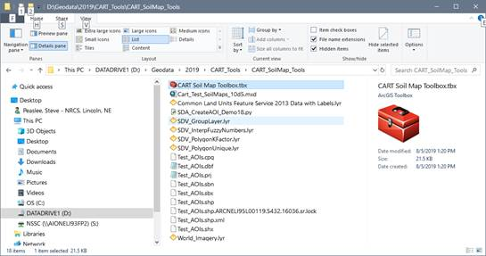

1. Open the Cart_Test_SoilMaps_10d3.mxd (show below). Please note. If you have problems opening the mxd, you can manually add the toolbox and the layer files (Common Landunits and World Imagery .lyr ) to your own ArcMap session. The background layers are all online, so it may take several seconds for the map to display.
2. If you were able to open the mxd, begin by selecting the two ‘Test_AOIs’ polygons for T9981 Fld3 and T9981 Fld4. If not, simply zoom to an area familiar to you and select a couple of landunit polygons in that area. The Common Landunit layer will not display below 1:50,000 scale.

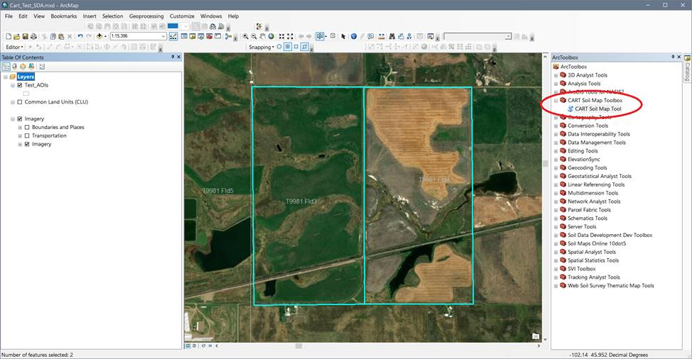

1. Open the CART Soil Map tool
2. Select ‘Test_AOIs’ layer from the first choice list. Which ever layer is selected as an AOI must have at least one polygon selected in order to run the tool.
3. Set the output folder where the new geodatabase and other output data will be written. Data in this database from previous runs may fail to overwrite until you quit out of ArcMap and start up again.

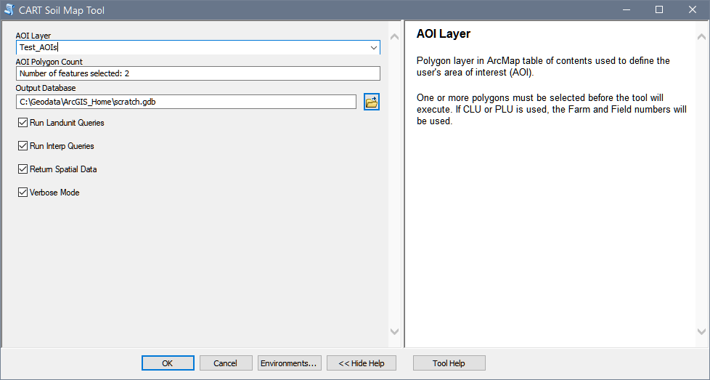

1. Click OK to execute the tool. Below is an example of the output messages for the two selected landunits. A lot of those messages have been eliminated in the current version.

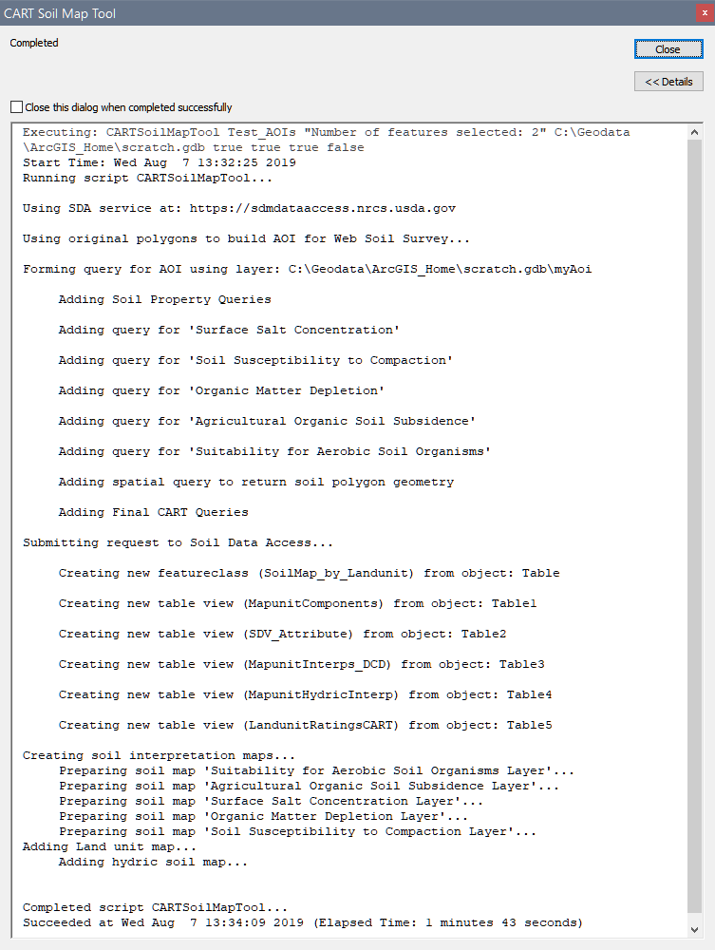

1. A group of soil maps are added to the ArcMap Table of Contents.

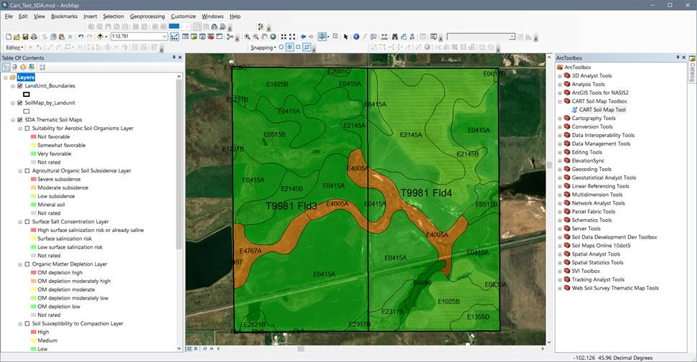

1. A set of attribute tables containing either soil map unit or landunit ratings is also generated.
2. The LandunitRatingsCART table contains the landunit rating for each soil-related resource concern.
3. The user can switch between and compare the different soil maps.
4. Other attribute information including basic component data can be explored by clicking on a soil polygon using the Identify button.
5. AOIs for other states can be run by opening the attribute table of the ‘Test_AOIs’ layer and then selecting a different table record and then running the tool again.
6. Other polygon layers can be used to define your AOI. However, these adhoc layers may not have the correct attribute fields that the tool will recognize as tract and field attributes.

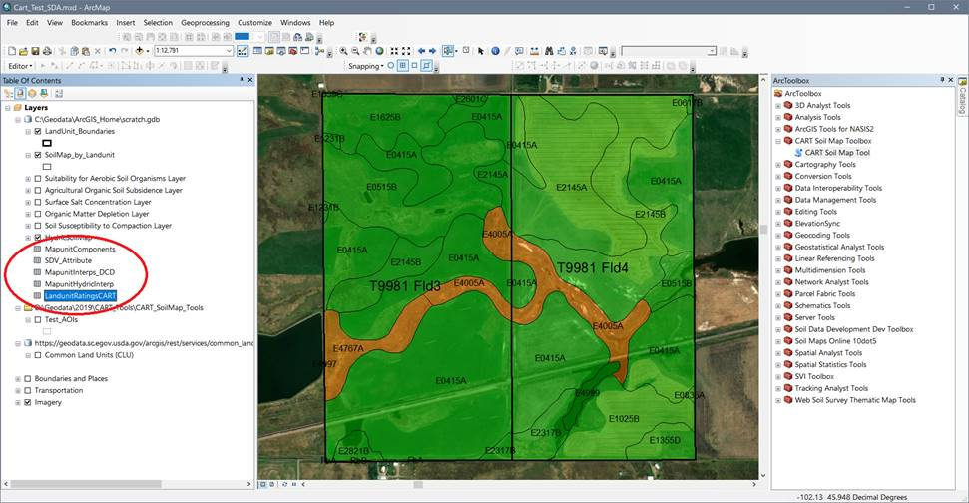

1. After the group of soil maps have been added to ArcMap, a spreadsheet with a map graphic and some summary tables will automatically popup. Check your taskbar if Excel has been minimized or buried behind another application. The spreadsheet is still a work in progress and there is a long list of enhancements…

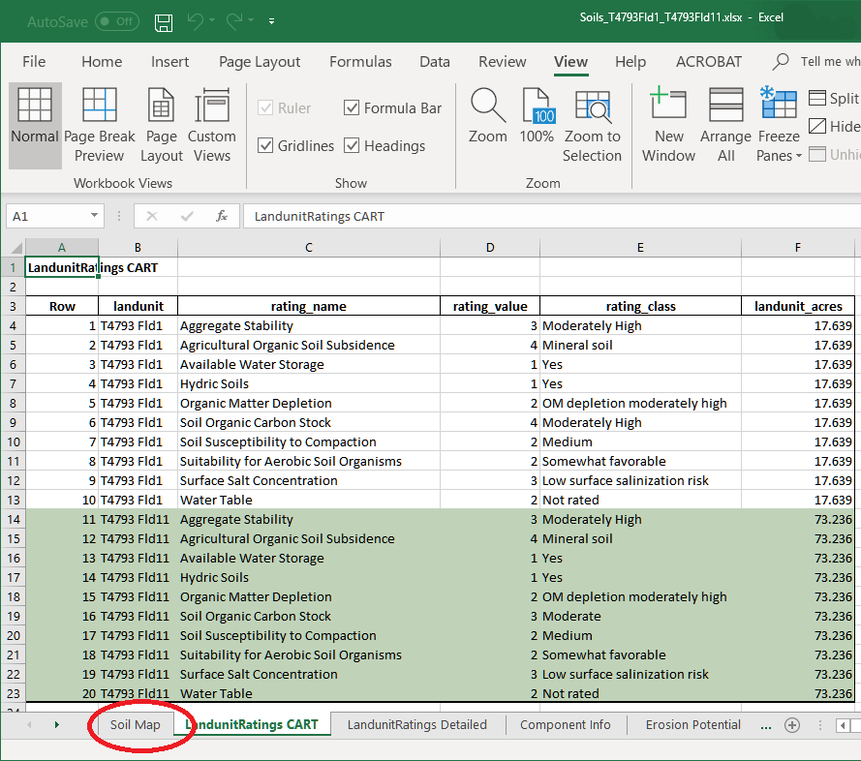

Testing…

On my fast laptop it takes between 2 and 4 minutes to run a scenario. Sometimes I can see significant variation in running the same AOI over and over. I don’t think it’s a Soil Data Access issue, rather something on my computer such as virus scan or our lousy network in Lincoln.

**Bug reporting**

Please e-mail Steve Peaslee ([steve.peaslee@usda.gov](mailto:steve.peaslee@usda.gov)) the text copy-pasted from the tool window (top to bottom please!). I prefer the text because screenshots can be difficult to read and often don’t include the top command line which may have scrolled off the top of the screen.

**Updating the tool**

Tool updates will be made periodically. Check here first for a newer version if you’re having problems…

NRCS GIS Sharepoint: Shared Documents and Tools/Tools/Soils Database Tools

[Soils Database Tools on NRCS-GIS Sharepoint](https://usdagcc.sharepoint.com/sites/nrcs_ssra/gis/Shared%20Documents/Forms/AllItems.aspx?id=%2Fsites%2Fnrcs%5Fssra%2Fgis%2FShared%20Documents%2FTools%2FSoils%20Database%20Tools%2FCART&viewid=00000000%2D0000%2D0000%2D0000%2D000000000000)