**Science of Soil Health Initiative**

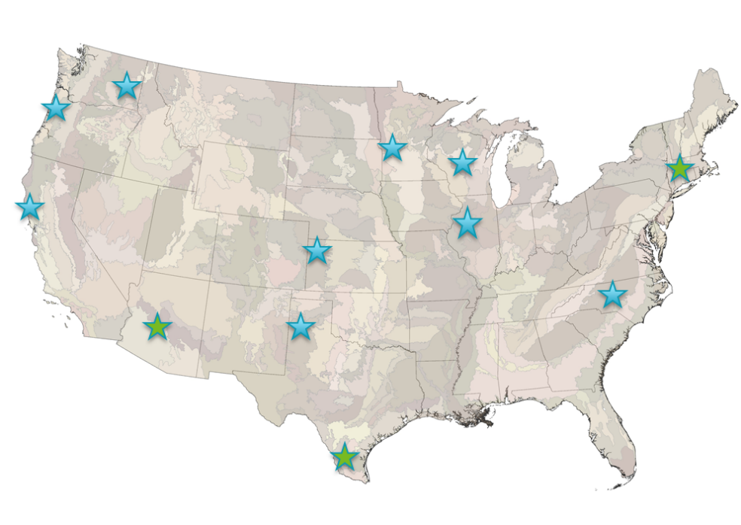Soil health has become an increasingly important area of emphasis in land management, particularly agricultural land management, within NRCS, in the larger scientific community and with the general public. As interest in soil health management continues to increase, so does the need for consistent, replicable, scientifically sound indicators, associated data, and interpretations that will allow for the assessment and monitoring of how agricultural management practices are affecting soil health. The Science of Soil Health Initiative seeks to gather, process and disseminate scientifically rigorous data for these purposes. Through the Science of Soil Health initiative, cooperators are collecting dynamic soil properties (DSPs). A common set of soil health metrics will be collected across regions and soils and linking the information gathered to soil survey DSP databases and products.

|  |  |
| --- | --- |
| **Soil Health Process** | **Indicator/Property** |
| Soil Structural Stability | Infiltration, Aggregate Stability |
| Organic Matter Cycling & C Sequestration | Soil Organic Carbon |
| General Microbial Activity | Soil Respiration, Soil Enzymes |
| Carbon Food Source | Active Carbon (Permanganate Oxidizable  Carbon, POXC) |
| Bioavailable Nitrogen | Available Organic Nitrogen |
| Microbial Community Composition | Community Structure (PLFA) |

**Outcomes:**

1. List of relevant DSPs and reference values that can be used to assess soil health status by soils under different management systems
2. Data (measurements) and information (interpretations) for a standard set of DSPs on one or more benchmark soils and soil landscapes to be included in national soil and ecological site databases maintained by NRCS
3. Recommendations for conservation planning and conservation effects assessment

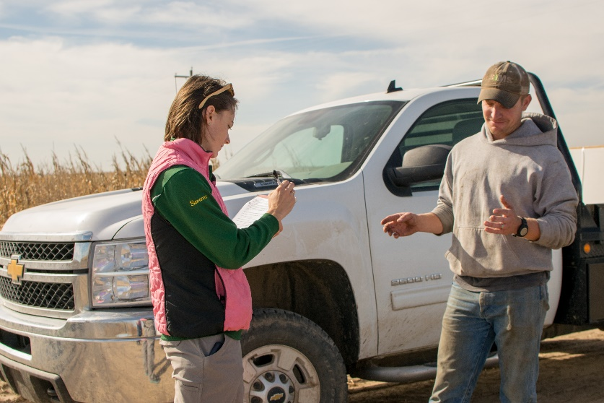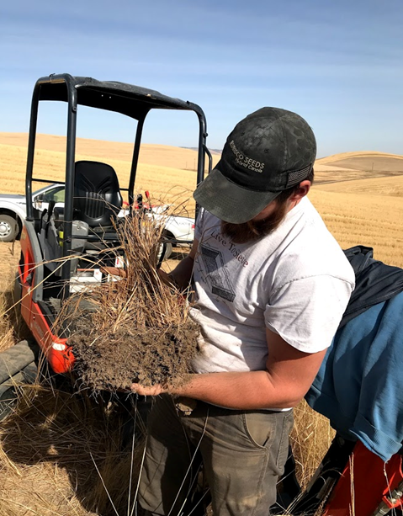**Current Status**

* Finished – data shared
  + Kansas State University
  + North Carolina State University
* In progress – Sample Collection and Analysis
  + Texas Agrilife
  + 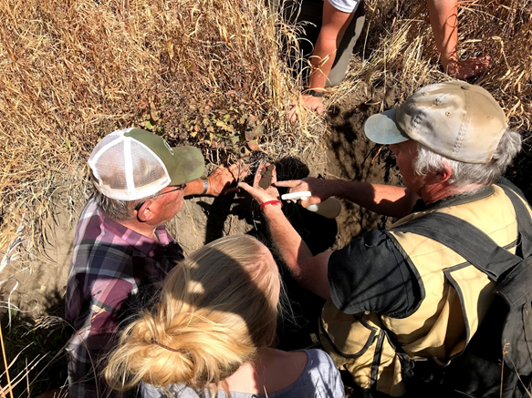Washington State University
  + University of Minnesota
  + University of Wisconsin
  + Chico State University
  + Oregon State University
  + University of Illinois
* Planning
  + University of Arizona
  + University of Texas – Rio Grande Valley
  + University of Connecticut

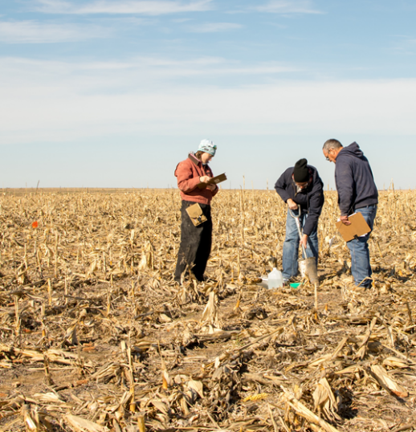

**Preliminary Results**

* Methods require further standardization before they are appropriate for commercialization across regions and soils
* Impact of soil health management varies by soil and institution
  + Climate, texture and crops grown influences management effects
* Perennial vegetation had significant and meaningfully better values for all properties evaluated thus far
* Differences between crop management systems are limited and applicable only within individual soils evaluated

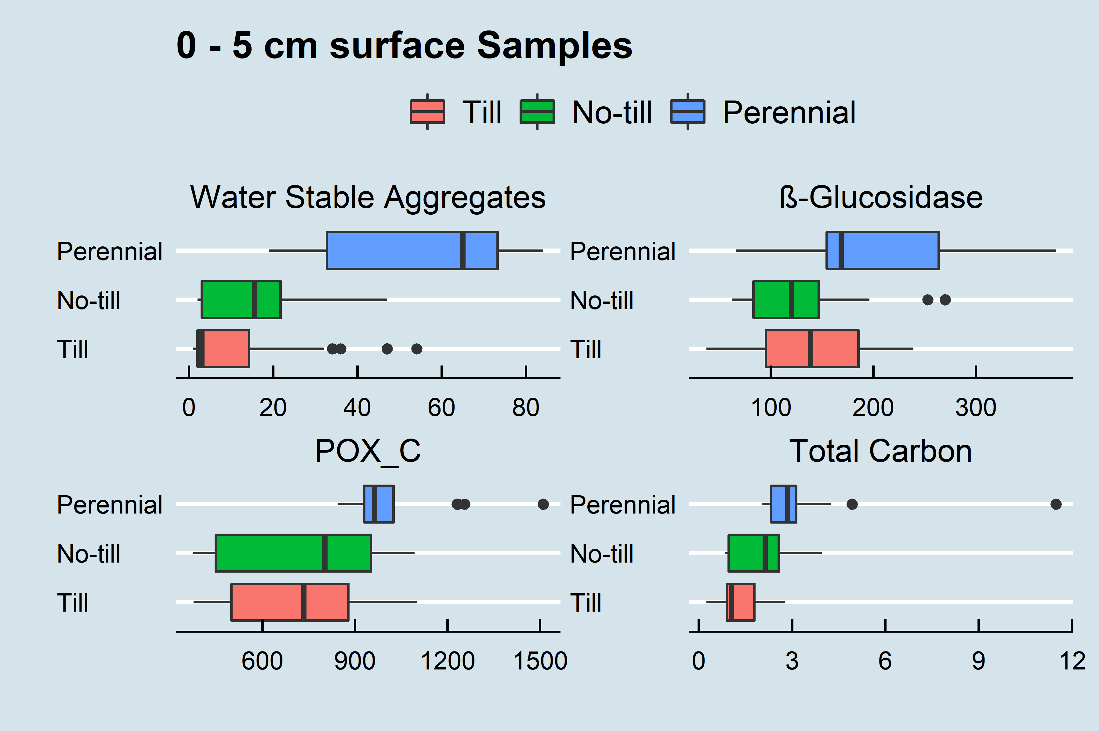Initial Analysis of Samples sent to KSSL for the upper approximately 3 inches of soil across all institutions. The bars represent the typical range of values in perennial vegetation, no-tillage cropping systems and business as usual cropping systems. The perennial vegetation is reliably higher, though not always significantly so. There is no observed difference between no-till and typical tillage systems. Aggregate stability (measured as % of aggregates that are stable in water after shaking) is nearly always higher in perennial systems; no-till is often greater than typical tillage but not always. The other enzyme and carbon analysis show a great deal of overlap between all systems evaluated.