**SHAPE – Soil Health Assessment Protocol and Evaluation**

Soil health can be assessed through the measurement of dynamic soil properties (DSPs) that change with land use and management. Soil health is improved with conservation practices such as increasing soil cover, increasing diversity of crops and minimizing disturbance. However, measuring those changes through DSPs is complicated by the inherent variability of soils and soil properties. For instance, you wouldn’t expect an Ultisol in the Southeast to have the same SOC content as a Mollisol in the Midwest.

The **Soil Health Assessment Protocol and Evaluation (SHAPE)** tool produces a standardized score for each DSP value based on peer groups of similar soils. Peer groups are groups of soils that have similar climate, texture and taxonomic classification. SHAPE uses a statistical algorithm to create a curve of expected values and computes a score for each DSP measurement. The score is scaled from 0 to 1 relative to what the DSP values are likely to be for that group: 0 - the lowest value likely to be measured, 1 - the highest value likely to be measured.

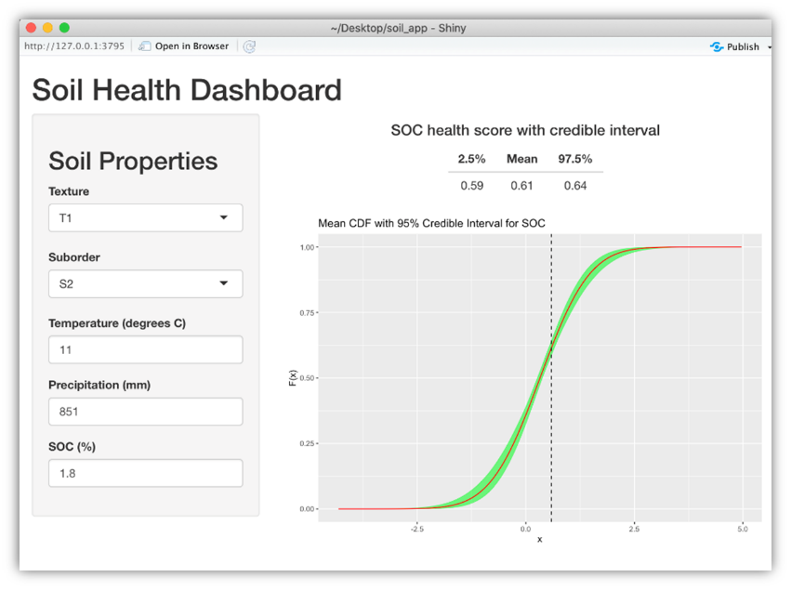This is a screenshot from an early implementation of the SHAPE curve and score based on user inputs. The DSP Hub will automate the population of inherent soil and climate properties based on location.

Each peer group has a distinct range and shape that relates the DSP value (SOC in this case) and the SHAPE score assigned.

For this peer group of soils, 1.59% SOC has a score of 0.61 meaning that roughly 60% of measurements are less than that and 40% are greater.

SHAPE was developed by a group of ARS, NRCS and University of Missouri scientists (Nunes et al; in press). The first SHAPE curve was developed for soil organic carbon (SOC) as it is widely measured and a keystone indicator of soil health, reflecting multiple soil functions and ecosystem services. There is ongoing work to develop SHAPE curves for the initial 5 properties to be assessed in the Conservation Innovation Grant On-farm Soil Health Demonstration Trials (CIG OF-SHDT) awardees. Future work will develop techniques for statistical analyses of scores across time, fields and conservation practices.