## Procedure for Updating Kellogg Soil Survey Laboratory (KSSL) Characterization Data

Steps 1 through 7 will be used in the new method of maintaining KSSL data. Formerly, pedon data were updated using the SOI-8 form. Historically, there have been duplicate sites and pedons in NASIS—one owned by KSSL (still referred to as NSSL in examples) and the other owned by the MLRA Office (MLRAxx_Office). This process will link the pedons to one site. Changes will need to be made in order to update the Correlated Name, Classification, and Location.

For sampled sites in need of updating:

1. The SDQS will load the sites and pedons into NASIS.

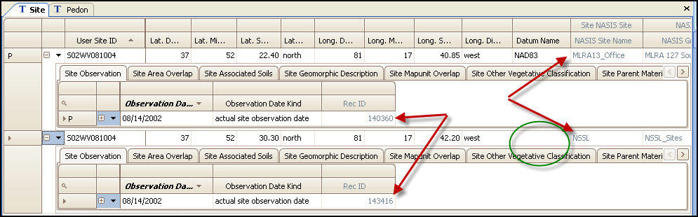

1. The site owned by KSSL will be the official site for all pedons associated with lab data. The SDQS will update the official site to include all additions, corrections, or updates to the various data fields. In this example, notice that location and datum are two that need to be reconciled and populated on the KSSL-owned site.
2. The MLRAxx_Office pedon will be modified and linked to the site owned by the KSSL_Sites_MO_XX Group in the NASIS KSSL Site. In the image below, the pedons are linked to each site—one to the KSSL_Sites_MO_XX site and the other to the MLRA13_Office.

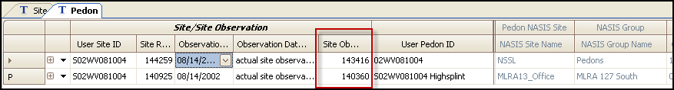

1. In the example above, the pedon linked to Site Observation 140360 will be edited and linked to Site Observation 143416 as noted in the image below.

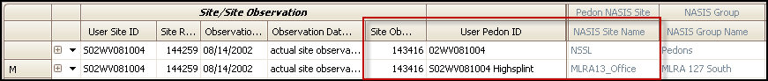

1. The MLRAxx_Office site record can then be deleted.
   1. If there are other pedons linked to the MLRAxx_Office site, the site should remain untouched.
   2. Before the MLRAxx_Office site is deleted, it should be compared to the KSSL site and any child table information should be updated in the KSSL Site table.
2. If there has been extensive updating to the MLRAxx_Office site and it is better to make this the official site, then change the ownership of that site to the KSSL_Sites_MO_XX group. Change the ownership of the original site in the KSSL_Sites_MO_XX group to the KSSL_sites_to_delete. KSSL will link their pedon to the MLRAxx_Office site that has been designated and the original KSSL site will be deleted.
3. This process involving one site and two pedons will replace the SOI-8 process. It will allow the soil survey regional office staff to provide quality assurance and maintain the correlation history of the sampled pedons. The staff will have the ability to maintain the site information and the pedon information.
4. This process will also allow the most current pedon description to be published with the lab data via the KSSL Web site. Before the MLRAxx_Office pedon can be published, two sets of data will need to be populated:
   1. The Lab Source ID and Lab Pedon# in the Pedon table. These fields in the KSSL and MLRAxx_Office pedons must match.

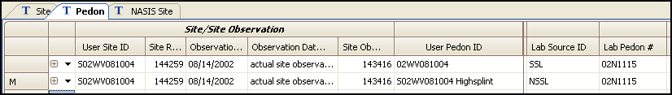

* 1. The “Lab Sample #” column in the new NASIS 6.2 Pedon Horizon Sample table.

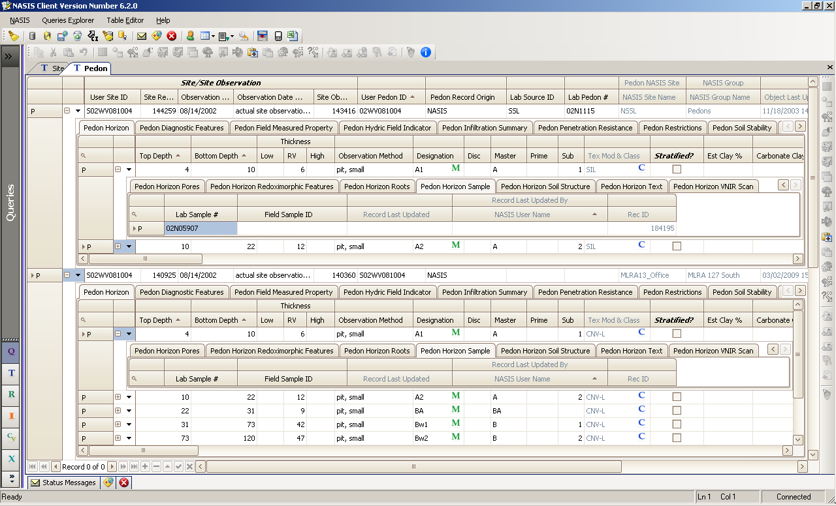

* 1. When the Lab Source ID, Lab Pedon #, and Pedon Horizon Sample table are populated in the MLRAxx_Office pedon, the KSSL Web site will use the MLRAxx_Office pedon as the official record for the lab data reports.

For more information, refer to the *Soil Survey Laboratory Information Manual*.