# Combine_nasis_ncss_table

NAIS Reports:

* KSSL: Site_Laboratory_Locations_Overlaps__NCSS_site
* KSSL: Site_Laboratory_Locations_Overlaps__NCSS_augmented_and_more

Other possible reports under: KSSL_Production

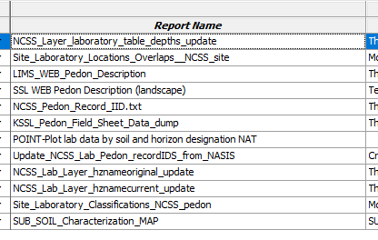

SQL Server Agent (JoB) Server AIONELI93AP1

## Job: Run Combine SSIS Package

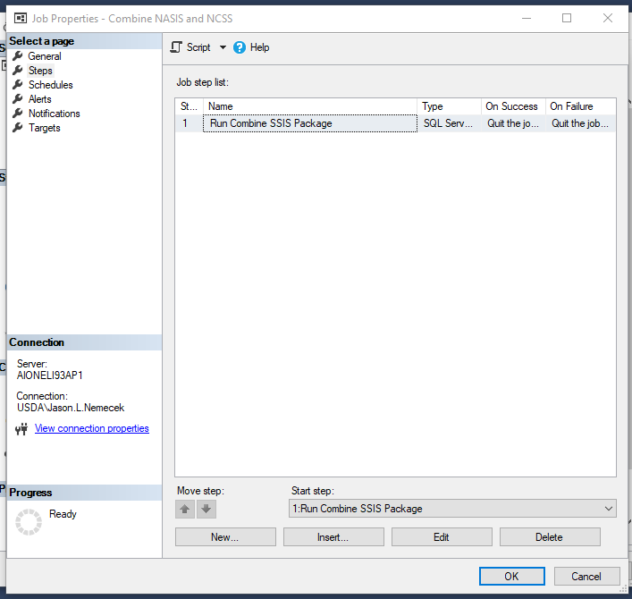

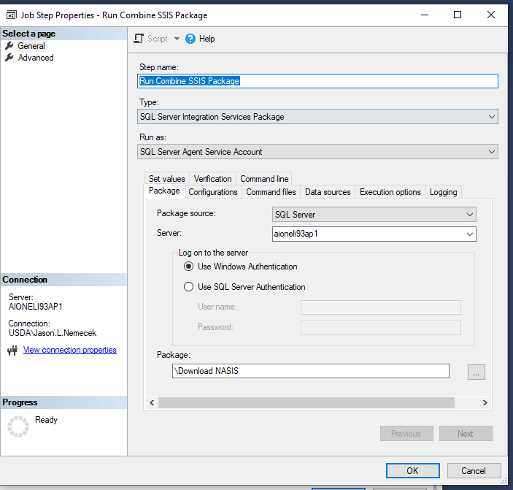

## Job: Update and Insert combine_nasis_ncss Table from View

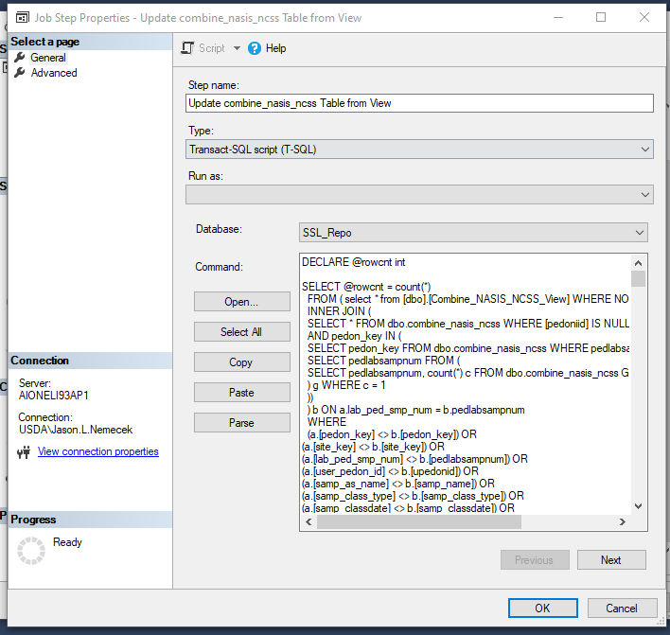

## **Database: SSL_Repo**

## **Step1**

DECLARE @rowcnt int

SELECT @rowcnt = count(*)

FROM ( select * from [dbo].[Combine_NASIS_NCSS_View] WHERE NOT lab_ped_smp_num IS NULL) a

INNER JOIN (

SELECT * FROM dbo.combine_nasis_ncss WHERE [pedoniid] IS NULL

AND pedon_key IN (

SELECT pedon_key FROM dbo.combine_nasis_ncss WHERE pedlabsampnum IN (

SELECT pedlabsampnum FROM (

SELECT pedlabsampnum, count(*) c FROM dbo.combine_nasis_ncss GROUP BY pedlabsampnum

) g WHERE c = 1

))

) b ON a.lab_ped_smp_num = b.pedlabsampnum

WHERE

(a.[pedon_key] <> b.[pedon_key]) OR

(a.[site_key] <> b.[site_key]) OR

(a.[lab_ped_smp_num] <> b.[pedlabsampnum]) OR

(a.[user_pedon_id] <> b.[upedonid]) OR

(a.[samp_as_name] <> b.[samp_name]) OR

(a.[samp_class_type] <> b.[samp_class_type]) OR

(a.[samp_classdate] <> b.[samp_classdate]) OR

(a.[samp_classification_name] <> b.[samp_classification_name]) OR

(a.[samp_taxorder] <> b.[samp_taxorder]) OR

(a.[samp_taxsuborder] <> b.[samp_taxsuborder]) OR

(a.[samp_taxgrtgroup] <> b.[samp_taxgrtgroup]) OR

(a.[samp_taxsubgrp] <> b.[samp_taxsubgrp]) OR

(a.[samp_taxpartsize] <> b.[samp_taxpartsize]) OR

(a.[samp_taxpartsizemod] <> b.[samp_taxpartsizemod]) OR

(a.[samp_taxfamhahatmatcl] <> b.[samp_taxfamhahatmatcl]) OR

(a.[samp_taxceactcl] <> b.[samp_taxceactcl]) OR

(a.[samp_taxreaction] <> b.[samp_taxreaction]) OR

(a.[samp_taxtempcl] <> b.[samp_taxtempcl]) OR

(a.[samp_taxmoistscl] <> b.[samp_taxmoistscl]) OR

(a.[samp_taxtempregime] <> b.[samp_taxtempregime]) OR

(a.[samp_taxminalogy] <> b.[samp_taxminalogy]) OR

(a.[samp_taxother] <> b.[samp_taxother]) OR

(a.[samp_osdtypelocflag] <> b.[samp_osdtypelocflag]) OR

(a.[corr_as_name] <> b.[corr_name]) OR

(a.[corr_class_type] <> b.[corr_class_type]) OR

(a.[corr_classdate] <> b.[corr_classdate]) OR

(a.[corr_classification_name] <> b.[corr_classification_name]) OR

(a.[corr_taxorder] <> b.[corr_taxorder]) OR

(a.[corr_taxsuborder] <> b.[corr_taxsuborder]) OR

(a.[corr_taxgrtgroup] <> b.[corr_taxgrtgroup]) OR

(a.[corr_taxsubgrp] <> b.[corr_taxsubgrp]) OR

(a.[corr_taxpartsize] <> b.[corr_taxpartsize]) OR

(a.[corr_taxpartsizemod] <> b.[corr_taxpartsizemod]) OR

(a.[corr_taxfamhahatmatcl] <> b.[corr_taxfamhahatmatcl]) OR

(a.[corr_taxceactcl] <> b.[corr_taxceactcl]) OR

(a.[corr_taxreaction] <> b.[corr_taxreaction]) OR

(a.[corr_taxtempcl] <> b.[corr_taxtempcl]) OR

(a.[corr_taxmoistscl] <> b.[corr_taxmoistscl]) OR

(a.[corr_taxtempregime] <> b.[corr_taxtempregime]) OR

(a.[corr_taxminalogy] <> b.[corr_taxminalogy]) OR

(a.[corr_taxother] <> b.[corr_taxother]) OR

(a.[corr_osdtypelocflag] <> b.[corr_osdtypelocflag]) OR

(a.[SSL_as_name] <> b.[SSL_name]) OR

(a.[SSL_class_type] <> b.[SSL_class_type]) OR

(a.[SSL_classdate] <> b.[SSL_classdate]) OR

(a.[SSL_classification_name] <> b.[SSL_classification_name]) OR

(a.[SSL_taxorder] <> b.[SSL_taxorder]) OR

(a.[SSL_taxsuborder] <> b.[SSL_taxsuborder]) OR

(a.[SSL_taxgrtgroup] <> b.[SSL_taxgrtgroup]) OR

(a.[SSL_taxsubgrp] <> b.[SSL_taxsubgrp]) OR

(a.[SSL_taxpartsize] <> b.[SSL_taxpartsize]) OR

(a.[SSL_taxpartsizemod] <> b.[SSL_taxpartsizemod]) OR

(a.[SSL_taxfamhahatmatcl] <> b.[SSL_taxfamhahatmatcl]) OR

(a.[SSL_taxceactcl] <> b.[SSL_taxceactcl]) OR

(a.[SSL_taxreaction] <> b.[SSL_taxreaction]) OR

(a.[SSL_taxtempcl] <> b.[SSL_taxtempcl]) OR

(a.[SSL_taxmoistscl] <> b.[SSL_taxmoistscl]) OR

(a.[SSL_taxtempregime] <> b.[SSL_taxtempregime]) OR

(a.[SSL_taxminalogy] <> b.[SSL_taxminalogy]) OR

(a.[SSL_taxother] <> b.[SSL_taxother]) OR

(a.[SSL_osdtypelocflag] <> b.[SSL_osdtypelocflag]) OR

(a.[user_site_id] <> b.[usiteid]) OR

(a.[observation_date] <> b.[site_obsdate]) OR

(a.[latitude_std_decimal_degrees] <> b.[latitude_decimal_degrees]) OR

(a.[longitude_std_decimal_degrees] <> b.[longitude_decimal_degrees]) OR

(a.[country_key] <> b.[country_key]) OR

(a.[state_admindiv_key] <> b.[state_key]) OR

(a.[county_key] <> b.[county_key]) OR

(a.[mlra_key] <> b.[mlra_key]) OR

(a.[ssa_key] <> b.[ssa_key]) OR

(a.[npark_key] <> b.[npark_key]) OR

(a.[nforest_key] <> b.[nforest_key]) OR

(a.[horizontal_datum_name] <> b.[horizontal_datum_name]) OR

(a.[latitude_direction] <> b.[latitude_direction]) OR

(a.[latitude_degrees] <> b.[latitude_degrees]) OR

(a.[latitude_minutes] <> b.[latitude_minutes]) OR

(a.[latitude_seconds] <> b.[latitude_seconds]) OR

(a.[longitude_direction] <> b.[longitude_direction]) OR

(a.[longitude_degrees] <> b.[longitude_degrees]) OR

(a.[longitude_minutes] <> b.[longitude_minutes]) OR

(a.[longitude_seconds] <> b.[longitude_seconds])

PRINT CAST(@rowcnt as varchar(20)) + ' pedons need to be updated.'

IF @rowcnt > 0 BEGIN

UPDATE dbo.combine_nasis_ncss

SET

[pedon_key] = new.[pedon_key],

[site_key] = new.[site_key],

[pedlabsampnum] = new.[lab_ped_smp_num],

[upedonid] = new.[user_pedon_id],

[samp_name] = new.[samp_as_name],

[samp_class_type] = new.[samp_class_type],

[samp_classdate] = new.[samp_classdate],

[samp_classification_name] = new.[samp_classification_name],

[samp_taxorder] = new.[samp_taxorder],

[samp_taxsuborder] = new.[samp_taxsuborder],

[samp_taxgrtgroup] = new.[samp_taxgrtgroup],

[samp_taxsubgrp] = new.[samp_taxsubgrp],

[samp_taxpartsize] = new.[samp_taxpartsize],

[samp_taxpartsizemod] = new.[samp_taxpartsizemod],

[samp_taxfamhahatmatcl] = new.[samp_taxfamhahatmatcl],

[samp_taxceactcl] = new.[samp_taxceactcl],

[samp_taxreaction] = new.[samp_taxreaction],

[samp_taxtempcl] = new.[samp_taxtempcl],

[samp_taxmoistscl] = new.[samp_taxmoistscl],

[samp_taxtempregime] = new.[samp_taxtempregime],

[samp_taxminalogy] = new.[samp_taxminalogy],

[samp_taxother] = new.[samp_taxother],

[samp_osdtypelocflag] = new.[samp_osdtypelocflag],

[corr_name] = new.[corr_as_name],

[corr_class_type] = new.[corr_class_type],

[corr_classdate] = new.[corr_classdate],

[corr_classification_name] = new.[corr_classification_name],

[corr_taxorder] = new.[corr_taxorder],

[corr_taxsuborder] = new.[corr_taxsuborder],

[corr_taxgrtgroup] = new.[corr_taxgrtgroup],

[corr_taxsubgrp] = new.[corr_taxsubgrp],

[corr_taxpartsize] = new.[corr_taxpartsize],

[corr_taxpartsizemod] = new.[corr_taxpartsizemod],

[corr_taxfamhahatmatcl] = new.[corr_taxfamhahatmatcl],

[corr_taxceactcl] = new.[corr_taxceactcl],

[corr_taxreaction] = new.[corr_taxreaction],

[corr_taxtempcl] = new.[corr_taxtempcl],

[corr_taxmoistscl] = new.[corr_taxmoistscl],

[corr_taxtempregime] = new.[corr_taxtempregime],

[corr_taxminalogy] = new.[corr_taxminalogy],

[corr_taxother] = new.[corr_taxother],

[corr_osdtypelocflag] = new.[corr_osdtypelocflag],

[SSL_name] = new.[SSL_as_name],

[SSL_class_type] = new.[SSL_class_type],

[SSL_classdate] = new.[SSL_classdate],

[SSL_classification_name] = new.[SSL_classification_name],

[SSL_taxorder] = new.[SSL_taxorder],

[SSL_taxsuborder] = new.[SSL_taxsuborder],

[SSL_taxgrtgroup] = new.[SSL_taxgrtgroup],

[SSL_taxsubgrp] = new.[SSL_taxsubgrp],

[SSL_taxpartsize] = new.[SSL_taxpartsize],

[SSL_taxpartsizemod] = new.[SSL_taxpartsizemod],

[SSL_taxfamhahatmatcl] = new.[SSL_taxfamhahatmatcl],

[SSL_taxceactcl] = new.[SSL_taxceactcl],

[SSL_taxreaction] = new.[SSL_taxreaction],

[SSL_taxtempcl] = new.[SSL_taxtempcl],

[SSL_taxmoistscl] = new.[SSL_taxmoistscl],

[SSL_taxtempregime] = new.[SSL_taxtempregime],

[SSL_taxminalogy] = new.[SSL_taxminalogy],

[SSL_taxother] = new.[SSL_taxother],

[SSL_osdtypelocflag] = new.[SSL_osdtypelocflag],

[usiteid] = new.[user_site_id],

[site_obsdate] = new.[observation_date],

[latitude_decimal_degrees] = new.[latitude_std_decimal_degrees],

[longitude_decimal_degrees] = new.[longitude_std_decimal_degrees],

[country_key] = new.[country_key],

[state_key] = new.[state_admindiv_key],

[county_key] = new.[county_key],

[mlra_key] = new.[mlra_key],

[ssa_key] = new.[ssa_key],

[npark_key] = new.[npark_key],

[nforest_key] = new.[nforest_key],

[horizontal_datum_name] = new.[horizontal_datum_name],

[latitude_direction] = new.[latitude_direction],

[latitude_degrees] = new.[latitude_degrees],

[latitude_minutes] = new.[latitude_minutes],

[latitude_seconds] = new.[latitude_seconds],

[longitude_direction] = new.[longitude_direction],

[longitude_degrees] = new.[longitude_degrees],

[longitude_minutes] = new.[longitude_minutes],

[longitude_seconds] = new.[longitude_seconds]

FROM (

SELECT a.*

FROM ( select * from [dbo].[Combine_NASIS_NCSS_View] WHERE NOT lab_ped_smp_num IS NULL) a

INNER JOIN (

SELECT * FROM dbo.combine_nasis_ncss WHERE [pedoniid] IS NULL

AND pedon_key IN (

SELECT pedon_key FROM dbo.combine_nasis_ncss WHERE pedlabsampnum IN (

SELECT pedlabsampnum FROM (

SELECT pedlabsampnum, count(*) c FROM dbo.combine_nasis_ncss GROUP BY pedlabsampnum

) g WHERE c = 1

))

) b ON a.lab_ped_smp_num = b.pedlabsampnum

--WHERE b.pedlabsampnum in ('13N92659')

WHERE

(a.[pedon_key] <> b.[pedon_key]) OR

(a.[site_key] <> b.[site_key]) OR

(a.[lab_ped_smp_num] <> b.[pedlabsampnum]) OR

(a.[user_pedon_id] <> b.[upedonid]) OR

(a.[samp_as_name] <> b.[samp_name]) OR

(a.[samp_class_type] <> b.[samp_class_type]) OR

(a.[samp_classdate] <> b.[samp_classdate]) OR

(a.[samp_classification_name] <> b.[samp_classification_name]) OR

(a.[samp_taxorder] <> b.[samp_taxorder]) OR

(a.[samp_taxsuborder] <> b.[samp_taxsuborder]) OR

(a.[samp_taxgrtgroup] <> b.[samp_taxgrtgroup]) OR

(a.[samp_taxsubgrp] <> b.[samp_taxsubgrp]) OR

(a.[samp_taxpartsize] <> b.[samp_taxpartsize]) OR

(a.[samp_taxpartsizemod] <> b.[samp_taxpartsizemod]) OR

(a.[samp_taxfamhahatmatcl] <> b.[samp_taxfamhahatmatcl]) OR

(a.[samp_taxceactcl] <> b.[samp_taxceactcl]) OR

(a.[samp_taxreaction] <> b.[samp_taxreaction]) OR

(a.[samp_taxtempcl] <> b.[samp_taxtempcl]) OR

(a.[samp_taxmoistscl] <> b.[samp_taxmoistscl]) OR

(a.[samp_taxtempregime] <> b.[samp_taxtempregime]) OR

(a.[samp_taxminalogy] <> b.[samp_taxminalogy]) OR

(a.[samp_taxother] <> b.[samp_taxother]) OR

(a.[samp_osdtypelocflag] <> b.[samp_osdtypelocflag]) OR

(a.[corr_as_name] <> b.[corr_name]) OR

(a.[corr_class_type] <> b.[corr_class_type]) OR

(a.[corr_classdate] <> b.[corr_classdate]) OR

(a.[corr_classification_name] <> b.[corr_classification_name]) OR

(a.[corr_taxorder] <> b.[corr_taxorder]) OR

(a.[corr_taxsuborder] <> b.[corr_taxsuborder]) OR

(a.[corr_taxgrtgroup] <> b.[corr_taxgrtgroup]) OR

(a.[corr_taxsubgrp] <> b.[corr_taxsubgrp]) OR

(a.[corr_taxpartsize] <> b.[corr_taxpartsize]) OR

(a.[corr_taxpartsizemod] <> b.[corr_taxpartsizemod]) OR

(a.[corr_taxfamhahatmatcl] <> b.[corr_taxfamhahatmatcl]) OR

(a.[corr_taxceactcl] <> b.[corr_taxceactcl]) OR

(a.[corr_taxreaction] <> b.[corr_taxreaction]) OR

(a.[corr_taxtempcl] <> b.[corr_taxtempcl]) OR

(a.[corr_taxmoistscl] <> b.[corr_taxmoistscl]) OR

(a.[corr_taxtempregime] <> b.[corr_taxtempregime]) OR

(a.[corr_taxminalogy] <> b.[corr_taxminalogy]) OR

(a.[corr_taxother] <> b.[corr_taxother]) OR

(a.[corr_osdtypelocflag] <> b.[corr_osdtypelocflag]) OR

(a.[SSL_as_name] <> b.[SSL_name]) OR

(a.[SSL_class_type] <> b.[SSL_class_type]) OR

(a.[SSL_classdate] <> b.[SSL_classdate]) OR

(a.[SSL_classification_name] <> b.[SSL_classification_name]) OR

(a.[SSL_taxorder] <> b.[SSL_taxorder]) OR

(a.[SSL_taxsuborder] <> b.[SSL_taxsuborder]) OR

(a.[SSL_taxgrtgroup] <> b.[SSL_taxgrtgroup]) OR

(a.[SSL_taxsubgrp] <> b.[SSL_taxsubgrp]) OR

(a.[SSL_taxpartsize] <> b.[SSL_taxpartsize]) OR

(a.[SSL_taxpartsizemod] <> b.[SSL_taxpartsizemod]) OR

(a.[SSL_taxfamhahatmatcl] <> b.[SSL_taxfamhahatmatcl]) OR

(a.[SSL_taxceactcl] <> b.[SSL_taxceactcl]) OR

(a.[SSL_taxreaction] <> b.[SSL_taxreaction]) OR

(a.[SSL_taxtempcl] <> b.[SSL_taxtempcl]) OR

(a.[SSL_taxmoistscl] <> b.[SSL_taxmoistscl]) OR

(a.[SSL_taxtempregime] <> b.[SSL_taxtempregime]) OR

(a.[SSL_taxminalogy] <> b.[SSL_taxminalogy]) OR

(a.[SSL_taxother] <> b.[SSL_taxother]) OR

(a.[SSL_osdtypelocflag] <> b.[SSL_osdtypelocflag]) OR

(a.[user_site_id] <> b.[usiteid]) OR

(a.[observation_date] <> b.[site_obsdate]) OR

(a.[latitude_std_decimal_degrees] <> b.[latitude_decimal_degrees]) OR

(a.[longitude_std_decimal_degrees] <> b.[longitude_decimal_degrees]) OR

(a.[country_key] <> b.[country_key]) OR

(a.[state_admindiv_key] <> b.[state_key]) OR

(a.[county_key] <> b.[county_key]) OR

(a.[mlra_key] <> b.[mlra_key]) OR

(a.[ssa_key] <> b.[ssa_key]) OR

(a.[npark_key] <> b.[npark_key]) OR

(a.[nforest_key] <> b.[nforest_key]) OR

(a.[horizontal_datum_name] <> b.[horizontal_datum_name]) OR

(a.[latitude_direction] <> b.[latitude_direction]) OR

(a.[latitude_degrees] <> b.[latitude_degrees]) OR

(a.[latitude_minutes] <> b.[latitude_minutes]) OR

(a.[latitude_seconds] <> b.[latitude_seconds]) OR

(a.[longitude_direction] <> b.[longitude_direction]) OR

(a.[longitude_degrees] <> b.[longitude_degrees]) OR

(a.[longitude_minutes] <> b.[longitude_minutes]) OR

(a.[longitude_seconds] <> b.[longitude_seconds])

) new

WHERE dbo.combine_nasis_ncss.pedlabsampnum = new.lab_ped_smp_num

END

GO

## **Database SSL_Repo**

## **Step2**

DECLARE @rowcnt int

SELECT @rowcnt = count(*)

FROM [dbo].[Combine_NASIS_NCSS_View] v

left join [dbo].[combine_nasis_ncss] c ON v.lab_ped_smp_num = c.pedlabsampnum

where c.pedon_key is null

PRINT CAST(@rowcnt as varchar(20)) + ' pedons need to be inserted.'

IF @rowcnt > 0 BEGIN

INSERT dbo.combine_nasis_ncss

SELECT v.[pedon_key]

,v.[site_key]

,v.[lab_ped_smp_num]

,v.[pedoniid]

,v.[user_pedon_id]

,v.[labdatadescflag]

,v.[priority]

,v.[priority2]

,v.[samp_as_name]

,v.[samp_class_type]

,v.[samp_classdate]

,v.[samp_classification_name]

,v.[samp_taxorder]

,v.[samp_taxsuborder]

,v.[samp_taxgrtgroup]

,v.[samp_taxsubgrp]

,v.[samp_taxpartsize]

,v.[samp_taxpartsizemod]

,v.[samp_taxceactcl]

,v.[samp_taxreaction]

,v.[samp_taxtempcl]

,v.[samp_taxmoistscl]

,v.[samp_taxtempregime]

,v.[samp_taxminalogy]

,v.[samp_taxother]

,v.[samp_osdtypelocflag]

,v.[corr_as_name]

,v.[corr_class_type]

,v.[corr_classdate]

,v.[corr_classification_name]

,v.[corr_taxorder]

,v.[corr_taxsuborder]

,v.[corr_taxgrtgroup]

,v.[corr_taxsubgrp]

,v.[corr_taxpartsize]

,v.[corr_taxpartsizemod]

,v.[corr_taxceactcl]

,v.[corr_taxreaction]

,v.[corr_taxtempcl]

,v.[corr_taxmoistscl]

,v.[corr_taxtempregime]

,v.[corr_taxminalogy]

,v.[corr_taxother]

,v.[corr_osdtypelocflag]

,v.[SSL_as_name]

,v.[SSL_class_type]

,v.[SSL_classdate]

,v.[SSL_classification_name]

,v.[SSL_taxorder]

,v.[SSL_taxsuborder]

,v.[SSL_taxgrtgroup]

,v.[SSL_taxsubgrp]

,v.[SSL_taxpartsize]

,v.[SSL_taxpartsizemod]

,v.[SSL_taxceactcl]

,v.[SSL_taxreaction]

,v.[SSL_taxtempcl]

,v.[SSL_taxmoistscl]

,v.[SSL_taxtempregime]

,v.[SSL_taxminalogy]

,v.[SSL_taxother]

,v.[SSL_osdtypelocflag]

,v.[siteiid]

,v.[user_site_id]

,v.[observation_date]

,v.[latitude_std_decimal_degrees]

,v.[longitude_std_decimal_degrees]

,v.[country_key]

,v.[state_admindiv_key]

,v.[county_key]

,v.[mlra_key]

,v.[ssa_key]

,v.[npark_key]

,v.[nforest_key]

,v.[note]

,v.[samp_taxfamhahatmatcl]

,v.[corr_taxfamhahatmatcl]

,v.[SSL_taxfamhahatmatcl]

,v.[pedobjupdate]

,v.[siteobjupdate]

,v.[physiographic_division]

,v.[physiographic_province]

,v.[physiographic_section]

,v.[local_physiographic_area]

,v.[geomorphic_setting]

,v.[upslope_shape]

,v.[cross_slope_shape]

,v.[primary_earth_cover]

,v.[secondary_earth_cover]

,v.[existing_vegetation]

,v.[parent_material]

,v.[bedrock_kind]

,v.[bedrock_depth]

,v.[bedrock_hardness]

,v.[bedrock_fracture_interval]

,v.[surface_fragments]

,v.[slope]

,v.[elevation]

,v.[aspect]

,v.[maat]

,v.[msat]

,v.[mwat]

,v.[map]

,v.[frost_free_days]

,v.[drainage_class]

,v.[slope_length]

,v.[upslope_length]

,v.[state_physiographic_area]

,v.[horizontal_datum_name]

,v.[latitude_direction]

,v.[latitude_degrees]

,v.[latitude_minutes]

,v.[latitude_seconds]

,v.[longitude_direction]

,v.[longitude_degrees]

,v.[longitude_minutes]

,v.[longitude_seconds]

FROM [dbo].[Combine_NASIS_NCSS_View] v

left join [dbo].[combine_nasis_ncss] c ON v.lab_ped_smp_num = c.pedlabsampnum

where c.pedon_key is null

END

GO