## Objective

NRCS developers and DBAs will need to use SQL Server Data Tools to generate the snapshot of the databases for promotion. The ability to generate similar dacpac /bacpac snapshots from SQL Server Management Studio is very limited.

## Visual Studio 2017

This licensed software that must be installed by CTS. There are some limitations to the Data Tools only configuration. These may not affect the current phase processes, but could limit collaboration.

The full VS will not be installed on any database hosts.

## SQL Server Data Tools

The SQL server Data Tools (SSDT) can be installed with or without Visual Studio. If installed with Visual Studio it must be installed second since the full VS install may overwrite some files. The version of SSDT should match the version of Visual Studio.

Scenarios

1. SQL Server Data Tools 2015 stand-alone.
2. Visual Studio 2017 plus SQL Server Data Tools 2017.

SQL Server Data Tools is not licensed and can be added by NRCS personnel if using the approved installs:

SSDT for VS 17 is here: T:\TEMP\jantrim\SSDT VS 2017\SSDT-Setup-ENU.exe

Steps to configure SSDT:

1. Copy executable to your desktop.
2. Right click and select “Run elevated”
3. Install, accepting defaults
4. Restart

### Configure Shortcut for SSDT with EDC Credentials

Create a shortcut on your laptop’s desktop so you can run this program using your EDC “p account.” Substitute your “p account” in the example below:

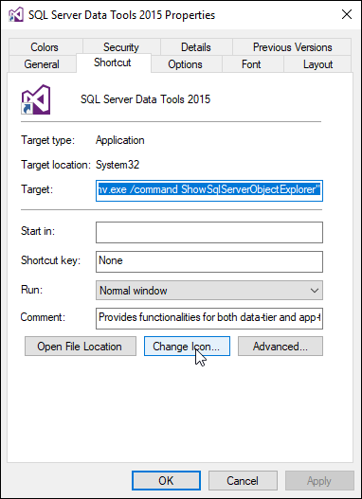C:\Windows\System32\runas.exe /netonly /user:EDC\p*lastf*01 "C:\Program Files (x86)\Microsoft Visual Studio 14.0\Common7\IDE\devenv.exe /command ShowSqlServerObjectExplorer"

<or for 2017>

C:\Windows\System32\runas.exe /netonly /user:EDC\paccount

"C:\Program Files (x86)\Microsoft Visual Studio XX.0\Common7\IDE\devenv.exe"

To update icon, click Change Icon and browse to:

C:\Program Files (x86)\Microsoft Visual Studio 14.0\Common7\IDE\devenv.exe

Choose un-even infinity symbol with white inside, then press OK.