Click the plug on the Team Explorer page in Visual Studio

Click Manage Connections then Connect to a Project

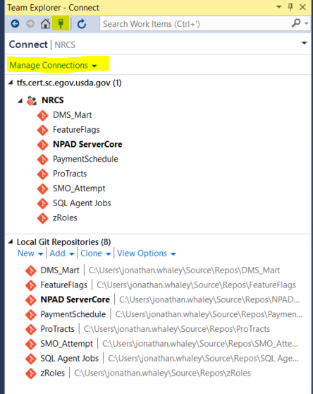

Click Add TFS Server

Enter the new URL <https://tfs.cert.sc.egov.usda.gov> and click Add

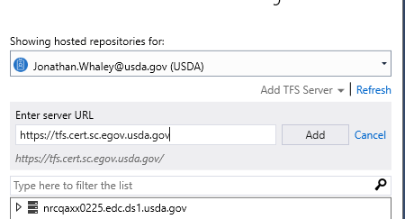

Expand NRCS

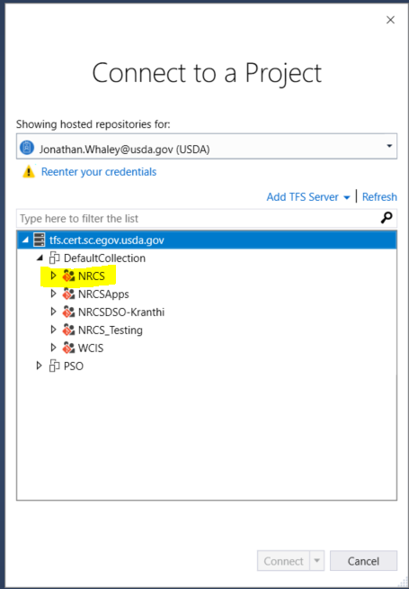

Click on WCIS and click Clone

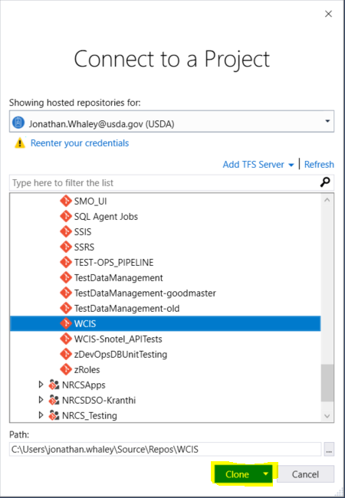

Click the Team Explorer button on the bottom of the opened window then click Settings

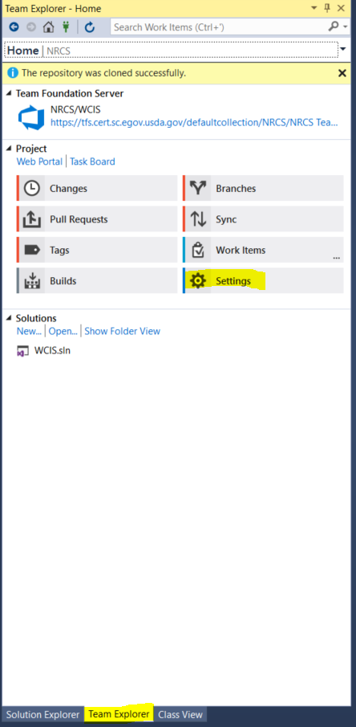

Click Global Settings

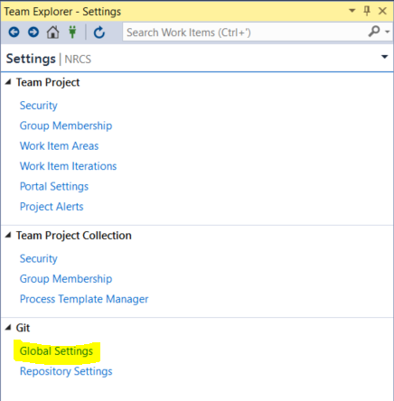

Find “Prune remote branches during fetch” and change the option to “True”

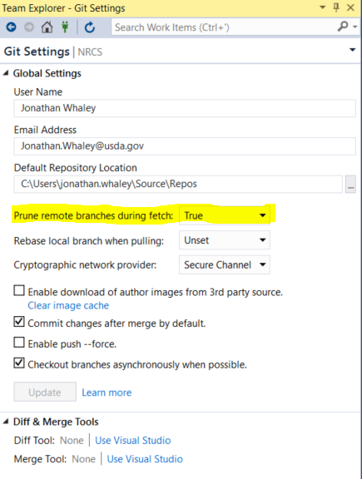

Click the Home button and double click the solution file

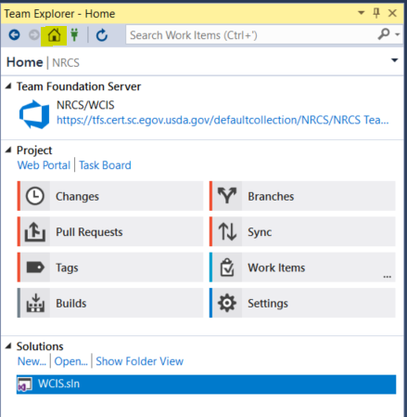

Click Solution Explorer on the bottom and collapse all

