# Objective

This document is designed to provide a guide on the check in/ merge process for TFS/GIT. It is assumed that you are using Visual Studio and have the Git repository already configured. It is also assumed that you make your code changes in Visual Studio.

# Instructions

## Open a Solution

Follow these steps if you need to clone a new repository

* Click the connect button( looks like a plug)
* Click Manage Connections> Connect to a Project

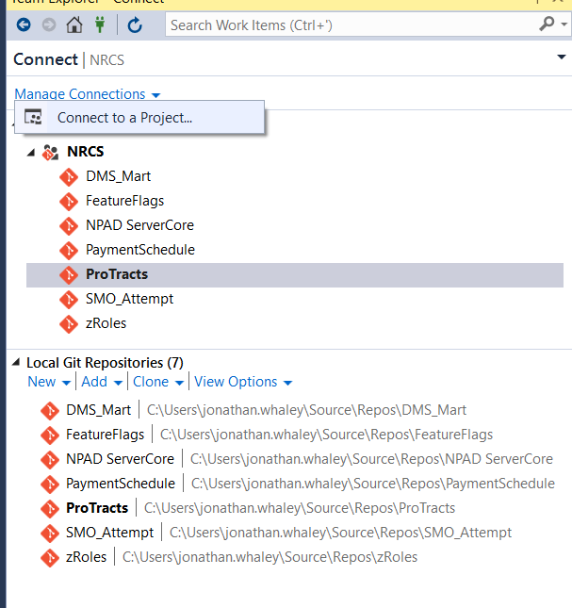

* Click the project from the list
* Click the Clone button
* If the button is “Connect” that project is already cloned
  + Click the Connect button if that is the case

Follow these steps if you already cloned a repository

* Click the connect button( looks like a plug)
* Click on the project you need such as NPAD ServerCore
* Click the Repository for the project needed such as NPAD ServerCore

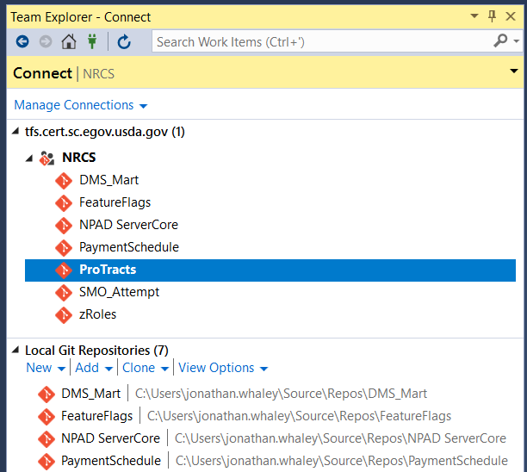

* Double click the solution file example NPAD.sln

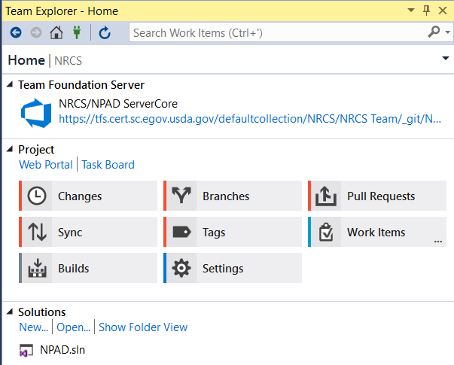

## Branching

* Click Branches
* Right-Click the branch( Ex. Release_2020_Hops)
* Perform a Fetch/Pull on your source branch ( Ex. Release_2020_Hops)
* Select New Local Branch from…

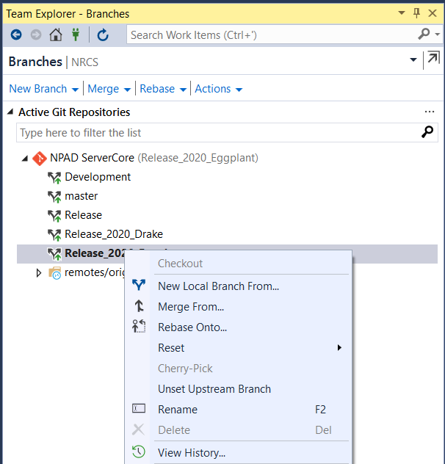

* Enter the name
  + NOTE: It is required to follow this format “FeatureReleaseName/FeatureName” (ex. FeatureHops/US22222)
  + Visual Studio is case sensitive for branches verify that ‘F’ in Feature is capitalized
* Select the branch from the drop down
* Click Create Branch

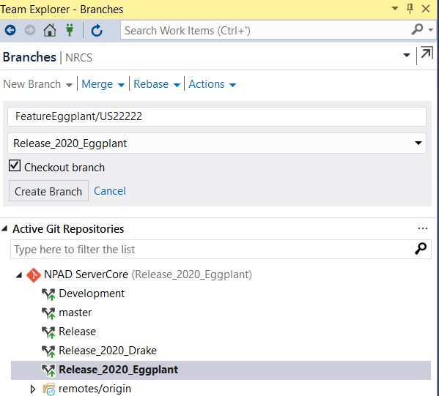

* Right-Click newly created branch and select Push
  + This will push the new branch to the remote repository

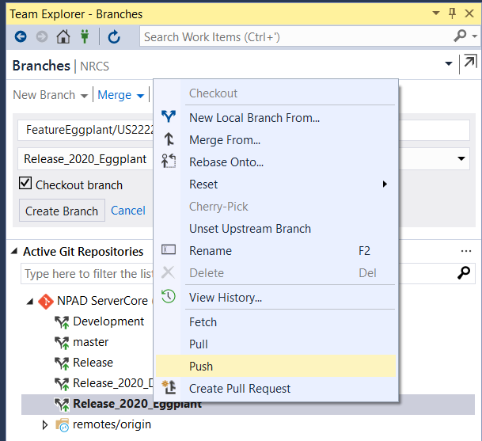

## Pull Request

* Once the feature is ready the Dev will create a “Pull Request”
* Right click the branch and click on the “Create Pull Request” from the Branches screen
* The Database DevOps team will complete the pull request

