Question 1: Insert yourself as a New Borrower. Do not provide the Card_no in your query.

Question 2: Update your phone number to (837) 721-8965.

Question 3: Increase the number of book_copies by 1 for the ‘East Branch’.

Question 4-a: Insert a new BOOK with the following info: Title: ‘Harry Potter and the Sorcerer's Stone’ ; Book_author: ‘J.K. Rowling’ ; Publisher_name: ‘Oxford Publisheing’.

Question 4-b: You also need to insert the following branches:

|  |  |
| --- | --- |
| North Branch | 456 NW, Irving, TX 76100 |
| UTA Branch | 123 Cooper St, Arlington TX 76101 |

INSERT INTO LIBRARY_BRANCH

VALUES ((SELECT COALESCE(MAX(branch_id), 0) + 1 FROM LIBRARY_BRANCH), 'North Branch', '456 NW, Irving, TX 76101');

LIBRARY_BRANCH count went from 3 to 4.

INSERT INTO LIBRARY_BRANCH (branch_id, branch_name, branch_address)

VALUES ((SELECT COALESCE(MAX(branch_id), 0) + 1 FROM LIBRARY_BRANCH), 'UTA Branch', '123 Cooper St, Arlington TX 76101');

LIBRARY_BRANCH count went from 4 to 5

.

Question 5: Return all Books that were loaned between March 5, 2022 until March 23, 2022. List Book title and Branch name, and how many days it was borrowed for.

SELECT

B.Title AS Book_Title,

LB.Branch_name AS Branch_Name,

julianday(BL.Returned_date) - julianday(BL.date_out) AS Days_Borrowed

FROM

BOOK_LOANS BL

JOIN BOOK B ON BL.book_id = B.Book_id

JOIN LIBRARY_BRANCH LB ON BL.branch_id = LB.Branch_id

WHERE BL.date_out BETWEEN '2022-03-05' AND '2022-03-23';

The number of records were not affected.

Question 6: Return a List borrower names, that have books not returned.

SELECT DISTINCT B.Name

FROM BORROWERS B

JOIN BOOK_LOANS BL ON B.Card_no = BL.Card_no

WHERE BL.Returned_date='NULL';

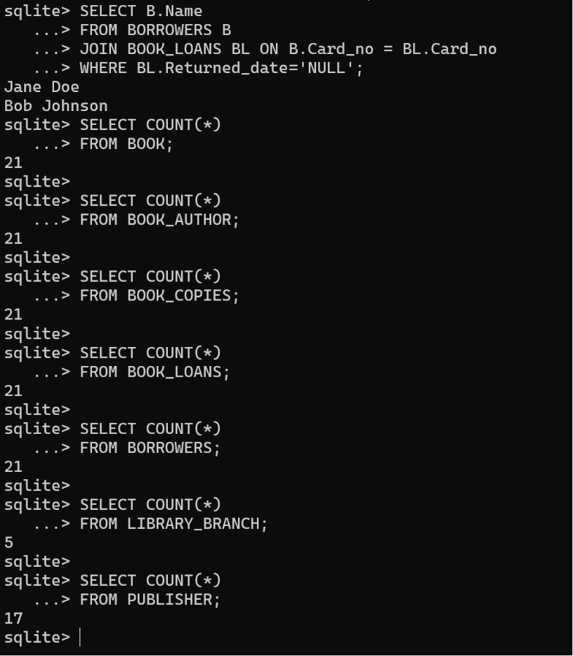

The number of records were not affected.

Question 7: Create a report that will return all branches with the number of books borrowed per branch separated by if they have been returned, still borrowed, or late.

Question 8: List all the books (title) and the maximum number of days that they were borrowed.

SELECT B.title, MAX(julianday(BL.Returned_date) - julianday(BL.date_out)) AS max_days_borrowed

FROM BOOK B

JOIN BOOK_LOANS BL ON B.book_id = BL.book_id

GROUP BY B.title;

The number of records were not affected.

Question 9: Create a report for Ethan Martinez with all the books they borrowed. List the book title and author. Also, calculate the number of days each book was borrowed for and if any book is late being returned. Order the results by the date_out.

SELECT

B.title AS book_title,

BA.Author_name AS author,

BL.date_out,

BL.due_date,

BL.Returned_date,

julianday(BL.Returned_date) - julianday(BL.due_date) AS days_late

FROM BOOK_LOANS BL

JOIN BORROWERS BOR ON BL.card_no = BOR.card_no

JOIN BOOK B ON BL.book_id = B.book_id

JOIN BOOK_AUTHOR BA ON B.book_id = BA.book_id

WHERE BOR.Name = 'Ethan Martinez'

ORDER BY BL.date_out;

The number of records were not affected.

Question 10: Return the names of all borrowers that borrowed a book from the West Branch include their addresses.