|  |  |  |  |  |  |  |
| --- | --- | --- | --- | --- | --- | --- |
|  | 1983-2007 | 1983-2016 | 1983-1989 | 1990-1999 | 2000-2007 | 2008-2016 |
| θ | 0.196 | 0.127 | 0.293 | 0.171 | 0.082 | 0.021 |
|  | (0.018) | (0.013) | (0.029) | (0.037) | (0.032) | (0.013) |
|  |  |  |  |  |  |  |
| $$R^{2}$$ | 0.293 | 0.190 | 0.547 | 0.154 | 0.066 | 0.025 |
| *obs.* | 300 | 402 | 84 | 120 | 96 | 102 |

**Table 1: Estimated Anchoring of U.S. Inflation Expectations Using the Cleveland Fed Inflation Expectations Data**

**Table 2: Estimated Anchoring of U.S. Inflation Expectations Using a Phillips Curve Regression**

|  |  |  |  |  |
| --- | --- | --- | --- | --- |
|  | 1983-1989 | 1990-1999 | 2000-2007 | 2008-2016 |
| γ | 0.160 | 0.118 | 0.017 | -0.004 |
|  | (0.043) | (0.046) | (0.014) | (0.012) |

**Table 3A: Estimated Anchoring of Inflation Expectations, Found Using the Coefficients from a Phillips Curve Regression with Headline Inflation, 1996-2013**

|  |  |  |  |  |  |  |
| --- | --- | --- | --- | --- | --- | --- |
|  | γ Coeff. | Std. Error |  | | γ Coeff. | Std. Error |
| Columbia | 1.067 | (0.069) | | U.K. | 0.018 | (0.022) |
| Brazil | 0.773 | (0.067) | | Finland | 0.014 | (0.016) |
| Mexico | 0.769 | (0.066) | | Korea | 0.014 | (0.019) |
| Turkey | 0.318 | (0.050) | | EA19 | 0.013 | (0.027) |
| Chile | 0.277 | (0.047) | | Portugal | 0.011 | (0.020) |
| Latvia | 0.228 | (0.046) | | Japan | 0.007 | (0.020) |
| Estonia | 0.226 | (0.046) | | Greece | 0.006 | (0.027) |
| Italy | 0.174 | (0.039) | | Netherland | 0.004 | (0.027) |
| Russia | 0.173 | (0.039) | | Sweden | 0.003 | (0.018) |
| Iceland | 0.132 | (0.034) | | Spain | 0.001 | (0.021) |
| Ireland | 0.112 | (0.032) | | Austria | 0.000 | (0.017) |
| OECDE | 0.065 | (0.018) | | Denmark | -0.002 | (0.030) |
| Hungary | 0.060 | (0.016) | | Luxembourg | -0.003 | (0.030) |
| Poland | 0.057 | (0.013) | | France | -0.003 | (0.018) |
| Slovenia | 0.047 | (0.019) | | G-7 | -0.004 | (0.016) |
| Israel | 0.047 | (0.017) | | U.S. | -0.005 | (0.016) |
| Czech Republic | 0.046 | (0.020) | | Norway | -0.006 | (0.020) |
| OECD | 0.043 | (0.018) | | Germany | -0.009 | (0.019) |
| Slovakia | 0.033 | (0.019) | | Canada | -0.009 | (0.017) |
| EU28 | 0.025 | (0.019) | | Belgium | -0.016 | (0.010) |
| India | 0.025 | (0.018) | |  |  |  |

**Table 3B: Estimated Anchoring of Inflation Expectations, Found Using the Coefficients from a Phillips Curve Regression with Headline Inflation, 1996-2016**

|  |  |  |  |  |  |
| --- | --- | --- | --- | --- | --- |
|  | γ Coeff. | Std. Error |  | γ Coeff. | Std. Error |
| Columbia | 1.069 | (0.064) | U.K. | 0.022 | (0.020) |
| Brazil | 0.783 | (0.063) | Finland | 0.021 | (0.017) |
| Mexico | 0.782 | (0.062) | EU28 | 0.019 | (0.015) |
| Turkey | 0.273 | (0.044) | Spain | 0.016 | (0.020) |
| Latvia | 0.228 | (0.046) | Portugal | 0.015 | (0.018) |
| Estonia | 0.226 | (0.046) | Greece | 0.013 | (0.022) |
| Chile | 0.216 | (0.039) | Denmark | 0.010 | (0.022) |
| Russia | 0.173 | (0.036) | Sweden | 0.007 | (0.017) |
| Iceland | 0.135 | (0.034) | France | 0.007 | (0.019) |
| Italy | 0.090 | (0.026) | Japan | 0.006 | (0.016) |
| Ireland | 0.074 | (0.024) | EA19 | 0.006 | (0.022) |
| OECDE | 0.068 | (0.018) | Netherland | 0.005 | (0.024) |
| Hungary | 0.062 | (0.014) | G-7 | 0.003 | (0.016) |
| Poland | 0.060 | (0.012) | Luxembourg | 0.001 | (0.028) |
| Israel | 0.053 | (0.017) | U.S. | 0.001 | (0.015) |
| Slovenia | 0.049 | (0.017) | Austria | 0.000 | (0.017) |
| Czech Republic | 0.048 | (0.019) | Germany | -0.002 | (0.020) |
| OECD | 0.047 | (0.017) | Belgium | -0.003 | (0.011) |
| Slovakia | 0.043 | (0.019) | Norway | -0.006 | (0.020) |
| Korea | 0.025 | (0.018) | Canada | -0.015 | (0.014) |
| India | 0.023 | (0.017) |  |  |  |

**Table 4A: Estimated Anchoring of Inflation Expectations, Found Using the Coefficients from a Phillips Curve Regression with Core Inflation, 1996-2013**

|  |  |  |  |  |  |
| --- | --- | --- | --- | --- | --- |
|  | γ Coeff. | Std. Error |  | γ Coeff. | Std. Error |
| Columbia | 0.688 | (0.065) | Portugal | 0.013 | (0.023) |
| Mexico | 0.630 | (0.062) | G-7 | 0.012 | (0.020) |
| Turkey | 0.117 | (0.023) | Japan | 0.011 | (0.021) |
| Hungary | 0.066 | (0.015) | U.K. | 0.010 | (0.024) |
| OECDE | 0.061 | (0.016) | Finland | 0.008 | (0.018) |
| Poland | 0.057 | (0.010) | Greece | 0.007 | (0.027) |
| OECD | 0.057 | (0.015) | France | 0.005 | (0.023) |
| Slovakia | 0.054 | (0.021) | Netherland | 0.004 | (0.031) |
| Ireland | 0.054 | (0.022) | Spain | 0.003 | (0.030) |
| Iceland | 0.052 | (0.020) | Canada | 0.002 | (0.024) |
| Latvia | 0.050 | (0.016) | Denmark | 0.001 | (0.043) |
| Estonia | 0.044 | (0.020) | EU28 | 0.001 | (0.050) |
| Israel | 0.043 | (0.016) | EA19 | 0.000 | (0.054) |
| Czech Republic | 0.042 | (0.018) | Austria | 0.000 | (0.025) |
| Chile | 0.033 | (0.020) | Norway | -0.001 | (0.021) |
| Korea | 0.025 | (0.015) | Sweden | -0.002 | (0.021) |
| Slovenia | 0.021 | (0.019) | Luxembourg | -0.003 | (0.052) |
| Italy | 0.020 | (0.013) | Germany | -0.004 | (0.035) |
| U.S. | 0.015 | (0.021) | Belgium | -0.011 | (0.019) |

**Table 4B: Estimated Anchoring of Inflation Expectations, Found Using the Coefficients from a Phillips Curve Regression with Core Inflation, 1996-2016**

|  |  |  |  |  |  |
| --- | --- | --- | --- | --- | --- |
|  | γ Coeff. | Std. Error |  | γ Coeff. | Std. Error |
| Columbia | 0.688 | (0.062) | Japan | 0.014 | (0.019) |
| Mexico | 0.614 | (0.058) | U.S. | 0.014 | (0.019) |
| Turkey | 0.111 | (0.019) | Greece | 0.010 | (0.024) |
| Hungary | 0.068 | (0.014) | G-7 | 0.009 | (0.019) |
| OECDE | 0.058 | (0.015) | U.K. | 0.008 | (0.024) |
| Poland | 0.058 | (0.009) | Finland | 0.007 | (0.017) |
| Slovakia | 0.056 | (0.021) | Spain | 0.006 | (0.026) |
| Iceland | 0.053 | (0.021) | France | 0.004 | (0.024) |
| OECD | 0.053 | (0.014) | Denmark | 0.004 | (0.034) |
| Latvia | 0.050 | (0.016) | Norway | 0.003 | (0.021) |
| Ireland | 0.045 | (0.019) | Netherland | 0.003 | (0.030) |
| Israel | 0.045 | (0.015) | Canada | 0.002 | (0.022) |
| Estonia | 0.044 | (0.020) | EU28 | -0.001 | (0.045) |
| Czech Republic | 0.041 | (0.017) | Sweden | -0.001 | (0.021) |
| Chile | 0.033 | (0.020) | EA19 | -0.001 | (0.051) |
| Italy | 0.026 | (0.013) | Austria | -0.002 | (0.026) |
| Korea | 0.024 | (0.014) | Luxembourg | -0.002 | (0.052) |
| Slovenia | 0.021 | (0.019) | Germany | -0.004 | (0.035) |
| Portugal | 0.014 | (0.021) | Belgium | -0.009 | (0.018) |

**Figure 1: The Parameter from the Phillips Curve Regression, as Estimated in Ten-Year Moving-Window Regressions**

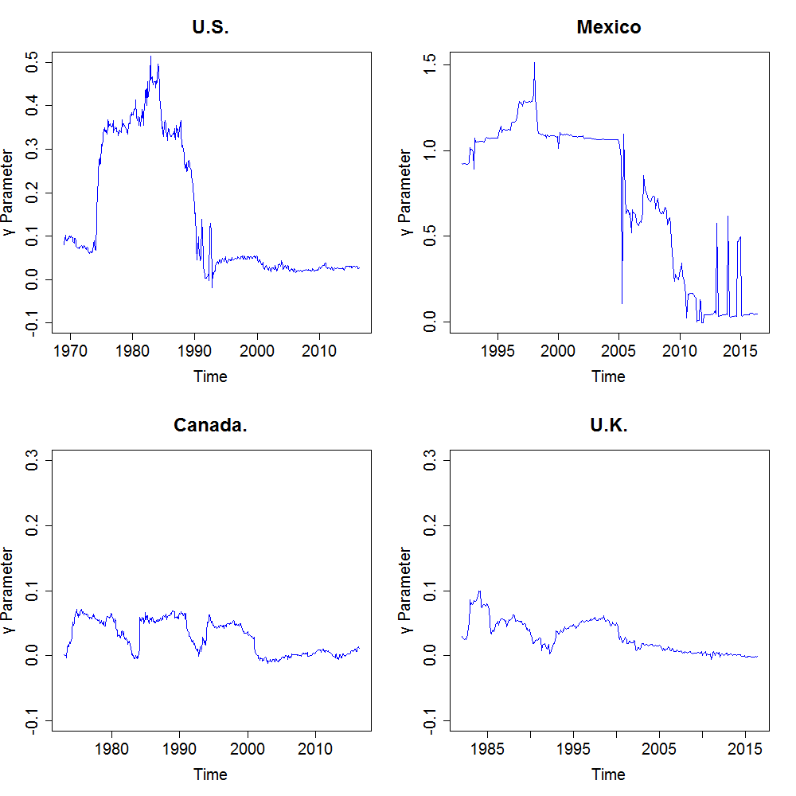

**Figure 2: The Parameter from the Phillips Curve Regression, as Estimated in Ten-Year Moving-Window Regressions in Euro-Area Core Countries**

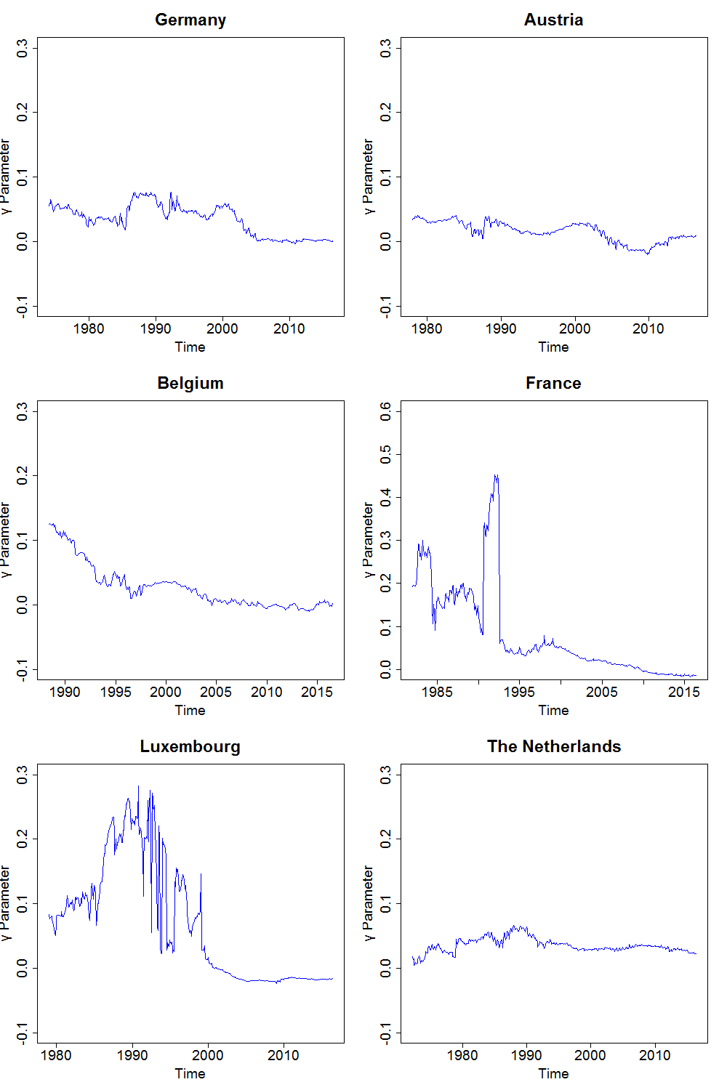

**Figure 3: The Parameter from the Phillips Curve Regression, as Estimated in Ten-Year Moving-Window Regressions in Euro-Area Periphery Countries**

