CIS 115 Test 2
REQUIREMENTS:
Read the instructions for each exercise carefully and allow yourself time to complete all four exercises. Be sure to submit ALL files, including the .txt files and .css file.
EXERCISE 1: You have been provided with a data file named rainfall.txt which contains 7 daily rainfall amounts, one on each line, representing the rainfall for each day of the week.
Open rainfall.html and rainfall.php. You do not have to change weeklyRainfall.html. Complete rainfall.php so that this program reads the seven rainfall amounts from the file, then calculates and displays the total rainfall for the week (see example). If the total rainfall is above 3 inches, also display a sub-heading and paragraph with the message “WARNING! Due to heavy rainfall this week, flooding may occur in low-lying areas. Be cautious when driving through standing water.”
Use the number_format function so that the total is displayed with 2 decimal places. The total should be 1.06. Change the first number in the file from 0.000 to 3.000 and run your program again to see that your warning message works correctly. This time the total should be 4.06.
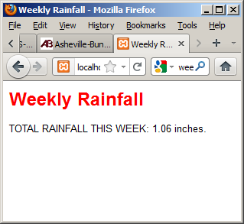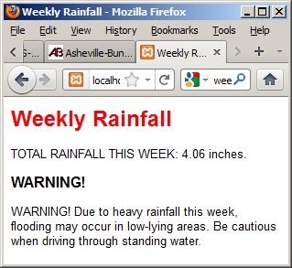
Output with 1.06” rainfall Output with more than 4.06” rainfall

EXERCISE 2. You have been provided with a data file named weatherStation.txt. This file contains two lines of weather data as follows:
Asheville:cloudy:82.4:5.6
Charlotte:rain:76.5:3.2

Each line contains a weather location, local conditions, local temperature, and local wind speed.
Open weatherStation.html and weatherStation.php. You do not need to change weatherStation.html. Complete weatherStation.php so that this program reads the two lines from the file and extracts the four values from each line. The code to display the results in a table has already been provided so be sure to use the same variable names in the code that you add! Your output should look like this:

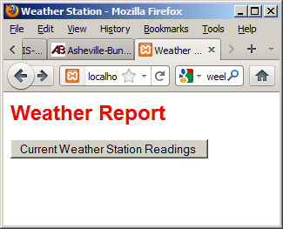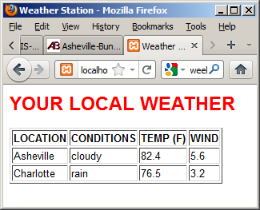

EXERCISE 3: You have been provided with ticketOrder1.html and ticketOrder1.php to process ticket orders for the Asheville Music Club. You do not need to change ticketOrder1.html.
You will see that ticketOrder1.html provides a form that asks the user for the number of tickets requested and what kind of seats are required (PREMIUM or STANDARD).
Complete ticketOrder1.php so that this program displays the order details and calculates and displays the total cost of the tickets (see example below). Premium seats cost $60 each, and standard seats cost $30 each. Be sure that your numeric output is formatted to two places.
Here are two tests to be sure your program works correctly:
- Enter 1 for the number of tickets and choose “PREMIUM” . The program should display the total cost of $60.00
- Enter 10 for the number of tickets and choose “STANDARD”. The program should display the total cost of $300.00

SAMPLE OUTPUT:

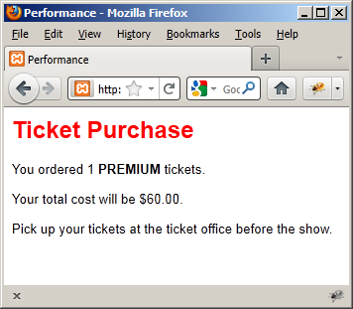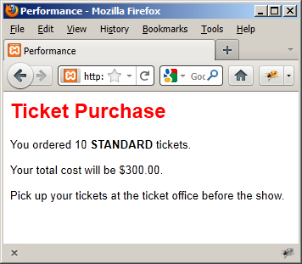
Test 1: One premium ticket Test 2: Ten standard tickets
4. You have been provided with ticketOrder2.html and ticketOrder2.php to process ticket orders for the Asheville Music Club. You do not need to change ticketOrder1.html. Note that the form now tells the user that he or she cannot order more than 10 tickets.

Complete ticketOrder2.php so that, if the user requests between 1 and 10 tickets, the program should process the order in the same way as exercise 3 (you can copy and paste code from ticketOrder1.php into ticketOrder2.php), otherwise, if the user requests less than 1 ticket, the program should display an error message “YOU MUST ORDER AT LEAST 1 TICKET!” and provide a link back to the order form, otherwise if the user requests more than 10 tickets , the program should display an error message “form YOU CANNOT ORDER MORE THAN 10 TICKETS!” and provide a link back to the order form. See the screenshots below for sample output.
HINT: In order meet the requirements, your program should only calculate and display the cost of the tickets if the order is at least 1 and not more than 10 tickets, otherwise the program should just display one of the two error messages and provide a link back to the form. This will require the use of chained as well as nested IF..ELSE structures.
Here are four tests to be sure your program works
- Enter 0 for the number of tickets and choose either “PREMIUM” or “STANDARD”. The program should display an error message and a link back to the form (see the screenshot below).
- Enter 11 for the number of tickets and choose either "PREMIUM” or “STANDARD”. The program should display an error message and a link back to the form (see the screenshot below).
- Enter 1 for the number of tickets and choose “PREMIUM”. The program should calculate and display the ticket cost as $60.00 (see the screenshot for test 1 in exercise 3 above)
- Enter 10 for the number of tickets and choose “STANDARD". The program should calculate and display the ticket cost as $300.00 00 (see the screenshot for test 2 in exercise 3 above)

SAMPLE OUTPUT:
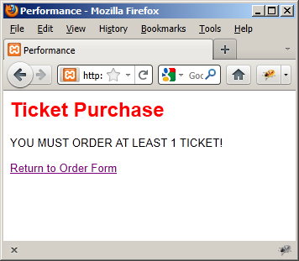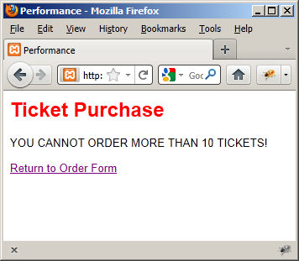
Test 1: User requests 0 tickets Test 2: User requests 11 tickets

