# CS 255 System Design Document Template

This template lays out all the different sections that you need to complete for Project Two. Each section has guidance to prompt your thinking. You will need to continually reference the interview transcript as you work to make sure that you are addressing your client’s needs. There is no required length for the final document. Instead the goal is to complete each section based on what your client’s needs are. Remove this note when you are finished, and replace all bracketed text with the relevant information.

## UML Diagrams

### UML Use Case Diagram

*[In Module Six, you were asked to complete a use case diagram based on your system design. If you would like to make any adjustments to your diagram, please do so. Please insert your use case diagram here. Check to make sure that you included appropriate components and symbols and that your design meets the client’s needs.]*

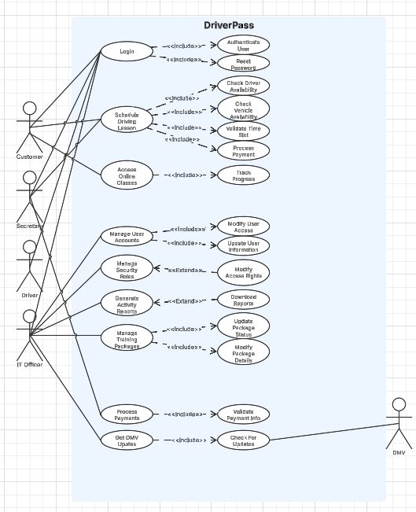

### UML Activity Diagrams

*[You were asked to choose* ***two*** *use cases and create* ***two*** *activity diagrams, one for each use case. Please insert* ***both*** *of your activity diagrams here. Check to make sure that you included appropriate components and symbols and that your design meets the client’s needs.]*

Manage Training Packages Activity Diagram

Manage User Accounts Activity Diagram

### UML Sequence Diagram

*[You were asked to create a sequence diagram based on* ***one*** *of the use cases you chose. Please insert your sequence diagram here. Check to make sure that you included appropriate components and symbols and that your design meets the client’s needs.]*

Login Sequence Diagram

### UML Class Diagram

*[You were asked to create a class diagram based on the different classes and attributes needed for your system design. You are* ***not*** *required to include methods, but you may if you wish. Please insert your class diagram here. Check to make sure that you included appropriate components and symbols and that your design meets the client’s requirements.]*

Class Diagram

## Technical Requirements

*[Based on the diagrams you have created, describe the technical requirements of your system. These requirements should address the required hardware, software, tools, and infrastructure necessary for your system design.]*

Hardware Requirements

* Cloud-based servers
* Server should have enough capacity to store user data, system data, and training materials
* Server should have enough processing power to handle a large amount of concurrent users
* Client be able to access modern web browsers like Chrome, Edge, Firefox, and Safari
* Client must use devices that have internet access
* Proper workstation for staff members

Software Requirements

* Cloude-based web hosting
* Database for data storage and management
* Authentication and authorization
* Backup/recovery
* SSL certificates for security purposes
* Payment processing
* Email notification

Tools

* System and performance monitoring
* Encryption tools for data protection
* Visual Studio or other IDE for coding, testing, and debugging
* Git or other version control
* Report generation
* User activity tracking

Infrastructure

* Cloud infrastructure with options to scale based on amount of users
* High-speed internet
* Firewall system for network security
* VPN to securely access system remotely
* DMV integration for constant updates