**No Budget, No Worries: Free and Open Source Publishing Software in Biomedical Publishing**

*Tarek Loubani1, Alison Sinclair1, Sally Murray1, Claire Kendall1, Anita Palepu1, Anne Marie Todkill1, John Willinsky2*

1 Editorial Team, *Open Medicine*

2409 Wyndale Crescent, Ottawa, Ontario, K1H 8J2, Canada

[email: tarek@tarek.org](mailto:tarek@tarek.org), [alison.sinclair@mac.com](mailto:alison.sinclair@mac.com), [smurray@openmedicine.ca](mailto:smurray@openmedicine.ca), [ckendall@openmedicine.ca](mailto:ckendall@openmedicine.ca), [apalepu@openmedicine.ca](mailto:apalepu@openmedicine.ca)

2Board of Directors, *Open Medicine*

2409 Wyndale Crescent, Ottawa, Ontario, K1H 8J2, Canada

e-mail: john.willinsky@ubc.ca

**Abstract**

*Open Medicine* (http://www.openmedicine.ca) is an electronic open access, peer-reviewed general medical journal that started publication in April 2007. The editors of *Open Medicine* have been exploring the use of Free and Open Source Software (FOSS) in constructing an efficient and sustainable publishing model that can be adopted by other journals. The goal of using FOSS is to minimize scarce financial resources and maximize return to the community by way of software code and high quality articles. Using information collected through archived documents and interviews with key editorial and technical staff responsible for journal development, this paper reports on the incorporation of FOSS into the production workflow of *Open Medicine*. We discuss the different types of software used; how they interface; why they were chosen; and the successes and challenges associated with using FOSS rather than proprietary software. These include the flagship FOSS office and graphics packages (OpenOffice, The GIMP, Inkscape), the content management system Drupal to run our *Open Medicine* Blog, wiki software MediaWiki to communicate and archive our weekly editorial and operational meeting agenda, minutes and other documents that the team can collectively edit, Scribus for automated layout and VOIP software Skype and OpenWengo to communicate. All software can be run on any of the main operating systems, including the free and open source GNU/Linux Operating system. Journal management is provided by Open Journal Systems, developed by the Public Knowledge Project (http://pkp.sfu.ca/?q=ojs). OJS assists with every stage of the refereed publishing process, from submissions, assignment of peer reviewers, through to online publication and indexing. The Public Knowledge Project has also recently developed Lemon8-XML (http://pkp.sfu.ca/lemon8), which automates the conversion of text document formats to XML, enabling structured markup of content for automated searching and indexing. As XML is required for inclusion in PubMed Central, this integrated, semi-automated processing of manuscripts is a key ingredient for biomedical publishing, and Lemon8-XML has significant resource implications for the many journals where XML conversion is currently done manually or with proprietary software. Conversion to XML and the use of Scribus has allowed semi-automated production of HTML and PDF documents for online publication, representing another significant resource saving. Extensive use of free and open source software by *Open Medicine* serves as a unique case study for the feasibility of FOSS use for all journals in scholarly publishing. It also demonstrates how innovative use of this software adds to a more sustainable publishing model that is replicable worldwide.

**Keywords:** Free and Open Source Software (FOSS), biomedical publishing, *Open Medicine*.

# 1. Introduction

The private interests of medical society and commercially owned medical journals do not encourage collaboration between journals for processes related to journal publishing. This is particularly apparent as journal publishing moves into the digital age: profit is sitting at the helm of an era where shared software code and reader-centric licenses could otherwise accelerate the development and advantages of electronic publishing for all readers and authors.

The focus on profit also prevents many potential readers from purchasing subscriptions. In a US periodical price survey published in early 2008, health science periodicals subscriptions averaged US$1330, representing a ten percent increase from 2007. The same study showed that average subscription prices in the health sciences increased by 43% between 2004 and 2008 [1]. A report commissioned by the Wellcome Trust showed similar data [2];in 2000 the average subscription price for a medical journal was £396.22, and the average cost of a medical journal increased 184% in the ten-year period between 1990 and 2000 [2]. These costs limit journal readership to academic and institution-affiliated professionals in developed countries, and exclude physicians and academics in developing countries not covered by initiatives such as the Health InterNetwork Access to Research Initiative (HINARI) [3].

Electronic publishing renders obsolete costly processes used to justify high subscription prices. In a recent publication costing study comparing print and electronic publications, Clarke [4] found that the publication costs of a print version of a non-profit association journal were more than double those of an electronic version (US$20 000 compared with US$8 000). Although editorial costs associated with the production of high-quality publications remain – and, for larger journals, can be a considerable part of their operating costs – it is clear that the impact of these costs on the financial viability of a journal can be considerably offset with reduced production costs. This has the potential to reduce the dependence of medical journals on pharmaceutical company and medical device manufacturer advertising, the effects of which have been well documented [5,6].

While the Clarke study does not itemize the contribution that publishing-related software makes to publication costs, it can only be assumed that the use of free and open source software (FOSS) would decrease these costs further. Willinsky and Mendis [7] recently published a paper describing their experience of publishing an entirely unfunded humanities journal using free publishing software and “a volunteer economy of committed souls”. Hitchcock [8] describes the only other journal that we are aware of that has exclusively used FOSS for this purpose. At *Open Medicine*, we employ “committed souls”, professional journal editors and FOSS to publish our biomedical journal.

# 2. Open access (OA) publication

Open access publication has emerged as another way of increasing integrity, transparency and accessibility in biomedical publishing [9]. In 2002, the Budapest Open Access Initiative (BOAI) was launched to encourage science to be freely available on the internet, the BOAI supports the archiving of scientific articles and the free availability, without copyright and proprietary limitations, of articles to be to read, downloaded, reproduced, distributed, printed, searched or linked to full-text articles, with proper attribution to the source (see <http://www.soros.org/openaccess>). Reframing traditional copyright limitations allows anyone the ability to use science for learning, teaching and discussion without having to pay for its use in the form of a subscription or re-print purchase. Without this kind of protection, even an article’s authors cannot freely use published articles for these purposes.

The trend towards opening access among journal publishers has been swift: the Directory of Open Access Journals now lists more than 3281 journals (http://www.doaj.org). The benefits of OA are also becoming clearer: studies are finding that articles published in open access journals are cited more widely [10], and studies that have made their data openly accessible have also increased citation advantage [11]. Academic institutions, funding bodies, regulators and even governments have recognized how open access might serve academic integrity and improve patient care [12].

# 3. Free and open source software (FOSS)

Like the copyright laws that continue to significantly limit readers' ability to download, reproduce, distribute, print, share and expand upon knowledge printed in many journals, copyright limitations apply to sharing novel software programs and code. Software development under a free license such as the GNU General Public License ensures that source code is freely available and can be used, examined, changed, improved or redistributed without limits except that any changes must be released back into the community with the same license (<http://en.wikipedia.org/wiki/Open_source_software>). Developers of FOSS range from software hobbyists to multinational corporations. Programmers may or may not be paid for their work, and their motivations include the wish to satisfy user need, and to use and develop their skills [13]. Free licenses encourage code sharing and code integrity, and enable the rapid identification and fixing of critical bugs, and the adaptation and re-purposing of code. Among the best-known open source software projects are the GNU/Linux operating system, the Mozilla Firefox web browser, Open Office productivity software, and the MediaWiki publishing platform that underlies Wikipedia.

The ability of many smaller journals to support open access publication has been enabled by the availability of open source journal management and publishing systems, including Open Journal Systems ([http://pkp.sfu.ca/ojs/](http://pkp.sfu.ca/ojs)), DPubS (<http://dpubs.org/>), GAPworks (<http://gapworks.berlios.de/>), Hyperjournal (<http://www.hjournal.org/>), ePublishing Toolkit (<https://dev.livingreviews.org/projects/epubtk/>), OpenACS (<http://openacs.org/>), and SciX Open Publishing Services (SOPS; <http://www.scix.net/>) (see <http://pkp.sfu.ca/ojs_faq>)**.** At *Open Medicine* we have taken our commitment to “openness” and developing a more sustainable publishing model a step further by using free and open source software (FOSS) for our journal management, blog and electronic publishing platform. We are also increasingly incorporating FOSS into our workflow to enable the production of XML (a document format required for NLM/MEDLINE indexing) and for our layout and copyediting process, with the end goal of publishing and managing the journal exclusively using a FOSS workflow.

The use of FOSS in medical publishing has many advantages. Cost is one commonly cited factor, though by no means the most important. By using FOSS, *Open Medicine* is replacing software with single license costs (non-educational versions) ranging from hundreds to thousands of dollars, representing savings in startup costs of many thousands of dollars; this use of FOSS also avoids costly upgrades of both software and hardware. FOSS tends to be available for a broader range of platforms – at a minimum, there are likely to be GNU/Linux, Apple Mac OSX and Microsoft Windows versions – and since older versions of the software are not commercially competitive with newer versions, support for established FOSS projects does not end according to a commercial cycle. This means that older, slower computers remain viable platforms. It also means that backward compatibility of programs is more often maintained. FOSS also produces documents in open formats such as the Open Document Format, which means that the user is able to transfer documents to another program should development on the original one cease, or a more suitable alternative be found – unlike data kept in a proprietary format. This problem, dubbed “vendor lock-in” will become more pronounced, with the introduction of Microsoft's new proprietary office format, as well as with “patented” proprietary formats from other companies.

# 4. FOSS at *Open Medicine*

Use of FOSS at *Open Medicine* was primarily driven by the added control, security, and usability of the software. However, it was also in part prompted by cost considerations. As a start-up independent journal, committed to editorial independence, we operate principally with volunteer staff with minimal institutional support: the purchase of expensive proprietary journal management software was not only undesirable, but unfeasible.

Our first step was to work with John Willinsky and the Public Knowledge Project to explore Open Journal Systems (OJS; http://pkp.sfu.ca/ojs). OJS is a free and open source online journal management and publishing system, developed by the Public Knowledge Project in a partnership among the Faculty of Education at the University of British Columbia, Simon Fraser Library and the Canadian Centre for Studies in Publishing [14]. We are not alone in recognizing the benefits of using OJS; there are now more than 1000 journals using OJS as a publishing platform, 20 percent of which are new titles and all of which offer some form of open access. Somewhat more than half are being published in low-income countries**.**

OJS offers a complete manuscript management and publishing system, helping track and organize documents from submission through review, copyediting, layout and publication. Correspondence between authors, editors, peer reviewers, coypeditors and layout editors can be managed within the system, with modifiable templates for correspondence. A database of peer reviewers, with contact information, interests and review history, is maintained within the system. Authors are able to track the progress of their manuscripts through the system, and peer reviewers are able to access their peer review requests, download the documents and enter or upload their completed peer reviews. OJS operates within a browser, with good attention to cross-platform, cross-browser compatibility (see Figure 1).

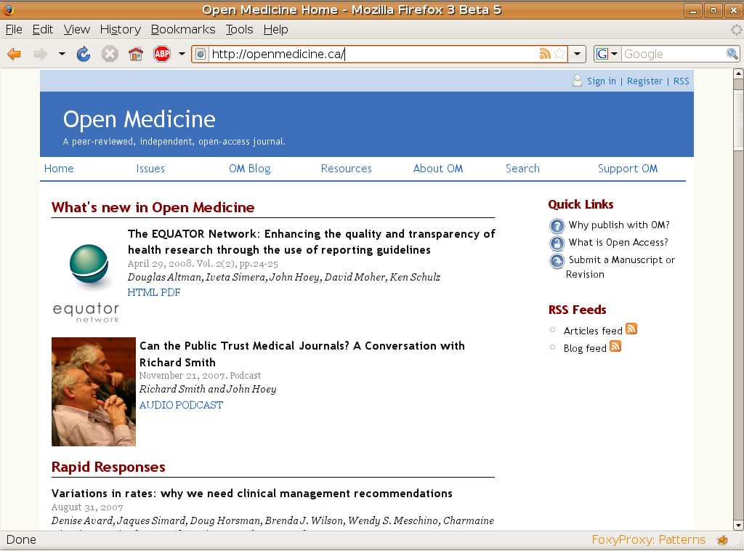

**Figure 1: *Open Medicine* home page published using OJS**

A critical advantage of OJS is its use of open source code and a free software license. This has allowed the technical staff at *Open Medicine*, with OJS support, to write new or revised code, targeted to our particular journal needs. And of course the cycle continues: any code written by our programmer with wider applicability for journal publishing has in turn been shared with the team at OJS and other journals.

This relationship has been particularly productive in our testing and use of Lemon8-XML for OJS. Lemon8-XML (http://pkp.sfu.ca/lemon8) is a web-based program that automates the conversion of text document formats to National Library of Medicine (NLM) XML, permitting myriad uses, including the easy transmission of article information to the NLM. XML ensures that text is marked up so as to enable meaningful computer searching. For example, it allows the orderly tagging of date of publication and author names so that computers can search and find data that would usually appear as text buried within the body of a document. XML conversion is required for PubMed/Medline indexing – a critical goal for any medical journal – and is currently performed in most journal operations either manually or with prohibitively expensive proprietary software. The development of Lemon8-XML will be a powerful contribution to data searching, and will have significant resource implications for journals, many of whom have been unable to produce XML because of the high costs and expertise required.

The easy creation of XML has enabled another recent innovation: the automated transformation of XML files into web-ready pages (HTML), as well as preliminary page layouts that can then be fine-tuned for print-ready publication (PDF). Some of our initial efforts at creating the editing-layout portion of the workflow involved using OpenOffice for both copy-editing and layout, and then generating both the XML markup version and the publication PDF from the final laid out document. OpenOffice, although suitable for editing and copy-editing tasks, proved to lack the flexibility and fine control required to produce layouts to professional standard. For example, fine-grain control over hyphenation, font kerning and so on were nearly impossible with OpenOffice. This led us to explore the use of Scribus, a well-established free and open-source desktop publishing software, for the layout stage. Rather than be obliged to maintain and reconcile separate XML and Scribus/laid out versions, our technical staff developed a plugin that enables conversion of the copy-edited XML version of an article directly to a final web-ready page and a preliminary layout in Scribus, ready for final refinement (see Figure 2).

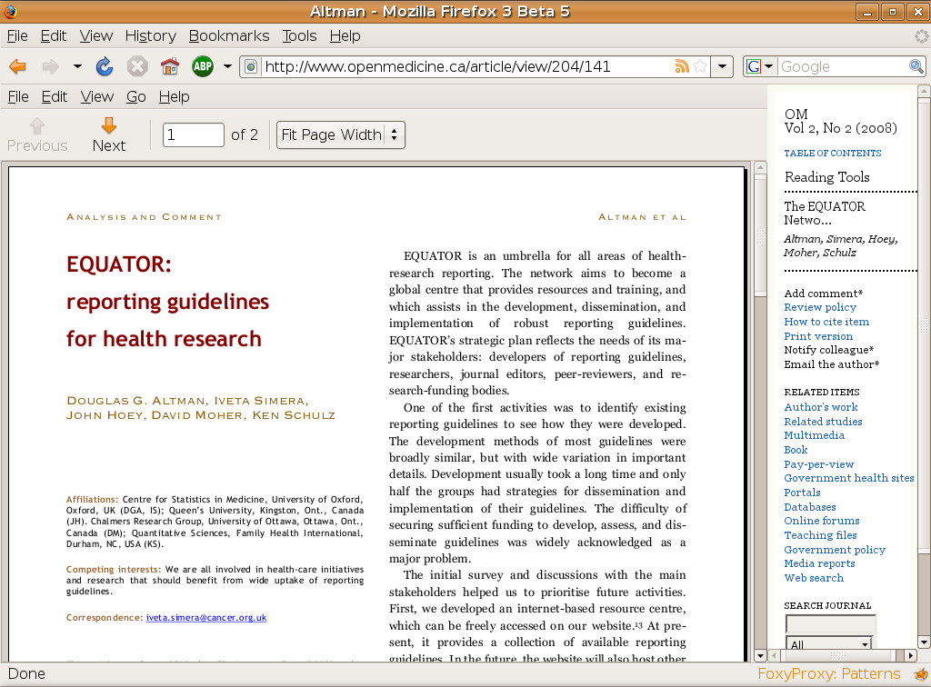

**Figure 2: Example of automated article layout using Lemon8-XML and Scribus**

Day-to-day operations within the journal are also performed using FOSS. As our editorial team is distributed across Canada and Australia, team members communicate using email, instant messaging (IM), and voice over internet (VoIP). We have also experimented with the SIP-based Wengophone (now Qutephone) to support teleconferences of more than three people, but have been unsuccessful to date; we are currently still reliant on a proprietary solution for teleconferences involving the entire team.

Coordination of journal activities is also made possible through an internal wiki, using MediaWiki (the platform originally written for Wikipedia). Editorial meeting agendas and minutes, projects and documents in development, lists of contacts and resources, and all other documentation associated with running the journal are all accessible to and editable by all members of the editorial team.

Table 1 offers a summary of the programs we have explored or are exploring as part of a Free and Open Source (FOSS) publishing workflow or in support of our operations. Figure 3 shows a schematic flowchart of our operations and sites of FOSS use..

| **Free and Open Source Program** | **Open Medicine Use(s)** | **Advantages** | **Disadvantages** |
| --- | --- | --- | --- |
| ***Article editing and preparation*** | | | |
| Open Office  <http://www.openoffice.org/> | Editing and copy-editing of manuscripts; preliminary layout  (Current industry standard: Microsoft Office) | Best established FOSS office suite Increasing acceptance in business and enterprise  Well-supported by documentation | Interface and customizations differ from proprietary alternative  Does not have fine control required for layout |
| GIMP  <http://www.gimp.org/> | Image editing  (Current industry standard: Adobe Photoshop) | Best all-around photo- and image-editing software  Well supported with documentation and forums | Contested user interface  CMYK support only with plugin (relevant for print publishing) |
| Inkscape  <http://www.inkscape.org/> | Figure preparation  (Current industry standards: Adobe Illustrator / Corel Draw) | Intuitive, thought out user interface  Excellent SVG support | Difficulty integrating with illustrators using Adobe Illustrator or Corel Draw |
| ***Article management, layout, and publishing*** | | | |
| Open Journal Systems (OJS)  <http://pkp.sfu.ca/ojs/> | Manuscript management  Reader tools  On-line publishing  Communication with editors, copyeditors & layout persons | Many users  Potential to request additional system features  Responsive developers | Some limitations with theme customization |
| Lemon8-XML  <http://lemon8.ca/> | XML generation | Removes considerable human resource cost as currently done manually at most journals | Still in early testing phase  Requires some manual reference searching  No current link with OJS author details requiring duplicate data entry (planned for final version) |
| Scribus  <http://www.scribus.net/> | Layout of articles for print (PDF) publication  (Current industry standard: Quark Xpress) | Fine grain control over text layout, font kerning  Excellent PDF export control  Excellent support community | Confusing development cycle  Poorly thought out document format |
| Drupal <http://drupal.org/> | Blog  (Current industry standards: Wordpress, Movable Type, Blogger.com) | Powerful content-management system with user-access controls; extensible with plug-ins  Active user community | Learning curve; requires expertise to set up and manage |
| ***Operations*** | | | |
| MediaWiki  <http://www.mediawiki.org/> | Meeting minutes; shared projects; shared resources | Web-based  Minimal learning required for use  Very flexible | Some expertise required for installation and maintenance |
| WengoPhone  <http://www.openwengo.org/> | Team communication | Multiple sites can conference simultaneously  Uses SIP standard | Unstable development  Small userbase  Decreased sound quality compared to other SIP products |
| Chandler <http://www.osafoundation.org/> | Shared calendars | Multiple users can enter data |  |
| Thunderbird  <http://www.mozilla.com/thunderbird/> | Team communication; editor-author-peer-reviewer communication |  |  |

# Table 1: Free and open source software used at *Open Medicine*

# 

# Figure 3: Workflow at *Open Medicine* using FOSS

# 5. Free and Open Source Software in Medical Publishing: the challenges

There is no denying that there are challenges unique to adopting FOSS to create a workflow that has hitherto involved proprietary software. Some of these challenges arise from the software themselves, some from integration (or lack of) between various FOSS programs, and others simply from the time taken to learn to use new programs and troubleshoot without traditional help forums.

For an individual user who is experienced in proprietary software and a proprietary workflow, the initial penalty of moving to FOSS is a loss of efficiency and a (re)learning curve. Users must learn one or several new interfaces, which may require them to adapt their personal workflow if it is not supported by the program, or to learn how to customize the program to suit their needs. This is especially true for little-used specialist components of software, which tend to be buried deep within the software and to be poorly documented. Users must find and identify sources and resources that will provide them with answers to questions that may be quite specific to the task; this can be time-consuming, particularly when the reason for there being no documentation is that that functionality has not been included in the software.

The user interfaces of FOSS differ from their proprietary counterparts, in part as a result of the opportunity to solve perceived problems with existing proprietary interfaces and improve their design, and in part because developers in today's litigious environment must avoid incorporating design elements that may be claimed under patent **[**see <http://en.wikibooks.org/wiki/FOSS_Open_Standards/Patents_in_Standards> for a discussion of patents and FOSS**]**. While improving on design, however, developers of the more “mainstream” and widely adopted FOSS (e.g., Firefox, GNOME, OpenOffice, GIMP) find themselves attempting to balance the needs of new users for an intuitive, familiar interface with the requirements of experienced users for a flexible interface that can be highly customized. Microsoft and Adobe own much of the software in common use in authoring and publishing, and have so shaped user expectations and workflow design such that what user interfaces they do not own, they influence. This results in consistency in the user interface when approaching different programs by the same manufacturer. One common complaint about FOSS interfaces is that they can be individually unique, even idiosyncratic, posing a barrier to new users. This problem has recently been recognized by the community, and is being addressed aggressively with massive usability projects (e.g., Open Usability; http://openusability.org/) and human interface guidelines (e.g., GNOME HIG http://developer.gnome.org/projects/gup/hig/; and KDE HIG <http://usability.kde.org/hig/>).

FOSS applications lend themselves to development on multiple operating systems, since any developer with an interest in a platform and some knowledge is free to modify the code. This leads to support for esoteric operating systems such as IBM’s long-defunct OS/2. The upside of availability on multiple platforms is balanced by the lower quality of versions in which developers are uninterested. Because free software is available to the public at all stages of its development cycle, this also means that sometimes installation of applications on underdeveloped platforms is confusing or poorly implemented. Scribus, one of our mainstay applications for layout editing, is an excellent example of this challenge. At the time of writing, Scribus version 1.3.3.11 is considered “stable”. However, versions 1.3.4 and 1.3.5 are in wide use as well, despite being “unstable”. Scribus’ installer for Mac OSX is also primitive, and does not install required libraries, or even the application itself in an intuitive way. The user needs to select the correct version, may need to download and install the supporting libraries or packages, and may need then to interpret and troubleshoot any resulting error messages. It is worthwhile noting that this problem is essentially eliminated within free software operating systems (e.g.*,* GNU/Linux), all of which use package management systems to easily install software and dependent libraries.

Publishing requires a workflow that faithfully preserves detail of presentation – font, layout, figures. For proprietary publishing, this workflow has been developed largely by the consolidation of products involved in the process into end-to-end product lines that smooth the integration but offer little choice to the consumer. The various components of FOSS are not integrated into a workflow and require additional customization and programming. Furthermore, given that almost all of our submissions are received in Microsoft Word document format, one of the areas the *Open Medicine* staff found most challenging was in importing figures and tables prepared in Word, and citations and reference lists prepared in another widely used proprietary software, EndNote. We have yet to resolve our dependency on proprietary fonts for standardization of appearance and layout across stages and platforms.

When difficulties are encountered in free software applications, solutions are not always easily located. The pace of progress means that documentation and technical support are primarily provided online by the user community, rather than in the form of published manuals. The majority of commercial publishers of books describing individual computer applications concentrate their efforts on mainstream proprietary software, which tends to have a much longer product lifecycle and slower development pace. Established FOSS projects commonly offer documentation in the form of a wiki (collectively edited multi-page manual), and support in the form of forums and online communities. Individual users may develop extensive tips and support sites, either out of interest, or in support of their consulting business (or both). To find the documentation that suits one’s level of learning, or the exact answer to a technical question, requires skills in searching, and some experience in assessing the receptiveness of a forum to “newbie questions”. The move to lesser-known free software also negates the often overlooked advantage of “the geek next door”, the friend with a slightly higher level of skill who can help achieve certain tasks. The increasing popularity of free software will eventually render this challenge moot, however it remains important at this time.

# 6. FOSS in Medical Publishing: the possibilities

By the very nature of FOSS, many of the frustrations cited should ease with increasing adoption of FOSS in scholarly publishing. Members of FOSS-OA publishing are forming their own community, exchanging experiences and developing documentation specific to the task of using FOSS for publishing. Experience will teach us which programs are best suited to which step in the editing-publishing workflow, which programs integrate best with others, and how they might be customized for ease of workflow. The open architecture of FOSS permits the development of macros and plugins to automate repeated steps and to facilitate import and export.

The most interesting possibilities presented by FOSS will have to do with the fruits of collaboration by several FOSS-OA publishers. A case in point: *Open Medicine* is collaborating with the Public Knowledge Project to develop a user commenting system for OJS, but we expect this system to truly mature and evolve when other publishers implement and expand upon it.

For our own part, we hope *Open Medicine* can become a working template and case study for other journals interested in publishing using a complete FOSS interface. Journals choosing to use FOSS because of their philosophy, cost considerations or availability of computing ‘power’ to run software applications can benefit from our learning experiences, and, given the nature of FOSS, the source code developed for our publishing purposes. We look forward to the ongoing dialogue and experience of pursuing a truly “Open”, academically independent, biomedical publishing option. For us, transparency and integrity are essential traits, and we want *Open Medicine* to embody these traits in the software we use as well as the articles we publish.

**7. References**

[1] Van Orsdel LC, Born K. Periodicals Price Survey 2008: Embracing Openness. Library Journal [Internet]. 2008. 15th Apr. [cited 2008 May 6]. Available from: http://www.libraryjournal.com/article/CA6547086.html

[2] SQW Limited. Economic analysis of scientific publishing: A report commissioned by the Wellcome Trust; Histon. Wellcome Trust, 2003

[3] The PLoS Medicine Editors. How Can Biomedical Journals Help to Tackle Global Poverty? PLoS Med [Internet]. 2006. 29 Aug [cited 2008 May 6]; 3(8): e380. Available from: http://medicine.plosjournals.org/perlserv/?request=getdocument&doi=10.1371/journal.pmed.0030380

[4] Clarke, R. The cost profiles of alternative approaches to journal publishing. First Monday [Internet]. 2007. 21 Nov [cited 2008 May 6]; 12(12). Available from: <http://www.uic.edu/htbin/cgiwrap/bin/ojs/index.php/fm/article/view/2048/1906>

[5] Smith R. Medical Journals Are an Extension of the Marketing Arm of Pharmaceutical Companies. PLoS Med [Internet]. 2005 [cited 2008 May 6]; 2(5): e138. Available from: http://medicine.plosjournals.org/perlserv/?request=getdocument&doi=10.1371/journal.pmed.0020138

[6] Fugh-Berman A, Alladin K, Chow J, Advertising in Medical Journals: Should Current Practices Change? PLoS Med [Internet]. 2006 [cited 2008. May 6]; 3(6): p. e130. Available from: http://medicine.plosjournals.org/perlserv/?request=getdocument&doi=10.1371/journal.pmed.0030130

[7] Willinsky J, Mendis R. Open access on a zero budget: a case study of Postcolonial Text. Information Research [Internet]. 2007 [cited 2008. May 6];12(3): paper 308. Available from: http://InformationR.net/ir/12-3/paper308.html

[8] Hitchcock S. The effect of open access and downloads ('hits') on citation impact: a bibliography of studies. 2007. [cited 2007 May 24]. Unpublished paper, University of Southampton. Available from: http://opcit.eprints.org/oacitation-biblio.html

[9] Willinsky J, Murray S, Kendall C, Palepu K. Doing Medical Journals Differently: Open Medicine,

Open Access and Academic Freedom. Canadian Journal of Communication [Internet]. 2007 [cited 2008. May 6]; 32(3): 595-612

[10] Eysenbach G. Citation advantage of open access articles. PLoS Biol [Internet]. 2006 [cited 2008. May 6]; 4(5):e157. Available from: http://biology.plosjournals.org/perlserv/?request=get-document&doi=10.1371%2Fjournal.pbio.0040157

[11] Piwowar HA, Day RS, Fridsma DB. Sharing detailed research data is associated with increased citation rate. PLoS ONE 2007 [cited 2008. May 6]; 2(3):e308. Available from: http://www.plosone.org/article/fetchArticle.action?articleURI=info:doi/10.1371/journal.pone.0000308

[12] Peter Suber. An open access mandate for the National Institutes of Health. Open Medicine [Internet] 2002;2(2) April 16. [cited 2008. May 10] Available from: http://www.openmedicine.ca/article/view/213/135

[13] Lakhani, KR, Wolf RG. Why Hackers Do What They Do: Understanding Motivation and Effort in Free/Open Source Software Projects. MIT Sloan Working Paper No. 4425-03. Sep 2003 [cited 2008. May 5]. Available from: http://ssrn.com/abstract=443040

[14] Willinsky J. Open Journal Systems: An example of open source software for journal management and publishing. Library Hi Tech [Internet]. 2005 [cited 2006. May 5]; 23(4);504-519. Available from:<http://research2.csci.educ.ubc.ca/eprints/archive/00000047/01/Library_Hi_Tech_DRAFT.pdf>