**Insulin versus an oral antidiabetic agent as add-on therapy in patients with type 2 diabetes failing their current oral antidiabetic regimen.**

J. M. Gamble, Scot H. Simpson, Lauren. C. Brown, Jeffrey A. Johnson

JM Gamble, BSc, BSc(Pharm), is a master’s student studying clinical epidemiology in the School of Public Health at the University of Alberta and is a research associate with the Institute of Health Economics in Edmonton, Alberta. Scot H. Simpson, PharmD, MSc, is an assistant professor in the Faculty of Pharmacy and Pharmaceutical Sciences at the University of Alberta and is a research fellow at the Institute of Health Economics in Edmonton, Alberta. Lauren C. Brown, BSc(Pharm), MSc, is a PhD candidate in the School of Public Health at the University of Alberta and is a research associate with the Institute of Health Economics in Edmonton, Alberta. Jeffrey A. Johnson, PhD, is a professor in the School of Public Health at the University of Alberta and is a research fellow at the Institute of Health Economics in Edmonton, Alberta.

Correspondence: Scot Simpson, Room 3126 Dentistry/Pharmacy Centre, University of Alberta, Edmonton Alberta, Canada, T6G2N8. Phone: (780) 492-7538

Fax: (780) 492-1217, ssimpson@pharmacy.ualberta.ca

**Competing Interests:** none declared

**Funding:**

The Alliance for Canadian Health Outcomes Research in Diabetes (ACHORD) New Emerging Team (NET) grant is sponsored by the Canadian Diabetes Association, the Heart and Stroke Foundation of Canada, the Kidney Foundation of Canada and CIHR (Institute of Nutrition, Metabolism and Diabetes and the Institute of Circulatory and Respiratory Health). Mr. Gamble is supported by a full-time Health Research Studentship through the Alberta Heritage Foundation for Medical Research (AHFMR) and a Canada Graduate Scholarship from the Canadian Institutes of Health Research (CIHR). Dr. Simpson is a New Investigator supported by the CIHR. Ms. Brown is supported by a full-time Health Studentship through the AHFMR. Dr. Johnson holds a Canada Research Chair in Diabetes Health Outcomes, is a Health Scholar through the AHFMR and is the Chair of a New Emerging Team (NET) grant to the Alliance for Canadian Health Outcomes Research in Diabetes (ACHORD).

**Word Count: Abstract: 242; Main text: 3315**

**Number of Tables: 2**

**Number of Figures: 6**

**Abstract**

**Background**

Evidence based guidelines for the treatment of type 2 diabetes mellitus provide clear recommendations for initial therapy; however, evidence surrounding the optimal treatment strategy following secondary failure is unclear. The objective of this systematic review was to compare the efficacy of using basal insulin versus an additional oral antidiabetic agent as add-on therapy.

**Methods**

Eligible randomized controlled trials were identified using 13 electronic databases including Medline, EMBASE, and Cochrane Control Trials Register. Reference lists of potentially relevant articles and clinical trials databases were searched, pharmaceutical manufacturers were contacted, and grey literature sources were also sought. Two reviewers independently screened articles, performed data extraction and assessed methodological quality. To compare overall efficacy between the two treatment strategies, change in A1C was pooled across studies using a random effects model and weighted mean difference (WMD).

**Results**

Eleven randomized controlled trials including 758 participants, with a median age of 56 and a mean known duration of diabetes of 11 years were included in our analysis. Insulin treatment demonstrated a small but statistically significant improvement in A1C compared to an additional oral agent as add-on therapy (WMD:-0.17; 95%CI: -0.33, -0.02).

**Conclusions**

Although insulin shows a slight benefit, our results indicate that improvement in glycemic control is comparable between basal insulin therapy and an oral agent when used as add-on therapy. Non-therapeutic differences must be considered when choosing between treatment strategies. More high quality studies with adequate safety data using more aggressive insulin titrations are recommended.

**Introduction**

Type 2 diabetes mellitus is a progressive metabolic disorder characterized by defective insulin action ((1). The public health burden of diabetes is on the rise, with the global prevalence of diabetes projected to increase to 366 million people by the year 2030 (2). Over 90% of these individuals will have type 2 diabetes. For the individual living with type 2 diabetes, the risk of many painful and devastating complications such as retinopathies, neuropathies, nephropathies, coronary heart disease, and stroke are substantially increased (1).

Lowering blood glucose was shown to decrease the risk of microvascular complications in the United Kingdom Prospective Diabetes Study (UKPDS) trial (3). In this study, patients randomized to the intensive policy (target fasting plasma glucose < 6 mmol/L) showed a significant reduction in microvascular complications and a trend towards reduced macrovascular complications (3). Based mainly on evidence from the UKPDS and other major diabetes clinical trials (4, 5), several organizations have guidelines with clear recommendations for the initial therapy of type 2 diabetes (1, 6, 7). However, with the progressive nature of type 2 diabetes (8), patients and their clinicians will inevitably have to intensify therapy to maintain glycemic control. Although clinical trial evidence conveys the importance of early and sustained blood glucose control (3, 4, 9), the optimal strategy for patients failing initial oral antidiabetic drug therapy is not well defined.

Current clinical practice guidelines (1) (6)(7) for type 2 diabetes recommend either the addition of insulin or another oral agent following inadequate control (A1C>7%) with monotherapy using an oral agent. The ideal choice between these two options in pharmacological management is unclear.

A randomized controlled trial assessing the efficacy of intensive glycemic control (A1c <6%) through an extensive protocol involving titration and addition of various antidiabetic strategies, the Action to Control Cardiovascular Risk in Diabetes (ACCORD Trial) (http.\\www.accordtrial.org) is currently underway; the results, however, are not expected until at least 2010. Previous systematic reviews have not explored whether to add insulin therapy or add an additional oral agent in patients with secondary failure. Goudswaard et al (10) focused on switching a patient's therapeutic regimen to insulin monotherapy in comparison to the addition of insulin to oral antidiabetic agents. Reviews assessing combination therapy of insulin and oral antidiabetic agents have been limited to a specific class of oral antidiabetic agents, most commonly sulfonylureas (11-13), and assessed whether combination therapy with insulin was beneficial compared to insulin monotherapy. Moreover, these previous reviews predate the launch of the newer long-acting insulins - insulin glargine and detemir.

The objective of this review was to evaluate the evidence of the efficacy of adding basal intermediate or long-acting insulin versus the addition of another oral antidiabetic agent in people with type 2 diabetes failing their current oral antidiabetic therapy.

**Methods**

**Search strategy**

The search strategy encompassed our patient population, consisting of people with type 2 diabetes currently using any class of oral antidiabetic therapy; our population problem, defined as current treatment failure; our intervention of insulin glargine, detemir or NPH; and our primary outcome measure of change in glycosylated hemoglobin (A1C). Our search strategy was developed in consultation with a research librarian well versed in systematic reviews and Medline MeSH headings and key terms.

The Medline-based search strategy formed the foundation for use in other databases. We searched the following electronic bibliographic databases from their inception until June 2007: Medline; EMBASE; Cochrane controls trials register; Web of Science; Scopus; CINAHL; International Pharmaceutical Abstracts; Academic OneFile; Pascal; Global Health; Lilacs; Health Star; PubMed. Other literature sources were also searched, including: reference lists of all included studies and relevant narrative reviews; clinical trials databases (ClinicalTrials.gov; CenterWatch Clinical Trials Listing Service and Current Controls Trials); OCLC proceedings first and OCLC papers first databases to identify studies presented at conferences and proceedings; and, Proquest and Index to Theses to identify relevant theses and dissertations. We contacted the pharmaceutical companies producing insulin glargine (Sanofi-Aventis), insulin detemir (NovoNordisk) and NPH (NovoNordisk & Lily) to inquire about other published or unpublished studies.

**Selection of Studies**

Citations identified in the literature search were independently screened by two reviewers (JG & SS) to select potentially relevant articles. The full articles from this list were retrieved and subsequently reviewed by 2 reviewers (JG & LB) for inclusion into the systematic review. Inter-rater agreement at this stage was assessed using Cohen's Kappa statistic. Disagreements between reviewers were reconciled by consensus; a 3rd party intermediary was not required. Reviewers were not blinded to the authors, journal, or publisher of the studies. Non-English abstracts and articles were assessed by one reviewer (SK).

Studies were included if they had the following characteristics**:** randomized controlled trials (RCTs), both parallel and cross-over design; subjects were inadequately controlled on their current oral antidiabetic regimen, defined as an A1c>7% or a fasting plasma glucose (FPG) >7 mmol/L; subjects were insulin naïve at baseline; subjects were randomized to the addition of either basal insulin therapy (insulin glargine, detemir, or NPH) or another oral antidiabetic agent from any class (biguanide, sulfonylurea, thiazolidinedione, non-sulfonylurea secretagogue, glucosidase inhibitor). We use the term basal to mean administration of an intermediate or long-acting insulin as 100% of daily insulin dose; specifically these would be regimens with NPH, glargine, or detemir (1). We felt cross-over trials were suitable for our clinical question as diabetes management is a chronic condition of which we do not expect a carry-over effect of treatment in respect to blood glucose levels. Data from cross-over trials were entered as a parallel study.

In addition to the above criteria, studies must have reported (or given the information to calculate) change in A1C (%) from baseline. Glycemic control was our primary outcome, measured by change in A1C and the proportion of individuals achieving an A1c ≤7%. Secondary outcomes included change in FPG (mmol/L), change in weight (kg) and the proportion of subjects experiencing ≥ 1 hypoglycemic event as defined by the study investigators.

**Data Extraction and Management**

Two independent reviewers (JG & LB) extracted the data from all articles that met predefined eligibility criteria. Data were recorded on a standardized form and all discrepancies were resolved by consensus. Both reviewers independently extracted data from two studies using a preliminary data extraction form. Minor revisions to the extraction form were made following the trial period to provide the content found in table 1. We attempted to contact authors to verify, interpret and obtain missing data. In addition to extracting data, the reviewers assessed the overall methodological quality of studies using the Jadad scale (14). In addition a scale by Schulz et al (15) was used to assess allocation of concealment. Funding sources for included studies was also considered.

If the mean change and its respective standard deviation were missing, we calculated the mean change from baseline by subtracting the mean baseline A1C from the mean A1C at the last follow-up date. Standard deviations were calculated using standard formulas (16), using a correlation coefficient of 0.5 to allow estimation of the combined standard deviations. In one study (17) we had to estimate the values of A1C and fasting plasma glucose from inspection of graphs as the exact values were not included in the publication. We substituted the mean standard deviation from the other studies that used an identical comparison agent.

**Data synthesis**

We chose a random effects model for our meta-analysis as it is more conservative than a fixed effect model, and less likely to overestimate treatment effects (18) . Statistical, clinical, and methodological heterogeneity were assessed to determine appropriateness of pooling data across studies. We evaluated statistical heterogeneity using the I2 statistic. A value of I2 greater than 50% was considered indicative of significant heterogeneity (16). We recognized the potential for variability in key clinical characteristics such as duration of diabetes, baseline A1C, and age; however, we explored the impact of each study on the overall summary effect by using the method described by Tobias (19). We further explored sources of potential heterogeneity through subgroup and sensitivity analyses. Subgroups defined *a priori* included stratification by the type of insulin (NPH, glargine, detemir) and the comparative oral agent (metformin, thiazolidinedione, acarbose). Sensitivity analyses were performed on the following factors defined *a priori*: fixed effects vs. random effects model; parallel vs. cross-over design; and duration of follow-up.

All continuous variables (changes in A1c, FPG, and weight) were expressed using a weighted mean difference and 95% confidence interval. All dichotomous outcomes (proportion of subjects achieving an A1c < 7%, and proportion of subjects experiencing ≥ 1 hypoglycemic episode) were expressed using a relative risk and 95% confidence interval. We chose relative risk as a measure of effect due to consistency and ease of interpretability. Publication bias was assessed by examining the symmetry of a funnel plot, where sample size is plotted against the treatment effect. A funnel plot was inspected for our primary outcome only, due to the small number of studies addressing our secondary outcomes.

**Results**

**Search Strategy**

Our search strategy identified 1234 unique citations and an additional 26 citations were identified from grey literature sources (Figure 1). After screening title, abstracts, and keywords, 54 citations were deemed potentially relevant to the review question and the full text for these studies was retrieved. Seven non-English articles were assessed by one reviewer (SK), who found that none met the eligibility criteria. Two independent reviewers assessed the remaining 47 potentially relevant articles and found that 11 studies met all of the eligibility criteria. The corrected kappa for trial selection was 0.74.

**Included Studies**

Seven studies had a parallel design and four studies had a cross-over design (20-23). Cross-over design studies tended to have smaller sample sizes, contributing 120 to a total of 758 people. Trial duration ranged from 12 weeks to 1 year follow-up. Sample sizes ranged from 16 to 135 people. Three studies used insulin glargine (24-26), seven studies used NPH insulin (20-23, 27-29) and one study did not specify the type of insulin (17). Five studies used a thiazolidinedione (n=1 for pioglitazone and n=4 for rosiglitazone) (24-27, 29), five studies used metformin, (17, 21, 23, 28) and one study used acarbose (20) as comparison agents. Baseline A1C ranged from 8.8 to 11.2 %. The overall quality of the studies was low (Jadad range 0-2) with one study adequately describing an allocation of concealment method (27). Five studies were sponsored by a pharmaceutical company (24-28). Baseline clinical and demographic data for each study are listed in Table 1. Most studies did not explicitly state their primary outcome. In Rosenstock 2006 (25) the primary outcome was identical to our systematic review - glycemic control measured using A1c.

**Outcome Results**

To compare the overall efficacy of the two treatment options – addition of a basal insulin versus another oral antidiabetic agent - outcome results from each study were pooled and an overall summary measure of effect was calculated. When all studies were pooled, insulin treatment demonstrated a statistically significant improvement in A1C compared to an oral agent as add-on therapy, but this difference was not clinically significant (weighted mean difference (WMD): -0.17; 95%CI: -0.33, -0.02) (Figure 2). The pooled analyses of patients achieving an A1C less than 7% favoured addition of insulin, however this did not reach statistical significance (Relative Risk (RR):1.10 95%CI: 0.80, 1.52) (Figure 3). A third measure of glycemic control was change in FPG from baseline, where an improvement in the insulin arm versus the oral agent was found (WMD: -1.29; 95%CI: -1.61, -0.98) (Figure 4). In terms of adverse events, more individuals in the insulin group experienced at least one hypoglycemic event compared to individuals in the oral agent group (RR: 1.42 95%CI: 1.11, 1.80) (Figure 5). Weight gain was not pooled into an overall meta-analysis due to significant heterogeneity among studies (I2: 92.8%; p<0.001) (Figure 6).

Results were categorized into clinically meaningful subgroups according to the type of insulin used. Eight studies compared a once daily injection of NPH versus an oral antidiabetic as add-on therapy (17, 20-23, 27-29). Two of these studies used a thiazolidinedione (27, 29), five studies used metformin (17, 21-23, 28) and one study used acarbose (20)as a comparator. No differences between groups were demonstrated for overall glycemic control as measured by change in A1C or proportion achieving an A1C<7% (Figure 2). A greater change in FPG was observed in the NPH group compared to the oral group (WMD: -1.64; 95%CI: -2.05, -1.22) (Figure 4). The proportion of subjects experiencing a hypoglycemic event was higher in the NPH treated group (RR: 1.89; 95%CI: 1.16, 3.10) (Figure 5) as was the change in weight in kilograms from baseline (WMD: 1.19; 95%CI: 0.61, 1.76) (Figure 6). As expected, when NPH was compared to metformin only, even more weight gain was seen in the NPH group (WMD: 1.29 95%CI: 0.62, 1.96).

Three studies compared the addition of insulin glargine to an oral agent (24-26). Rosiglitazone was the only oral agent used in all three studies. Glycemic control did not differ significantly between groups, although the point estimates favour the addition of insulin glargine for both change in A1C (WMD: -0.13; 95%CI: -0.31, 0.06) (Figure 2) and the proportion of subjects achieving a target A1C<7% (RR: 1.22; 95%CI: 0.76, 2.76) (Figure 3). A significant difference was seen in favour of insulin for change in FPG (WMD: -1.03; 95%CI: -1.09, -0.97) (Figure 4) as well as weight gain (WMD: -1.30; 95%CI: -1.41, -1.19) (Figure 6). No difference was demonstrated between groups in respect to hypoglycemia (RR: 1.29; 95%CI; 0.98, 1.71) (Figure 5).

Sensitivity analyses, using a fixed effects model, stratifying by study design, or stratifying by study duration, did not result in a substantial change in the magnitude or direction of the summary effect. To test the robustness of our summary measure of effect for change in A1C, we used the method developed by Tobias (19) by which each study is omitted and the summary effect measure is compared to the original result. The WMD did not change by more than 10% except for when Rosenstock et al (25) was omitted the WMD changed by 28% in favour of insulin treatment. The possibility of publication bias was suggested by an asymmetrical funnel plot.

**Discussion**

Management of type 2 diabetes mellitus is multifaceted, incorporating blood glucose, blood pressure, lipid, and weight control. While guidelines recommend tight glucose control to reduce the risk of microvascular complications (1, 6, 7) many patients remain above recommended glycemic targets (30).The progressive nature of type 2 diabetes further exacerbates the difficulty in achieving and maintaining glycemic control (31). The objective of this review was to evaluate the efficacy of two different treatment strategies in people with type 2 diabetes failing initial oral antidiabetic therapy. We compared the addition of a basal insulin injection to the addition of another oral antidiabetic agent.

The results of this systematic review indicate that glycemic control is comparable between basal insulin therapy and an oral agent when used as add-on therapy. Although insulin showed a statistically significant benefit, the difference was small and of limited clinical importance. We reported pooled estimates of the weighted mean difference in change in A1C from baseline between insulin and oral agent treatment according to the type of insulin agent used. Although the overall pooled estimate favoured the addition basal insulin, when we stratified by type for an indirect comparison (32),there was no apparent difference between NPH or glargine when compared to the addition of an oral antidiabetic agent. Another outcome of interest representing glycemic control was the number of patients in each treatment group who achieved a target A1C below 7% (1, 6). The small number of patients achieving optimal A1C target likely related to the conservative dosing of insulin. A much larger magnitude of effect is observed with change in FPG compared to A1C, but this might be expected as insulin dosing was titrated based on FBG levels in all of the studies. Significant heterogeneity existed between the NPH and glargine group, therefore the magnitude of effect must be taken into context. Insulin glargine was generally used as a 3rd line agent, whereas NPH was added as a second line agent. Therefore other factors are potentially influencing the magnitude of effect; such as differences in post-prandial blood glucose control accounting for the diminished effect observed in change in A1C (25).

The relative safety of the two treatment strategies was evaluated using two secondary outcomes – proportion of subjects experiencing a hypoglycemic event and change in weight. As expected a greater number of subjects experienced a hypoglycemic event in the insulin group compared to the oral agent group. This appears to mostly driven by the large number of studies using metformin as a comparator agent. The magnitude of effect is diminished and is statistically non-significant when only studies using TZD’s are considered. Overall, there was no difference in weight gain when comparing insulin to an oral agent as add-on therapy. Significant heterogeneity was observed (I2: 92.8%; p<0.001) and is partially explained by exploring the subgroups which show opposite findings. Of the 7 studies using NPH and reporting weight as an outcome measure, 4 used metformin as the comparative oral agent and showed a non-significant increase in weight gain in the NPH users (WMD: 1.29; 95%CI: 0.62, 1.96). This is consistent with metformin use in general, as it is advocated for overweight patients (1). In the insulin glargine subgroup, insulin users experienced significantly less weight than those who used rosiglitazone as an add-on agent (WMD: -1.30; 95%CI: -1.41, -1.19).

There are several limitations to recognize when interpreting our results. Follow-up times were relatively short considering people with type 2 diabetes receive treatment for the rest of their lives. Two studies had a follow-up of 1 year (17, 29). Therefore the two treatment groups may not show comparable efficacy after 2, 5 or 10 years. Longer follow-up times would increase the external validity of the results. A second limitation is that our primary outcomes are surrogate markers and lack information on long-term outcomes, such as microvascular or cardiovascular events. A third consideration concerns the limit to which a triple oral therapy can lower A1C. The addition of a third oral agent is unlikely to decrease A1c levels by greater than 1.5 to 2.0%; therefore, insulin may be a more appropriate option for those very poorly controlled (>9.5%) with secondary oral antidiabetic therapy. Evidence for this exists from Rosenstock 2006 (25)where the benefit of insulin glargine was greater when baseline A1C was ≥9.5% in respect to FPG, albeit a similar benefit was not seen for A1C. A fourth limitation is the absence of data for secondary outcomes. Hypoglycemic event reporting was inconsistent and definitions of hypoglycemia were rare (n=3) (25-27). Similarly, reporting on weight change was inconsistent among studies. Consistent reporting of other side-effects such as edema or injection site pain would aid in the applicability of the results.

Although every effort was made to minimize biases in the review process, potential biases still exist. These biases were limited by having two independent reviewers involved at each major stage in the review process. Publication bias was suggested due to asymmetry was observed on the funnel plot, although other sources of bias including selection bias, true heterogeneity, data irregularities, artefact, or chance may explain this asymmetry(33).

The results of this systematic review are relevant for practitioners working with an individual with poorly controlled type 2 diabetes who is using either a sulfonylurea as monotherapy or in combination with metformin. The choice of treatment regimens for add-on therapy should be evaluated in light of one’s current A1C and risk of hypoglycemia. Non-therapeutic reasons such as cost and patient preference or adverse effects should be given adequate weight due to the small magnitude of benefit observed for insulin use as add-on therapy. The optimal strategy for adding basal insulin therapy to one's oral antidiabetic regimen remains to be demonstrated. More rigorous studies are required to establish the ideal treatment strategy for people with type 2 diabetes with secondary failure to oral antidiabetic therapy.

**Acknowledgements:**

The authors thank Tamara Durec for assistance designing and implementing the search strategy; Stefan Kuhle for evaluating all non-English articles; Donna Dryden for providing comments on an early draft; and Dr’s Raymond Reynolds, Curtis Triplitt, and Gary Ko for providing additional data from their respective studies.

**Author Contributions:**

JM Gamble was responsible for protocol development, searching for trials, trial selection, quality assessment, data extraction, statistical analysis, and the preparation of the first draft of this manuscript. Scot Simpson developed the research question, assisted with protocol design, independently screened for trial selection. Lauren Brown was responsible for trial selection, quality assessment of trials, data extraction. All authors contributed to interpretation of the results and provided revisions to the manuscript.

**References:**

1. Canadian Diabetes Association Clinical Practice Guidelines Expert Committee. Canadian diabetes association 2003 clinical practice guidelines for the prevention and management of diabetes in canada. Can J Diabetes. 2003;27(supp 2).

2. Wild S, Roglic G, Green A, Sicree R, King H. Global prevalence of diabetes: Estimates for the year 2000 and projections for 2030.see comment. Diabetes Care. 2004 May;27(5):1047-53.

3. UK Prospective Diabetes Study (UKPDS) Group. Intensive blood-glucose control with sulphonylureas or insulin compared with conventional treatment and risk of complications in patients with type 2 diabetes (UKPDS 33). Lancet. 1998 Sep 12;352(9131):837-53.

4. Ohkubo Y, Kishikawa H, Araki E, Miyata T, Isami S, Motoyoshi S, Kojima Y, Furuyoshi N, Shichiri M. Intensive insulin therapy prevents the progression of diabetic microvascular complications in japanese patients with non-insulin-dependent diabetes mellitus: A randomized prospective 6-year study.see comment. Diabetes Res Clin Pract. 1995 May;28(2):103-17.

5. Abraira C, Colwell JA, Nuttall FQ, Sawin CT, Nagel NJ, Comstock JP, Emanuele NV, Levin SR, Henderson W, Lee HS. Veterans affairs cooperative study on glycemic control and complications in type II diabetes (VA CSDM). results of the feasibility trial. veterans affairs cooperative study in type II diabetes. Diabetes Care. 1995 Aug;18(8):1113-23.

6. American Diabetes Association . Standards of medical care in diabetes--2007. Diabetes Care. 2007 January 1;30(suppl_1):S4-41.

7. Authors/Task Force Members , Ryden L, Standl E, Bartnik M, Berghe GVd, Betteridge J, de Boer M, Cosentino F, Jonsson B, Laakso M, Malmberg K, Priori S, Ostergren J, Tuomilehto J, Thrainsdottir I, Other Contributors , Vanhorebeek I, Stramba-Badiale M, Lindgren P, Qiao Q, ESC Committee for Practice Guidelines (CPG), Priori SG, Blanc J, Budaj A, Camm J, Dean V, Deckers J, Dickstein K, Lekakis J, McGregor K, Metra M, Morais J, Osterspey A, Tamargo J, Zamorano JL, Document Reviewers , Deckers JW, Bertrand M, Charbonnel B, Erdmann E, Ferrannini E, Flyvbjerg A, Gohlke H, Juanatey JRG, Graham I, Monteiro PF, Parhofer K, Pyorala K, Raz I, Schernthaner G, Volpe M, Wood D. Guidelines on diabetes, pre-diabetes, and cardiovascular diseases: Full text: The task force on diabetes and cardiovascular diseases of the european society of cardiology (ESC) and of the european association for the study of diabetes (EASD). Eur Heart J Suppl. 2007 June 1;9(suppl_C):C3-74.

8. UK Prospective Diabetes Study (UKPDS) Group. U.K. prospective diabetes study 16. overview of 6 years' therapy of type II diabetes: A progressive disease. Diabetes. 1995 November 1;44(11):1249-58.

9. The Diabetes Control and Complications Trial Research Group. The effect of intensive treatment of diabetes on the development and progression of long-term complications in insulin-dependent diabetes mellitus. the diabetes control and complications trial research group.see comment. N Engl J Med. 1993 Sep 30;329(14):977-86.

10. Goudswaard AN, Furlong NJ, Valk GD, Stolk RP, Rutten GEHM. Insulin monotherapy versus combinations of insulin with oral hypoglycaemic agents in patients with type 2 diabetes mellitus. Cochrane Database of Systematic Reviews. 2006;4.

11. Johnson JL, Wolf SL, Kabadi UM. Efficacy of insulin and sulfonylurea combination therapy in type II diabetes: A meta-analysis of the randomized placebo-controlled trials. ARCH INTERN MED. 1996;156(3):259-64.

12. Peters AL, Davidson MB. Insulin plus a sulfonylurea agent for treating type 2 diabetes. ANN INTERN MED. 1991;115(1):45-53.

13. Pugh JA, Wagner ML, Sawyer J, Ramirez G, Tuley M, Friedberg SJ. Is combination sulfonylurea and insulin therapy useful in NIDDM patients: A metaanalysis. DIABETES CARE. 1992;15(8):953-9.

14. Jadad AR, Moore RA, Carroll D, Jenkinson C, Reynolds DJ, Gavaghan DJ, McQuay HJ. Assessing the quality of reports of randomized clinical trials: Is blinding necessary? Control Clin Trials. 1996 Feb;17(1):1-12.

15. Schulz KF, Chalmers I, Hayes RJ, Altman DG. Empirical evidence of bias. dimensions of methodological quality associated with estimates of treatment effects in controlled trials.see comment. JAMA. 1995 Feb 1;273(5):408-12.

16. Higgins JPT, Green S. Cochrane handbook for systematic reviews of interventions 4.2.6. Higgins JPT, Green S, editor. Chichester, UK: John Wiley & Sons, LTD; 2006.

17. Klein W. Sulfonylurea-metformin-combination versus sulfonylurea-insulin-combination in secondary failures of sulfonylurea monotherapy. results of a prospective randomized study in 50 patients. Diabete Metab. 1991 May;17(1 Pt 2):235-40.

18. Scott I, Greenberg P, Poole P, Campbell D. Cautionary tales in the interpretation of systematic reviews of therapy trials. Intern Med J. 2006 Sep;36(9):587-99.

19. Tobias A. Assessing the influence of a single study in the meta-analysis estimate. The Stata Technical Bulletin. 1999(STB-47):15-7.

20. LopezAlvarenga JC, AguilarSalinas CA, VelascoPerez ML, AritaMelzer O, Guillen LE, Wong B, Brito G, Mercado V, GomezPerez FJ, RullRodrigo JA. Acarbose vs. bedtime NPH insulin in the treatment of secondary failures to sulphonylurea-metformin therapy in type 2 diabetes mellitus. Diabetes Obes Metab. 1999 Jan;1(1):29-35.

21. Trischitta V. Italia S. Raimondo M. Guardabasso V. Licciardello C. Runello F. Mazzarino S. Sangiorgi L. Anello M. Vigneri,R. Efficacy of combined treatments in NIDDM patients with secondary failure to sulphonylureas. is it predictable ? 1998.

22. Trischitta V, Italia S, Mazzarino S, Buscema M, Rabuazzo AM, Sangiorgio L, Squatrito S, Vigneri R. Comparison of combined therapies in treatment of secondary failure to glyburide. Diabetes Care. 1992 Apr;15(4):539-42.

23. Vigneri R, Trischitta V, Italia S, Mazzarino S, Rabuazzo MA, Squatrito S. TREATMENT OF NIDDM PATIENTS WITH SECONDARY FAILURE TO GLYBURIDE - COMPARISON OF THE ADDITION OF EITHER METFORMIN OR BED-TIME NPH INSULIN TO GLYBURIDE. Diabetes Metab. 1991;17(1BIS):232-4.

24. Reynolds LR, Kingsley FJ, Karounos DG, Tannock LR. Differential effects of rosiglitazone and insulin glargine on inflammatory markers, glycemic control, and lipids in type 2 diabetes. Diabetes Res Clin Pract. 2007 Jan 17.

25. Rosenstock J, Sugimoto D, Strange P, Stewart JA, Insulin Glargine Study Invest. Triple therapy in type 2 diabetes - insulin glargine or rosiglitazone added to combmiation therapy of sulfonylurea plus metformin in insulin-naive patients. Diabetes Care. 2006;29(3):554-9.

26. Triplitt C, Glass L, Miyazaki Y, Wajcberg E, DeFronzo RA. Comparison of glargine insulin versus rosiglitazone addition in poorly controlled type 2 diabetic patients on metformin plus sulfonylurea. Diabetes Care. 2006;29(11):2371-7.

27. ALJABRI Khaled. KOZAK Sharon E. THOMPSON David,M. Addition of pioglitazone or bedtime insulin to maximal doses of sulfonylurea and metformin in type 2 diabetes patients with poor glucose control: A prospective, randomized trial. 2004.

28. Bastyr III EJ, Stuart CA, Brodows RG, Schwartz S, Graf CJ, Zagar A, Robertson KE. Therapy focused on lowering postprandial glucose, not fasting glucose, may be superior for lowering HbA(1c). Diabetes Care. 2000;23(9):1236-41.

29. Ko GT, Tsang PC, Wai HP, Kan EC, Chan HC. Rosiglitazone versus bedtime insulin in the treatment of patients with conventional oral antidiabetic drug failure: A 1-year randomized clinical trial. Adv Ther. 2006 Sep-Oct;23(5):799-808.

30. Harris SB, Ekoe JM, Zdanowicz Y, Webster-Bogaert S. Glycemic control and morbidity in the canadian primary care setting (results of the diabetes in canada evaluation study). Diabetes Res Clin Pract. 2005 Oct;70(1):90-7.

31. Turner RC, Cull CA, Frighi V, Holman RR. Glycemic control with diet, sulfonylurea, metformin, or insulin in patients with type 2 diabetes mellitus: Progressive requirement for multiple therapies (UKPDS 49). UK prospective diabetes study (UKPDS) group. JAMA. 1999 Jun 2;281(21):2005-12.

32. Song F, Altman DG, Glenny AM, Deeks JJ. Validity of indirect comparison for estimating efficacy of competing interventions: Empirical evidence from published meta-analyses. BMJ. 2003 Mar 1;326(7387):472.

33. Sterne, J. A. C.; Egger, M.; Smith, G. D. Investigating and dealing with publication and other biases. In: Egger, M.; Smith, G. D.; Altman, D. G., editors. Systematic Reviews in Health Care. Meta-analysis in context. London: BMJ; 2001. p. 189.

**Table 1: Data Extraction**

|  |  |  |  |  |  |  |
| --- | --- | --- | --- | --- | --- | --- |
| **General** | **Study Method** | **Population** | **Intervention** | **Comparison** | **Outcomes** | **Analysis** |
| * study id * name of reviewer * date of extraction * bibliographic source | * design * method of randomization * length of study * number loss to follow up * number of withdrawals/dropouts * reasons for withdrawal * inclusion/exclusion criteria * Setting and location * funding source | * sample size * age and gender * current oral antidiabetic regimen * baseline A1c(%) * baseline BMI (kg/m2) and/or weight (kg) * baseline FPG (mmol/L) * diabetes duration at baseline | * type of insulin * dose * time of daily injection * duration of therapy | * type of oral antidiabetic agent * dose, frequency * duration of therapy | * primary outcomes stated * change or follow up A1c * change or follow up fasting glucose * Definition and number of hypoglycemic episodes * Change or follow up weight. | * intention to treat or per protocol, how authors dealt with missing data |

**FIGURE 1: FLOW DIAGRAM OF STUDY SELECTION**

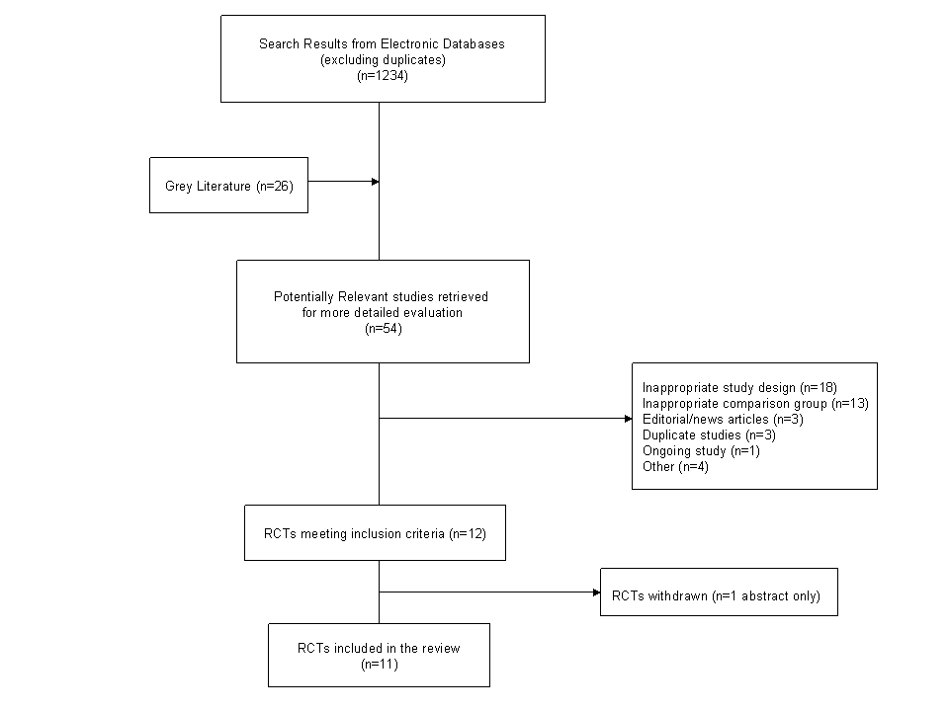

**TABLE 2: STUDY DESIGN, CLINICAL AND DEMOGRAPHIC BASELINE CHARACTERISTICS**

|  |  |  |  |  |  |  |  |  |  |  |  |  |
| --- | --- | --- | --- | --- | --- | --- | --- | --- | --- | --- | --- | --- |
| **Study id** | **Year** | **Design\*** | **”N” randomized/”N” analyzed** | **Insulin**  **Type** | **Oral**  **Agent** | **Duration of Diabetes** | **A1C (%)** | **Age**  **(yrs)** | **Sex**  **%M/F** | **BMI (kg/m2)** | **OAD\*** | **Jadad Score** |
| Aljabri | 2004 | P | 62/58 | NPH | pioglitazone | 10 | 9.9 | 58 | 60/40 | 25.5 | Met+SU or Met + nateglinide | 2 |
| Ko | 2006 | P | 112/104 | NPH | rosiglitazone | 13 | 9.9 | 58 | 56/44 | 24.9 | SU or Met+SU | 1 |
|  |  |  |  |  |  |  |  |  |  |  |  |  |
| Bastyr | 2000 | P | 131/114 | NPH | metformin | 8 | 10.2 | 57 | 60/40 | 28.4 | glyburide | 1 |
| Klein | 1991 | P | 50/35 | NR* | metformin | 12 | NR* | 67 | 24/76 | NR* | glibenclamide | 1 |
| Trishitta | 1992 | C | 20/16 | NPH | metformin | 12 | 10.2 | 43 | 35/65 | NR* | glyburide | 1 |
| Trishitta | 1998 | C | 50/45 | NPH | metformin | 13 | 9.1 | 56 | 24/76 | 27.8 | glibenclamide | 1 |
| Vingeri | 1991 | C | 12/12 | NPH | metformin | 12 | NR* | 52 | NR* | NR* | glyburide | 1 |
|  |  |  |  |  |  |  |  |  |  |  |  |  |
| Lopez | 1999 | C | 47/29 | NPH | acarbose | 10 | 11.2 | 53 | 28/72 | 27.3 | chlorpropamide + Met | 1 |
|  |  |  |  |  |  |  |  |  |  |  |  |  |
| Reynolds | 2007 | P | 40/35 | glargine | rosiglitazone | 11 | 9.0 | 61 | 100/0 | 31.6 | Met+SU | 1 |
| Rosenstock | 2006 | P | 219/216 | glargine | rosiglitazone | 8 | 8.8 | 56 | 52/48 | 34.1 | Met +SU | 1 |
| Triplitt | 2006 | P | 20/20 | glargine | rosiglitazone | 8 | 9.3 | 48 | 40/60 | 30.2 | Met +SU | 0 |

*P=parallel design; C=cross-over design; OAD=oral antidiabetic therapy; Met=metformin; SU=sulfonylurea; NR=not reported

**FIGURE 2: CHANGE IN A1C (%)**

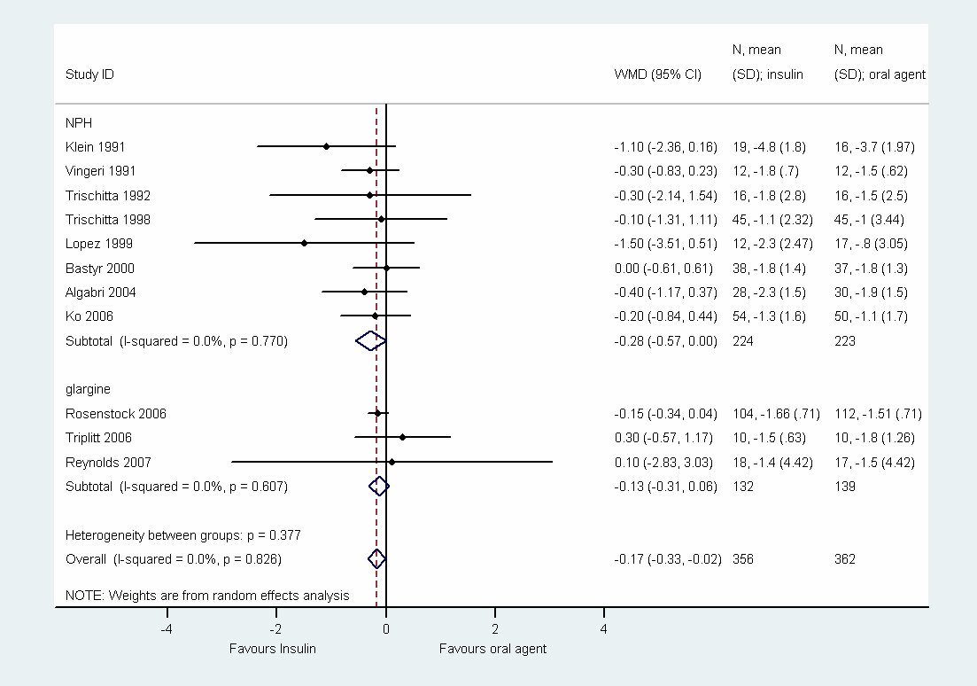

**FIGURE 3: PROPORTION OF SUBJECTS ACHIEVING TARGET A1C<7%**

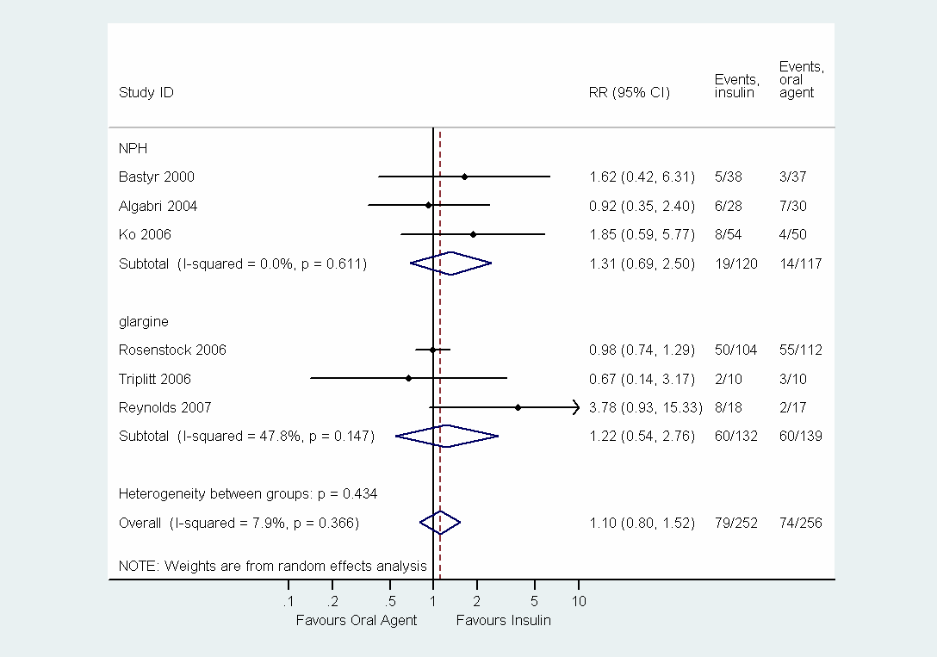

**Figure 4: Change in Fasting Plasma Glucose (mmol/L)** 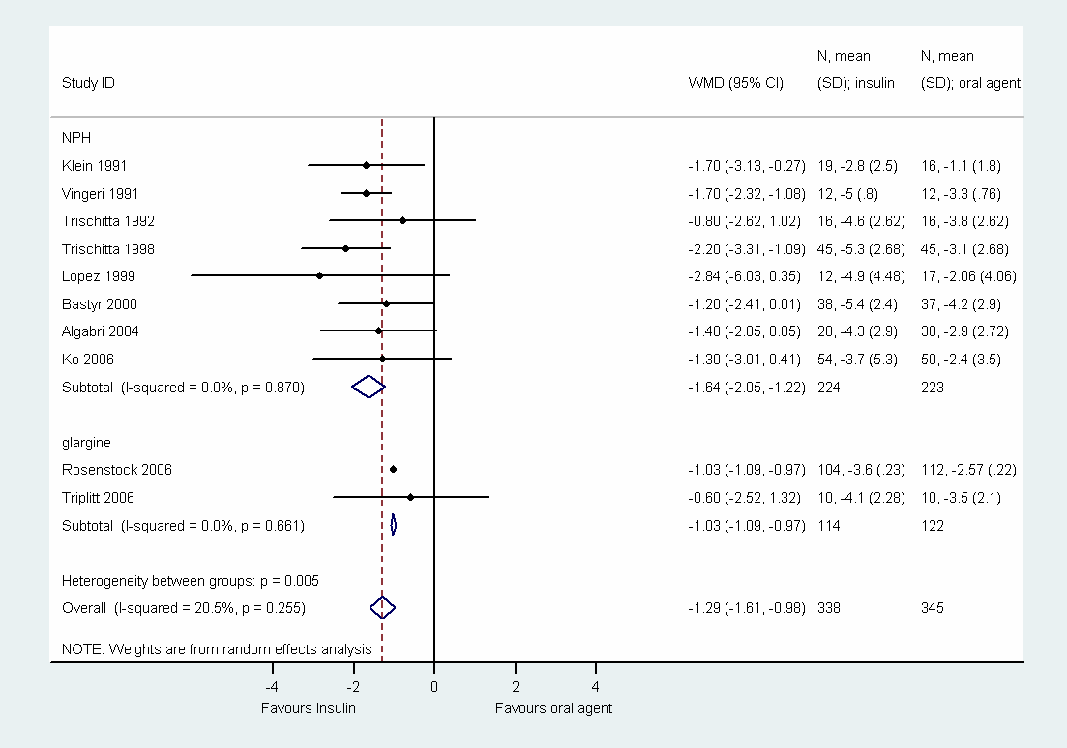

**Figure 5: Proportion of Subjects experiencing a hypoglycemic event**

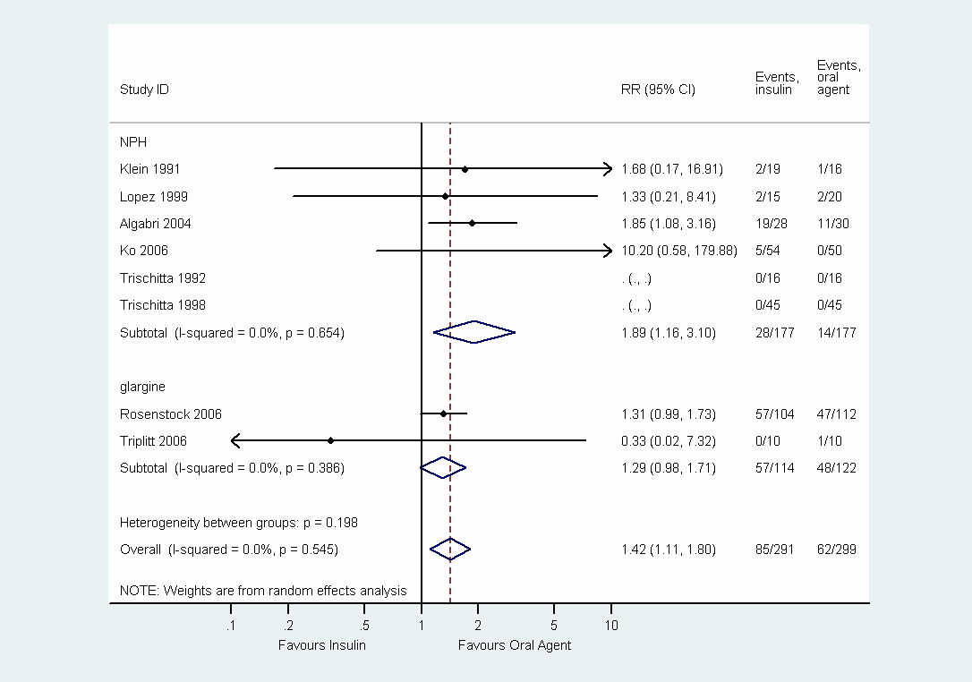

**Figure 6: Weight Change (kg)**

