**Equity in the use of medicare services in British Columbia, 1992 and 2002**

Kimberlyn M. McGrail is a post-doctoral fellow at the

Centre for Health Services and Policy Research at UBC and a

senior researcher with the Health Information and Research Division of Statistics Canada

**Corresponding author:**

Kimberlyn M. McGrail

Centre for Health Services and Policy Research

201-206 East Mall

Vancouver, BC V6T 1Z3

P: 604.822.8044

F: 604.822.5690

[kmcgrail@chspr.ubc.ca](mailto:kmcgrail@chspr.ubc.ca)

**Source of support:**

Financial support for this work was provided by a CIHR doctoral research award and by the Centre for Health Services and Policy Research.

**Word count (text only):** 2,720

**Tables and Figures:** 1 table and 3 figures

## Abstract

*Background* The primary equity principle in Canada is the provision of services based on need rather than ability to pay. Despite this, many OECD countries, including Canada, exhibit income-related variations in the use of health care services. This paper extends previous analyses to include surgical day care, assesses changes in equity between 1992 and 2002 in B.C. and tests the feasibility of using administrative data for equity analyses.

*Methods* Data derive from the B.C. Linked Health Database and from a custom tabulation of income tax filer data provided by Statistics Canada. Analyses measure inequity in the probability and conditional use of services using concentration indices, which summarize health care services use for individuals ranked by income, after standardizing for age, sex, region of residence and need for health care services.

*Results* There are small but systematic relationships between income and use for all types of services except the probability of GP visits. Lower income is associated with greater conditional use of GPs and greater use of acute inpatient care. Higher income is associated with greater use of specialist and surgical day care services, and the latter inequity grew substantially over time.

*Conclusions* Deviations from equity deserve further investigation, especially as the use of day care surgery continues to expand. For example, understanding the reasons for differential admission rates to acute and day surgery might offer guidance as to whether community-based services could help shift some acute care use among lower income groups to surgical day care. Future research should use administrative data to look at regional variations and equity in more detailed areas, such as medical vs. surgical admissions to acute care.

##### Word count (abstract): 272

##### Introduction

The primary equity principle underlying medicare in Canada is the provision of hospital and physician services based on need rather than ability to pay (1). Despite this, van Doorslaer et al. (2) recently showed that after controlling for need, many OECD countries, including Canada, exhibit income-related variations in the use of health care services. While there is generally little income-related inequity in the use of GP services, utilization of specialist services consistently (and sometimes substantially) favours higher income groups. The opposite is often seen for inpatient hospital services, for which utilization is higher (after needs-adjustment) among lower income groups. These findings are broadly consistent with previous Canadian research in this area (3-6).

This paper makes three contributions to this literature. First, it extends analyses beyond physicians and acute inpatient hospital service use to include surgical day care services as well. This is an important extension, as surgical day care is a rapidly growing area of health care services (7). Second, the analyses are intended to assess changes in equity between 1992 and 2002 in British Columbia, a decade of many changes in the delivery of health care services. Third, these analyses test the feasibility of use of administrative data for equity analyses, whereas previous work has been based almost exclusively on survey data. The use of population-based, administrative data enables the first two contributions, since these data are routinely collected (making comparisons over time possible) and cover all publicly-funded services (allowing the extension to surgical day care). In addition, administrative data pertain to the whole population rather than a sample, which circumvents the problem that surveys may have in representing the tails of the income distribution (8).

These analyses confirm previous findings of relative equity in the use of general practitioners, some inequities favouring higher income groups in the use of specialist services and inequities favouring lower income groups in the use of inpatient acute services. The present study also finds inequities favouring higher income groups in the use of surgical day care services, and furthermore that these inequities appear to be increasing over time. Finally, it confirms the utility of administrative data for equity research on health care services utilization.

## Methods

### *Data sources and variable construction*

Data derive from the B.C. Linked Health Database (BCLHD), a collection of population-based, linkable data covering the use of physician and hospital services (9), and from a custom tabulation of income tax filer data provided by Statistics Canada. The study population is all residents of British Columbia in 1992 and 2002, which in 2002 was about 4 million individuals.

Income

Using data from income tax filers, analysts at Statistics Canada calculated an income per person equivalent[1] for each postal code in B.C., ranked postal codes from lowest to highest equivalent income, and then created 1,000 income bands, each containing (approximately) 1,400 families and 3,600 individuals (more detail is available in (1)). This approach was chosen because it allowed the creation of a large number of income, bands and while the resulting variable is ecological, the heterogeneity of income within postal codes (as used here) will be smaller than the heterogeneity within Statistics Canada dissemination areas, which are the unit used to create the commonly used income quintiles and deciles (10).

###### Health care services use

The central file of the BCLHD includes all residents registered with the province for health care insurance. This file includes demographic and location information for all individuals regardless of whether they actually use health care services. The information used here was age (aggregated into six age groups: 0-14, 15-44, 45-64, 65-74, 75-84 and 85+), sex, and postal code of residence. Postal codes were used both to assign individuals to one of the 1,000 income bands described above, and to create a variable indicating residence in one of five geography-based health authorities responsible for health care planning and administration in British Columbia.[2]

The health care services utilization files of the BCLHD include information on: 1) all separations from hospitals in British Columbia, as well as all out of province (and some out of country) hospitalizations for residents of BC; 2) services provided by physicians to BC residents, and reimbursed on a fee-for-service basis, as well as out-of-province services provided to BC residents. Physician expenditures were divided into specialty and general practice services based on whether the specific fee item paid is predominantly used by specialists or general practitioners. This means that the designations of “specialist” and “general practice” refer to the type of service provided rather than to characteristics of the provider (1).

The analyses require the conversion of all health care services utilization into expenditures. Fees paid were included as part of the physician file. Hospital costs were estimated using Resource Intensity Weights and Day Resource Intensity Weights applied to acute inpatient and surgical day care separations, respectively, following procedures used routinely by the BC Ministry of Health (11).

#### Need for health care services

Need is measured using the Adjusted Clinical Group (ACG) system, a validated case-mix grouper for health care services developed at Johns Hopkins University (12). The ACG system groups individuals based on the range of diagnoses each receives from physician and hospital encounters over the course of a year. The categories, such as “acute minor” and “chronic major with psychosocial”, characterize the morbidity profile of each individual, and were designed to reflect expected use of health care services. Because assignment to groups depends on all diagnoses accumulated during a year, the analyses were limited to individual who were resident in B.C. for a minimum of nine months of the year to avoid the potential for misclassification bias.

### *Analysis*

The analyses employ the methods developed by the ECuity group[3] and now widely used in health equity research (including van Doorslaer et al. (2)) Within this framework, inequity is measured using a concentration index, which measures the extent of inequality in the distribution of a good (in this case health care services use) where the population is ranked by income. Concentration indices can take on values from –1 to 1, with negative values indicating greater concentration among lower income groups, and positive values indicating greater concentration in higher income groups.

It is not sufficient, of course, merely to rank the population by income and calculate a concentration index of health care services use, because there will be systematic differences in age, sex and need for health care services by income (see, for example, (13)). The ECuity group has shown that it is possible to use linear regression to standardize for these differences. The steps involved are: 1) regress total health care expenditures on a vector of variables that are related to health care services use; 2) use the resulting model to calculate predicted health care services use for each individual; 3) calculate a standardized *y* (health care services use) for each individual by subtracting predicted from actual expenditures and adding population mean expenditures; 4) calculate a concentration index for the standardized *y*’s. This approach is, then, a test of whether differences between actual and expected use of health care services are systematically related to income.

Separate models were run for four types of health care services for each of 1992 and 2002. As is common for health care utilization studies, analyses were conducted using a two-part estimation model in which utilization was broken into: (1) the decision whether to use any service, estimated via a linear probability model; and (2) conditional on being a user, the amount of services used, estimated using OLS (14). Approval for access to de-identified research data was provided through the BC Linked Health Database (15) and ethics approval was provided by the University of British Columbia Behavioural Research Ethics Board.

## Results

The overall study populations for 1992 and 2002 totaled just over three million and 3.8 million individuals (Table 1). This is less than the population of B.C. in these years because of the exclusion of individuals who were resident in the province for fewer than nine months of the year. The majority of the population used at least one type of medicare service, and this was true of both sexes and all age groups. Nine out of ten females had some contact with medicare services during 1992 compared to a little over eight in ten males. The likelihood of service use tends to rise with age, though declines slightly in the oldest age group, likely because of the greater proportion of this group living in residential care facilities. The proportion of the population who use services was slightly lower in the Northern Health Authority, and proportions for all types of use declined slightly from 1992 to 2002. These findings may be the result of the increasing importance of non-fee-for-service remuneration of physicians over this time period (16), for which there is no patient-level encounter information.

There is no income-related difference in the probability of visiting a general practitioner after adjusting for age, sex, region of residence and need for health care services (Figure 1). The probability of specialist visits, however, is more heavily concentrated in higher income groups, and this inequity increases slightly over time (Figure 1 includes error bars indicating 95% confidence intervals, but they tend to be narrow and so are not apparent for all outcomes). There is greater probability of admission to acute inpatient care among lower income groups, while use of surgical day care shows the opposite – greater likelihood with higher income. In addition, the concentration index for probability of use of surgical day care increases substantially over time.

The conditional use of services shows slightly different patterns for GP services (Figure 2). Given some contact with GPs, there is greater use of services among individuals in lower income groups, and this increases (meaning becomes more heavily concentrated in lower income groups) over time. The other service types show the same relationships as seen for the probability of use; greater conditional use of specialist services and surgical day care among higher income groups, and greater use of inpatient acute care among lower income groups. There is some suggestion that inequities in conditional use of specialist services may be decreasing and of acute inpatient care may be increasing, but the changes are smaller in magnitude than that seen for the probability of use of surgical day care.

### Discussion

This study shows that with the development of variables for income and need, administrative data can be used to measure equity in the use of health care services. The use of administrative data means it is possible to analyze equity in the use of surgical day care, a service type that is not currently asked about in Canadian household surveys on health and health care use. Results here suggest that this is an important extension, as there are inequities favouring higher income groups for day care surgery, and these inequities are increasing over time.

One of the research questions following implementation of medicare in Canada was whether removing financial barriers created socioeconomic or income-based equity in the use of health-care services (5;17) The general result of the early studies was that inequities in access were reduced but not eliminated. More recent research is generally consistent in showing that higher income individuals are more likely to visit specialists (2;4;18;19) while lower income individuals are more likely to receive more inpatient acute care (2;18). Some of these studies also show that higher income individuals are more likely to visit a GP, but this finding is not universal (e.g. (4)), and was not the case in the present study. One previous study (3) linked survey and administrative data and found no relationship between income and total physician or specialist physician use after controlling for health status. It is not clear how generalizable those results are, however, as they were limited to a small population (n ~ 2,000) in a single province (Ontario) in the mid-1990s.

A direct comparison with van Doorslaer et al. (2) is useful because the method of analysis was the same, though the sources of data were different. Figure 3 shows that compared to that earlier study, the results reported here for Canada in the probability of seeing a GP are lower in magnitude, but generally would lead to similar conclusions about Canada with respect to international comparisons (results for other comparisons are similar, data not shown).

One reason for lowered magnitude of results is that the income variable used here is ecological, and while at a very fine-grained level of aggregation, this still means that these analyses very likely underestimate the true relationship between income and health care services use. Another limitation is that the physician data do not include any detailed information for services provided by physicians paid by non-fee-for-service methods (e.g. contracts, salary, sessional payments). These alternative payment arrangements have traditionally represented less than 10% of total payments to physicians, but the proportion has been rising in recent years (16). Finally, the analyses here were limited to the sectors of the health care system that are part of medicare and thus covered by (essentially) full public payment. Analyses of other health care sectors, where there are out-of-pocket payments, would surely indicate higher inequities in use.

The concentration indexes reported in Figures 2 and 3 are all close to zero, indicating small but systematic relationships between income and use after adjusting for need. Lower income individuals have higher conditional use of GP services and both greater probability and higher conditional use of acute inpatient services, while higher income individuals tend to receive more specialist and surgical day care services.

In fact, it is only for the likelihood of visits with GPs where there is no income-based inequity in the use of services. In other words, inequities in use are found for physician-referred rather than patient-initiated services, suggesting that income-based inequities in the system are more likely the result of the way patients are cared for rather than the result of patient behaviours and decisions about presenting for care. Ultimately, however, it is difficult to disentangle patient vs. physician effects, since higher income patients might be more likely to request specific services or referrals (4) and physicians often find it difficult to say “no” once patients make direct requests.(20)

The results suggest that there may be a trade-off between GP and specialist services and between acute and surgical day care services. One reason this might occur is because of geography and the uneven distribution of specialty services, such that individuals in areas under-served by specialists (who also tend to have lower average income) might make more use of GP services. This explanation seems unlikely, however, since region of residence was included (and adjusted for) in the analyses. A trade-off might also occur if there is an imperfect adjustment for health status, leaving a remaining relationship between income and severity of disease unaccounted for in the analyses. On closer inspection, however, this explanation also does not seem plausible, because the results for hospital services would suggest that the (unmeasured) severity of illness is greater for lower income groups (which receive more acute care services) while physician services suggest the opposite (lower income groups receive fewer specialist services).

Some inequities in services became more pronounced between 1992 and 2002, particularly for the likelihood of referral for surgical day care services (which favours higher income groups) and expenditures on total hospital care, including both acute inpatient and surgical day care (which favour lower income groups). These differences deserve further investigation, especially as the use of day care surgery continues to expand. A better understanding, for example, of the reasons for differential admission rates to acute and day surgery might offer some guidance as to whether relatively inexpensive community-based services could help shift some acute care use among lower income groups to surgical day care.

The general picture of equity in physician and hospital services use in British Columbia is that the system is largely delivering services according to need. The differences by income group in the use of physician and hospital services are relatively small, but there is always room for improvement. Future research should take advantage of the breadth of coverage of administrative data to analyse trends at provincial and sub-provincial levels, and in more precise categories such as medical vs. surgical care within acute care hospitals. Certainly there is a need to continue to monitor equity as health reforms continue.

**Acknowledgements:** This work was completed in partial fulfillment of the requirements for a PhD in the Department of Health Care and Epidemiology at UBC. Comments on earlier versions of these analyses were provided by my thesis committee, Morris Barer, Robert Evans and Clyde Hertzman. I am also grateful to Jerry Hurley for comments on an earlier draft of this paper and to Dawn Mooney for creating the Figures used here.

**References**

1. McGrail KM. Equity in health, health care services use and health care financing in British Columbia, 1992 and 2002. 2006. The University of British Columbia.

Ref Type: Thesis/Dissertation

2. van Doorslaer E, Masseria C, Koolman X, for the OECD Health Equity Research Group. Inequalities in access to medical care by income in developed countries. Canadian Medical Association Journal 2006;177-83.

3. Finkelstein MM. Do factors other than need determine utilization of physicians' services in Ontario? Canadian Medical Association Journal 2001;565-70.

4. Dunlop S, Coyte PC, McIsaac W. Socio-economic status and the utilisation of physicians' services: results from the Canadian National Population Health Survey. Social Science & Medicine 2000;123-33.

5. Birch S, Abelson J. Is Reasonable Access What We Want - Implications of, and Challenges to, Current Canadian Policy on Equity in Health-Care. International Journal of Health Services 1993;629-53.

6. Newbold KB, Eyles J, Birch S. Equity in health care: Methodological contributions to the analysis of hospital utilization within Canada. Social Science & Medicine 1995;1181-92.

7. Canadian Institute for Health Information. Trends in Acute Inpatient Hospitalizations and Day Surgery Visits in Canada, 1995-1996 to 2005-2006. 2007. Ottawa, Canadian Institute for Health Information. Analysis in Brief: Taking health information further. 7-6-2007.

Ref Type: Report

8. Frenette M, Green DA, Picot G. Rising income inequality amid the economic recovery of the 1990s: An exploration of three data sources. 1-32. 2004. 2-4-2004.

Ref Type: Electronic Citation

9. Chamberlayne R, Green B, Barer ML, Hertzman C, Lawrence WJ, Sheps SB. Creating a population-based linked health database: a new resource for health services research. Canadian Journal of Public Health 1998;270-3.

10. Wilkins R. PCCF+ Version 3G User's Guide (Geocodes/PCCF): Automated geographic coding based on the Statistics Canada Postal Code Conversion Files including postal codes to June 2001. 82F0086-XDB, 1-61. 2001. Ottawa, Statistics Canada. 17-2-2004.

Ref Type: Electronic Citation

11. Lee S. Personal communication [availabiliity of hospital-specific expenditures by weighted case]. 2002.

Ref Type: Personal Communication

12. Reid RJ, MacWilliam L, Verhulst L, Roos N, Atkinson M. Performance of the ACG case-mix system in two Canadian provinces. Medical Care 2001;86-99.

13. Roos NP, Mustard CA. Variation in health and health care use by socioeconomic status in Winnipeg, Canada: Does the system work well? Yes and no. Milbank Quarterly 1997;89-&.

14. van Doorslaer E, Masseria C, OECD Health Equity Research Group Members. Income-related inequality in the use of medical care in 21 OECD countries. OECD Health Working Paper No. 14, 1-88. 2004. Paris, OECD. OECD Health Working Papers. 23-11-2004.

Ref Type: Report

15. British Columbia Ministry of Health, Centre for Health Services and Policy Research (UBC). Access policy for research uses of linked health data. 1-21. 1996. Victoria, British Columbia Ministry of Health.

Ref Type: Report

16. Canadian Institute for Health Information. The Status of Alternative Payment Programs for Physicians in Canada. 2005. Ottawa, Canadian Institute for Health Information.

Ref Type: Report

17. Beck RG, Horne JM. Economic-Class and Risk Avoidance - Experience Under Public Medical-Care Insurance. Journal of Risk and Insurance 1976;73-86.

18. Asada Y, Kephart G. Equity in health services use and intensity of use in Canada. BMC Health Services Research 2007.

19. Nabalamba A, Millar WJ. Going to the doctor. Health Reports 2006;23-35.

20. Carlsen B, Norheim OF. "Saying no is no easy matter" a qualitative study of competing concerns in rationing decisions in general practice. BMC Health Services Research 2005;70.

##### Table 1: Descriptive information for study population

|  |  |  |  |  |
| --- | --- | --- | --- | --- |
|  | **1992** | | **2002** |  |
|  | N | % users | N | % users |
| Total population | 3,042,415 | 86.4% | 3,856,959 | 82.3% |
|  |  |  |  |  |
| Males | 1,467,647 | 82.1% | 1,892,380 | 77.6% |
| Females | 1,574,768 | 90.4% | 1,964,579 | 86.9% |
|  |  |  |  |  |
| Age group |  |  |  |  |
| 0-14 | 608,593 | 86.2% | 656,032 | 79.3% |
| 15-44 | 1,368,785 | 85.1% | 1,620,110 | 79.0% |
| 45-64 | 642,313 | 85.8% | 1,029,512 | 84.4% |
| 65-74 | 247,103 | 91.1% | 286,938 | 92.0% |
| 75-84 | 136,523 | 93.7% | 194,468 | 93.5% |
| 85+ | 39,098 | 92.5% | 69,899 | 87.1% |
|  |  |  |  |  |
| Regional health authority | |  |  |  |
| Interior HA | 533,606 | 85.1% | 644,837 | 81.8% |
| Fraser HA | 936,669 | 87.8% | 1,304,046 | 83.4% |
| Vancouver Coastal HA | 773,633 | 86.8% | 980,391 | 81.4% |
| Vancouver Island HA | 539,525 | 87.2% | 645,171 | 84.4% |
| Northern HA | 258,982 | 81.3% | 282,514 | 77.3% |

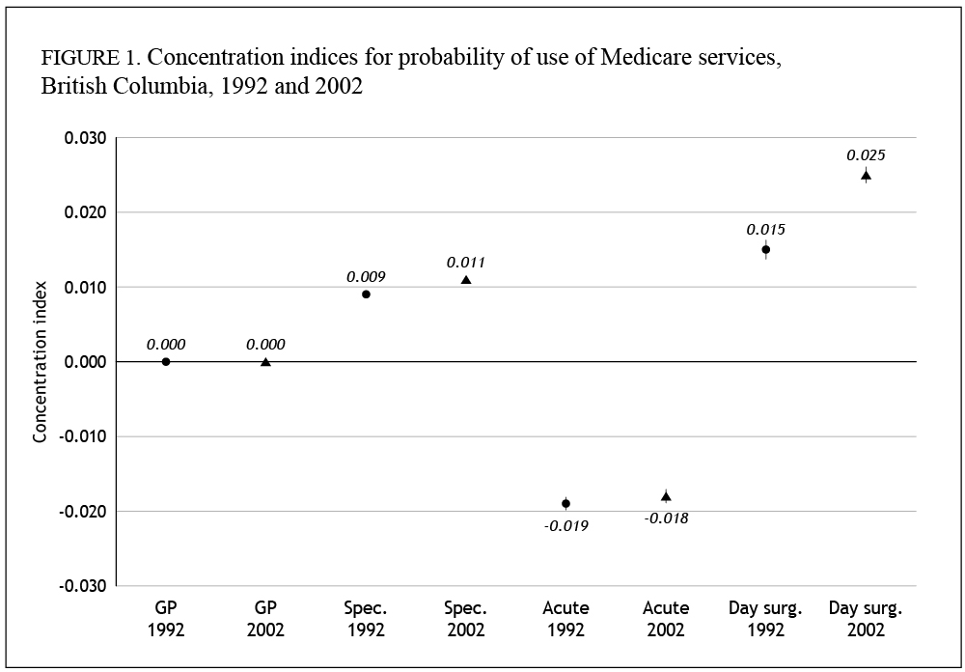

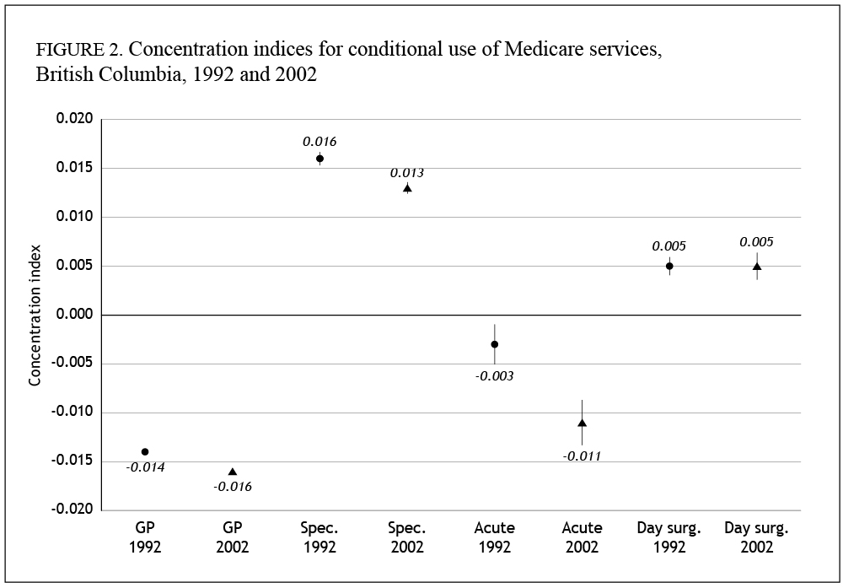

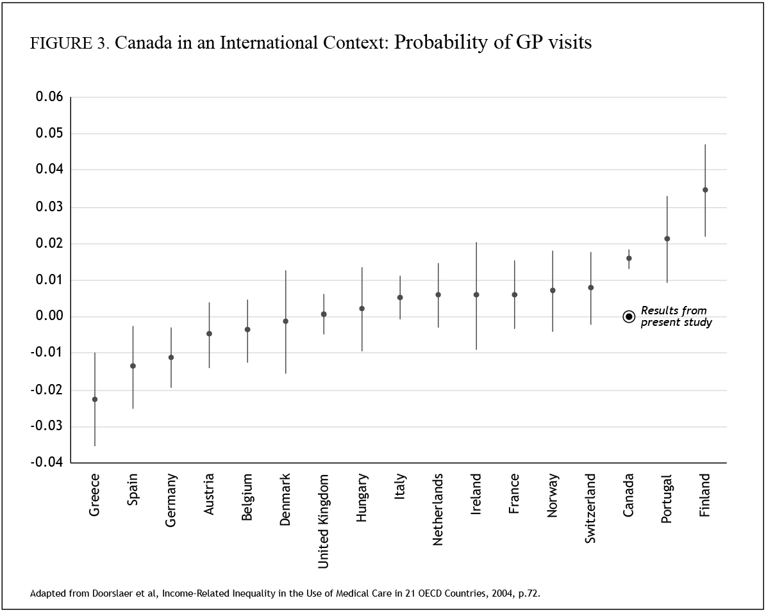

1. A “person equivalent” is a way of saying that there are economies of scale in running a household; for example, a family of four does not require twice the income of a family of two in order to achieve the same standard of living. Total household income is equivalized (i.e. adjusted to reflect household size), counting the first adult as “1”, remaining adults as “0.5” and children as “0.3” each. Equivalized household income was calculated by summing total tax filer income for each household and dividing by the number of person equivalents (e.g, 2.1 for a household with two adults and two children). Average income per postal code was than calculated as a weighted average of each household’s income per person equivalent, with the weight equal to the number of person equivalents.
2. Information about these five health authorities, from the second edition of the B.C. Health Atlas, can be found here: http://www.chspr.ubc.ca/Research/health-atlas.php?sect=1&sub=5
3. More information about this group is available at: http://www2.eur.nl/ecuity/