**Renal outcomes and mortality following hydroxyethyl starch resuscitation in critically ill patients: A meta-analysis of randomized trials**

Ryan Zarychanski MD, Alexis F Turgeon MD MSc., Dean A Fergusson MHA PhD, Deborah J Cook MD MSc, Paul Hébert MD MSc, Sean M Bagshaw MD Msc, Danny Monsour, Lauralyn McIntyre MD MHSc.

Ryan Zarychanski, Assistant Professor, Divisions of Hematology and Critical Care, University of Manitoba, Winnipeg, Manitoba, R3E 0V9, Ottawa Health Research Institute and the University of Ottawa, Ottawa, ON, Canada, K1H 8L6, [ryan@zarychanski.com](mailto:ryan@zarychanski.com) ; Alexis F Turgeon, Assistant Professor, Centre de Recherche du CHA, Department of Anesthesia and Division of Critical Care Medicine, Hôpital de l’Enfant-Jésus, Université Laval, Quebec City, Quebec, G1J 1Z4, [alexisturgeon@yahoo.ca](mailto:alexisturgeon@yahoo.ca) ; Dean A Fergusson, Senior Scientist, Ottawa Health Research Institute and the University of Ottawa, Ottawa, ON, Canada, K1H 8L6, [dafergusson@ohri.ca](mailto:dafergusson@ohri.ca) ; Deborah J Cook, Professor, Departments of Medicine, Clinical Epidemiology & Biostatistics, McMaster University, Hamilton, Ontario, L8N 4A6, [debcook@mcmaster.ca](mailto:debcook@mcmaster.ca) ; Paul Hébert, Professor, Department of Medicine, Division of Critical Care, The University of Ottawa, Ottawa, ON, Canada, K1H 8L6, [Paul.Hebert@cma.ca](mailto:Paul.Hebert@cma.ca) ; Sean M. Bagshaw, Assistant Professor, Division of Critical Care Medicine, University of Alberta, Edmonton, Alberta, Canada, T6G 2B7, [bagshaw@ualberta.ca](mailto:bagshaw@ualberta.ca) ; Danny Monsour, University of Ottawa, Ottawa, Ontario, Canada, K1H 8L6, [monsourdanny@gmail.com](mailto:monsourdanny@gmail.com) ; Lauralyn McIntyre, Assistant Professor, Department of Medicine, Division of Critical Care, The Ottawa Hospital, Ottawa, Ontario, K1H 8L6

Correspondence to:

Lauralyn McIntyre MD, MSc.

Assistant Professor, Department of Medicine (Division of Critical Care)

Associate Scientist, Ottawa Health Research Institute

The Ottawa Hospital, 501 Smyth Road, Box 201

Ottawa, ON K1H 8L6

Phone: 613.737.8899 Ext 73231 / Fax: 613.739-6266

[lmcintyre@ottawahospital.on.ca](mailto:lmcintyre@ottawahospital.on.ca)

**Running head:** HES and renal outcomes

**Keywords:** Hydroxyethyl starch, renal failure, sepsis, critical care, meta-analysis

**Word Count**: 3539

# Conflict of Interest/Competing interest statement:

Lauralyn McIntyre has received unrestricted grant support from Bristol Myers Squibb and Abbott Laboratories. The remaining authors have no such conflicts of interest to declare.

**Abstract**

**Background:** Hydroxyethyl starch (HES) fluids are commonly used for fluid resuscitation in patients admitted to the intensive care unit but there is insufficient evidence from randomized controlled trials about their safety and efficacy.

**Purpose:** To evaluate the impact of HES solutions on adverse renal outcomes and mortality in critically ill patients requiring acute volume resuscitation.

**Data Sources:** We searched electronic databases from 1950 to 2008 (MEDLINE, EMBASE, the Cochrane Central Registry of Controlled Trials, and the SCOPUS database). Conference proceedings and grey literature sources were searched from 2002-2007.

**Study Selection:** Randomized controlled trials (RCTs) of acute volume resuscitation with HES fluid compared to an alternative resuscitation fluid in the critically ill.

**Data extraction**: Two reviewers independently assessed trial eligibility, extracted data, and evaluated trial quality.

**Data Synthesis:** Twenty-two trials (n=1865) were included. Patients receiving HES were more likely to receive renal replacement therapy [odds ratio [OR] 1.90 (95% confidence interval [CI] 1.22-2.96, I2 9.5%); n=749]. There was no difference in overall mortality [OR 1.07 (95%CI 0.85-1.34); n=1657]. However, in trials including patients with severe sepsis and septic shock, in high quality and multicentre trials, and in trials with adequate allocation concealment, there was a trend toward increased risk of death associated with HES.

**Limitations:** Data regarding adverse events, including renal outcomes, were not reported in the majority of published randomized trials. Considerable clinical and methodologic heterogeneity existed among trials.

**Conclusions:** The use of HES for acute volume resuscitation in critically ill patients, and in particular severe sepsis and septic shock, appears to be associated with increased use of renal replacement therapy. Further RCTs evaluating clinically important endpoints are required to examine the efficacy and safety of HES fluids in the critically ill.

**Introduction**

In the management of critically ill patients, fluid resuscitation is paramount to prevent organ failure and death1. Many resuscitation fluids exist and are broadly categorized as crystalloids (solutions that can pass through a semi-permeable membrane) or colloids (suspensions whereby fine particles of one substance are spread evenly throughout another). Despite considerable research over several decades, debate remains regarding the relative advantage of either type of solution2.

The use of colloidal starch solutions, have increased in practice despite the higher cost of these products compared to crystalloid solutions3,4 and a lack of evidence demonstrating their clinical superiority5-7. Hydroxyethyl starches (HES) now appear in several resuscitation guidelines, including the US Hospital Consortium Guidelines6,8. Adverse events associated with short term HES exposure include coagulopathy and allergic reactions such as anaphylaxis5,9; continuous use is associated with severe and long-lasting pruritus10. Acute kidney injury has also been intermittently reported with the use of HES in various patient populations 11-14.

Acute kidney injury is an important adverse outcome in critically ill patients because it is an independent risk factor for mortality, and confers increased risk of long term morbidity, impaired quality of life and possible dialysis dependence15-18. Some critically ill patients such as those with severe sepsis or septic shock are at increased risk for developing acute kidney injury because of underlying chronic kidney disease and other comorbidities, older age, and/or the septic process itself. This population may be especially vulnerable to resuscitation fluids that impact adversely on kidney function. Evidence about adverse renal outcomes associated with HES administration from observational studies19-22 and randomized controlled trials14,23-26 are conflicting. Moreover, clinical trials of starch solutions are published in various journals with diverse visibility, making it difficult for clinicians and investigators to be aware of the totality of the evidence. Given the significance of renal failure in critically ill patients we undertook this systematic review and meta-analysis to evaluate the effect of HES on adverse renal outcomes and mortality in patients admitted to an intensive care unit.

**Methods**

**Study Sources and Searches**

Before commencing this systematic review, we (RZ, LM, AFT, and DF) planned and finalized all aspects of the study protocol, including the clinical question, search strategy, outcomes, and analysis.

We developed a strategy to search OVID MEDLINE (1950-2007 August week 2). This search strategy was adapted to search EMBASE (1980-2007 week 33) and the Cochrane Central Register of Controlled Trials (to third quarter 2007). The search strategy was refined by an information specialist at The Ottawa Hospital, incorporating highly sensitive terms to identify clinical studies27, and was updated in December 2008. The complete MEDLINE search strategy is presented in Appendix I. We also searched the SCOPUS abstract and citation database so that studies from relevant journals were not missed by the preceding search methods. To identify ongoing or planned studies, we searched 3 trial registries including the UK National Research Register, the Australian Clinical Trials Registry and the ClinicalTrials.gov database. We used the Scientific and Technical Information Network chemical abstracts database and Google Scholar to assist in the identification of relevant grey literature. We contacted the manufacturers of HES (Bristol Myers Squibb, Fresenius Kabi, Bruan, BioTime, and Abbott Laboratories) to identify published, unpublished, and ongoing studies of HES for resuscitation. We searched the abstracts and conference proceeding from the European Society of Intensive Care Medicine, International Symposium on Intensive Care Medicine, Society of Critical Care Medicine, American College of Chest Physicians, American Thoracic Society, American Society of Anaesthesiology, Canadian Anesthesiologists’ Society, and International Anaesthesia Society, and the American Association for the Surgeons of Trauma from 2002-2007. We also searched the bibliographies of all included studies and relevant reviews for suitable trials not identified in the electronic search strategy. No language restrictions were applied.

We included randomized controlled trials enrolling patients 18 years of age or older who had an indication for acute fluid resuscitation (hypovolemia, hypotension, inadequate indicators of pre-load or filling pressures) and that compared HES with crystalloids, albumin, gelatins, or dextran. We excluded cross over trials, trials including blood as the comparator fluid, and trials examining HES fluids in elective surgery or for acute normovolemic hemodilution. Though HES solutions have varied over time, a uniform mechanism of injury is presumed to occur between products. Thus, all HES solutions were considered in this review, but analyzed separately according to available data.

Our primary outcome was acute kidney injury, defined by the use of renal replacement therapy. Supplementary renal outcomes included the severity of kidney injury as defined by the RIFLE criteria (Risk of renal dysfunction; Injury to the kidney; Failure of kidney function, Loss of kidney function and End-stage kidney disease)28 and the measurement of urinary biomarkers indicative of kidney injury. Secondary clinical outcome measures included mortality, duration of mechanical ventilation, duration of ICU stay, bleeding and transfusion packed red cell units. Mortality analyses were based on the longest time interval at which this outcome was assessed.

The title, abstract and keywords of each record in English were independently screened for relevance by 2 reviewers (RZ and DM). Records excluded by both reviewers were eliminated at this stage. Full-text articles were obtained for all remaining records. Non-English records were translated as required. Two reviewers (RZ and LM) independently adjudicated each full-text article applying the inclusion and exclusion criteria to select relevant trials. We calculated inter-rater agreement using Cohen’s kappa statistic29. Non-English articles were adjudicated by a single reviewer (RZ) after translation. Discrepancies were resolved by discussion and consensus with a third reviewer (DF).

**Data Extraction and Quality Assessment**

Two reviewers abstracted data from the English language trials independently using a standardized data abstraction form (RZ, AT) which had been piloted to ensure completeness and feasibility. Data from non-English language trials were abstracted by one reviewer fluent in the language of publication. If essential data were ambiguous or missing, we contacted the first author or corresponding author by email.

Two reviewers assessed the methodologic quality of each trial using the Jadad scale30 which provides a score based on the description of randomization (0 to 2 points), double blinding (0 to 2 points), and participant withdrawals (1 point). Possible scores varied from 0 to 5; we considered a score of 3 or greater to be of ‘high’ methodological quality. We assessed allocation concealment using the method developed by Schultz and colleagues and scored it as ‘adequate,’ ‘unclear,’ or ‘inadequate’31. We used a double-data entry system to minimize transcription errors.

**Data Synthesis and Analysis**

Group sample means were compared using Welsh’s unpaired t-test for unequal variances. Summary effect measures were calculated using Review Manager (Version 4.2 for Windows, The CochraneCollaboration, Oxford, England). We performed analyses according to the intention-to-treat principle using eligible randomized patients. We employed a random-effects model using inverse variance weights for all summary measures of effect, expressing these as odds ratios with 95% confidence intervals. An odds ratio of more than 1 suggests a higher odds of the outcome among patients receiving HES compared to patients in the control group.

We assessed for evidence of statistical heterogeneity using the I2 statistic. This statistic is interpreted as the proportion of total variation across trials due to heterogeneity (min-max, 0%-100%). We investigated sources of heterogeneity by conducting subgroup analyses based on clinical and methodologic characteristics defined *a priori*; these included the patient population, type of HES, type of fluid comparator, high versus low quality trials, presence or absence of allocation concealment, and single versus multi-centre trials. We visually examined the potential for publication bias using funnel plots.

**Role of the funding source:**

There was no external funding source for this work.

**Results**

In Figure 1, we present a description of all citations and trials identified and reasons for their exclusion at each level of screening. Of the 2381 reports identified, 2220 were excluded after initial screening. We retrieved full-text articles for 161 studies published in 8 languages. Of these 161 articles, 23 trials were selected for inclusion. Agreement between the 2 reviewers at level 2 screening is reflected in kappa = 0.68. Discrepancies were resolved by discussion and consensus. During data extraction, we found that 2 publications were separate analyses of the same trial population32,33; thus, we included the article that was most informative for the purposes of this review33. From trial registries, we identified 3 ongoing randomized trials which were not included in our analyses.

A total of 1865 patients were randomized in 22 trials, with a median of 48 patients enrolled per trial (range 12 to 537). Twenty trials were published in peer-reviewed journals, 1 trial is currently in press26, and 1 has only been published in abstract form34. Twenty trials were reported in English language journals14,24-26,33-48, 1 was in French49 and 1 in German50. Five trials were conducted in North America26,33,43,45,47, 16 in Europe14,24,25,34-42,44,46,49,50, and 1 in South America48. Four trials received grant funding from manufacturers of HES22,24,45,47, and 16 trials reported no funding source25,33-43,46,48-50.

Eight trials exclusively enrolled patients with sepsis, severe sepsis or septic shock14,24,26,41,43,44,46,47, 6 with trauma34,35,40,45,48,49, 5 with trauma and sepsis36-39,42, 1 with ‘hypovolemic shock’33, and 1 in which the type of critically ill patients were not reported50. One trial randomized brain dead organ donors to either HES or gelatin25; the final unit of analysis was number of transplanted kidneys in the recipients.

Trials compared HES to 20% albumin36-42,46, 5% albumin33,43,47, gelatin14,25,34,35,44,49,50, dextran34, or a crystalloid solution24,26,33,45,48. Two trials included pentoxifylline as a comparator; however, these arms were not incorporated into this systematic review40,41. Six different HES fluids, varying by molecular weight and molar substitution, were represented (Table 1).

All trials enrolled patients requiring urgent fluid resuscitation; however, justification for volume loading varied widely and was not explicitly stated in 2 full publications35,50 and 1 abstract34. Many trials used either systolic blood pressure or mean arterial blood pressure as justification for fluid administration14,24,26,33,43,45,47-49. Three trials enrolling patients with severe sepsis/septic shock also incorporated increased arterial lactate and cardiac index of <2.2 L/min as criteria for fluid loading33,43,47. In 8 trials, a central venous pressure or pulmonary capillary wedge pressure of <10-12 mmHg served as the single trigger for volume loading36-42,46. One trial incorporated clinical signs of hypoperfusion49. Two trials used echocardiographic indicators as surrogates for hypovolemia25,44.

The amount and type of fluid received prior to randomization was reported in 4 trials24,26,39,46. The duration of study protocols varied from less than 1 hour to a maximum of 21 days. Twelve protocols administered HES within the first 24 hours of clinical presentation25,26,33-35,43-45,47-50. Total study fluid administered differed considerably among trials: the mean volume of HES given varying from 364 ml (SD 64)48 to 5,350 ml (SD 650)41.

Regarding relevant co-interventions, all patients in trials conducted by Boldt et al. received continuous dopamine infusions at 3 mcg/kg/min36-42. Gelatin was administered to the HES group after receiving 2000 ml of the study colloid in 1 trial49. In 1 trial, the components of early goal directed therapy protocolized the use of red blood cell transfusions and inodilators in addition to fluid26. Vasopressors and inotropes were used when necessary in all studies, generally after initial volume resuscitation.

Four trials listed renal sequelae as primary or secondary outcomes14,24-26. Four trials reported the requirement for renal replacement therapy14,24-26 and 5 trials reported variable definitions for acute renal failure with creatinine concentrations14,24,25,35,42. Patients with evidence of renal impairment or renal failure, defined by serum creatinine or the need for hemodialysis, were excluded from enrollment in 9 trials14,24,26,35-39,46. Baseline renal function (serum creatinine) was reported in 5 trials14,24-26,42. Comorbidities and risk factors for renal injury were detailed in 2 trials14,24.

Most included trials were small, single centered, and of low methodologic quality (Table 2). Assessing the methodologic quality of 1 published abstract was not possible without an available manuscript34. Four trials were of high methodologic quality14,24-26. Adequate allocation concealment was reported in 5 trials14,24,26,48,49. Nine of 21 evaluable trials reported blinding25,26,36-42, but only 1 described the blinding methods26. Losses to follow-up were reported in 5 trials14,24-26,35. Analysis according to the intention to treat principle was reported in 4 trials14,24-26 and the method was unclear in 16 trials due to the absence of information regarding losses to follow-up33,36-50.

*Primary Outcome: Acute Kidney Injury*

The pooled odds ratio (OR) for renal replacement therapy associated with HES fluid in the 4 trials that reported this outcome was 1.90 (95% CI 1.22-2.96, I2 9.5%, n=749)14,24-26. The summary statistic was heavily influenced by the findings of a single large randomized controlled trial that accounted for 70% of the pooled statistical weight24. Three of these 4 trials included patients with severe sepsis or septic shock for which the pooled OR of renal replacement therapy was 1.82 (95% CI 1.27-2.61, I2 0%, n=702)14,24,26. HES use was also associated with an increased odds of renal replacement therapy in the 1 trial of kidney transplant recipients (OR 9.5 and 95% CI 1.09-82.72, n=47). Further sensitivity analysis was limited by the low number of trials that reported renal outcomes.

Indices reflecting changes in serum creatinine were reported in 5 trials but were not suitable for pooling due to variable definitions of acute kidney injury and timing of laboratory measurements14,24,25,35,42. One trial in kidney transplant recipients found higher serum creatinine values in patients who received kidneys from donors resuscitated with HES as compared with donors who were resuscitated with gelatin in the first 10 days after transplantation (p<0.01)25. In another trial of resuscitation in septic shock, the median peak serum creatinine was higher in those receiving HES:200/0.62 compared to those receiving gelatin [2.5 (IQR 1.5-3.8) mg/dl vs. 1.9 (1.2-3.1) mg/dl, p=0.04]14. However, in this trial, baseline serum creatine concentrations were significantly higher in patients randomized to receive HES. Two trials that included patients with trauma and sepsis or trauma alone reported similar mean serum creatinine values in the HES and control groups; these analyses were based on patients remaining in ICU at day 535,42.No trial evaluated acute kidney injury according to RIFLE categories or characterized changes in urinary biomarkers.

In the 2 trials enrolling patients with severe sepsis and septic shock, the pooled OR of acute kidney injury, defined as a doubling of serum creatinine or the requirement for renal replacement therapy, was 1.91 (95% CI 1.36-2.68; I2 0%, n=662) in patients receiving HES14,24. In 1 trial that reported acute kidney injury as a creatinine >221 mol/L or urine output <20 ml/hr, there were no differences between the 2 groups42.

*Secondary Outcomes: mortality, duration of mechanical ventilation and ICU stay*

Mortality was reported in 17 of 22 trials (Figure 3). The pooled odds ratio for death associated with HES was 1.07 (95%CI 0.85-1.34), I2 0%, n=1657. In the 6 trials that enrolled patients with severe sepsis or septic shock, the pooled OR for death associated with HES was 1.23 (95% CI 0.92 -1.65, I2=0%)14,24,26,32,41,44; in trauma, the OR for death was 1.52 (95% CI 0.48-4.75); and in trials that included sepsis and trauma patients, the OR for death was 0.82 (95% CI 0.55-1.21) (Figure 4). No significant differences in the odds ratios for death were evident with different durations of the study protocols or with use of early goal directed therapy (data not shown). No significant differences in the odds ratio for death existed with the different fluid comparator groups or when specific molecular weights of HES were analyzed (Figure 4).

In the 3 trials of higher methodologic quality (Jadad score 3-5) the pooled OR for death was 1.27 (95% CI 0.93-1.72, I2=0%)14,24,26. In the 4 multicentre trials, HES administration was associated with an OR for death of 1.31 (95% CI 0.97-1.76, I2=0%)14,24,26,49. In the 5 trials with adequate allocation concealment, the summary OR for death associated with the of HES was 1.28 (95% CI 0.96-1.72, I2=0%)14,24,26,48,49(Figure 4).

The duration of mechanical ventilation42,45 and ventilator free-days24 were similar in the 3 trials reporting these outcomes. The mean44 or median14,24,26 duration of ICU stay was comparable between the HES and control groups in the 4 trials of septic shock. In 1 trial of 59 patients suffering acute traumatic injuries, mean (±SD) ICU length of stay was shorter (8.8 days (3.3) vs. 11.1 days (3.4), p=0.01) in patients receiving HES35.

*Safety Outcomes:*

Three of 22 included trials reported information concerning allergic reactions or anaphylaxis secondary to HES administration25,47,49. No allergic reactions were reported in these 3 studies which included 11% (n=211) of the total patients enrolled. One study (n=20) explicitly reported no complications related to the infusion of HES48, and 1 study reported no differences in a composite measure of serious adverse events which included allergic reactions and bleeding24.

Insufficient and heterogeneous reporting of coagulopathy, bleeding and red cell transfusions precluded a pooled analyses and summary statements.

*Publication bias*

We minimized the potential for publication bias by conducting an extensive search of the literature including grey literature sources, consulting content experts and avoiding language restrictions. Funnel plot analysis was not possible for renal outcomes since only 4 trials reported these outcomes. No pattern consistent with publication bias was evident on the funnel plots generated for the outcome of mortality (Figure 5).

**Discussion:**

In this systematic review, we found that the use of HES for acute volume resuscitation in critically ill patients was associated with a 2 fold increase in the odds of renal replacement therapy in the 4 trials reporting this outcome. In the 3 trials that enrolled patients with severe sepsis and septic shock, the odds of receiving renal replacement therapy was increased by 82%. No difference in overall mortality was found; however, among studies enrolling patients with severe sepsis and septic shock, and in trials that were multicentred, of high methodological quality, or that reported adequate allocation concealment, there was a trend toward increased odds of death associated with HES. Serious adverse events, including bleeding or coagulopathy, were poorly characterized and inadequately reported.

Hydroxyethyl starch solutions are effective volume expanders but deposit widely into tissues, including the skin, liver, muscle, spleen, endothelial cells, and kidneys5,10. Just as persistent and significant pruritus is now recognized as a deleterious consequence of starch administration10, so are the potential kidney consequences5,51. Case reports, observational studies, and randomized controlled trials in different patient populations exposed to different HES fluids have inconsistently reported of the occurrence of adverse kidney outcomes5,11,19,20,22,23 Though the pathophysiologic mechanism of acute renal injury is unclear, microscopic changes referred to as ‘osmotic-nephrosis-like lesions’ have been observed11,25. Although different HES compounds have unique pharmacokinetic properties which vary according to the mean molecular weight, the degree of substitution, and the C2:C6 ratio52, it is unclear whether these differences affect clinically important outcomes.

There are several limitations to this systematic review. Though patients allocated to HES were more likely to receive renal replacement therapy across all trials that reported this outcome, pooled analyses were substantially influenced by 1 large trial of patients with severe sepsis and septic shock24. Notably, this trial was unblinded, there were fluid protocol violations in both study arms (26% HES and 27% crystalloid arm), and the dose limit for HES (20 ml/kg/day) was exceeded in 38% of patients on at least day 1 of the study protocol.

The heterogeneous clinical and methodologic characteristics of included trials in this review presents challenges when making inferences about these data. Variable primary and secondary outcome rates could have been influenced by the patient population and the duration of follow-up. Similarly, event rates may have varied based on the type of HES and comparator fluids, as well as the dosing, duration of exposure, and the reasons for fluid administration. Few trials reported important baseline characteristics, such as illness severity, or potential risk factors/exposures for acute kidney injury, which would be essential for ensuring study groups were similar at randomization. Few trials transparently reported relevant co-interventions or details of key renal outcomes such as the duration of renal replacement therapy, renal recovery, the progression to chronic kidney disease, or dialysis dependence. Nevertheless, the development of acute kidney injury in critically ill patients, independent of receiving renal replacement therapy, has been associated with increased mortality18. Whether or not patients with severe sepsis or septic shock should receive colloids, and especially HES for initial, (‘early gold directed’) volume resuscitation requires further careful.

A lower molecular weight, and less substituted HES fluid is currently available and marketed as having an excellent safety profile53. Although a safer HES fluid is likely to be valued highly by clinicians, at present there is no published clinical evidence from large definitive randomized controlled trials in the critically ill that demonstrates the safety of this product, or superior safety compared to previously marketed products. Moreover, all manufacturers of starch solutions list kidney dysfunction and/or oliguria as contraindications.

In conclusion, our systematic review documented that HES administered to critically ill patients appears to be associated with increased use of renal replacement therapy. This finding was consistent among the 3 studies of severe sepsis and septic shock that reported this adverse outcome. It is unclear whether these adverse effects apply to all HES fluids and all critically ill patients. Methodologically rigorous, adequately powered RCTs with the newer, lower molecular weight and less substituted starch solutions are necessary to define the clinical benefits and potential risks associated with their use in critically ill patients. Until the results of future studies become available, prudence regarding the use of HES solutions in critically ill patients, particularly in patients with severe sepsis or septic shock should be considered.

# Acknowledgement

The authors thank Mrs. Risa Shorr (information specialist) for her assistance with the final search strategy and Jodi Peters for her assistance in formatting this manuscript. We also acknowledge the translation assistance for adjudicating non-English and non-French trials: Mr. Hongbin Xu (Japanese), Mr. Pavel Milman (Russian), Mr. Jess Riis Jensen (Danish), Dr. Mauro Verrelli (Italian), Dr. Andrew Czarnecki (Polish), and Dr. Sandra Froeschl (German). We would also like to thank several anonymous reviewers for their suggestions on earlier drafts of this manuscript.

# Funding Sources:

No specific funds were obtained for this systematic review. Lauralyn McIntyre holds a Canadian Institutes of Health Research/Canadian Blood Services New Investigator award. Ryan Zarychanski is the recipient of a research fellowship supported by Cancercare Manitoba (Winnipeg, Canada) and Canadian Blood Services & the Ottawa Health Research Institute (Ottawa, Canada). Deborah Cook holds a Canada Research Chair of the Canadian Institutes of Health Research. These agencies were not involved in the design or conduct of the review.

**Figure 1:** Study Flow Diagram

Records identified from bibliographic databases and manual methods (n=2381)

2357 Electronic Search (MEDLINE, EMBASE, Cochrane)

19 SCOPUS abstract and citation database

5 Conference abstracts/Hand-searching

**Table 1:** Characteristics of the 22 studies included in the systematic review

|  |  |  |  |  |  |  |  |  |  |  |
| --- | --- | --- | --- | --- | --- | --- | --- | --- | --- | --- |
| **Trial/Year** (reference) | **No. of patients:**  Total  HES/control | **Population** | **Severity of illness score**  HES/control | | **Rationale for Fluid Administration** | | **Intervention**  **Protocol**  (molecular weight/molar substitution) | **Control**  **Protocol** | **Total Study Fluid given** | **Duration of Study Protocol** |
| Brunkhorst/0824 | 537  262 / 275 | Severe Sepsis & Septic Shock | APACHE II  20.1 / 20.3 | | CVP <8 mmHg or if MAP<70 mmHg or SvO2 <70% | | HES: (200/0.5)  To maintain endpoints based on MAP, CVP, and ScvO2; Max dose 20 ml/Kg/day, then Ringers Lactate | Ringers Lactate  To maintain endpoints based on MAP, CVP, and ScvO2; No Max dose | HES:  (median)  70.4 ml/kg (IQR 33.4-144.2) | 21 days |
| McIntyre/0826 | 41  21 / 20 | Septic shock | APACHE II  21.1 / 20.3 | | MAP<65 mmHg, SBP<90 mmHg, or a SBP of >40 mmHg below baseline | | HES (260/0.45)  500 ml boluses with endpoints based on MAP, CVP and ScvO2; Max dose 28 ml/kg or 3 L in a 12 hour period, then open label Normal Saline | Normal Saline  500 ml boluses with endpoints based on MAP, CVP and ScvO2; Max dose 28 ml/kg or 3 L in a 12 hour period, then open label Normal Saline | HES: 2100 ml (SD 600)  Saline: 1900 ml (SD 600) | 12 hours |
| Palumbo/0646 | 20  10 / 10 | Severe Sepsis | APACHE II  (combined)  18.9 | | PCWP <15 mmHg | | HES: 130/0.4  To maintain PCWP 15-18 mmHg | 20% albumin  To maintain PCWP 15-18 mmHg | NR | 5 days |
| Molnar/0444 | 30  15 / 15 | Septic shock | SAPS II  34 / 34 | | Intra-thoracic blood volume <750 ml/kg | | HES: (200/0.6)  250 ml boluses every 15 minutes until intrathoracic blood volume >900 ml/m2; Max 1000 ml | Gelatin  250 ml boluses every 15 minutes until intrathoracic blood volume >900 ml/m2; Max 1000 ml | HES: 750 ml (SD 274)  Gelatin: 714 ml (SD 254) | 1 hour |
| Schortgen/0114 | 129  65 / 64 | Severe sepsis & Septic shock | | SAPS II  53.0 / 50.0 | | Hypotension or signs and symptoms of acute organ dysfunction or hypoperfusion | HES: (200/0.6)  500 ml boluses: Max dose, 33 ml/kg on day 1; then 20 ml/kg. Protocol emended during the trial to include max duration therapy of 4 days or to a cumulative limit of 80 ml/kg | Gelatin  At the discretion of the physician; no dose limitation | (Median)  HES: 31 ml/kg (IQR 19-51)  Gelatin: 43 ml/kg  (IQR 19-60) | 4 days |

APACHE, Acute Physiology and Chronic Health Evaluation; SAPS, simplified acute physiology score; MAP, mean arterial pressure; SBP, systolic blood pressure; HES, hydroxyethyl starch; Max, maximum; CVP, central venous pressure; PCWP, pulmonary capillary wedge pressure, CI, cardiac index; SvO2, systemic venous oxygen saturation; IQR, interquartile range; SD, standard deviation; NR, not reported.

|  |  |  |  |  |  |  |  |  |  |
| --- | --- | --- | --- | --- | --- | --- | --- | --- | --- |
| Carli/0049 | 164  85 / 79 | Patient’s with traumatic injuries being transported to the hospital | Revised Trauma Score  5.5 / 5.7 | | systolic BP <100 mmHg with signs of peripheral hypo-perfusion | HES: (200/0.5)  To keep systolic BP >100 mmHg; max volume 2000 ml | Gelatin  To keep systolic BP >100 mmHg; max volume 2000 ml | HES: 820 ml (SD 63)  Gelatin: 840 ml (SD 56) | Time to hospital transport:  (55-60 minutes) |
| Allison/9935 | 59  30 / 29 | Blunt trauma | Injury Severity Score  20.0 / 18.1 | | Not reported | HES: (260/0.45)  As necessary as the only resuscitation colloid for the first 24 hours | Gelatin  As necessary as the only resuscitation colloid for the first 24 hours | (1st 24 hours)  HES: 2744 ml (SD 1068 ml)  Gelatin: 3132 ml (SD 914) | 24 hours |
| Boldt/9842 | 300  150 / 150 | Trauma or sepsis secondary to major surgery | | APACHE II  20.5 / 20.7 | PCWP <12 mmHg | HES: (200/0.5)  To maintain a PCWP between 12 and 15 mmHg | 20% Albumin  To maintain a PCWP between 12 and 15 mmHg | HES: 4970 ml (SD 835)  Albumin: 2160 ml (SD 325) | 5 days |
| Younes/9848 | 23  12 / 11 | Traumatic injuries in the emergency department | | Revised Trauma Score  9.2 / 8.6 | SBP < 90 mmHg | HES: (260/0.45)  250 ml boluses until SBP >100 mmHg | Normal Saline  250 ml boluses until SBP >100 mmHg | HES: 364 ml  (SD 64)  Saline: 1420 ml (SD 298) | Until SBP >100 mmHg |
| Jovanovic/9734  (abstract) | 60  HES: 20  Dextran: 20  Gelatin: 20 | Poly-traumatized patients with hemorrhagic shock | | NR | Hemorrhagic shock, not otherwise specified | HES: (450/0.7)  A single bolus of 10-15 mg/kg | Dextran:  A single bolus of 7-10 mg/kg  Gelatin:  A single bolus of 10-15 ml/kg | NR | Less than 2 hours |
| Cittanova/9625 | 27  15 / 12  Patients  (Final unit of analysis was kidneys; n=47 kidneys) | Brain dead kidney donors | | NR | LVED area <5.5 cm2/m2 or obliteration of the LV cavity at end systole | HES: (200/0.62)  For hypovolemia up to a maximum of 33 ml/kg; then gelatin as necessary | Gelatin  As necessary with no maximum | HES: 2100 ml  (SD 660)  Gelatin: 2875 ml (SD 1384) | Until organ procure-ment |

|  |  |  |  |  |  |  |  |  |
| --- | --- | --- | --- | --- | --- | --- | --- | --- |
| Boldt/9637 | 56  28 / 28 | Trauma or sepsis secondary to major surgery | APACHE II  19.5 / 20.2 | CVP or PCWP < 12 mmHg | HES: (200/0.5)  To maintain CVP or PCWP 12-16 mmHg | 20% Albumin  To maintain CVP or PCWP 12-16 mmHg | HES: 4065 ml (SD 890)  Albumin: 1820 ml (SD 390) | 5 days |
| Boldt/9639 | 60  30 / 30 | Trauma or sepsis secondary to major surgery | APACHE II  19.4 / 19.3 | PCWP <12 mmHg | HES: (200/0.5)  To maintain PCWP 12-18 mmHg | 20% Albumin  To maintain PCWP 12-18 mmHg | HES: 4720 ml (SD 1155)  Albumin: 2030 ml (SD 300) | 5 days |
| Boldt/9640 | 30  15 / 15 | Trauma | APACHE II  20.3 / 20.0 | CVP or PCWP <12 mmHg | HES: (200/0.5)  To maintain CVP or PCWP 12-18 mmHg | 20% Albumin  To maintain CVP or PCWP 12-18 mmHg | HES: 4880ml (SD 510)  Albumin: 1390 ml (SD 330) | 5 days |
| Boldt/9638 | 56  28 / 28 | Trauma or sepsis secondary to major surgery | APACHE II  18.5 / 18.5 | PCWP <10 mmHg | HES: (200/0.5)  To maintain CVP or PCWP 10-15 mmHg | 20% Albumin  To maintain CVP or PCWP 10-15 mmHg | HES: 4125 ml (SD 750)  Albumin: 2025 ml (SD 375) | 5 days |
| Boldt/9641 | 28  14 / 14 | Sepsis | APACHE II  24.3 / 22.9 | CVP or PCWP < 10 mmHg | HES: (200/0.5)  To maintain CVP or PCWP 10-15 mmHg | 20% Albumin  To maintain CVP or PCWP 10-15 mmHg | HES: 5350 ml (SD 650)  Albumin: 2525 ml (SD 350) | 5 days |
| Boldt/9536 | 60  30 / 30 | Trauma or sepsis secondary to major surgery | APACHE II  20.2 / 20.2 | CVP or PCWP <12 mmHg | HES: (200/0.5)  To maintain CVP or PCWP 12-16 mmHg | 20% Albumin  To maintain CVP or PCWP 12-16 mmHg | HES: 4170 ml (SD 745)  Albumin: 1835 ml (SD 300) | 5 days |
| Nagy/9345 | 41  21 / 20 | Traumatic injuries presenting to a trauma unit | Injury severity score  18.4 / 18.4 | SBP <90 mmHg | HES: (260/0.45)  Repeated boluses until SBP >100 and urine output >30 cc/hr. Max 4 L, then Ringers Lactate | Ringers Lactate  Repeated boluses until SBP >100 and urine output >30 cc/hr. | HES: 1750 ml  Ringers Lactate: 3629 ml | Until SBP >100 mmHg and urine output >30 mmHg |

|  |  |  |  |  |  |  |  |  |
| --- | --- | --- | --- | --- | --- | --- | --- | --- |
| Rackow/8947 | 20  10 / 10 | Severe sepsis | NR | SBP <90 mmHg, lactate >2mmol/L CI <2.2, or PCWP <12 mmHg | HES: (260/0.45)  250 ml boluses every 15 minutes until PCWP >15: Max 2000 ml | 5% Albumin  250 ml boluses every 15 minutes until PCWP >15: Max 2000 ml | HES: 900 ml (SD 205)  Albumin: 975 ml (SD 169) | Until PCWP >15 mmHg |
| Falk/8843 | 12  6 / 6 | Septic shock | NR | SBP <90 mmHg, CI <2.2 L/min or lactate > 2 mmol/L | HES: (450/0.7)  250 ml boluses every 15 minutes until PCWP >15; fluid then continued at 100 ml/hour for 24 hours | 5% Albumin  250 ml boluses every 15 minutes until PCWP >15; fluid then continued at 100 ml/hour for 24 hours | HES: 4934 ml (SD 1354)  Albumin: 3067 ml (SD 256) | 24 hours |
| Hopf/8750 | 87  42 / 45 | Critically ill patients requiring resuscitation | NR | NR | HES: (70/0.58)  1000 ml bolus, thereafter 500 ml Ringers Lactate, 500 ml D5W, and 500 ml Laevulose 5% every 12 hours | Gelatin  1000 ml bolus, thereafter 500 ml RL, 500 ml D5w, and 500 ml Laevulose 5% every 12 hours | HES: 1000 ml  Gelatin: 1000 ml | 24 hours |
| Haupt/8233 | 26  HES: 9  Albumin: 9  Saline: 8 | Hypovolemic shock, not traumatic | NR | SBP <90 or lactate >18 mg/dl, and PCWP <15 and CI <2.2 L/min | HES: (450/0.7)  250 ml bolus every 15 minute until PCWP 10-15 mmHg. PCWP maintained for 25 hours with additional study fluid | 1.) Normal Saline  2.) 5% Albumin  250 ml bolus every 15 minute until PCWP 10-15 mmHg. PCWP maintained for 25 hours with additional study fluid | HES: 4466 ml (SD 477)  Albumin: 3134 ml (SD 370)  Saline: 6371 ml (SD 1088) | 24 hours |

APACHE, Acute Physiology and Chronic Health Evaluation; SAPS, simplified acute physiology score; MAP, mean arterial pressure; SBP, systolic blood pressure; HES, hydroxyethyl starch; Max, maximum; CVP, central venous pressure; PCWP, pulmonary capillary wedge pressure, CI, cardiac index; SvO2, systemic venous oxygen saturation; IQR, interquartile range; SD, standard deviation; NR, not reported.

**Table 2:** Methodologic quality and potential risks of bias in the included randomized controlled trials

|  |  |  |  |  |  |  |  |  |
| --- | --- | --- | --- | --- | --- | --- | --- | --- |
|  |  |  | **Jadad Score\*** | | |  |  |  |
| **Study/Year** | **RCT type** | **Sponsor** | **Total** | **Random-ization** | **Blinding** | **Attrition Information** | **Allocation Concealment** | **Intention-to-treat analysis** |
| Brunkhorst/0824 | Multicentre | Unrestricted Industry grant plus public funds | 3 | 2 | 0 | 1 | Adequate | Yes |
| McIntyre/0826 | Multicentre | Bristol Myers Squibb  (unrestricted grant) | 5 | 2 | 2 | 1 | Adequate | Yes |
| Palumbo/0646 | Single centre | NR | 1 | 1 | 0 | 0 | Unclear | ? |
| Molnar/0444 | Single centre | Ministry of Education, Hungary | 1 | 1 | 0 | 0 | Unclear | ? |
| Schortgen/0114 | Multicentre | Assistance  Publique-Hôpitaux de Paris | 3 | 2 | 0 | 1 | Adequate | Yes |
| Carli/0049 | Multicentre | NR | 1 | 1 | 0 | 0 | Adequate | ? |
| Allison/9935 | Single centre | NR | 1 | 0 | 0 | 1 | Inadequate | No |
| Boldt/9842 | Single centre | NR | 2 | 1 | 1 | 0 | Unclear | ? |
| Younes/9848 | Single centre | NR | 1 | 1 | 0 | 0 | Adequate | ? |
| Jovanovic/9734  (abstract) | ? | ? | ? | 1 | ? | ? | ? | ? |
| Cittanova/9625 | Single centre | NR | 3 | 1 | 1 | 1 | Unclear | Yes |
| Boldt/9637 | Single centre | NR | 2 | 1 | 1 | 0 | Unclear | ? |
| Boldt/9639 | Single centre | NR | 2 | 1 | 1 | 0 | Unclear | ? |
| Boldt/9640 | Single centre | NR | 2 | 1 | 1 | 0 | Unclear | ? |
| Boldt/9638 | Single centre | NR | 2 | 1 | 1 | 0 | Unclear | ? |
| Boldt/9641 | Single centre | NR | 2 | 1 | 1 | 0 | Unclear | ? |
| Boldt/9536 | Single centre | NR | 2 | 1 | 1 | 0 | Unclear | ? |
| Nagy/9345 | Single centre | American Critical Care | 1 | 1 | 0 | 0 | Unclear | ? |
| Rackow/8947 | Single centre | Dupont | 1 | 1 | 0 | 0 | Unclear | ? |
| Falk/9843 | Single centre | NR | 1 | 1 | 0 | 0 | Unclear | ? |
| Hopf/8750 | Single centre | NR | 1 | 1 | 0 | 0 | Unclear | ? |
| Haupt/8233 | Single centre | NR | 1 | 1 | 0 | 0 | Unclear | ? |

*The Jadad scale assigns methodologic quality score based on the reported methods and description of randomization (0-2 points), blinding (0-2 points) and the reporting of participant withdrawals (0-1 point). Possible scores vary from 0 to 5, with a score of 5 indicating high methodologic quality.

NR, not reported

**Figure 2:** Renal replacement therapy associated with hydroxyethyl starch

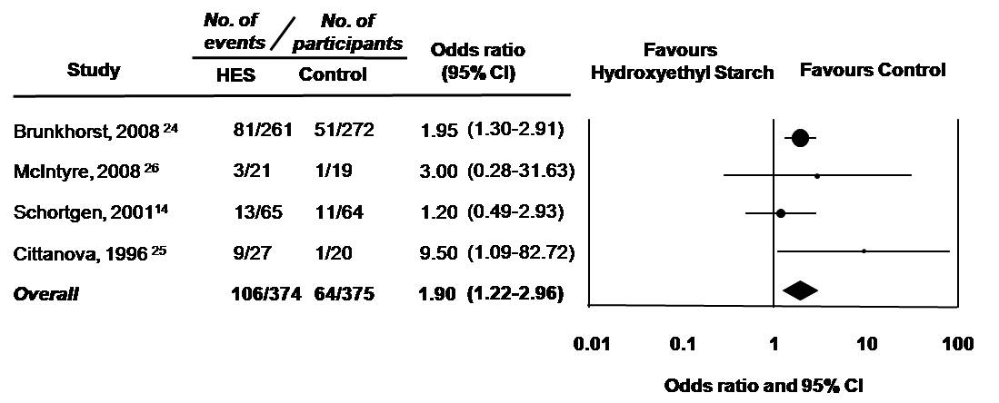

**Figure 3**: Overall mortality of all included studies

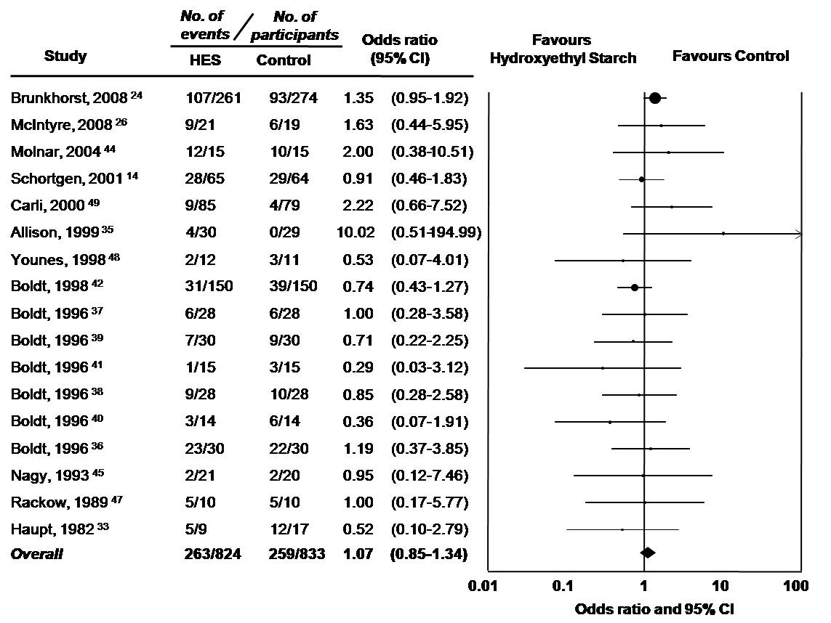

**Figure 4:** Mortality according to duration of treatment protocol, enrolled population, resuscitation strategy, type of HES, type of comparator fluid, and methodologic quality

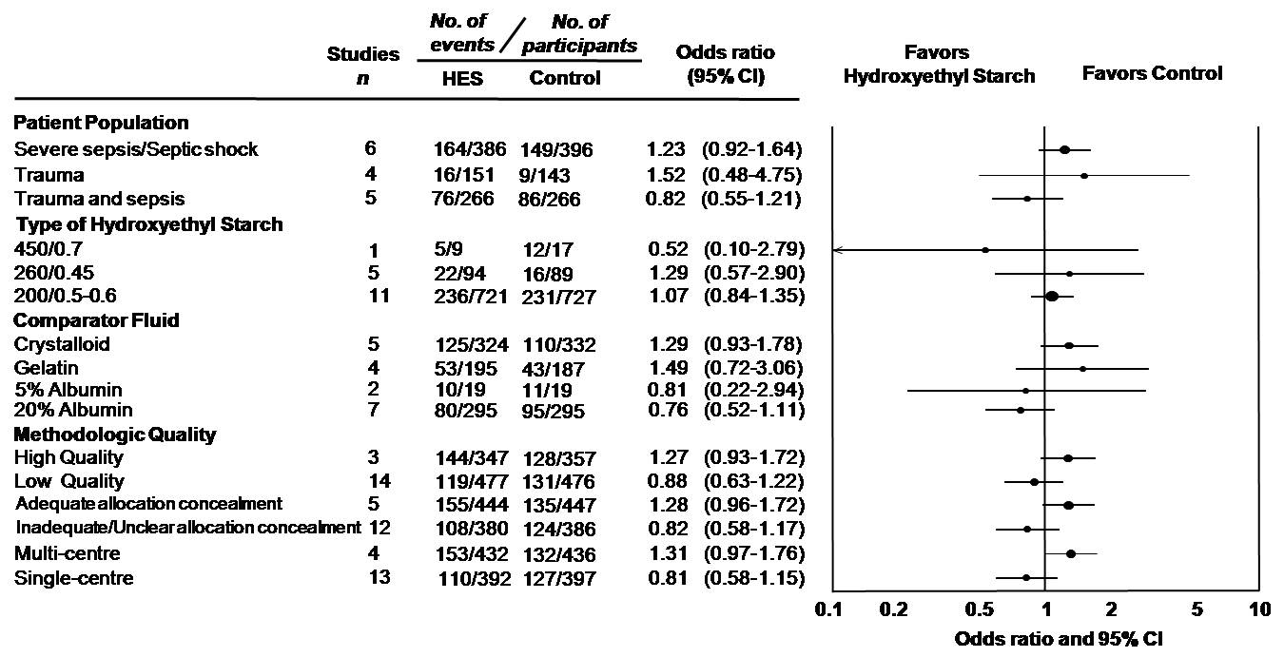

**Figure 5:** Assessment of publication bias for overall mortality

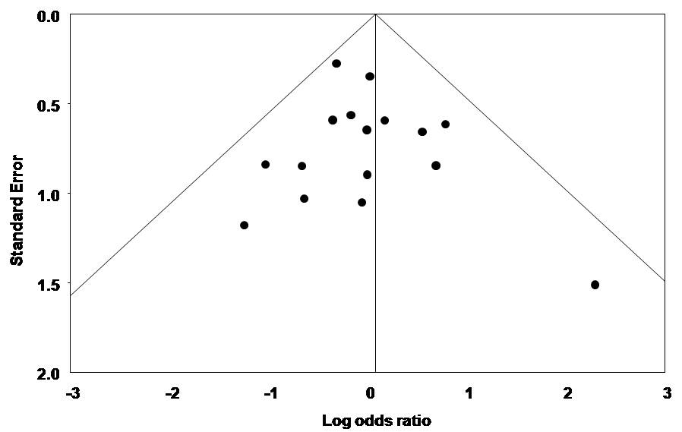

**Appendix 1:** Medline Search Strategy

Database: Ovid MEDLINE(R) <1950 to August Week 2 2007>

Search Strategy:

-----------------------------------------------------------------------------

1 hetastarch/ (1694)

2 hetastarch$.tw. (324)

3 (hydroxyethyl starch$ or hydroxyethylstarch$).tw. (1747)

4 pentastarch$.tw. (100)

5 (haes-steril or Hextend or Elohes or Expafusin or Voluven or

hemohes or hespan or pentafraction or pentaspan

or plasmasteril).tw. (214)

6 hes.tw. (2087)

7 or/1-6 (3725)

8 randomized controlled trial.pt. (240431)

9 controlled clinical trial.pt. (75750)

10 randomized controlled trials.sh. (50403)

11 random allocation.sh. (58745)

12 double blind method.sh. (92784)

13 single-blind method.sh. (11237)

14 clinical trial.pt. (439656)

15 exp clinical trials/ (195189)

16 (clin$ adj25 trial$).ti,ab. (134236)

17 ((singl$ or doubl$ or trebl$ or tripl$) adj25

(blind$ or mask$)).tw. (92205)

18 placebo$.sh. (27848)

19 placebo$.ti,ab. (104329)

20 random$.ti,ab. (382044)

21 research design.sh. (48798)

22 comparative study.pt. (1358262)

23 exp evaluation studies/ (610724)

24 follow up studies.sh. (344218)

25 prospective studies.sh. (226595)

26 (control$ or prospectiv$ or volunteer$).ti,ab. (1825986)

27 or/8-26 (3854705)

28 animals/ not humans/ (3168650)

29 27 not 28 (3008945)

30 7 and 29 (1177)

Updated December Week 2 2008

Reference List

(1) Boldt J. II. The balanced concept of fluid resuscitation. *Br J Anaesth.* 2007;99:312-315.

(2) Bellomo R. Fluid resuscitation: colloids vs. crystalloids. *Blood Purif.* 2002;20:239-242.

(3) Baker M. Email communication: The cost of normal saline. Concordia Hospital. Winnipeg, Canada. 2008.

(4) Haun M. Email communication: The cost of pentaspan. Canadian Blood Services. Ottawa Canada. 2008.

(5) Wiedermann CJ. Hydroxyethyl starch--can the safety problems be ignored? *Wien Klin Wochenschr.* 2004;116:583-594.

(6) Roberts I, Alderson P, Bunn F, Chinnock P, Ker K, Schierhout G. Colloids versus crystalloids for fluid resuscitation in critically ill patients. *Cochrane Database Syst Rev.* 2004;CD000567.

(7) Choi PT, Yip G, Quinonez LG, Cook DJ. Crystalloids vs. colloids in fluid resuscitation: a systematic review. *Crit Care Med.* 1999;27:200-210.

(8) Vermeulen LC, Jr., Ratko TA, Erstad BL, Brecher ME, Matuszewski KA. A paradigm for consensus. The University Hospital Consortium guidelines for the use of albumin, nonprotein colloid, and crystalloid solutions. *Arch Intern Med.* 1995;155:373-379.

(9) Barron ME, Wilkes MM, Navickis RJ. A systematic review of the comparative safety of colloids. *Arch Surg.* 2004;139:552-563.

(10) Bork K. Pruritus precipitated by hydroxyethyl starch: a review. *Br J Dermatol.* 2005;152:3-12.

(11) Davidson IJ. Renal impact of fluid management with colloids: a comparative review. *Eur J Anaesthesiol.* 2006;23:721-738.

(12) Winkelmayer WC, Glynn RJ, Levin R, Avorn J. Hydroxyethyl starch and change in renal function in patients undergoing coronary artery bypass graft surgery. *Kidney Int.* 2003;64:1046-1049.

(13) Dehne MG, Muhling J, Sablotzki A, Papke G, Kuntzsch U, Hempelmann G. [Effect of hydroxyethyl starch solution on kidney function in surgical intensive care patients]. *Anasthesiol Intensivmed Notfallmed Schmerzther.* 1997;32:348-354.

(14) Schortgen F, Lacherade JC, Bruneel F et al. Effects of hydroxyethylstarch and gelatin on renal function in severe sepsis: a multicentre randomised study. *Lancet.* 2001;357:911-916.

(15) Ostermann M, Chang RW. Acute kidney injury in the intensive care unit according to RIFLE. *Crit Care Med.* 2007;35:1837-1843.

(16) Bagshaw SM, Laupland KB, Doig CJ et al. Prognosis for long-term survival and renal recovery in critically ill patients with severe acute renal failure: a population-based study. *Crit Care.* 2005;9:R700-R709.

(17) Uchino S, Kellum JA, Bellomo R et al. Acute renal failure in critically ill patients: a multinational, multicenter study. *JAMA.* 2005;294:813-818.

(18) Hoste EA, Clermont G, Kersten A et al. RIFLE criteria for acute kidney injury are associated with hospital mortality in critically ill patients: a cohort analysis. *Crit Care.* 2006;10:R73.

(19) Sakr Y, Payen D, Reinhart K et al. Effects of hydroxyethyl starch administration on renal function in critically ill patients. *Br J Anaesth.* 2007;98:216-224.

(20) Schortgen F, Girou E, Deye N, Brochard L. The risk associated with hyperoncotic colloids in patients with shock. *Intensive Care Med.* 2008;34:2157-2168.

(21) Honore PM, Joannes-Boyau O, Boer W. Hyperoncotic colloids in shock and risk of renal injury: enough evidence for a banning order? *Intensive Care Med.* 2008;34:2127-2129.

(22) McIntyre LA, Fergusson D, Cook DJ et al. Resuscitating patients with early severe sepsis: a Canadian multicentre observational study. *Can J Anaesth.* 2007;54:790-798.

(23) Dehne MG, Muhling J, Sablotzki A, Dehne K, Sucke N, Hempelmann G. Hydroxyethyl starch (HES) does not directly affect renal function in patients with no prior renal impairment. *J Clin Anesth.* 2001;13:103-111.

(24) Brunkhorst FM, Engel C, Bloos F et al. Intensive insulin therapy and pentastarch resuscitation in severe sepsis. *N Engl J Med.* 2008;358:125-139.

(25) Cittanova ML, Leblanc I, Legendre C et al. Effect of hydroxyethylstarch in brain-dead kidney donors on renal function in kidney-transplant recipients. *Lancet.* 1996;348:1620-1622.

(26) McIntyre LA, Fergusson D, Cook DJ et al. Fluid resuscitation in the management of early septic shock (FINESS): a randomized controlled feasibility trial. *Can J Anaesth.* 2008;55:819-826.

(27) Dickersin K, Scherer R, Lefebvre C. Identifying relevant studies for systematic reviews. *BMJ.* 1994;309:1286-1291.

(28) Bellomo R, Ronco C, Kellum JA, Mehta RL, Palevsky P. Acute renal failure - definition, outcome measures, animal models, fluid therapy and information technology needs: the Second International Consensus Conference of the Acute Dialysis Quality Initiative (ADQI) Group. *Crit Care.* 2004;8:R204-R212.

(29) Fleiss JL, Cohen J. The equivalence of weighed kappa and the intraclass correlation coefficient as measures of realibility. *Educ Psychol Meas.* 1973;33:613-619.

(30) Jadad AR, Moore RA, Carroll D et al. Assessing the quality of reports of randomized clinical trials: is blinding necessary? *Control Clin Trials.* 1996;17:1-12.

(31) Schulz KF, Chalmers I, Hayes RJ, Altman DG. Empirical evidence of bias. Dimensions of methodological quality associated with estimates of treatment effects in controlled trials. *JAMA.* 1995;273:408-412.

(32) Rackow EC, Falk JL, Fein IA et al. Fluid resuscitation in circulatory shock: a comparison of the cardiorespiratory effects of albumin, hetastarch, and saline solutions in patients with hypovolemic and septic shock. *Critical care medicine.* 1983;11:839-850.

(33) Haupt MT RE. Colloid osmotic pressure and fluid resuscitation with hetastarch, albumin, and saline solutions. *Critical care medicine.* 1982;10:159-162.

(34) Jovanovic K. Hetastarch In Replacement Of Circulation Volume Compared To Haemaccel And Dextran 70 In Pre-Hospital Resuscitation Of Polytraumatised Patients. *Intensive care medicine.* 1997;23:S184.

(35) Allison KP GP. Randomized trial of hydroxyethyl starch versus gelatine for trauma resuscitation. *The Journal of trauma.* 1999;47:1114-1121.

(36) Boldt J, Heesen M, Welters I et al. Does the type of volume therapy influence endothelial-related coagulation in the critically ill? *British journal of anaesthesia.* 1995;75:740-746.

(37) Boldt J. Influence of different volume therapies on platelet function in the critically ill. *Intensive care medicine.* 1996;22:1075-1081.

(38) Boldt J, Mueller M, Menges T et al. Influence of different volume therapy regimens on regulators of the circulation in the critically ill. *British journal of anaesthesia.* 1996;77:480-487.

(39) Boldt J, Heesen M, Muller M et al. The effects of albumin versus hydroxyethyl starch solution on cardiorespiratory and circulatory variables in critically ill patients. *Anesthesia & Analgesia.* 1996;83:254-261.

(40) Boldt J, Heesen M, Padberg W et al. The influence of volume therapy and pentoxifylline infusion on circulating adhesion molecules in trauma patients. *Anaesthesia.* 1996;51:529-535.

(41) Boldt J, Muller M, Heesen M et al. Influence of different volume therapies and pentoxifylline infusion on circulating soluble adhesion molecules in critically ill patients. *Critical care medicine.* 1996;24:385-391.

(42) Boldt J, Muller M, Mentges D et al. Volume therapy in the critically ill: is there a difference? *Intensive care medicine.* 1998;24:28-36.

(43) Falk JL, Rackow EC, Astiz ME et al. Effects of hetastarch and albumin on coagulation in patients with septic shock. *Journal of clinical pharmacology.* 1988;28:412-415.

(44) Molnar Z, Mikor A, Leiner T et al. Fluid resuscitation with colloids of different molecular weight in septic shock. *Intensive care medicine.* 2004;30:1356-1360.

(45) Nagy KK, Davis J, Duda J et al. A comparison of pentastarch and lactated Ringer's solution in the resuscitation of patients with hemorrhagic shock. *Circulatory shock.* 1993;40:289-294.

(46) Palumbo D, Servillo G, D'Amato L et al. The effects of hydroxyethyl starch solution in critically ill patients. *Minerva anestesiologica.* 2006;72:655-664.

(47) Rackow EC, Mecher C, Astiz ME et al. Effects of pentastarch and albumin infusion on cardiorespiratory function and coagulation in patients with severe sepsis and systemic hypoperfusion. *Critical care medicine.* 1989;17:394-398.

(48) Younes RN, Yin KC, Amino CJ et al. Use of pentastarch solution in the treatment of patients with hemorrhagic hypovolemia: randomized phase II study in the emergency room. *World journal of surgery.* 1998;22:2-5.

(49) Carli P. Prehospital care of hypovolemic trauma patients: 6% Hydroxyethyl (Hesteril(TM)) starch versus gelatin (Plasmion(TM)). *Jeur.* 2000;13:101-105.

(50) Hopf HB, Siepmann HP, Hopf HB, Siepmann HP. [Comparative study of the modification of blood, blood coagulation, cardiovascular circulation by 3% modified, fluid gelatins and 6% low-molecular weight hydroxyethyl starch]. *Infusionstherapie und klinische Ernahrung.* 1987;14 Suppl 2:31-35.

(51) Boldt J, Priebe HJ. Intravascular volume replacement therapy with synthetic colloids: is there an influence on renal function? *Anesth Analg.* 2003;96:376-82, table.

(52) Jungheinrich C, Neff TA. Pharmacokinetics of hydroxyethyl starch. *Clin Pharmacokinet.* 2005;44:681-699.

(53) Bristol Meyers Squibb Canada. Voluven: New in plasma volume expansion: Excellent safety profile. 2006 [Pamphlet].